**Contract Audit Follow-Up User Manual 3.5**



This manual is provided by General Dynamics Information Technology as a service to Defense Contract Management Agency. [Manual Version: 3.5 Release Date: 03/21/2016]

**Table of Contents**

Overview 5

Contract Audit Follow-Up 3.5 5

Enhancement Areas for Contract Audit Follow-Up 3.5 6

Reportable and Non-Reportable Audits 8

CAFU Functions by Role 10

Contracting Officer (CO) Functions 10

Major Command (MC) Monitor Functions 10

District Monitor Functions (DCMA only) 11

Headquarters Monitor Functions 11

DoDIG 11

Layout Screen 12

Look and Feel 12

Header 12

Content Area 13

Footer 14

Common Indicators 15

Calendar 16

User Profile 17

Modifying Browser Text Size 17

Application Messages 18

Home Page 19

Home Page Content 19

Enhancements and CAFU Features 19

Work Screen Layout 20

My Work Screen 20

View My Activity 21

Workgroup Audits 22

My Workgroup Overview 22

DCMA 23

Army 23

Navy 24

TRICARE 24

Air Force 25

Audits 26

Workgroup Audits Screen 26

DCMA District and HQ Monitors 26

View Audit Layout 26

Viewing Audit Details and Actions 26

From Audit number listings/Audit Screen: 27

From My Work 27

Printing the Audit Record 28

Working with Audit Records 29

CAFU Pipeline 29

Work Flow Diagram 29

Working with Audit Records Overview 32

Common Actions 32

Validation Error 33

Searching for Audits 34

Using the Search Screen 34

Search Results 35

Add New Audit by Monitor 35

Add New Audit 35

Plan 37

Resolve 38

Disposition or Defer Layout 40

Forward / Send Document 43

Forwarded 45

Correction by Monitors 45

Take Over an Audit from the View Audit Follow-Up Screen 47

Take Over by Monitors 47

Updating Remarks by CO and Monitors 48

Update Revised Target Date (CO and Monitors) 49

Deleting Audits 50

Transferring an Audit Report 51

Milestones 52

Milestones Overview 52

Adding Milestones 53

Updating and Deleting Milestones 54

Viewing Milestones from View Audit Follow-Up Screen 55

Activity Logging 56

Activity Overview 56

Activity Logging per Audit Report 57

Activity Logging per User 58

DCMA Reports List 59

CAFU Semi-Annual Open Report 59

CAFU Semi-Annual Closed Report 60

CAFU Individual Contract Audit Inquiry 60

CAFU Inquiry by Type of Audit 60

CAFU Unresolved Audits Over Six Months 60

CAFU Added/Deleted Audit Report 60

CAFU Audit List 60

CAFU Import Failure Report 60

CAFU Summary by Type Of Audit With Cost Question Summary 61

CAFU Top Level Summary by Type 61

CAFU User Access Report 61

CAFU Audits by Resolution Status 61

Service Reports 61

Service Report Details 61

CAFU Inquiry by Type Audit 62

CAFU Semi Annual Closed Report 62

CAFU Semi Annual Open Report 62

CAFU Frequently Asked Questions 62

Using the Calendar Function CBT 63

Glossary 63

# Overview

## Contract Audit Follow-Up 3.5

The CAFU 3.5 web application has been constructed in consonance with the decision-making role of the contracting officer, and the financial advisory role of the **contract** auditor. It is designed to receive new audit report records from the Defense Contract Auditing Agency (DCAA) and assign them to Contracting Officers (COs). CAFU supports the following DoD Components.

* AIR FORCE
* ARMY
* DCMA
* NAVY
* TRICARE
* DoDIG

Please see DCMA CAFU Instruction and the DoD Instruction 7640.02 (August 22, 2008) for more information on Contract Audit Follow-Up:

[DCMA CAFU Policy/ Instruction link](http://www.dcma.mil/policy/126/DCMA-INST-126.pdf)

<http://www.dtic.mil/whs/directives/corres/pdf/764002p.pdf>

**Quick Reference to Fundamental Steps in the CAFU eTool:**

1. Assign Audit report records in the system = System assigns when the record is imported into eTools or CMO Monitor can add manually assign. The CMO Monitor can transfer/assign audit records within their workgroup. HQ Monitors can transfer to other workgroups or outside of DCMA.

2. Add Audit report record to the system = The CMO and District Monitor can create an audit record. The CO/ACO and HQ/District Monitor roles cannot create a record.

3. Edit = input data to the audit record by user/ACO such as target dates, revised disposition target dates, actual resolution date, actual disposition date, penalty assessed amount or penalty waiver date.

4. Correct = corrections are done by Monitors (CMO, HQ, District).

5. Submit or Reset = Two important actions/action button features for each input screen. Submit will take the action and update the record. Reset will clear the action so that it does not update the record. The Submit and Reset buttons appear at the bottom of the input screen.

6. Calendar = Allow CO or Monitor to pick date for input and hit enter or submit and it updates the record. The CO or Monitor can choose the Clear button if they realize they have picked a date that is not accurate and have not hit Submit yet. Once the user hits the Submit button, the Monitor will have to take the record and clear or reset it or both.

*For further information, see the section of this manual that contains the User Roles.*

## Enhancement Areas for Contract Audit Follow-Up 3.5

DoDI 7640.02 requires users to capture detailed information on penalties and interest and to track unresolved cost.

The enhancements for CAFU 3.5 are focused on these new fields:

**New data fields are:**

1. Qualified or Unresolved Cost (received from DCAA)
2. Questioned Cost Subject to Penalty (received from DCAA)
3. Penalty Assessed (Yes/No radio buttons)
4. Penalty Amount (entered by CO, whole dollars)
5. Interest Amount (entered by CO, whole dollars)
6. Penalty Date Assessed (entered by CO, format dd/mm/yyyy)
7. Penalty Waiver Date (entered by CO, format dd/mm/yyyy)
8. DUNS Field

**These new data fields will capture:**

* Whether or not a penalty was recommended by DCAA
* Whether or not a penalty was assessed by the CO
* Penalty Amount
* Interest Amount
* Date penalty was assessed
* Penalty Waiver date (field will populate if NO was selected on penalty assessed by CO)
* Data Universal Numbering System (DUNS) for each contractor

**Qualified or Unresolved Cost** (received from DCAA):

This field displays either **Yes** or **No**. The Yes or No is pulled from the DCAA data load.

**Note**: This field will be empty for the open existing audit records under 3.0.

**Questioned Cost Subject to Penalty** (received from DCAA):

Questioned Cost Subject to Penalty will always have data, either 0 (zero) or another number. It will never be blank. The application carries the field throughout all CAFU records in the 3.5 version, even though it only applies to certain audit types.

**Penalty Assessed** (Yes/No radio buttons):

This applies to only those audit records where there are costs questioned subject to penalty. The CO has option to decide Yes or No as to whether penalty is assessed.

If **Questioned cost subject to penalty** is greater than zero, the Penalty Assessed will be **Yes,** otherwise **No**. When either the **Yes** or **No** radio button is selected in error, it must be cleared by using the **Reset button** at the bottom of the input screen. Do not hit the Submit button if you think you have made an error because the radio button choice will become part of the permanent record in CAFU.

If Yes was entered by the CO on Penalty Assessed, Penalty Amount (Whole Dollars), Penalty Date Assessed (dd/mm/yyyy), and Interest Amount (Whole Dollars) field will display.

If No was entered by the CO on Penalty Assessed, Penalty Waiver Date (dd/mm/yyyy) field will display.

**Penalty Amount:**

CO/Monitor will input the value for Penalty Amount. This is a required field when Penalty Assessed is Yes. This amount will be positive whole dollars, with two decimal places like 25 or 25.00

**Interest Amount:**

CO/Monitor will input the value for Interest Amount. This amount will be positive whole dollars, with two decimal places like 25 or 25.00 This is not a required/mandatory input field.

**Penalty Date Assessed** (dd/mm/yyyy):

User can select the date for the field from the calendar.

**Penalty Waiver Date** (dd/mm/yyyy):

When the CO selects Penalty Assessed as No, Penalty Waiver Date can be entered.

This is not a required/mandatory input field.

.

**Business Rule:** Penalty Date Assessed and Penalty Waiver Date cannot be prior to audit issue date and it cannot be future date.

**DUNS Field:**

The Data Universal Numbering System (DUNS) Number in Contract Audit Follow-up (CAFU) is a nine-digit (alpha and numeric characters) identification number for a single business entity assigned by Dun & Bradstreet. The DUNS number is a required editable field. The DUNS number flows from DCAA's DMIS system to the CAFU eTool or can be inserted while creating a new record using the CAFU tool

**Process Improvements:**

* Forward feature has been made a requirement when entering a Disposition Actual Date (Only for Reportables)
* Notice has been added when using the Forward feature (Only for Reportables)

## Reportable and Non-Reportable Audits

Reportable audits are identified in the DoDI 7640.02, as all contract audit report that include questioned costs or recommendations and require contracting officer action are subject to the reporting requirements, except for those involving: Contractor estimates of future costs, Agreed-upon procedures, and Nonaudit Services.

Nonreportable audits are reports covering agreed –upon procedures, nonaudit services, and contractor estimates of future costs.

## Matrix of CAFU Functions & Capabilities by Role/User:



# Layout Screen

## Look and Feel

This section covers the overall Look and Feel and User Interface of the CAFU 3.5 application.

There are three main sections to the application layout:

* Header
* Content Area
* Footer

### Header



The Header consists of:

**Title Bar**

* Branding: e-Tools logo and application name with version.
* User Name: Clicking on the user's name shows user's profile.
* Help: Provides access to the help files.
* Exit: Quits the CAFU application.

**Menu Bar**

Provide links for easy navigation throughout the application.

* Main application links: High-level links that allow the user to access the main features of the CAFU application.
* Context sensitive links: Provide access to cross-reference information and content related to current page.

### Content Area

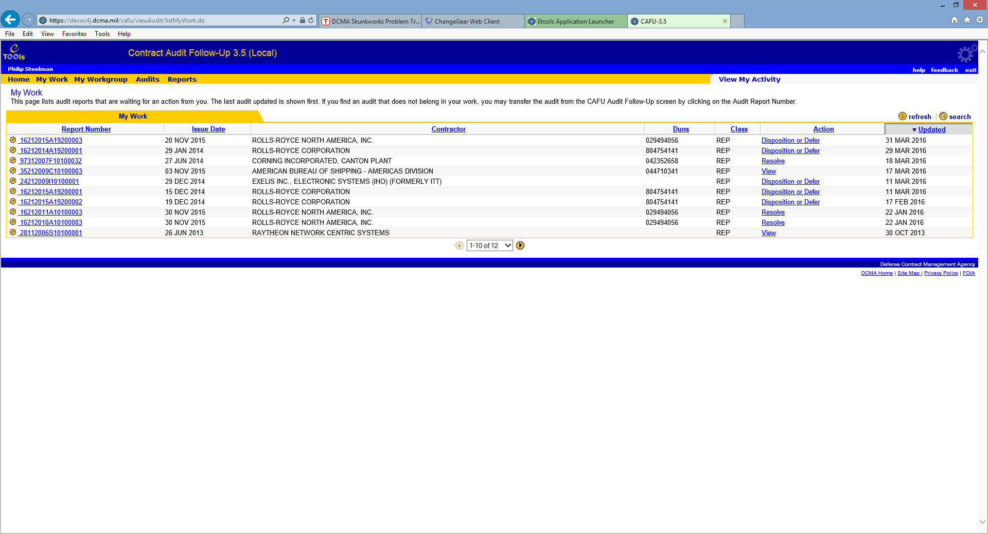

**Data Table**

**Title and Description**

This section displays the title and description of the page. It also provides the purpose of the page and the actions that the user can perform.

**Data Table**

This section displays a table of records related to the page. It also provides actions that can be performed on the table, such as refresh and search. Data Table is only used on pages that need to display records.

**Dynamic Sorting**



This feature allows users to arrange the records in the order they prefer. Clicking on the column header sorts the table by that column. Clicking on the same column again reverses the sort order.

For example, to sort by Contractor Name, click on the Contractor Name heading. The result will be records sorted by Reportable first, then Contractor Name second.

**Note**: Reportable records are presented first when presenting an audit list to the user. This applies regardless of a user's selected sort order.

**Record Scroller**

The record scroller displays the number of records in the current view and allows the user to scroll through the pages of records. The record scroller is only used in conjunction with a Data Table; it is omitted if there are no records.



The record scroller displays the current page of records you are viewing in groups of 10.

You can select the page to jump to by clicking on the dropdown. The left and right pointers allow you to navigate to previous and next pages. Note that the pointers will be faded out when not applicable, for example the left pointer in the image above is not available because we are on the first page.

### Footer



The footer provides links to standard DCMA web sites.

### Common Indicators

Standard icons and indicators are used throughout the application to provide consistent behavior and improve usability. The following are some of the most commonly used icons:

|  |  |  |
| --- | --- | --- |
| **Icon** | **Name** | **Description** |
|  | Calendar | Display the calendar in a pop-up window to help user select a date. |
|  | Edit | Edit the record. |
|  | Close | Close a pop-up window. |
|  | Error | Indicates a validation error that must be fixed by the user. |
|  | Hint | Shows usage hint(s) related to the current page. |
|  | Print | Print the current page. |
|  | Refresh | Refresh the related Data Table. |
|  | Search | Search within the related Data Table. |
|  | Add | Add a new record. |
|  | Delete | Delete the record. |
|  | Jump down | Jump down to a bookmark on the page. This icon is also used to denote the order of sorting. |
|  | Jump up | Jump up to a bookmark on the page. This icon is also used to denote the order of sorting. |
|  | Next | Jumps to the next page or record. |
|  | Previous | Jumps to the previous page or record. |

### Calendar

The calendar provides a convenient way to input dates. It ensures that the format of the date will be accurate and consistent.

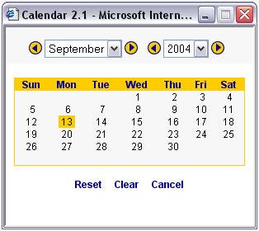

To select a date, follow these steps:

1. Click on the  Calendar icon.

Select the month desired by clicking on the arrow on the left or right surrounding the month; select the year by clicking on the left or right arrows surrounding the years on top.



Single-click on the desired day.

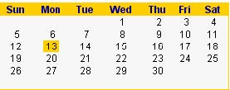

The date will be automatically populated in the correct format. 13 SEP 2004

### User Profile

Your user profile can be accessed from any screen in the application (except for confirmation pages). To access your profile follow these steps:

1. Click on your name in the light blue section of the header.



1. Your User Profile will appear in a pop-up window.

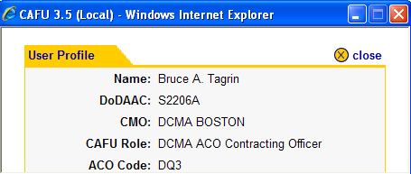

To close the pop-up window click on close in the upper right hand corner of the window.

**NOTE**: To correct any wrong data found in User Profile, CAFU user needs to open a helpdesk ticket.

### Modifying Browser Text Size

Internet Explorer

1. Select View from the menu bar.



2. Select Text Size.

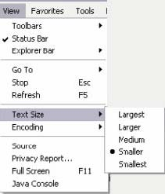

3. Choose the desired text size:

* Largest
* Larger
* Medium (Default)
* Smaller
* Smallest

### Application Messages

If you have selected Submit, Cancel or an action on a Data Table, you will receive a message informing you that the system has performed the appropriate action. The confirmation will direct you to the screen from which you originated or to a related screen.

For example:

A successful submit confirmation

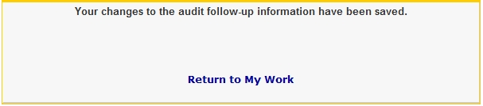

A cancellation confirmation

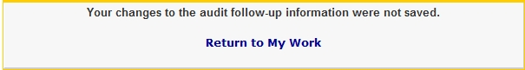

System Time Out

If the user has taken no action in CAFU (i.e. click on link or button) for 4 hours, the system will automatically log the user out of the application. At this point, you must log back in.

# Home Page

## Home Page Content

The Home Page is the first page that the user will see when they access CAFU. It displays a brief description about CAFU current enhancements and features.

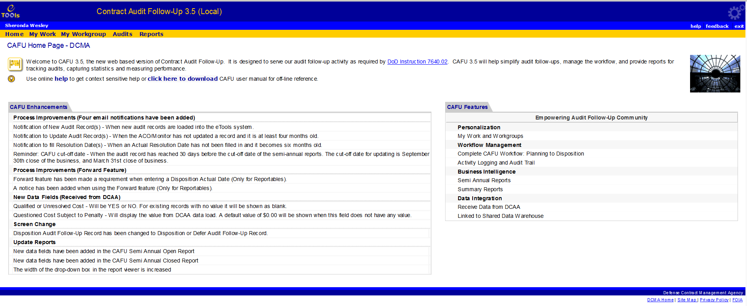

## Enhancements and CAFU Features

This section lists the enhancements to CAFU since the last release.

# Work Screen Layout

## My Work Screen

My Work displays audits that are waiting for an action to be completed by you.

Monitors are responsible for assignment, correction, and adding (HQ and MACOM) and deleting (HQ) audits assigned to them or audits taken-over from their workgroup. COs are responsible for the follow-up activities from planning to forwarding the memo.

**NOTE**: There are only three different user roles for Non DCMA agencies as HQ Monitor, Major Command Monitor and CO. The workgroup for service agencies, include all users within the agency.

To jump to the edit audit screen, simply click on the edit (pencil) icon.



Clicking on the Audit Report Number takes you to the View Audit Follow-Up screen that shows the details about the audit. Clicking on the Contractor name shows details about the Contractor (if available). Clicking on the Action link takes you to the CAFU Work Flow Diagram. The CAFU Work Flow Diagram displays the description of the pipeline that represents the action that needs to be taken for the selected audit. This explains the difference in pipeline positions shown when editing the record. (See Below)

The example below shows that audit 27012008A11070002 has been assigned and is ready to be planned.

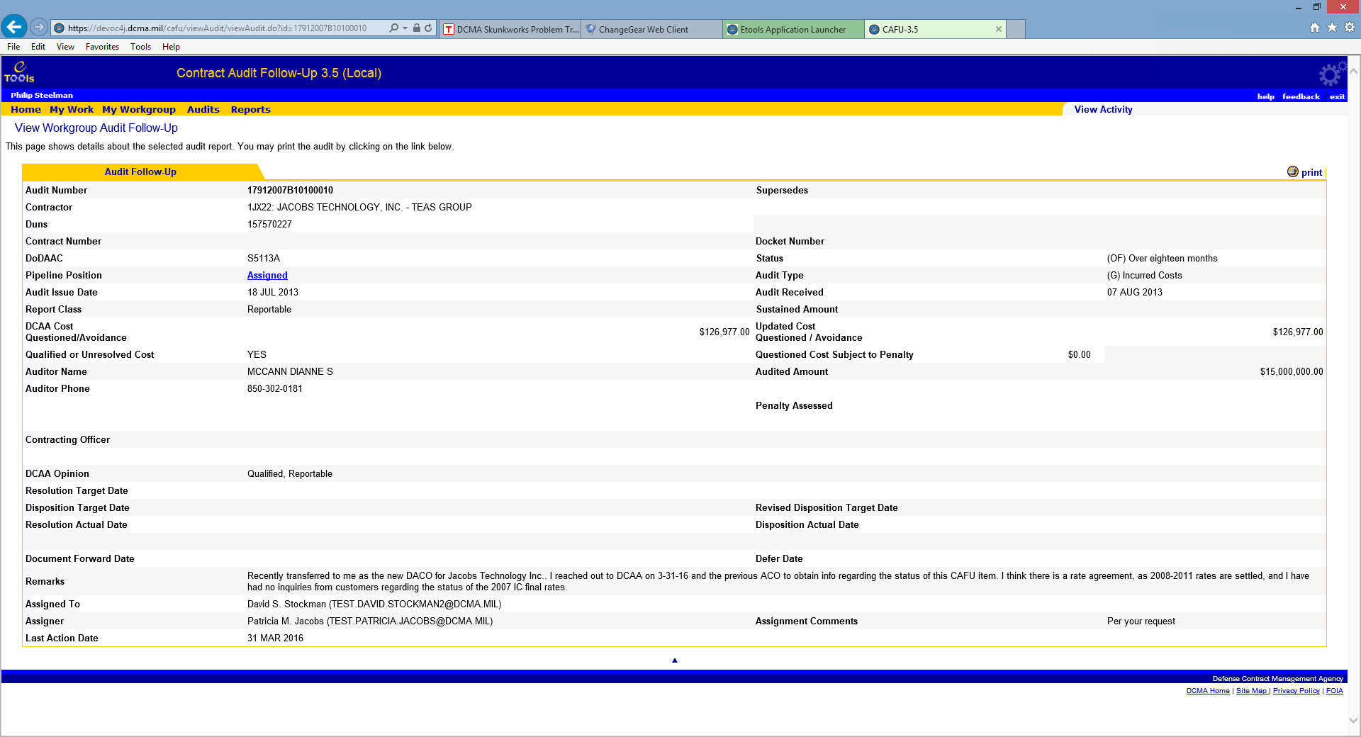

REDACTED

If you are expecting new audits in your work since you last logged in, click on the **refresh** link to have the system look for newly assigned audits.

You can filter this list to locate specific audits by using the **search** link. Note that using the search feature here will only search within the audits in your work.

The **add audit** feature is available to CMO, District and MC Monitors. If you have received an audit report from DCAA that is not in your work, please have your CMO, HQ or MACOM/District add it to the system.

## View My Activity

View My Activity displays activities for the current user.

Clicking on the Date and Time takes you to a snapshot of the Audit Report if available. Clicking on the Audit Report Number takes you to the View Audit Follow-Up screen.

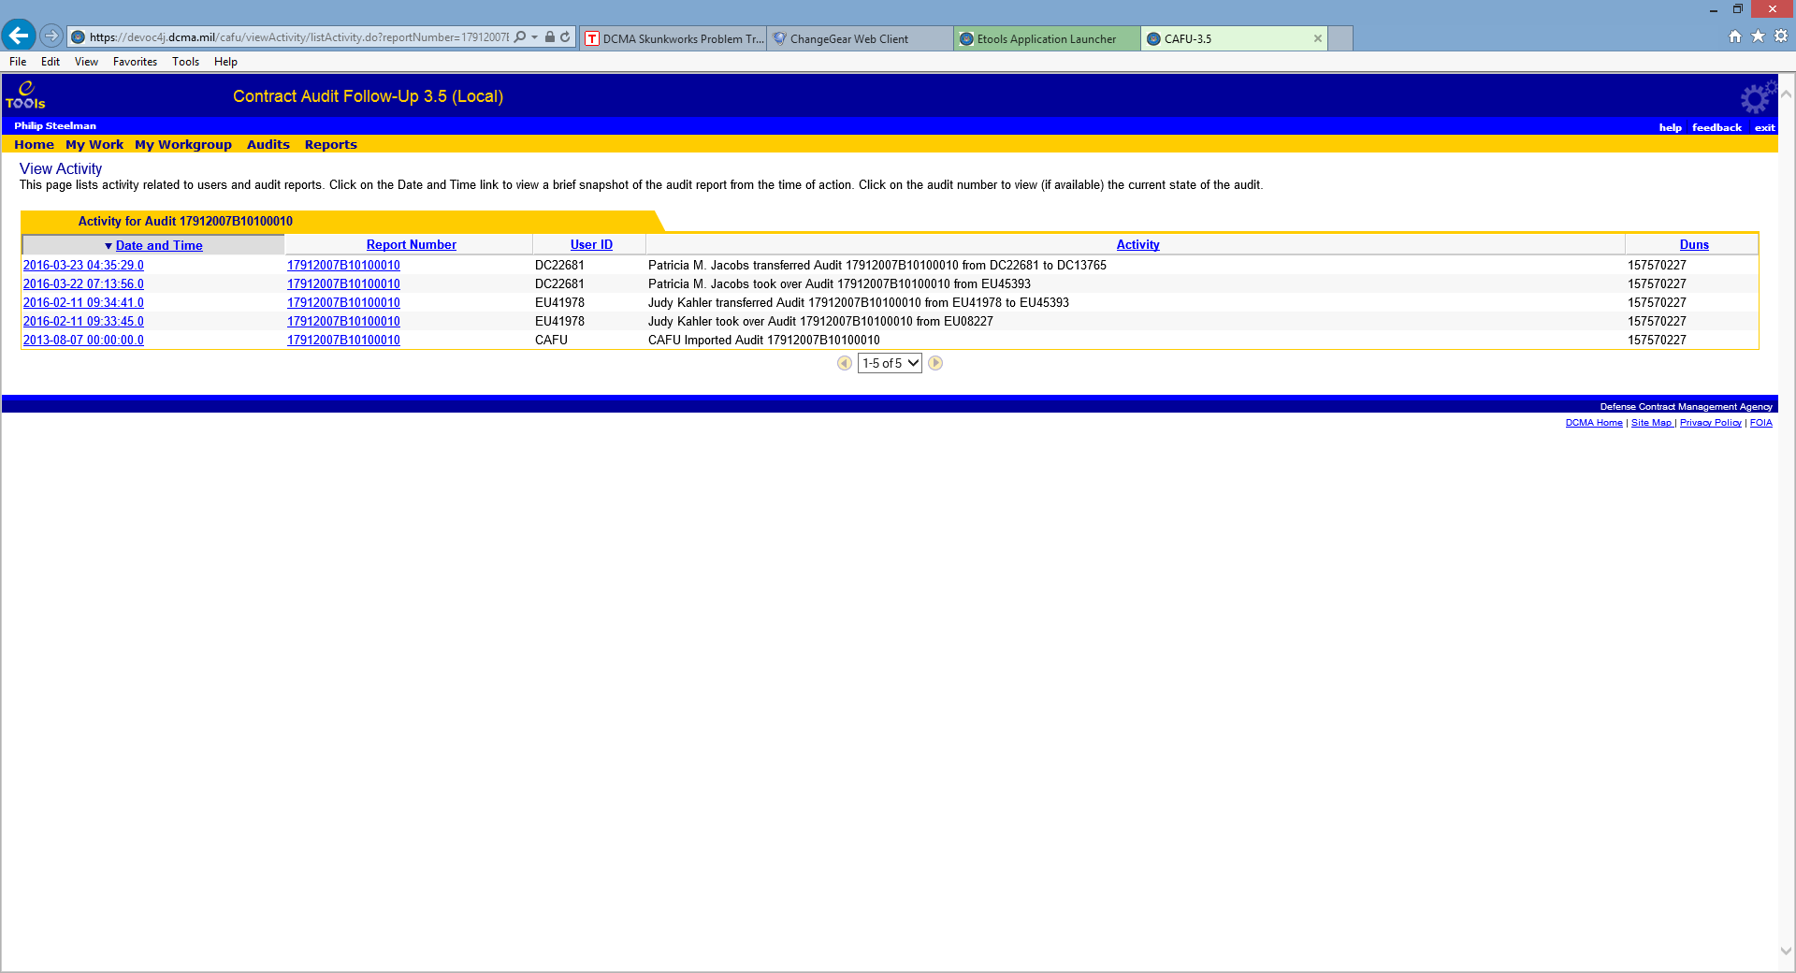

# Workgroup Audits

## My Workgroup Overview

This page provides information about your CAFU account, your workgroup, and members of your workgroup. Actions pertaining to a role cannot be taken directly from My Workgroup. Only Monitors have the option to take over an audit from their workgroup, at which time, actions can be taken against an audit directly from My Work screen.

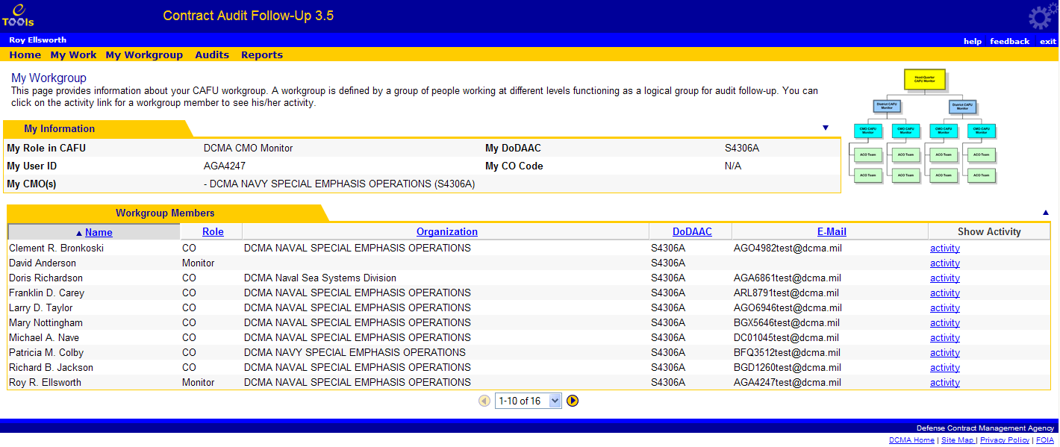

For each user in your workgroup, a list of their activities can be viewed by clicking on the activity link located in the Show Activity column.

**NOTE:** **Invalid** may appear in the Role column when a user does not have proper access privileges.

### DCMA

This page provides information about your CAFU account, your workgroup, and members of your workgroup. The CAFU workgroup consists of two roles and three levels, as illustrated in the following organization chart:

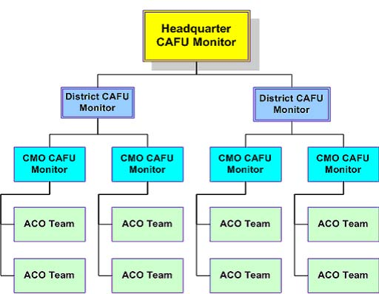

Monitors are responsible for assignment, correction, and adding (CMO and District) and deleting (District) audits within their workgroup. ACOs are responsible for the follow-up activities from the Planning stage through the Forwarding stage.

### Army

This page provides information about your CAFU workgroup. The Army CAFU workgroup consists of two roles and three levels, as illustrated in the following organization chart:

**Army Workgroup**

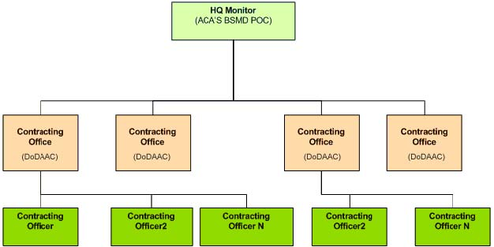

### Navy

This page provides information about your CAFU account, your workgroup, and members of your workgroup. The Navy CAFU workgroup consists of two roles and two levels, as illustrated in the following organization chart:

**Navy Workgroup**

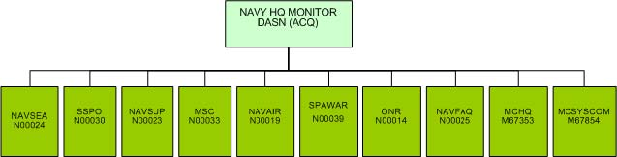

### TRICARE

This page provides information about your CAFU account, your workgroup, and members of your workgroup. The TRICARE CAFU workgroup consists of two roles and two levels, as illustrated in the following organization chart:

**TRICARE Workgroup**

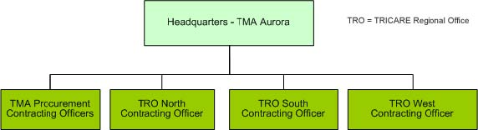

### Air Force

This page provides information about your CAFU account, your workgroup, and members of your workgroup. The Air Force CAFU workgroup consists of two roles and four levels, as illustrated in the following organization chart:

**Air Force Workgroup**

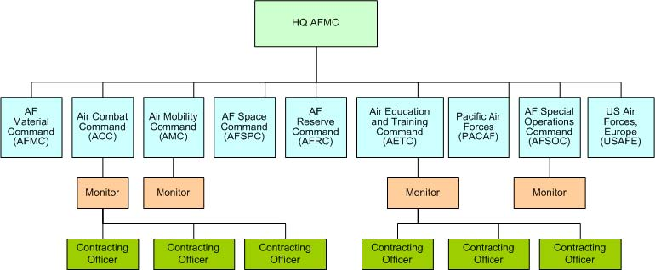

# Audits

## Workgroup Audits Screen

Accessible from the menu through the **Audits** link, this screen provides a list of all audits that are in your workgroup. For Non DCMA agencies, the workgroup consists of users within the Agency/DoD component. Clicking on the Report Number takes you to the View Workgroup Audit Follow-Up screen with details about the audit. Clicking on the Pipeline column shows you the CAFU Work Flow Diagram. The CAFU Work Flow Diagram will display the description of the pipeline that the audit has completed.

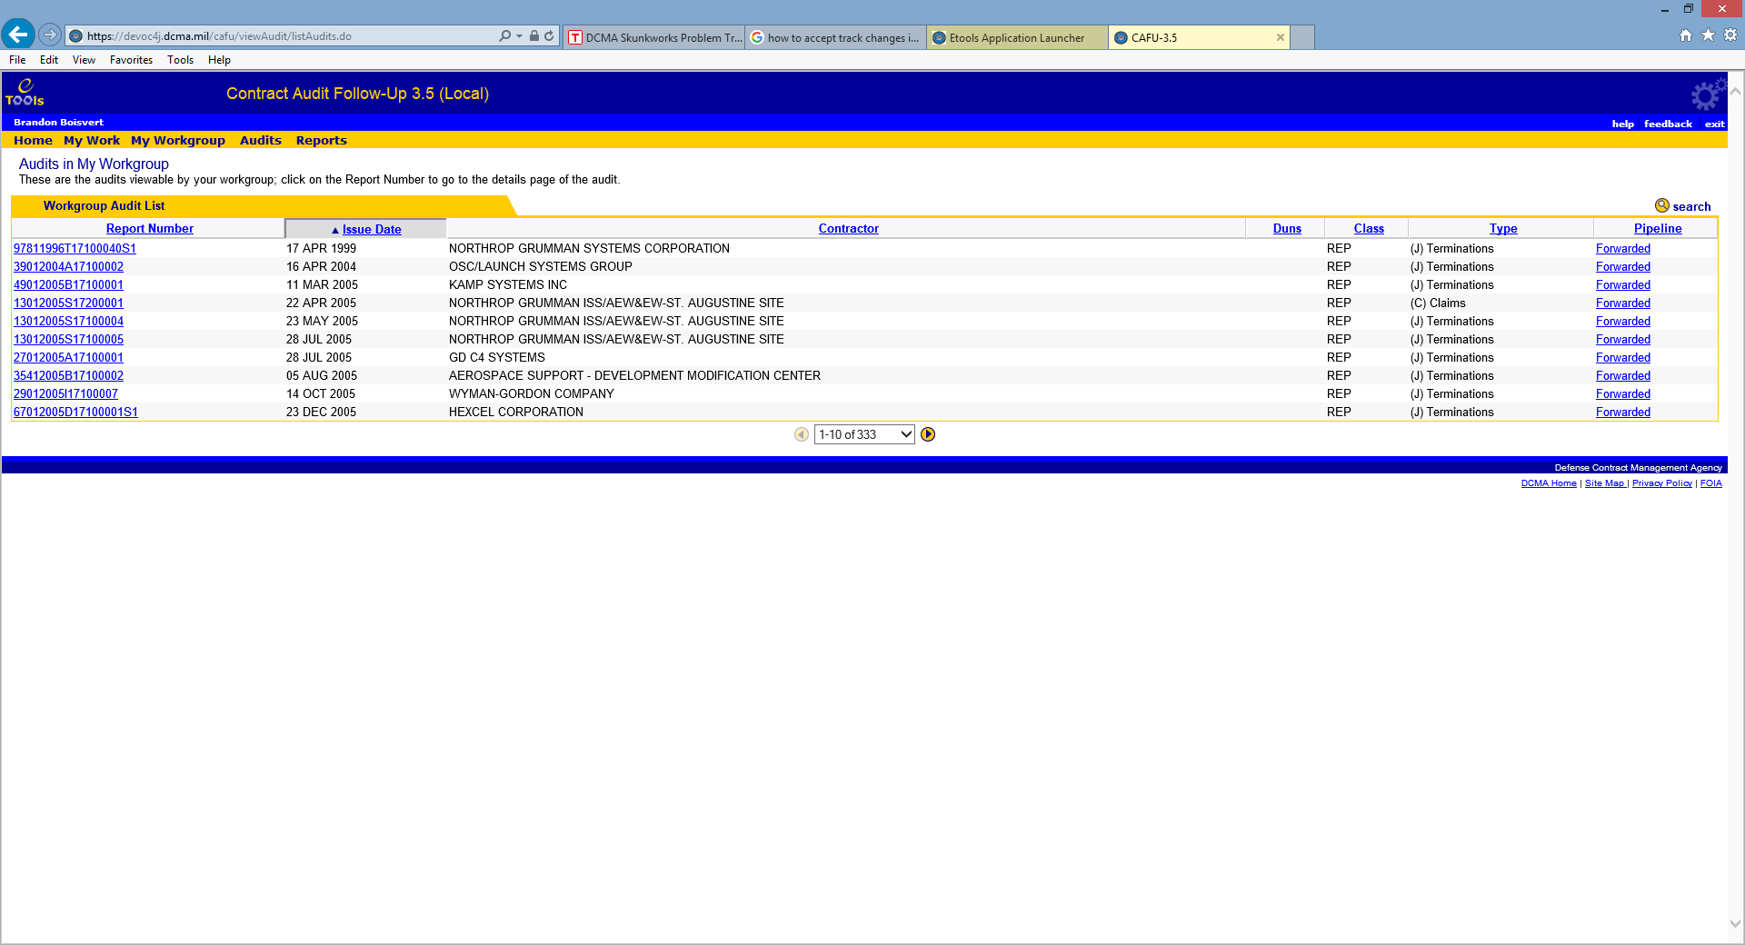

You can filter this list to locate specific audits by using the search link.

To edit an Audit it must be assigned to you and appear under your My Work screen.

Note: using the Take-Over feature for an audit record, which is already in the user's My Work, will override the original assigner to that of the current user.

## DCMA District and HQ Monitors

By default, DCMA District and HQ Monitors do not see any audit numbers/records in the Audits screen. This restriction is due to the fact that there are too many audits in the District and HQ workgroups. You can access all audit numbers/records in the workgroup that you are interested in by using the search feature.

# View Audit Layout

## Viewing Audit Details and Actions

The View Audit Follow-Up screen provides details of audit records. It also provides links to common actions that can be taken on an audit outside of the pipeline. The View Audit Follow-Up screen displays all of the information about an audit report for read only purposes; none of the fields are editable.

There are two versions of the View Audit Follow-Up screen; one available from My Work screen and the other from Audits screen.

### From Audit number listings/Audit Screen:

* Go to Audits
* Click on Report Number to access View Audit Follow-Up screen
* Click on the View Activity menu option to view Activity for the specific Audit.

The Audits screen lists audit numbers/records from the entire workgroup and may include audits that are not assigned to you. Hence, this aspect of View Audit Follow-Up will not give you links for update milestones, update remarks or edit.

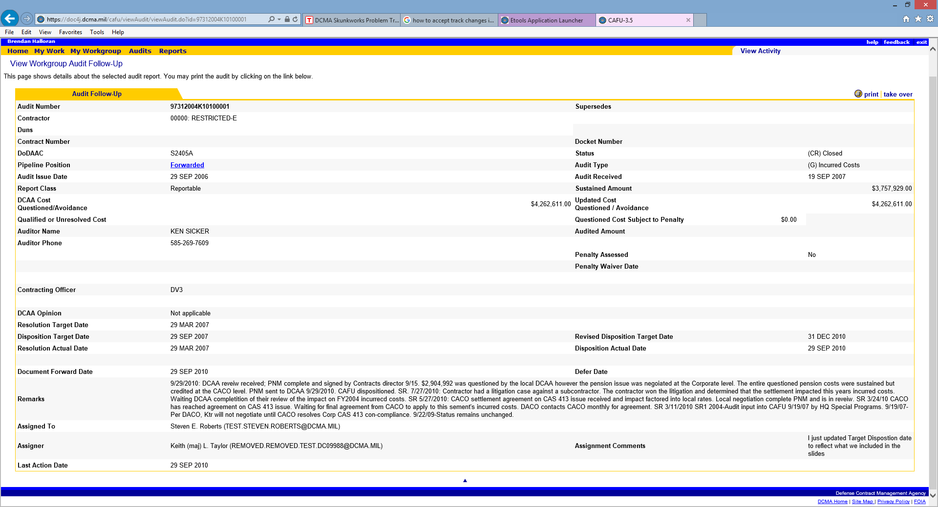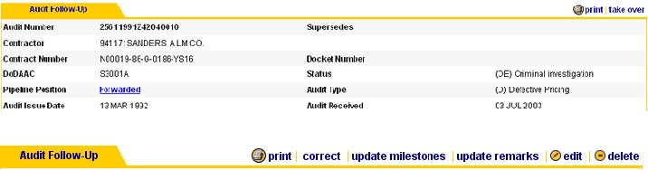

**Note**: The **delete** action is only available to DCMA & Service HQ Monitors; **correct** is available to MC/Service HQ and DCMA District Monitors.

### From My Work

* Go to My Work.
* Click on Audit Number to access View Audit Follow-Up screen.
* Click on View Activity menu option to view activity for a specific audit.



The My Work version of the View Audit Follow-Up screen provides links for print, correct, update milestones, update remarks, update target date and edit.

**Note**: The **delete** action is only available to DCMA & Service HQ Monitors; **correct** is available to MC/Service HQ and DCMA District Monitors.

## Printing the Audit Record

To print the audit record details, click on the **print** link from the View Audit Follow-Up screen.



The print dialog box for your default printer will be displayed. Click on Print button to start the printing.

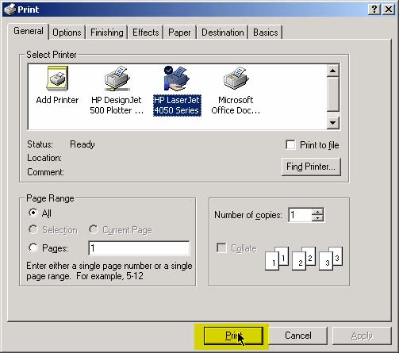

To print pages other than View Audit Follow-Up, click on the print button from your browser (such as Internet Explorer or Netscape) toolbar:



Or from the File menu:

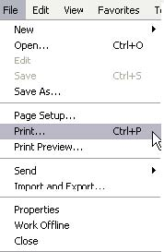

**Note**: If you do not have a printer installed on your computer, this feature will not work.

# Working with Audit Records

## CAFU Pipeline

### Work Flow Diagram

The CAFU Pipeline is defined as the work flow that an audit goes through in the Contract Audit Follow-Up process. Each activity in the work flow is referred to as a position in the pipeline. The application enforces business rules such as who can do what to an audit for each position.

Below is a diagram that illustrates the CAFU work flow.

The following table provides a brief description of each activity:

|  |  |  |
| --- | --- | --- |
| **Activity** | **Performed By** | **Description** |
| Plan | CO | CO inputs the planned resolution and disposition dates. |
| Resolve | CO | CO inputs the resolution actual date. |
| Disposition or Defer | CO | CO inputs the disposition actual date. In the case of Litigation or Criminal Investigation, CO inputs defer date and reason to defer. |
| Disposition after Defer | CO | CO inputs the disposition actual date after a deferral. |
| Forward | CO | CO sends notification to DCAA of completion of audit work and any applicable memo such as post negotiation memo and |
|  |  | inputs the date it was forwarded. The audit record will no longer be available for editing in his/her work. The audit record now appears in his/her workgroup audits list as viewable only. Once a forward date is entered in CAFU, the CO has an option to have the CAFU application generate an E-Mail for them, rather than mail outside CAFU eTools.  The E-mail in eTools is automatically generated and addressed to the cognizant DCAA Office that issued the audit report. A memo can be attached to the email. |
| Archive / Forwarded | CAFU System | CAFU System archives the audit after it has been dispositioned for 2 years. |
| Correction | Monitor | Monitor corrects the audit based on a user's transfer or |
|  |  | Monitor's Take Over of an Audit. Monitors may actively correct an audit without a transfer being completed. |

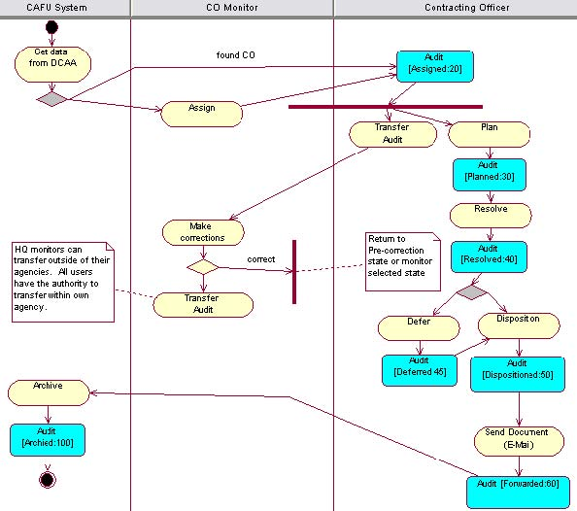



**Add Audit**, performed by Monitor- Add an audit is a feature of the CAFU System to enable input of a missing DCAA record for audit reports received by the CO. The cognizant monitor can input manually an audit record.

**Delete Audit**, performed by HQ Monitor - Delete an audit is used very sparingly, for only certain reasons such as: the audit record is found to be for an audit report that was written for other agencies, DoD components that do not use CAFU eTools database; Restricted type audits that have wrong data in them.

**Transfer to CO**, by Monitor or from CO to CO-CAFU Monitors normally assign, transfer audits to COs within their cognizance (DoDAACS) within own agency. HQ Monitors can transfer audits outside of his/her agency.

**Take Over by Monitor** – The Monitor may view audits assigned to any CAFU user in their cognizance (DoDAACS) or My Workgroup and actively assign any number of those audits to himself/herself. This type of assignment is referred to as a Take Over. It is for purpose of working the audit record, may need to also be transferred to another CO within the agency, DoD component.

**View**- Once an audit is forwarded, CAFU users can still see the audit in his/her workgroup audits list. However CAFU Monitors can take over the audit record to his/her workload but at this moment the action for that audit record is “View”. No edits are allowed at this stage and an attempt to edit the record will result in an error message indicating that the record is for viewing only. However, a Monitor can make certain corrections but will have to put the audit record back into an active stage of the pipeline such as “disposition”.

Pipeline Meter



The Pipeline Meter is a handy visual tool available on edit screens that shows which pipeline position the audit is currently in, which activities have been completed and what remains to be done on the audit to complete the work flow.

## Working with Audit Records Overview

This section provides a detailed explanation of all the actions that can be performed on an audit for each pipeline position.

To edit this audit report record, click on the edit icon from My Work on the View Audit Follow-Up screen.

### Common Actions

There are common actions that can be performed in most pipeline positions. Those actions are

* **Auditor Name:** Allows the user to change the auditor’s name.
* **Auditor Phone Number:** Allows the user to change the auditor's phone number.
* **Input Remarks:** This is an open entry text field that allows the user to add notes, and remarks that are important to the audit report. The remarks text field is limited to 2500 characters.
* **Revise Target Date:** Allows the user to change the Disposition Target Date.
* **Reset:** This action returns all fields to their value when the screen was accessed. This action does not leave the edit screen.
* **Cancel:** This action cancels any change made to the form and leaves the edit audit screen.
* **Refresh:** This action updates the information with the latest information that has been modified.

All other changes or modifications that a CO or Monitor can make on an audit depend on the position of the audit in the pipeline. (For more information on the pipeline see CAFU Pipeline)

**Note:** An asterisk (*) next to an input field denotes that an input is required before an audit report can be submitted to the next stage in the pipeline. For example:

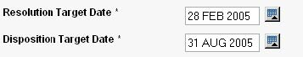

### Validation Error

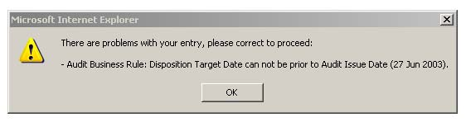



A validation error will occur when a user inputs data that does not pass all the required business rules. Error message will pop-up and (when applicable) appear at the top of the page. You must correct the problem and pass all business rules to be able to complete the action.

## Searching for Audits

CAFU has a convenient way of locating audits that you may be interested in. A search can be performed based on one or more criteria. The Search feature can be accessed from the My Work screen or the Audits screen.

**From My Work Screen:**



**From Audits screen:**



**Note**: Add audit is only available to CMO, MC and District Monitors.

### Using the Search Screen

The search screen allows you to filter the audits in My Work or Workgroup Audits based on one or more criteria.

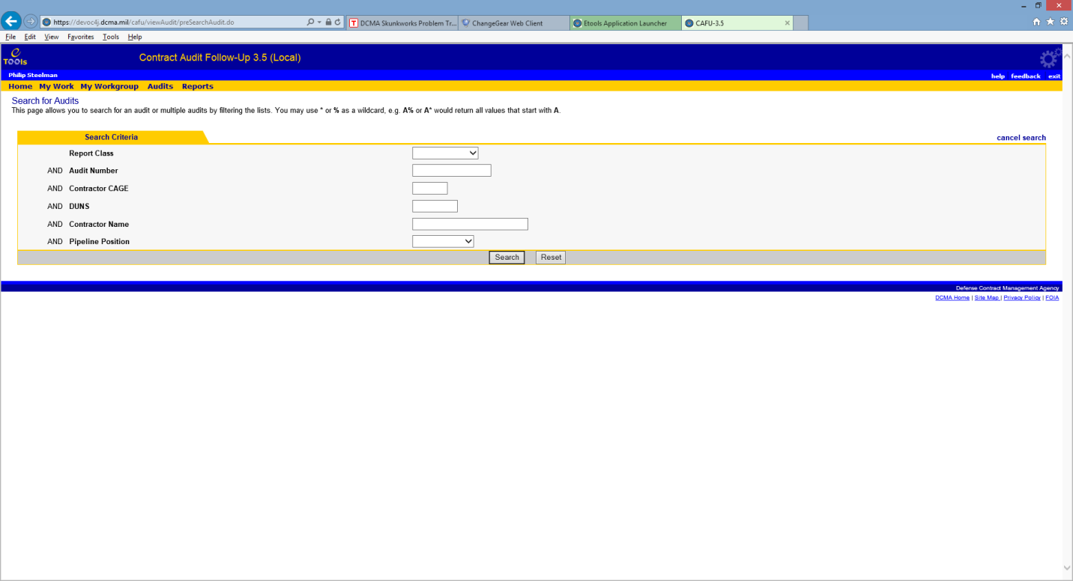

For example: You can search for a specific audit by entering an Audit Number and clicking on **search**. Alternatively, you can locate Audits by Contractor CAGE Code or Contractor Name.

You can also perform partial searches by making a partial entry or by using wildcards. For example, a Contractor Name of AM or AM% or AM* returns audits for American Industrial Casting, AMETEK, and any other contractor with a name starting with AM.

Clicking on **cancel search** will clear search and show everything available in the table.

The search can be accessed either from My Work or Audits. When a user accesses search functionality from **My Work** and then performs search from **Audits** tab without clearing the previous search criteria it will not display the expected results. In this scenario the user needs to first clear the search criteria by clicking on **cancel search.**



**Monitors**

Monitors have more criteria, such as DoDAAC and CO, for finding audits. These options help find audits assigned to specific COs and offices.

### Search Results

When a search is in effect, the My Work or Audits table shows a magnifying glass icon to inform the user that only some of the audits (based on the criteria) are being displayed.

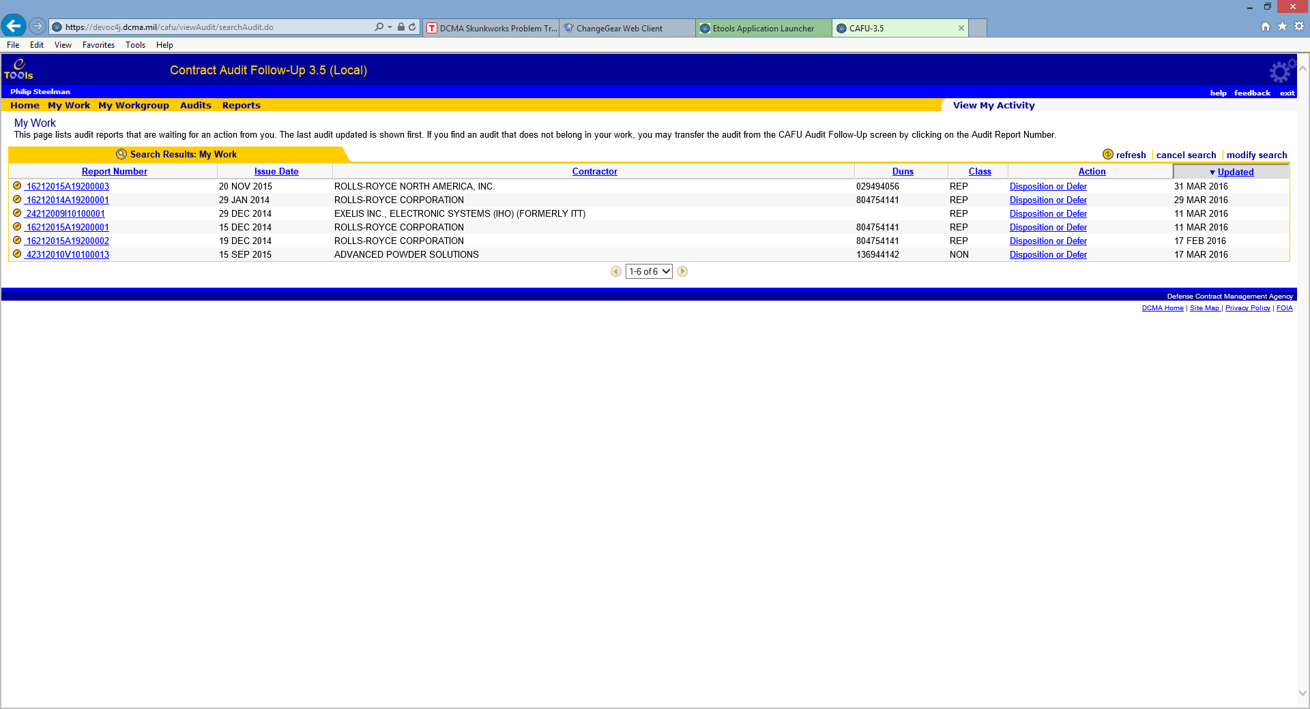

.

To turn off the search and show all audits in the table, click on cancel search. To search for something else, click on **modify search.** Use “cancel “and “refresh” in between searches, when searching for several different numbering criteria, groups, to ensure it is filtering and searching for the current audit number or the current criteria entered.

## Add New Audit by Monitor

### Add New Audit

The Monitor is authorized to add new audit records to the CAFU system. This feature is provided to enter audit report records manually for each agency (DCMA, ARMY, NAVY, AIR FORCE, and TRICARE) when audit records are missing, have not been entered through the DCAA DMIS system into CAFU eTools system automatically.

**STEPS:**

To do this:

* Go to My Work.
* Click on Add Audit.

To ensure data integrity and to minimize errors, the Add Audit feature requires three steps:

**Step 1: Search for Contractor**

Enter the name of the Contractor for which the new audit is being created. The system will search for existing audits for the Contractor to use as a template. You can enter partial names and wildcards as * or %.

**Step 2: Select Contractor**

The system will search for audits based on the Contractor Name provided in Step 1. It will then list the different variations of the contractor name that MCs and COs used for that Contractor in the past. You can click on the CAGE code to select the variation to use as a template for the new Audit.

If no matching contractors are found, you can try **searching again** with a different name.

If you are unable to find existing audits for the Contractor, you can click on **new contractor**.

**Step 3: Enter Audit Details**

The third and final step allows you to enter the required details about the audit.

**Business Rules**

If you enter a superseded audit number, the superseded audit must exist in the system.

* The DoDAAC must belong to your workgroup.
* Cost Questioned / Avoidance must be entered. Must enter 0 if it doesn't apply.
* Audit report number must be valid and unique.

**Format of Audit Numbers**

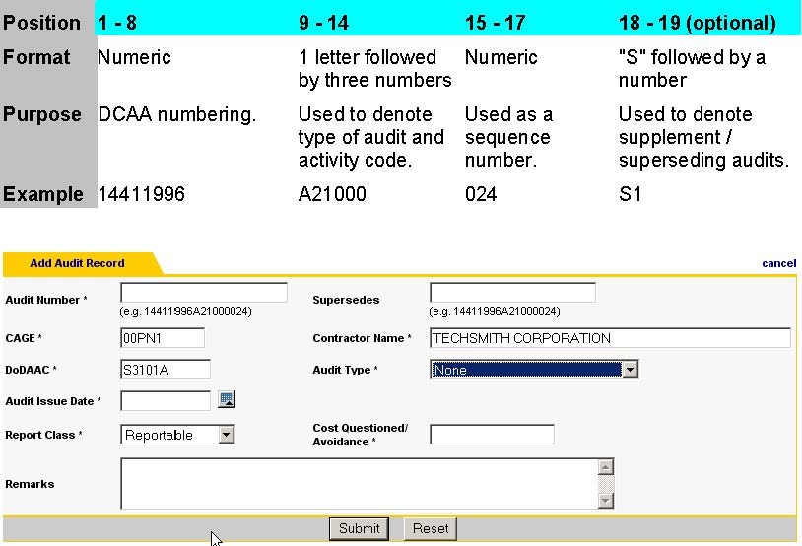

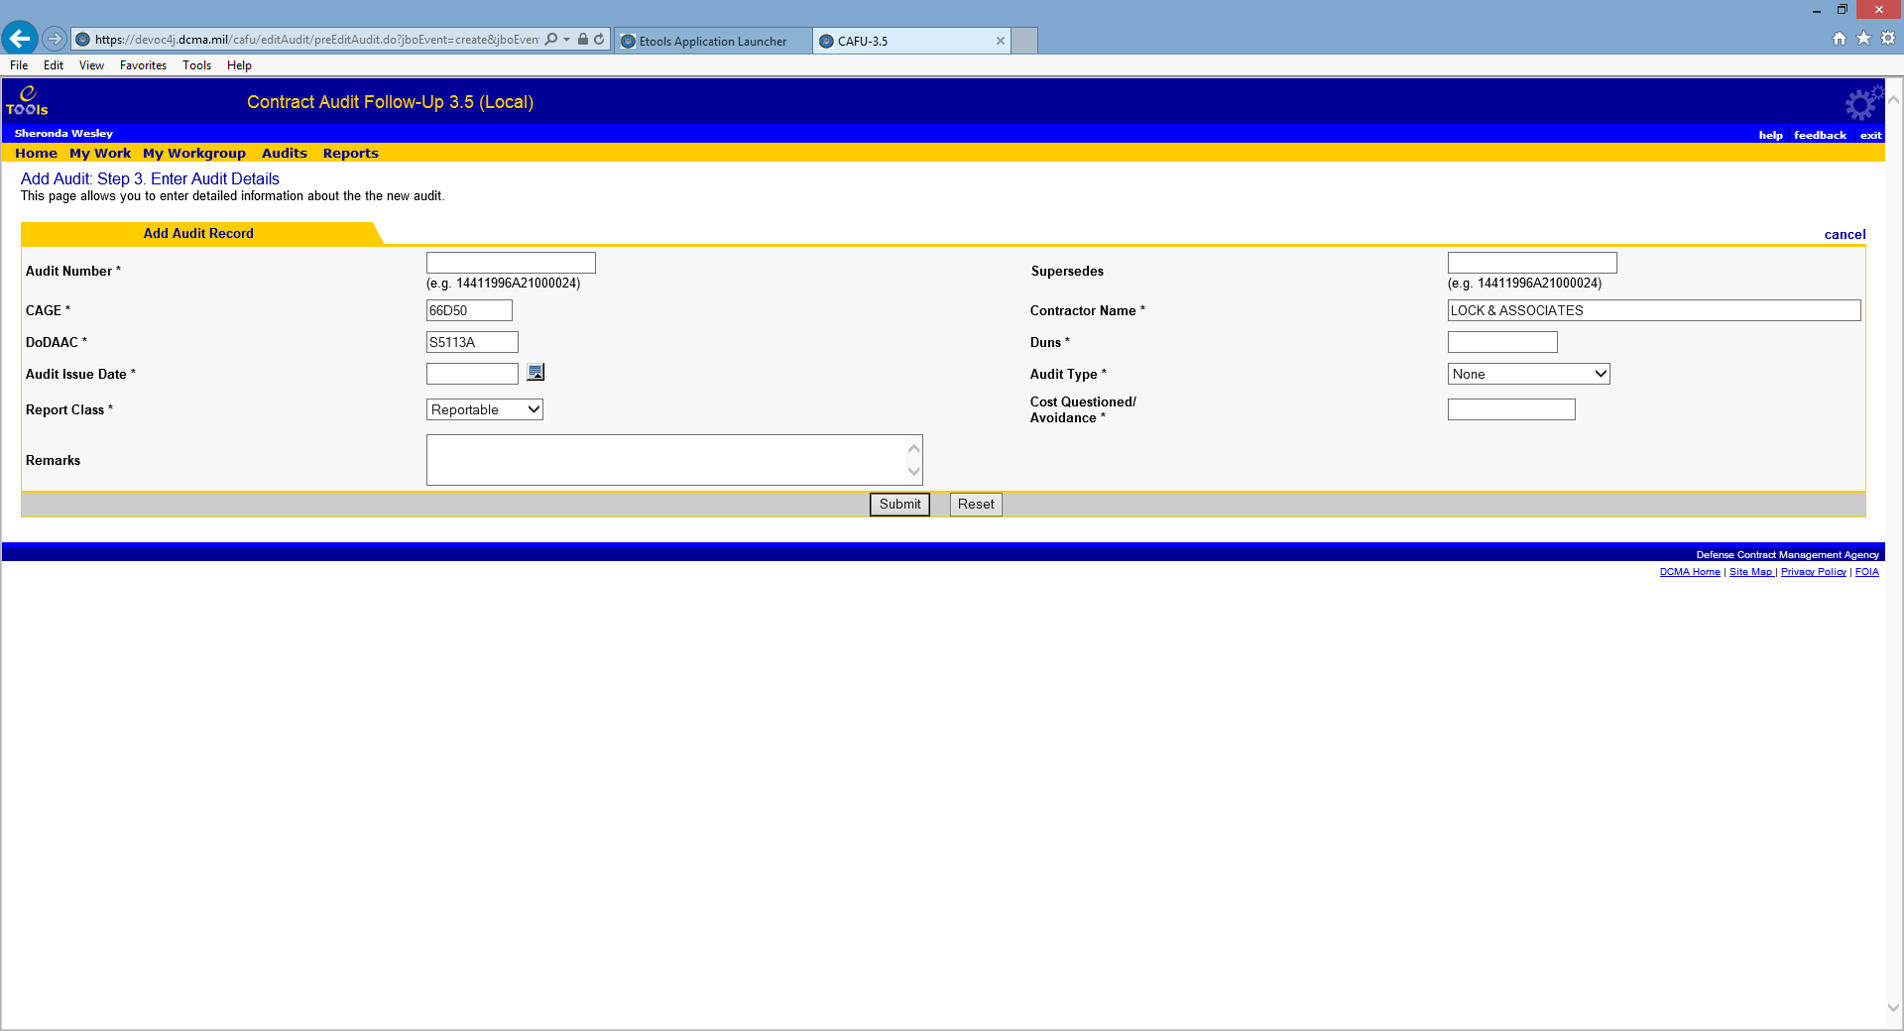

After all the rules are validated, a new record is created and the audit is transferred to Monitor for verification and assignment.

**New Contractor**

If no contractor was found during Step 2, you can still add a new audit by clicking on new contractor.

### Plan

At this stage the audit report has been assigned to the appropriate CO. This page allows the CO to enter the target date for resolution and disposition.

**Required Fields**

* Resolution Target Date
* Disposition Target Date

**Business Rules**

* The Resolution Target Date and Disposition Target Date cannot be prior to the Audit Issue Date.
* The Resolution Target Date cannot be later than six months from the Audit Issue Date.
* The Disposition Target Date cannot be later than one year from the Audit Issue Date.
* The Disposition Target Date cannot be prior to the Resolution Target Date.

For information on how to select a date see **Calendar**.

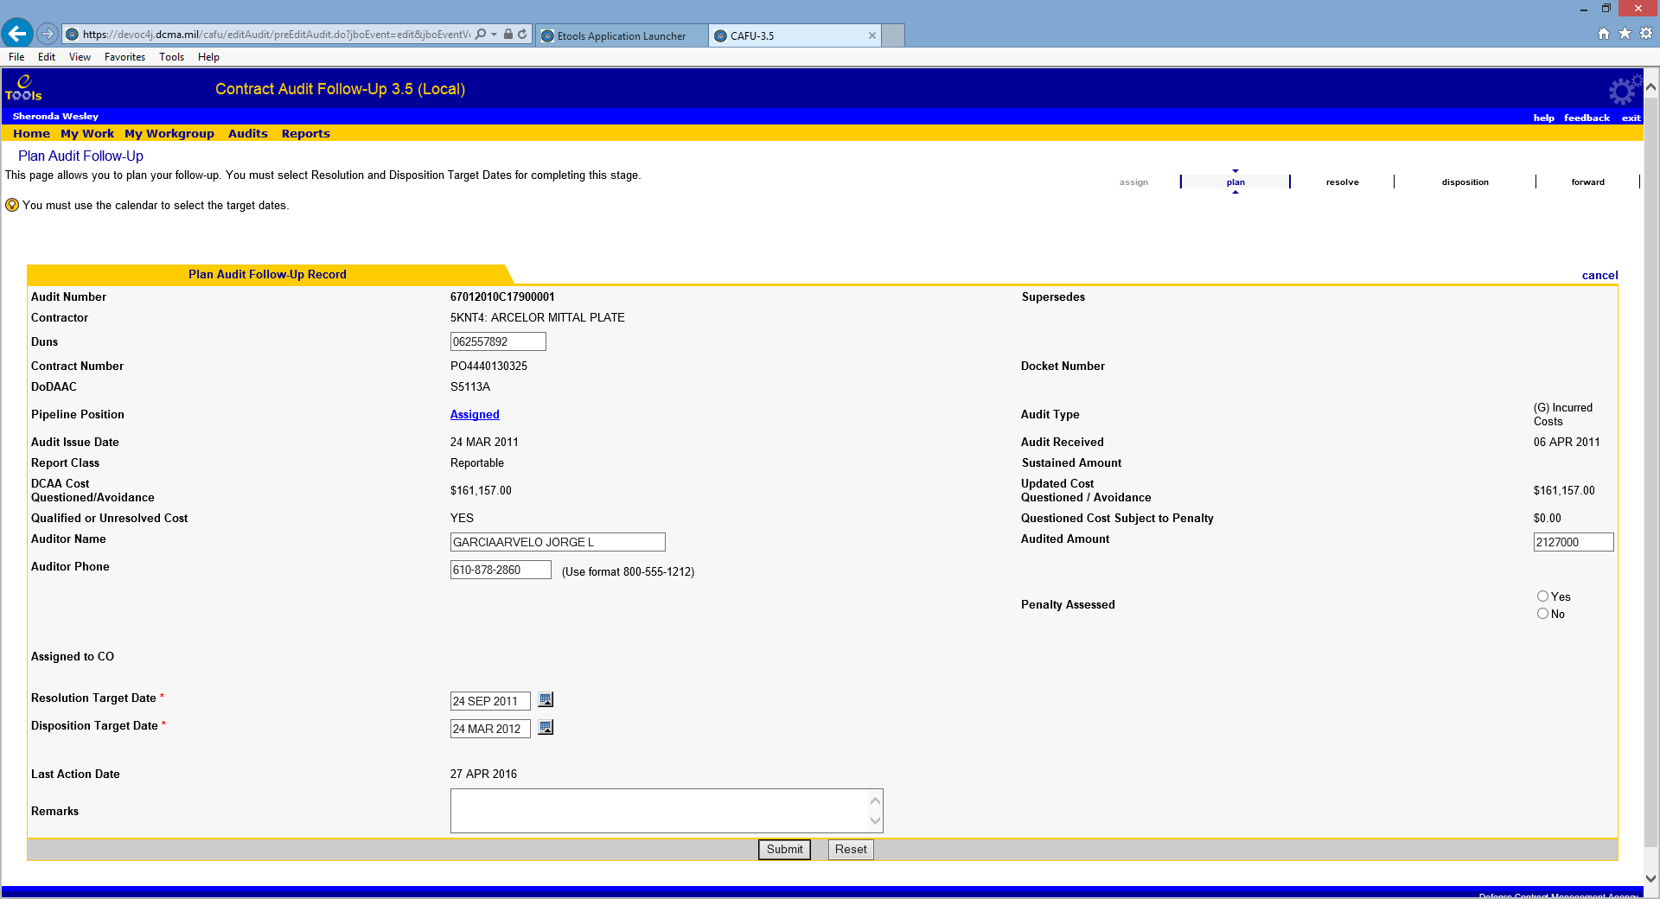

### Resolve

At this stage the audit has been planned, and resolution or pre-negotiation has been achieved. The CO must input the Resolution Actual Date to resolve.

**Required Fields**

• Resolution Actual Date

**Optional Fields**

* Updated Cost Questioned / Avoidance
* Revised Disposition Target Date
* DCAA Opinion – Two new opinions are added in the system as part of CAFU 3.5.

1. Qualified, Reportable means the audit report contains qualification
2. Not Acceptable means the system is not acceptable

The new audit opinion codes come in from DCAA’s system, and are as above.

**Business Rules**

* The Resolution Actual Date cannot be a future date.
* The Resolution Actual Date cannot be prior to Audit Issue Date.

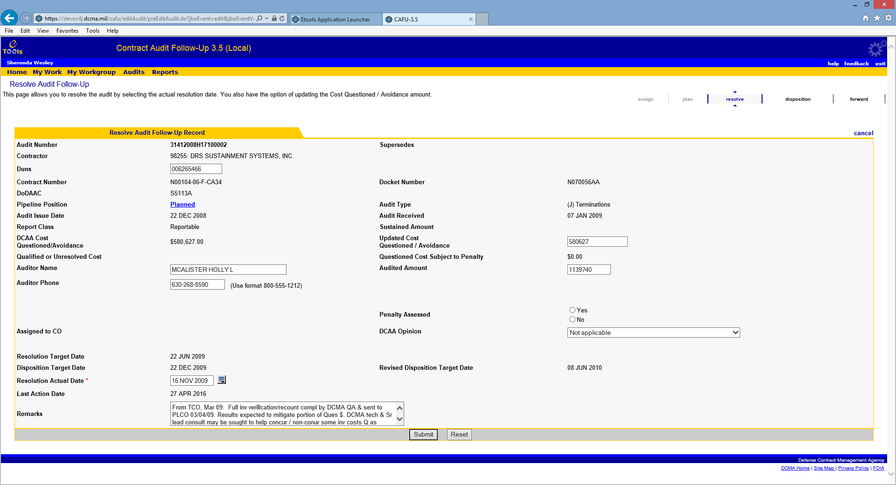

For information on how to select a date see **Calendar**.

### Disposition or Defer Layout

**Disposition or Defer**

At this stage the audit has been resolved. To disposition, the CO must enter a Disposition Actual Date. If the Audit is undergoing Litigation or Criminal Investigation, the CO must select a reason to defer and the defer date.

**Required Fields**

**Disposition**

• Disposition Actual Date

• Penalty Assessed (if Questioned Cost Subject to Penalty greater than zero)

• Penalty Amount (if Penalty Assessed is YES)

• Penalty Waiver Date (if Penalty Assessed is NO, fillable but not mandatory)

• Sustained Amount (if Cost Questioned / Avoidance greater than zero)

OR

•When needing to Defer, rather than dispositioning, enter Reason to Defer:

* Litigation or Criminal Investigation
  + And enter the Defer Date

**Optional Fields**

* Sustained Amount
* Updated Cost Questioned / Avoidance
* DCAA Opinion
* Revised Disposition Target Date

**Business Rules**

Sustained amount cannot be negative.

Sustained amount cannot be greater than the questioned costs (either questioned costs or updated questioned costs).

Disposition

* The Disposition Actual Date cannot be prior to the Audit Issue Date.
* The Disposition Actual Date cannot be prior to the Resolution Actual Date.
* The Disposition Actual Date cannot be a future date.
* A Revised Disposition Target Date (for less than 12months of age) cannot be prior to the Audit Issue Date.
* A Revised Disposition Target Date (for less than 12 months of age) cannot be prior to the Resolution Actual date.
* The Penalty assessed field, if yes, must have Penalty and/or interest dollar amount

Defer

* Defer Date cannot be prior to Audit Issue Date.
* Defer Date cannot be prior to Resolution Actual Date.
* Defer Date cannot be a future date.

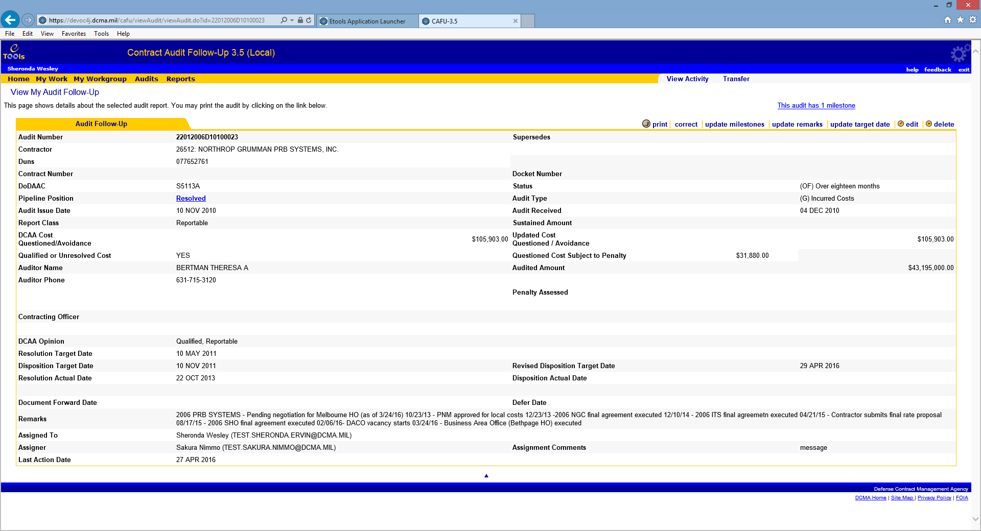

Redacted

For information on how to select a date see **Calendar**.

**Disposition after Defer**

Once an audit report record is brought out of the deferred stage, it can be dispositioned. To disposition, the CO must enter a Disposition Actual Date.

**Required Field**

* Disposition Actual Date
* Sustained Amount (if cost questioned / avoidance greater than zero)
* Penalty Assessed (if Questioned Cost Subject to Penalty greater than zero)
* Penalty Amount (if Penalty Assessed is YES)

**Optional Field**

• The Revised Disposition Target Date is to be entered once the audit report is 1 year or more past the audit issue date

**Business Rules**

* The Disposition Actual Date cannot be prior to the Audit Issue Date.
* The Disposition Actual Date must be equal to or after the Resolution Actual Date.
* The Disposition Actual Date must be equal to or after the Defer Date.
* The Disposition Actual Date cannot be a future date.
* The Revised Disposition Target Date cannot be prior to Resolution Target.
* The Revised Disposition Target Date cannot be prior to the Audit Issue Date.

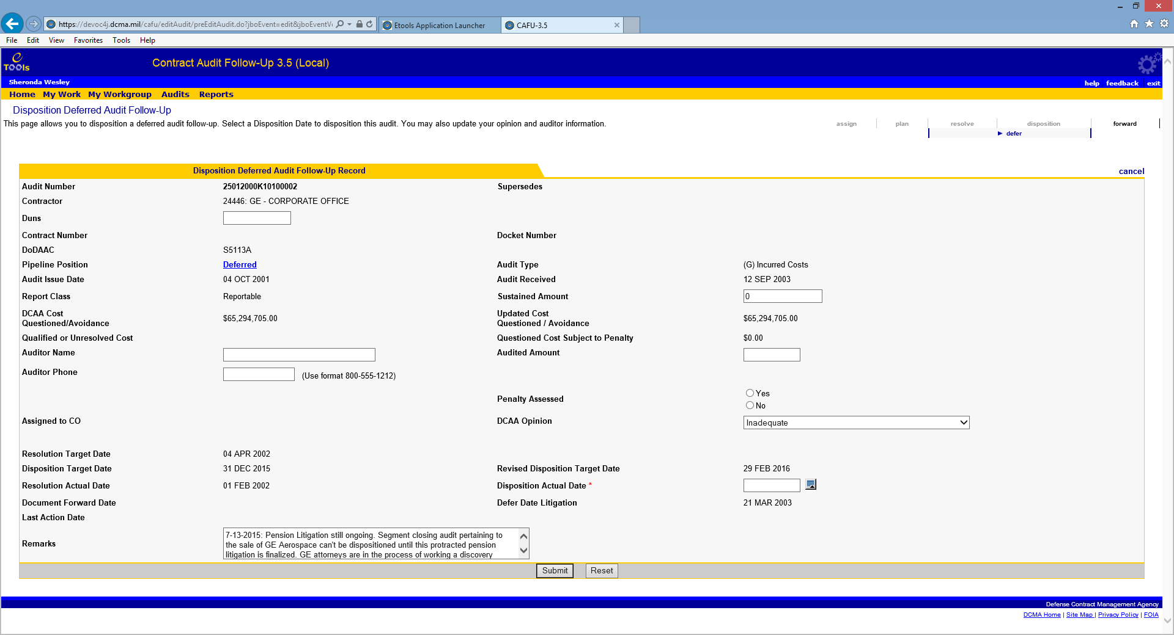

### Forward / Send Document

At this stage, the audit has been dispositioned. This screen allows the CO to record a document forward date to document that the memo has been sent to DCAA. This action completes the follow-up of the audit.

**Required Field**

• Document Forward Date

**Business Rules**

* The Document Forward Date cannot be prior to the Audit Issue Date.
* The Document Forward Date must be equal to or after the Disposition Actual Date.
* The Document Forward Date cannot be a future date.

The following text will display in red:

Reminder: The Contracting Officer must use the Forward feature after entering the Disposition Actual Date in order to close out the record (for Reportables only).

The following screen shows Forward Audit Follow-Up Record screen for Non-Reportables.

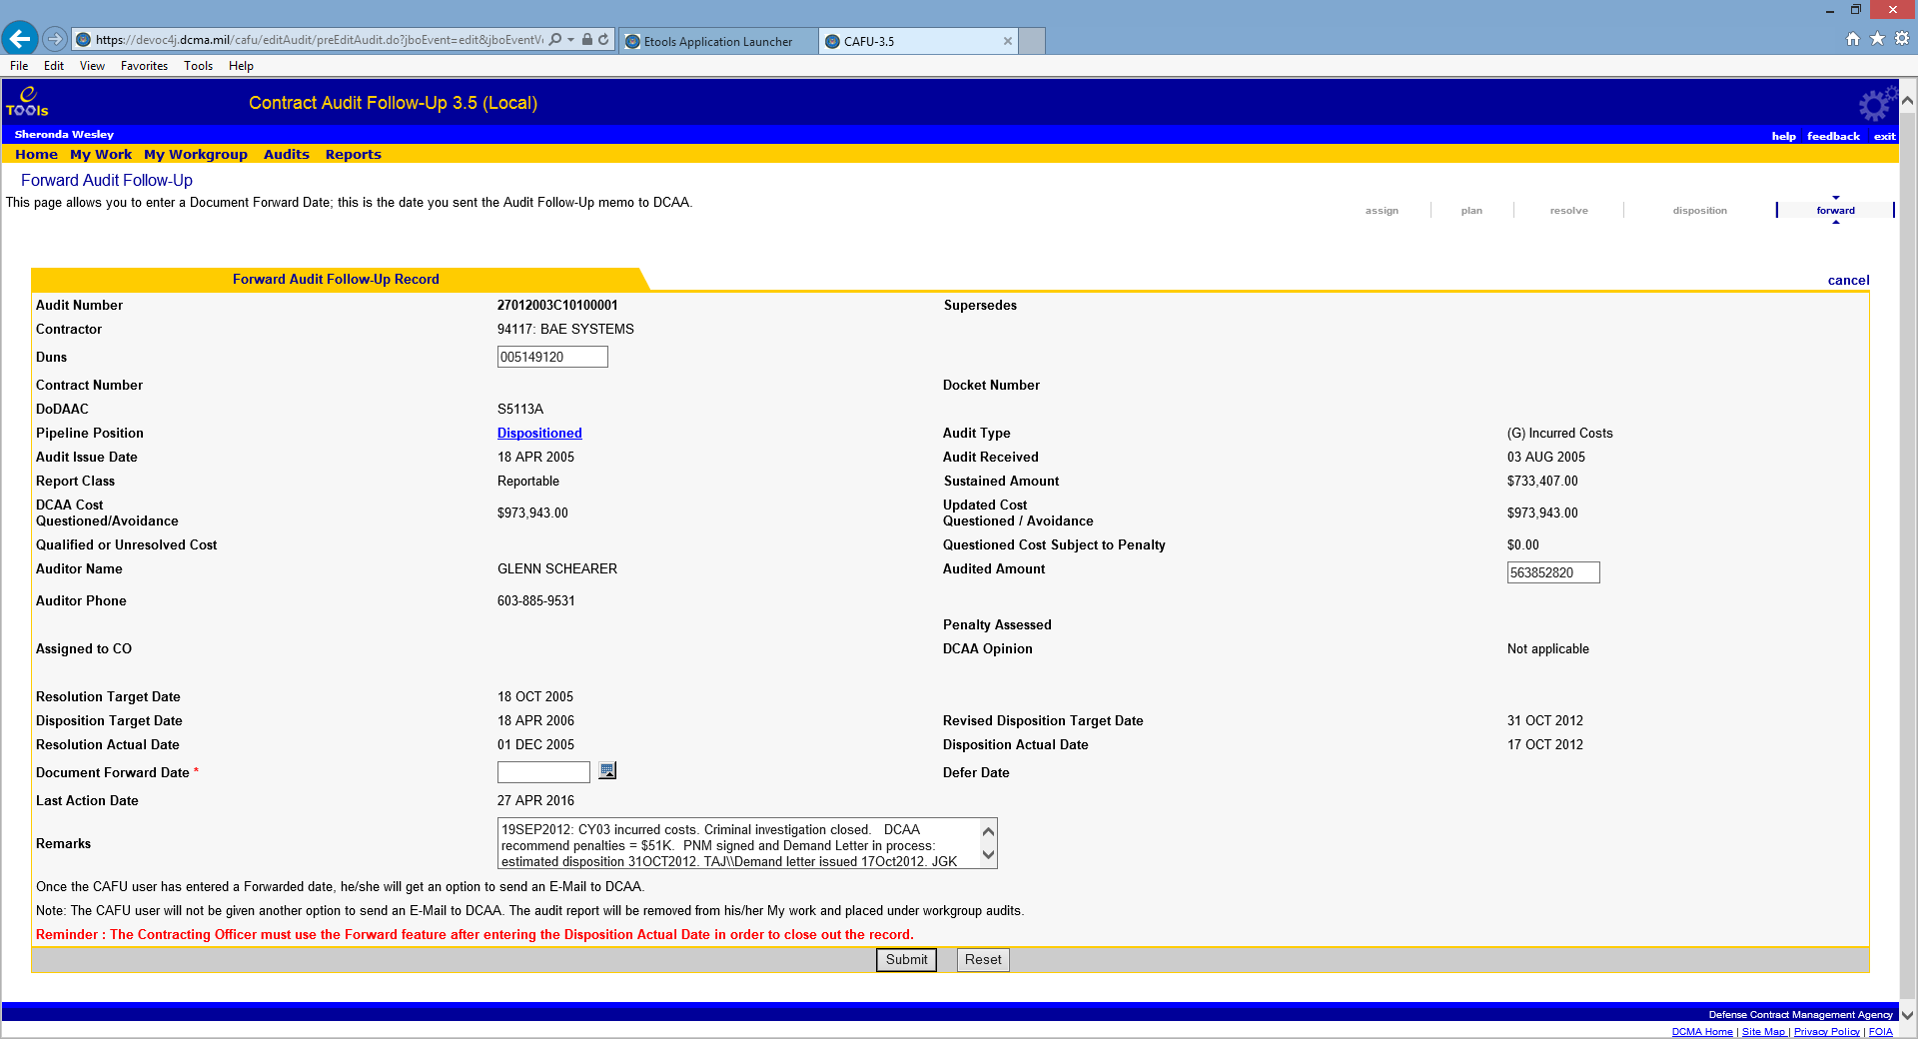

Once the CAFU user has entered a Forwarded date, he/she will get an option to send an email to DCAA. The email is pre-addressed to the DCAA audit office that issued the audit. The CO can change the standard statement in the email or add to it, and can attach documents such as the negotiation memorandum.

NOTE: The CAFU user will not be given another option to send an email to DCAA within the CAFU eTool. The audit report number will be removed from his/her My Work and placed under workgroup audits.

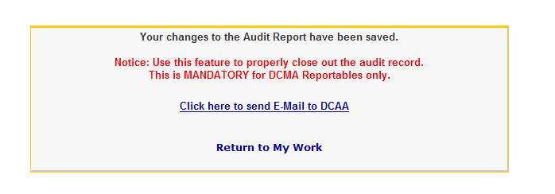

### Forwarded

At the Forwarded Pipeline Position, the audit follow-up process has been completed. The audit record will be available for viewing from the Audits screen for three years after entering the Document Forward Date. The audit record will be in the Forwarded Pipeline Position for the first two years and in the Archived Pipeline Position during the third year. An audit record will be deleted from CAFU during the month end processing 36 full months after the audit's Document Forward Date.

For an audit record with a Document Forward Date of 15 Dec 2012, date ranges examples are provided below which show exactly when it’s Pipeline Position would change. In addition to archiving, each automated month end processing includes capturing the end-of-month state of all audits for historical reports and metrics.

**Pipeline Rule for Archiving Example Date Range Position**

Forwarded 0 - 23 full months after Document Forward 15 Dec 2012 to 30 Nov 2014 Date

Archived 24 - 35 full months after Document Forward 1 Dec 2014 to 30 Nov 2015 Date

Not Available 36 full months after Document Forward Date 1 Dec 2015

### Correction by Monitors

CAFU Monitors can "correct" an audit report record that is either in their "My Work" or has been taken-over by the Monitor. A CAFU Monitor can use the Correction screen to make changes. The correction screen allows several fields to be modified. This enables a Monitor to perform many actions, including:

* Update Contractor Information, Contract Number, and Docket Number
* Assign audit to a different DoDAAC
* Change the pipeline position of the audit report record
* Change report class (reportable / non-reportable)
* Update auditor information (i.e.: Auditor Name, Auditor Phone)
* Modify Sustained Amount and Updated Cost Questioned / Avoidance Amount
* Modify target and actual dates
* Modify Reason to Defer Date as well as the Defer Date
* Modify/Update remarks section
* Modify DUNS number

**Business Rules**

* DoDAAC and CO combination must be valid if the Pipeline Position is related to a CO activity.
* Business rules related to the selected Pipeline Position will be enforced.

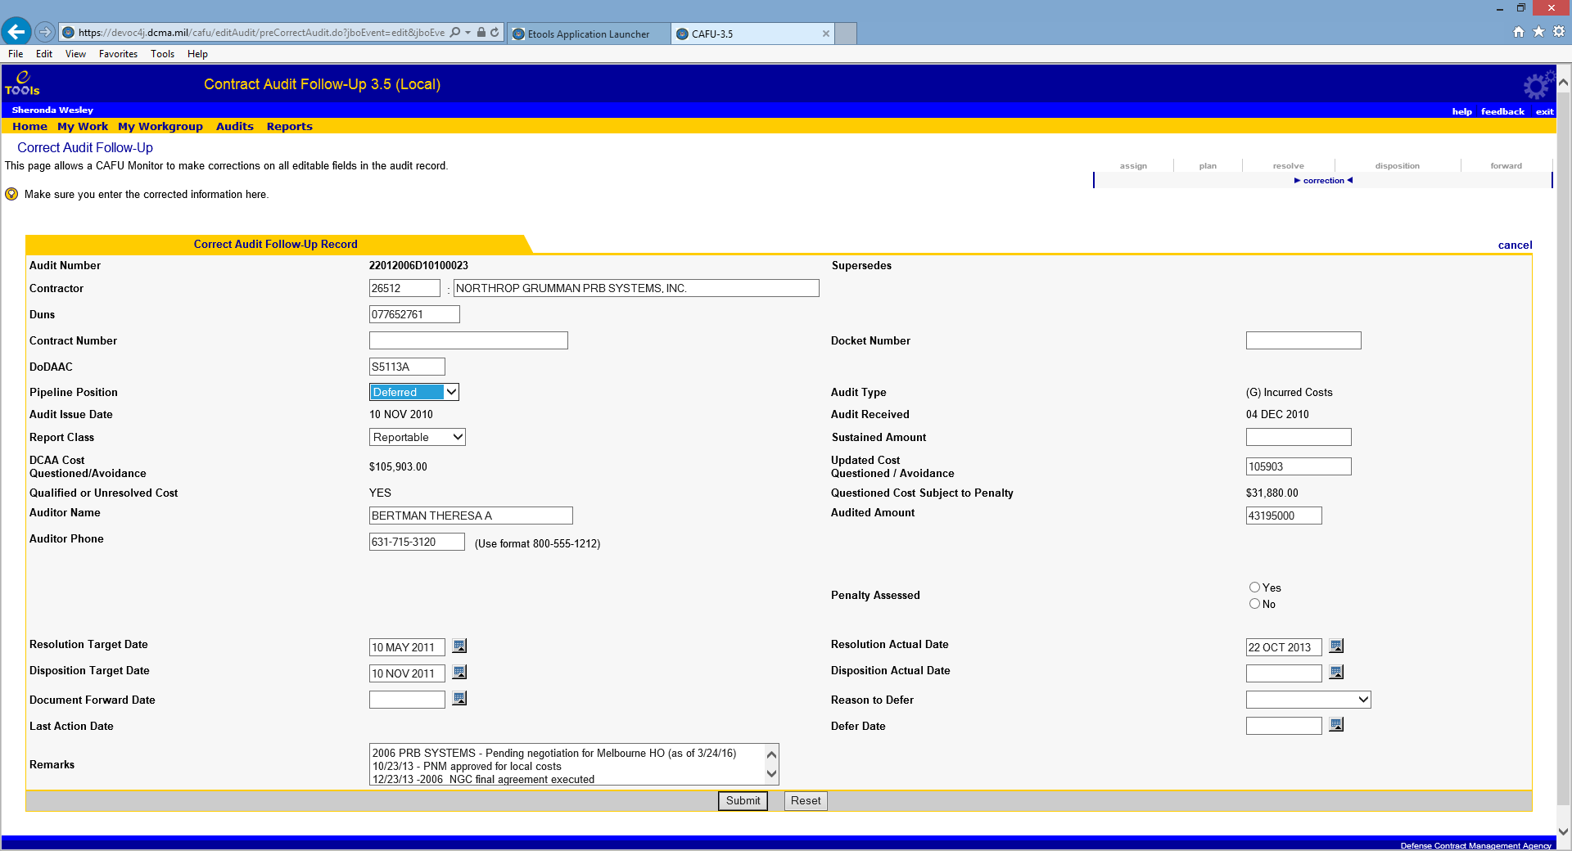

### Take Over an Audit from the View Audit Follow-Up Screen

### Take Over by Monitors

Monitors are authorized to Take Over an audit record. This feature allows you to transfer any audit in your workgroup from the current owner or assignee to your My Work. When an audit is taken over within an agency,

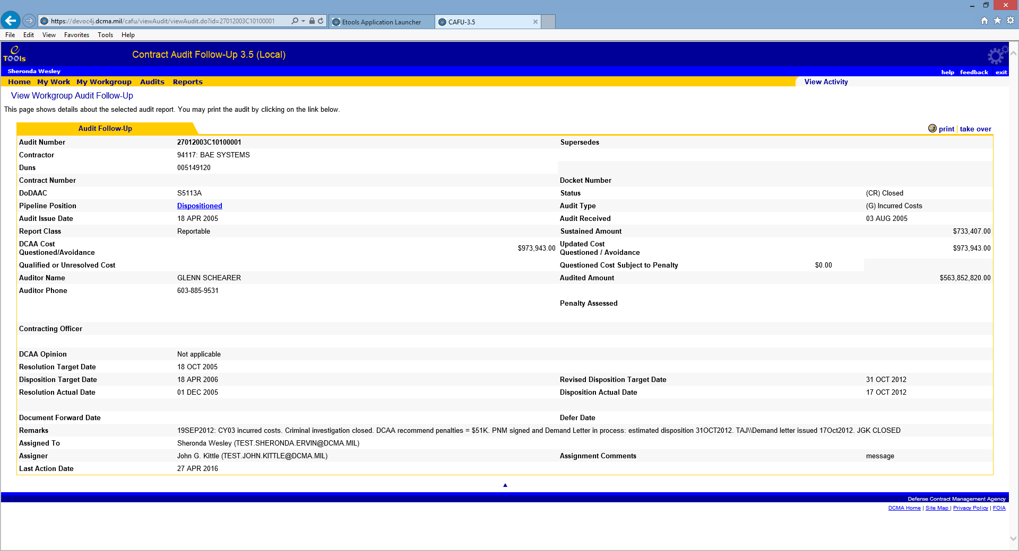

a confirmation shown below is provided, which allows the CAFU user the options to immediately go to the correction screen, view his/her work, or return to his/her workgroup audit list. Note: Once a correction or transfer is done, check you’re My Work to see that the audit record has been returned to correct CO, that it is not still found under your "My Work".

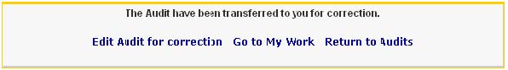

**Business Rule**

• When an audit is taken over, the audit will inherit one or both of the following items from the new user: The chart below, displays the various possible scenarios.

1. DoDAAC

2. CO Code

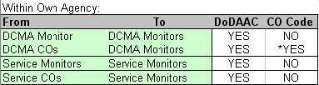

*CO Code will update to an empty string since Monitors do not have CO Codes.

### Updating Remarks by CO and Monitors

The Update Remarks allows a CO or Monitor to update remarks for an audit record without completing a pipeline activity. This can be done any time once the audit record is established in the CAFU eTool.

To do this:

* Go to My Work.
* Click on Audit Report Number to access View Audit Follow-Up screen.
* Click on **update remarks** action.



This takes you to Update Remarks screen.

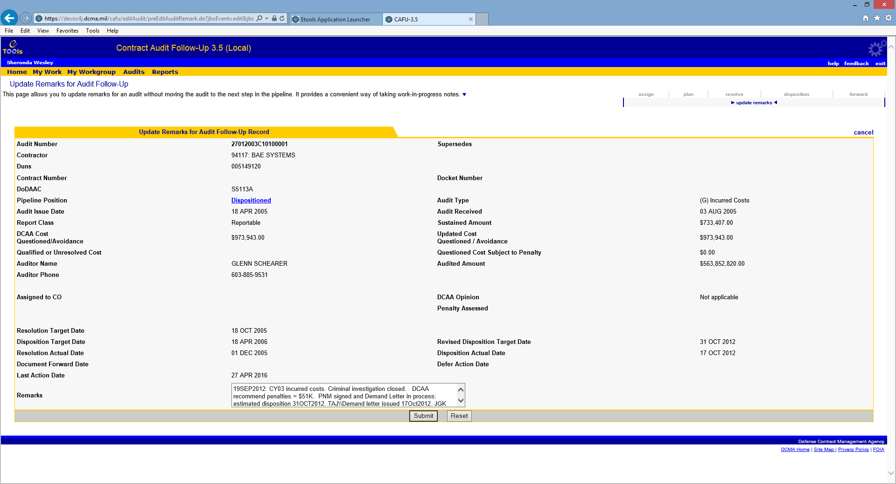

Clicking on Submit will update the remarks without moving the audit to the next stage. For example, if the audit is in the Resolution stage, the new remarks will be saved and the audit will remain in the Resolution stage. A history of remarks can be viewed by clicking view activity and following the instructions for Activity Logging.

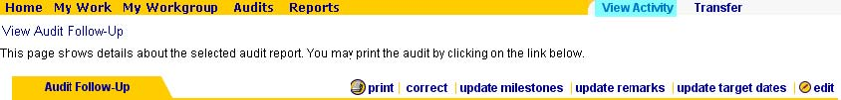

### Update Revised Target Date (CO and Monitors)

The option to Update Target Date allows a CO or MC Monitor to add or update the Disposition Target Date for an audit record without completing a pipeline activity, as well as, update remarks.

To do this:

* Go to My Work.
* Click on Audit Report Number to access View Audit Follow-Up screen.
* Click on **update target date** action.



Clicking on Submit will update the revised disposition target date without moving the audit to the next stage. For example, if the audit is in the Resolution stage, the revised target date will be saved and the audit will remain in the Resolution stage.

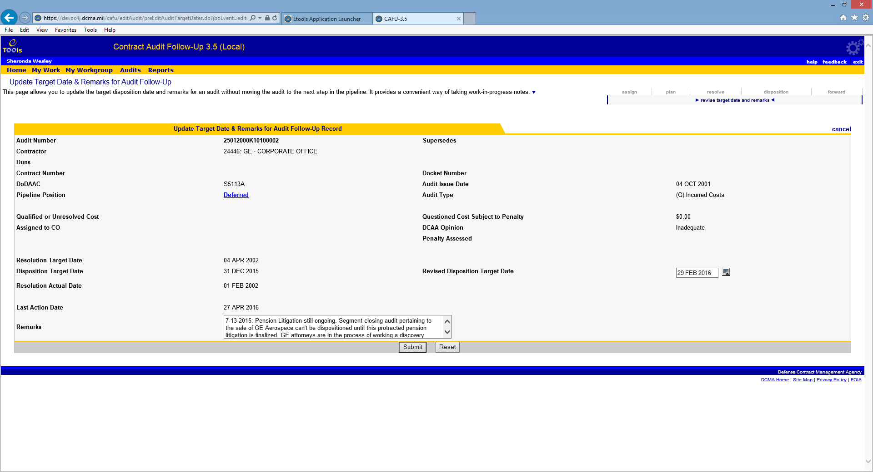

The Revised Disposition Target Date will be available. The user will have the option to revise an audit record once it has been Planned and before a Resolution Actual Date has been entered.

### Deleting Audits

DCMA HQ and Service HQ Monitors are authorized to delete an audit. The delete audit link is available to these Monitors on the View Audit Follow-Up screen.

To do this:

* Go to My Work
* Click on the Audit Report Number
* Click on **delete**.



**WARNING**: Use this feature with caution. Deleted Audits will not be recoverable without Database Administrator intervention.

### Transferring an Audit Report

At this state the audit has been assigned to the user. This page allows users to transfer an audit report to any user within their agency. ONLY HQ Monitors can transfer outside their agencies.

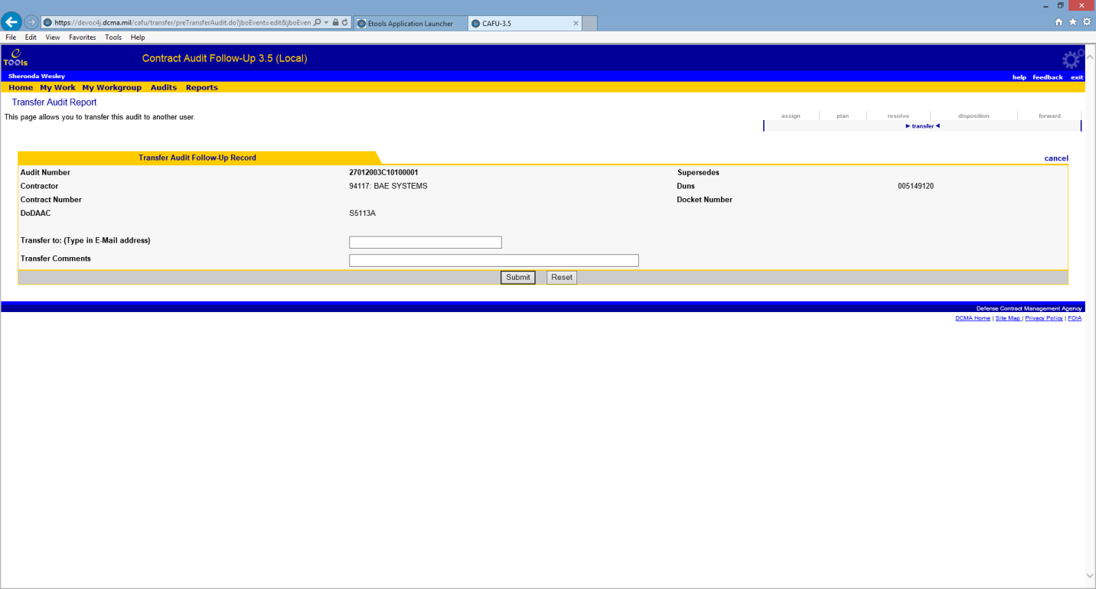

**Required Field**

* Transfer to E-Mail address
* Transfer comments

**Business Rule**

* CAFU users can transfer any audit that is assigned to them to another CO as long as the CO is part of the user's agency.
* When transferring an audit within or outside an agency, the current audit will inherit one or more of the following items from the new user: Refer to the chart below to see the various scenarios.

1. DoDAAC

2. CO

3. Agency Code

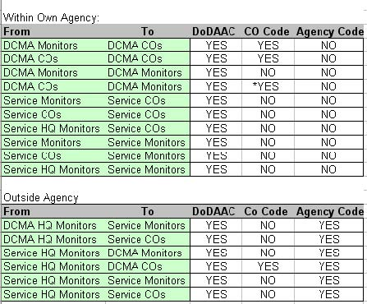

*CO Code will update to an empty string since Monitors do not have CO Codes.

# Milestones

## Milestones Overview

Milestones are intermediate steps in the Follow-Up process associated with an audit. This feature is provided in CAFU to help COs set intermediate goals with target dates, remarks, actual, and revised dates. Monitors can view the milestones attached to audits from the View Audit Follow-Up page. The milestone feature can help the workgroup manage the audits more effectively and improve performance.

The following table shows the available milestones along with the pipeline position in which it can be used:

|  |  |
| --- | --- |
| **Milestone** | **Pipeline Position** |
| Request legal review | **Planned** |
| Receive legal reply | **Planned** |
| Contact contractor | **Planned** |
| Receive contractor response | **Planned** |
| Complete negotiations | **Resolved** |
| Start litigation or criminal investigation | **Deferred** |
| Complete litigation or criminal investigation | **Deferred** |

Generic milestones can be added at any time for goals not in the above list.

You can access the Audit Milestones page by clicking on the Audit Report Number from My Work to access the View Audit Follow-Up page.

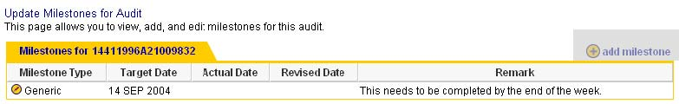

### Adding Milestones

As a CO, you can add milestones to an audit currently assigned to you. To add a milestone, click on Add Milestone from the update milestones for audit (instructions above).

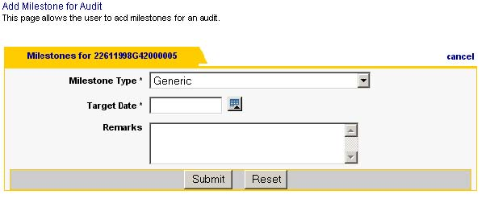

You can select the type of milestone, the target date, and the remarks. The type of milestone you can add depends on the pipeline position of the audit.

**Required Fields**

* Milestone Type
* Target Date

**Optional Field**

• Remarks (The remarks text field is limited to 2500 characters)

**Business Rules**

* Milestone Type drop down is based on the pipeline position of the audit and milestones already added.
* Target Date cannot be in the past.

**Note**: You can enter the Actual Date and the Revised Date later but you will not be able to change the original Target Date.

### Updating and Deleting Milestones

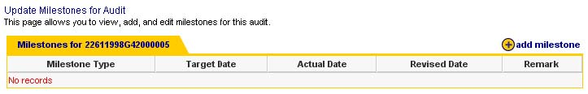

To **update** milestones:

• Go to My Work.

• Click on the Audit Report Number to access the View Audit Follow-Up screen.

• Click on **update** milestones.

• Click on the edit icon for the milestone.

You can update the target date by entering a Revised Date. You can enter the Actual Date when a milestone has been completed. If you want to remove the milestone, simply click on the delete link marked below.

**Business Rule**

* Target dates are to stay within the parameter of the DoDI 7640.02, i.e., 6 months for Resolution target and 12 months for Disposition target.

**Optional Fields**

* Actual Date
* Revised Date
* Remarks (The remarks text field is limited to 2500 characters)

**Business Rule**

• Actual Date cannot be a future date.

### Viewing Milestones from View Audit Follow-Up Screen

To view milestones for an audit in your workgroup that is not assigned to you, you can access the View Audit Follow-Up from the Audits screen.

Click on Milestones link to see the milestones at the bottom of the page.



Clicking on the blue pointer will take you back to the upper half of the page.



# Activity Logging

## Activity Overview

The Activity Logging feature allows CAFU users to view all activity related to a user or an audit report. This information helps track the history of an audit as it goes through the workflow by listing what action was taken on the audit, who took the action, and when it was completed.

The activity screen shows a table with the date and time the action was taken, Audit Report Number of the audit on which the action was taken, the user that took the action, the pipeline position of the audit after the action was completed, and the description of the activity.



Clicking on the Date and Time link of an activity will show details of the activity and a snapshot of some fields from the audit report.

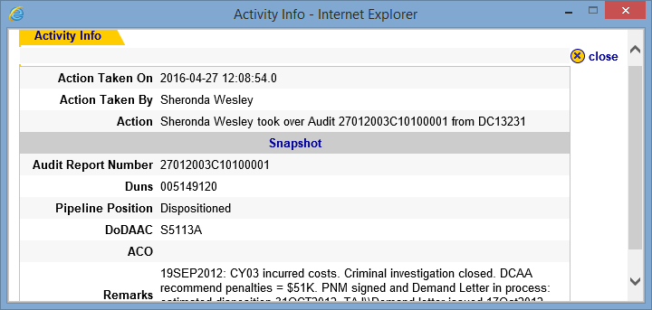

REDACTED

Note: Activity related to milestones is not logged.

## Activity Logging per Audit Report

To view activity of an individual audit report, simply click on the Audit Number on the My Work or Audits screen to view the audit and click on View Activity.

From Audits:

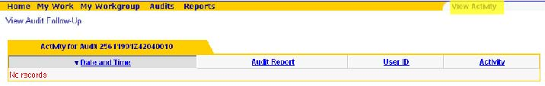

From My Work:

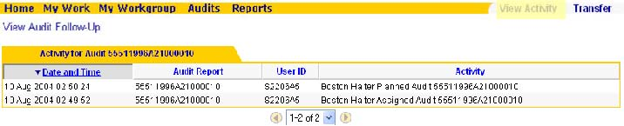

## Activity Logging per User

Activity logging per user shows the list of actions completed by a user. This feature is helpful in viewing your own activity for reminders and tracking your work. You can also view the activity of members in your workgroup to trace transfers.

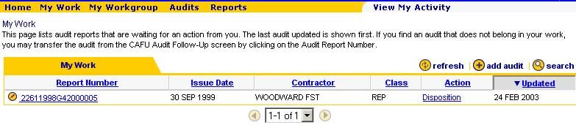

To view your activity, click on the View My Activity link in the context menu of the My Work page.

Activity for other members of the workgroup can be accessed from the My Workgroup page. Note that this screen also provides a quick way of searching for audits assigned to a CO in your workgroup. To do this, click on the audits link under Show Audits column.

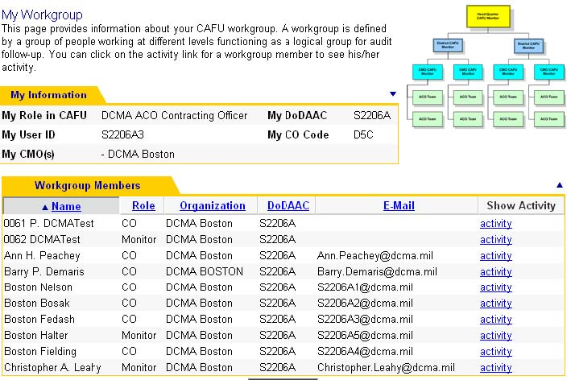

REDACTED

# DCMA Reports List

Reports are available to all CAFU users to view status of report records, obtain statistics and summary of audits. To access the main reports page, click on Reports from the menu and click on the name of the report to run it.

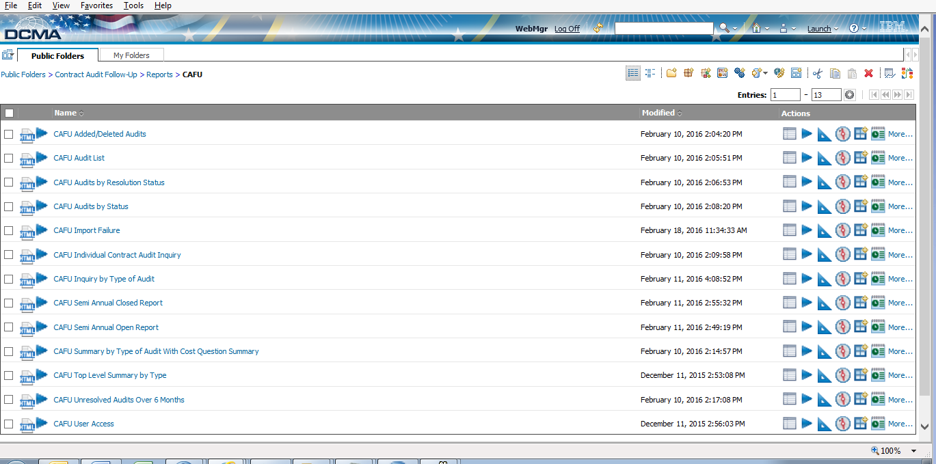

The DCMA reports list includes a series of reports. These reports include CAFU Added/Deleted Audits, CAFU Audit List, CAFU Audits by Resolution Status, CAFU Import Failure, CAFU Individual Contract Audit Inquiry, CAFU Inquiry by Type of Audit, CAFU Semi-Annual Closed Report , CAFU Semi-Annual Closed Report – CSV, CAFU Semi-Annual Open Report, CAFU Semi-Annual Open Report – CSV, CAFU Summary By Type Of Audit With Cost Question Summary, CAFU Top Level Summary by Type, CAFU Unresolved Audits Over 6 Months and CAFU User Access.

## CAFU Semi-Annual Open Report

The CAFU Semi-Annual Open Report will allow the user to view specific contract audit reports. This report displays open reportables. There are no parameters for this report, and it is run on September 30 and March 31 each year. The DUNS Number and Audit Opinion fields are added to the report.

## CAFU Semi-Annual Closed Report

The CAFU Semi-Annual Closed Report will allow the user to view reportable contract audit records which are closed during a period. There are no parameters for this report, and it is run on September 30 and March 31 each year. The DUNS Number and Audit Opinion fields are added to the report.

## CAFU Individual Contract Audit Inquiry

The CAFU Individual Contract Audit Inquiry displays information for individual audits. The user is prompted to select an Audit Report Number. The report will provide detailed information for the selected audit such as dates, figures, codes, and descriptions. The DUNS Number and Audit Opinion fields are added to the report.

## CAFU Inquiry by Type of Audit

The CAFU Inquiry by Type of Audit Report will allow the user the ability to view audits by DCMA (All) /District/CMO, audit type, and reportable or non-reportable status. The user will be prompted to select all or a specific District/CMO, audit type and reportable or non-reportable status. The DUNS Number and Audit Opinion fields are added to the report.

## CAFU Unresolved Audits Over Six Months

The CAFU Unresolved Audits Over Six Months Report allows the user to view unresolved audits over six months from the Audit Report Date. The report has no actual resolution date. The user will be prompted to select all or a specific District/CMO and reportable/non­reportable status. The DUNS Number and Audit Opinion fields are added to the report.

## CAFU Added/Deleted Audit Report

This report displays audits that were added and deleted. The transaction message and audit information is displayed. The DUNS Number and Audit Opinion fields are added to the report.

## CAFU Audit List

Displays information on reportable and non reportable audits by contractor's name, issue date, and status in the CAFU system pipeline. Users can click on the audit number to obtain other details. The DUNS Number and Audit Opinion fields are added to the report.

## CAFU Import Failure Report

This report displays audits that have failed to import to the IDB database. The error message and audit information is displayed. The DUNS Number and Audit Opinion fields are added to the report.

## CAFU Summary by Type Of Audit With Cost Question Summary

Displays the amount of questioned cost for each type of audit and displays summary by totals by CMO, District, and all of DCMA. The DUNS Number and Audit Opinion fields are added to the report.

## CAFU Top Level Summary by Type

Displays the total number of open audit reports by category type for an office, the DCE Group, District or all of DCMA (All). The DUNS Number and Audit Opinion fields are added to the report.

## CAFU User Access Report

This report displays user access information. The user type, first and last name, and/or the ACO code are displayed. The data source that feeds this report comes through IWAMS or EWAMS, based on the users’ access level received. The DUNS Number and Audit Opinion fields are added to the report.

## CAFU Audits by Resolution Status

This report shows the resolution status of all open audit reports by status. The DUNS Number and Audit Opinion fields are added to the report.

# Service Reports

## Service Report Details

Service Reports are available to all service CAFU users to view metrics, statistics and summary of audits. To access the main reports page, click on Reports from the menu and click on the name of the report to run it.

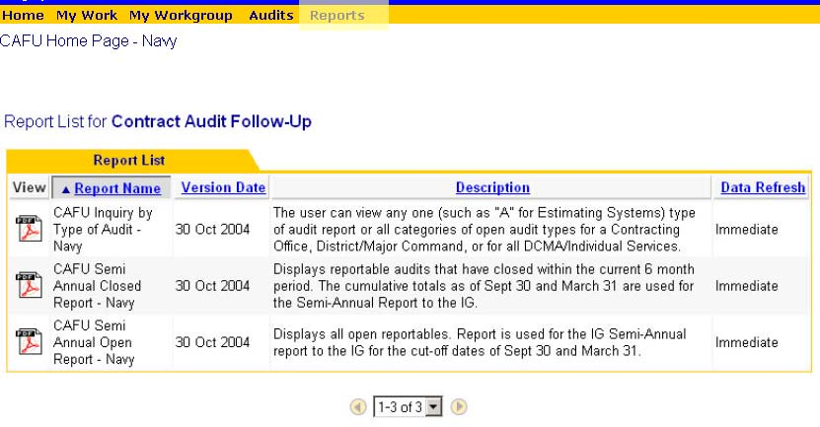

### CAFU Inquiry by Type Audit

This report can view open audits by various Audit Types or all  Audit Types for a Contracting Office, District/Major Command specific to your service.

### CAFU Semi Annual Closed Report

This reports displays reportable audits that have closed within the current 6 month period.  The cumulative totals as of Sept 30 and March 31 are used for the Semi-Annual Report to IG.

### CAFU Semi Annual Open Report

This report displays all open reportable audits.  The reports is used for the Semi-Annual report to IG for the cut-off dates of Sept 30 and March 31.



Bottom of Form

# CAFU Frequently Asked Questions

I am getting no records back when I use the search feature.

If you use the search action from My Work, the system will only search within audits currently assigned to you. To search for all audits in your workgroup, make sure you use the search action from the Audits screen. See Searching for Audits for details.

I am trying to update remarks but the system keeps prompting me for other inputs.

If you want to update remarks without completing a pipeline activity, such as resolve or disposition, you must use the update remarks feature. Updating remarks from the edit screen requires satisfying all business rules. See Updating Remarks for details.

I just completed the Forward Document activity on my audit and it disappeared from My Work screen.

As a CO, once you complete the Forward Document activity, you are done with the audit; hence it is no longer assigned to you. You can still find the audit in the Workgroup Audits screen. See Forward Document and Workgroup Audits Screen for details.

# Using the Calendar Function CBT

To watch a live demonstration (CBT) to learn how to use the Calendar functionality in the application, please refer to the online Help link provided on any page in the CAFU 3.5 application.

# Glossary

A

ACO: Administrative Contracting Officer

C

CAGE: Commercial and Government Entity

CAS: Cost Accounting Standards

CIPR: Contractor Insurance and Pension Review

CMO: Contract Management Office

CO: Contracting Officer

D

DBA: Database Administrator

DCAA: Defense Contract Audit Agency

DCE/CACO: Defense Corporate Executive/Corporate Administrative Contracting Officer

DCMA: Defense Contract Management Agency

DLA: Defense Logistics Agency

DoD: Department of Defense

DoDAAC: Department of Defense Activity Address Code

DUNS: Data Universal Numbering System

F

FAO: Field Audit Office

FOIA: Freedom of Information Act

Form 1: When agreement cannot be reached with the contractor, the auditor will issue a DCAA Form 1, Notice of Contract Costs Suspended and/or Disapproved, in addition to the advisory report to the administrative contracting officer. It details the items of exception and advises the contractor that requests for reconsideration should be submitted in writing to the administrative contracting officer.

FY: Fiscal Year

H

HQ: Headquarters

I

IDB: Integrated Database

**M**

**MOCAS:** Mechanization of Contract Administration Services

**Milestones:** Milestones are intermediate steps in the Follow-Up process associated with an audit. This feature is provided in CAFU to help CO/Monitors set intermediate goals with target dates, remarks, actual, and revised dates. Monitors can view the milestones attached to audits from the View Audit Follow-Up page. The milestone feature can help the workgroup manage the audits more effectively and improve performance.

**My Workgroup:** This page provides information about User’s CAFU account, workgroup, and members of workgroup. Actions pertaining to a role cannot be taken directly from My Workgroup. Only Monitors have the option to take over an audit from their workgroup, at which time, actions can be taken against an audit directly from My Work screen.

**P**

**Plan:** This is the action where CO/Monitor inputs the planned resolution and disposition dates.

**Pipeline Position:** A pipeline position is an action that can be performed on an audit. Every pipeline position in the work flow diagram has a different set of business rules.

**Q**

**Qualified or Unresolved Cost:**

This field (Yes/No) is populated from DCAA data load. This field will be empty for the open existing audit records that were in the system prior to deployment of 3.5.

**R**

**Resolution Target Date:** This is a system assigned date but the **Plan** pipeline position allows the CO/Monitor to change the target date for resolution. The Resolution Target Date cannot be later than six months from the Audit Issue Date.

**Resolve:** Resolve is a pipeline position which comes after Plan. At this stage the audit has been planned, and resolution or pre-negotiation has been achieved. The CO/Monitor must input the Resolution Actual Date to resolve.

**S**

**Semi-Annual Reports:** Two types of Semi- Annual Reports are available in CAFU. Open and Closed.

Open report displays all open reportable. Report is used for the Semi-Annual report to the IG for the cut-off dates of Sept 30 and March 31. Closed report displays reportable audits that have closed within the current 6 month period. The cumulative totals as of Sept 30 and March 31 are used for the Semi-Annual Report to the IG.

**Sustained Amount:** This is an amount that must be entered by CO/Monitor in the **Disposition stage** screen if Cost Questioned / Avoidance is greater than zero.

**T**

**Take Over:** Monitor may view audits assigned to a CAFU user in his/her agency and actively assign any number of those audits to himself/herself. This type of assignment is referred to as a Take Over. Only Monitors have the option to take over an audit from their workgroup, at which time actions to correct the audit records can be taken against an audit directly from My Work screen.

**Transfer:** CAFU user assigns his/her audit to another CAFU user within the same agency. Only HQ Monitors can transfer audits outside of his/her agency. When transferring an audit outside the user's agency, the audit will inherit the assignees DoDAAC.

**U**

**Updated Cost Questioned/Avoidance**: This field can be populated by a CO or Monitor when there is an obvious error in the original amount brought over by the DCAA data load into eTools. (It must be verifiable.) CO/Monitor can modify Updated Cost Questioned/Avoidance in resolve, disposition pipeline position.

**W**

**Work Flow Diagram**: The CAFU Work Flow Diagram displays the description of the pipeline that represents the action that needs to be taken for the selected audit.

**Index**

ACOs 23, 54

Action 20

Activity 21, 23, 27, 49, 54, 56, 57, 58, 63

Activity Logging 49, 54, 56, 57, 58

Activity Overview 54, 56

Actual Date 38, 39, 40, 41, 42, 43, 44, 50, 54, 55, 65

Add Audit 10, 11, 31, 36

Add Milestones 10, 11

Add New Audit 35

Agency 0, 5, 10, 11, 51, 63

Air Force 25

Archived Pipeline Position 45

Army 23, 24

Army CAFU workgroup 23

Audit 0, 5, 6, 10, 20, 21, 26, 27, 28, 29, 31, 32, 34, 35, 36, 38, 39, 40, 41, 42, 43, 45, 47, 48, 49, 50, 51, 52, 53, 55, 56, 57, 60, 61, 63, 64, 65

Audit Details 26, 36

Audit Issue Date 38, 39, 40, 41, 42, 43, 65

Audit Milestones 53

Audit Number 27, 34, 36, 57

Audit Records Overview 32

Audit Report 20, 21, 31, 45, 48, 49, 50, 51, 53, 55, 56, 57, 60

Audit Report Number 20, 21, 48, 49, 50, 53, 55, 56, 60

Auditor Name 32, 46

Auditor Phone 32, 46

Auditor Phone Number 32

Audits 8, 10, 11, 22, 26, 27, 34, 35, 45, 50, 55, 57, 58, 60, 62, 63

Browser Text Size 17

Business Rules 36, 38, 39, 40, 42, 43, 46, 54

CAFU 5, 10, 11, 12, 19, 20, 22, 23, 24, 25, 26, 29, 31, 32, 33, 34, 35, 44, 45, 47, 51, 52, 56, 59, 60, 61, 62, 64, 65

CAFU Current Features 11

CAFU Frequently Asked Questions 62

CAFU Functions 10

CAFU Monitors 45

CAFU workgroup 23, 24, 25

Calendar 15, 16, 38, 40, 41

Cancel 18, 33

CAS 63

change 32, 33, 45, 54

Change 46

Clicking 12, 14, 20, 21, 26, 35, 49, 55, 56

CMO 21, 23, 61, 63

CO 10, 32, 33, 35, 37, 38, 39, 40, 41, 43, 46, 47, 48, 49, 51, 52, 53, 58, 63, 65

Common Indicators 15

Content Area 12, 13

Contract Audit Follow-Up 0, 5, 6, 29

Contractor 14, 20, 34, 35, 36, 37, 45, 63

Correction 45

Cost Accounting Standards 63

Cost Questioned 36, 39, 40, 46, 65

Criminal Investigation 40

Data Table 13, 14, 15, 18

Date 0, 21, 33, 37, 38, 39, 40, 41, 42, 43, 44, 45, 46, 49, 50, 54, 55, 56, 60, 65

DCAA 5, 21, 31, 39, 43, 44, 63, 64

DCMA 5, 11, 14, 20, 23, 26, 27, 28, 35, 59, 60, 61, 63

DCMA District 26, 27, 28

DCMA District Monitors 27, 28

Defense Activity Address Code 63

Defense Contract Auditing Agency 5

Defer 10, 40, 41, 46, 65

Defer Audits 10

Defer Date 40, 41, 46

Delete Audits 11

Delete Milestones 11

Department 63

Description 13, 15

Disposition Actual Date 40, 41, 42, 43, 44

Disposition Audits 10

Disposition Audits After Deferral 10

Disposition Target Date 10, 11, 33, 37, 38, 39, 40, 42, 49, 50

District 11, 21, 23, 26, 27, 28, 34, 61

District Monitor Functions 11

Document Forward Date 43, 45

DoDAAC 35, 36, 46, 47, 51, 63, 65

DoDIG 5, 11

dropdown 14

Edit 10, 11, 15

E-Mail 44, 51

enter 36, 37, 40, 41, 54, 55

entering 34, 44, 45, 55

e-Tools 12

Example Date Range 45

Features 10, 11, 19

File menu 29

Forward / Send Document 43

Forward Document 63

Forwarded 44, 45

Forwarded Pipeline Position 45

Government Entity 63

Header 12

Headquarters Monitor Functions 11

Home Page 19

HQ 20, 21, 26, 27, 28, 31, 32, 50, 51, 65

IDB 64

include 10, 11, 20, 27, 59

input 33, 38, 65

Input Remarks 33

Inquiry 60

Internet Explorer 17, 28

Just Update Remarks 10, 11

Litigation 40

Look and Feel 12

MACOM/District 21

Major Command 10, 20

MC Monitor 21, 49

MC Workgroup 10, 11

Milestone Type 54

Milestones 10, 11, 52, 53, 54, 55, 64

Milestones Overview 52

Modify Reason 46

Modify Sustained Amount 46

Modifying 17

Monitor Functions 10, 11

Months Report 59, 60

My Work Screen 20, 34

My Workgroup 22, 58, 64

Navy CAFU workgroup 24

Netscape 28

Non-Reportable 8

Pipeline 26, 29, 32, 33, 45, 46

Pipeline Meter 32

Plan 10, 37

Plan Audits 10

Print button 28

Printing 28

Reason 40, 46

Remarks 10, 11, 33, 48, 54, 55, 63

Report Number 20, 21, 26, 27, 48, 49, 50, 53, 55, 56, 60

Reports 10, 11, 31, 59, 61

Resolution 37, 38, 39, 40, 41, 49, 50, 65

Resolution Actual Date 38, 39, 40, 41, 50, 65

Resolution Target Date 37, 38, 65

Resolve Audits 10

Revise Target Date 33

Revised Date 54, 55

Revised Disposition Date 40, 41

Revised Disposition Target Date 10, 11, 39, 40, 42, 50

Role 10, 23

Scroller 14

Search 10, 11, 15, 34, 35, 36

Search & Print Audits 10, 11

Search Audits 11

Semi-Annual Closed Report 59, 60

Semi-Annual Open Report 59, 60

Send 43

Service HQ Monitors 27, 28, 50

Show Audits 58

Sort Audits 10

Status Closed Report 59

Status In Litigation Report 59

Submit 18, 49

Summary 61

Sustained Amount 40, 41, 46

System Time Out 19

Take Over 10, 11, 32, 47, 65

Target Date 10, 11, 33, 37, 38, 39, 40, 42, 49, 50, 54, 65

Time 19, 21, 56

Title Bar 12

Transfer Audit 10, 11

Transferring 51

TRICARE 5, 24, 25, 36

TRICARE CAFU workgroup 24

Unresolved Audits Over Six Months Report 60

Update Contractor Information 45

Update Remarks 10, 11, 48

Update Revised Disposition Target Date 10, 11

Update Revised Target Date 49

Update Target Date 49

Updated Cost Questioned 39, 40, 46

Updating 48, 54, 63

Updating Remarks 48, 63

User Interface 12

User Name 12

User Profile 17

View & Edit Audits Assigned 10

View Activity 27, 57

View Activity menu 27

View Audit Follow-Up 20, 21, 26, 27, 28, 32, 47, 48, 49, 50, 52, 53, 55, 64

View My Activity 21, 58

Viewing 26, 55

Work Flow Diagram 20, 26, 29

Workgroup Audits Screen 26, 63