Shipping Instructions Request
(SIR)
User Manual
Version 2.5

Updated October 10, 2015

Defense Contract Management Agency

By

Contents
1 Introduction 1
2 Version 2.5 (Phase 1) Release Notes 1
3 Process Flow 1
4 User Access 2
4.1 Contractor 2
4.2 DCMA Transportation Officer (TO) 3
4.3 Traffic Management Specialist (TMS) 3
4.4 Team Chief (TC) 3
4.5 Admin 4
5 Common Elements 4
5.1 Application Toolbar 4
5.2 Icons 5
6 Launching SIR 6
7 Functionality 7
7.1 Homepage 7
7.1.1 External Users 7
7.1.2 Internal Users – TO, TMS, TC, & Admin 8
7.2 Add New Shipping Instructions Request 9
7.2.1 Add Items to be Shipped 11
7.2.1.1 Search for Items 11
7.2.1.2 Add New Items 13
7.2.2 Enter Shipping Origin 15
7.2.3 Enter Shipping Destination and Dates 16
7.2.4 Enter Special Shipping Requirements 18
7.2.5 Add Attachments 21
7.2.6 Save & Submit Request 22
7.2.7 Enter Correspondence 25
7.3 Edit, Delete, & Copy Request for Shipping Instructions 26
7.3.1 Edit Request 26
7.3.2 Delete Request 26
7.3.3 Copy Request 27
7.4 Search Requests 27
7.5 View & Update NOA Information 29
7.6 View & Update DCMA Transportation Input 30
7.7 Cancel, Save & Print Request 32
7.8 Generate Shipping Instructions 32
7.9 DCMA Transportation Shipment Instructions/Summary Screen 34
7.9.1 Upload Attachment & Finish Request 34
7.10 Delay Request Completion 34
7.11 Transfer Requests 37
7.12 Assign Request to TMS 38
7.13 Administration 39
7.13.1 Transportation Group 39
7.13.1.1 Manage Member 40
7.13.1.2 Team Summary View 40
7.13.1.3 Edit Region-Team 41
7.13.1.4 Administrators/Notes 42
7.13.2 Security Risk Category 43
7.13.3 Hazard Class/Division 44
7.13.4 Remarks 44
7.13.5 Package/Container Type 45
7.14 E-Mail Notifications 45
8 Reports 47
9 Glossary 47

Introduction
Shipping Instruction Request (SIR) eTool is used by DCMA Transportation Officers to process and keep track of the shipping instructions requests submitted by the contractors.

Version 2.5 (Phase 1) Release Notes
The enhancements focus on improving usability and providing new features and additional reporting capabilities, which were identified by current users of the eTool. All existing SIR functionality will remain unchanged, unless otherwise mentioned in this document.

- Provide transportation more control and tracking of SIR requests by creating additional internal roles.
- Create an administrator user role to allow management of transportation teams and transportation members.
- Provide the Contractor with the ability to view the status of their application/request.
- Modify existing tool to improve usability, provide enhance email capabilities, and provide additional reporting capabilities.
- Establish the SIR eTool as the system for transportation records.

Process Flow
The Process Flow diagram below illustrates the Shipping Instruction Request process.

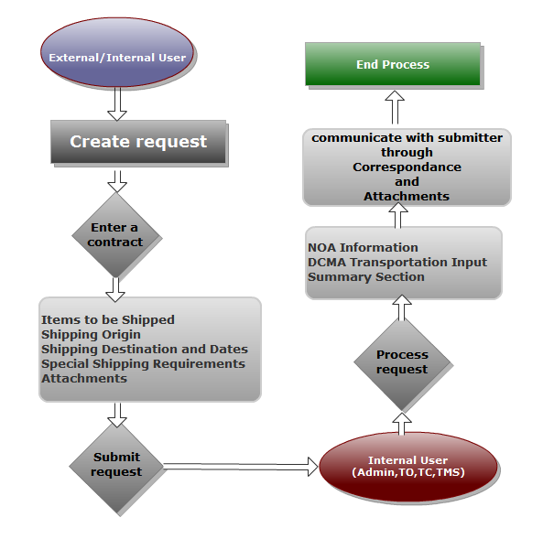
Figure 3-1 Process Flow Diagram

User Access
There are five user types for this application. User permissions are granted via the External Web Access Management (EWAM) application for external users and Internal Web Access Management (IWAM) application for internal DCMA users. User tasks are depicted in the user role diagram below. The user types and functionality are defined in the sections below.

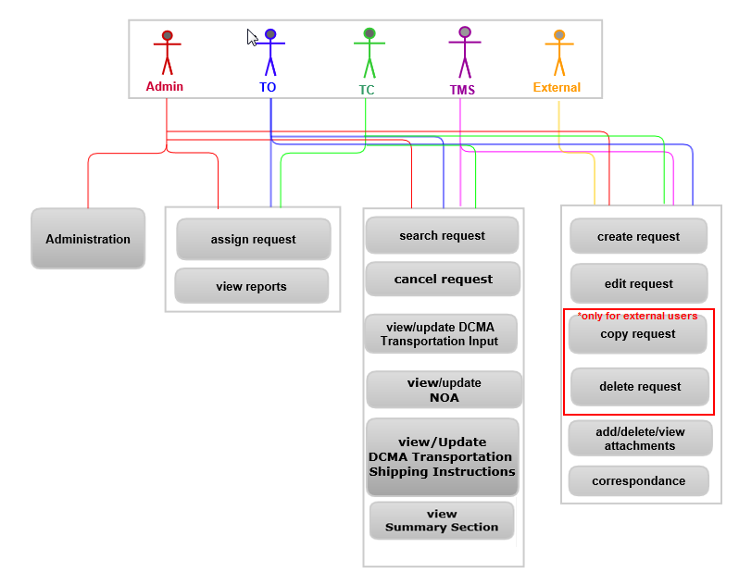
Figure 4-1. User Role Diagram

Contractor
These users create the request for shipping instructions and submit it for review and processing.
They can:
- Add, edit, delete, and copy requests.
Note: These users will not have access to the NOA, DCMA Transportation Input tab, and the DCMA Shipping Instructions screen.
- Add, delete, and view attachments.
- Access the Correspondence section.

DCMA Transportation Officer (TO)
These users review and process the Contractor’s Request for Shipping Instructions and determines the necessary shipping documents needed.
They can:
- Add, edit, search, and cancel requests.
- Add, delete, and view attachments
- View and update NOA Information, DCMA Transportation Inputs, and DCMA Transportation Shipping Instructions.
- Access the Correspondence section.
- View and update NOA Information, DCMA Transportation Inputs, and DCMA Transportation Shipping Instructions.
- Assign requests to a TMS and transfer requests to another CMO.
- Search for requests.
- View Summary screen.
- View reports.

Traffic Management Specialist (TMS)
These users review and process the Contractor’s Request for Shipping Instructions and determines the necessary shipping documents needed.
They can:
- Add, edit, search, and cancel requests.
- Add, delete, and view attachments.
- Access the Correspondence section.
- View and update NOA Information, DCMA Transportation Inputs, and DCMA Transportation Shipping Instructions.
- Search for requests.
- View Summary screen.

Team Chief (TC)
These users review and process the Contractor’s Request for Shipping Instructions and determines the necessary shipping documents needed.
They can:
- Add, edit, search, and cancel requests.
- Add, delete, and view attachments.
- Access the Correspondence section.
- View and update NOA Information, DCMA Transportation inputs, and DCMA Transportation Shipping Instructions.
- Assign requests to a TMS and transfer requests to another CMO.
- Search for requests.
- View Summary screen.
- View reports.

Admin
These users review and process the Contractor’s Request for Shipping Instructions and determines the necessary shipping documents needed in addition to certain application administrative functions.
They can:
- Add, edit, search, and cancel requests.
- Add, delete, and view attachments.
- Access the correspondence section.
- View and update NOA Information, DCMA Transportation Inputs, and DCMA Transportation Shipping Instructions.
- Search for requests.
- Assign requests to a TMS and transfer requests to another CMO.
- Access the Administration section.
- View Summary screen.
- View reports.

Common Elements
There are several common elements within the SIR application user interface. The sections below describe these common elements.

Application Toolbar
The application toolbar contains three links within the SIR application. Depending on your user role some or all of these links may or may not be available.
Home – Available to all users. Clicking on this link takes users to the application Homepage.
Search – Available to all users except for Contractors. Clicking on this link takes users to the application Search page.
Reports – Available to TO, TC, and Admin Users. Clicking on this link takes users to the Reports Portal Page.
Administration – Available to Admin users only. Clicking on the Administration links take users to the Administration Home page.
Figure 5-1. Contractor Application Toolbar

Figure 5-2. Transportation Officer and Team Chief Application Toolbar

Figure 5-3. Traffic Management Specialist Application Toolbar

Figure 5-4. Admin Toolbar

Icons
The table below displays all available icons and their description:
Icons | Description
 | The Add icon allows users to add a new record or additional information within the record.
 | The View icon allows users to view the record or information within the record or column.
 | The Delete icon allows users to delete the record or information within the record.
 | The Copy icon allows user to copy an existing request.
 | The Edit icon allows users to edit the record or information within the record.
 | The Calendar icon brings up the ‘Automated Calendar’ pop-up window. Users can select the Year, Month and Day to populate corresponding date fields.
 | The Print View icon allows users to export the current list of records into an Excel spreadsheet.
The Spell Check icon allows users to run the spell check tool for free text fields.
Note: The spell check tool has limitations and will not detect spelling errors as effectively as Microsoft Word or other document editing software.
 | The Search icon allows users to Search for specific data within the application.
 | The Refresh icon refreshes the data table.
 | The Transfer icon allows users to transfer requests to another CMO.
 | The Expand and Collapse links expands or collapses information presented in the table.
 | The Correspondence icon takes users to the Correspondence Tab.
 | The Print icon allows user to print a particular record.
 | The Records Navigation Bar located below the data table allows users to select the number of records they would like to see on the screen at one time. Clicking on the single left and right arrows takes users back or forward to view the record sets. The double back and forward arrows takes users to the first and last pages of the record sets.

Launching SIR
To access the SIR application:
- Login to the eTools Web Applications page.
- Click the SIR application icon from the Web Access Manager (WAM) screen.
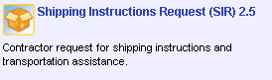
Figure 6-1. SIR Application Icon
- The Home page screen displays.

Functionality
This section illustrates the functionality and user interface of the SIR application. Please refer to Section 4 to determine the functionality and access based on the user roles.

Homepage
The sections below describe the internal and external user Homepage.

External Users
The External User Homepage displays when users log in to the application. This screen displays a list of draft and submitted requests.
Click on the Column Headers to sort the data in ascending or descending order. An arrow to the left side of the column name indicates the sorting order.
There are three available tabs:
Available Actions – Contains a link to add a new Shipping Instruction Request.
Draft Requests – Displays all requests that the user has saved.
Submitted Requests – Displays all requests that the user has submitted.

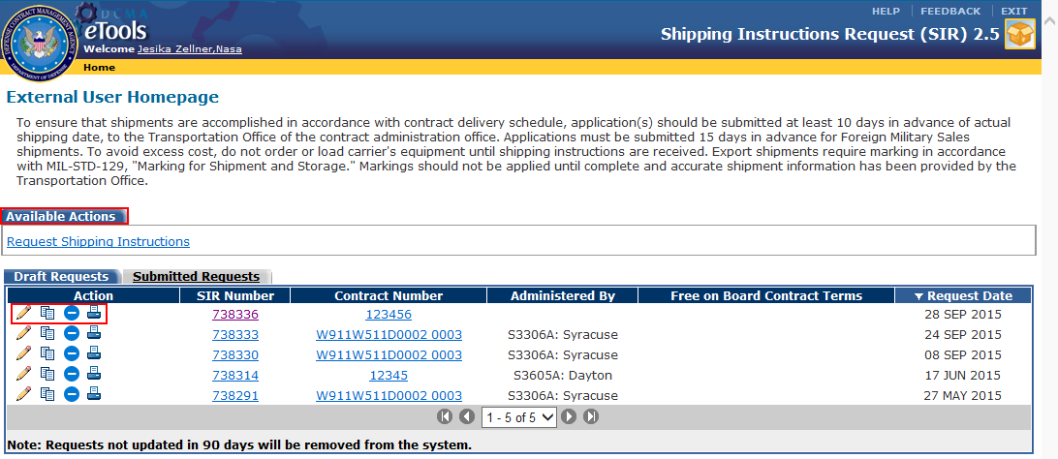
Figure 7-1. External User (Contractor) Homepage
The ‘Edit’ icon allows users to edit the requests.
The ‘Copy’ icon allows user to copy information from an existing request to a new request.
The ‘Delete’ icon allows users to delete requests.
The ‘View’ icon allows users to view requests that have been submitted.
The ‘Print’ iconbrings up the request in a pdf format.
Clicking on the SIR Number link takes users to the request screen.
Clicking on the Contract Number link takes users to the Contract View application to view details about the selected contract.

Internal Users – TO, TMS, TC, & Admin
The Internal User Homepage displays when users log in to the application. This screen displays a list of Customer Requests and Completed Requests.
Click on the column headers to sort the data in ascending or descending order. An arrow to the left side of the column name indicates the sorting order.
There are two available tabs:
Customer Requests – Displays requests that have been submitted for processing. Requests that do not have a ‘Completed’ status in 3 or more days will highlighted in red and bold font. When a record is sent to the user for processing the status of the record is ‘Received. When the TMS has been assigned to the request, the status will change to ‘In Progress’.
Completed Requests – Displays requests that have been completed. When the TMS completes/finishes the request the status of the request is ‘Complete’. When the TMS cancels a request the status will be marked as ‘Cancelled’. When a shipment’s record status is completed, the shipment record moves to this tab. It can be viewed for ten business days excluding Holidays and Weekends. After this period it can be viewed using the Search functionality.
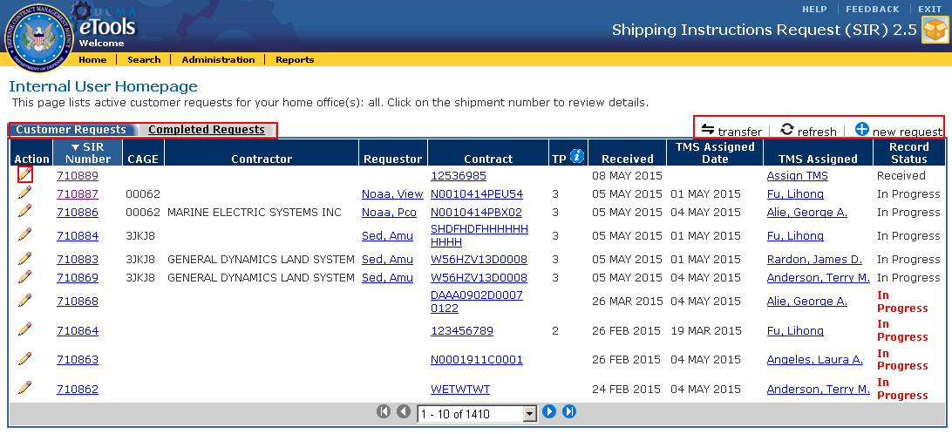
Figure 7-2. Internal User Homepage (Admin User Example)
The ‘Edit’ icon allows users to edit requests.
The ‘View’ icon on the ‘TP’ column displays information about data presented in that column. On the ‘Completed Requests’ tab users can click on this icon to view the completed request.
The ‘Add New Request’ icon allows users to add a new Shipping Instruction Request.
Clicking on the ‘Refresh’ icon refreshes the data table with the most recent requests.
The ‘Transfer’ icon allows to transfers requests to another CMO.
Note: This icon and functionality is only available to Admin users.
Clicking on the ‘Correspondence’ icon from the ‘Completed Request’ tab takes users to the ‘Correspondence’ Tab for the selected request.
Clicking on the SIR Number link takes users to the request screen.
Clicking on the Requestor link opens up an outlook message addressed to the selected requestor
Clicking on the Contract link takes users to the Contract View application to view details about the selected contract.
Clicking on the TMS Assigned link opens up the TMS assignment pop-up screen. Users can select a TMS to assign the request to.

Add New Shipping Instructions Request
Requests can be initiated by External (Contractors) users or by Internal Users (TO, TMS, TC, Admin) on behalf of Contractors.
To add new Shipping Instruction Requests:
- From the ‘External User Homepage’, click on the ‘Request for Shipping Instructions’ link from the ‘Available Actions’ Tab.
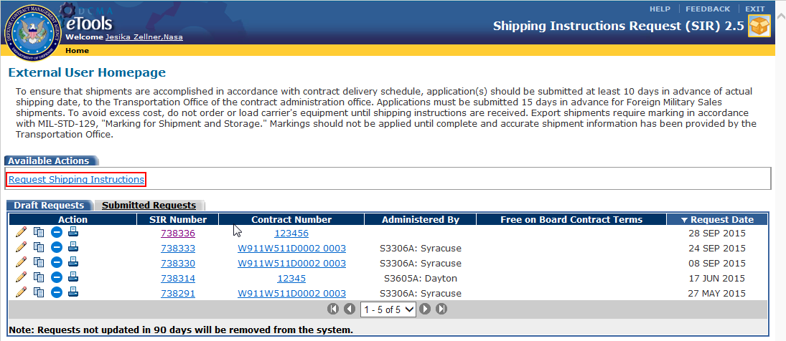
Figure 7-3. External User Homepage – Add New Request Link

- For internal users, click on the ‘Add New Request’ icon from the ‘Internal User Homepage’.
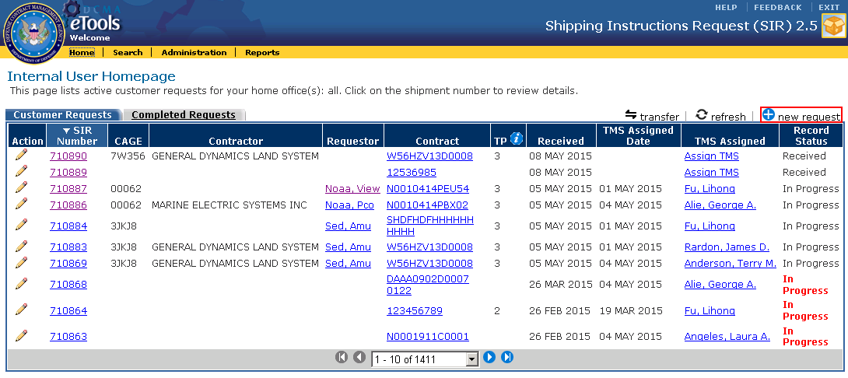
Figure 7-4. Internal User Homepage (Admin User Example) – Add New Request Icon

- The ‘Contract Number’ screen appears. Enter the Contract Number in the field provided and click on the ‘Request Shipping Instructions’ button .
Note: The Contract Number is associated with the Commercial and Government Entity (CAGE) Number.
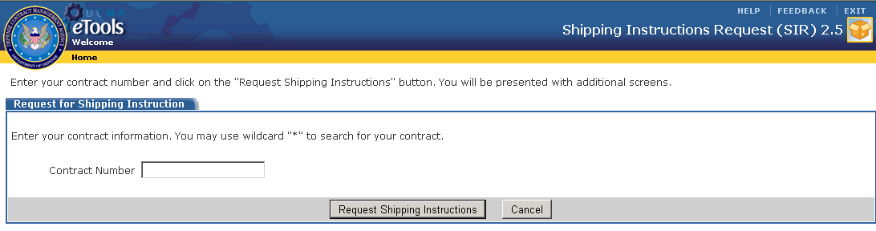
Figure 7-5. Contract Number
- If the Contract Number is not found the ‘Contract Not Found’ screen appears. Users have the option to either click on the ‘Continue’ button to proceed using the existing contract number or search for a different Contract Number from the Re-Enter Contract Number field.
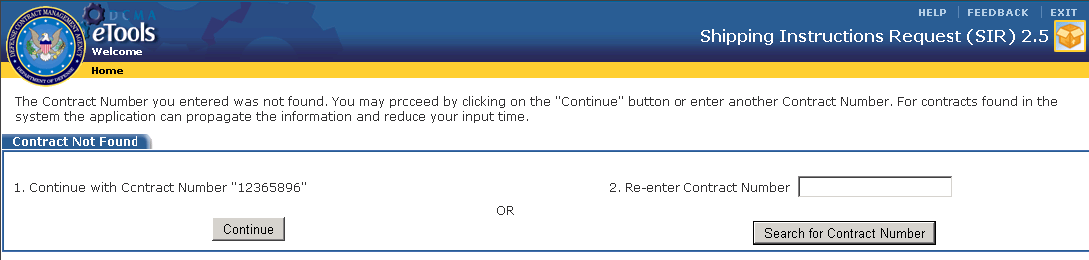
Figure 7-6. Contract Not Found
- Once the Contract Number is found, the ‘Items to be Shipped’ Tab displays.
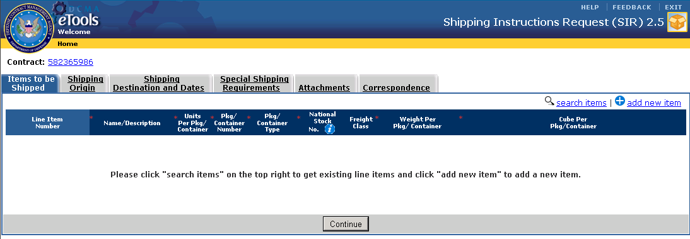
Figure 7-7. Items to be Shipped Tab

Note: Fields with a red asterisks to the left of the field names are required entries and must be filled in. Fields without the red asterisks are optional entries.

Add Items to be Shipped
To add an item to be shipped, users can either search for items that exist in the current contract, in other contracts, or add a new item.

Search for Items

To search for a Line Item:
- Click on the Search Items icon.
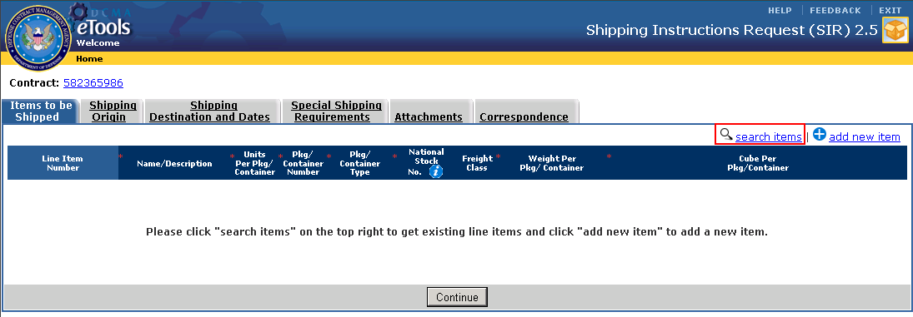
Figure 7-8. Items to be Shipped Tab – Search Items Icon

- A list of line items opens up in a new window. Items are listed in ascending order according to the Shipping Item ID. Click on the checkbox to select the item(s) to be added. Click on the ‘Get Line Items’ button. Click on the ‘Close Window’ button.
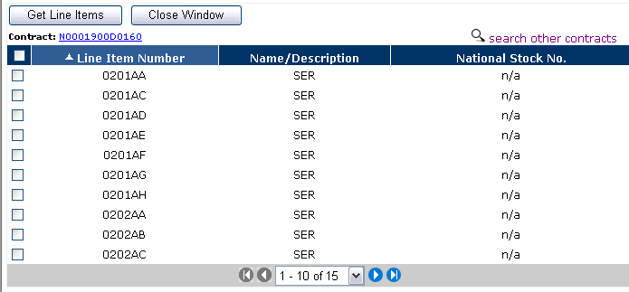
Figure 7-9. Search Line Items Window
- To get line items associated with other contracts, click on the ‘Search Other Contracts’ link. A list of Contract Numbers appears in a new window. Click on the radio button to make the selection and click on the ‘Get Contract’ button. A list of line items appears. Select the line item(s) to be added to the ‘Items to be Shipped’ Tab.
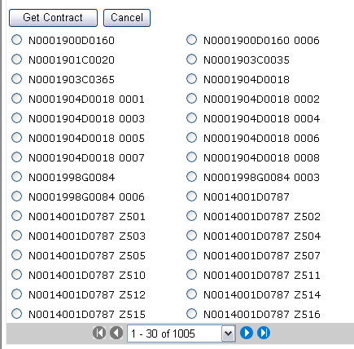
Figure 7-10. Get Contract Screen
- Enter the information in the respective fields for the populated line items.
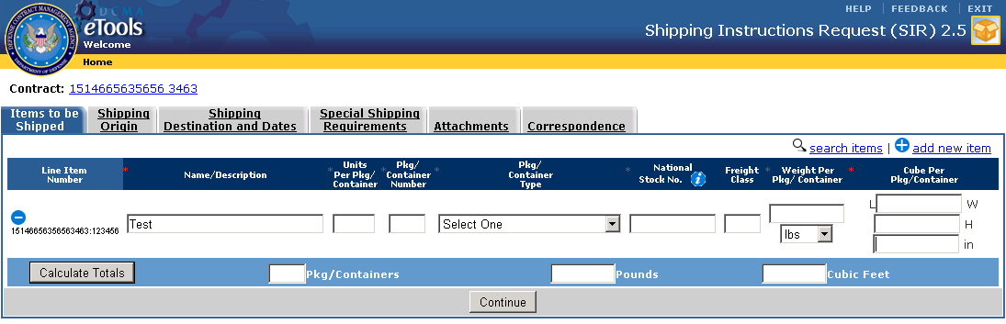
Figure 7-11. Items to be Shipped Tab – Populated Line Items

Add New Items
To add a new Line Item:
- Click on the ‘Add New Item’ icon .
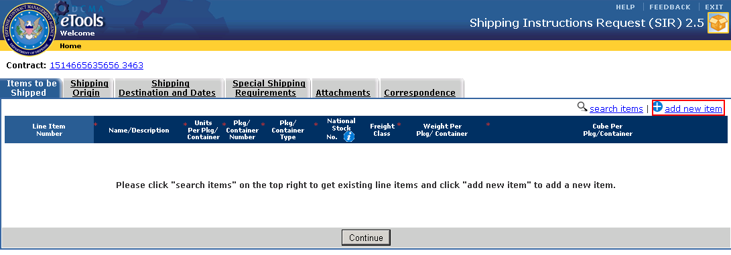
Figure 7-12. Items to be Shipped Tab – Add New Items Icon
- The ‘Add New Line Item’ window appears. Enter the required information in the fields provided and click on the ‘Add This Item’ button . Click on the ‘Close Window’ button.
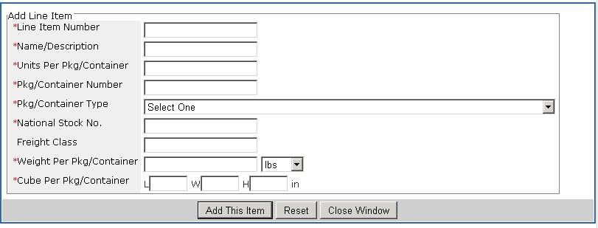
Figure 7-13. Add Line Item Window
- The new line item displays in the ‘Items to be Shipped’ tab. Clicking on the Delete icon removes any of the previously entered Line Items.
- Click on the ‘Calculate Totals’ button to add the total number of packages, weight, and measurement for the listed line items.
Note: The weight and the measurement totals will be calculated in pounds and cubic feet.
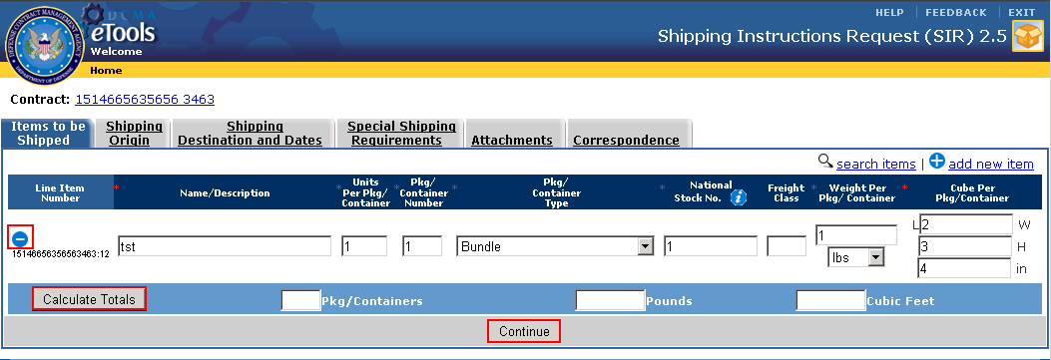
Figure 7-14. Items to be Shipped Tab – New Line Item Added
- Click the ‘Continue’ button to save the entered information and proceed to the ‘Shipping Origin’ tab.

Enter Shipping Origin
To enter the origin of the shipment into the Request for Shipping Instructions:
- Enter the information in the respective fields for the ‘Contractor Information’, ‘Origin’, and ‘Shipper’ sections.
- The Shipper’s location (facility) could be different from the Contractor or Origin.
- If the user is a Contractor, the Contractor Name and CAGE field under the Contractor Information section is pre-populated with the user’s information from the user profile. These fields are in read-only format.
- Internal users creating a request on behalf of a Contractor will be able to edit the CAGE code field. The Contractor name will be populated automatically and display in read-only format.
- Click on the ‘same address as above’ checkbox if the origin address is the same as the contractors or if the shipper address is the same as the origin or contractor.
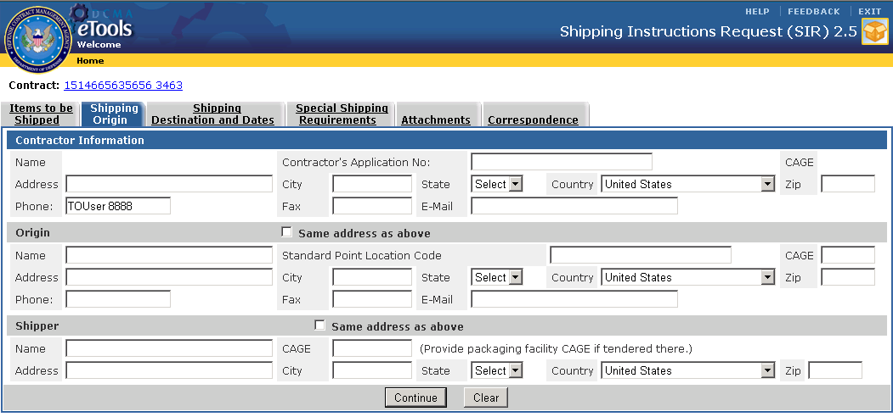
Figure 7-15. Shipping Origin Tab
- Click the ‘Continue’ button to save the entries and proceed to the ‘Shipping Destination and Dates’ tab

Enter Shipping Destination and Dates
To enter the Shipping Destination and Dates into the Request for Shipping Instructions:
- In the ‘Shipping Destination and Dates tab, enter the required and applicable optional entries in the fields provided in the Ship To, Ultimate Destination , and Shipping Dates sections.
- The codes for the Department of Defense Activity Address Code/Military Assistance Program Address Code (DoDAAC/MAPAC) field can be found by clicking on the ‘Lookup DoDAAC’ link located in the upper right corner of the screen or click on the DODAAC/MAPAC field name link on the ‘Ship To’ header. The Defense Logistics Agency (DLA) Transaction Services website will open in a new window where users can search for the codes.
- Once the DoDAAC/MAPAC is entered, the Destination TAC1/TAC2/TAC3 drop-down will automatically display ‘TAC 2’ as the default option. The address field will automatically populate. If no address was found, manual entry will be required in the address field below. Click on the ‘Other Destination’ radio button and fill the address in the given fields.
- If the Other Destination radio button and OCONUS checkbox is selected, the City, State, and Zip fields are not required entries.
Note: If OCONUS is selected, the option in the ‘Country’ field must not be United States.
- If the ‘Required Delivery Date’ field is entered, the ‘RD Julian Date’ will populate.
- If the ‘Air’ option is selected from the ‘Shipping Mode’ field, the ‘Domestic’ and ‘International’ radio buttons are required fields and an option must be selected before being able to proceed.

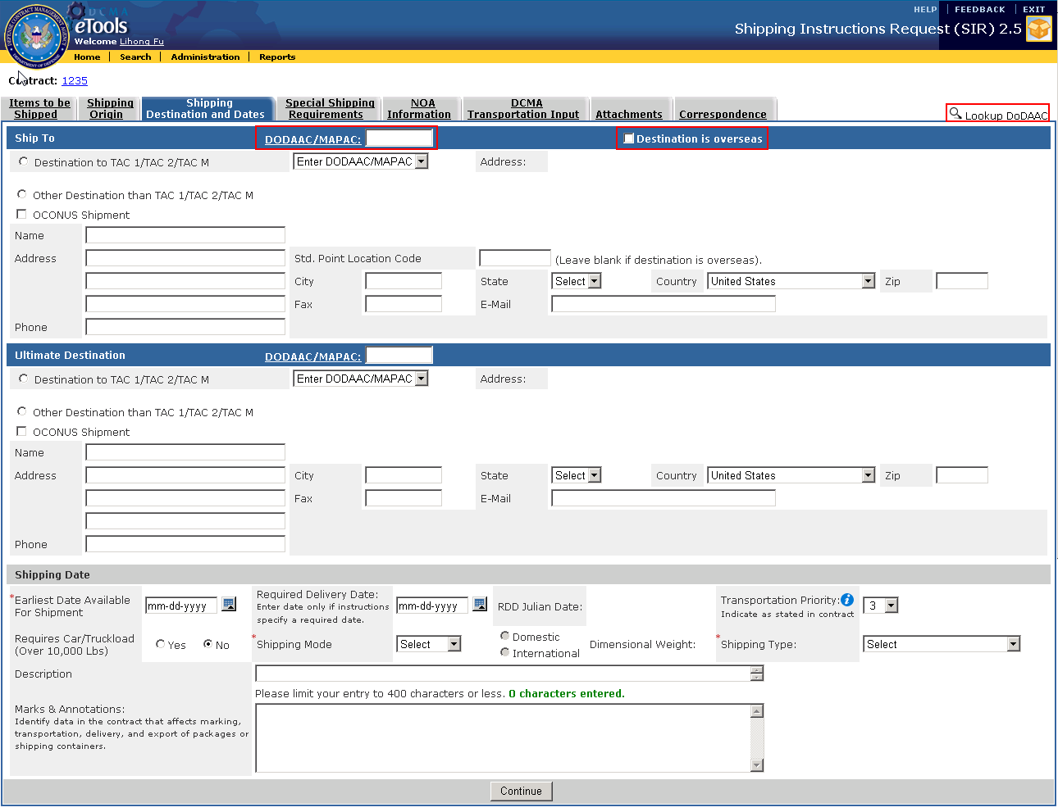
Figure 7-16. Shipping Destination and Dates Tab
- Click the ‘Continue’ button to save the entries and proceed to the ‘Special Shipping Requirements’ tab.
- A soft warning will appear stating that Contractors can only input one destination per request. Click on ‘OK’ on the warning prompt and click on the ‘Continue’ button again to proceed to the ‘Enter Special Shipping Requirements’ Tab.

Enter Special Shipping Requirements
This tab allows user to enter information on special shipping requirements.
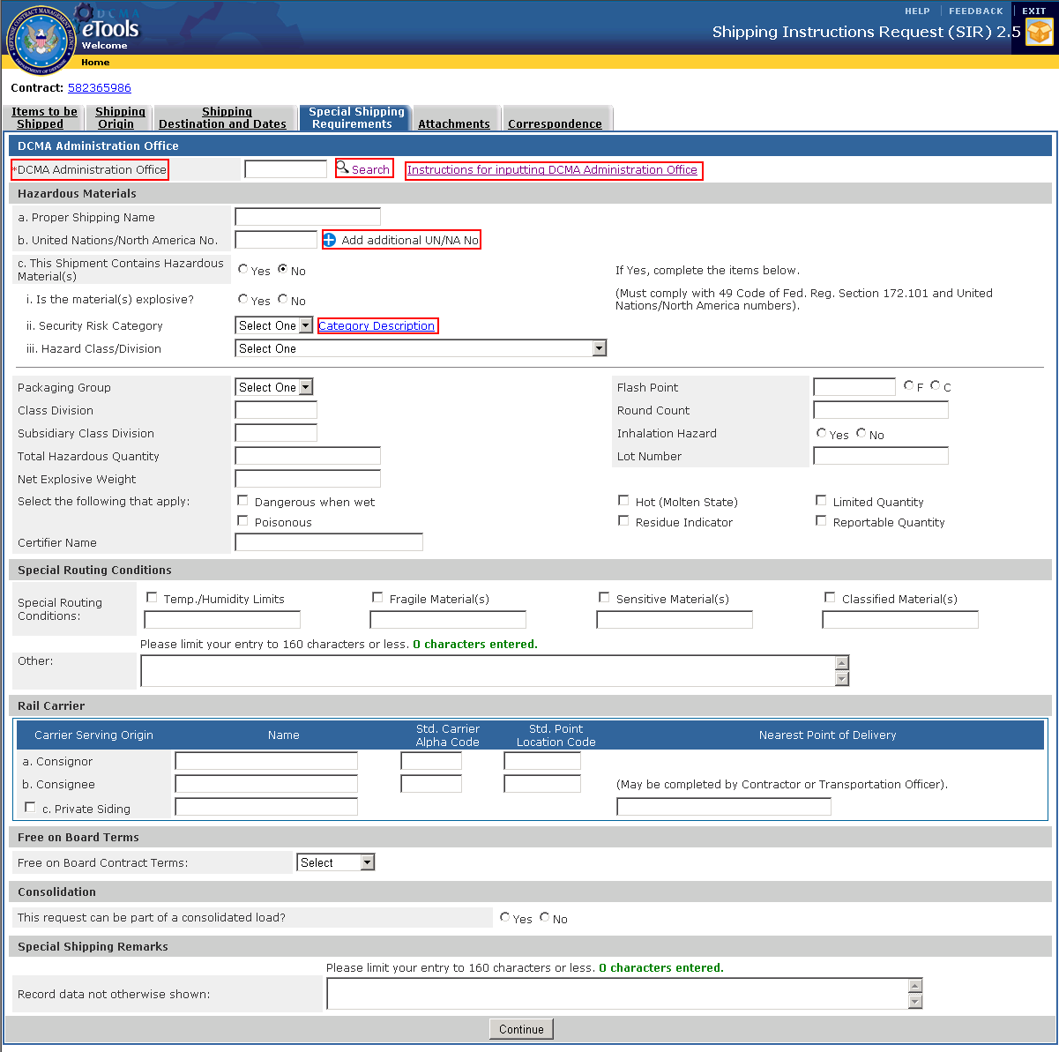
Figure 7-17. Special Shipping Requirements Tab

To enter special shipping requirements:
- Enter the DCMA Administration Office. Click on the Search icon to select a DCMA Transportation Office. The DCMA Transportation Office Search window appears. Select the DoDAAC by clicking on the radio button and click on ‘Select a DCMA Transportation Office’ button. Click on the ‘Close Window’ button.
- Click on the ‘Instructions for inputting DCMA Administration Office’ link next to this field for guidance on how to input information in this field. A new window will open.

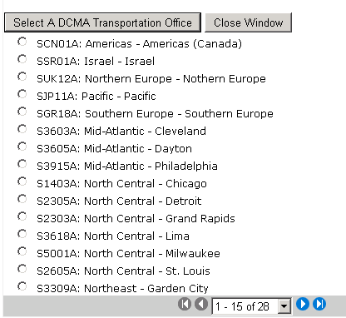
Figure 7-18. DCMA Transportation Office Search Window

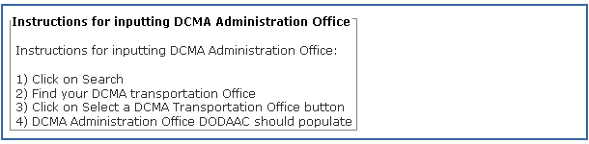
Figure 7-19. Instructions for Inputting DCMA Administration Office Window

- Enter the applicable fields in the ‘Hazardous Materials’, ‘Special Routing Conditions’, ‘Rail Carrier’, ‘Free On Board Terms’, ‘Consolidation’, and ‘Special Shipping Remarks’ sections.
- To add a United Nations / North America No., enter the information in the field and click on the Add icon . The added field will display below. Click on the Delete icon to remove previously entered values. A maximum of 3 values can be entered for this field.
- If you select ’Yes’ for the field labeled ‘C - This Shipment Contains Hazardous Materials ‘under the Hazardous Materials section, fields ‘A – Proper Shipping Name’ and sub items listed under ‘C – i,ii,iii’, ‘United Nations North America No.’, ‘Security Risk Category’, ‘Hazard Class/Division’, ‘Packaging Group’, ‘Class Division’, ‘Total Hazardous Quantity’, and ‘Certifier Name’ are required fields and must be filled in.
- Clicking on the ‘Category Description’ link next to the ‘C(i) Security Risk Category’ field opens up a new window which details the Security Risk Category Descriptions.

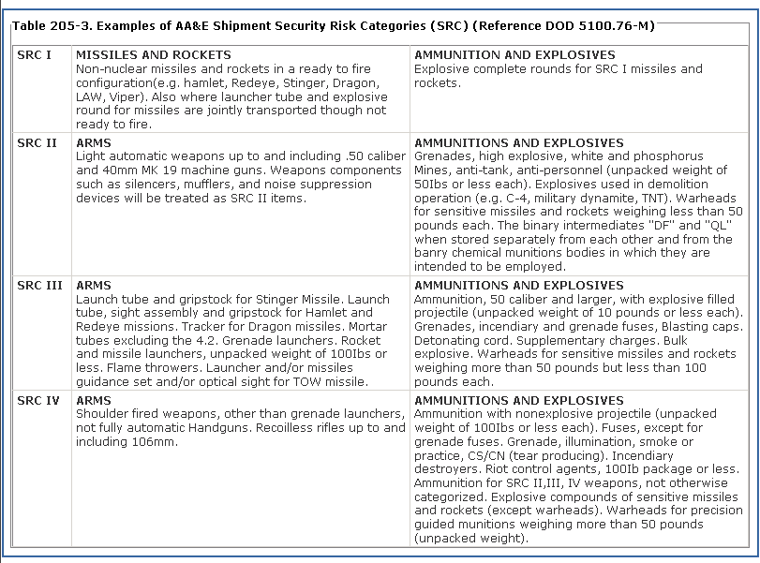
Figure 7-20. Security Risk Category Description Window
- Click the ‘Continue’ button to save the entries and proceed to the ‘Attachments’ tab.

Add Attachments
The ‘Attachment’s tab allows users to attach any supporting documentation to the request if applicable.
There are two tabs to enter attachments:
- The ‘By Contractor’ tab displays attachments uploaded by the Contractor.
- The ‘By Traffic Management Specialist’ tab lists attachments uploaded by the TMS. Refer to Section 7.9. When the request is closed by the TMS, the DCMA Shipping Instructions will automatically be included as an attachment under the TMS section. Internal users can also click on the Add Attachment icon and follow the same steps as the contractor to upload an attachment.
Note: Contractors will only see this tab once the request has been completed.
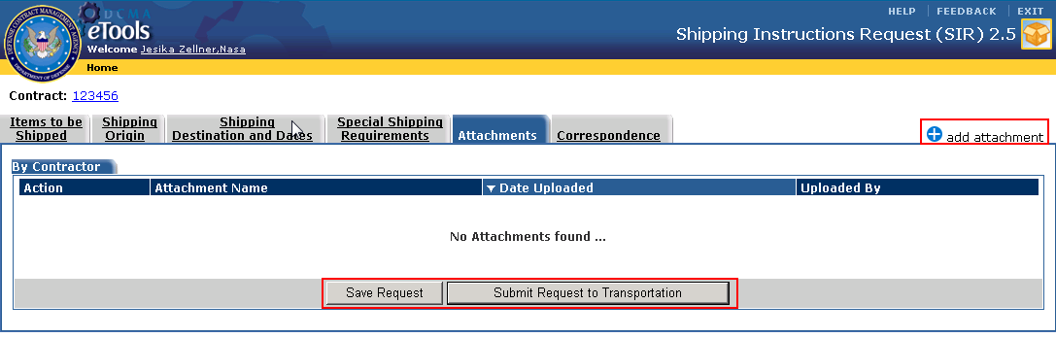
Figure 7-21. Attachment Tab – By Contractor Tab
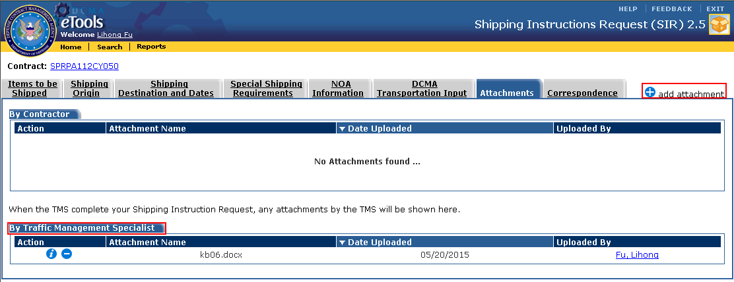
Figure 7-22. Attachment Tab – By Traffic Management Specialist Tab

To add an attachment:
- Click on the ‘Add Attachment’ icon . The ‘Contractor Attachment’ screen appears.
- Enter the Document Title and Location. Click on the Browse button to locate the file you would like to upload.
- Click on the ‘Submit’ button. Click on the ‘Cancel’ button to cancel the upload and go back to the Attachments tab.

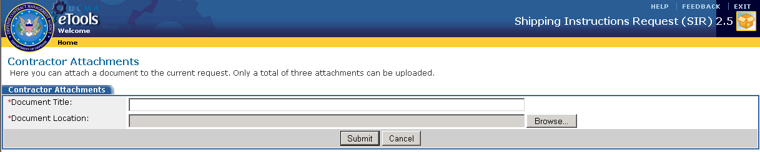
Figure 7-23. Contractor Attachments
- The Attachment screen appears displaying the added attachment.
- Click on the ‘Delete’ icon to delete a particular attachment.
- Click the View icon to view the attachment.

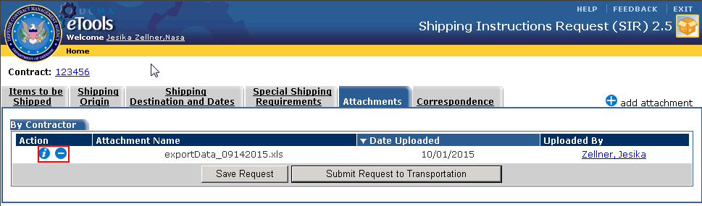
Figure 7-24. Attachments Tab – Added Attachment – Contractor

Save & Submit Request
Only external users can save and submit the request for processing from the attachment tabs.
To save a request:
- From the Attachments tab, click on the ‘Save Request’ button.
Note: This button will only be available to External Users.
- The record will be saves and users will be directed back to the ‘Draft Request’ tab on the ‘External User Homepage’.
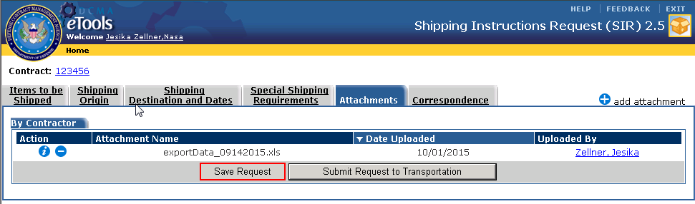
Figure 7-25. Attachments Tab – Save Request

To submit the request:
- Click on the ‘Submit Request to Transportation’ button.
Note: This button will only be available to External Users.
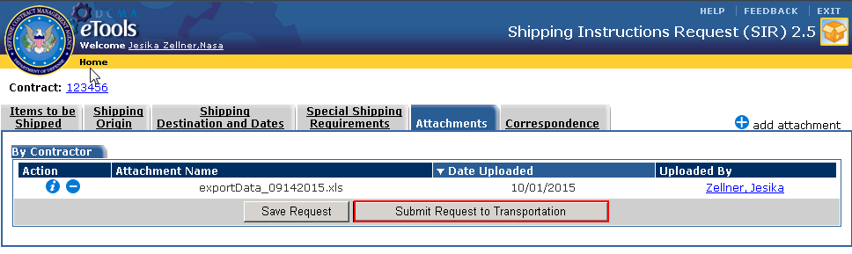
Figure 7-26. Attachments Tab – Submit Request to Transportation

- Users will be directed back to the Transportation Request Summary screen. The request will now be moved to the ‘Submitted Requests’ tab. Once submitted, Contractors will not be able to edit the Request. Click on the Print icon to print the Transportation Request Summary.
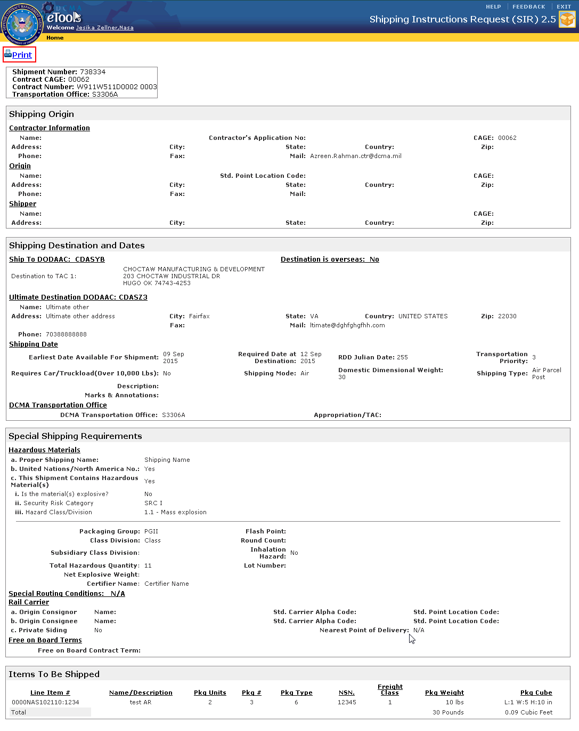
Figure 7-27. Transportation Request Summary

Enter Correspondence
This tab enables Contractors and internal users to communicate by posting a message. All messages include the names of the person posting the message, their user role, and the date and time each message is posted.
To enter correspondence:
- Click on the Correspondence Tab.
- Enter the message in the text input field.
- Click on the ‘Post Message’ button.
- The ‘TMS’ Button only displays for TMS users. The ‘CTR’ button only displays for Contractors. The ‘Admin’ button displays for Administrators. The ‘TO’ button displays for Transportaion Officers. The ‘TC’ button appears for Team Chiefs. Users can also click on this button to post a message.
Note: This button works the same way as the ‘Post Message’ button
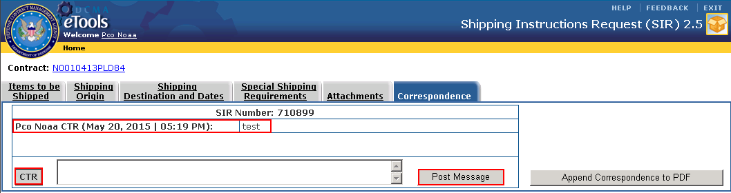
Figure 7-28. Correspondence Tab – Contractor View
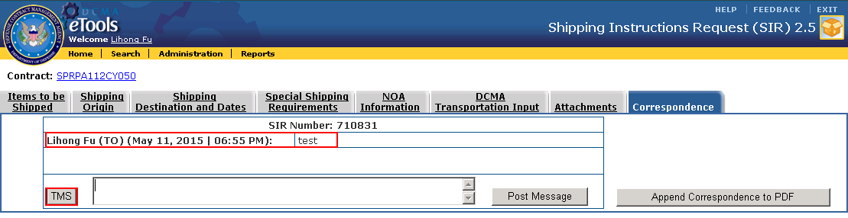
Figure 7-29. Correspondence Tab – TMS View
- To append the message of correspondence and export it as PDF click on the ‘Append Correspondence to PDF’ button. The PDF file of the correspondence will be generated and a file download prompt will appear. Users can choose to open or save the document.

Edit, Delete, & Copy Request for Shipping Instructions
Contractors will only be able to edit, delete, and copy ‘Requests for Shipping Instructions’ that are saved and not yet submitted. These requests reside in the ‘Draft Requests’ tab on the Homepage.
Internal Users (TO, TMS, TC, and Admin) will be able to edit requests that have been submitted with a status of ‘Received’ and ‘In Progress’ from the ‘Internal User Homepage Customer Requests’ Tab and the ‘Search Results’ screen.
Note: Requests that are not updated within a 90-day period is removed from the system.

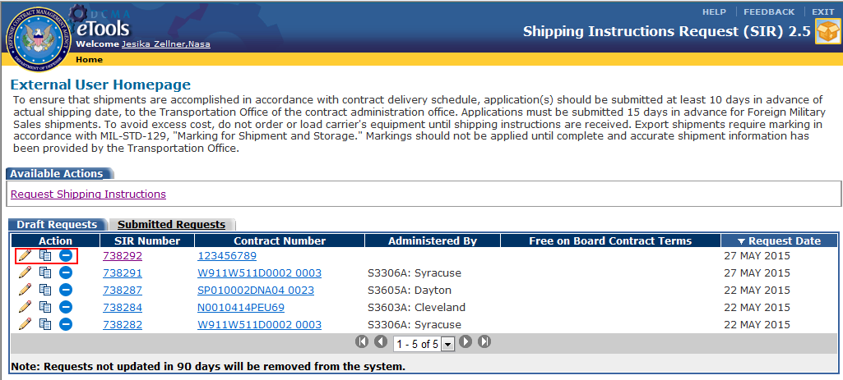
Figure 7-30. External User Homepage – Draft Requests Tab

Edit Request
To edit a Request:
- Click on the ‘Edit’ icon from the ‘Action’ column for the selected Request.
- Enter the required and optional information in the fields provided.
- Click the ‘Continue’ button to save the entries and proceed to the next tabs. Repeat these steps until all edits are made. Follow steps listed in Section 7.2.

Delete Request
To delete a Request:
- Click on the ‘Delete’ icon from the ‘Action’ column for the selected Request.
- A delete confirmation dialog box appears. Click on OK’ button to proceed with the deletion. The contract is removed from the list of contracts. Click on ‘Cancel’ to abort the delete action.

Copy Request
To copy a Request:
- Click on the ‘Copy’ icon.
- A dialog box stating ‘Are you sure you want to copy this Request?’ appears.
- Click the ‘OK’ button.
- A copy of the Request displays in the tab.
Note: Any attachments will not be copied.

Search Requests

Only Internal Users will be able to use the search functionality to search for a particular request within the SIR application.
To search for a request:
- Click on the ‘Search’ link from the application toolbar.
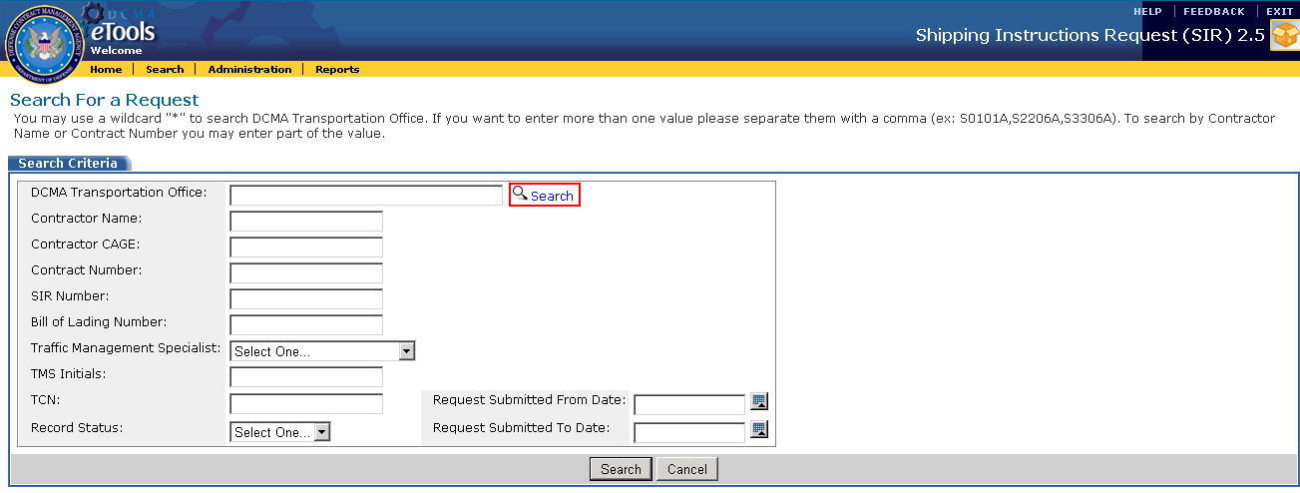
Figure 7-31. Search For Request - Search Link
- The ‘Search For a Request’ screen displays.
- Enter the search criteria in the fields provided.
- The ‘Bill of Lading Number’ field must be entered exactly in order for the search to execute correctly.
- You may use a wildcard "*" to search for a DCMA Transportation Office. To enter more than one value, use to the comma to separate them. To search by Contractor Name or Contract Number part of the value may be entered.
- To search for a DCMA Transportation Office, click on the ‘Search’ icon next to this field. The Search Transportation Offices Window appears. Select the desired value by clicking on the checkboxes and click on the ‘Select DCMA Transportation Office’ button.
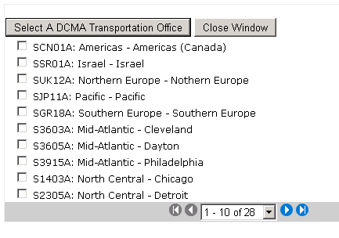
Figure 7-32. Search Transportation Offices Window
- The ‘Traffic Management Specialist’ field will only display members that the person conducting the search is permitted to see based on the regions and teams assigned by the Administrator.
- Click on the ‘Search’ button.
- The ‘Search Results’ screen appears displaying the results based on the search criteria(s) entered.
Note: A user’s search is limited to their visibility of records as assigned by the Administrator.

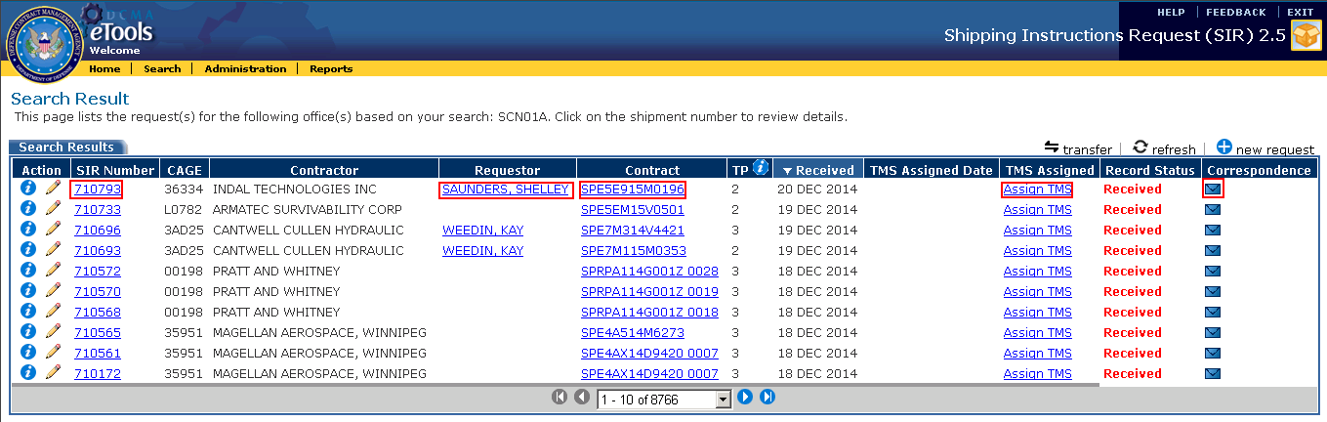
Figure 7-33. Search Results
Click on the ‘Edit’ icon to edit the Request.
Click the ‘View’ icon on the ‘TP’ column to display information about data presented in that column. On the Completed Requests tab users can click on this icon to view the completed request.
Click the ‘View’ icon to view the specific Request.
Clicking on the ‘Correspondence’ icon from the ‘Completed Request’ tab takes users to the ‘Correspondence’ Tab for the selected request.
Clicking on the SIR Number link takes users to the Request screen.
Clicking on the Requestor link opens up an outlook message addressed to the selected requestor
Clicking on the Contract link takes users to the Contract View application to view details about the selected contract.
Clicking on the TMS Assigned link opens up the TMS assignment pop-up screen. Users can select a TMS to assign the request to.

View & Update NOA Information
Only Internal users will be able to access this section. Refer to Section 4 on for details on which users can perform this function.
To view and update NOA information:
- Click on the ‘Edit’ icon for a Request from the Homepage or Search Results screen.
- Click on the ‘NOA Information’ tab.
Note: Some of the information on this screen will be populated with data from the DCMA Transportation Office entered within the ‘Special Shipping Requirements’ tab and the ‘Items to be Shipped’ tab.
- Enter the ‘Notice of Availability/Shipment information’, ‘Required Information’, ‘Other Information’, ‘Hand-off Dates’, and ‘Freight Forwarder Information’.
Note: If you entered the date for the NOA Sent to FF field in the Hand-off Dates section, you must enter the FF Response Received field in order to continue and generate the shipping instructions.
- To generate an NOA form, click on the ‘Generate NOA’ button . The form will be generated in PDF format for your records.
- Click on the ‘Continue’ button to save the information and move to the DCMA Transportation Input tab.
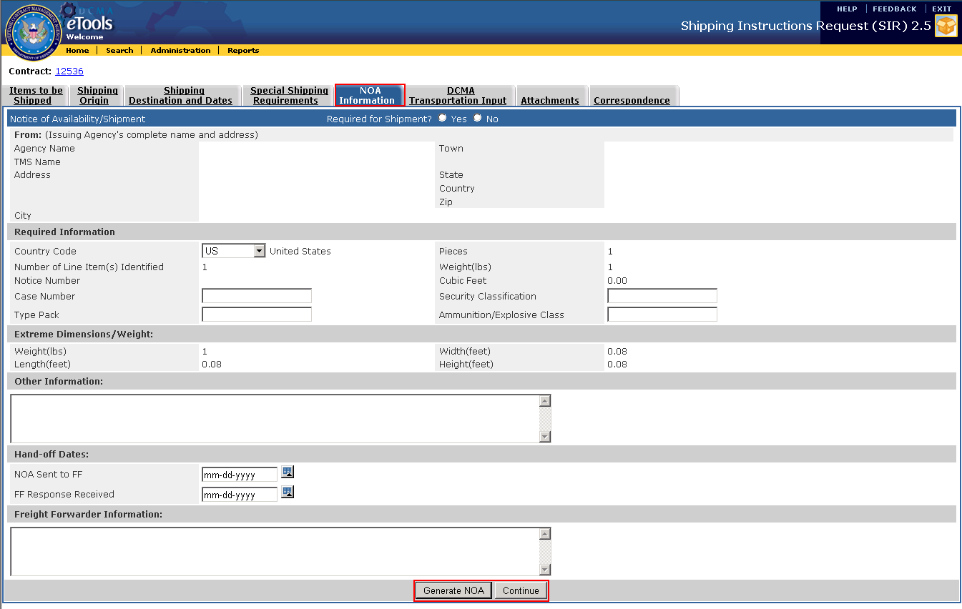
Figure 7-34. NOA Information

View & Update DCMA Transportation Input
Only Internal users will be able to access this section. Refer to Section 4 on for details on which users can perform this function.
To view and update DCMA Transportation Input:
- Click on the Edit icon for a Request from the Homepage or Search Results screen.
- Click on the ‘DCMA Transportation Input’ tab.
- Enter the ‘Carrier Routing Information’, ‘Shipment Information’, ‘Shipping Instructions’, and ‘Additional Information’ for the Request.
- Once the value has been added on the ‘MILSTRIP/TCN/REQ No.’ field in the ‘Carrier/Routing Info’ section, click on the ‘Add’ icon next to add it to the request. Click on the ‘Delete’ icon to remove previously entered values. A maximum of five values can be added for this field.
- If the ‘Small Package Express’ checkbox in the ‘Shipping Instructions’ section is checked, the ‘Tracking/Way Bill Number’ and ‘SPE Issuance Date’ fields are required entries.
- If the ‘Export Shipment’ checkbox in the ‘Shipping Instructions’ section is checked, at least one of the checkboxes (FACTS, IBIS, AES) on the right side of this field must be selected.
Note: Users will only be able select either FACTS or IBIS.
- If the’ IBIS’ checkbox is selected, the ‘ETTR Submitted’ and ‘Returned to SDDC Date’ fields are required entries.
- If the Shipping Destination Country is other than Canada and the export shipment checkbox is selected, either the FACT or IBIS checkboxes must be selected.
- If the Export Shipment checkbox is selected, the Electronic Export Information (EEI) checkbox and ITN# must be entered in order to submit the record.
- If the ‘Transportation Delegation Only’ checkbox in the ‘Shipping Instructions’ section is checked, the ‘Installation Name’, ‘Country’, and ‘Delegation Details’ fields are required entries.
- If the Shipment is delayed, users must select an option from the ‘Remarks’ drop-down list in the Shipping Instructions section. See Section 7.10.
- Click on the ‘See Archive Remarks’ link in the ‘Shipping Instructions’ section to open up a new window containing all archived ‘Commercial Bill of Lading’ remarks.
- At least one of the checkboxes needs to be selected in the ‘Shipping Instructions’ section before being able to generate the Shipping Instructions.
- Clicking on the ‘DD Form 626’,’836’, and ‘651’ links in the ‘Additional Information’ section, takes users to the ‘DoD Issuance’ website where users can download the form.
- Refer to Section 7.7 and 7.8 to complete processing the request in this tab.

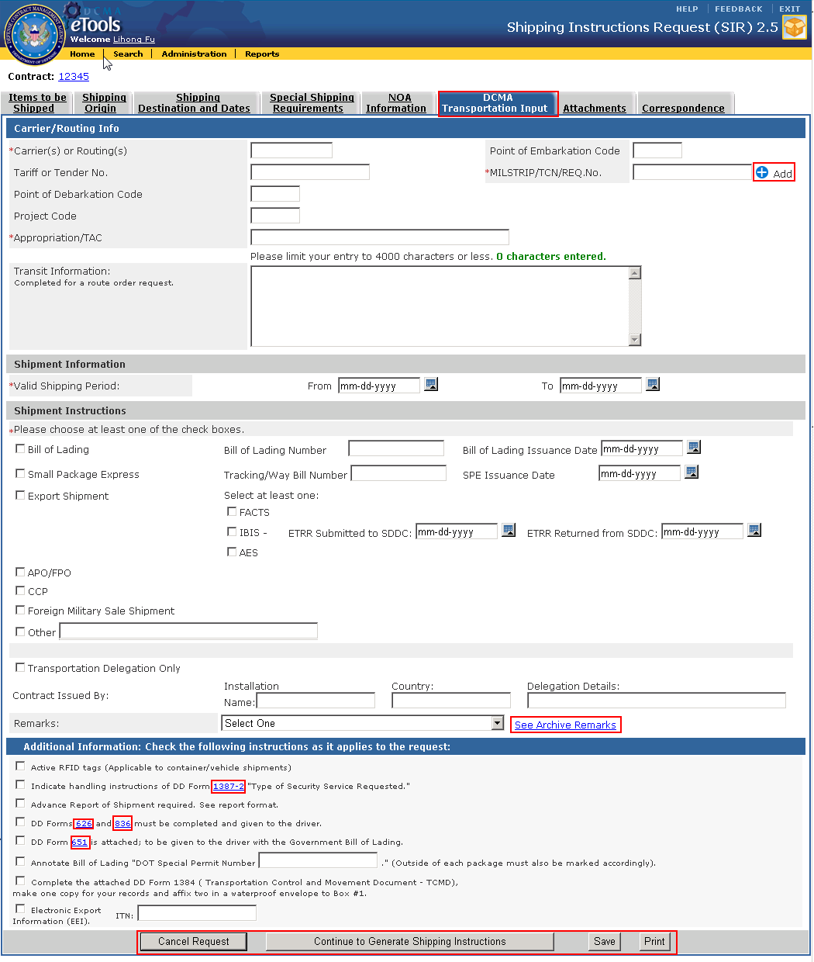
Figure 7-35. DCMA Transportation Input Screen

Cancel, Save & Print Request
From the ‘DCMA Transportation Input’ Tab, users can save, cancel, or print a request.
To save a Request:
- Click on the ‘Save’ button. The data entered will be saved.

To cancel a Request:
- Click on the ‘Cancel Request’ button. A’ Cancel Confirmation’ dialog box appears. Click on the ‘OK’ button to proceed with the cancellation or ‘Cancel to abort the action.

To print the Request:
- Click the Print button.
- A PDF file will be generated and users can choose to save the file in a specific location.

Generate Shipping Instructions
Only Internal users will be able to access this section. Refer to Section 4 on for details on which users can perform this function.
From the ‘DCMA Transportation Input’ tab, users can Generate Shipping Instructions.
To Generate Shipping Instructions:
- Click on the ‘Continue to Generate Shipping Instructions’ button.
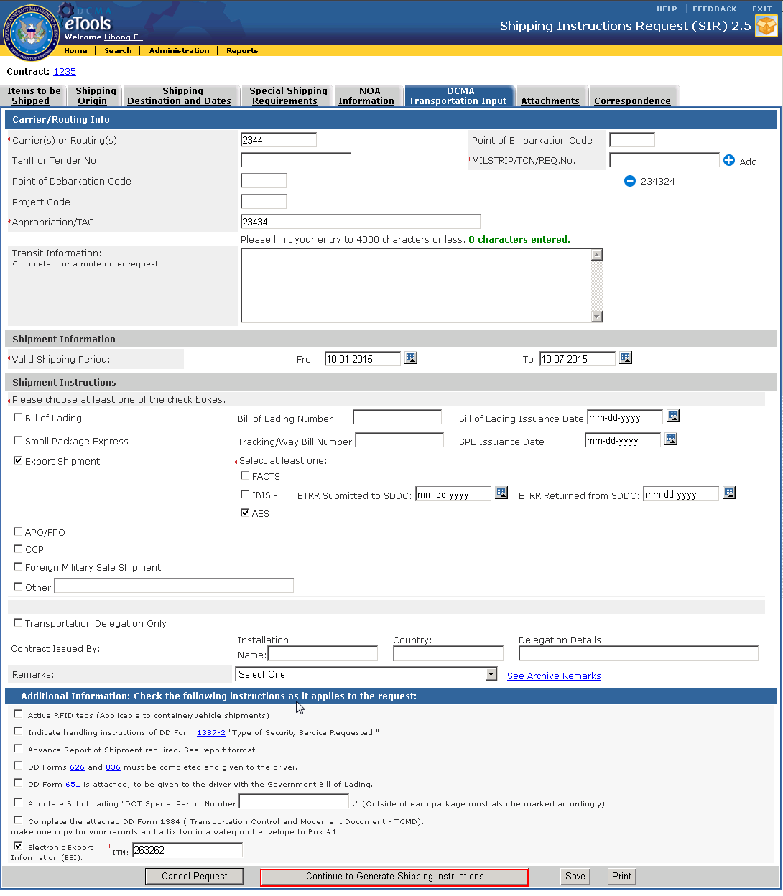
Figure 7-36. DCMA Transportation Input Screen
- The ‘DCMA Transportation Shipment Instructions’ screen appears. This screen is also known as the Summary screen.
- Refer to Section 7.9 to complete this process.

DCMA Transportation Shipment Instructions/Summary Screen
The ‘DCMA Transportation Shipment Instructions’ screen, also known as the ‘Summary’ screen allows user to enter additional comments to the Shipping Instructions and complete the request.
Only Internal users will be able to access this section. Refer to Section 4 on for details on which users can perform this function.

Upload Attachment & Finish Request
To upload attachments and finish the Request:
- Enter any comments in the ‘Comments’ field. Click on the ‘Save’ button to save the comments entered.
- Click on the ‘Upload Attachment to Contractor and Finish Request’ button.
- A notification E-Mail will be sent to the Contractor. The ‘DCMA Shipping Instructions’ will be converted to a PDF file and automatically included in the ‘Attachments’ tab.
- Users will be directed to ‘Correspondence’ Tab.

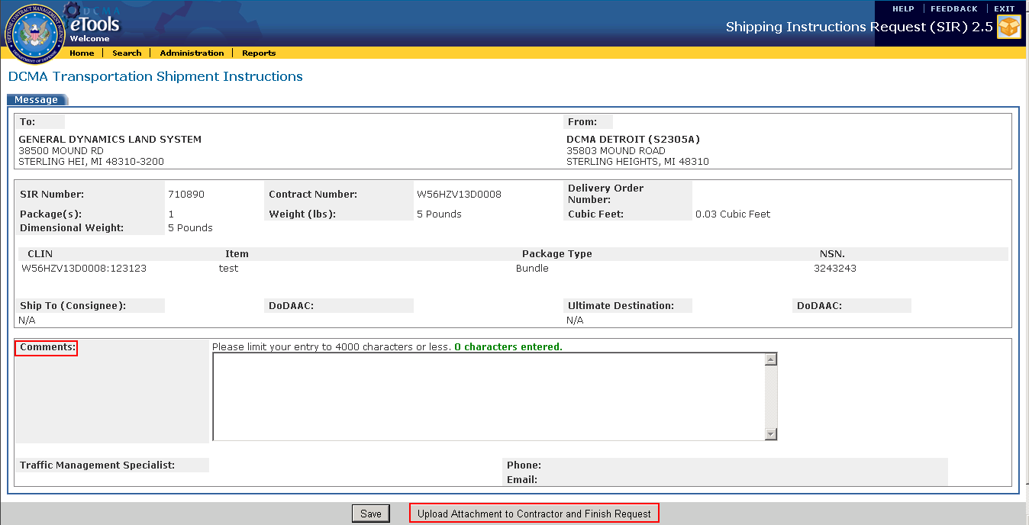
Figure 7-37. DCMA Transportation Shipment Instructions

Delay Request Completion
The completion of a Request is considered delayed when the Transportation Priority specified in the ‘Shipping Destination and Dates’ Tab and the ‘Received’ date for when the Request was submitted has exceeded the specified time.
The timeline for the Transportation Priorities are listed below:
- 1 - Requires the completion of the Request within 24 hours;
- 2 - Requires the completion of the Request within 48 hours;
- 3 - Requires the completion of the Request before the ‘Required Delivery Date’ (displayed in the ‘Shipping Destination and Dates tab).
Note: For Requests received after 4:45 PM, start time for completing the Request does not begin until 7 AM. In addition the clock does not count on weekends or Government holidays.
To complete a delayed request:
- Click on the ‘SIR Number’ link to access the delayed Request.
- From the ‘DCMA Transportation Input’ tab, select the ‘Remarks’ from the drop-down list.
- Click on the ‘Save’ or ‘Continue to Generate Shipping Instructions’ buttons.
- Follow the steps listed in Section 7.9 to finish the Request if applicable.
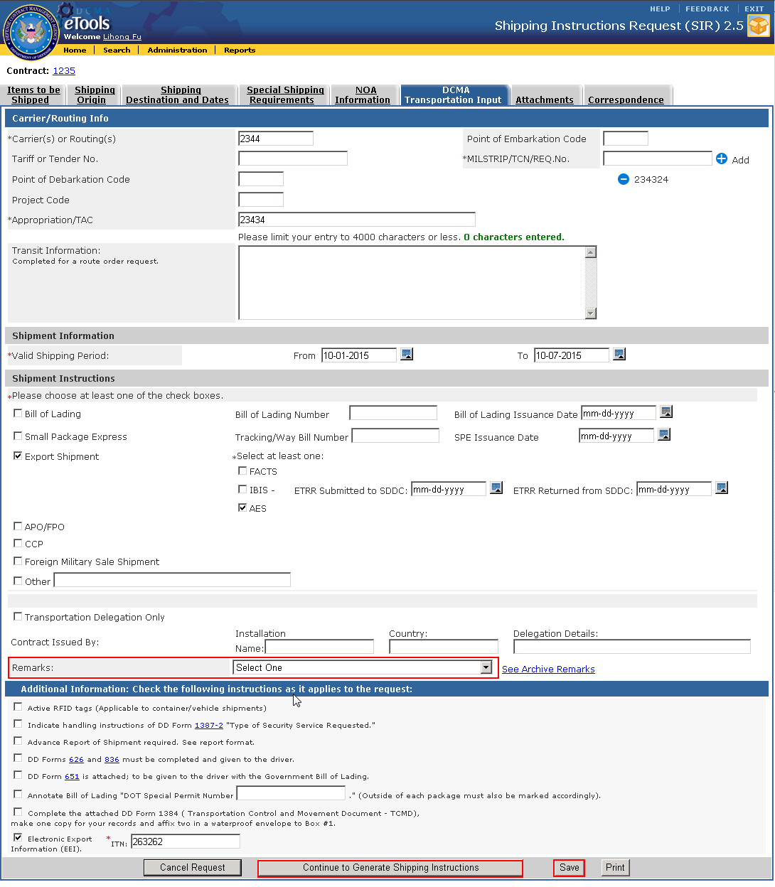
Figure 7-38. DCMA Transportation Input Screen – Remarks Field

Transfer Requests
Only Internal users will be able to access this section. Refer to Section 4 on for details on which users can perform this function.
Users can transfer requests to another Contract Management Office (CMO).
To transfer a Request:
- In the Internal User Homepage or Request Search Results page, click on the ‘Transfer’ icon.
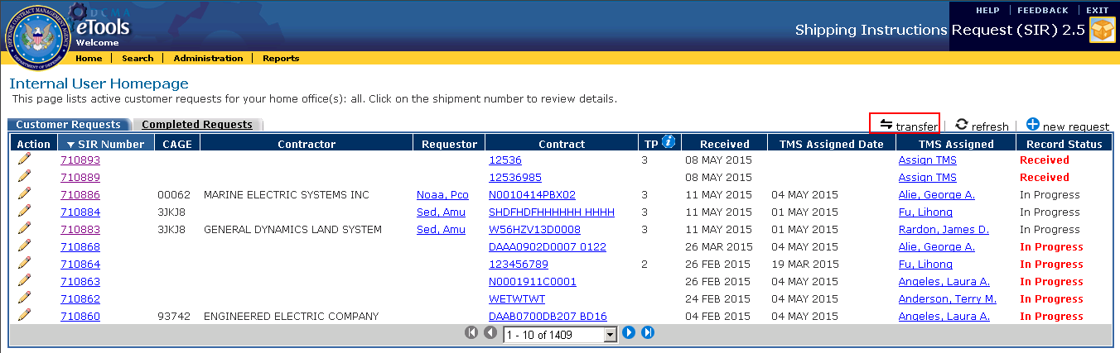
Figure 7-39. Internal User Homepage – Transfer Icon
- The ‘Transfer To’ window displays. Users can select a request from the list of options, enter a CMO, or search for a particular CMO.
- Select CMO from list – Select, by clicking the boxes, the individual Requests you desire to transfer. Note: If the request is closed, an X will appear in lieu of the checkbox next to the request.
- Enter CMO - In the ‘Transfer To’ field, enter the CMO to transfer the request(s) to.
- Search for CMO – Click on the Search icon to the right of the ‘Transfer To’ field. Select the desired office.
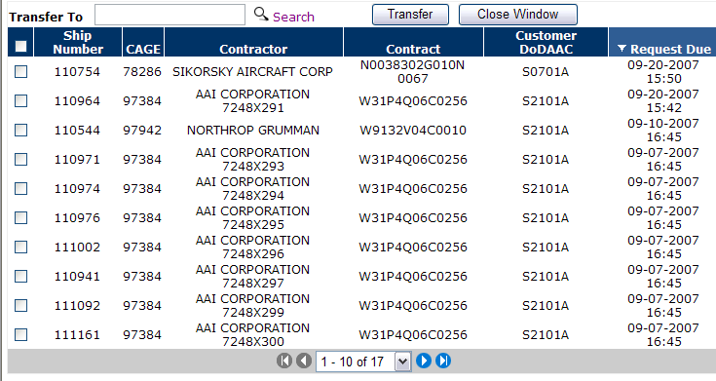
Figure 7-40. Transfer To Window
- Click the ‘Transfer’ button. Users are directed back to the Internal User Homepage. The transferred request(s) will no longer be listed.

Assign Request to TMS
Only Internal users except for TMS will be able to assign customer requests to a specific TMS. Refer to Section 4 on for details on which users can perform this function.
To assign requests to the TMS:
- From the ‘Internal User Homepage’, locate a request that has an ‘Assign TMS’ hyperlink from the ‘TMS Assigned’ column.
Note: Only Requests with a ‘Received’ status will need to have a TMS assigned. Requests that have been marked as ‘In Progress’ has already been assigned to a TMS. However, clicking on the name hyperlink allows users to edit the TMS assignments.
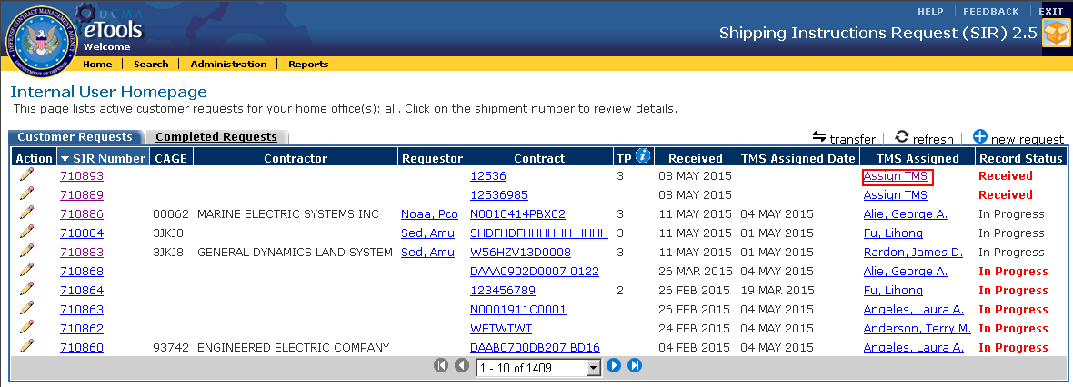
Figure 7-41. Internal User Homepage – Assign TMS Link
- The ‘TMS Assignment’ window appears. Click on the ‘TMS Assigned’ drop-down and select a user to assign the request to. Click on the ‘Save’ button.
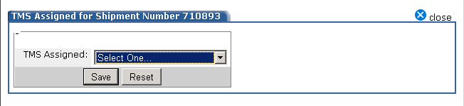
Figure 7-42. TMS Assignment Window
- The TMS assignment is saved and users are directed back to the ‘Internal User Homepage’. The TMS name appears on the ‘TMS Assigned’ column. An E-Mail notification is sent to the Contractor and Assigned TMS notifying them of the assignment.
- Click on the ‘TMS name’ hyperlink to edit the TMS assignments.
Note: If a request is complete, the TMS users name will appear without the hyperlink.

Administration
Only Administrators will be able to access the ‘Administration’ section of the application to perform application related administration tasks.
To acces this section, click on the ‘Administration’ link from the application toolbar. This screen allows users to manage or view application related information by clicking on the associated links.
Users can add and edit information listed within the ‘Manage’ section. Information listed within the ‘View’ section is read-only.
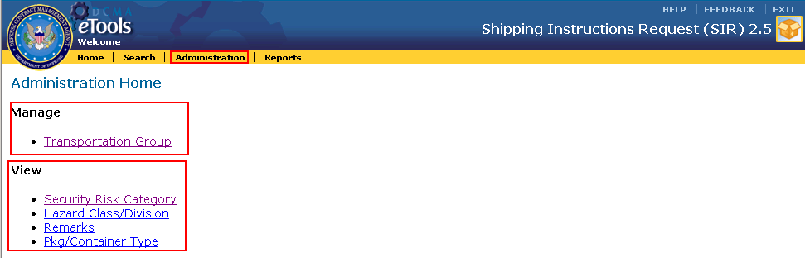
Figure 7-43. Administration Home

Transportation Group
To access the ‘Transportation Group’ section click on the ‘Transportation Group’ link.

There are four available tabs:
- Manage Member – Lists all transporation members. Users can map members to specific teams and locations.
Note: Administrators will not be listed here and instead listed on the Administrators/Notes tab.
- Team Summary View - Lists a summary of Transportation Teams and associated Region.
- Edit Region-Team – Allows users to manage Regions and Teams.
- Administrators/Notes - Lists all Administrators and allow users to enter notes in this section.

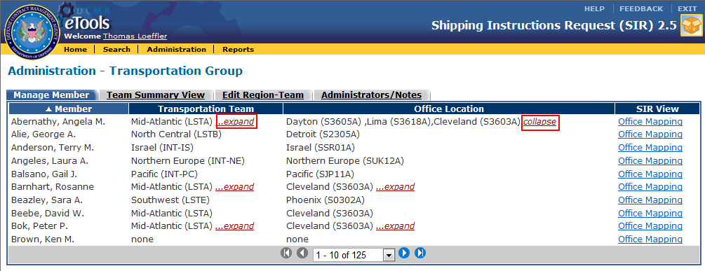
Figure 7-44. Administration – Transportation Group (Manage Member Tab)
Click on the ‘Expand’ link to view more details on the user’s mapping or the ‘Collapse’ link to close the details from the ‘Transportation Team’ and ‘Office Location’ columns.

Manage Member
To manage members:
- Click on the ‘Manage Members’ tab.
- Click on the ‘Office Mapping’ link from the ‘SIR View’ Column.
- The ‘Office Mapping’ window appears for the specific user.The box on the left allows users to added a new Team and Location. The box on the right lists existing Teams and Locations assigned to the user.
- To add a new team and location, select the ‘Transportation Team’ and ‘Office Location’ from the drop-down lists.
- Click on the ‘Submit’ button. The added team and location appears in the box on the right.
- To delete an existing team and location, click on the ‘Delete’ icon.
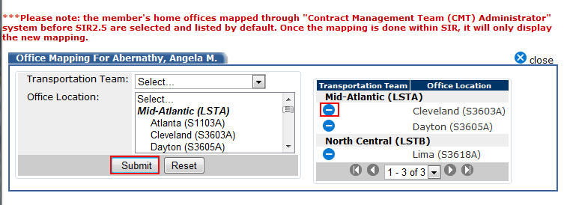
Figure 7-45. Transportation Group – Office Mapping Window

Team Summary View
This tab displays teams members grouped within their assigned teams. Unassigned TMS users also appear on this screen.
To view the Team Summary:
- Click on the ‘Team Summary View’ tab.
- To view assigned teams members, click on any of the Team/Regions. A list of names display directly below it.
- To view unassigned TMS, click on the ‘Unassigned TMS’ link.

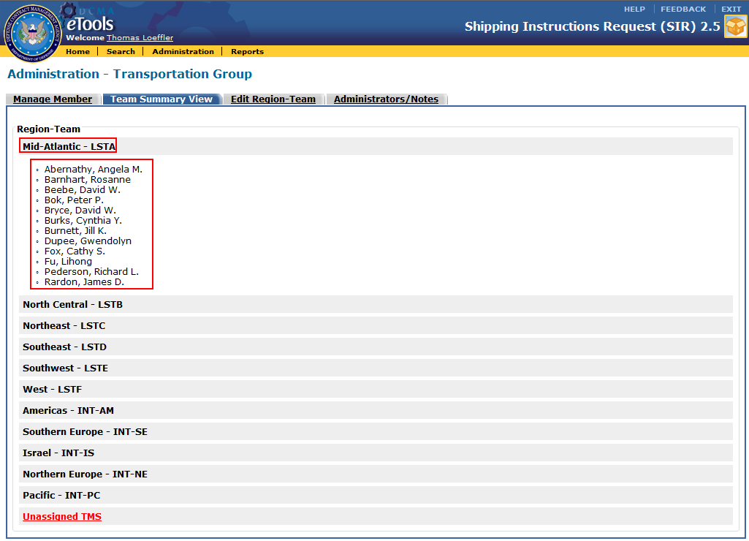
Figure 7-46. Administration – Transportation Group (Team Summary Tab)

Edit Region-Team
This tab allows users to add or delete Locations to the Regions.

To add a Location to the Region-Team:
- Click on the ‘Edit Region-Team’ tab.
- Select the Location from the ‘Location’ list.
- Click on the ‘Add’ button next to the ‘Region-Team’ box.
- The selected location will now be added to the specified ‘Region-Team’ sections.

To delete a Location from the Region-Team:
- Select the option from the ‘Region-Team’ box.
- Click on the ‘Remove’ button.
- The Location will now be removed from the ‘Region-Team’ section.
Note: To select multiple options, use the Shift or Ctrl keys on your keyboard and click the options or double click the options to be added.
Note: If a Location has not been assigned to any of the Region-Team sections on the right, it will appear in the ‘Location’ list under an ‘Unassigned’ header.
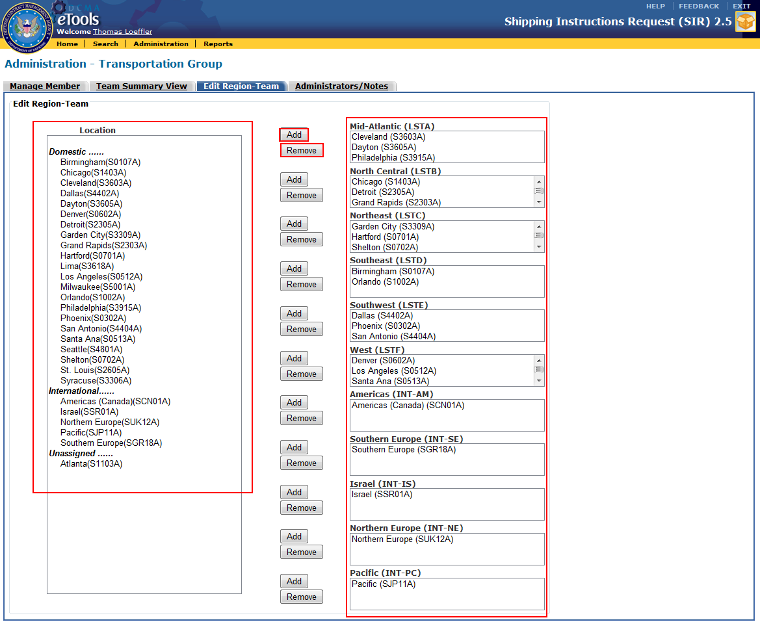
Figure 7-47. Administration – Transportation Group (Edit Region-Team Tab)

Administrators/Notes
The Administrators tab displays a list of Administrator names. Users can also enter any notes in the ‘Notes’ field. Previous notes submitted by other Administrators will also be displayed. The name and date the note was submitted will appear and sorted based on the most recent submission.
To add and view a note:
- Click on the ‘Administrators/Notes’ tab.
- Enter the text in the ‘Notes’ field.
- Click on the ‘Submit’ button.
- To view a log of notes entered, click on the ‘Administrator/Notes Log’ icon.
- A list of notes submitted appears in the ‘Administrator/Notes Log’ Window.

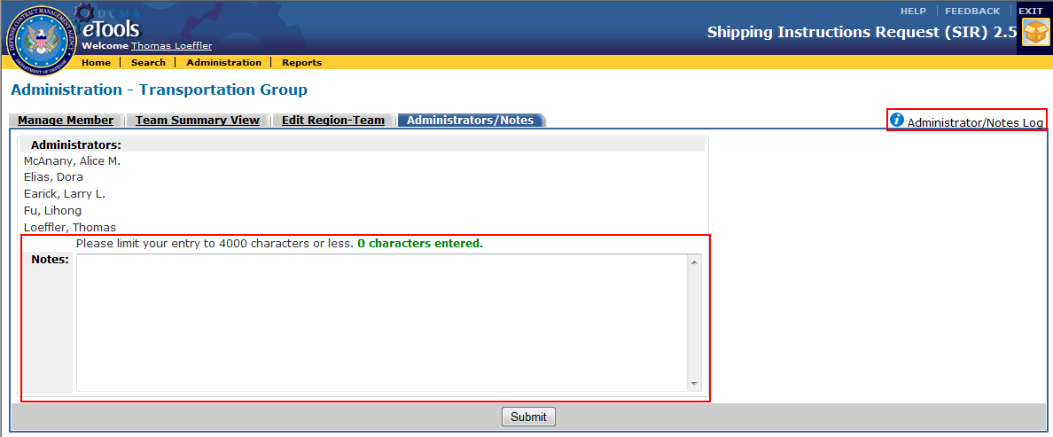
Figure 7-48. Administration – Transportation Group (Administrators/Notes Tab)

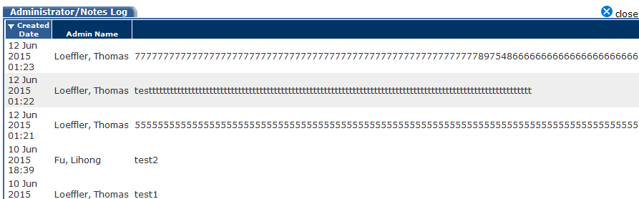
Figure 7-49. Administrator/Notes Log Window

Security Risk Category

To access the ‘Security Group Risk Category’ section click on the ‘Security Group Risk Category’ link.
A list of ll security categories appear.

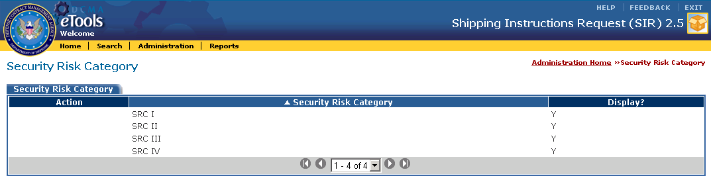
Figure 7-50. Administration – Security Risk Category

Hazard Class/Division

To access the ‘Hazard Class/Division’ section click on the ‘Hazard Class/Division’ link.
A list of Hazard/Class Divisions appear.
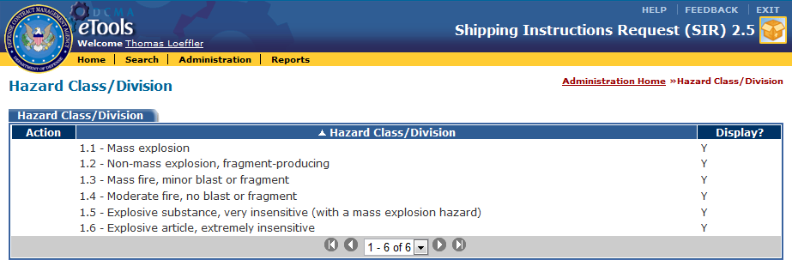

Figure 7-51. Administration – Hazard Class/Division

Remarks

To access the ‘Remarks’ section click on the ‘Remarks’ link.
A list of all remarks appear.

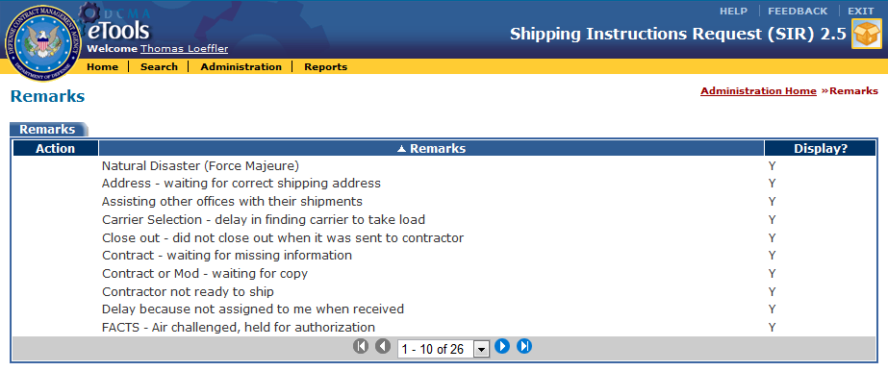
Figure 7-52. Administration – Remarks

Package/Container Type

To access the ‘Package/Container Type’ section click on the ‘Pkg/Container Type’ link.
A list of Package/Container Types appear.

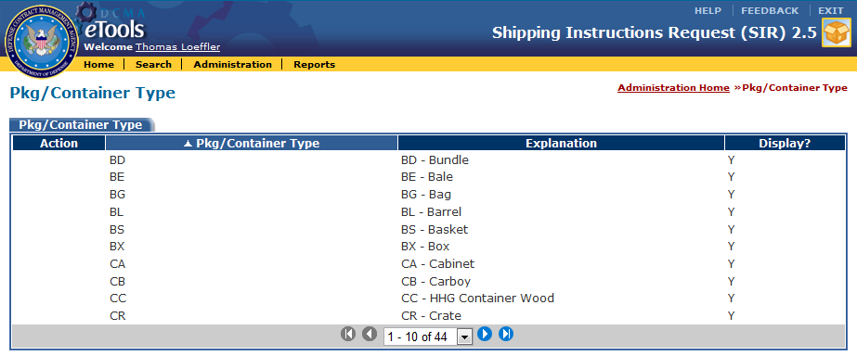
Figure 7-53. Administration – Pkg/Container Type

E-Mail Notifications
Several E-Mail notifications have been set up within the application:
- Contractors will receive a notification when a TMS has been assigned to the submitted request.
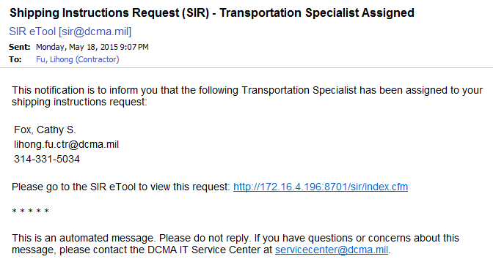
Figure 7-54. E-Mail Notification to Contractor - Request Assigned to TMS

- TMS users will receive a notification when a request has been assigned to them. This also includes reassignment of a request that they have been initially assigned.

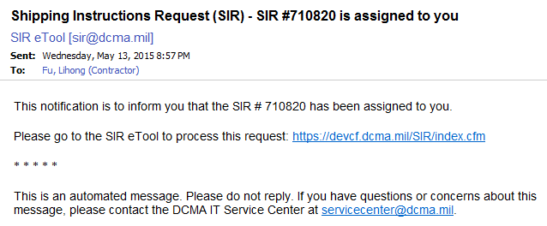
Figure 7-55. E-Mail Notification to TMS - Request Assigned

- When TO, TMS, Admin, and TC users click on the ‘Upload Attachment to Contractor and Finish Request’ button (See Section 7.9), a notification E-Mail will be sent to the Contractor. Any attachments are listed and users are directed to the Attachment tab for the request to view it.
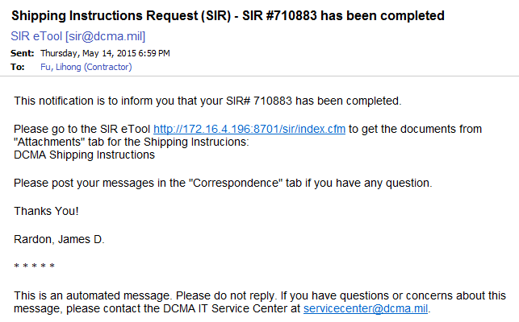
Figure 7-56. E-Mail Notification to Contractor - Request Completed

Reports
DCMA Transportation Officers can access reports for the SIR application. Click on the Reports link from the application toolbar to bring up the reports interface.
Note: You will need to ensure that pop-up blockers are disabled from your browser in order to allow the new window to launch.
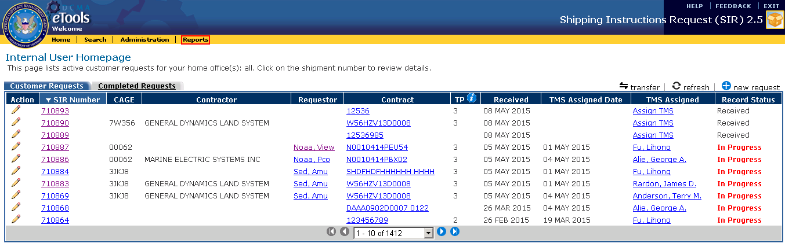
Figure 8-1. Reports Link

Glossary
Acronyms and abbreviations used in the SIR application are listed below.
CAGE | Commercial and Government Entity Code
CMO | Contract Management Office
CONUS | Continental United States
DCMA | Defense Contract Management Agency
DLA | Defense Logistics Agency
DoDAAC | Department of Defense Activity Address Code
EWAM | External Web Access Management
IDB | Integrated Database
MAPAC | Military Assistance Program Address Code
MSL | Military Shipment Label
NOA | Notice of Availability
PDF | Portable Document Format
SIR | Shipping Instructions Request
SPE | Small Package Express
TC | Team Chief
TMS | Transportation Management Specialist
TO | Transportation Officer

