DCMA Web Applications Common Elements

Overview
The Defense Contract Management Agency (DCMA) Web Applications provide a set of tools for the input, management, retrieval, modification and storage of data in accordance with established DCMA policies, procedures and goals. While the web applications service a wide variety of metrics, they share certain characteristics that make them look and feel the same. They were designed to promote consistency and ease of use. The purpose of this chapter is to introduce you to the features that you will see and use repeatedly.

Using the Internet and Tips for Optimal Viewing
While running a DCMA application you will be connected to the system via the Internet. This allows connection to the IDB database.

System Busy
Occasionally while you are running an application and you submit a request such as Save or Browse, you may see that your cursor has turned to an hourglass (system busy). This is telling you that the system is busy processing the information. Wait until the regular cursor (system ready) appears before you continue using the application.

 | The cursor turns to an hourglass, or its equivalent, to signal that the system is busy.

Status Bar
Both Netscape and Microsoft Internet Explorer have a Status Bar that is displayed along the bottom of the screen. In Netscape, the status bar contains a bar that flows back and forth indicating that information is being processed. Within the status bar there is also a message displayed indicating the status of the request, for example, “Connect: Host (URL) contacted. Waiting for reply…” or “Document: Done.” The status bar in Internet Explorer contains a bar that flows only from left to right in increments as information is processed. It also contains a message indicating the status of the request, for example, “Opening page (URL)…” or “Done.”

Specific Internet Browser Conditions
Caution: To prevent loss of data, please read the appropriate information below regarding your particular browser.

Netscape
- Use Netscape version 4.76 (or higher).
- Netscape does not differentiate between active/enabled (selectable) and inactive/disabled (unselectable) fields. Some fields may appear to be active when they are not.
- It is very important to save your work before resizing your screen.
- Do not resize your screen while an application is running.
- To disable Netscape cache:
- Open Netscape. (Refer to Figure 1-1 for Steps 2 – 5.)
- Select Edit from the browser menu bar.
- Select Preferences.
- Expand Advanced.
- Click on Cache.
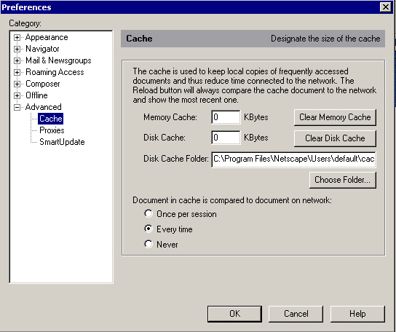
Figure 1-1 Netscape Cache Settings
- Change Memory Cache and Disk Cache to 0 (zero) KBytes.
- Under “Document in cache is compared to document on network:” select Every time.
- Click OK.
- For currect proxy setting, you may need to change your default setting. To check/change this setting:
  - Open Netscape. (Refer to Figure 1-2 for Steps 2 – 8.)
  - Select Edit from the browser menu bar.
  - Select Preferences.
  - Expand Advanced.
  - Click on Proxies.
  - Choose Automatic proxy configuration.
  - Please contact your system administrator for the correct URL to enter in the Configuration location (URL): text box. The following table contains selected examples of proxy location URLs.
Proxy location | URL
East | http://proxy.hq.dcmde.dcma.mil:8080
West | http://proxy.hq.dcmdw.dcma.mil:8080
HQ | http://proxy.hq.dcma.mil:8080

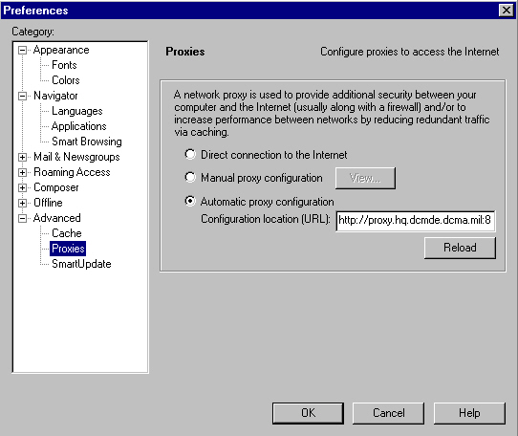
Figure 1-2 Netscape Proxies Window
  - Click OK.

Microsoft Internet Explorer
- Use DCMA standard load of Internet Explorer, currently SP1 version 5.5 (or higher).
- Use caution when using the Backspace key. If the cursor is in a field, it will delete the previous character; however, if the cursor is not in a field, the Backspace key will take you back to the previous screen and any data entered will not have been saved.
- To disable Internet Explorer cache:
- Open Internet Explorer.
- Select Tools from the browser menu bar. Select Internet Options from the drop-down menu.
- If the General window is not open, select the General tab.
- Click the Settings button to open the Settings window.
- From the Settings window, click the “Every visit to the page” radio button. Use the arrows or slider to reduce the cache size to 1 MB. You cannot disable the cache completely.
- Click OK to return to the Internet Options window.
- Click the Delete Files button to delete files present in the cache. Click OK to confirm the deletion.
- Click OK to close the Internet Options window.
- For currect proxy setting, you may need to change your default setting. To check/change this setting:
- Open Internet Explorer. (Refer to Figure 1-3 for Steps 2 – 9.)
- Select Tools from the browser menu bar. Select Internet Options from the drop-down menu.
- Select the Connections tab.
- Select the LAN Settings… button.
- Make sure that the box next to Use automatic configuration script is checked.
- Please contact your system administrator for the correct address to enter in the Address text box. The following table contains selected examples of proxy location addresses.
Proxy location | Address
East | http://proxy.hq.dcmde.dcma.mil:8080
West | http://proxy.hq.dcmdw.dcma.mil:8080
HQ | http://proxy.hq.dcma.mil:8080
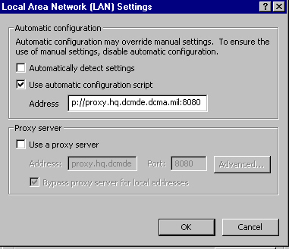
Figure 1-3 Internet Explorer Proxy Window
- Make sure the box next to Use a proxy server is not checked.
- Click OK.
- Click OK again.

Display
The applications are best viewed on a 15” (or larger) monitor.
It is recommended that your display resolution setting is 800 x 600. If necessary, follow the steps below to change the display resolution setting.

Changing the Display Resolution Setting
To change the display resolution on your computer:
1. Click Start on your desktop.
2. Select Settings.
3. Select Control Panel.
4. Select Display.
5. Select the Settings Tab.
From this window you will be able to view or change your resolution settings. You may need to restart your computer for the settings to be recognized.

Printing Web Pages
Although you can access the Print function from the web browser menu bar, you may not get the results you want. Web pages are built in frames, meaning that the page is broken up in different sections or “frames.” If you choose File, Print, you will print the “frame” that your cursor is in. You most likely will not get the entire page. One option that is available for you is to print a screen shot.
One option for capturing a screen shot is as follows:
Click Alt-Prnt Scrn to copy the active window to the clipboard. Open a new document in your word processing application. Paste the image of the window from the clipboard to the document. You can then print the document with the window image on it.

Login
When the Login Screen (Figure 1-4) appears on your monitor, the cursor (blinking vertical line) is in the Username box, ready for you to type in your Username. Go ahead and type in your Username.
Note: Your Username is your 7-position Login ID, often your Employee Identification Number (EIN). This is your standard DCMA Username. Your Login and Password are case sensitive.
After you type in your Username, move the cursor to the Password box. You can move the cursor to the Password box by pressing and releasing the Tab key or by using your mouse to position the cursor arrow in the Password box and then press and release the left mouse button one time. Each of these methods places the cursor where it needs to be for you to type in your Password.
Type in your existing Password. You will notice that regardless of what letter you type, an asterisk mask shows up in the Password box. This prevents others from seeing your Password. Next, press Tab. (The system will let you know if you typed it correctly when you complete the login process.) To complete the login process, click on the Login button. The system will display to the DCMA Application Access Screen (Figure 1-4).
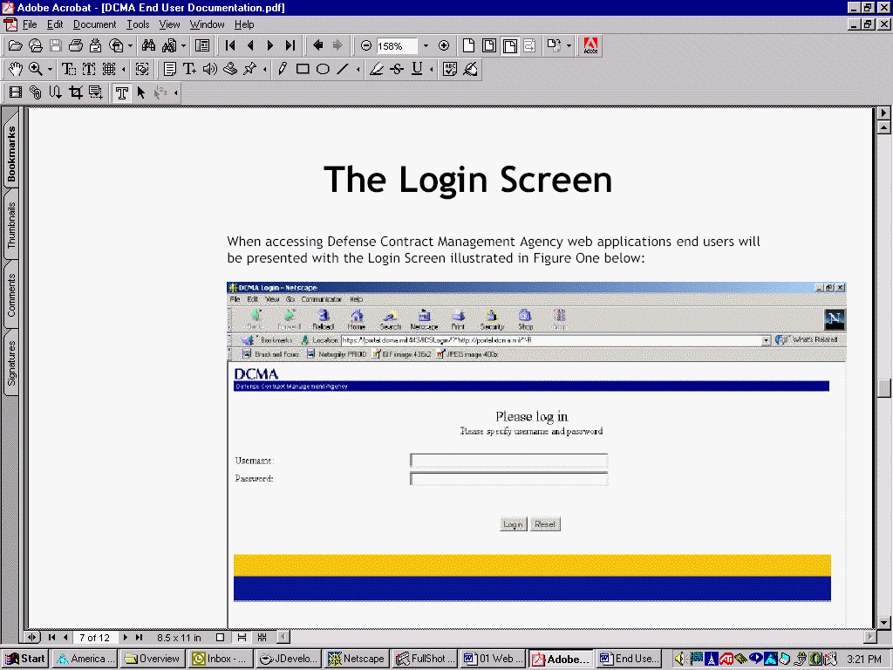
Figure 1-4 Log In Screen
The applications that are available to you (according to login information) will be displayed on the Access Screen (Figure 1-5) as links. Click on the link associated with your application. The Home screen for that application will be displayed.
Note: The DCMA Application Access Screen will be updated to include applications as they are deployed.
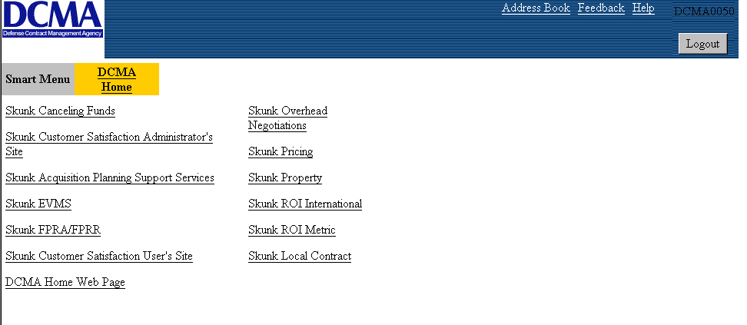
Figure 1-5 DCMA Application Access Screen
If your login attempt was unsuccessful (you may have typed in your Password incorrectly), an error message pops up on your monitor. Retry the login procedure by clicking the OK button and entering your information again.

Integrated Database Connectivity
Once login is successful, the system checks for connectivity to the Integrated Database (IDB). The system connects to the IDB to collect information for certain applications. If the system cannot connect to the IDB database, an error message will pop up on your monitor (Figure 1-6). Click OK and try again later. If this happens again, contact your system administrator.
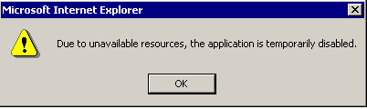
Figure 1-6 Disabled Application Dialog Box
Note: If the system is unable to connect to the IDB during the login procedure additional functions may be “grayed out” (unselectable).

Introduction to the DCMA Web Applications Home Screen
Provided you have the necessary access privileges, you can use the web applications Home screen (Figure 1-7) to get to whatever functions you need. To gain access to the Home screen, you must have successfully logged onto the application (as explained in Section 1.3).
Note: If you do not have the necessary access privileges to open a function, it is “grayed out,” and nothing happens if you click on it.
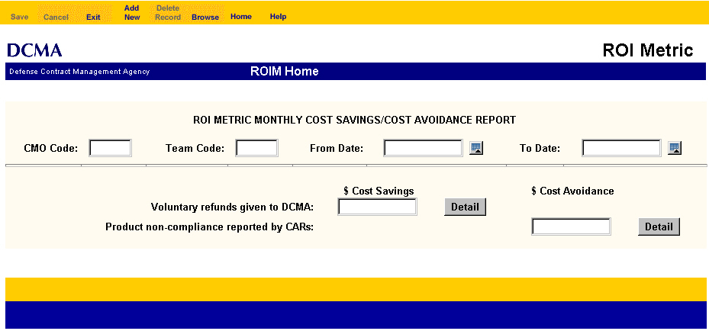
Title
Footer
DCMA Title
Application
Work
Area
Title
Header
Figure 1-7 Home Screen Example

Common Screen Elements
DCMA web applications are designed so that certain elements remain constant throughout the entire system. These elements include, but are not limited to the colors of the screens and where information is located on the screens.

Menu Bar
The Menu Bar is located at the top of your screen. It is a gold bar with blue letters. The menu bar contains the command buttons used to add new records, edit records, navigate screen-by-screen through your application, perform maintenance functions and obtain Help.

Title Header
The Title Header is located below the Menu Bar. It is a white bar with blue letters over a blue bar with white letters. The white bar contains the DCMA acronym and the application name. The blue bar contains the agency title and the screen name.

Application Work Area
The application work area is located in the center of the screen below the Title Header and above the Footer. It has a gray background. It is the area of the screen where application activity is performed such as data entry or links to other areas of the application.

Footer
DCMA application screens contain a footer along the bottom of the screen. It is a gold bar over a blue bar. The footer may contain information relative to a particular screen. It is an indication that you are at the bottom of that particular screen.

Local Use Contract Maintenance
The Local Use Contract Maintenance Screen is available only to Super Users and Admin Users. This screen allows for updating the list of Contract Numbers not in Shared Data Warehouse (SDW)/ System for Integrated Contract Management (SICM) but used locally. Specifically, authorized users can use this module to change existing information, add new Contract Numbers for local use and delete local use Contract Numbers that are not needed. Please coordinate with the Super User or Admin User to have Contract Numbers added.

The DCMA Menu Bar
Figure 1-8 The DCMA Web Application Menu Bar
All the applications have the same visual look including the menu bar (Figure 1-8), the same process to access application functions and the same functions to perform specific activities. The basic function of each command on the menu bar is explained in detail below. The Menu Bar Command Functions table shows a brief description of each command. Commands that have application specific functions are described within the application’s chapter of the User Manual. After you open an application function, you can return to the home screen by clicking Home on the tool bar. You may quit the application at any time by clicking Exit from the application’s home screen.
Note: Only those options that are required for your specific application are included on the menu bar. Depending on the screen displayed on your monitor, some options may be “grayed out.” This means that you cannot select these items; that is, if you click on them, nothing happens.
Table 1 Menu Bar Command Functions
Command | Function
Save | Allows the user to save the data entered.
Cancel | Clears the current screen without saving and allows the user to input new data.
Exit | Allows the user to Exit the application
Add New | Opens a New Record Screen. Allows the user to enter a new record into the database.
Delete Record | Allows the user to delete an entire record from the database.
Browse | Opens a Search Screen. Enables the user to search for and view a specific record or groups of records with common search criteria.
First Record | Highlights the first record.
Previous Record | Highlights the previous record.
Previous Page | Highlights the first record of the previous page.
Next Page | Highlights the first record of the next page.
Next Record | Highlights the next record.
Last Record | Highlights the last record.
Edit Record | Opens an Edit Record Screen. Allows the user to modify, delete or add information to an existing record.
Copy Record | Allows the user to copy a record with common data and modify that record to reflect new record information. Note: The purpose of this feature is to save your work by allowing you to reuse some of the data from an existing record.
Home | Opens the Home Screen of the application, allowing the user to return to the Home Screen of their application.
Help | Opens the Application’s on-line Help feature.

Dialog Boxes
Dialog boxes appear on the screen to assist you as you work in a web application. These boxes require you to take an action. For example, after selecting Save or Delete Record a dialog box will appear to confirm that you want to complete the action that was selected. You have the option of selecting OK and your action will be processed as requested or Cancel and your screen will appear as it was. The Save and Delete Record dialog boxes are explained in detail below.

SAVE Command
The Save command is used to save a newly created record or changes made to an existing record.
Select Save after adding a new record or making changes to an existing record. A dialog box will appear (Figure 1-9) asking you to confirm that you want to save the changes. Click OK and the system will save the new record or changes. A dialog box will appear to confirm that the record has been saved. Click OK and you will then be redirected to an Edit Record screen or the existing Edit Record screen will be displayed with any changes saved.
or
Click Cancel and your New Record or Edit Record screen will be displayed as it was and your changes will not be saved.
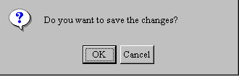
Figure 1-9 Save Changes Confirmation Dialog Box

Delete Record Command
The Delete Record command is used to remove a record from the database permanently.
After a record has been displayed, select Delete Record and a dialog box will appear (Figure 1-10) asking you to confirm that you want to delete the record. Click OK to delete the record. A dialog box will appear to confirm that the record has been deleted. Click OK and the record will be deleted.
or
Click Cancel to redisplay the previous screen.
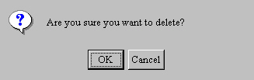
Figure 1-10 Delete Confirmation Dialog Box

Navigation Overview
You need to be able to move through DCMA web applications on several different levels. First, you may need to access more than one function. Second, once you have opened an application, it is likely more than one screen will be needed to complete the task. Finally, you need to be able to move from one data field to another as you enter and edit information.
Note: Some functions were developed for supervisory use only.

Navigating Between Screens
Whenever you open an application, you must open an existing record or add a new one. Then you are ready to view, edit, insert or delete information. If the function you are using has more than one screen, you will have to advance to the next screen for that function. You may even want to go back to a previous screen.
Figure 1-11 Navigation Buttons | To move from one screen to another use the Navigation Buttons on the Menu Bar (Figure 1-11). Click on the Next Page button to go to the next screen or click on the Previous Page button to go back to the previous screen.

Navigating Between Data Fields
If you are entering a new record, you can, and in some cases must, enter the information in a specified order. This order, called a tab order, was established when the application was developed. A tab order means that when the cursor is in one data field and you press the Tab key, the cursor moves to the next data field in the tab order list. The tab order is based on a “logical” order for entering the information. One way to move from one data field to another is to keep pressing the Tab key until the cursor is in the data field you want. If you need to go backwards, press the Shift and the Tab key at the same time.

A second way of moving the cursor is to use your mouse to position the pointer in the data field you want, and then click the left mouse button. Although you may use the tabbing method most often, you will find times when it is quicker to use the mouse.

Selecting from a Drop-down List
A Drop-down list, (also referred to as a pick list) (Figure 1-12) displays values to fill a data field.
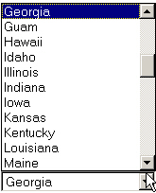
Scroll Bar
Data Field
Drop Down List
Figure 1-12 Sample of a Drop-Down List
There are several ways to choose a value from a drop-down list:
- Use the up and down (previous/next) arrows on the scroll bar or the arrow keys on your keyboard to find the choice you want.
- Type in the first letter of the one you want until it appears in the data field.
- Use the Up and Down arrows on your keyboard to move up or down the list to find the value you want.

Returning the Data Field to Blank
Once you have filled the data field of a drop-down box, it may be necessary to remove the data entered and leave the field empty. To do this, the drop-down list will have a blank space, usually located at the top or bottom of the list, that will appear highlighted when you cursor is placed on it. Click on this blank space. The data field will appear blank.
Note: Not all drop-down boxes have a blank space as an option.

Special Data Fields

Automatically Populated Data
Some data fields may be automatically populated. This means that the application “tells” your computer to put specific information in certain data fields. The information may be:
- Information associated with your Username entered during the login procedure.
- Information associated with information you entered in another data field.
- The system (or current) date or time.
- A number generated by your computer as being the next sequential number.
- A value calculated by your computer.
Most automatically populated boxes are protected; i.e., you cannot change (or even select) the information displayed in them. However, some can be edited as you would information in any other data field.

Required Data
Some data fields may be mandatory; i.e., you must enter the requested information before you can save and exit. These are said to be required data fields. In certain cases, you cannot even move on to another data field until you enter the requested information. If you move off a required data field or try to exit without first entering the required information, a dialog box will pop up on your screen. Click OK. Then add the missing information or exit the screen without saving.

Optional Data
Data fields that are not mandatory are optional. You can enter information for the optional fields or not, depending on what information you have available to enter.

Conditionally Required Data
Some data fields are conditionally required. This means that in one situation they may be required, while in another they may not. For example, a choice you make between Yes and No for one data field may determine whether or not another data field is required or optional.
Also, for some application functions there is a difference between what fields are required prior to closing a record and what fields are required to close the record. Thus, when you signal the computer that you are ready to close a record, the application checks to see that you have entered all information required to close the record before it allows you to close and save.
Note: Some conditionally required data fields may be “grayed out” (unselectable).

Protected/Unselectable Data
Some data fields are protected. In some cases this means that the application will not allow you to edit or select the information that appears in them. In other cases this means that only certain users can enter or edit information. In some instances, depending on what information you enter, the application “decides” what data fields or screens you can access; i.e., what you enter one place determines what information you can enter elsewhere. Data fields that appear on your screen, but do not allow you to enter data, are “grayed out.” You cannot place the cursor in or make a selection from such fields.

Validated Data
Sometimes when you enter information in one data field, the application “tells” your computer to enter associated information in other data fields. Where such a relationship exists between what you enter and what appears, the information you enter must match a record already stored in the database. If it does not, you will see a message similar to the one shown in (Figure 1-13) appear on your monitor. Take note of the message, and then click OK. The message window disappears, and you can recheck or reenter the information.
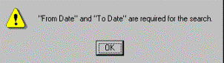
Figure 1-13 Validation Message Dialog Box

Entering and Editing Data

Entering Data
In order to enter data onto the application screens, you must first go to the appropriate function, and then select Add New or Browse (to get to the Edit Record screen).
You are now ready to type in/edit your information. Unless otherwise instructed in a specific application, use the following guidelines:

Entering Quantities
- Enter a whole number (no fractions or decimals).

Entering Amounts
- Enter whole dollar amounts (no cents).

Entering Commercial (Non-DSN) Telephone Numbers
For commercial (non DSN) telephone numbers, you can enter either of the following:
- Ten (10) numbers that will be automatically formatted as xxx-xxx-xxxx.
- Eleven—twenty-six (11-26) numbers that will be displayed as they appear when you type them (no automatic formatting).

Entering DSN Telephone Numbers
For entering DSN telephone numbers, you can enter the following:
- Seven (7) numbers that will be automatically formatted as xxx-xxxx.
- Ten (10) numbers that will be automatically formatted as xxx-xxx-xxxx.
- Eleven—fifteen (11-15) numbers that will be displayed as they appear when you type them (no automatic formatting).

Editing Data Fields
The Editing Data Fields table describes how to edit text in different types of data fields.
Table 2 Editing Data Fields
Type | Procedure
Scrolling Text Box | Position the cursor where you want to edit. Then make your changes as you would with a word processor such as Microsoft Word. Tab out of the text box.
Non-scrolling Text Box | Select the box you want to edit. The information is highlighted. If you start to type over highlighted text, the highlighted information is automatically deleted and replaced with what you type. If you do not want to delete all of the highlighted text, click on the highlighted text to remove the highlight and position the cursor in the box, and edit the information as needed.
Option Buttons, also referred to as Radio Buttons | One option button will be selected (filled in) by default. Clicking in another button will select (fill in) that option and deselect the previous option.
Check Boxes | To place a check mark in a box, simply click on it. To "uncheck" a checked box, click on it. The check mark disappears.
Note: You cannot edit information if the information is in a protected data field. You cannot leave a required data field blank if you want to save the record.

The Automated Calendar

Overview
The automated calendar feature provides the User a simple way for entering dates into the various date fields. Click once on the calendar button, which is located to the right of the date field (Figure 1-14).
Note: You cannot Tab to the date field. You must click on the calendar button to enter a date.
Calendar Button
Date Field
Figure 1-14 Date Field & Calendar Button
If the calendar is opened on a blank field, it will default to the current year and month with the current day’s date highlighted in red (Figure 1-15). If the field had been previously populated, the calendar will display the date currently in the field.
Note: If the calendar disappears from your screen, click on the Calendar Button. The calendar will re-appear on your screen.
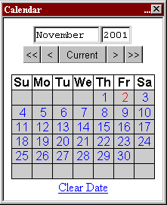
Figure 1-15 Calendar with Current Date Selected
Note: The month and year appear at the top of the calendar.

Moving Month-to-Month and Year to Year

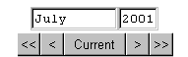  Figure 1-16 Calendar Navigation Arrows | To move the calendar forward or back one month at time, click the single arrow buttons at either end of the Current button (Figure 1-16). When the desired month is presented, click on the desired calendar day. The date will be automatically entered into the date field. Click on the Current button to reset the calendar to the current date.  To move the calendar forward or backward one year at a time, click the double arrow buttons at either end of the single arrow buttons (Figure 1-16). When the desired year is presented, click on the desired calendar day. The date will be automatically entered into the date field.

Clearing a Date
Click on the Clear Date link at the bottom of the calendar to clear the date entered. The date field will be blank until a new date is entered.

Going Back to the Current Date
If you entered a date but wish to return to the current date, click on the Current button then the number representing the current calendar day to display the current date..

Help
DCMA web applications provide you with extensive online Help that is available from any function screen. This Help reflects the contents of this Users Guide and is available through the Help button on the menu bar.

Exiting Your Application
DCMA web applications can be closed from most screens using the Exit menu button. Selecting this command causes an Exit Confirmation Dialog Box to appear (Figure 1-17). This box requests you confirm your interest in exiting the application.

Figure 1-17 Exit Confirmation Dialog Box
Click Cancel if you want to continue running the application.
or
Click OK if you decide you do indeed want to exit. If you did not make changes to any records during your session, clicking OK will close the application. If you made changes to any records during your session, clicking OK will display the Save Changes Dialog Box (Figure 1-9).

