Fix for EWAM compatibility with Internet Explorer Version 9
If you are not able to add your organization to the organization drop down in EWAM, this is most likely because you are running Internet Explorer v.9. To resolve the issue, please follow the following steps:
- When accessing EWAM, select the “compatibility view” icon in the web address bar.
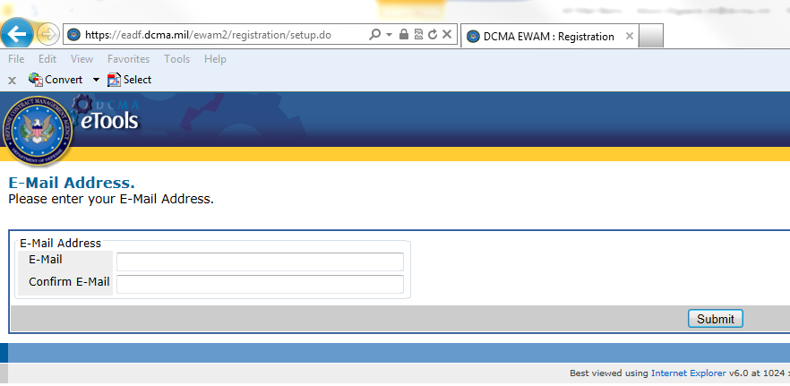

- Once selected the icon will turn blue.
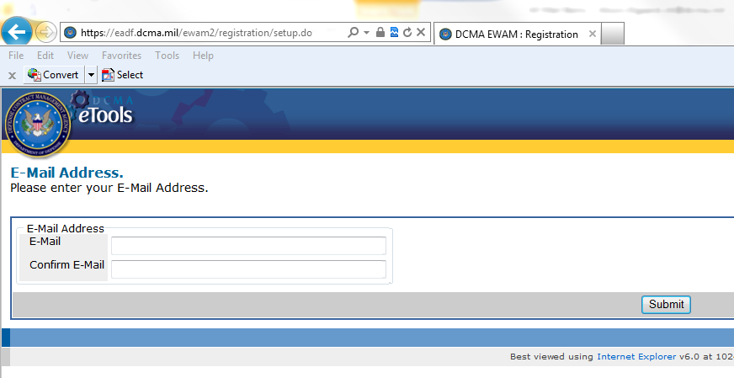
- If necessary, select “other” in the organization drop down and enter your organization name.

