System Requirements for Registration in External Web Access Management (EWAM)
- DoD Root Certificate
- What is the purpose of the DoD Root Certificate?
A certificate is a digital document providing the identity of a website or individual. DoD websites and DCMA uses a certificate to identify itself to its users and to enable a secure connection.
- Certificate Error: Navigation Blocked
If you receive "Certificate Error: Navigation Blocked" in IE while visiting any DCMA secure sites (https), more than likely you do not have the DoD Root CA 2 certificate installed in your IE browser. Installing the DoD Root Certificates will allow your web browser to trust the identity of websites whose secure communications are authenticated by Department of Defense agencies. The DoD Root CA 2 certificate is included with InstallRoot_v3_15A.exe.
- Installing the certificates
  - Go to https://www.dodpke.com/installroot/
  - Download the InstallRoot_v3_15A.zip file and unzip the file
  - Run InstallRoot_v3_15A.exe
  - If you are running InstallRoot_v3_15A.exe on MS Vista or MS Windows 7, you may encounter an additional popup box, Program Compatibility Assistant.
  - The Program Compatibility Assistant box will prompt you to select one of the following choices:
    - Reinstall using recommended settings.
    - This Program Installed Correctly.
  - Select "This Program Installed Correctly" to complete the install.
  - Reboot the machine.
- Checking the installed root certificates
  - Open IE.
  - Click Tools/Internet Options/Content/Certificates.
  - You should see a list of root certificates including DoD Root CA 2 under the Trusted Root Certification Authorities tab.
  - Once verified, close the internet options windows by selecting close and cancel.
  - Your browser is now configured to visit DCMA secure sites.

- Internet Browser
eTools applications including EWAM are best working with Internet Explorer version 7.x and 8.x. Version 9 is supported with Compatibility View turned on. Other Internet Browsers are not currently supported by the DCMA.
There are 2 procedures to enable the Compatibility View in IE 9.
- Procedure 1
  - After opening any web page, click on compatibility icon which is just next to URL as shown below. If the site is displayed in compatible view the icon will turn blue and if the compatible view is not enabled, the icon will remain white.
- Procedure 2
If you don’t want to set “compatibility view” every time for particular websites you can set the compatibility view for a list of particular websites so that every time one opens the website it will automatically switch to compatible mode.

  - Click on Tools and select Compatibility View settings

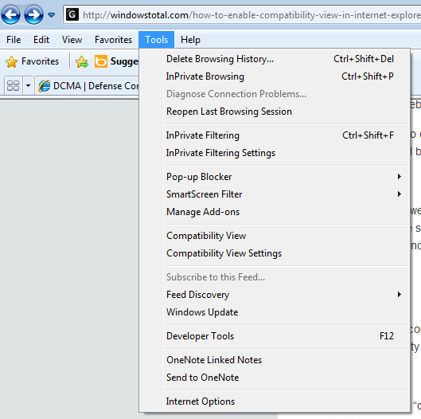

  - After clicking on “Compatibility View settings” option, a new pop up will be popped up where in you will be asked to add the websites in “Add this website field” and click on “Add” so that web pages which are added will be opened in compatibility mode by default.

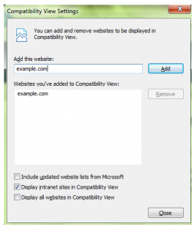

  - If you want to display all websites in Compatible view by default, you can do so by checking the option “Display all websites in compatibility view”.

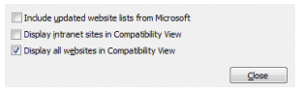
  - Now, after selecting the option “Display all web pages in compatibility view”, click on “close” and you can now view all web pages in the compatible view without needing to make changes every time you surf the net.

