

Modifications and Delivery Orders (MDO)

Version 4.0

Application User's Manual

21 July 2014

Table Of Contents

[1 Introduction 7](#_Toc393705803)

[1.1 About MDO 7](#_Toc393705804)

[1.2 User Roles and Tasks 7](#_Toc393705805)

[1.3 Summary of the MDO Process 8](#_Toc393705806)

[1.4 Navigation Elements 10](#_Toc393705807)

[1.4.1 User Information 10](#_Toc393705808)

[1.4.2 Links 10](#_Toc393705809)

[1.4.3 Tabs 12](#_Toc393705810)

[1.4.4 Icons 13](#_Toc393705811)

[1.4.5 Buttons 14](#_Toc393705812)

[1.5 Printing Documents 14](#_Toc393705813)

[1.6 Reports and Cubes 15](#_Toc393705814)

[1.6.1 Reports 15](#_Toc393705815)

[1.6.2 Cubes 16](#_Toc393705816)

[2 Contract Modifications 19](#_Toc393705817)

[2.1 Generating a Contract Modification 19](#_Toc393705818)

[2.2 Browsing Contract Modifications 22](#_Toc393705819)

[2.3 Managing a Contract Modification 23](#_Toc393705820)

[2.4 Viewing a Payment Rate 25](#_Toc393705821)

[2.5 Editing a Payment Rate 26](#_Toc393705822)

[2.6 Adding Free Text to a Contract Modification 28](#_Toc393705823)

[2.7 Editing a Contract Modification 30](#_Toc393705824)

[3 Delivery Orders 35](#_Toc393705825)

[3.1 Generating a Delivery Order 35](#_Toc393705826)

[3.2 Browsing Delivery Orders 37](#_Toc393705827)

[3.3 Managing a Delivery Order 39](#_Toc393705828)

[3.4 Adding Free Text to a Delivery Order 41](#_Toc393705829)

[3.5 Editing a Delivery Order 43](#_Toc393705830)

[4 EDA-Only Contract Modifications 47](#_Toc393705831)

[4.1 Generating an EDA-Only Contract Modification 47](#_Toc393705832)

[4.2 Browsing EDA-Only Contract Modifications 52](#_Toc393705833)

[4.3 Managing an EDA-Only Contract Modification 53](#_Toc393705834)

[4.4 Adding Free Text to an EDA-Only Contract MOD 55](#_Toc393705835)

[4.5 Editing an EDA-Only Contract Modification 57](#_Toc393705836)

[5 ACRNs 61](#_Toc393705837)

[5.1 Browsing ACRNs 61](#_Toc393705838)

[5.2 Viewing an ACRN 62](#_Toc393705839)

[5.3 Adding an ACRN 63](#_Toc393705840)

[5.3.1 DCMA Policy: LOA and FPDS 69](#_Toc393705841)

[5.3.1.1 The Treasury Account Symbol 69](#_Toc393705842)

[5.3.2 LOA Errors 69](#_Toc393705843)

[5.3.2.1 Four Major LOA Patterns 70](#_Toc393705844)

[5.3.2.2 Review: Parts of the LOA and FPDS 73](#_Toc393705845)

[5.4 Editing an ACRN 74](#_Toc393705846)

[5.5 Deleting an ACRN 76](#_Toc393705847)

[6 Clauses and Provisions 77](#_Toc393705848)

[6.1 Browsing Provisions and Clauses 77](#_Toc393705849)

[6.2 Adding a Provision or Clause 78](#_Toc393705850)

[6.2.1 Adding a Special Provision 78](#_Toc393705851)

[6.2.2 Adding a Clause 79](#_Toc393705852)

[7 Line Items 81](#_Toc393705853)

[7.1 Browsing Line Items 81](#_Toc393705854)

[7.2 Viewing a Line Item 82](#_Toc393705855)

[7.3 Adding a Line Item 84](#_Toc393705856)

[7.4 Editing a Line Item 90](#_Toc393705857)

[7.5 Browsing Schedules 96](#_Toc393705858)

[7.6 Viewing a Schedule 98](#_Toc393705859)

[7.7 Adding a Schedule to a Line Item 98](#_Toc393705860)

[7.8 Editing a Schedule 100](#_Toc393705861)

[8 Attaching a File 103](#_Toc393705862)

[9 Browsing Changes 105](#_Toc393705863)

[10 Canceling a MOD 107](#_Toc393705864)

[11 Submitting a MOD to the ACO 109](#_Toc393705865)

[12 Transferring Mods 111](#_Toc393705866)

[13 Recalling a MOD 113](#_Toc393705867)

[14 Rejecting a MOD 115](#_Toc393705868)

[15 Releasing a MOD 117](#_Toc393705869)

[16 Mass MODs 119](#_Toc393705870)

[16.1 Mass MOD Types 119](#_Toc393705871)

[16.2 Generating a Mass Mod 124](#_Toc393705872)

[16.3 Correcting a Mass Mod 127](#_Toc393705873)

[16.4 Submitting, Rejecting, and Releasing Mass MODs 128](#_Toc393705874)

[16.5 FPDS Mass Mods 131](#_Toc393705875)

[17 FPDS CARs 133](#_Toc393705876)

[17.1 Entering Your FPDS Login Information 133](#_Toc393705877)

[17.2 MDO-FPDS Overview and Process Flow 133](#_Toc393705878)

[17.2.1 DCMA Policy: Brief Overview 133](#_Toc393705879)

[17.2.2 Process Flow 134](#_Toc393705880)

[17.3 Generating an FPDS CAR 135](#_Toc393705881)

[17.4 Identifying FPDS Base Documents 138](#_Toc393705882)

[17.5 Generation Errors 138](#_Toc393705883)

[17.6 MDO-FPDS Equivalencies 139](#_Toc393705884)

[17.6.1 DCMA Policy: Resolving Generation Errors 141](#_Toc393705885)

[17.7 Validating and Approving an FPDS CAR 141](#_Toc393705886)

[17.8 FPDS Mass Mods 142](#_Toc393705887)

[17.8.1 DCMA Policy: Approving an FPDS CAR After MOD Release 143](#_Toc393705888)

[17.9 Validation Errors 144](#_Toc393705889)

[17.9.1 DCMA Policy: Resolving Validation Errors 144](#_Toc393705890)

[17.10 Browsing FPDS CARs 145](#_Toc393705891)

[17.11 Managing an FPDS CAR 147](#_Toc393705892)

[17.12 Additional Resources 149](#_Toc393705893)

[18 Glossary 151](#_Toc393705894)

# Introduction

## About MDO

Modifications and Delivery Orders (MDO) Version 4.0 is a Web-based application for Administrative Contracting Officers (ACOs) and Contract Administrators (CAs) who support the contract modification and delivery order process.

Further information about modifications to contracts and delivery orders is available from the *DCMA Guidebook* at <http://guidebook.dcma.mil/15/dc07-086.htm>.

This user's manual is organized as follows:

* The Table of Contents lists the topics relevant to contract modifications, delivery orders, and EDA-only contract modifications.
* The Index at the end of the document is organized by subject and task, in alphabetical order rather than in process order.
* The word "MOD" is used to mean a contract modification, delivery order, or EDA-only contract modification. If a task can be performed for one or two of the types of mods, or only by one of the two user roles, the description of the task will state the limitation. If no restriction is described, then any user role can perform the task for a contract modification, delivery order, or EDA-only contract modification. This approach helps you understand the tasks that others perform to support your objectives, and how your role interacts with their tasks. See the topic [User Roles and Tasks](#all_o_user_roles_and_tasks_htm) for more information.

For an explanation of the roles and associated tasks, see the topic [User Roles and Tasks.](#all_o_user_roles_and_tasks_htm)

For a summary of the contract and delivery order modification process, see the topic [Summary of the MDO Process](#all_o_summary_htm).

For an explanation of the MDO 4.0 navigation features and icons, see the topic [Navigation Elements](#all_o_navigation_elements_htm).

## User Roles and Tasks

MDO 4.0 supports three user roles:

* Contracting Officer (ACO)
* Contract Administrator (CA). Procurement Technicians who are responsible for issuing modifications and delivery orders are assigned the Contract Administrator role.
* Firm Center User

These user roles are assigned and managed using the Internal Web Access Manager (IWAM). To see the MDO 4.0 icon and link in the eTools portal, your user ID must be assigned a role in MDO 4.0 using IWAM.

Contact your supervisor for assistance if you do not see MDO 4.0 on your eTools portal page, or if you see error messages when you try to view MDO 4.0.

To reduce reading, this user's manual uses the word "MOD" to mean a contract modification, delivery order, or EDA-only contract modification.

The ACO and CA roles can do the following tasks for both contract modifications and delivery orders:

* generate a MOD
* browse mods
* view a MOD
* edit a MOD
* transfer one or more mods to a different person
* cancel a MOD

Only the CA role can do the following:

* submit a MOD to the ACO for review

Only the ACO role can do the following:

* reject a MOD
* release a MOD
* review, validate, approve FPDS CARs

The Firm Center User can do the following:

* assign a MOD release date
* reject a mass MOD

For an explanation of the purpose of MDO 4.0, see the topic [About MDO](#all_o_about_mdo_htm).

For a summary of using MDO 4.0, see the topic [Summary of the MDO Process](#all_o_summary_htm).

For an explanation of the MDO 4.0 navigation features and icons, see the topic [Navigation Elements](#all_o_navigation_elements_htm).

## Summary of the MDO Process

**To create a MOD,** the following process occurs:

1. Search for the contract number and generate a [contract modification](#contract_mods_t_generating_a_con_5288), [delivery order](#delivery_orders_t_generating_a_d_5901), or [EDA-only contract modification](#eda_only_t_generating_an_eda_mod_6259).
2. On the View My Work Page, view the mods that you generated or that were [transferred](#all_t_transferring_mods_htm) or [submitted](#all_t_submitting_mod_to_aco_htm) to you.
3. Edit the MOD to provide additional information before it can be [submitted](#all_t_submitting_mod_to_aco_htm) or [released](#all_t_releasing_a_mod_htm). You can save your work without [submitting](#all_t_submitting_mod_to_aco_htm) or [releasing](#all_t_releasing_a_mod_htm) it. (Optional)
4. [Browse ACRNs](#acrn_t_browsing_acrns_htm); [view](#acrn_t_viewing_an_acrn_htm), [add](#acrn_t_adding_an_acrn_htm), [edit](#acrn_t_updating_an_acrn_htm), or [delete an ACRN](#acrn_t_deleting_an_acrn_htm) (contract modifications and delivery orders only). (Optional)
5. [Browse payment rates](#contract_mods_t_viewing_a_paymen_170) or [edit a payment rate](#contract_mods_t_editing_a_paymen_31) (contract modifications only). (Optional)
6. [Browse special provisions;](#sp_prov_t_browsing_special_provi_9455) [add](#sp_prov_t_adding_special_provisi_7485) or [delete a special provision](#sp_prov_t_browsing_special_provi_2922) (contract modifications and delivery orders only). (Optional)
7. [Browse line items](#line_items_t_browsing_line_items_5523); [view](#line_items_t_viewing_a_line_item_2062), [add](#line_items_t_adding_a_line_item__2572), [edit](#line_items_t_editing_a_line_item_5449), or [delete a line item](#line_items_t_browsing_line_items_2952) (contract modifications and delivery orders only). (Optional)
8. [Browse schedules](#line_items_t_browsing_schedules__4567); [view](#line_items_t_viewing_a_schedule__5676), [add](#line_items_t_adding_a_schedule_t_2094), [edit](#line_items_t_editing_a_schedule__2170), or [delete](#line_items_t_browsing_schedules__4567) a schedule associated with a line item (contract modifications and delivery orders only). (Optional)
9. Add and edit text to appear in the [contract modification](#contract_mods_t_adding_free_text_1650), [delivery order](#delivery_orders_t_adding_free_te_8549), or [EDA-only contract modification](#eda_only_t_adding_free_text_eda__6149).
10. [Attach a file](#all_o_attaching_a_file_htm) to the MOD. (Optional)
11. [Browse changes](#all_t_browsing_changes_htm) to the MOD. (Optional)
12. [View the PDF](#all_o_printing_documents_htm) of the resulting MOD. (Optional)
13. [Submit the MOD](#all_t_submitting_mod_to_aco_htm) to the ACO for review. (CA user role only)
14. [Generate an FPDS CAR](#generating_an_fpds_car_before_re_4968). (ACO user role only)
15. [Validate and Approve an FPDS CAR](#generating_an_fpds_car_before_re_8330). (ACO user role only)
16. [Release the MOD](#all_t_releasing_a_mod_htm). (ACO user role only)

Additional functionality that helps you manage work in MDO 4.0:

1. [Reject the MOD](#all_t_rejecting_a_mod_htm) and return it to a CA. (ACO user role only)
2. [Recall the MOD](#all_t_recalling_a_mod_htm) after it has been [submitted to the ACO](#all_t_submitting_mod_to_aco_htm), [rejected](#all_t_rejecting_a_mod_htm), or [transferred](#all_t_transferring_mods_htm).
3. [Cancel the MOD,](#all_t_cancelling_a_mod_htm) which removes it from everyone's View My Work Page in MDO 4.0.
4. [Transfer one or more mods](#all_t_transferring_mods_htm) from your workload to another individual's workload.

**For information about these processes,** see the following topics:

* [Generating a Contract Modification](#contract_mods_t_generating_a_con_5288)
* [Generating a Delivery Order](#delivery_orders_t_generating_a_d_5901)
* [Browsing Contract Modifications](#contract_mods_t_browsing_contrac_4723)
* [Browsing Delivery Orders](#delivery_orders_t_browsing_deliv_8362)
* [Editing a Contract Modification](#contract_mods_t_editing_a_contra_2108)
* [Editing a Delivery Order](#delivery_orders_t_editing_a_deli_9154)
* [Mass MODs](#mass_mods_mass_mods_htm)
* [Generating a Mass Mod](#mass_mods_generating_a_mass_mod__8265)
* [Correcting a Mass Mod](#mass_mods_correcting_a_mass_mod__869)
* [Submitting, Rejecting, and Releasing Mass MODs](#mass_mods_submitting_rejecting_a_5014)

For an explanation of the purpose of MDO 4.0, see the topic [About MDO](#all_o_about_mdo_htm).

For an explanation of the roles and associated tasks, see the topic [User Roles and Tasks](#all_o_user_roles_and_tasks_htm).

For an explanation of the MDO 4.0 navigation features and icons, see the topic [Navigation Elements](#all_o_navigation_elements_htm).

## Navigation Elements

The navigation elements of MDO 4.0 help you find information and work efficiently.

### User Information

The left side of the top of the page provides a link on your name (Figure 1). If you click this link, your user information will appear in a pop-up window (Figure 2).



Figure 1: User name link and menu bar

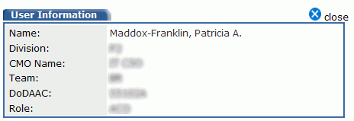

Figure 2: User profile information pop-up window

Click the close close link to close the pop-up window.

### Links

The right side of the top of the page provides the following links (Figure 3):

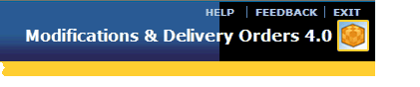

Figure 3: Help, Feedback, and Exit links

Help: Displays the online help topic specific to the page you are currently viewing.

Feedback: Displays an E-Mail window so that you can submit your comments for enhancements to MDO 4.0.

Exit: Closes MDO 4.0 and ends your session.

The menu bar that appears below your name provides links to functionality in MDO 4.0.

Home: Displays the Modifications & Delivery Orders-Home Page which appears by default when you start MDO 4.0 (Figure 4).

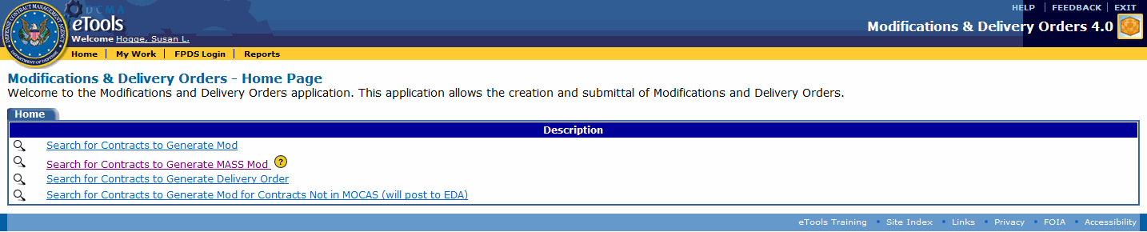

Figure 4: Modifications & Delivery Orders-Home Page

My Work: Displays the View My Work Page, which shows contract modifications, delivery orders, and EDA-only contract modifications that you have generated or that are assigned to you (Figure 5).

The FPDS CARs (Federal Procurement Data System Contract Action Reports) tab appears for the ACO user role and displays Draft and Error FPDS CAR records.

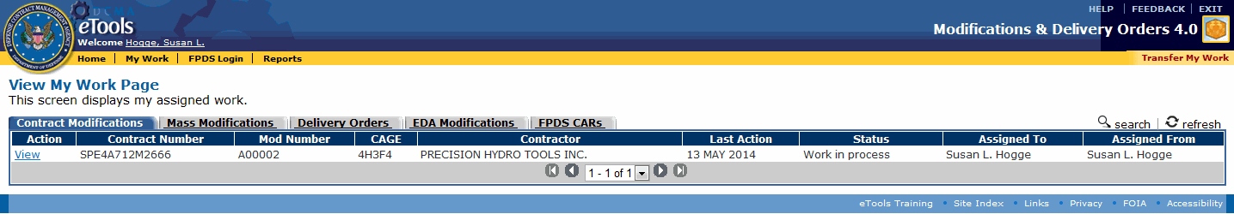

Figure 5: View My Work Page, with Contract Modifications tab selected

See the topic [Browsing Contract Modifications](#contract_mods_t_browsing_contrac_4723), [Browsing Delivery Orders](#delivery_orders_t_browsing_deliv_8362), or [Browsing EDA-Only Contract Modifications](#eda_only_t_browsing_eda_mods_htm) for more information.

FPDS Login: Goes to the FPDS Login page (appears for the ACO user role).

Reports: Displays the Report List for MDO 4.0 which allows you to select reports you wish to view and print. See the topic [Reports and Cubes](#all_t_reports_htm) for more information.

Transfer My Work: Displays the Transfer My Work page. Link appears on the View My Work Page. See [Transferring Mods](#all_t_transferring_mods_htm) for more information.

The footer at the bottom of every page provides links to standard DCMA Web sites (Figure 6).

Page footer

Figure 6: Page footer

eTools Training: Online videos with sound that describe how to use the application.

Site Index: Displays <http://home.dcma.mil/siteindex.htm>, which is an index of the DCMA Web site.

Links: Displays <http://www.dcma.mil/links.htm>, which lists US Government, DoD and DLA links.

Privacy: Displays <http://home.dcma.mil/notice.htm>, which states how the server shall be used.

FOIA: Displays <http://www.dcma.mil/foia.htm>, which states rights to information under the Freedom of Information Act (FOIA) and provides a contact for FOIA inquiries.

Accessibility: Displays <http://home.dcma.mil/508.htm>, which provides contact information for accessibility questions.

### Tabs

Tabs organize your work.

**To view information on a tab,** click the tab. The active tab will appear blue with white type. Inactive tabs appear gray with black type that is underlined (Figure 7).

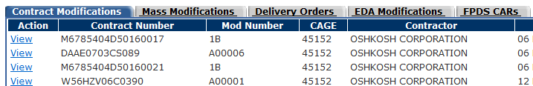

Figure 7: Tabs, table, columns, and column headings

Each column in a table allows you to sort information in either ascending or descending order by clicking the column heading.

Clicking the column heading sorts the table by that column. Clicking the same column again reverses the sort order. The column used for the sort order appears as light blue with an arrow that shows whether the data appears in ascending or descending order.

On pages that display only a portion of the records, you can move to the first, previous, next, or last request by clicking the buttons that appear at the bottom of the page (Figure 8).

First, previous, next, and last buttons

Figure 8: First, previous, next, and last buttons

Alternatively, you can select the range of requests you wish to view by selecting a range from the drop-down list box (Figure 9).



Figure 9: Drop-down list box

### Icons

The following icons link to additional functionality:

|  |  |
| --- | --- |
| close | Close the page or pop-up that you are viewing. |
| search | Search for information. |
| refresh | Refresh the page. |
| add | Add information. |
| image1.gif | Generate an EDA modification. |
| pencil | Edit information. |
| image2.gif | Close the screen you’re currently on, and return you to the previous screen. Any newly entered data on a screen that is unsaved is lost. |
| Calendar | Display a pop-up calendar to select a date. |
| delete | Delete information. |
| cut.gif | Cut text. |
| copy.gif | Copy text. |
| paste.gif | Paste text. |
| print.gif | Print. |
| spellcheck.gif | Check the spelling of text you have typed. |
| print | Display a print preview where you can view a document as an Adobe Acrobat PDF and either save or print it. |
| checkmark | Submit for approval; Approve/Release. |

### Buttons

Buttons, which appear at the bottom of the pages used for creating and editing mods, perform the following tasks:

Query: Searches for information that match the selected criteria.

Reset: Clears data you have typed on the page to show either the original data that was entered (if you edited an existing record) or null values (if you were creating a new record).

Cancel: Cancels the current action. The page that is currently displayed closes and the page displayed previously appears.

Generate: Creates the MOD and causes it to appear on the View My Work Page.

For an explanation of the purpose of MDO 4.0, see the topic [About MDO](#all_o_about_mdo_htm).

For an explanation of the roles and associated tasks, see the topic [User Roles and Tasks](#all_o_user_roles_and_tasks_htm).

For a summary of the contract and delivery order modification process, see the topic [Summary of the MDO Process](#all_o_summary_htm).

## Printing Documents

All of the user roles in MDO 4.0 can print MOD documents.

* If your user role is ACO, the signature block of the document will display.
* If your user role is CA, the signature block of the document will not display, but all other sections of the document are visible.

If data was not provided in the MOD, that information will not appear in the PDF. This includes:

* Optional data on the Manage MOD Page, Manage Delivery Order Page, or Manage EDA MOD Page
* Payment rates (contract modifications only)
* ACRNs (contract modifications and delivery orders only)
* Special provisions (contract modifications and delivery orders only)
* Line items and schedules (contract modifications and delivery orders only)
* Attachments
* Free text (description, opening remarks, special payment instructions, closing remarks, line item or ACRN text)

To print, click the view as PDF link that appears on the [Manage MOD Page](#contract_mods_t_managing_a_contr_6912), the [Manage Delivery Order Page](#delivery_orders_t_managing_a_del_5335), or the [Manage EDA MOD Page](#eda_only_t_managing_an_eda_mod_h_9453). The document will appear as an Adobe Acrobat PDF file in a new browser window.

You have the following options:

To save the file without printing, click the Save icon that appears in Adobe Acrobat. You will see a window that will let you choose where to save the file on your computer. You also can rename the file when you save it.

To print the file, click the Print icon that appears in Adobe Acrobat.

To return to MDO 4.0, close the browser window that displays the Adobe Acrobat file.

## Reports and Cubes

### Reports

The Report List for Modifications and Delivery Orders page appears in a new window when you click the Reports link on the MDO application's menu bar (Figure 10) and (Figure 11).

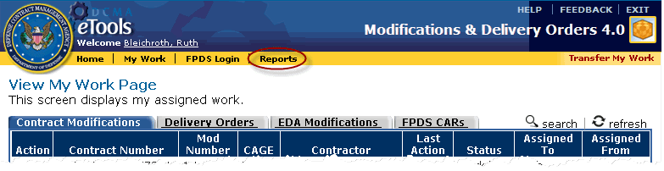

Figure 10: Reports link on menu bar

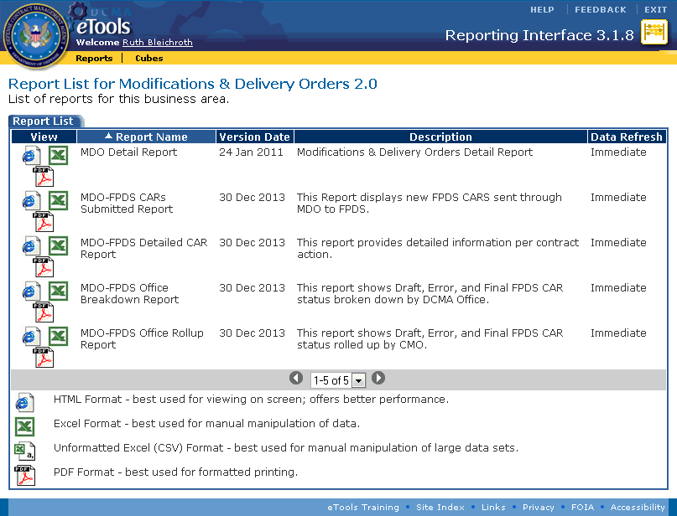

Figure 11: Report List for MDO page

Reports are available to all MDO 4.0 users to view metrics, statistics, and summary of mods.

To view a report, click the i_ie.gif Internet Explorer icon, the i_excel.gif Microsoft Excel icon, or the i_pdf.gifAdobe PDF icon to open and view the report in that format.

### Cubes

The Cube List for MDO page appears when you click Cubes on the Reporting Interface menu bar (Figure 12).

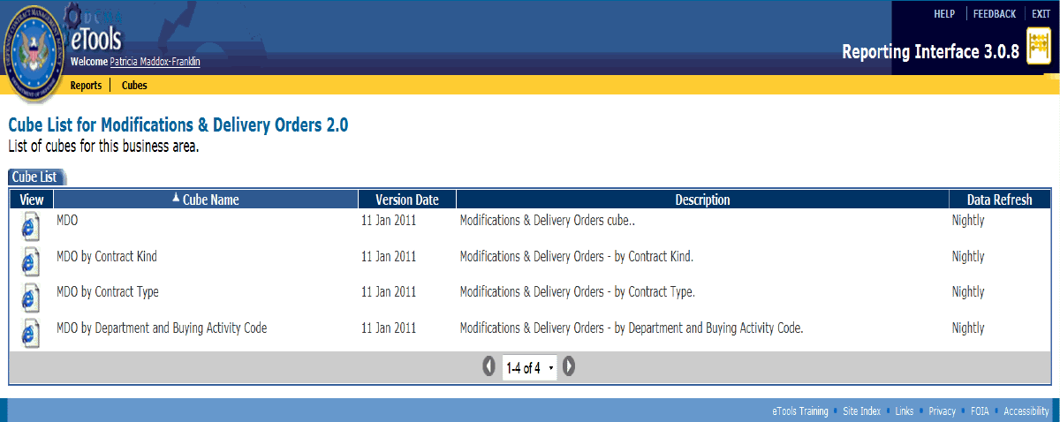

Figure 12: Cube List for MDO page

Cubes are available to all MDO users to view metrics, statistics and summary of released mods.

**To view a cube report,** click the i_ie.gif Internet Explorer icon for the report you wish to view.

**For additional assistance with using MDO reports,** click the Help link in the Reporting Interface tool.

# Contract Modifications

## Generating a Contract Modification

The ACO and CA user roles can generate a contract modification.

To generate a contract modification, do the following:

1. On the Modifications & Delivery Orders - Home Page, click the Search for Contracts to Generate MOD link (Figure 13).

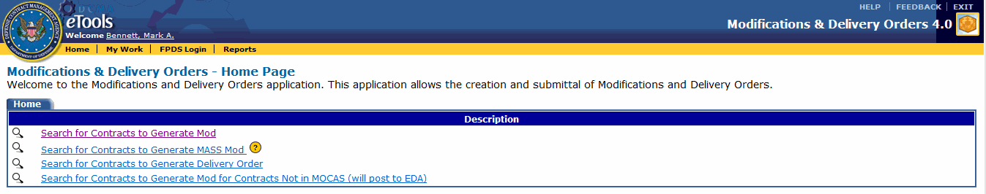

Figure 13: Modifications & Delivery Orders-Home Page

The Contract Modification Search Page appears (Figure 14).

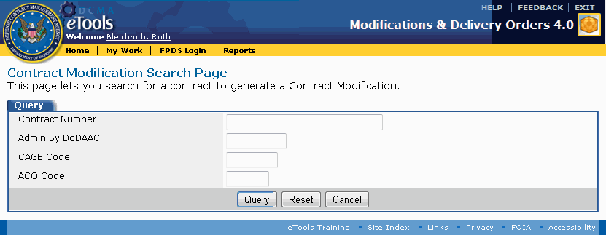

Figure 14: Contract Modification Search Page

1. Type partial or complete information in any, all, or none of the text boxes provided (you can use a wildcard character (\*) at the beginning, end, or at both sides of a word or partial word to search for items containing that word):

Contract Number: Returns a list of contracts that match the value typed in the text box. You can type a partial value, or a complete PIIN and SPIIN.

Admin by DoDAAC: Returns a list of contracts managed by the DoDAAC typed in the text box. If you type a partial value in the box, the contracts shown will be for any DoDAACs that match that partial value. For example, typing S051\* would return contracts for DCMA Los Angeles, DCMA San Diego, and DCMA Santa Ana.

CAGE Code: Returns a list of contracts for the CAGE code information typed in the text box.

ACO Code: Returns a list of contracts assigned to a specific ACO code.

1. Click the Query button.

Buttons at the bottom of the Contract Modification Search Page provide the following functionality:

Query: Searches for information that matches the selected criteria. Results appear on the Browse Query Results Page.

Reset: Clears data you have typed or selected.

Cancel: Cancels the current action. The page that is currently displayed closes and the page displayed previously appears.

The Browse Query Results Page appears when you query your search criteria. This page displays 10 contracts at a time (Figure 15). If necessary, use the controls at the bottom to sort through the search results.

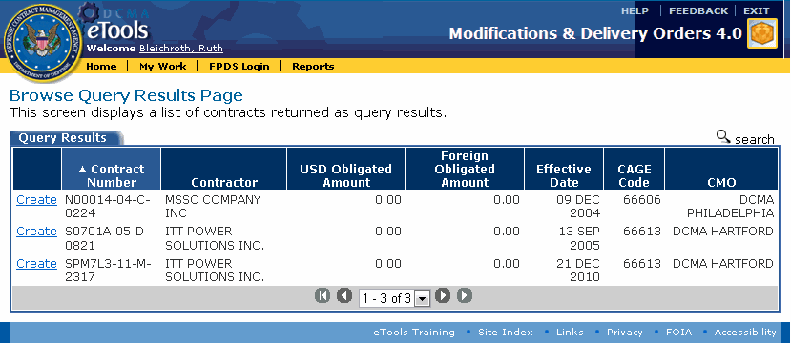

Figure 15: Browse Query Results Page

1. Click the Create link for the contract for which you wish to generate a modification (to search again, click the search search link. The Contract Modification Search Page appears and displays the search criteria that you used previously). The Create MOD Page appears (Figure 16).

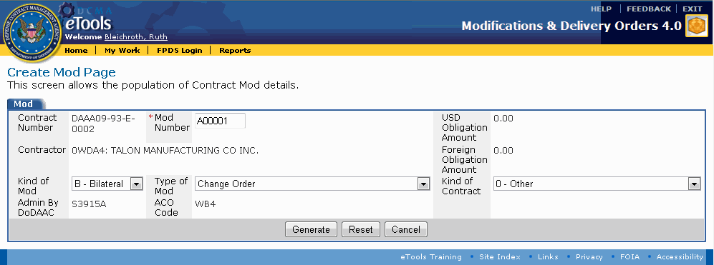

Figure 16: Create MOD Page

The Create MOD Page permits you to specify the following information:

MOD Number: (Required) A sequential number for the number of modifications to the contract. This number is automatically provided, but you can modify it. No other contract modification for this contract number should have this same number.

Kind of MOD: Select whether the modification is Unilateral or Bilateral from the drop-down list box. By default, Bilateral is selected.

Type of MOD: Select the type of contract modification from the drop-down list box.

Kind of Contract: Select the kind of contract from the drop-down list box.

1. Click the Generate button. A Confirmation tab appears notifying you that the MOD was successfully created (Figure 17).

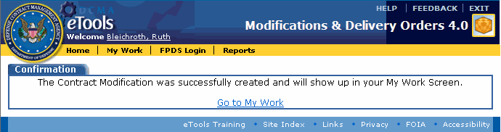

Figure 17: Confirmation tab

Buttons at the bottom of the Create MOD Page provide the following functionality:

Generate: Creates the MOD; displays the contract modification confirmation page.

Reset: Clears data you have typed or selected.

Cancel: Cancels the current action. The page that is currently displayed closes and the Browse Query Results Page appears.

**To view the MOD you generated,** click the Go to My Work link. The contract modification you generated appears on the View My Work Page, Contract Modifications tab. See the topic [Browsing Contract Modifications](#contract_mods_t_browsing_contrac_4723) for more information.

## Browsing Contract Modifications

The ACO and CA user roles can browse contract modifications.

**To browse contract modifications,** click the My Work link on the menu bar. The View My Work Page appears (Figure 18).

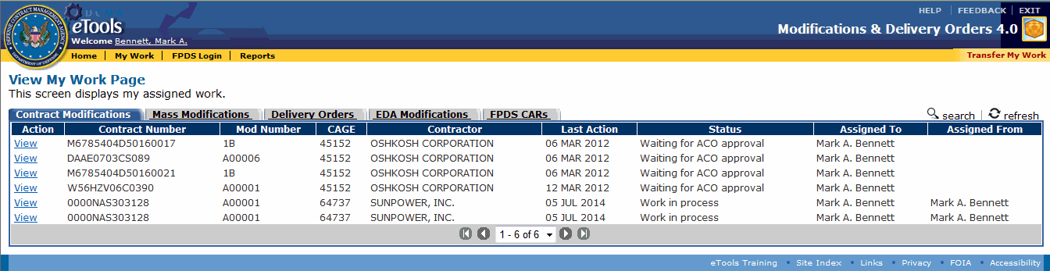

Figure 18: View My Work Page with the Contract Modifications tab displayed

The column headings that appear on the View My Work Page, Contract Modifications tab are as follows:

**Action:** Displays a View link or a Recall link. These links display both the action that may be performed and the state of the MOD. A View link means the MOD may be viewed and that it has not yet been submitted to the ACO. A Recall link means the MOD has been submitted to the ACO and that it can be recalled from the ACO.

**Contract Number:** Displays the contract number of the contract being modified.

**MOD Number:** Displays the MOD Number. No other contract modification for this contract number should have this same number. See the topic [Editing a Contract Modification](#contract_mods_t_editing_a_contra_2108).

**CAGE:** Displays the CAGE.

**Contractor:** Displays the contracting company name.

**Last Action:** Displays the date the last action was performed on the MOD.

**Status:** Displays the MOD's current status.

**Assigned To:** Displays the name of the CA or ACO who currently has the MOD.

**Assigned From:** Displays the name of the CA who assigned (or sent) the MOD.

To view details about a contract modification, on the View My Work Page, in the Contract Modifications tab, click the View link for a contract modification. The Manage MOD Page appears. See the topic [Managing a Contract Modification](#contract_mods_t_managing_a_contr_6912) for more information.

To recall a contract modification, on the View My Work Page, in the Contract Modifications tab, click the Recall link. See the topic [Recalling a MOD](#all_t_recalling_a_mod_htm) for more information.

To create a contract modification, on the View My Work Page, with the Contract Modifications tab displayed, click the search search link. The Contract Modification Search Page appears. See the topic [Generating a Contract Modification](#contract_mods_t_generating_a_con_5288) for more information.

To reassign work to another person, on the View My Work Page, click the Transfer My Work link on the menu bar. See the topic [Transferring Mods](#all_t_transferring_mods_htm) for more information.

To view the current delivery orders, on the View My Work Page, click the Delivery Orders tab. See the topic [Browsing Delivery Orders](#delivery_orders_t_browsing_deliv_8362) for more information.

To view the current EDA-only contract modifications, on the View My Work Page, click the EDA Modifications tab. See the topic [Browsing EDA-Only Contract Modifications](#eda_only_t_browsing_eda_mods_htm) for more information.

**To view the current FPDS CARs,** on the View My Work Page, click the FPDS CARs tab (appears for the ACO user role). See the topic [Browsing FPDS CARs](#browsing_fpds_cars_htm).

To update the View My Work Page, click the refresh refresh link.

## Managing a Contract Modification

The ACO and CA user roles can manage a contract modification.

**To manage a contract modification,** do the following:

1. Click the My Work link on the menu bar. The View My Work Page appears.
2. In the Contract Modifications tab, click the View link for the MOD you wish to view. The Manage MOD Page appears (Figure 19).

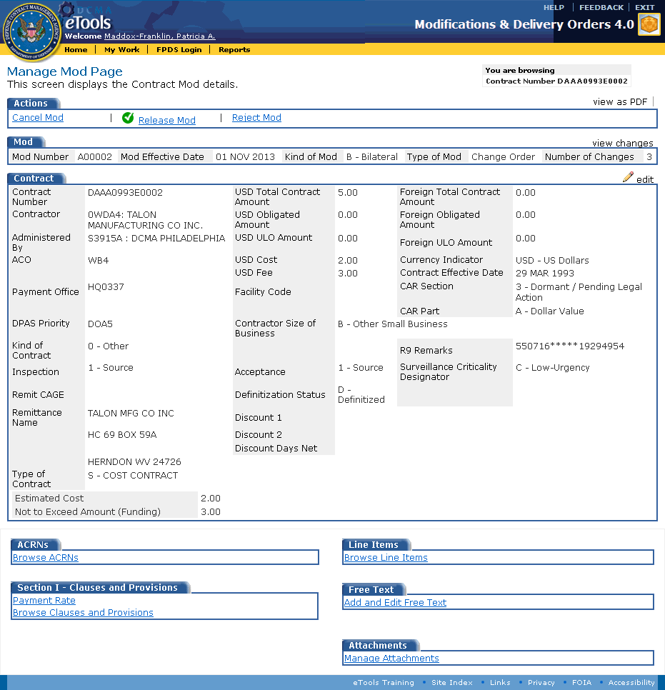

Figure 19: Manage MOD Page

In the MOD tab, the MOD Number, MOD Effective Date, Kind of MOD, and Type of MOD fields may be edited anytime during the modification process by clicking the penciledit link on the Manage MOD Page.

Links on the Manage MOD Page display the following information:

view as PDF: Downloads the SF 30 in an Adobe Acrobat PDF. See the topic [Printing Documents](#all_o_printing_documents_htm) for more information.

Cancel MOD: Displays the contract modification cancellation confirmation page, where you can choose to cancel the contract modification. If you choose to do this, the contract modification will no longer appear on your View My Work Page. See the topic [Canceling a MOD](#all_t_cancelling_a_mod_htm) for further information.

Submit to Contracting Officer for approval: Appears for the CA user role. See the topic [Submitting a MOD to the ACO](#all_t_submitting_mod_to_aco_htm) for more information.

Release MOD: Appears for the ACO user role. The ACO clicks this link to sign and release the contract modification. See the topic [Releasing a MOD](#all_t_releasing_a_mod_htm) for more information.

Reject MOD: Appears for the ACO user role. The ACO clicks this link to return a contract modification to the submitter for review. See the topic [Rejecting a MOD](#all_t_rejecting_a_mod_htm) for more information.

view changes: Displays the [Browse Changes page](#all_t_browsing_changes_htm), where you can see the changes to the contract modification since it was generated. See the topic [Browsing Changes](#all_t_browsing_changes_htm) for more information.

**i_pencil.gif**edit: Displays the [Edit Contract Page](#contract_mods_t_editing_a_contra_2108), where you can edit the contract modification information. See the topic [Editing a Contract Modification](#contract_mods_t_editing_a_contra_2108) for more information.

The ACRNs, Line Items, Section I - Clauses and Provisions, Free Text, and Attachments tabs contain additional links which display the following information:

Browse ACRNs: Displays the [Browse ACRNs Page](#acrn_t_browsing_acrns_htm), which shows the ACRNs for the contract modification. See the topic [Browsing ACRNs](#acrn_t_browsing_acrns_htm) for further information.

Browse Line Items: Displays the [Browse Line Items Page](#line_items_t_browsing_line_items_5523), which shows the line items for the contract modification. See the topic [Browsing Line Items](#line_items_t_browsing_line_items_5523) for more information.

Payment Rate: Link appears only for contract modifications. Displays the [View Payment Rate Page](#contract_mods_t_viewing_a_paymen_170), which shows the payment rates for the contract modification. See the topic [Viewing a Payment Rate](#contract_mods_t_viewing_a_paymen_170) for more information.

Browse Clauses and Provisions: Displays the [Section I - Clauses and Provisions Page](#sp_prov_t_browsing_special_provi_9455), which shows the current clauses and special provisions for the contract modification. See the topic [Browsing Clauses and Provisions](#sp_prov_t_browsing_special_provi_9455) for more information.

Add and Edit Free Text: Displays the [Contract Modification Text Page](#contract_mods_t_adding_free_text_1650), where you can type the purpose of the modification, special payment instructions, and closing remarks. See the topic [Adding Free Text to a Contract Modification](#contract_mods_t_adding_free_text_1650) for more information.

Manage Attachments: Displays a page where you can attach files. See the topic [Attaching a File](#all_o_attaching_a_file_htm) for more information.

## Viewing a Payment Rate

The ACO and CA user roles can view a payment rate.

Only contract modifications may have payment rates.

If a contract number has percentages specified for payment rates, then the contract modification will permit you to view and edit the payment rates.

To view payment rates, do the following:

1. Locate the MOD whose payment rate you wish to view. See the topic [Browsing Contract Modifications](#contract_mods_t_browsing_contrac_4723) to locate a MOD.
2. On the Manage MOD Page, in the Section I - Clauses and Provisions tab, click the Payment Rate link (Figure 20). The View Payment Rate Page appears (Figure 21).

Section I - Clauses and Provisions tab with Payment Rate active

Figure 20: Section I - Clauses and Provisions tab with Payment Rate active

The Section I - Clauses and Provisions tab displays the Payment Rate link if a payment rate is available for the contract.

If payment rate is not applicable to the contract modification, the words, "No Payment Rate" appear instead of a link to the payment rate.

The View Payment Rate Page displays the payment rates for US progress, FMS progress, US liquidation, and FMS liquidation.

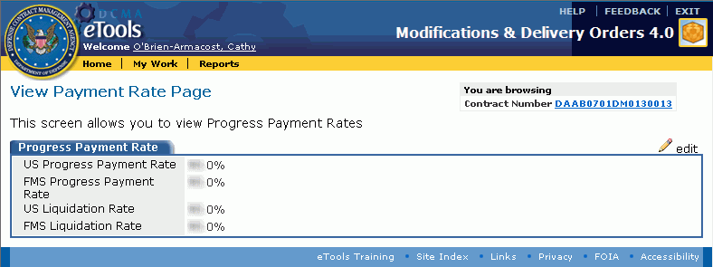

Figure 21: View Payment Rate Page

To edit a payment rate, on the View Payment Rate Page, click the i_pencil.gif edit link. The Edit Progress Payment Rate page appears. See the topic [Editing a Payment Rate](#contract_mods_t_editing_a_paymen_31) for more information.

To return to the contract modification, click the Contract Number link. The Manage MOD Page appears. See the topic [Managing a Contract Modification](#contract_mods_t_managing_a_contr_6912) for more information.

## Editing a Payment Rate

The ACO and CA user roles can edit a payment rate.

Only contract modifications may have payment rates.

If a contract number has percentages specified for payment rates, then the contract modification will permit you to edit the percentages for the payment rates.

**To edit payment rates,** do the following:

1. Locate the MOD whose payment rate you wish to edit. See the topic [Browsing Contract Modifications](#contract_mods_t_browsing_contrac_4723) to locate a MOD.
2. On the Manage MOD Page, in the Section I - Clauses and Provisions tab, click the Payment Rate link. The View Payment Rate Page appears.
3. On the View Payment Rate Page, click the penciledit link. The Edit Progress Payment Rate page appears (Figure 22).

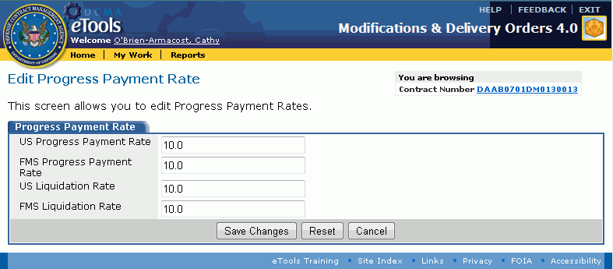

Figure 22: Edit Progress Payment Rate page

1. The Edit Progress Payment Rate page displays text boxes for each of the following payment rates: US progress, FMS progress, US liquidation, and FMS liquidation. Type/Edit values in the text boxes provided. Do not type a percent sign (%), and do not type a value greater than 100. You may specify tenths of a percent (for example, 90.1).
2. Click the Save Changes button.

The buttons on the Edit Progress Payment Rate Page perform the following functionality:

Save Changes: Saves the changes that you made on this page. The View Payment Rate Page appears. See the topic [Viewing a Payment Rate](#contract_mods_t_viewing_a_paymen_170) for further information.

Reset: Clears data you have typed.

Cancel: Cancels the current action. The View Payment Rate Page appears. See the topic [Viewing a Payment Rate](#contract_mods_t_viewing_a_paymen_170) for more information.

## Adding Free Text to a Contract Modification

To add free text to a contract modification, do the following:

1. Locate the MOD to which you wish to add free text. See the topic [Browsing Contract Modifications](#contract_mods_t_browsing_contrac_4723) to locate a MOD.
2. On the Manage MOD Page, click the Add and Edit Free Text link (Figure 23).

Free Text tab with links

Figure 23: Free Text tab with link

The Contract Modification Text Page appears (Figure 24).

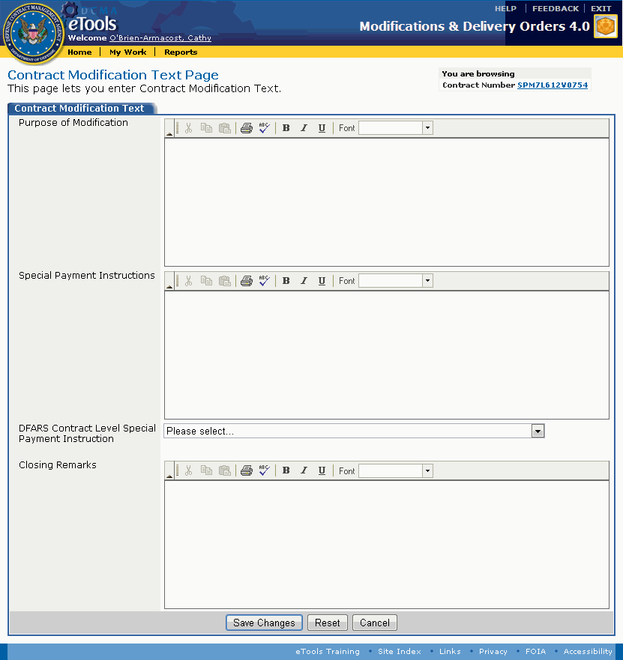

Figure 24: Contract Modification Text Page

1. Type text in the text boxes provided. Each text box allows 4,000 characters, and permits you to paste text, format text to use bold, italics, or underlining, to specify a font, and spell-check text:

Purpose of Modification: The first line is used to state the authority for issuing the contract modification in the Adobe Acrobat PDF document of the contract modification.

Special Payment Instructions: Causes a section to appear in the Adobe Acrobat PDF document of the contract modification.

Closing Remarks: Appears in the Adobe Acrobat PDF document of the contract modification.

1. Select the DFAS Contract Level Special Payment Instruction from the drop-down list box.
2. Click the Save Changes button.

Buttons at the bottom of the Contract Modification Text Page provide the following functionality:

Save Changes: Saves the changes that you made on this page. The [Manage MOD Page](#contract_mods_t_managing_a_contr_6912) appears.

Reset: Clears data you have typed.

Cancel: Cancels the current action. The page that is currently displayed closes and the [Manage MOD Page](#contract_mods_t_managing_a_contr_6912) appears.

## Editing a Contract Modification

The ACO and CA user roles can edit contract modifications in their workloads.

To edit a contract modification, do the following:

1. Locate the MOD you wish to edit. See the topic [Browsing Contract Modifications](#contract_mods_t_browsing_contrac_4723) to locate a MOD.
2. On the Manage MOD Page, click the i_pencil.gifedit link. The Edit Contract Page appears (Figure 25).

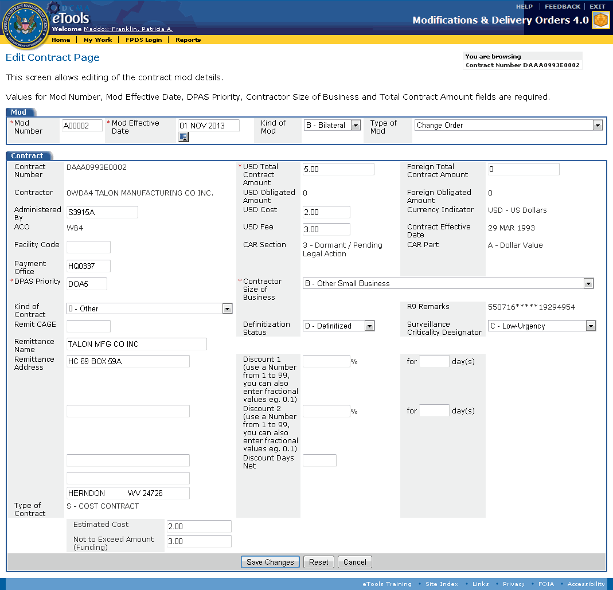

Figure 25: Edit Contract Page

1. Type or select the following information on the Edit Contract Page as necessary (some fields are not editable):

MOD Number: (Required) This text box displays a MOD number automatically. You cannot change this number. The number generated is temporary until the MOD is released. Once released, a permanent MOD number is automatically generated and assigned.

MOD Effective Date: (Required) Type or select the effective date for the contract modification. Use the format dd mmm yyyy or click the Calendar calendar icon to select the date from a pop-up calendar.

Kind of MOD: Displays either Unilateral or Bilateral.

Type of MOD: Displays the type of MOD selected.

Contract Number: Displays the contract number of the contract being modified.

USD Total Contract Amount: (Required) Displays the amount of money in the contract. You may edit this number.

**Foreign Total Contract Amount:** Displays the amount of money in currency other than USD.

Contractor: Displays the contracting company name and, if available, CAGE.

USD Obligated Amount: Displays the amount of money from the contract that is obligated.

**Foreign Obligated Amount:** Displays the amount of money from the contract that is obligated in currency other than USD.

Administered By: Displays the DoDAAC with cognizance for the contract. You can edit this information to change the DoDAAC of cognizance.

USD Cost: Type the cost. Do not use the dollar sign ($) or commas (,). You can use a decimal point to show cents or equivalent.

Currency Indicator: Displays the type of currency.

**A**ACO: Displays the ACO code for the ACO who has cognizance.

USD Fee: Type the fee. Do not use the dollar sign ($) or commas (,). You can use a decimal point to show cents or equivalent.

Contract Effective Date: Displays the date that the contract came into effect.

Facility Code: You can type a CAGE for a specific facility where the work will be performed if it differs from the contractor CAGE. You can edit this information.

CAR Section: Displays the CAR section associated with the contract number.

CAR Part: Displays the CAR Part code associated with the contract number.

Payment Office: Displays the DoDAAC responsible for paying the contractor. You can edit this information.

DPAS Priority: (Required) Displays the DPAS priority. You can edit this information.

Contractor Size of Business: (Required) Select an item from the drop-down list box.

Kind of Contract: Select the Kind of Contract from the drop-down list box.

R9 Remarks: Displays R9 Remarks information.

Remit CAGE: You can provide a CAGE where payments should be remitted, if different from the contractor CAGE.

Remittance Name: Displays the name of the company that receives the payments, if different from the contractor name. You can edit this information.

Remittance Address: Displays the address of the company that receives the payments. You can edit this information.

Definitization Status: You can select either D - Definitized or U - Un-Definitized.

Surveillance Criticality Designator: Displays the Surveillance Criticality Designator. You can select an item from the drop-down list box.

Discount 1: Type the percent discount available.

for days: Type the number of days to which the percent discount applies.

Discount 2: Type the percent discount available.

for days: Type the number of days to which the percent discount applies.

Discount Days Net: Type the number of days that any discount is available.

Type of Contract: Displays a description of the contract type.

**[Various Items]:** Based upon the Type of Contract, an additional text box (or text boxes) may appear beneath the Type of Contract field. Type applicable data in these additional text boxes (for text boxes requiring dollar amounts, do not type a dollar sign ($) or comma (,) in this box. You can use a decimal point (.) to specify cents).

1. Click the Save Changes button.

Buttons at the bottom of the page provide the following functionality:

Save Changes: Saves the changes that you made on this page. The Manage MOD Page appears and displays the updated information. See the topic [Managing a Contract Modification](#contract_mods_t_managing_a_contr_6912) for more information.

Reset: Clears data you have typed or selected.

Cancel: Cancels the current action. The Manage MOD Page appears. Any changes you made are not saved or displayed. See the topic [Managing a Contract Modification](#contract_mods_t_managing_a_contr_6912) for more information.

# Delivery Orders

## Generating a Delivery Order

The ACO and CA user roles can generate a delivery order.

To generate a delivery order, do the following:

1. On the Modifications & Delivery Orders - Home Page, click the Search for Contracts to Generate Delivery Order link (Figure 26).



Figure 26: Modifications & Delivery Orders-Home Page

The Delivery Order Search Page appears (Figure 27).

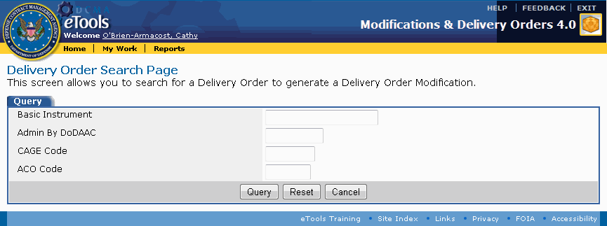

Figure 27: Delivery Order Search Page

1. Type partial or complete information in any, all, or none of the text boxes provided (you can use a wildcard character (\*) at the beginning, end, or at both sides of a word or partial word to search for items containing that word):

Basic Instrument: Type the PIIN of the contract.

Admin by DoDAAC: Returns a list of contracts managed by the DoDAAC typed in the text box. If you type a partial value in the box, the contracts shown will be for any DoDAACs that match that partial value. For example, typing S051\* would return contracts for DCMA Los Angeles, DCMA San Diego, and DCMA Santa Ana.

CAGE Code: Returns a list of contracts for the CAGE code information typed in the text box.

ACO Code: Returns a list of contracts assigned to a specific ACO code.

1. Click the Query button. The Browse Query Results Page appears.

Buttons at the bottom of the Delivery Order Search Page provide the following functionality:

Query: Searches for information that matches the selected criteria.

Reset: Clears data you have typed or selected.

Cancel: Cancels the current action. The page that is currently displayed closes and the page displayed previously appears.

The Browse Query Results Page displays the search results, 10 contracts at a time (Figure 28).

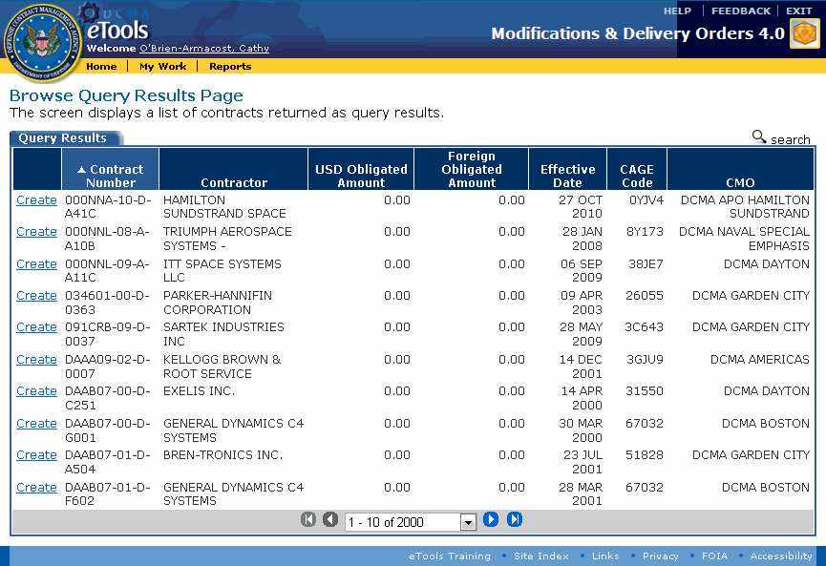

Figure 28: Browse Query Results Page

1. Click the Create link for the contract for which you wish to generate a delivery order (to search again, click the search search link. The Delivery Order Search Page appears and displays the search criteria that you used previously). The Create Delivery Order Page appears (Figure 29).

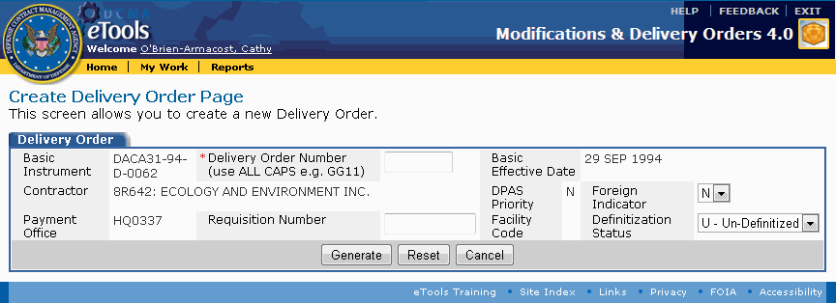

Figure 29: Create Delivery Order Page

The Create Delivery Order Page permits you to type or select the following information:

Delivery Order Number: (Required) Type the sequential number for the delivery order; no other delivery order for this contract number should have this same number.

**Foreign Indicator:** Select Y [Yes] or N [No] from the drop-down list box.

Requisition Number: Type the requisition number for the delivery order.

Definitization Status: Select either Un-Definitized or Definitized from the drop-down list box. Un-Definitized is displayed by default.

1. Click the Generate button. A Confirmation tab appears notifying you that the delivery order was successfully created.

Buttons at the bottom of the Create Delivery Order Page provide the following functionality:

Generate: Displays the delivery order confirmation page. The delivery order that you generated appears on the View My Work Page, Delivery Orders tab. See the topic [Browsing Delivery Orders](#delivery_orders_t_browsing_deliv_8362) for more information.

Reset: Clears data you have typed or selected.

**C**ancel: Cancels the current action. The page that is currently displayed closes and the Browse Query Results Page appears.

**To view the delivery order you generated,** click the Go to My Work link. The delivery order you generated appears on the View My Work Page, Delivery Orders tab. See the topic [Browsing Delivery Orders](#delivery_orders_t_browsing_deliv_8362) for more information.

## Browsing Delivery Orders

The ACO and CA user roles can browse delivery orders.

**To browse delivery orders,** do the following:

1. Click the My Work link on the menu bar. The View My Work Page appears.
2. Click the Delivery Orders tab. The Delivery Orders tab is displayed (Figure 30).

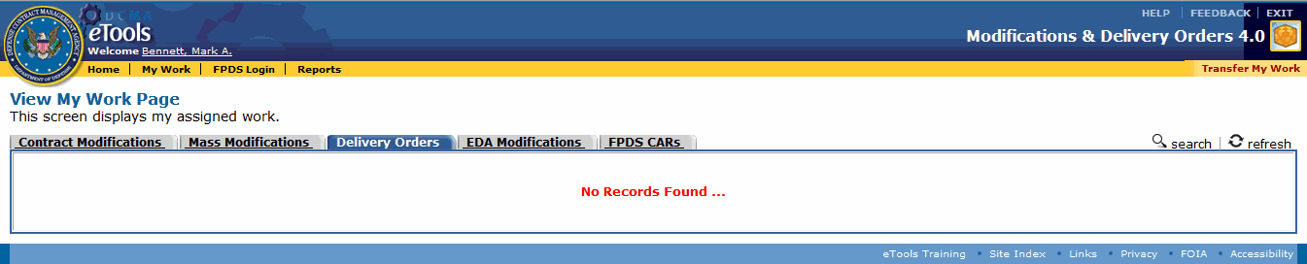

Figure 30: View My Work Page with Delivery Orders tab displayed

The column headings that appear on the View My Work Page, Delivery Orders tab are as follows:

* **Action:** Displays a View link or a Recall link. These links display both the action that may be performed and the state of the MOD. A View link means the MOD may be viewed and that it has not yet been submitted to the ACO. A Recall link means the MOD has been submitted to the ACO and that it can be recalled from the ACO.
* **Basic Instrument:** Displays the PIIN of the contract number of the contract being modified.
* **Delivery Order:** Displays the delivery order number. No other delivery order for this contract number should have this same number. See the topic [Editing a Delivery Order](#delivery_orders_t_editing_a_deli_9154).
* **CAGE:** Displays the CAGE.
* **Contractor:** Displays the contracting company name.
* **Last Action:** Displays the date the last action was performed on the MOD.
* **Status:** Displays the MOD's current status.
* **Assigned To:** Displays the name of the CA or ACO who currently has the MOD.
* **Assigned From:** Displays the name of the CA who assigned (or sent) the MOD.

To view details about a delivery order, on the View My Work Page, click the View link for a delivery order. The Manage Delivery Order Page appears. See the topic [Managing a Delivery Order](#delivery_orders_t_managing_a_del_5335) for more information.

To recall a delivery order, on the View My Work Page, in the Delivery Orders tab, click the Recall link. See the topic [Recalling a MOD](#all_t_recalling_a_mod_htm) for more information.

To create a delivery order, on the View My Work Page, with the Delivery Orders tab displayed, click the i_search.gif search link. The Delivery Order Search Page appears. See the topic [Generating a Delivery Order](#delivery_orders_t_generating_a_d_5901) for more information.

To reassign work to another person, on the View My Work Page, click the Transfer My Work link on the menu bar. See the topic [Transferring Mods](#all_t_transferring_mods_htm) for more information.

To view the current contract modifications, on the View My Work Page, click the Contract Modifications tab. See the topic [Browsing Contract Modifications](#contract_mods_t_browsing_contrac_4723) for more information.

To view the current EDA-only contract modifications, on the View My Work Page, click the EDA Contract Modifications tab. See the topic [Browsing EDA-Only Contract Modifications](#eda_only_t_browsing_eda_mods_htm) for more information.

**To view the current FPDS CARs,** on the View My Work Page, click the FPDS CARs tab (appears for the ACO user role). See the topic [Browsing FPDS CARs](#browsing_fpds_cars_htm).

To update the View My Work Page, click the i_refresh.gif refresh link.

## Managing a Delivery Order

The ACO and CA user roles can manage a delivery order.

**To manage a delivery order,** do the following:

1. Click the My Work link on the menu bar. The View My Work Page appears.
2. Click the Delivery Orders tab. The Delivery Orders tab is displayed.
3. Click the View link for the delivery order you wish to view. The Manage Delivery Order Page appears and displays the delivery order information (Figure 31).

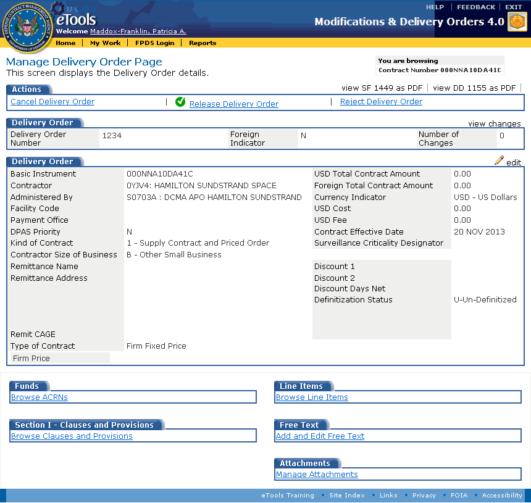

Figure 31: Manage Delivery Order Page

The data displayed on this page cannot be edited on this page, but can be edited on other pages by clicking links. Links on this page display the following information:

view SF 1449 as PDF: Downloads the SF 1449 in an Adobe Acrobat PDF. See the topic [Printing Documents](#all_o_printing_documents_htm) for more information.

view DD 1155 as PDF: Downloads the DD 1155 in an Adobe Acrobat PDF. See the topic [Printing Documents](#all_o_printing_documents_htm) for more information.

Cancel Delivery Order: Displays the delivery order cancellation confirmation page, where you can choose to cancel the delivery order. If you choose to do this, the delivery order will no longer appear on your View My Work Page. See the topic [Canceling a MOD](#all_t_cancelling_a_mod_htm) for more information.

Submit to Contracting Officer for Approval: The CA uses this link to submit the delivery order to the ACO for review. It does not appear for the ACO. See the topic [Submitting a MOD to the ACO](#all_t_submitting_mod_to_aco_htm) for more information.

Release Delivery Order: Appears for the ACO user role. The ACO uses this link to sign and release the delivery order. See the topic [Releasing a MOD](#all_t_releasing_a_mod_htm) for more information.

Reject Delivery Order: Appears for the ACO user role. The ACO uses this link to return a delivery order to the submitter for review. See the topic [Rejecting a MOD](#all_t_rejecting_a_mod_htm) for further information.

view changes: Displays the Browse Changes page, where you can see the changes to the delivery order since it was generated. See the topic [Browsing Changes](#all_t_browsing_changes_htm) for more information.

**i_pencil.gif**edit: Displays the [Edit Delivery Order Page](#delivery_orders_t_editing_a_deli_9154). See the topic [Editing a Delivery Order](#delivery_orders_t_editing_a_deli_9154) for more information.

The Funds, Line Items, Section I - Clauses and Provisions, Free Text, and Attachments tabs contain additional links which display the following information:

Browse ACRNs: Displays the Browse ACRNs Page, which shows the ACRNs for the delivery order. See the topic [Browsing ACRNs](#acrn_t_browsing_acrns_htm) for more information.

Browse Line Items: Displays the Browse Line Items Page, which shows the line items for the delivery order. See the topic [Browsing Line Items](#line_items_t_browsing_line_items_5523) for more information.

Browse Clauses and Provisions: Displays the Section I - Provisions Page, which shows the current clauses and special provisions for the delivery order. See the topic [Browsing Clauses and Special Provisions](#sp_prov_t_browsing_special_provi_9455) for more information.

Add and Edit Free Text: Displays the [Delivery Order Text Page](#delivery_orders_t_adding_free_te_8549), where you can type the opening remarks, special payment instructions, and closing remarks. See the topic [Adding Free Text to a Delivery Order](#delivery_orders_t_adding_free_te_8549) for more information.

Manage Attachments: Displays a page where you can attach files. See the topic [Attaching a File](#all_o_attaching_a_file_htm) for more information.

## Adding Free Text to a Delivery Order

The ACO and CA user roles can add free text to a delivery order.

To add free text to a delivery order, do the following:

1. Locate the delivery order to which you wish to add free text. See the topic [Browsing Delivery Orders](#delivery_orders_t_browsing_deliv_8362) to locate a delivery order.
2. On the Manage Delivery Order Page, click the Add and Edit Free Text link. The Delivery Order Text Page appears (Figure 32).

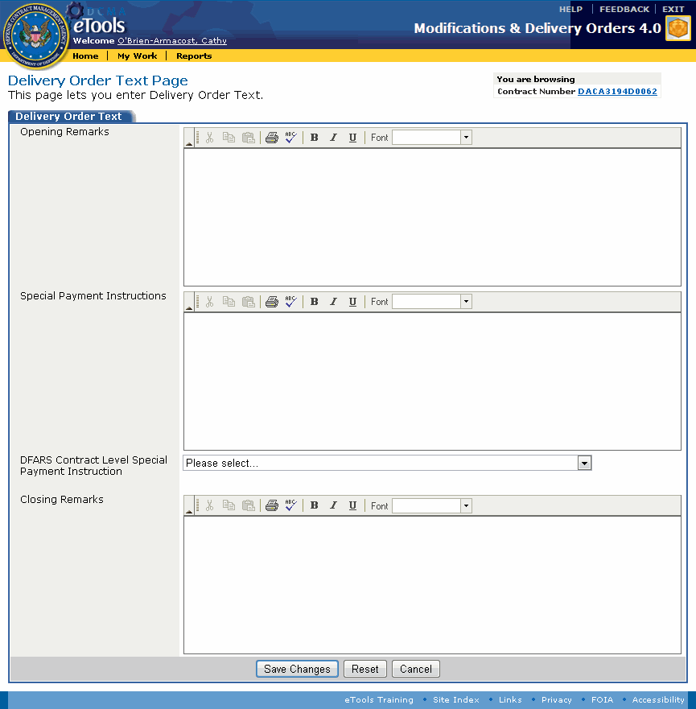

Figure 32: Delivery Order Text Page

1. Type text in the text boxes provided. Each text box allows 4,000 characters, and permits you to paste text, format text to use bold, italic, underlining, to specify a font, and spell-check text:

Opening Remarks: Appears in the Adobe Acrobat PDF document of the delivery order.

Special Payment Instructions: Causes a section to appear in the Adobe Acrobat PDF document of the delivery order.

Closing Remarks: Appears in the Adobe Acrobat PDF document of the delivery order.

1. Select the DFAS Contract Level Special Payment Instruction from the drop-down list box.
2. Click the Save Changes button.

Buttons at the bottom of the Delivery Order Text Page provide the following functionality:

Save Changes: Saves the changes that you made on this page. The [Manage Delivery Order Page](#delivery_orders_t_managing_a_del_5335) appears.

Reset: Clears data you have typed.

Cancel: Cancels the current action. The page that is currently displayed closes and the [Manage Delivery Order Page](#delivery_orders_t_managing_a_del_5335) appears.

## Editing a Delivery Order

The ACO and CA user roles can edit delivery orders in their workloads.

**To edit a delivery order,** do the following:

1. Locate the delivery order you wish to edit. See the topic [Browsing Delivery Orders](#delivery_orders_t_browsing_deliv_8362) to locate a delivery order.
2. On the Manage Delivery Order Page, click the pencil edit link. The Edit Delivery Order Page appears (Figure 33).
3. Type or select the following information on the Edit Delivery Order Page as necessary (some fields are not editable):

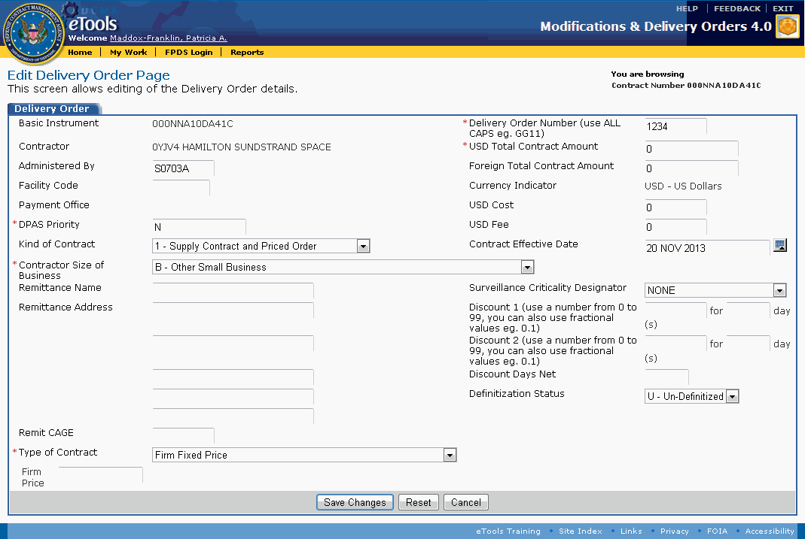

Figure 33: Edit Delivery Order Page

Basic Instrument: Displays the PIIN of the contract number of the contract being modified.

Delivery Order Number: (Required) This text box displays a delivery order number automatically. You can change this number. No other delivery order for this contract number should have this same number.

Contractor: Displays the contracting company name and, if available, CAGE.

USD Total Contract Amount: (Required) Displays the amount of money in the contract. You may edit this number.

Administered By: Displays the DoDAAC with cognizance for the contract. You can edit this information to change the DoDAAC of cognizance.

**Foreign Total Contract Amount:** Displays the amount of money in the contract in currency other than USD.

Facility Code: You can provide a CAGE for a specific facility where the work will be performed if it differs from the contractor CAGE.

Currency Indicator: Displays the type of currency.

Payment Office: Displays the DoDAAC responsible for paying the contractor.

USD Cost: Type the cost. Do not use the dollar sign ($) or commas (,). You can use a decimal point (.) to specify cents.

DPAS Priority: (Required) Displays the DPAS priority. You can edit this information.

USD Fee: Type the fee. Do not use the dollar sign ($) or commas (,). You can use a decimal point (.) to specify cents.

Kind of Contract: Select the Kind of Contract from the drop-down list box.

Contract Effective Date: Type or select the effective date for the contract modification. Use the format dd mmm yyyy or click the Calendarcalendar icon to select the date from a pop-up calendar.

Contractor Size of Business: (Required) Select an item from the drop-down list box.

Remittance Name: Displays the name of the company that receives the payments, if different from the contractor name.

Remittance Address: Displays the address where payments are remitted. You can edit this information if needed.

Remit CAGE: Provide a CAGE where payments should be remitted, if different from the contractor CAGE.

Surveillance Criticality Designator: You can select an item from the drop-down list box. Default value is None.

Discount 1: Type the percent discount. Value may use tenths of a percent (for example, 2.4). Do not type a percent sign (%).

for days: Type the number of days to which the percent discount applies. Value must be 10 or greater.

Discount 2: Type the percent discount. Value may use tenths of a percent (for example, 2.4). Do not type a percent sign (%).

for days: Type the number of days to which the percent discount applies. Value must be 10 or greater.

Discount Days Net: Type the number of days that any discount is available.

Definitization Status: You can select either D - Definitized or U - Un-Definitized.

Type of Contract: (Required) Select the Type of Contract from the drop-down list box.

**[Various Items]:** Based upon the Type of Contract selected, an additional text box (or text boxes) may appear beneath the Type of Contract field. Type applicable data in these additional text boxes (for text boxes requiring dollar amounts, do not type a dollar sign ($) or comma (,) in this box. You can use a decimal point (.) to specify cents).

1. Click the Save Changes button.

The buttons at the bottom of the Edit Delivery Order Page perform the following functionality:

Save Changes: Saves the changes that you made on this page. The Manage Delivery Order Page appears and displays the updated information. See the topic [Managing a Delivery Order](#delivery_orders_t_managing_a_del_5335) for more information.

Reset: Clears data you have typed or selected.

Cancel: Cancels the current action. The Manage Delivery Order Page appears. Any changes you made are not displayed. See the topic [Managing a Delivery Order](#delivery_orders_t_managing_a_del_5335) for more information.

# EDA-Only Contract Modifications

## Generating an EDA-Only Contract Modification

The ACO and CA user roles can generate an EDA-only contract modification.

**To generate an EDA-only contract modification,** do the following:

1. On the Modifications & Delivery Orders - Home Page, click the Search for Contracts to Generate MOD for Contracts Not in MOCAS (will post to EDA) link (Figure 34).



Figure 34: Modifications & Delivery Orders-Home Page

The Contract EDA MOD - Search Page appears (Figure 35).

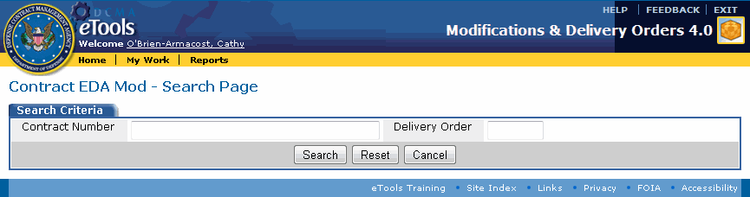

Figure 35: Contract EDA MOD - Search Page

1. Type the contract number in the Contract Number text box.
2. Type the delivery order number in the Delivery Order text box.
3. Click the Search button. The Contract EDA MOD - Search Results Page appears.

The following buttons at the bottom of the Contract EDA MOD - Search Page perform the following functionality:

Search: Searches for information that matches the selected criteria. Results appear on the Contract EDA MOD - Search Results page.

Reset: Clears data you have typed or selected.

Cancel: Cancels the current action. The page that is currently displayed closes and the page displayed previously appears.

The Contract EDA MOD - Search Results Page appears and shows whether the contract number is present in MOCAS (Figure 36).

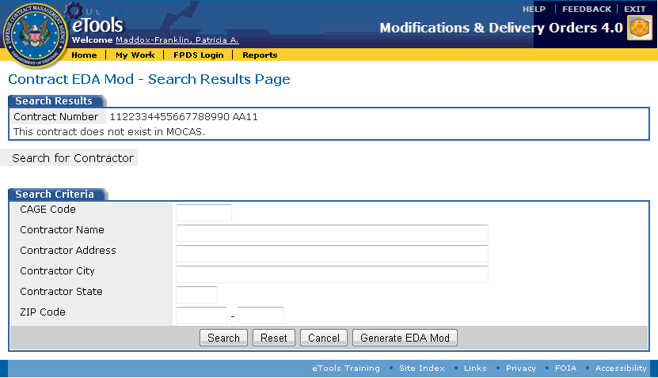

Figure 36: Contract EDA MOD - Search Results Page

1. Use the Search Criteria tab's text boxes to either look up contractor information for the EDA-only contract modification, or to specify contractor information. Type partial or full values. If used to search for a contractor, the boxes provide the following functionality:

CAGE Code: Returns a list of businesses whose CAGE codes match what is typed in the text box.

Contractor Name: Returns a list of businesses whose names match what is typed in the text box.

Contractor Address: Returns a list of businesses whose addresses match what is typed in the text box.

Contractor City: Returns a list of businesses located in the city that is typed in the text box.

Contractor State: Returns a list of businesses located in the state that is typed in the text box.

ZIP Code: Returns a list of businesses located in the ZIP code that is typed in the text box.

1. Click the Search button to search for a contractor; the Contractor Search Results Page appears. Click the Generate EDA MOD button to generate an EDA MOD without searching. The Create EDA MOD Page appears.

The following buttons at the bottom of the Contract EDA MOD - Search Results Page perform the following functionality:

Search: Searches for information that matches the provided criteria. Results appear on the Contractor Search Results page (Figure 37). Click a image1.gif "G" icon to generate the EDA-only contract modification using a contractor's information. The Create EDA MOD Page appears with the Contractor's information. Click close_icon.gif close to return to the Contract EDA MOD - Search Results page.

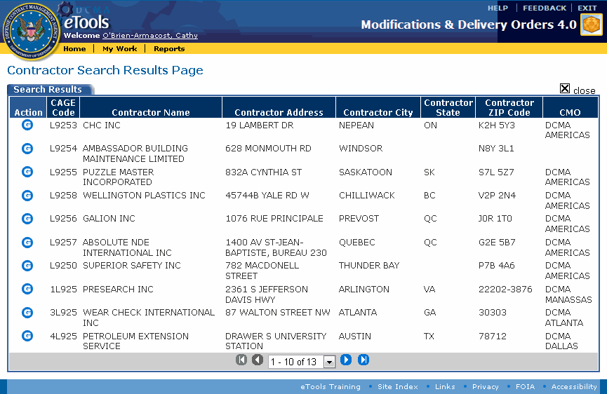

Figure 37: Contractor Search Results Page

Reset: Clears data you have typed or selected.

Cancel: Cancels the current action. The page that is currently displayed closes and the page displayed previously appears.

Generate EDA MOD: Generates the EDA-only contract modification using the contract number and contractor information shown on the Contract EDA MOD - Search Results Page. The Create EDA MOD Page appears (Figure 38).

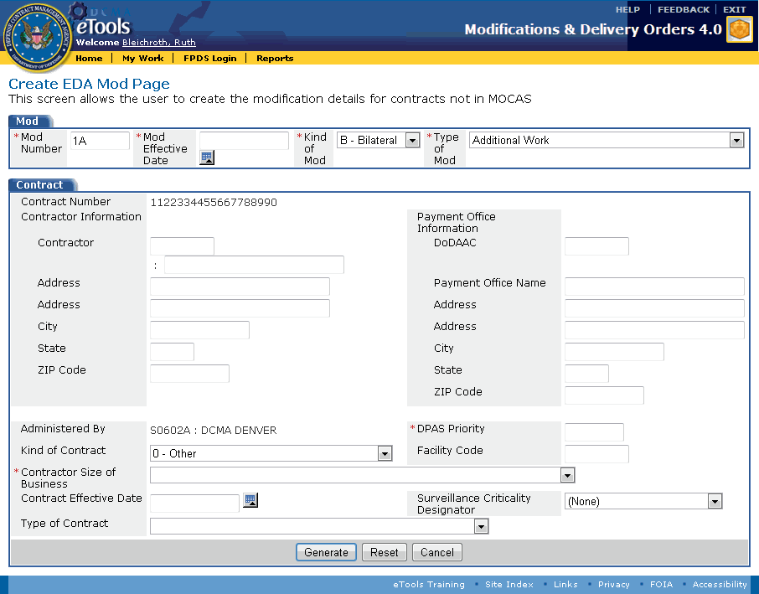

Figure 38: Create EDA MOD Page

1. Type complete information in at least the required text boxes; an asterisk (\*) indicates an item is required:

MOD Number: A sequential number for the number of modifications to the contract. No other contract modification for this contract number should have this same number.

MOD Effective Date: Displays the effective date for the EDA-only contract modification. You may edit this date. Use the format dd mmm yyyy or click the i_calendar.gifcalendar icon to select the date from a pop-up calendar.

Kind of MOD: Select either Unilateral or Bilateral.

Type of MOD: Select the type of contract modification from the drop-down list box.

Contract Number: Displays the contract number specified for the EDA-only contract modification.

Contractor Information: Specify the contracting company's information for the EDA-only contract modification.

**Contractor:** Type the name of the contracting company.

**Address:** Type the address of the contracting company.

**City:** Type the city in which the contracting company is located.

**State:** Type the state in which the contracting company is located.

**ZIP Code:** Type the ZIP code in which the contracting company is located.

Payment Office Information: If applicable, specify the payment office information in the text boxes provided.

DoDAAC: Type the DoDAAC responsible for paying the contractor.

Payment Office Name: Type the name of the payment office (for example, DCMA Boston) responsible for paying the contractor.

Address: Type the street address of the payment office responsible for paying the contractor.

City: Type the city of the payment office responsible for paying the contractor.

State: Type the state of the payment office responsible for paying the contractor.

ZIP Code: Type the ZIP Code of the payment office responsible for paying the contractor.

Administered By: Displays the DCMA contracting office and DoDAAC with cognizance for the contract.

DPAS Priority: (Required) Type the DPAS priority.

Kind of Contract: Select the contract kind from the drop-down list box.

Facility Code: Provide a CAGE for a specific facility where the work will be performed if it differs from the contractor CAGE.

Contractor Size of Business: (Required) Select an item from the drop-down list box.

Contract Effective Date: Click the calendar.gifcalendar icon to select the date that the contract came into effect or type the date using the format dd mmm yyyy.

Surveillance Criticality Designator: Select an item from the drop-down list box.

**T**ype of Contract: Select the contract type from the drop-down list box.

**[Various Items]:** Based upon the Type of Contract, additional text box (or text boxes) may appear beneath the Type of Contract field. Type applicable data in these additional text boxes (for text boxes requiring dollar amounts, do not type a dollar sign ($) or comma (,) in this box. You can use a decimal point (.) to specify cents).

1. Click the Generate button.

The buttons at the bottom of the Create EDA MOD Page perform the following functionality:

Generate: Displays the EDA-only contract modification confirmation page. The EDA-only contract modification you generated appears on the View My Work Page, EDA Contract Modification tab. See the topic [Browsing EDA-Only Contract Modifications](#eda_only_t_browsing_eda_mods_htm) for more information.

Reset: Clears data you have typed or selected.

Cancel: Cancels the current action. The page that is currently displayed closes and the home page appears.

**To view the EDA-only contract modification you generated,** click the Go to My Work link. The MOD you generated appears on the View My Work Page, EDA Modifications tab. See the topic [Browsing EDA-Only Contract Modifications](#eda_only_t_browsing_eda_mods_htm) for more information.

## Browsing EDA-Only Contract Modifications

The ACO and CA user roles can browse EDA-only contract modifications.

**To browse EDA-only contract modifications,** do the following:

1. Click the My Work link on the menu bar. The View My Work Page appears.
2. Click the EDA Modifications tab. The EDA Modifications tab is displayed (Figure 39).

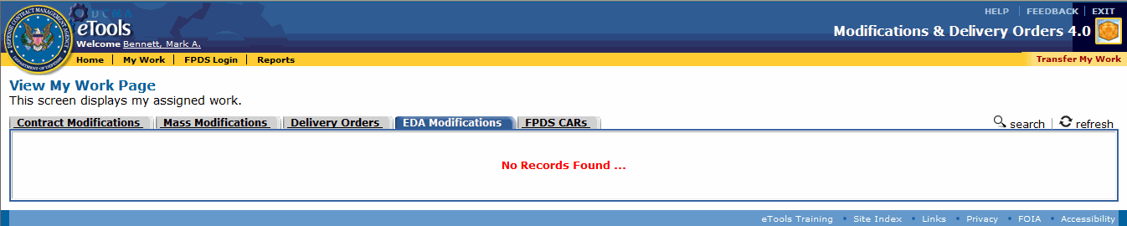

Figure 39: View My Work Page with EDA Modifications tab displayed

The column headings that appear on the View My Work Page, EDA Modifications tab are as follows:

* **Action:** Displays a View link or a Recall link. These links display both the action that may be performed and the state of the MOD. A View link means the MOD may be viewed and that it has not yet been submitted to the ACO. A Recall link means the MOD has been submitted to the ACO and that it can be recalled from the ACO.
* **Contract Number:** Displays the contract number of the contract being modified.
* **MOD Number:** Displays the MOD Number. No other EDA-only contract modification for this contract number should have this same number. See the topic [Editing an EDA-Only Contract Modification](#eda_only_t_editing_an_eda_mod_ht_6928).
* **CAGE:** Displays the CAGE.
* **Contractor:** Displays the contracting company name.
* **Last Action:** Displays the date the last action was performed on the MOD.
* **Status:** Displays the MOD's current status.
* **Assigned To:** Displays the name of the CA or ACO who currently has the MOD.
* **Assigned From:** Displays the name of the CA who assigned (or sent) the MOD.

To view details about an EDA-only contract modification, on the View My Work Page, in the EDA Modifications tab, click the View link for an EDA contract modification. The Manage EDA MOD Page appears. See the topic [Managing an EDA-Only Contract Modification](#contract_mods_t_managing_a_contr_6912) for more information.

To recall an EDA-only contract modification, on the View My Work Page, in the EDA Modifications tab, click the Recall link. See the topic [Recalling a MOD](#all_t_recalling_a_mod_htm) for further information.

**To generate an EDA-only contract modification,** on the View My Work Page, with the EDA Modifications tab displayed, click the i_search.gif search link. The Contract EDA MOD - Search Page appears. See the topic [Generating an EDA-Only Contract Modification](#eda_only_t_generating_an_eda_mod_6259) for more information.

To reassign work to another person, on the View My Work Page, click the Transfer My Work link on the menu bar. See the topic [Transferring Mods](#all_t_transferring_mods_htm) for more information.

To view the current contract modifications, on the View My Work Page, click the Contract Modifications tab. See the topic [Browsing Contract Modifications](#contract_mods_t_browsing_contrac_4723) for more information.

To view the current delivery orders, on the View My Work Page, click the Delivery Orders tab. See the topic [Browsing Delivery Orders](#delivery_orders_t_browsing_deliv_8362) for more information.

**To view the current FPDS CARs,** on the View My Work Page, click the FPDS CARs tab (appears for the ACO user role). See the topic [Browsing FPDS CARs](#browsing_fpds_cars_htm).

To update the View My Work Page, click the refresh refresh link.

## Managing an EDA-Only Contract Modification

The ACO and CA user roles can manage an EDA-only contract modification.

**To manage an EDA-only contract modification,** do the following:

1. Click the My Work link on the menu bar.
2. Click the EDA Modifications tab. The EDA Modifications tab is displayed.
3. Click the View link for the EDA-only MOD you wish to view. The Manage EDA MOD Page appears (Figure 40).

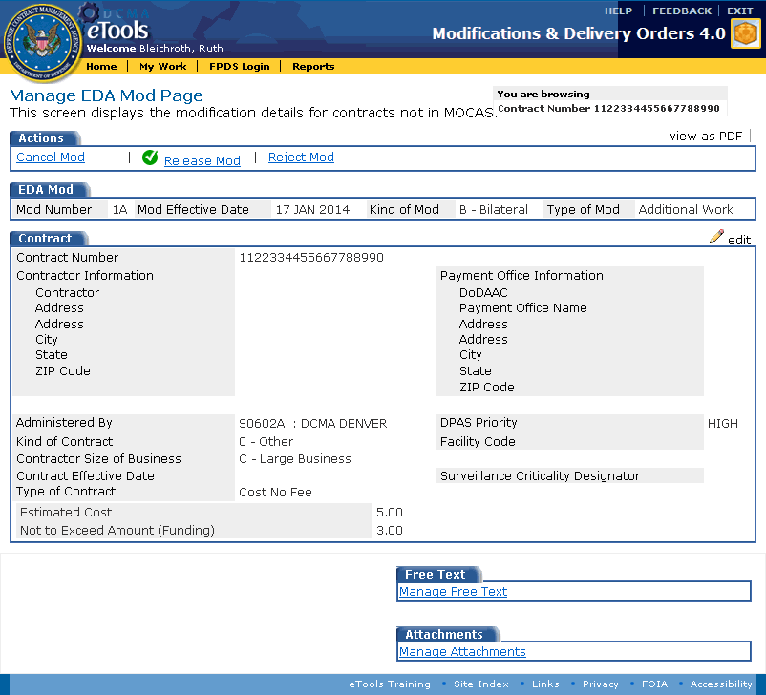

Figure 40: Manage EDA MOD Page

The data displayed on this page cannot be edited on this page, but can be edited on other pages by clicking links. Links on this page display the following information:

view as PDF: Downloads the SF-30 in an Adobe Acrobat PDF. See the topic [Printing Documents](#all_o_printing_documents_htm) for further information.

Cancel MOD: Displays the cancellation confirmation page, where you can choose to cancel the EDA-only contract modification. If you choose to do this, the EDA-only contract modification will no longer appear on your View My Work Page. See the topic [Canceling a MOD](#all_t_cancelling_a_mod_htm) for more information.

Submit to Contracting Officer for Approval: Appears for the CA user role. See the topic [Submitting a MOD to the ACO](#all_t_submitting_mod_to_aco_htm) for more information.

Release MOD: Appears for the ACO user role. The ACO uses this link to sign and release the EDA-only contract modification. See the topic [Releasing a MOD](#all_t_releasing_a_mod_htm) for more information.

Reject MOD: Appears for the ACO user role. The ACO uses this link to return an EDA-only contract modification to the submitter for review. See the topic [Rejecting a MOD](#all_t_rejecting_a_mod_htm) for further information.

**i_pencil.gif**edit: Displays the [Edit EDA MOD Page](#eda_only_t_editing_an_eda_mod_ht_6928), where you can edit the EDA-only contract modification information. See the topic [Editing an EDA-Only Contract Modification](#eda_only_t_editing_an_eda_mod_ht_6928) for more information.

An EDA-only contract modification cannot record changes nor have ACRNs, line items, special provisions, or payment rates, so these links are not available.

Manage Free Text: Displays the [EDA-Only Contract Modification Text Page](#eda_only_t_adding_free_text_eda__6149), where you can type the purpose of modification, special payment instructions, and closing remarks. See the topic [Adding Free Text to an EDA-Only Contract MOD](#eda_only_t_adding_free_text_eda__6149) for more information.

Manage Attachments: Displays a page where you can attach files. See the topic [Attaching a File](#all_o_attaching_a_file_htm) for further information.

## Adding Free Text to an EDA-Only Contract MOD

The ACO and CA user roles can add free text to an EDA-only contract modification.

To add text to an EDA-only contract modification, do the following:

1. Locate the EDA-only contract MOD to which you wish to add free text. See the topic [Browsing EDA-Only Contract Modifications](#eda_only_t_browsing_eda_mods_htm) to locate an EDA-only contract MOD.
2. On the Manage EDA MOD Page, click the Manage Free Text link (Figure 41).

Free Text tab

Figure 41: Free Text tab with Manage Free Text link

The EDA-Only Contract Modification Text Page appears (Figure 42).

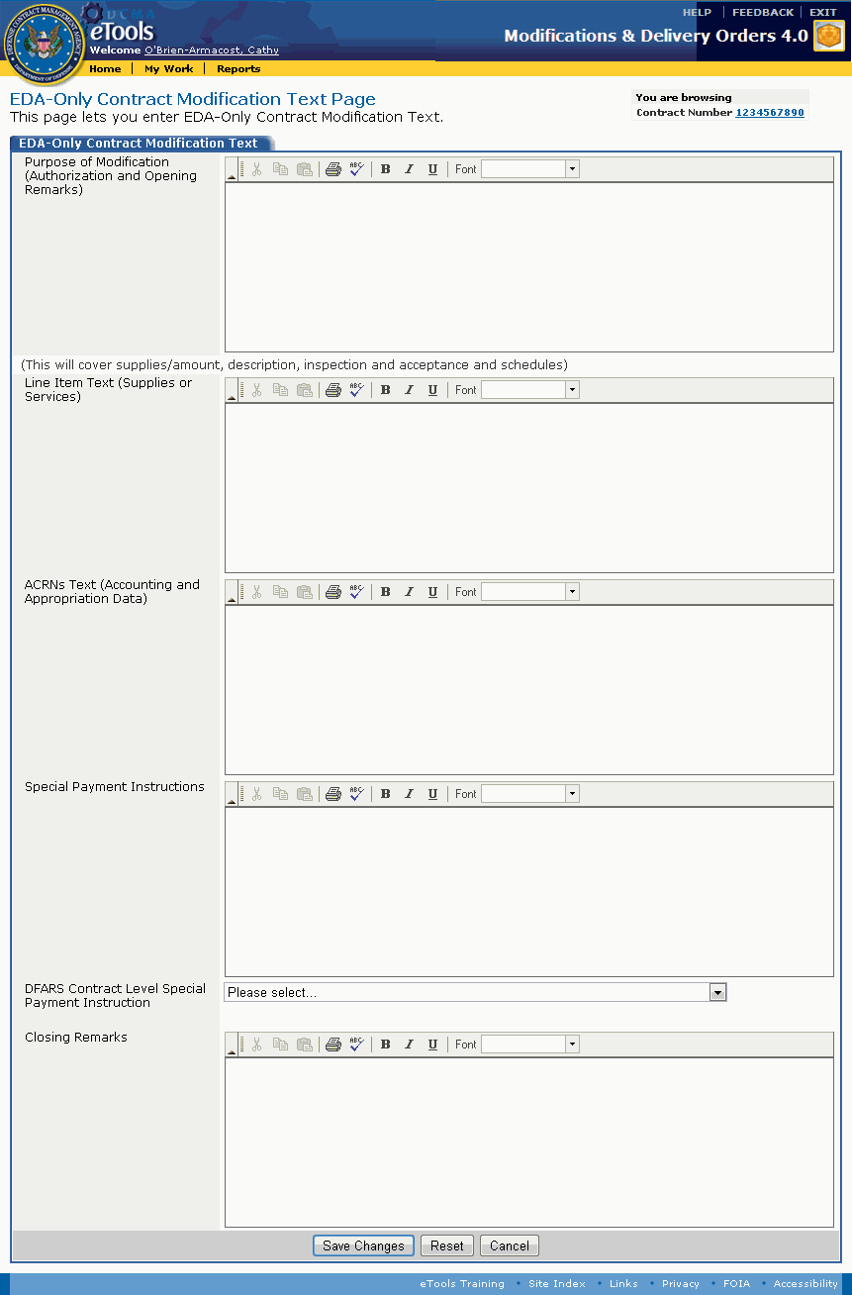

Figure 42: EDA-Only Contract Modification Text Page

1. Type free text in the text boxes provided. Each text box allows 4,000 characters, and permits you to paste text, format text to use bold, italics, or underlining, to specify a font, and spell-check text:

Purpose of Modification (Authorization and Opening Remarks): The first line is used to state the authority for issuing the contract modification in the Adobe Acrobat PDF document of the EDA-only contract modification.

Line Item Text (Supplies or Services): Causes a section to appear in the Adobe Acrobat PDF document of the EDA-only contract modification.

ACRNs Text (Accounting and Appropriation Data): Causes a section to appear in the Adobe Acrobat PDF document of the EDA-only contract modification.

Special Payment Instructions: Causes a section to appear in the Adobe Acrobat PDF document of the EDA-only contract modification.

Closing Remarks: Appears in the Adobe Acrobat PDF document of the EDA-only contract modification.

1. Select the DFAS Contract Level Special Payment Instruction from the drop-down list box.
2. Click the Save Changes button.

Buttons at the bottom of the EDA-Only Contract Modification Text Page provide the following functionality:

Save Changes: Saves the changes that you made on this page. The [EDA-Only Manage MOD Page](#eda_only_t_managing_an_eda_mod_h_9453) appears.

Reset: Clears data you have typed.

Cancel: Cancels the current action. The page that is currently displayed closes and the [EDA-Only Manage MOD Page](#eda_only_t_managing_an_eda_mod_h_9453) appears.

## Editing an EDA-Only Contract Modification

The ACO and CA user roles can edit EDA-only contract modifications in their workloads.

**To edit a contract modification,** do the following:

1. Locate the EDA-only contract MOD you wish to edit. See the topic [Browsing EDA-Only Contract Modifications](#eda_only_t_browsing_eda_mods_htm) to locate an EDA-only contract MOD.
2. On the Manage EDA MOD Page, click the penciledit link. The Edit EDA MOD Page appears (Figure 43).

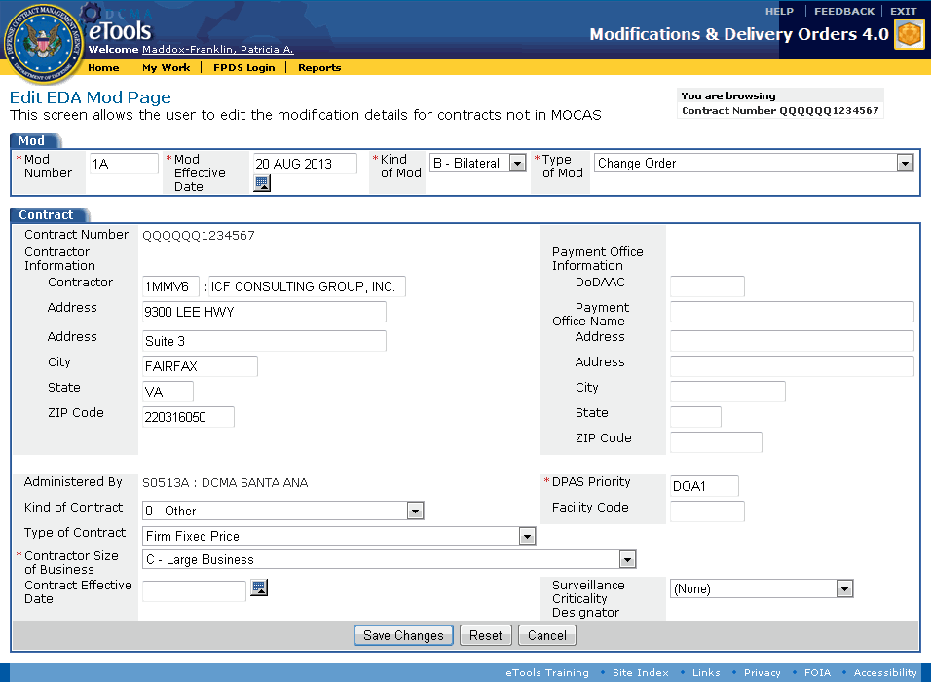

Figure 43: Edit EDA MOD Page

1. Type or select the following information on the Edit EDA MOD Page as necessary (some fields are not editable):

MOD Number: A sequential number for the number of modifications to the contract. No other contract modification for this contract number should have this same number.

MOD Effective Date: Displays the effective date for the EDA-only contract modification. You may edit this date. Use the format dd mmm yyyy or click the Calendar calendar icon to select the date from a pop-up calendar.

Kind of MOD: Select either U - Unilateral or B - Bilateral.

Type of MOD: Select the type of contract modification from the drop-down list box.

Contract Number: Displays the contract number specified for the EDA-only contract modification.

Contractor Information: If applicable, specify the contractor information in the text boxes provided.

Contractor CAGE and Name: Type the contractor's CAGE in the first text box; type the contractor company name in the second text box.

Address: Type the street address of the contractor.

City: Type the city of the contractor.

State: Type the state of contractor.

ZIP Code: Type the ZIP Code of the contractor.

Payment Office Information: If applicable, specify the payment office information in the text boxes provided.

DoDAAC: Type the DoDAAC responsible for paying the contractor.

Payment Office Name: Type the name of the payment office (for example, DCMA Boston) responsible for paying the contractor.

Address: Type the street address of the payment office responsible for paying the contractor.

City: Type the city of the payment office responsible for paying the contractor.

State: Type the state of the payment office responsible for paying the contractor.

ZIP Code: Type the ZIP Code of the payment office responsible for paying the contractor.

Administered By: Displays the DCMA DoDAAC and contracting office with cognizance for the contract.

DPAS Priority: (Required) Type the DPAS priority.

Kind of Contract: Select the contract kind from the drop-down list box.

Facility Code: Provide a CAGE for a specific facility where the work will be performed if it differs from the contractor CAGE.

Type of Contract: Select the contract type from the drop-down list box.

Contractor Size of Business: Select an item from the drop-down list box.

Contract Effective Date: Click the calendar.gif calendar icon to select the date that the contract came into effect or type the date using the format dd mmm yyyy.

Surveillance Criticality Designator: Select an item from the drop-down list box.

1. Click the Save Changes button.

The buttons at the bottom of the Edit EDA MOD Page perform the following functionality:

Save Changes: Saves the changes that you made on this page. The EDA-only Manage MOD Page appears and displays the updated information. See the topic [Managing an EDA-Only Contract Modification](#eda_only_t_managing_an_eda_mod_h_9453) for more information.

Reset: Clears data you have typed or selected.

Cancel: Cancels the current action. The EDA-only Manage MOD Page appears. Any changes you made are not displayed. See the topic [Managing an EDA-Only Contract Modification](#eda_only_t_managing_an_eda_mod_h_9453) for more information.

# ACRNs

## Browsing ACRNs

The ACO and CA user roles can browse ACRNs.

ACRNs may be present for a contract modification or delivery order.

To specify ACRN information for EDA-only contract modifications, see the topic [Adding Free Text to an EDA-Only Contract MOD](#eda_only_t_adding_free_text_eda__6149).

**To browse a list of ACRNs,** do the following:

1. Locate the MOD whose ACRNs you wish to browse. See the topic [Browsing Contract Modifications](#contract_mods_t_browsing_contrac_4723) or [Browsing Delivery Orders](#delivery_orders_t_browsing_deliv_8362) to locate a MOD.
2. On the Manage MOD Page or Manage Delivery Order Page, click the Browse ACRNs link (Figure 44).

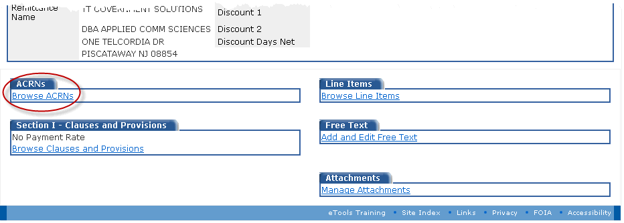

Figure 44: Browse ACRNs link

The Browse ACRNs Page appears. If you are viewing ACRNs for a newly-generated delivery order, no ACRNs will be displayed.

If one or more ACRNs are associated with a contract modification or delivery order, the Browse ACRNs page displays a list of the ACRNs (Figure 45).

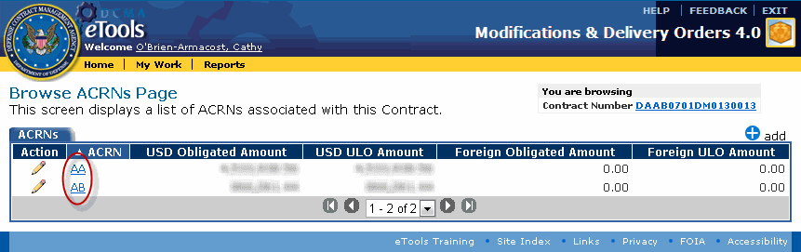

Figure 45: Browse ACRNs Page with ACRNs

To view an ACRN, on the Browse ACRNs Page, click the link in the ACRN column for the ACRN you wish to view. The [View ACRN Page](#acrn_t_viewing_an_acrn_htm) appears. See the topic [Viewing an ACRN](#acrn_t_viewing_an_acrn_htm) for further information.

**To edit an ACRN,** on the Browse ACRNs Page, click the edit edit icon for the ACRN you wish to edit. The [Edit ACRN Page](#acrn_t_updating_an_acrn_htm) appears. See the topic [Editing an ACRN](#acrn_t_updating_an_acrn_htm) for further information.

To view the MOD, on the Browse ACRNs Page, click the Contract Number link (Figure 46). The [Manage MOD Page](#contract_mods_t_managing_a_contr_6912) or [Manage Delivery Order Page](#delivery_orders_t_managing_a_del_5335) appears.

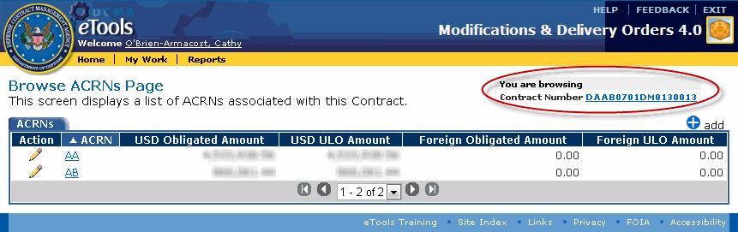

Figure 46: Contract Number link

## Viewing an ACRN

The ACO and CA user roles can view ACRNs.

To view an ACRN, do the following:

1. Locate the MOD whose ACRNs you wish to view. See the topic [Browsing Contract Modifications](#contract_mods_t_browsing_contrac_4723) or [Browsing Delivery Orders](#delivery_orders_t_browsing_deliv_8362) to locate a MOD; see the topic [Browsing ACRNs](#acrn_t_browsing_acrns_htm) to locate an ACRN.
2. On the Browse ACRNs Page, click the link in the ACRN column for the ACRN you wish to view (Figure 47).



Figure 47: ACRN links

The View ACRN Page appears (Figure 48).

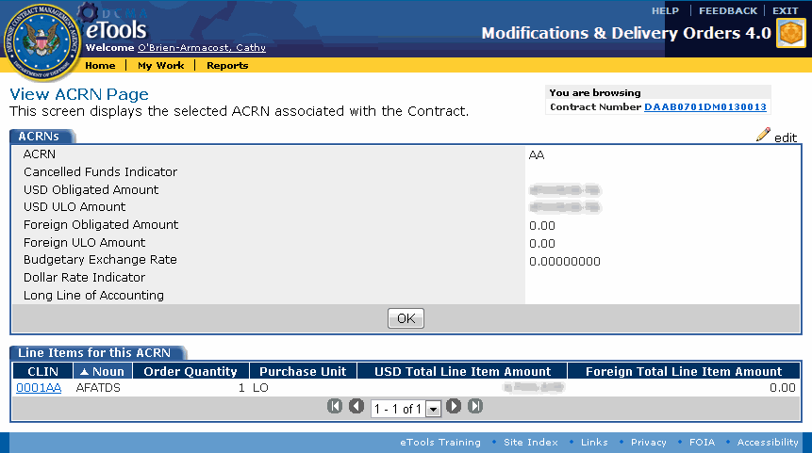

Figure 48: View ACRN Page

To edit an ACRN, on the View ACRN Page, click the edit edit link. The [Edit ACRN Page](#acrn_t_updating_an_acrn_htm) appears. See the topic [Editing an ACRN](#acrn_t_updating_an_acrn_htm).

To browse ACRNs, on the View ACRN Page, click the OK button. The [Browse ACRNs Page](#acrn_t_browsing_acrns_htm) appears. See the topic [Browsing ACRNs](#acrn_t_browsing_acrns_htm).

To view a line item associated with an ACRN, on the View ACRN Page, in the Line Items for this ACRN tab, click the CLIN link for the line item you wish to view. The [View Line Item Page](#line_items_t_viewing_a_line_item_2062) appears. See the topic [Viewing a Line Item](#line_items_t_viewing_a_line_item_2062) for more information.

To view the MOD, on the View ACRN Page, click the Contract Number link. The [Manage MOD Page](#delivery_orders_t_editing_a_deli_9154) or [Manage Delivery Order Page](#delivery_orders_t_editing_a_deli_9154) appears. See the topic [Editing a Contract Modification](#contract_mods_t_editing_a_contra_2108) or [Editing a Delivery Order](#delivery_orders_t_editing_a_deli_9154) for more information.

## Adding an ACRN

The ACO and CA user roles can add ACRNs.

To add an ACRN, do the following:

1. Locate the MOD to which you wish to add ACRNs. See the topic [Browsing Contract Modifications](#contract_mods_t_browsing_contrac_4723) or [Browsing Delivery Orders](#delivery_orders_t_browsing_deliv_8362) to locate a MOD; also, see the topic [Browsing ACRNs](#acrn_t_browsing_acrns_htm).
2. On the [Browse ACRNs Page](#acrn_t_browsing_acrns_htm), click the add add link. The Add ACRN page appears (Figure 49).

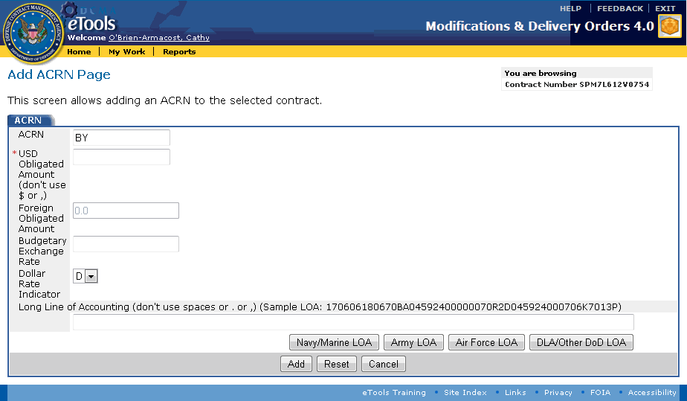

Figure 49: Add ACRN Page

1. Type the following information in the text boxes provided; an asterisk (\*) indicates that the information is required:

ACRN: The ACRN text box is populated automatically with a value that is not already used by another ACRN for this MOD.

USD Obligated Amount: Type the USD obligated amount, if applicable. You can use a decimal point (.) to specify dollars and cents, but do not use the dollar sign ($) or commas (,).

Foreign Obligated Amount: Type the foreign obligated amount, if applicable. You can use a decimal point (.) to specify dollars and cents, but do not use the dollar sign ($) or commas (,).

**Budgetary Exchange Rate:** Type the budgetary exchange rate.

**Dollar Rate Indicator:** Select a dollar rate indicator from the drop-down list box.

Long Line of Accounting: The following LOA template buttons are displayed: Navy/Marine LOA, Army LOA, Air Force LOA, DLA/Other DoD LOA. Click the applicable LOA button to type the Long Line of Accounting (LOA). See the subtopic [DCMA Policy: LOA and FPDS](#acrn_t_adding_an_acrn_htm_dcma_p_4589) within this topic for more information on the LOA.

**To view a template to help you build a Navy/Marine Long Line of Accounting,** click the Navy/Marine LOA button. The Navy/Marine LOA page appears (Figure 50). **Note:** This template is applicable to Navy/Marine; the template is not applicable to Navy ERP, Navy FMS, or Army GFEBS.

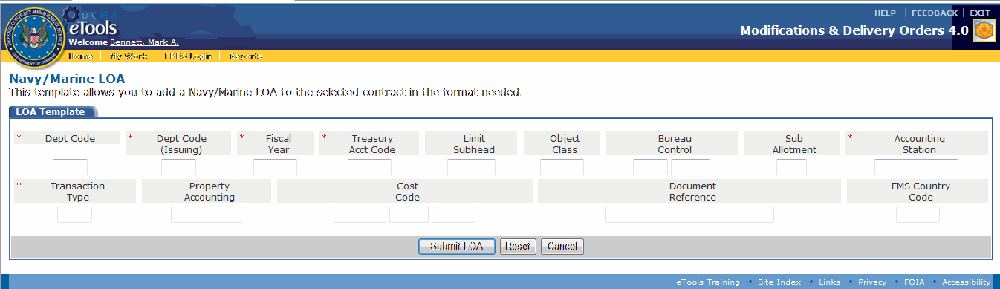

Figure 50: Navy/Marine LOA page

The Navy/Marine LOA template contains the following fields (maximum characters allowed is shown):

* Department Code (2 characters)
* Dept Code (Issuing) (2 characters)
* Fiscal Year (4 characters)
* Treasury Acct Code (4 characters)
* Limit Subhead (4 characters)
* Object Class (3 characters)
* Bureau Control (5 characters)
* Sub Allotment (1 character)
* Accounting Station (8 characters)
* Transaction Type (2 characters)
* Property Accounting (6 characters)
* Cost Code (12 characters)
* Document Reference (17 characters)
* FMS Country Code (3 characters)

**Note:** The text boxes in the Navy/Marine Long Line of Accounting template are all required to generate the Long Line of Accounting, but are not required to add the ACRN.

**To view a template to help you build an Army Long Line of Accounting,** click the Army LOA button. The Army LOA page appears (Figure 51).

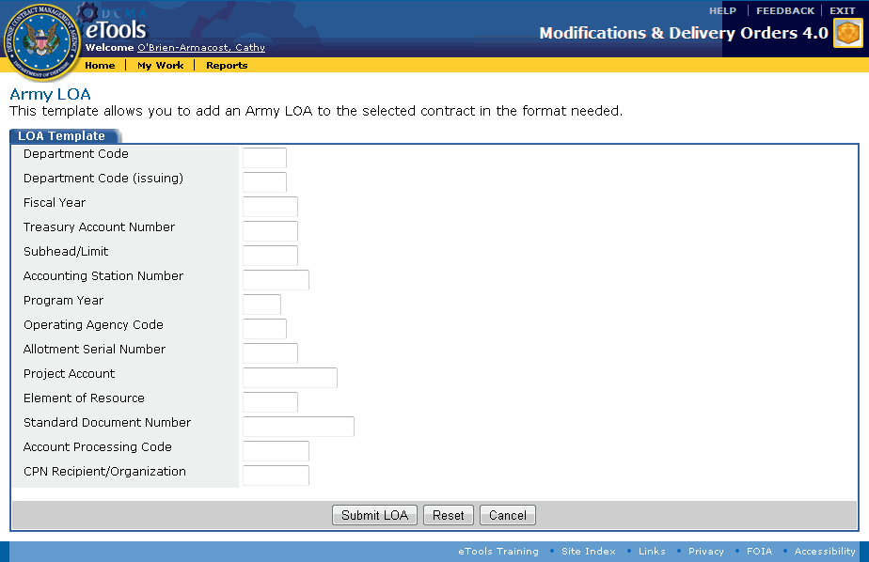

Figure 51: Army LOA page

The Army LOA template contains the following fields (maximum characters allowed is shown):

* Department Code (2 characters)
* Department Code (Issuing) (2 characters)
* Fiscal Year (4 characters)
* Treasury Account Number (4 characters)
* Subhead/Limit (4 characters)
* Accounting Station Number (6 characters)
* Program Year (1 character)
* Operating Agency Code (2 characters)
* Allotment Serial Number (4 characters)
* Project Account (11 characters)
* Element of Resource (4 characters)
* Standard Document Number (14 characters)
* Account Processing Code (6 characters)
* CPN Recipient/Organization (6 characters)

**To view a template to help you build an Air Force Long Line of Accounting,** click the Air Force LOA button. The Air Force LOA page appears (Figure 52).

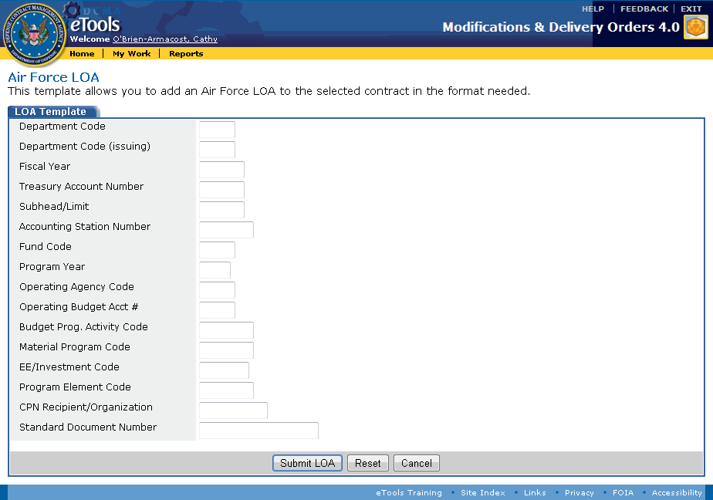

Figure 52: Air Force LOA page

The Air Force LOA template contains the following fields (maximum characters allowed is shown):

* Department Code (2 characters)
* Department Code (Issuing) (2 characters)
* Fiscal Year (4 characters)
* Treasury Account Number (4 characters)
* Subhead/Limit (4 characters)
* Accounting Station Number (6 characters)
* Fund Code (2 characters)
* Program Year (1 character)
* Operating Agency Code (2 characters)
* Operating Budget Acct # (2 characters)
* Budget Prog. Activity Code (6 characters)
* Material Program Code (6 characters)
* EE/Investment Code (5 characters)
* Program Element Code (6 characters)
* CPN Recipient/Organization (8 characters)
* Standard Document Number (17 characters)

**To view a template to help you build a DLA/Other DoD Long Line of Accounting,** click the DLA/Other DoD LOA button. The DLA/Other DoD LOA page appears (Figure 53).

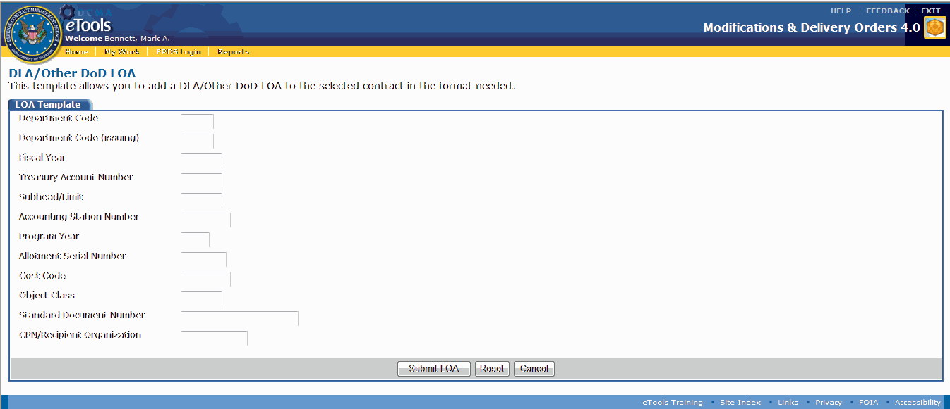

Figure 53: DLA/Other DoD LOA page

The DLA/Other DoD LOA template contains the following fields (maximum characters allowed is shown):

* Department Code (2 characters)
* Department Code (Issuing) (2 characters)
* Fiscal Year (4 characters)
* Treasury Account Number (4 characters)
* Subhead/Limit (4 characters)
* Accounting Station Number (6 characters)
* Program Year (1 character)
* Allotment Serial Number (5 characters)
* Cost Code (6 characters)
* Object Class (4 characters)
* Standard Document Number (17 characters)
* CPN/Recipient Organization (8 characters)

1. Use the selected LOA template to type the LOA.
2. Click the Submit LOA button to populate the Long Line of Accounting on the Add ACRN Page.
3. Click the Add button on the Add ACRN Page.

The buttons on the Add ACRN Page perform the following functions:

Add: Adds the ACRN to the delivery order or contract modification. The new ACRN appears on the [Browse ACRNs Page](#acrn_t_browsing_acrns_htm).

Reset: Clears data you have typed.

Cancel: Closes the Add ACRN Page and displays the Browse ACRNs Page. No ACRN will be added to the contract or appear on the Browse ACRNs Page.

### DCMA Policy: LOA and FPDS

### The Treasury Account Symbol

The Treasury Account Symbol (TAS), a portion of the Line of Accounting (LOA), must be properly entered into MDO so that a related FPDS CAR can pass [FPDS validation](#generating_an_fpds_car_before_re_8330); the FPDS Treasury Account Symbol (TAS) is mapped from MDO.

The TAS is composed of three primary data fields:

* Department Code (mandatory, two numeric)
* Treasury Account (mandatory, four alpha-numeric)
* Sub Account (three numeric, mandatory when FMS indicator "11" is present in LOA, otherwise null)

The US Treasury symbol includes the Department Code (period of availability/fiscal year) and Treasury Account number (basic symbol) prescribed by the US Treasury Department.

The **Department Code** (also known as the "**Agency Identifier**") is a two or four-digit code, which identifies the military department or government entity receiving the appropriation.

The **Treasury Account** number (also known as the "**Main Account**" number) is a four-digit code indicating the type of funds or major purpose of the appropriation.

Foreign Military Sales (FMS) funds are appropriated to the Executive Office of the President department code 11, when present in the LOA; the FMS three position **Sub Account** is applicable. Otherwise, the Sub Account value is null or "000."

Each data field is a separate component of the DoD DFAS Line of Accounting required for MOCAS.

The three data fields are validated in FPDS against GSA tables.

### LOA Errors

The LOA cannot be edited in MDO after a new Delivery Order or funding Modification has been [released](#all_t_releasing_a_mod_htm).

If the MDO LOA has errors in positions 1 through 10, the FPDS CAR Treasury Account Symbol will not validate and returns the following error message:

The "Treasury Account Symbol" code is not valid. Please enter a valid "Treasury Account Symbol" code or contact your Agency Administrator.

Always make sure that the Draft FPDS CAR does not contain a Treasury Account Symbol error before [releasing a MOD or delivery order](#all_t_releasing_a_mod_htm) containing a new LOA (see the topics for [Viewing](#acrn_t_viewing_an_acrn_htm), [Adding](#acrn_t_adding_an_acrn_htm), and [Editing](#acrn_t_updating_an_acrn_htm) an ACRN).

* The LOA cannot be edited after the MOD or order has been released. As a result, it may be necessary to issue a modification to correct the erroneous data.

After MOD release, correction of the Line of Accounting (LOA) and FPDS Treasury Account Symbol (TAS) would require:

* Editing obligated amount on erroneous LOA and creating new (correct) LOA.
* Canceling the modification and starting over.
* Finalizing the FPDS CAR (with an erroneous) TAS and releasing the MDO document with an erroneous LOA, then manually correcting the FPDS Treasury Account Symbol. FPDS will accept a null TAS.

### Four Major LOA Patterns

A review performed on the Procurement Activities Lines of Accounting (LOAs) revealed that there are four major patterns of LOAs.

The Treasury Symbol data (that is, the Department Code and Treasury Account number) and position of that data in the LOA as received by DCMA are shown in these four patterns (Figure 54).

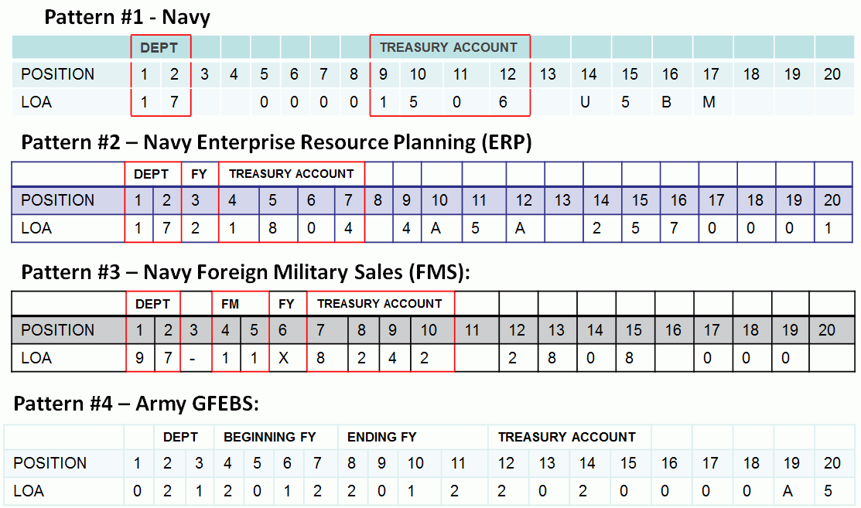

Figure 54: Four major LOA patterns

#### MDO's LOA Data Field

The following scenarios describe how you can identify the Treasury Symbol data in an LOA and reposition the data in the LOA (for input into MDO) for FPDS validation.

***Scenario One*:** You receive a funding document with the following LOA:

17  00001506 U5BM     050120 252000190    2D 000000 A00000903513

**Step 1** – Identify which of the four major LOA patterns matches your funding LOA. You identify pattern #1 - Navy (Figure 55).

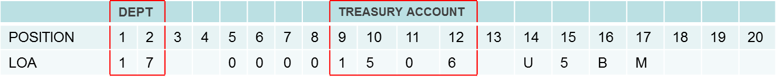

Figure 55: LOA Pattern 1

**Step 2** – Remove the two spaces in position 3 and 4. The resulting LOA is as follows (Figure 56):



Figure 56: LOA with spaces 3 and 4 removed

**Step 3** – Verify that the Department Code is in position one and two and the Treasury Account number is in positions seven through 10.

The FPDS system validates the Department code and the Treasury Account number by checking positions 1 and 2 for the Department Code and positions 7 through 10 for the Treasury Account number.

Therefore, the position of the data that is input into MDO is very important when adding a new Line of Accounting to a contract by issuing a modification or when issuing a new delivery order.

If the Treasury Symbol data (Department Code & Treasury Account number) is out of position, it will be rejected by the FPDS Validation process.

In order to properly reposition the LOA Treasury Symbol for input into MDO, follow the three steps listed.

***Scenario Two*:** You receive a funding document with the following LOA:

1721804 4A5A 2570001900501202D000000A00000912744050120

**Step 1** – Identify which of the four major patterns matches your funding LOA. You identify pattern #2 - Navy Enterprise Resource Planning (ERP) (Figure 57).

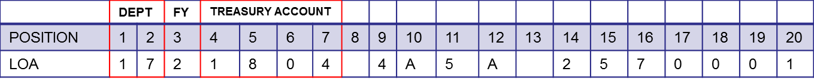

Figure 57: LOA Pattern 2

**Step 2** – Add three spaces after the Department code (17) (Figure 58).

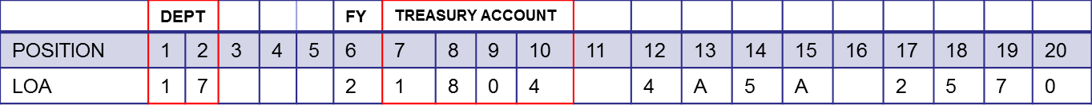

Figure 58: LOA with spaces after Department Code

**Step 3** – Verify that the Department code is in positions 1 and 2 and that the Treasury Account number is in positions 7 through 10.

***Scenario Three*:** You receive a funding document with the following LOA:

97-11X8242 2808 000 74 082 0 065916 2D PFRT44 930680020GUR

**Step 1** – Identify which of the four major LOA patterns matches your funding LOA. You identify pattern #3 - Navy Foreign Military Sales (FMS) (Figure 59).

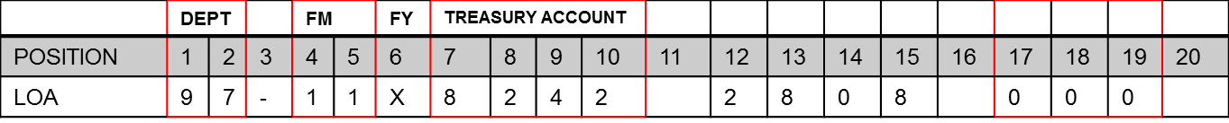

Figure 59: LOA Pattern 3

**Step 2** – The FMS indicator “11” must be in positions 3 and 4.  Therefore, delete the dash "-" in position 3. Leave a space in front of the “X” in position 6 (Figure 60).



Figure 60: LOA with dash removed, FMS indicator repositioned, space added

**Step 3** – Verify that the Department code is in positions 1 and 2 and that the Treasury Account number is in positions 7 through 10.

When the LOA has a Foreign Military (FM) fund indication as shown in Pattern #3, positions 4 and 5 contain 11; you must also locate the three-digit mandatory Sub Account number located in positions 17 through 19.

Follow the steps listed.

The FMS indicator "11" must be in positions three and four for the Treasury Symbol to pass FPDS validation.

***Scenario Four*:** You receive a funding document with the following LOA:

021201220122020000A57FB324020TFNC257500101483550040051883021001

**Step 1** – Identify which of the 4 major LOA patterns matches your funding LOA. You identify pattern #4 - Army GFEBS (Figure 61).

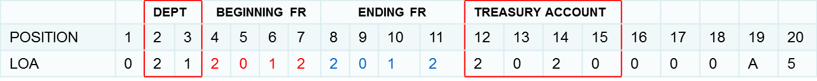

Figure 61: LOA Pattern 4

**Step 2** – Delete the “0” in the first position. Delete the two digits of the beginning and ending years representing the obligation period (Figure 62).

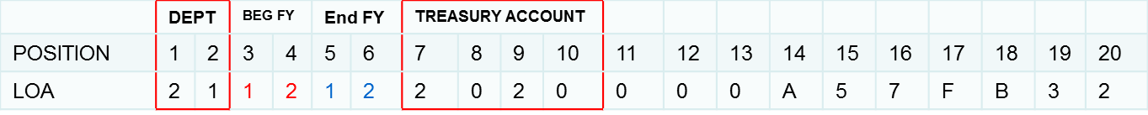

Figure 62: LOA with digits deleted

**Step 3** – Verify that the Department code is in positions 1 and 2 and that the Treasury Account number is in positions 7 through 10.

### Review: Parts of the LOA and FPDS

(Figure 63)

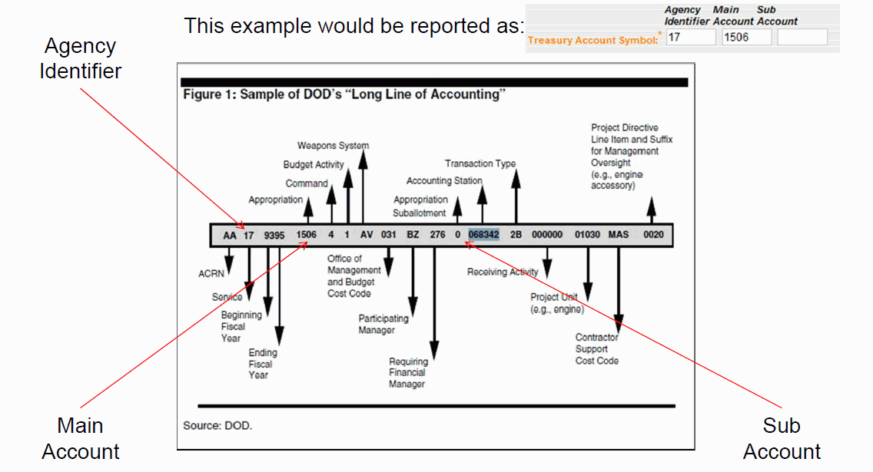

Figure 63: Sample LOA

**Note**: The Agency Identifier (Department Code), Main Account number (Treasury Account number), the Sub Account number, and their corresponding positions within the Treasury Account Symbol (which appears on the FPDS CAR).

See the FPDS CARs section of this online Help user's manual for more information on FPDS CARs.

See the topic [Additional Resources](#additional_resources_htm) for additional help with LOAs and FPDS.

Images and Data taken from DCMA's Line of Accounting Treasury Symbol ppt, MDO LOA ppt, and FPDS Training for CMOs-Phase 2 pdf. Topic About MDO highlights what was to be covered in manual.

## Editing an ACRN

The ACO and CA user roles can edit ACRNs.

To edit an ACRN, do the following:

1. Locate the MOD whose ACRN you wish to edit. See the topic [Browsing Contract Modifications](#contract_mods_t_browsing_contrac_4723) or [Browsing Delivery Orders](#delivery_orders_t_browsing_deliv_8362) to locate a MOD; also, see the topic [Browsing ACRNs](#acrn_t_browsing_acrns_htm).
2. On the Browse ACRNs page, click the i_pencil.gif edit icon for the ACRN you wish to edit (Figure 64).

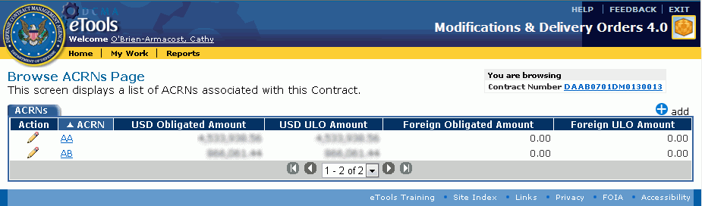

Figure 64: Edit icon

The Edit ACRN Page appears (Figure 65).

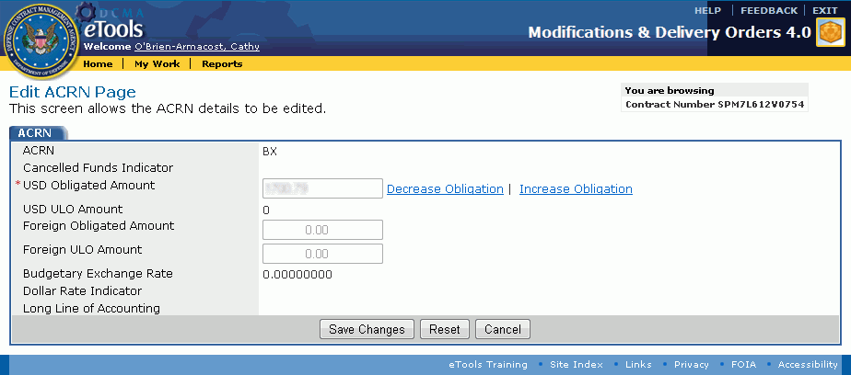

Figure 65: Edit ACRN Page

The Obligated Amount is displayed but cannot be edited directly.

**To decrease the obligation,** click the Decrease Obligation link. The Decrease Obligation dialog box appears (Figure 66).

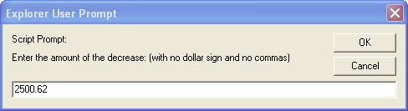

Figure 66: Decrease Obligation dialog box

Type the amount by which you wish to decrease the obligation amount, then click the OK button. The Obligation Amount shown on the Edit ACRN Page decreases by that amount.

**To increase the obligation,** click the Increase Obligation link. The Increase Obligation dialog box appears (Figure 67).

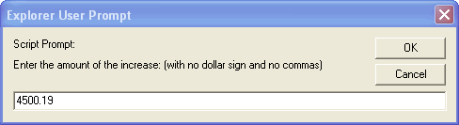

Figure 67: Increase Obligation dialog box

Type the amount by which you wish to increase the obligation amount, then click the OK button. The Obligation Amount shown on the Edit ACRN Page increases by that amount.

1. Make any additional edits.   
   **Note:** The Long Line of Accounting is editable if you added it to the MOD.
2. Click the Save Changes button.

The buttons on the Edit ACRN Page have the following functions:

Save Changes: Saves the updates made to the ACRN and displays the View ACRN Page.

Reset: Clears data you have typed.

Cancel: Closes the Edit ACRN Page and displays the View ACRN Page. No changes will be saved.

To view the MOD, on the Browse ACRNs Page, click the Contract Number link. See the topic [Managing a Contract Modification](#contract_mods_t_managing_a_contr_6912) or [Managing a Delivery Order](#delivery_orders_t_managing_a_del_5335) for more information.

To view the Browse ACRNs Page, on the View ACRN Page, click the OK button. See the topic [Browsing ACRNs](#acrn_t_browsing_acrns_htm) for more information.

To edit the ACRN shown on the View ACRN Page, click the edit edit link.

To view line items associated with an ACRN, on the View ACRN Page, in the Line Items for this ACRN tab, click the CLIN link for the line item you wish to view. See the topic [Viewing a Line Item](#line_items_t_viewing_a_line_item_2062) for more information.

To add line items to the ACRN, see the topic [Adding a Line Item](#line_items_t_adding_a_line_item__2572).

## Deleting an ACRN

When you generate a contract modification, it might also generate ACRNs.

* There is no means to delete auto-generated ACRNs from the contract modification.
* ACRNs that you have added to a generated contract modification or delivery order can be deleted by viewing the change history. See the topic [Browsing Changes](#all_t_browsing_changes_htm) for more information.

# Clauses and Provisions

## Browsing Provisions and Clauses

The ACO and CA user roles can browse clauses and provisions.

The Section I - Clauses and Provisions tab appears on the [Manage MOD Page](#contract_mods_t_managing_a_contr_6912) and the [Manage Delivery Order Page](#delivery_orders_t_managing_a_del_5335).

This functionality is not available on the Manage EDA MOD Page.

**To browse special provisions,** do the following:

1. Locate the MOD whose special provisions you wish to browse. See the topic [Browsing Contract Modifications](#contract_mods_t_browsing_contrac_4723) or [Browsing Delivery Orders](#delivery_orders_t_browsing_deliv_8362) to locate a MOD.
2. On the Manage MOD Page or the Manage Delivery Order Page, click the Browse Clauses and Provisions link (Figure 68).

Section I - Clauses and Provisions tab

Figure 68: Section I - Clauses and Provisions tab

The Section I - Clauses and Provisions Page appears (Figure 69).

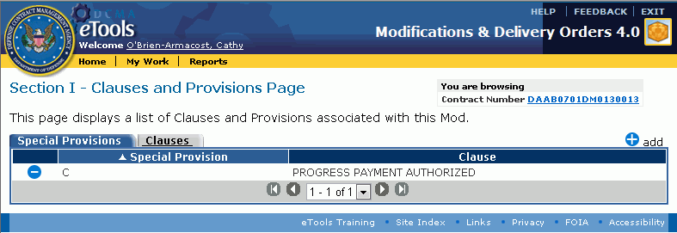

Figure 69: Section I - Clauses and Provisions Page

This page lists the special provisions currently associated with the MOD. The Special Provisions tab is displayed by default.

You cannot edit an existing special provision, but you can delete a special provision, then add the special provision you need.

To add a special provision, on the Section I - Clauses and Provisions Page, click the add add link. See the topic [Adding a Provision or Clause](#sp_prov_t_adding_special_provisi_7485) for more information.

**To view a clause,** on the Section I - Clauses and Provisions Page, click the Clauses tab. The Clauses tab is displayed (Figure 70).

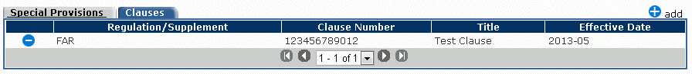

Figure 70: Clauses tab

To add a clause, on the Section I - Clauses and Provisions Page, click the add add link. See the topic [Adding a Provision or Clause](#sp_prov_t_adding_special_provisi_7485) for more information.

Deleting a Provision or Clause

To delete a special provision, on the Section I - Clauses and Provisions Page, in the Special Provisions tab, click the delete delete icon for the special provision you wish to delete. The special provision no longer appears on the Section I - Clauses and Provisions Page.

To delete a clause, on the Section I - Clauses and Provisions Page, in the Clauses tab, click the delete delete icon for the clause you wish to delete. The clause no longer appears on the Section I - Clauses and Provisions Page.

To view the MOD, on the Section I - Clauses and Provisions Page, click the Contract Number link. The [Manage MOD Page](#contract_mods_t_managing_a_contr_6912) or [Manage Delivery Order Page](#delivery_orders_t_managing_a_del_5335) appears. See the topic [Managing a Contract Modification](#contract_mods_t_managing_a_contr_6912) or [Managing a Delivery Order](#delivery_orders_t_managing_a_del_5335) for more information.

## Adding a Provision or Clause

### Adding a Special Provision

The ACO and CA user roles can add a special provision.

Special provisions are not applicable to EDA-only contract modifications.

To add a special provision to a contract modification or delivery order, do the following:

1. Locate the MOD to which you wish to add a special provision. See the topic [Browsing Contract Modifications](#contract_mods_t_browsing_contrac_4723) or [Browsing Delivery Orders](#delivery_orders_t_browsing_deliv_8362) to locate a MOD; also, see the topic [Browsing Provisions and Clauses](#sp_prov_t_browsing_special_provi_9455).
2. On the Manage MOD Page or Manage Delivery Order Page, click the Browse Clauses and Provisions link. The Section I - Clauses and Provisions Page appears.
3. Click the i_add.gif add link. The Add [MOD or Delivery Order] Special Provision Page appears (Figure 71).

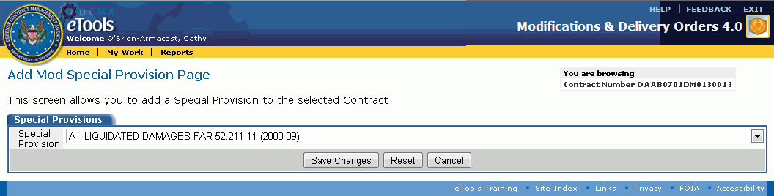

Figure 71: Add Special Provision Page

1. Select a special provision from the drop-down list box.
2. Click the Save Changes button.

The buttons at the bottom of the Add Special Provision Page perform the following functionality:

Save Changes: Adds the special provision to the contract modification.

Reset: Clears data you have selected on the page.

Cancel: Cancels the current action, closes the Add MOD Special Provision page.

### Adding a Clause

The ACO and CA user roles can add a clause.

Clauses are not applicable to EDA-only contract modifications.

To add a clause to a contract modification or delivery order, do the following:

1. Locate the MOD to which you wish to add a clause. See the topic [Browsing Contract Modifications](#contract_mods_t_browsing_contrac_4723) or [Browsing Delivery Orders](#delivery_orders_t_browsing_deliv_8362) to locate a MOD; also, see the topic [Browsing Provisions and Clauses](#sp_prov_t_browsing_special_provi_9455).
2. On the Manage MOD Page or Manage Delivery Order Page, click the Browse Clauses and Provisions link. The Section I - Clauses and Provisions Page appears.
3. Click the Clauses tab. The Clauses tab is displayed.
4. Click the i_add.gif add link. The Add [MOD or Delivery Order] Clause Page appears (Figure 72).

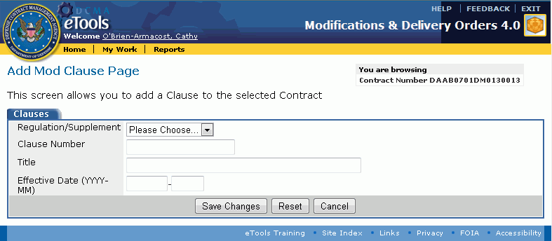

Figure 72: Add MOD Clause Page

1. Select the Regulation/Supplement from the drop-down list box.
2. Type the Clause Number in the text box provided (12 characters allowed).
3. Type the clause's Title in the text box provided (50 characters allowed).
4. Type the Effective Date in the text boxes provided (use the format yyyy-mm).
5. Click the Save Changes button.

The buttons at the bottom of the Add Clause Page perform the following functionality:

Save Changes: Adds the clause to the MOD.

Reset: Clears data you have entered on the page.

Cancel: Cancels the current action, closes the Add Clause Page.

# Line Items

## Browsing Line Items

The ACO and CA user roles can browse line items.

Line items are not applicable to EDA-only contract modifications.

**To browse a list of the line items for a contract modification or delivery order,** do the following:

1. Locate the MOD whose line items you wish to browse. See the topic [Browsing Contract Modifications](#contract_mods_t_browsing_contrac_4723) or [Browsing Delivery Orders](#delivery_orders_t_browsing_deliv_8362) to locate a MOD.
2. On the Manage MOD Page or Manage Delivery Order Page, click the Browse Line Items link (Figure 73).

Browse Line Items link

Figure 73: Browse Line Items link

The Browse Line Items Page appears (Figure 74).

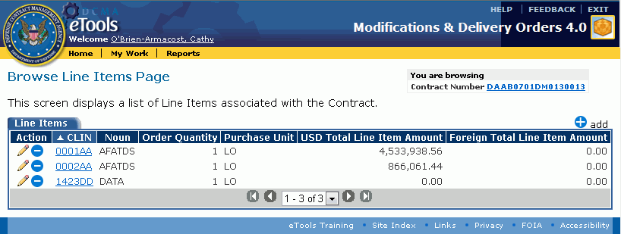

Figure 74: Browse Line Items Page

To view a line item, on the Browse Line Items Page, click the CLIN link for the line item you wish to view. The View Line Item Page appears. See the topic [Viewing a Line Item](#line_items_t_viewing_a_line_item_2062) for more information.

To view the MOD, click the Contract Number link. The [Manage MOD Page](#delivery_orders_t_editing_a_deli_9154) or [Manage Delivery Order Page](#delivery_orders_t_editing_a_deli_9154) appears. See the topics [Editing a Contract Modification](#contract_mods_t_editing_a_contra_2108) and [Editing a Delivery Order](#delivery_orders_t_editing_a_deli_9154) for more information.

To add a line item, on the Browse Line Items Page, click the i_add.gif add link. The Add Line Item Page appears. See the topic [Adding a Line Item](#line_items_t_adding_a_line_item__2572) for more information.

To edit a line item, on the Browse Line Items Page, click the edit edit icon for the line item you wish to edit. The Edit Line Item Page appears. See the topic [Editing a Line Item](#line_items_t_editing_a_line_item_5449) for more information.

To delete a line item, on the Browse Line Items Page, click the delete delete icon for the line item you wish to delete. The line item is deleted from the contract modification or delivery order.

## Viewing a Line Item

The ACO and CA roles can view a line item.

Line items are not applicable to EDA-only contract modifications.

**To view the line items for a contract modification or delivery order,** do the following:

1. Locate the MOD whose line item you wish to view. See the topic [Browsing Contract Modifications](#contract_mods_t_browsing_contrac_4723) or [Browsing Delivery Orders](#delivery_orders_t_browsing_deliv_8362) to locate a MOD; also, see the topic [Browsing Line Items](#line_items_t_browsing_line_items_5523).
2. On the Manage MOD Page or Manage Delivery Order Page, click the Browse Line Items link. The Browse Line Items Page appears.
3. On the Browse Line Items Page, click the CLIN link for the line item you wish to view. The View Line Item Page appears (Figure 75).

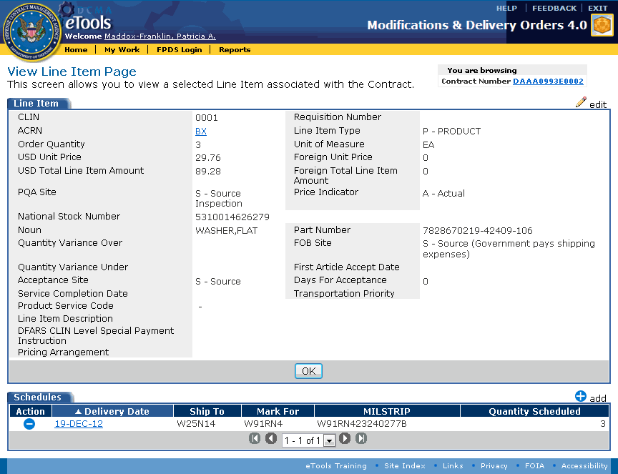

Figure 75: View Line Item Page

To view the MOD, click the Contract Number link. See the topic [Managing a Contract Modification](#contract_mods_t_managing_a_contr_6912) or [Managing a Delivery Order](#delivery_orders_t_managing_a_del_5335) for more information.

To browse line items, on the View Line Item Page, click the OK button. The [Browse Line Items Page](#line_items_t_browsing_line_items_5523) appears. See the topic [Browsing Line Items](#line_items_t_browsing_line_items_5523) for more information.

To edit the line item, on the View Line Item Page, click the i_pencil.gif edit link. The [Edit Line Item Page](#line_items_t_editing_a_line_item_5449) appears. See the topic [Editing a Line Item](#line_items_t_editing_a_line_item_5449) for more information.

To see the View ACRN Page, on the View Line Item Page, in the Line Item tab, click the link for the ACRN. The [View ACRN Page](#acrn_t_viewing_an_acrn_htm) appears. See the topic [Viewing an ACRN](#acrn_t_viewing_an_acrn_htm) for more information.

To view a schedule associated with the line item, on the View Line Item Page, in the Schedules tab, click the link for the Delivery Date. See the topic [Viewing a Schedule](#line_items_t_viewing_a_schedule__5676) for more information.

To add a schedule to the line item, on the View Line Item Page, click the i_add.gif add link. See the topic [Adding a Schedule to a Line Item](#line_items_t_adding_a_schedule_t_2094).

To delete a schedule from the line item, on the View Line Item Page, in the Schedules tab, click the delete icon delete for the schedule you wish to delete. The schedule will be deleted.

## Adding a Line Item

The ACO and CA user roles can add a line item.

To add a line item to a contract modification or delivery order, do the following:

1. Locate the MOD to which you wish to add a line item. See the topic [Browsing Contract Modifications](#contract_mods_t_browsing_contrac_4723) or [Browsing Delivery Orders](#delivery_orders_t_browsing_deliv_8362) to locate a MOD; also, see the topic [Browsing Line Items](#line_items_t_browsing_line_items_5523).
2. On the Browse Line Items Page, click the add add link. The Add Line Item Page appears (Figure 76).

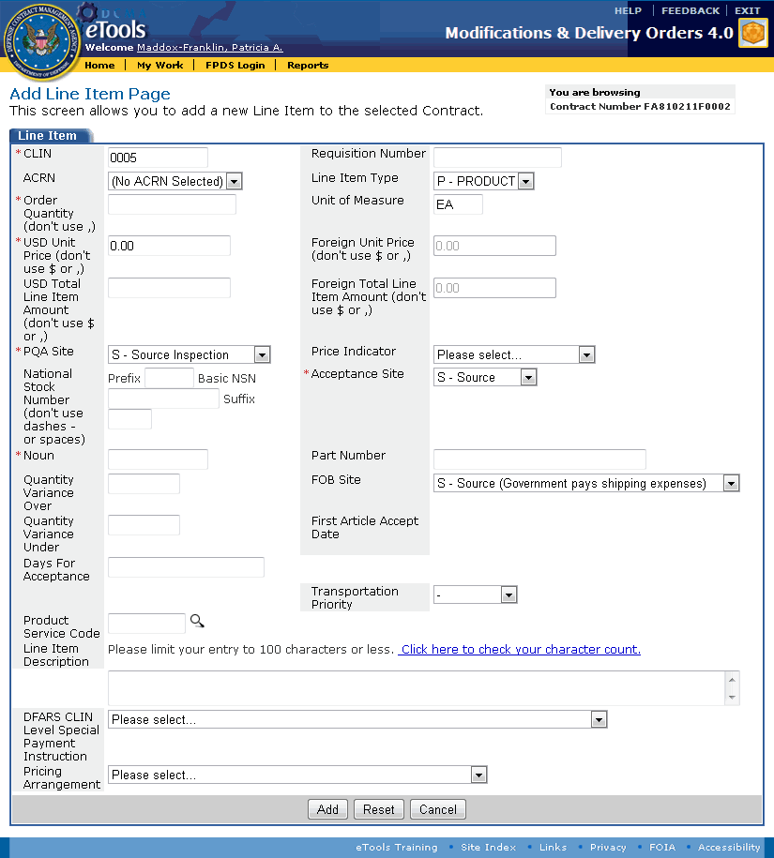

Figure 76: Add Line Item Page

1. Select or type information on this page as follows; an asterisk (\*) indicates that the information is required:

CLIN: Type a unique contract line item number. No other CLIN for this mod should have this same number.

Requisition Number: Type the requisition number for the line item.

ACRN: Select an ACRN from the drop-down list box.

Line Item Type: Select the type of line item from the list of options.

Order Quantity: Type a number to show the quantity of items ordered. Do not type a comma (,) in this box.

Unit of Measure: Select the relevant unit of measure from the list of options.

USD Unit Price: Text box appears only if the Line Item Type selection is Product. Type a number to show the cost for the type of item ordered. Do not type a dollar sign or comma in this box. You can specify cents.

**Foreign Unit Price:** Displays the unit price in currency other than USD.

USD Total Line Item Amount: Displays the product of the order quantity and unit price. You can type a different price in this box. Do not type a dollar sign ($) or comma (,) in this box. You can use a decimal point (.) to specify cents.

**Foreign Total Line Item Amount:** Displays the total line item amount in currency other than USD.

PQA Site: Select the site where PQA will be performed from the drop-down list box.

**P**rice Indicator: Select the Price Indicator from the drop-down list box. Appears in the PDF; see the topic [Printing Documents](#all_o_printing_documents_htm) for more information.

National Stock Number: Type the National Stock Number (NSN) in the boxes provided. Do not type dashes or spaces.

Acceptance Site: Select the site where acceptance will be performed from the drop-down list box.

Noun: Type the noun in this box.

Part Number: Type the part number in the box provided.

Quantity Variance Over: Type the acceptable quantity variance over in this box.

FOB Site: Select the Free On Board site from the drop-down list box.

Quantity Variance Under: Type the acceptable quantity variance under in this box.

**First Article Accept Date:** Displays the First Article Accept Date.

Days for Acceptance: Text box appears only when you add the line item and if the Line Item Type selection is Product. Type the number of days for acceptance in this box.

**Service Completion Date:** Text box appears only when you add the line item and if the Line Item Type selection is Service. Type the date using the format dd mmm yyyy or click the calendar icon calendar.gif to select a date from a pop-up calendar.

Transportation Priority: Drop-down list box appears only if the Line Item Type selection is Product. Select the transportation priority from the drop-down list box.

P**roduct Service Code:** Type the Product Service Code in the text box, or click the search icon i_search.gif to search for and select a product service code. If you click the search icon i_search.gif, the Product Service Code Search tab appears in a new window (Figure 77).

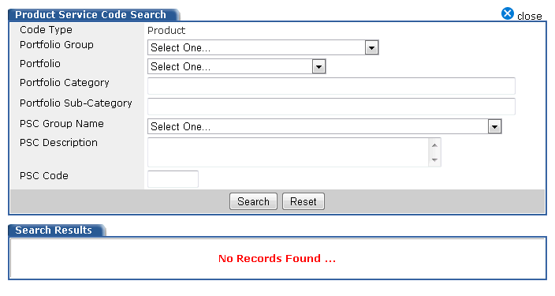

Figure 77: Product Service Code Search tab

1. Enter search criteria in any, all, or none of the fields in the Product Service Code Search tab (menu options are based on the DoD Portfolio Taxonomy):
   1. Select an item from the following drop-down list boxes: Portfolio Group, Portfolio, PSC Group Name.
   2. Type applicable data in the following text boxes: Portfolio Category, Portfolio Sub-Category, PSC Description, PSC Code.
2. Click the Search button. Search results appear in the Search Results tab (Figure 78).

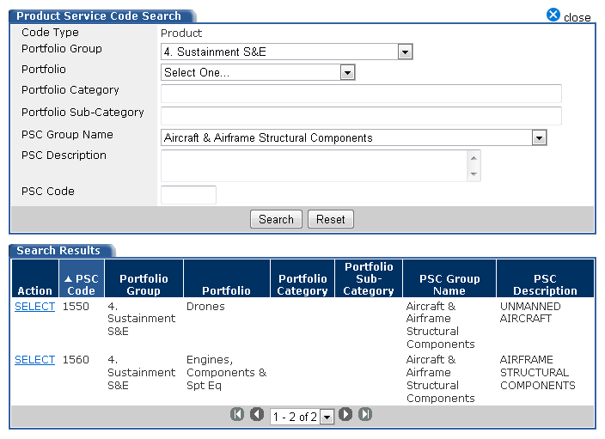

Figure 78: Search Results tab

1. Click the SELECT link for the PSC Code you wish to select. The Add Line Item Page appears with the Product Service Code you selected.

Line Item Description: Type your notes, up to 100 characters, regarding the line item.

**DFARS CLIN Level Special Payment Instruction:** Select the DFARS CLIN Level Special Payment Instruction from the drop-down list box.

Pricing Arrangement: Select the Pricing Arrangement from the drop-down list box. Appears in the PDF; see the topic [Printing Documents](#all_o_printing_documents_htm) for more information.

Once the Pricing Arrangement is selected, the following dialog box appears (Figure 79), notifying the user that the Pricing Arrangement Value must be referenced in the Remarks section of the mod; see the Closing Remarks information in the topic [Adding Free Text to a Contract Modification](#contract_mods_t_adding_free_text_1650) or the topic [Adding Free Text to a Delivery Order](#delivery_orders_t_adding_free_te_8549):

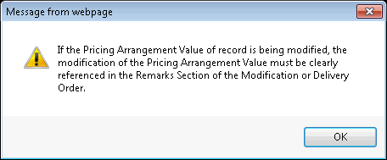

Figure 79: Dialog box

**[Various Items]:** Based upon the Pricing Arrangement selected, an additional text box (or text boxes) may appear beneath the Pricing Arrangement field (Figure 80). Type applicable data in these additional text boxes (for text boxes requiring dollar amounts, do not type a dollar sign ($) or comma (,) in this box. You can use a decimal point (.) to specify cents).

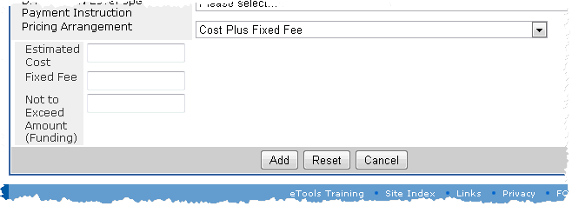

Figure 80: Text boxes

1. Click the Add button. A Confirmation tab appears.

The buttons on the Add Line Item Page perform the following actions:

Add: Adds the line item to the delivery order or contract. A confirmation page appears to show that the line item has been added. The new line item appears on the [Browse Line Items Page](#line_items_t_browsing_line_items_5523).

Reset: Clears data you have typed or selected.

Cancel: Cancels the current action. The Add Line Item Page closes and the [Browse Line Items Page](#line_items_t_browsing_line_items_5523) appears.

Links in the Confirmation tab do the following:

View this Line Item: Displays the View Line Item Page. See the topic [Viewing a Line Item](#line_items_t_viewing_a_line_item_2062) for more information.

Add a Schedule to this Line Item: Displays the Add Schedule Page, where you can add a schedule to the line item. See the topic [Adding a Schedule to a Line Item](#line_items_t_adding_a_schedule_t_2094) for more information.

Add Similar Line Item: Displays the Add Line Item Page with the data from the previous line item added present in all boxes except for the CLIN. The CLIN is incremented by 1 so that it is unique.

Back to Browse Line Items: Displays the Browse Line Items Page. See the topic [Browsing Line Items](#line_items_t_browsing_line_items_5523) for further information.

One of the following links will appear:

Back to Manage MOD: Displays the Manage MOD Page. See the topic [Managing a Contract Modification](#contract_mods_t_managing_a_contr_6912) for more information.

Back to Manage Delivery Order: Displays the Manage Delivery Order Page. See the topic [Managing a Delivery Order](#delivery_orders_t_managing_a_del_5335) for more information.

## Editing a Line Item

The ACO and CA user roles can edit a line item.

To edit a line item, do the following:

1. Locate the MOD whose line item you wish to edit. See the topic [Browsing Contract Modifications](#contract_mods_t_browsing_contrac_4723) or [Browsing Delivery Orders](#delivery_orders_t_browsing_deliv_8362) to locate a MOD; also, see the topic [Browsing Line Items](#line_items_t_browsing_line_items_5523).
2. On the Browse Line Items Page, click the edit edit icon for the line item you wish to edit. The Edit Line Item Page appears (Figure 81).

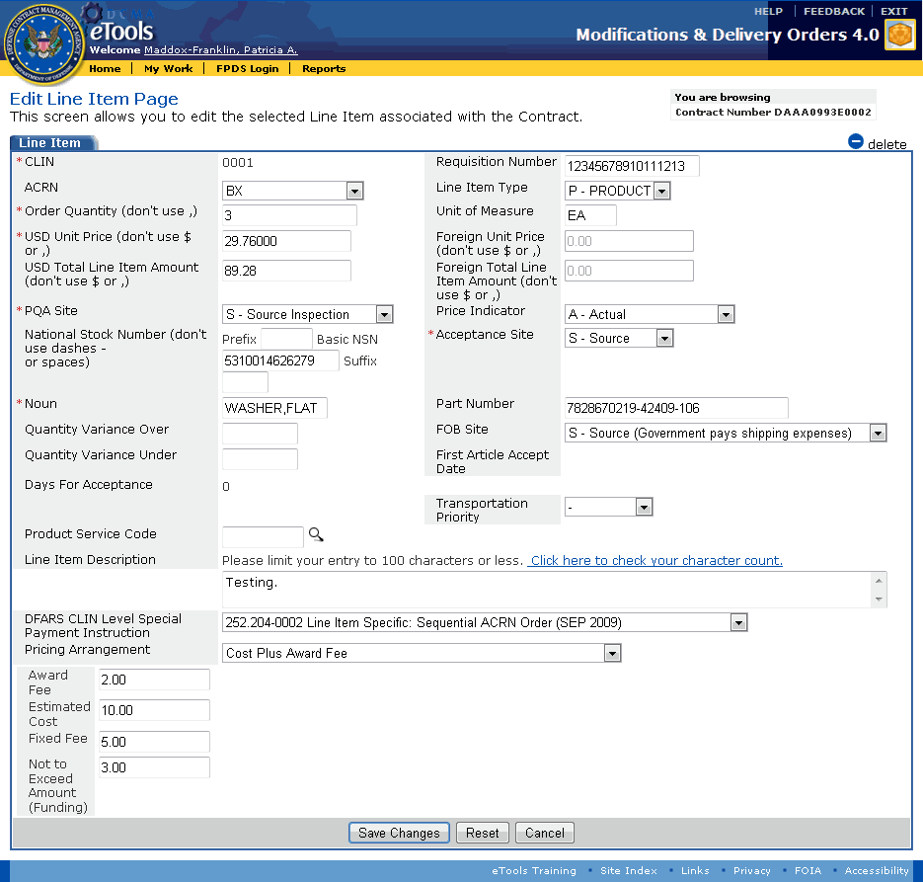

Figure 81: Edit Line Item Page

1. Select or type information on this page as follows; an asterisk (\*) indicates that the information is required:

CLIN: Type a unique contract line item number. No other CLIN for this mod should have this same number.

Requisition Number: Type the requisition number for the line item.

ACRN: Select an ACRN from the drop-down list box.

Line Item Type: Select the type of line item from the list of options.

Order Quantity: Type a number to show the quantity of items ordered. Do not type a comma (,) in this box.

Unit of Measure: Select the relevant unit of measure from the list of options.

USD Unit Price: Text box appears only if the Line Item Type selection is Product. Type a number to show the cost for the type of item ordered. Do not type a dollar sign or comma in this box. You can specify cents.

**Foreign Unit Price:** Displays the unit price in currency other than USD.

USD Total Line Item Amount: Displays the product of the order quantity and unit price. You can type a different price in this box. Do not type a dollar sign ($) or comma (,) in this box. You can use a decimal point (.) to specify cents.

**Foreign Total Line Item Amount:** Displays the total line item amount in currency other than USD.

PQA Site: Select the site where PQA will be performed from the drop-down list box.

**P**rice Indicator: Select the Price Indicator from the drop-down list box. Appears in the PDF; see the topic [Printing Documents](#all_o_printing_documents_htm) for more information.

National Stock Number: Type the National Stock Number (NSN) in the boxes provided. Do not type dashes or spaces.

Acceptance Site: Select the site where acceptance will be performed from the drop-down list box.

Noun: Type the noun in this box.

Part Number: Type the part number in the box provided.

Quantity Variance Over: Type the acceptable quantity variance over in this box.

FOB Site: Select the Free On Board site from the drop-down list box.

Quantity Variance Under: Type the acceptable quantity variance under in this box.

**First Article Accept Date:** Displays the First Article Accept Date.

Days for Acceptance: Text box appears only when you add the line item and if the Line Item Type selection is Product. Type the number of days for acceptance in this box.

**Service Completion Date:** Text box appears only when you add the line item and if the Line Item Type selection is Service. Type the date using the format dd mmm yyyy or click the calendar icon calendar.gif to select a date from a pop-up calendar.

Transportation Priority: Drop-down list box appears only if the Line Item Type selection is Product. Select the transportation priority from the drop-down list box.

P**roduct Service Code:** Type the Product Service Code in the text box, or click the search icon i_search.gif to search for and select a product service code. If you click the search icon i_search.gif, the Product Service Code Search tab appears in a new window (Figure 82).



Figure 82: Product Service Code Search tab

1. Enter search criteria in any, all, or none of the fields in the Product Service Code Search tab (menu options are based on the DoD Portfolio Taxonomy):
   1. Select an item from the following drop-down list boxes: Portfolio Group, Portfolio, PSC Group Name.
   2. Type applicable data in the following text boxes: Portfolio Category, Portfolio Sub-Category, PSC Description, PSC Code.
2. Click the Search button. Search results appear in the Search Results tab (Figure 83).



Figure 83: Search Results tab

1. Click the SELECT link for the PSC Code you wish to select. The Add Line Item Page appears with the Product Service Code you selected.

Line Item Description: Type your notes, up to 100 characters, regarding the line item.

**DFARS CLIN Level Special Payment Instruction:** Select the DFARS CLIN Level Special Payment Instruction from the drop-down list box.

Pricing Arrangement: Select the Pricing Arrangement from the drop-down list box. Appears in the PDF; see the topic [Printing Documents](#all_o_printing_documents_htm) for more information.

Once the Pricing Arrangement is selected, the following dialog box appears (Figure 84), notifying the user that the Pricing Arrangement Value must be referenced in the Remarks section of the mod; see the Closing Remarks information in the topic [Adding Free Text to a Contract Modification](#contract_mods_t_adding_free_text_1650) or the topic [Adding Free Text to a Delivery Order](#delivery_orders_t_adding_free_te_8549):



Figure 84: Dialog box

**[Various Items]:** Based upon the Pricing Arrangement selected, an additional text box (or text boxes) may appear beneath the Pricing Arrangement field (Figure 85). Type applicable data in these additional text boxes (for text boxes requiring dollar amounts, do not type a dollar sign ($) or comma (,) in this box. You can use a decimal point (.) to specify cents).



Figure 85: Text boxes

1. Click the Save Changes button.

The buttons on the Edit Line Item Page perform the following actions:

Save Changes: Saves the changes made to the line item and displays the View Line Item Page (Figure 86).

Reset: Clears data you have typed or selected.

Cancel: Closes the Edit Line Item Page and displays the View Line Item Page. No edits to the page will be saved.



Figure 86: View Line Item Page

## Browsing Schedules

The ACO and CA user roles can browse schedules.

A schedule is associated with a line item. Only line items where the Line Item Type is P-Product may have schedules. Schedules are not applicable to services.

**To browse the schedules for a line item,** do the following:

1. Locate the MOD whose line item schedules you wish to browse. See the topic [Browsing Contract Modifications](#contract_mods_t_browsing_contrac_4723) or [Browsing Delivery Orders](#delivery_orders_t_browsing_deliv_8362) to locate a MOD; also, see the topic [Browsing Line Items](#line_items_t_browsing_line_items_5523).
2. On the Browse Line Items Page, in the CLIN column, click the link for the line item whose schedules you wish to browse. The View Line Item Page appears (Figure 87). A Schedules tab is displayed on the View Line Item Page.



Figure 87: View Line Item Page

To view a schedule associated with the line item, on the View Line Item Page, in the Schedules tab, Delivery Date column, click the link for the schedule you wish to view. The View Schedule Page appears. See the topic [Viewing a Schedule](#line_items_t_viewing_a_schedule__5676) for more information.

To add a schedule to the line item, on the View Line Item Page, click the i_add.gif add link. See the topic [Adding a Schedule to a Line Item](#line_items_t_adding_a_schedule_t_2094).

To delete a schedule from the line item, on the View Line Item Page, in the Schedules tab, click the delete delete icon for the schedule you wish to delete. The schedule is deleted.

To view the MOD, on the View Line Item Page, click the Contract Number link. See the topic [Managing a Contract Modification](#contract_mods_t_managing_a_contr_6912) or [Managing a Delivery Order](#delivery_orders_t_managing_a_del_5335) for more information.

To browse line items, on the View Line Item Page, click the OK button. The Browse Line Items Page appears. See the topic [Browsing Line Items](#line_items_t_browsing_line_items_5523) for more information.

To edit the line item, on the View Line Item Page, click the i_pencil.gif edit link. The Edit Line Item Page appears. See the topic [Editing a Line Item](#line_items_t_editing_a_line_item_5449) for more information.

To see the View ACRN Page, on the View Line Item Page, in the Line Item tab, click the link for the ACRN. The View ACRN Page appears. See the topic [Viewing an ACRN](#acrn_t_viewing_an_acrn_htm) for more information.

## Viewing a Schedule

The ACO and CA user roles can view a schedule.

To view a schedule associated with a line item, do the following:

1. Locate the MOD whose line item schedule you wish to view. See the topic [Browsing Contract Modifications](#contract_mods_t_browsing_contrac_4723) or [Browsing Delivery Orders](#delivery_orders_t_browsing_deliv_8362) to locate a MOD or delivery order; also, see the topic [Browsing Line Items](#line_items_t_browsing_line_items_5523).
2. On the View Line Item Page, in the Schedules tab, Delivery Date column, click the link for the schedule you wish to view. The View Schedule Page appears (Figure 88).

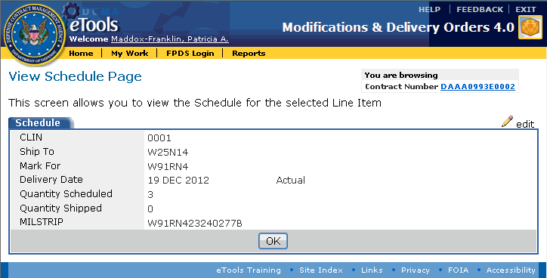

Figure 88: View Schedule Page

To edit the schedule, on the View Schedule Page, click the i_pencil.gif edit link. The Edit Schedule Page appears. See the topic [Editing a Schedule](#line_items_t_editing_a_schedule__2170) for more information.

To view the line item for the schedule, on the View Schedule Page, click the OK button. The [View Line Item Page](#line_items_t_viewing_a_line_item_2062) appears.

To view the MOD, on the View Line Item Page or View Schedule Page, click the Contract Number link. The [Manage MOD Page](#contract_mods_t_managing_a_contr_6912) or [Manage Delivery Order Page](#delivery_orders_t_managing_a_del_5335) appears.

## Adding a Schedule to a Line Item

The ACO and CA user roles can add a schedule to a line item.

A schedule is associated with a line item. Only line items where the Line Item Type is P-Product may have schedules.

Schedules are not applicable to S-Service Line Item Types.

To add a schedule to a line item, do the following:

1. Locate the MOD to whose line item you wish to add a schedule. See the topic [Browsing Contract Modifications](#contract_mods_t_browsing_contrac_4723) or [Browsing Delivery Orders](#delivery_orders_t_browsing_deliv_8362) to locate a MOD or delivery order; also, see the topic [Browsing Schedules](#line_items_t_browsing_schedules__4567).
2. On the View Line Item Page, click the add add link (Figure 89).



Figure 89: Add link

The Add Schedule Page appears (Figure 90).

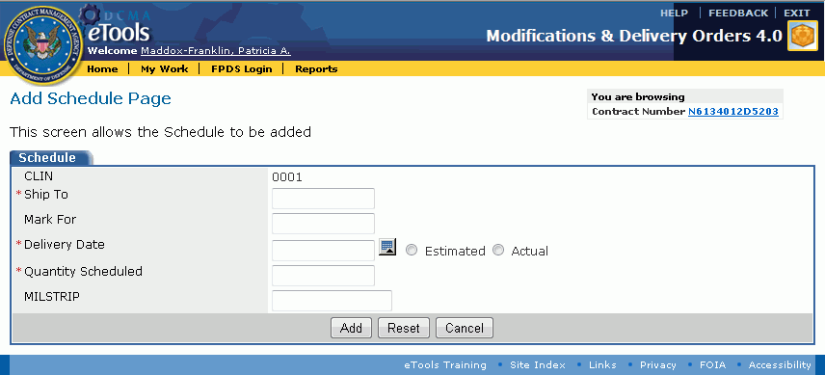

Figure 90: Add Schedule Page

1. The CLIN from the line item is displayed. Type or select information for the remaining fields as follows (an asterisk (\*) indicates that the information is required):

Ship To: Type the DoDAAC receiving the goods or services.

Mark For: Type the DoDAAC for which the goods or services are marked.

Delivery Date: Type the delivery date using the format dd mmm yyyy; or, click the i_calendar.gif calendar icon to select the date from a pop-up calendar. Indicate whether the delivery date is Estimated or Actual by selecting the applicable option button.

Quantity Scheduled: Type the quantity scheduled for delivery. Note that the quantity scheduled cannot exceed the quantity ordered.

MILSTRIP: Type the MILSTRIP associated with the CLIN, schedule, and contract.

1. Click the Add button.

Buttons on the Add Schedule Page perform the following functionality:

Add: Adds the schedule to the line item for the delivery order or contract. The new schedule appears on the View Line Item Page. See the topic [Viewing a Line Item](#line_items_t_viewing_a_line_item_2062) for more information.

Reset: Clears data you have typed or selected.

Cancel: Cancels the current action. The View Line Item Page appears. See the topic [Viewing a Line Item](#line_items_t_viewing_a_line_item_2062) for more information.

## Editing a Schedule

The ACO and CA user roles can edit a schedule.

To edit a schedule, do the following:

1. Locate the MOD whose line item schedule you wish to edit. See the topic [Browsing Contract Modifications](#contract_mods_t_browsing_contrac_4723) or [Browsing Delivery Orders](#delivery_orders_t_browsing_deliv_8362) to locate a MOD; also, see the topic [Browsing Schedules](#line_items_t_browsing_schedules__4567).
2. On the View Line Item Page, in the Schedules tab, click the Delivery Date link for the schedule you wish to edit. The View Schedule page appears.
3. Click the pencil edit link. The Edit Schedule Page appears (Figure 91).

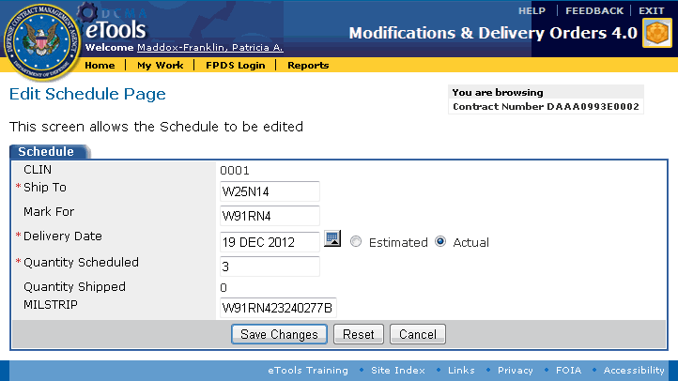

Figure 91: Edit Schedule Page

1. The CLIN from the line item, Ship To DoDAAC, Delivery Date, Quantity Scheduled, and Quantity Shipped are displayed. You can edit information in the remaining text boxes as follows (an asterisk (\*) indicates that the information is required):

Ship To: Type the DoDAAC receiving the goods or services.

Mark For: Type the DoDAAC for which the goods or services are marked.

Delivery Date: Specify the delivery date. Use the format dd mmm yyyy or click the i_calendar.gif calendar icon to select the date from a pop-up calendar. Indicate whether the delivery date is Estimated or Actual by selecting the applicable option button.

Quantity Scheduled: (Required) Type the quantity scheduled for delivery. Note that the quantity scheduled cannot exceed the quantity ordered.

MILSTRIP: Type the MILSTRIP associated with the CLIN, schedule and contract.

1. Click the Save Changes button.

Buttons on the Edit Schedule Page perform the following tasks:

Save Changes: Saves the changes to the schedule. The new schedule appears on the View Line Item Page. See the topic [Viewing a Line Item](#line_items_t_viewing_a_line_item_2062) for more information.

Reset: Clears data you have typed or selected.

Cancel: Cancels the current action. The View Schedule Page appears. See the topic [Viewing a Schedule](#line_items_t_viewing_a_schedule__5676) for further information.

# Attaching a File

The ACO and CA user roles can attach a file.

To attach a file, do the following:

1. Locate the MOD to which you wish to attach a file. See the topic [Browsing Contract Modifications](#contract_mods_t_browsing_contrac_4723), [Browsing Delivery Orders](#delivery_orders_t_browsing_deliv_8362), or [Browsing EDA-Only Contract Modifications](#eda_only_t_browsing_eda_mods_htm) to locate a MOD.
2. On the Manage MOD Page, Manage Delivery Order Page, or Manage EDA MOD Page, in the Attachments tab, click the Manage Attachments link (Figure 92).

Manage Attachments link

Figure 92: Manage Attachments link

The Attachments page appears (Figure 93).

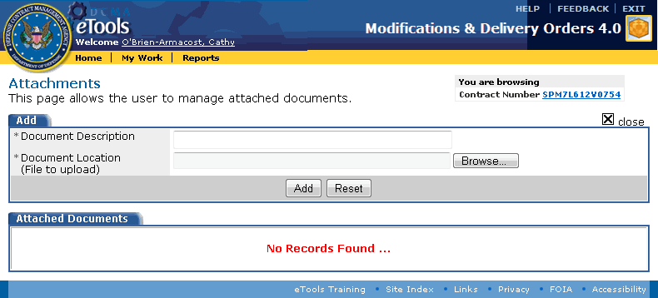

Figure 93: Attachments page

1. In the Document Description text box, type the description of the file you are attaching.
2. Click the Browse button. In the dialog box that appears, locate and select the file you wish to attach. You can attach only one file at a time. In the dialog box, double-click the file or click Open to select the file. The dialog box closes. The Document Location text box displays the path and file name of the file you selected to be attached. Acceptable attachment file types are .bmp, .doc, .jpg, .mpp, .msg, .pdf, .ppt, .rtf, .tif, .txt, .vsd, .xls.
3. Click the Add button. The file appears in the Attached Documents tab (Figure 94).

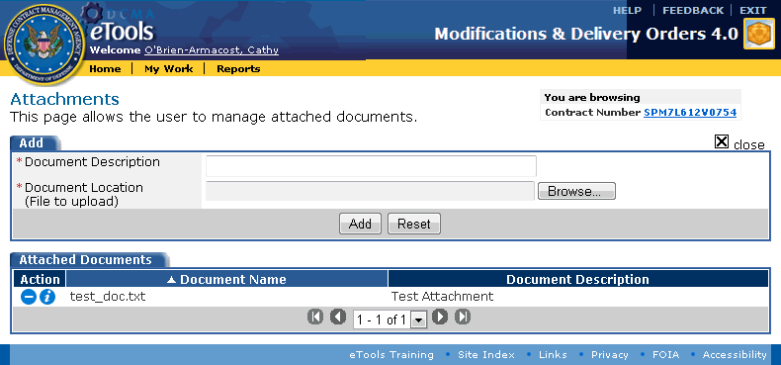

Figure 94: Attached Documents tab

To view an attached file, on the Attachments page, in the Attached Documents tab, click the Info icon view icon for the file you wish to view. A dialog box appears, allowing you to either save the file or to view it.

To delete an attached file, on the Attachments page, in the Attached Documents tab, click the delete delete icon for the file you wish to delete. In the dialog box that appears, click the OK button.

To return to the previously viewed page, click the close_icon.gif close link.

# Browsing Changes

The ACO and CA user roles can browse changes.

The Browse Changes page shows the differences between a contract modification or delivery order as originally generated versus the edits made to it since it was generated.

This functionality is not applicable to EDA-only contract modifications as those data are all provided by one or more user roles, not by existing contract data.

To view changes to a contract modification or delivery order, do the following:

1. Locate the MOD whose changes you wish to browse. See the topic [Browsing Contract Modifications](#contract_mods_t_browsing_contrac_4723) or [Browsing Delivery Orders](#delivery_orders_t_browsing_deliv_8362) to locate a MOD.
2. On the Manage MOD Page or Manage Delivery Order Page, click the view changes link (Figure 95).

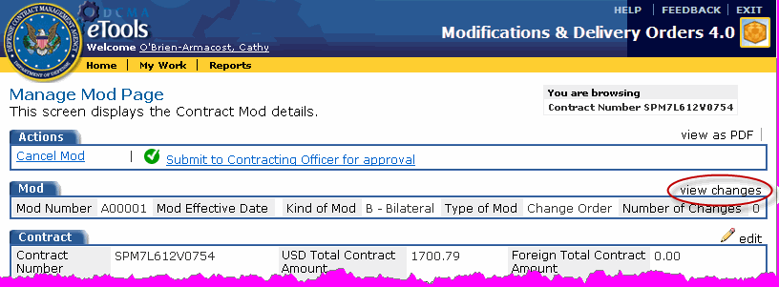

Figure 95: Manage MOD Page with view changes link

The Browse Changes Page appears (Figure 96).

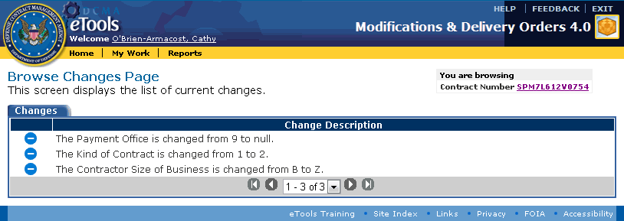

Figure 96: Browse Changes Page

The Change Description column lists the changes to the MOD since it was generated from MOCAS data.

To undo a change, on the Browse Changes Page, click the i_delete.gif delete icon for the change you wish to undo. The contract modification or delivery order shows the original rather than the new value and the change no longer appears on the Browse Changes page.

To return to the MOD, click the Contract Number link. The [Manage MOD Page](#contract_mods_t_managing_a_contr_6912) or the [Manage Delivery Order Page](#delivery_orders_t_managing_a_del_5335) appears. See the topic [Managing a Contract Modification](#contract_mods_t_managing_a_contr_6912) or [Managing a Delivery Order](#delivery_orders_t_managing_a_del_5335) for more information.

# Canceling a MOD

The ACO and CA user roles can cancel contract mods, delivery orders, or EDA mods in their workloads. Once the MOD is canceled, it no longer appears on the View My Work Page.

You will not be able to recover a MOD that you have canceled, but you can create a new MOD.

**To cancel a MOD,** do the following:

1. Locate the MOD you wish to cancel. See the topic [Browsing Contract Modifications](#contract_mods_t_browsing_contrac_4723), [Browsing Delivery Orders](#delivery_orders_t_browsing_deliv_8362), or [Browsing EDA-Only Contract Modifications](#eda_only_t_browsing_eda_mods_htm) to locate a MOD.
2. On the Manage MOD Page, Manage Delivery Order Page, or Manage EDA MOD Page, in the Actions tab, click the Cancel link (Figure 97).

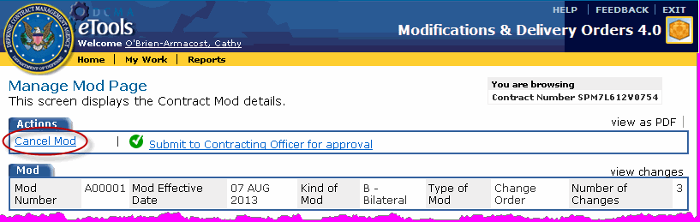

Figure 97: Actions tab with Cancel link

The Confirmation tab appears (Figure 98).

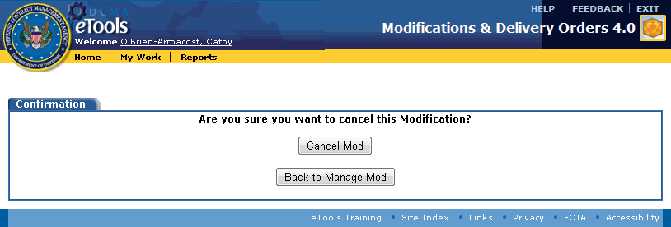

Figure 98: Cancellation confirmation page

To proceed with canceling the MOD or delivery order, click the Cancel MOD button or Cancel Delivery Order button. The MOD will no longer appear on the View My Work Page, and cannot be recalled.

To leave the page without canceling, click the Back to Manage MOD button, Back to Manage Delivery Order button, or Back to Manage EDA MOD button. See the topic [Managing a Contract Modification](#contract_mods_t_managing_a_contr_6912), [Managing a Delivery Order](#delivery_orders_t_managing_a_del_5335), or [Managing an EDA-Only Contract Modification](#eda_only_t_managing_an_eda_mod_h_9453) for more information.

# Submitting a MOD to the ACO

The CA user role must submit mods to the ACO for review. Only the ACO user role can release a MOD to EDA and MOCAS.

When the CA submits a MOD, it appears on the View My Work Page for both users, but on the CA's View My Work Page, the link in the MOD's action column changes from View to Recall, and the status updates to read, Waiting for ACO Approval.

Once the CA submits a MOD, the ACO reviews it. The ACO should review the MOD because that user role has permission to view the signature blocks that appear in the PDF version of the MOD. The CA user role will not see the signature blocks on the PDF. The ACO may [cancel](#all_t_cancelling_a_mod_htm), [release](#all_t_releasing_a_mod_htm) or [reject](#all_t_rejecting_a_mod_htm) the MOD. Upon ACO release, the MOD no longer appears on any View My Work Page.

A CA may [recall a MOD](#all_t_recalling_a_mod_htm) after it has been submitted to the ACO, if it has not yet been released or rejected by the ACO.

**To submit a MOD to the ACO,** do the following:

1. Locate the MOD you wish to submit to the ACO. See the topic [Browsing Contract Modifications](#contract_mods_t_browsing_contrac_4723), [Browsing Delivery Orders](#delivery_orders_t_browsing_deliv_8362), or [Browsing EDA-Only Contract Modifications](#eda_only_t_browsing_eda_mods_htm) to locate a MOD.
2. On the Manage MOD Page or Manage Delivery Order Page, click the i_checkmark.gif Submit to Contracting Officer for approval link (Figure 99).

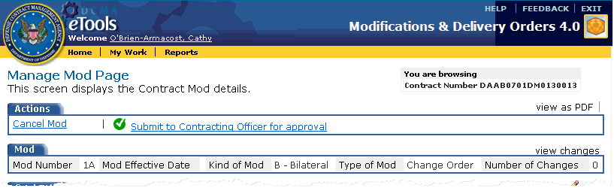

Figure 99: Submit to Contracting Officer for approval link

The Send My Work Page appears (Figure 100).

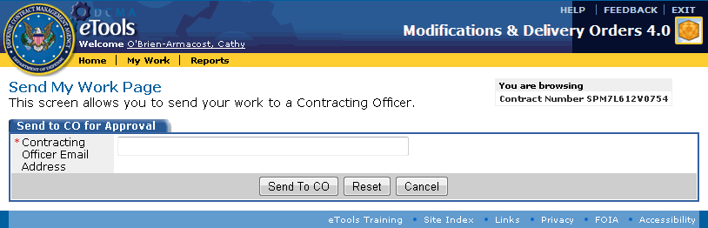

Figure 100: Send My Work Page

1. In the Contracting Officer Email Address text box, type the ACO's email address (for example, Jane.Doe@dcma.mil). The CA may submit a MOD to any ACO. MDO 4.0 does not restrict users to an organizational element.
2. Click the Send to ACO button.

The buttons on the Send My Work Page perform the following tasks:

Send to ACO: Sends the MOD to the ACO specified. The modification now appears in the ACO's workload with a status of Waiting for ACO Approval. The ACO does not receive an email message notification. Users must monitor the View My Work Page for status of mods. Upon ACO approval/release, the MDO document will disappear from the CA and ACO's View My Work Page.

Reset: Clears data you have typed.

Cancel: Cancels the current action and displays the previous page.

# Transferring Mods

The ACO and CA user roles can transfer work to another individual who has access to MDO 4.0.

To transfer your work to another person, do the following:

1. Click the My Work link on the menu bar. The View My Work Page appears.
2. Click the Transfer My Work link on the menu bar (Figure 101).



Figure 101: View My Work Page

The Transfer My Work Page appears and displays all of the mods assigned to you (Figure 102).

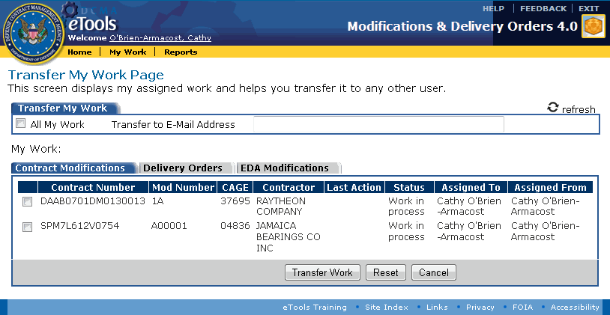

Figure 102: Transfer My Work Page

1. To transfer all of your work, in the Transfer My Work tab, click the All My Work check box.

To transfer specific mods, in the Contract Modifications tab, Delivery Orders tab, and/or EDA Modifications tab, click the check boxes for the mods you wish to transfer.

1. In the Transfer To E-Mail Address text box, type the email address of the person receiving the work.
2. Click the Transfer Work button (the Reset button clears the check boxes you have selected and data you have typed; the Cancel button returns you to the View My Work Page, but no work is transferred). A confirmation page appears (Figure 103).

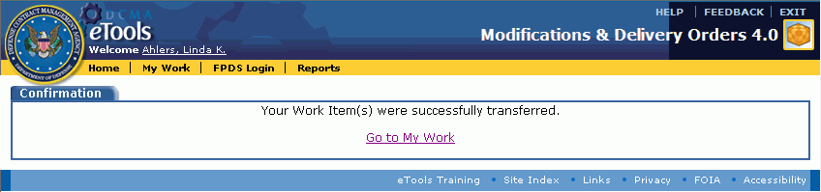

Figure 103: Confirmation page

1. Click the Go to My Work link to see the results of the transfer.

# Recalling a MOD

You can recall a MOD that you have transferred, rejected, or submitted.

A CA can recall a MOD if the ACO has not yet approved or rejected it.

If the ACO rejects a MOD, the ACO can recall it and the CA can view it.

You cannot recall a MOD that has been released to MOCAS and EDA.

To recall a MOD, do the following:

1. Click the My Work link on the menu bar. The View My Work Page appears (Figure 104).

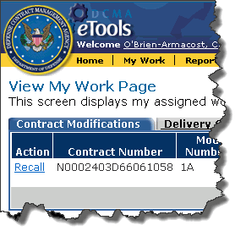

Figure 104: View My Work Page

1. Click the Contract Modifications tab, the Delivery Orders tab, or the EDA Modifications tab to display the tab.
2. Click the Recall link for the MOD you wish to recall. The [Manage MOD Page](#contract_mods_t_managing_a_contr_6912), [Manage Delivery Order Page](#delivery_orders_t_managing_a_del_5335), or [Manage EDA MOD Page](#eda_only_t_managing_an_eda_mod_h_9453) appears.

# Rejecting a MOD

The ACO user role can reject a MOD that has been submitted for review. Once the MOD is rejected, it appears on the View My Work Page with the status Rejected. The ACO can [recall a rejected MOD](#all_t_recalling_a_mod_htm), if necessary.

**To reject a MOD,** do the following:

1. Locate the MOD you wish to reject. See the topic [Browsing Contract Modifications](#contract_mods_t_browsing_contrac_4723), [Browsing Delivery Orders](#delivery_orders_t_browsing_deliv_8362), or [Browsing EDA-Only Contract Modifications](#eda_only_t_browsing_eda_mods_htm) to locate a MOD.
2. On the Manage MOD Page, Manage Delivery Order Page, or Manage EDA MOD Page, in the Actions tab, click the Reject link (Figure 105).

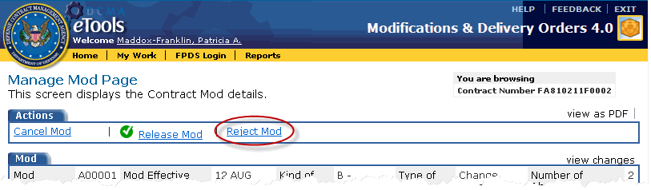

Figure 105: Reject MOD link

The Reject Page appears (Figure 106).

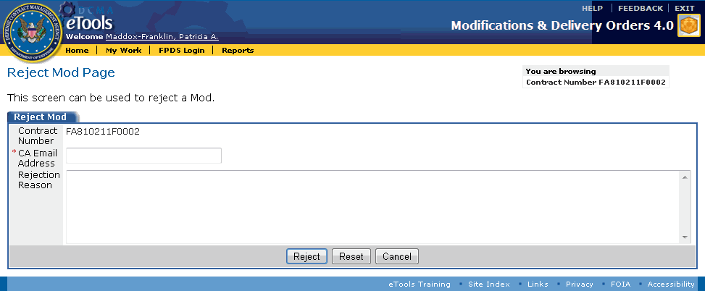

Figure 106: Reject MOD Page

1. In the Reject tab, type the following information (an asterisk (\*) indicates that the information is required):

CA Email Address: Type the email address of the CA who should see that the MOD was rejected.

Rejection Reason: Type a reason for the rejection.

1. Click the Reject button.

Buttons on the bottom of the Reject MOD Page perform the following tasks:

Reject: Marks the MOD as Rejected on the View My Work Page. The person rejecting the MOD sees the Recall link. MDO 4.0 routes the MOD to the CA's View My Work Page based on this information. MDO 4.0 does not send an email notification of the rejection.

Reset: Clears data you have typed.

Cancel: Cancels the current action. The Reject MOD Page closes and the [Manage MOD Page](#contract_mods_t_managing_a_contr_6912), [Manage Delivery Order Page](#delivery_orders_t_managing_a_del_5335), or the [Manage EDA MOD Page](#eda_only_t_managing_an_eda_mod_h_9453) appears.

# Releasing a MOD

The ACO user role can release a MOD to MOCAS. Once the MOD is released, it no longer appears on the View My Work Page for any user. You cannot recall a MOD once it is released.

To release a MOD, do the following:

1. Locate the MOD you wish to release. See the topic [Browsing Contract Modifications](#contract_mods_t_browsing_contrac_4723), [Browsing Delivery Orders](#delivery_orders_t_browsing_deliv_8362), or [Browsing EDA-Only Contract Modifications](#eda_only_t_browsing_eda_mods_htm) to locate a MOD.
2. On the Manage MOD Page, Manage Delivery Order Page, or Manage EDA MOD Page, in the Actions tab, click the i_checkmark.gif Release link (Figure 107).

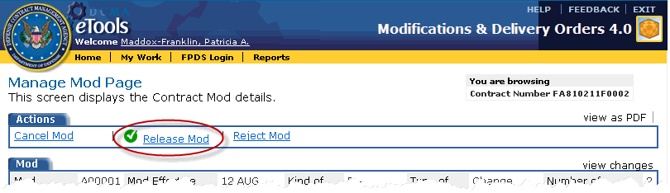

Figure 107: Release MOD link

The Confirmation Page appears (Figure 108).

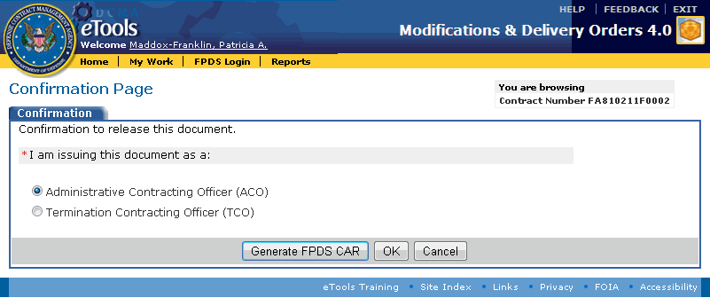

Figure 108: Confirmation Page

1. Select whether the MOD or delivery order shall be released with your title as Administrative Contracting Officer or as Termination Contracting Officer; click the appropriate option button. If you are releasing a delivery order, you will be asked to select whether you are releasing Delivery Order Form DD 1155 or SF 1449; click the appropriate option button.
2. Generating an FPDS CAR might or might not be necessary:

* If generating an FPDS CAR for the MOD or delivery order is necessary (refer to FAR/DFAR for reasons to generate an FPDS CAR), see the topic [Generating an FPDS CAR](#generating_an_fpds_car_before_re_4968).
* If generating an FPDS CAR is unnecessary, click the OK button to release the MOD to MOCAS as usual (click the Cancel button to leave the page without releasing the MOD). The release confirmation page appears.

1. On the release confirmation page, click the Go to My Work link. The View My Work Page appears and no longer displays the MOD.

# Mass MODs

## Mass MOD Types

Both ACOs and CAs are able to initiate a mass MOD and revise a mass MOD in Draft status.

There are 5 types of Mass MODs, which may only change specific contracts or contractor data.

* Physical Address Change
* Name Change
* Novation/Change-of-Name
* Block Change/SPI MOD
* Workload Adjustments

Attachments may be added to each type of Mass MOD. There is a 12MB attachment size limit for each attachment to a Mass MOD.

Questions to be answered are determined by the type of Mass MOD selected, and in some instances, previously answered questions.

**Physical Address Change** Mass MODs support changes to the physical address of the contractor in the event of a contractor relocation (Figure 109) and (Figure 110).

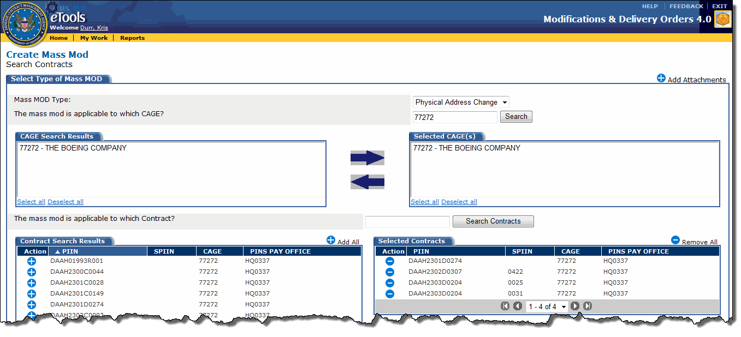

Figure 109: Create Mass MOD page for a Physical Address Change

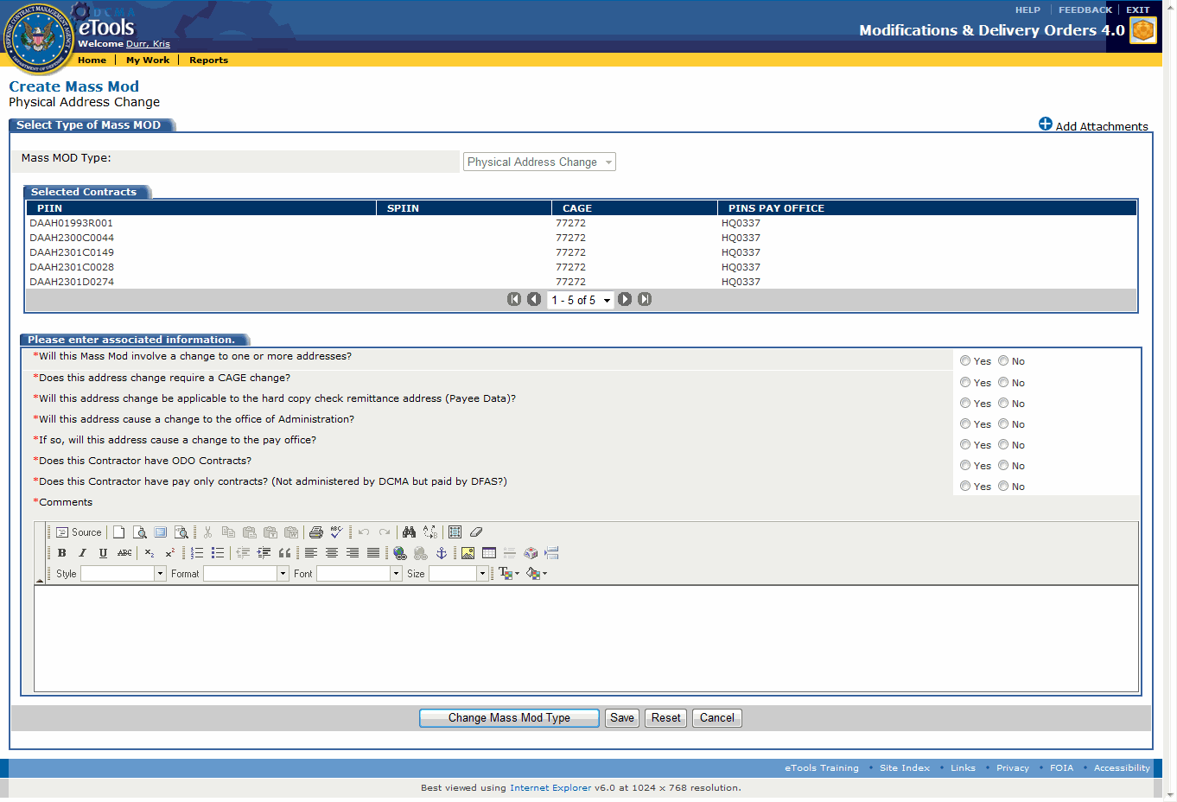

Figure 110: Create Mass MOD Questions for a Physical Address Change

**Name Change** Mass MODs may only change the contractor name upon an approved change of name agreement (Figure 111) and (Figure 112).

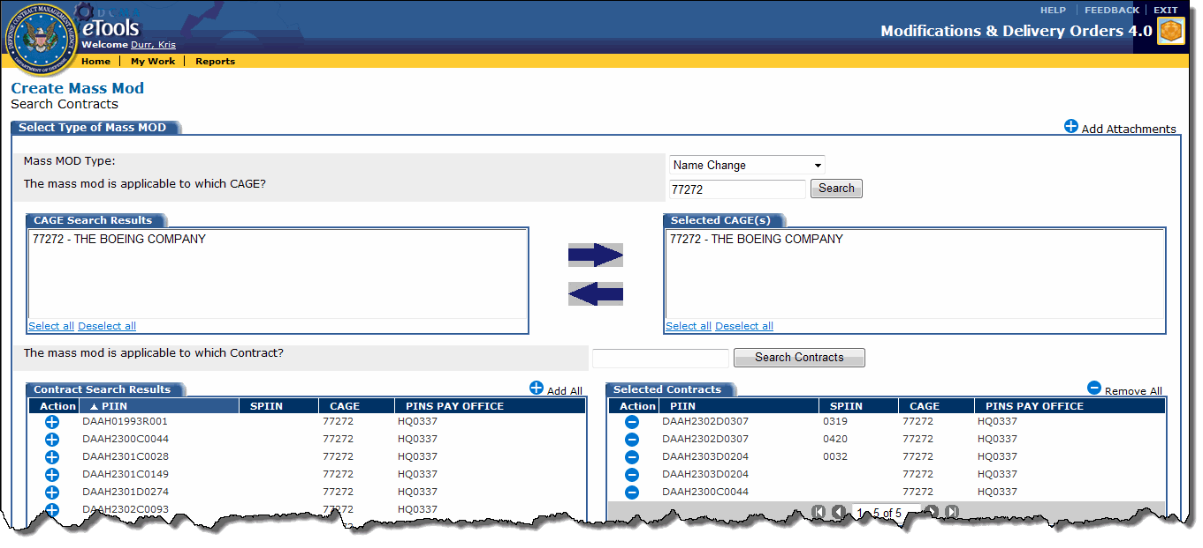

Figure 111: Create Mass MOD page for a Name Change

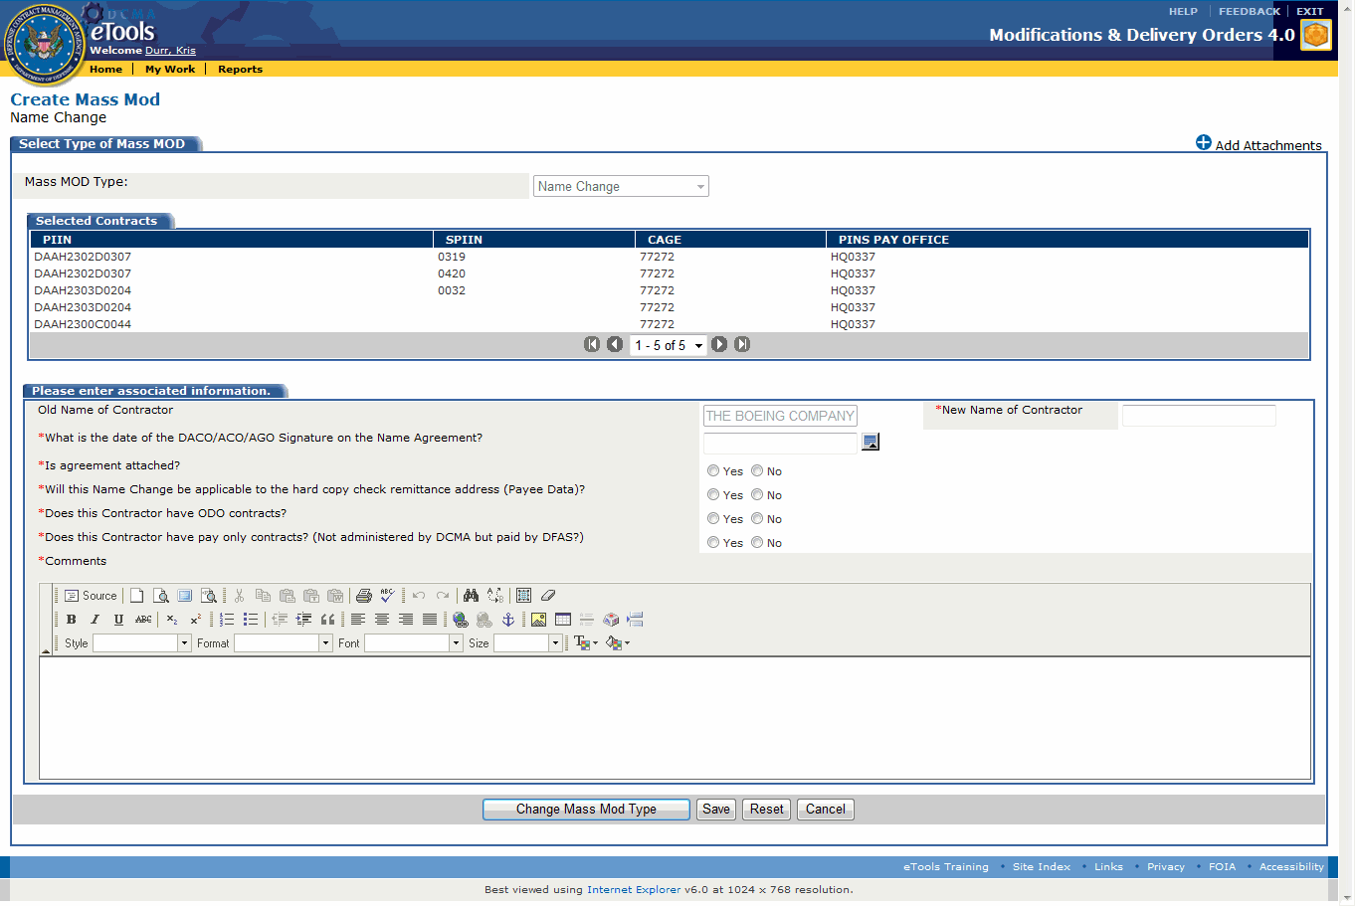

Figure 112: Create Mass MOD Questions for a Name Change

**Novation/Change-of-Name** Mass MODs can change the contractor name and/or the obligated party and must follow a Novation Agreement (Figure 113) and (Figure 114).

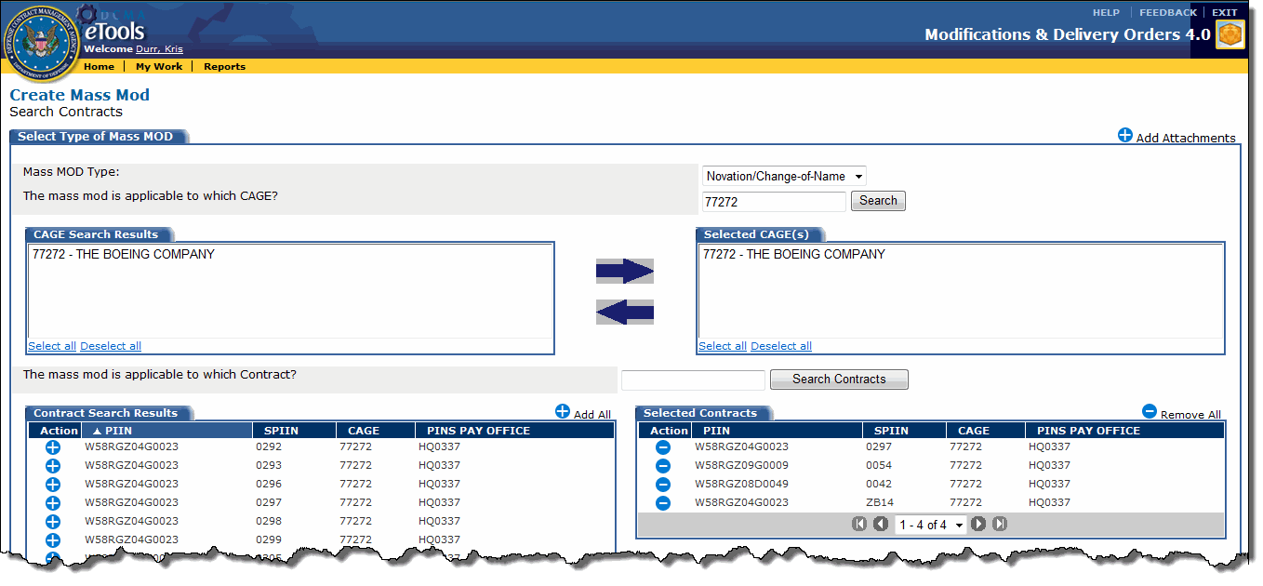

Figure 113: Create Mass MOD page for a Novation/Change-of-Name

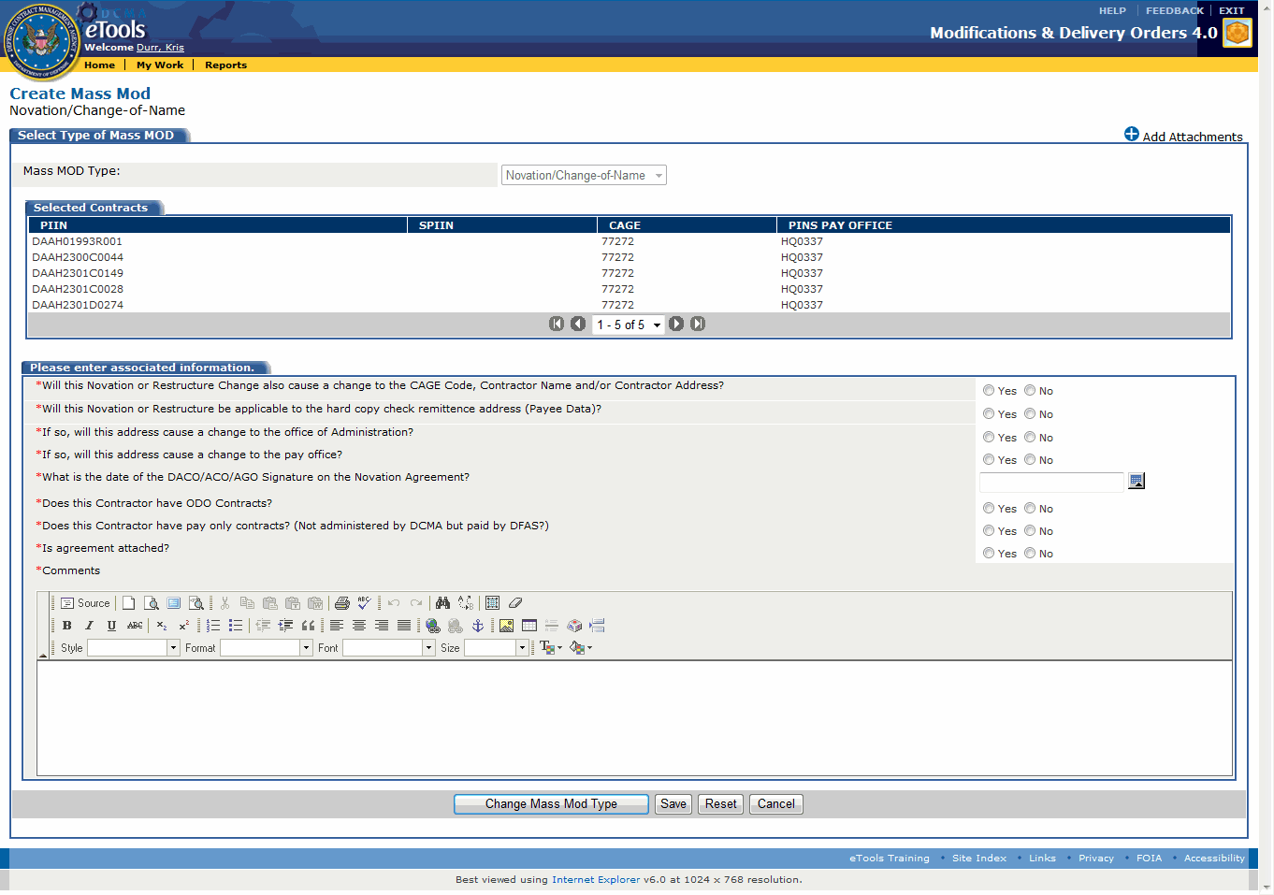

Figure 114: Create Mass MOD Questions for a Novation/Change-of-Name

**Block Change/SPI MODs** allow a PDF to be generated for any modification which does not meet the criteria of the other available Mass MOD types (Figure 115) and (Figure 116).

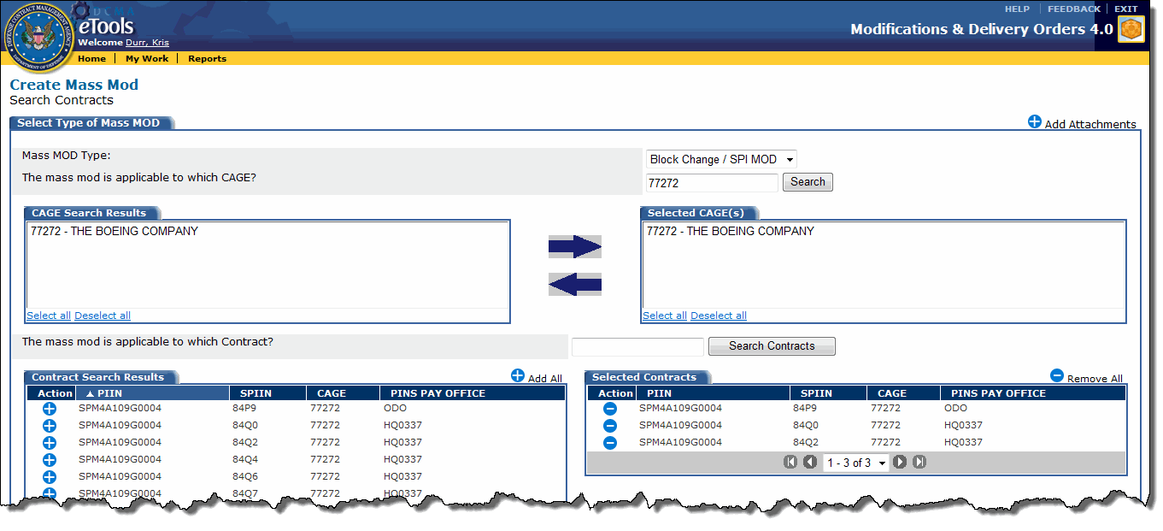

Figure 115: Create Mass MOD page for a Block Change/SPI MOD

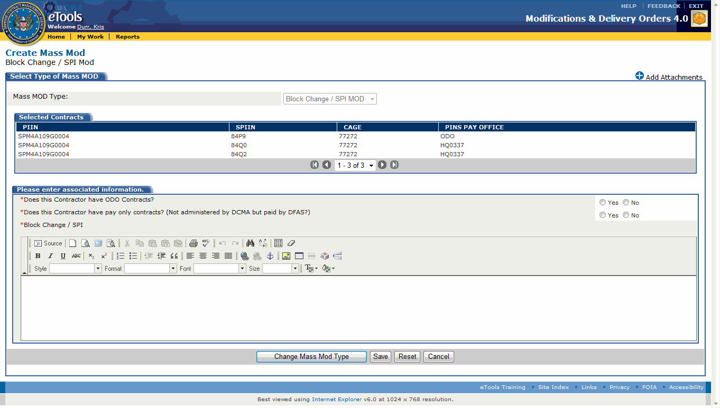

Figure 116: Create Mass MOD Questions for a Block Change/SPI MOD

**Workload Adjustments** are created to realign the workload (Figure 117) and (Figure 118).

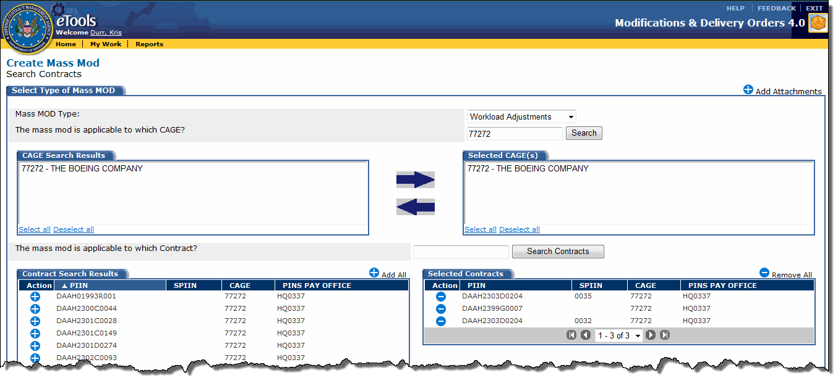

Figure 117: Create Mass MOD page for Workload Adjustments

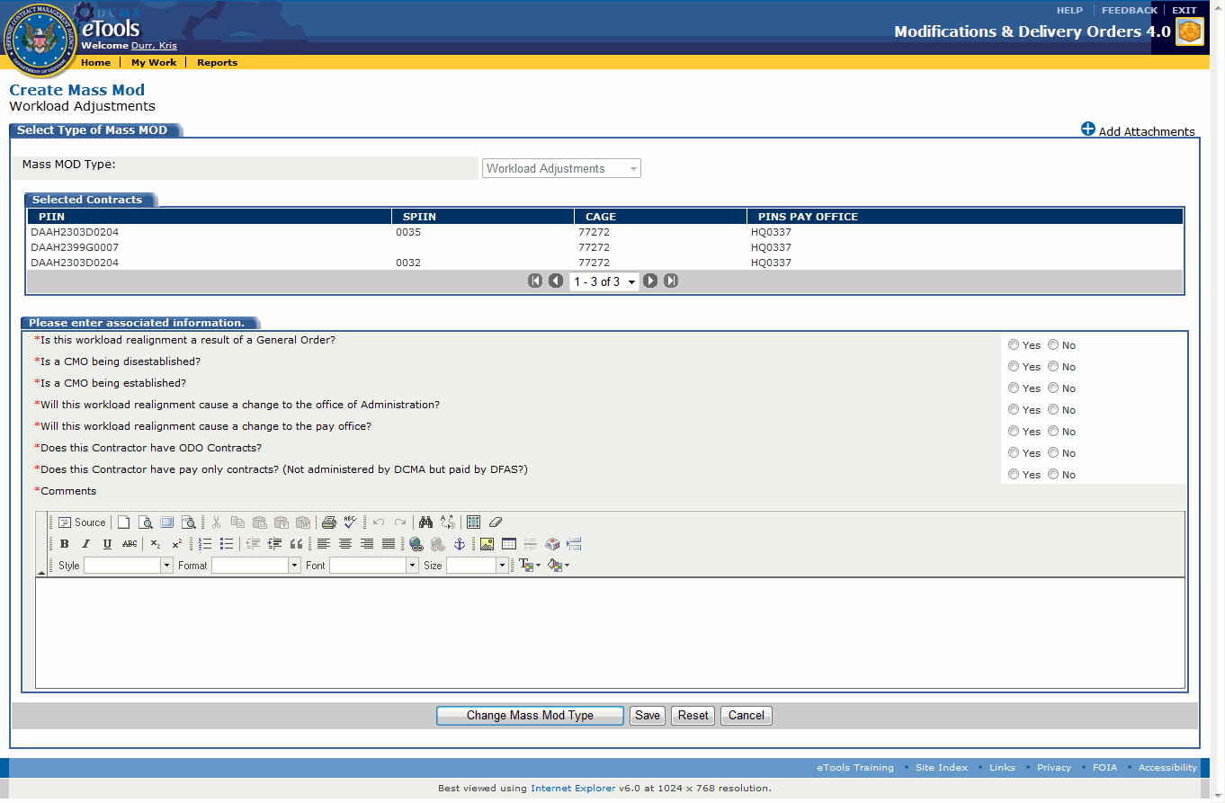

Figure 118: Create Mass MOD Questions for Workload Adjustments

## Generating a Mass Mod

**To generate a mass MOD,** click the Search for Contracts to Generate MASS Mod link on the Modifications & Delivery Orders - Home Page. The Create Mass Mod page appears (Figure). Initially, the page is blank. The user must search by CAGE and then by contract. This page assists with filtering (Figure 119) and (Figure 120).

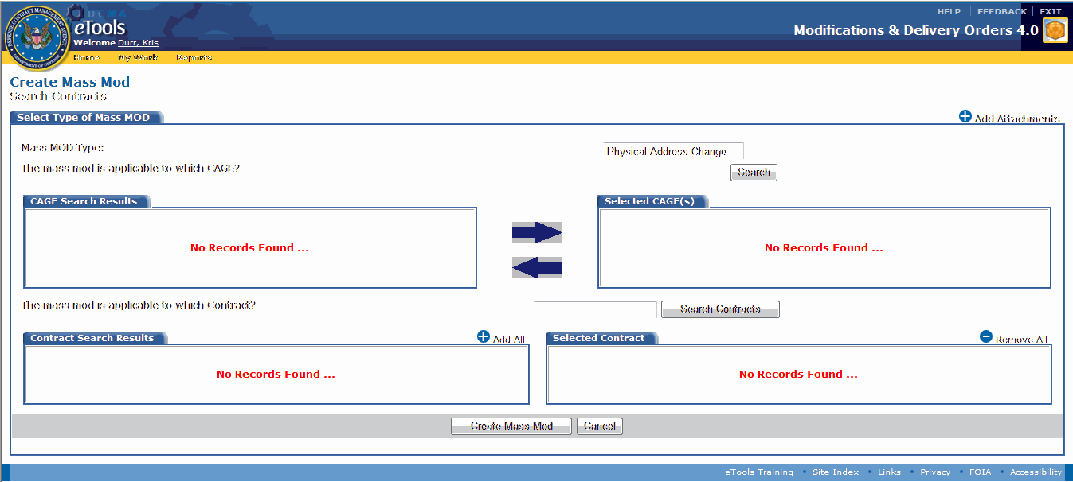

Figure 119: Create Mass MOD page before filtering



Figure 120: Create Mass Mod page once filtered

In the Select Type of Mass MOD tab, select the Mass MOD Type using the drop down list box.

Search for and select one or more CAGES and one or more contracts. You may choose to add all of the contracts with the i_add.gif add all link or remove all contracts from the selected contracts section using the i_delete.gif remove all link.

The Mass MOD can be changed on the questions page by clicking the Change Mass MOD Type button. Once the Mass MOD has been changed, the questions will change and populate for the new Mass MOD type.

If any selected contracts have null paying offices, an error box will appear.

**To correct the null paying office issue,** see [Correcting a Mass Mod](#mass_mods_correcting_a_mass_mod__869).

Click the Create Mass Mod button. Questions are populated based on the Mass MOD Type selected (Figure 121).

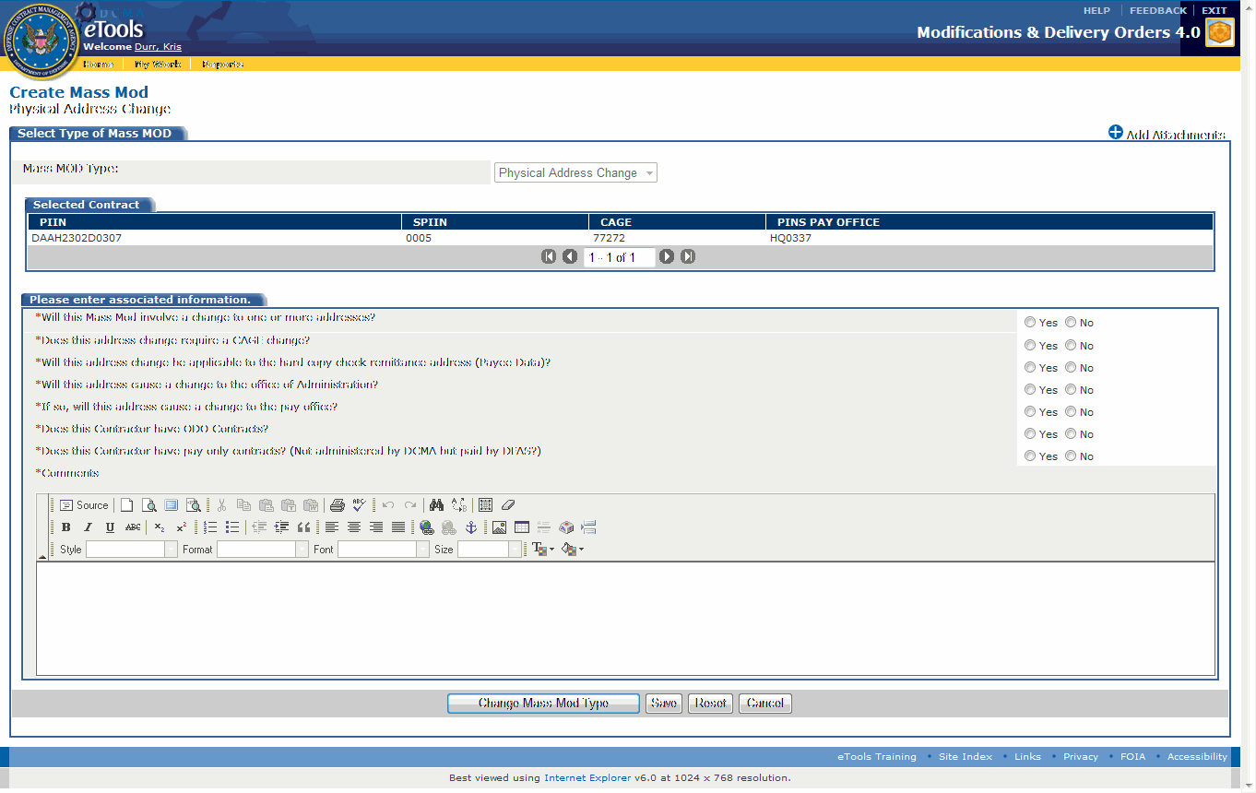

Figure 121: Mass MOD Questions page

Required questions are noted with a red asterisk. Answer all required questions. Add any necessary attachments using the i_add.gif Add Attachments link. Click the Save button. The Mass MOD is created and added to the appropriate tab under the Mass MOD tab on the View My Work Page. The status of each Mass MOD will appear on the View My Work Page.

**Note:** The Mass MOD is in the "created" status at this point.

The ACO and CA create a Mass MOD in the same way. The CA must then submit the Mass MOD to the ACO.

**To submit the Mass MOD to the ACO,** the CA types the ACO's email into the ACO Email text box under the Submit to Contracting Office for Approval tab on the View My Work Page (Figure 122). Click the boxes of the Mass MODs to submit. Click the Submit to ACO button.

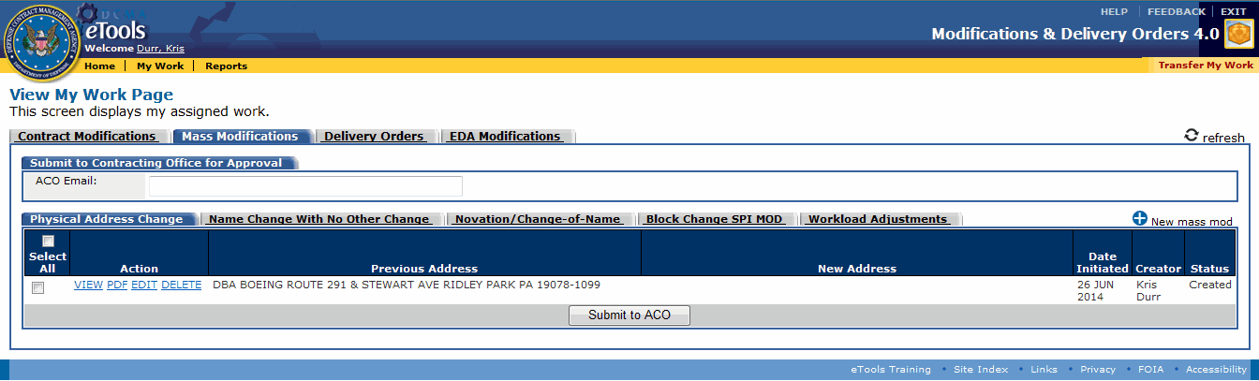

Figure 122: CA Mass MOD Workload page

**To view, edit or delete the mass MOD,** click the VIEW link, EDIT link or DELETE link, respectively, in the Action column.

**To preview the generated PDF in the application,** click the PDF link in the Action column on the View My Work Page. This action can also be completed using the i_info.gifview as PDF link on the View Mass Mod page.

**To submit the mass MOD to the FIRM,** see [Submitting, Rejecting, and Releasing Mass MODs](#mass_mods_submitting_rejecting_a_5014).

**To create a new mass MOD from the View My Work Page,** click the i_add.gif New mass mod link.

## Correcting a Mass Mod

If contracts with null paying offices are selected, this issue shows in the Selected Contract tab and an error box will appear stating corrections need to be made before continuing (Figure 123).

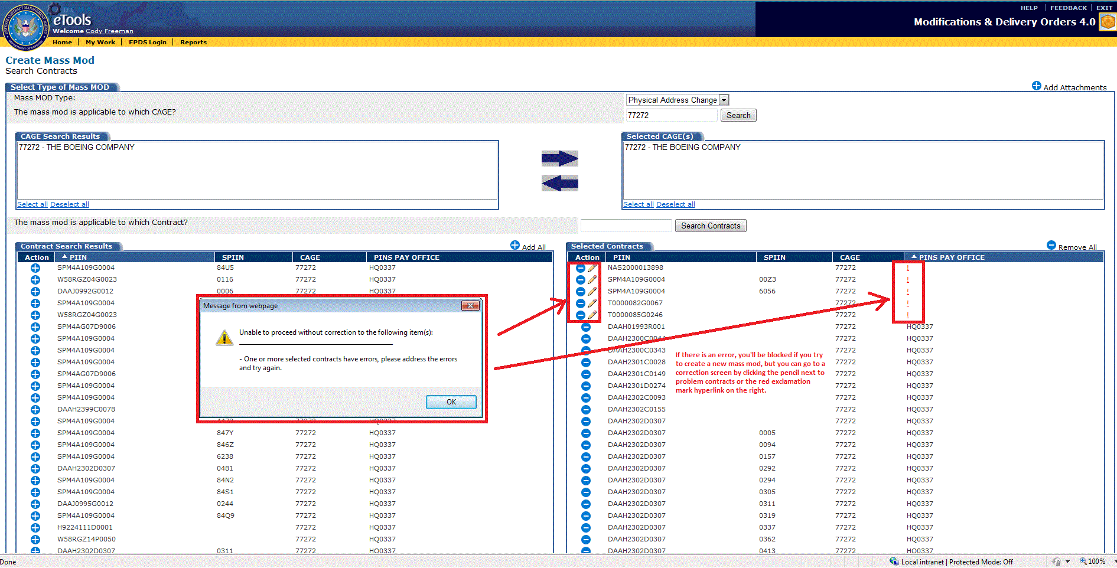

Figure 123: Contracts with errors page

**To correct the contracts with null paying offices,** click the i_pencil.gif edit link next to the contract in the Action column. This opens the Mass MOD Correction page (Figure 124). Every contract with null paying offices will be listed.

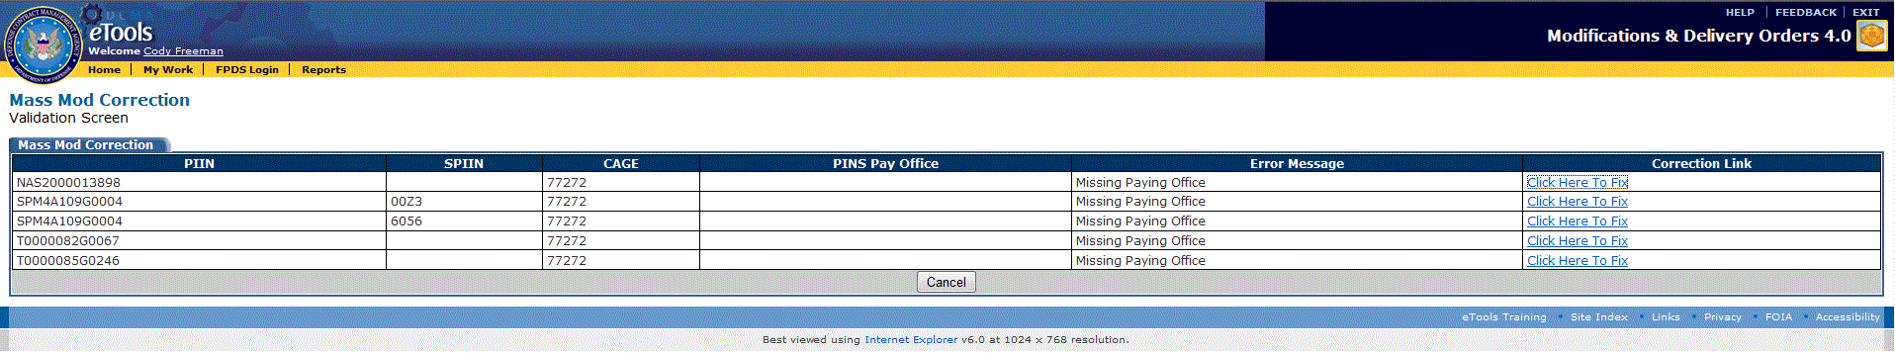

Figure 124: Mass MOD Correction page

The Correction Link column on the right allows the user to correct each null paying office. Clicking the link takes the user to the validation screen where a paying office can be selected (Figure 125). Click the Save button when finished.

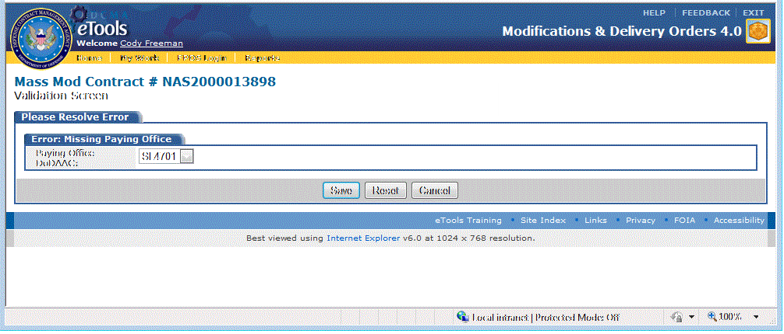

Figure 125: Mass MOD Correction Validation page

After saving the paying office information a confirmation page is displayed.

## Submitting, Rejecting, and Releasing Mass MODs

An ACO has the ability to submit a Mass MOD to the FIRM for approval or rejection. A CA must submit the Mass MOD to the ACO, who can then submit them to the FIRM. The CA can submit the Mass MOD to the ACO in two ways.

To submit a Mass MOD to an ACO is to enter the ACO's email address in the ACO email text box under the Submit to Contracting Office for Approval tab on the View My Work Page. Click the check boxes in the far left column next to the Mass MODs needing to be submitted. Then click the Submit to ACO button.

The Mass MOD must be submitted to a valid ACO. The Mass MOD cannot be submitted to a non-MDO user, a CA, or a FIRM center user.

**To submit the mass MOD to the FIRM,** the ACO selects the box in the far left column next to the mass MOD to be submitted and click the Submit to FIRM button. A confirmation box appears. Click the OK button to submit the mass MOD. The selection box on the left disappears (Figure 126).

The ACO can also click on the view link next to the Mass MOD to be submitted and click the Submit to FIRM button. A confirmation box appears. Click the OK button to submit the Mass MOD.

Note: The Mass MOD is in the "submitted" status.

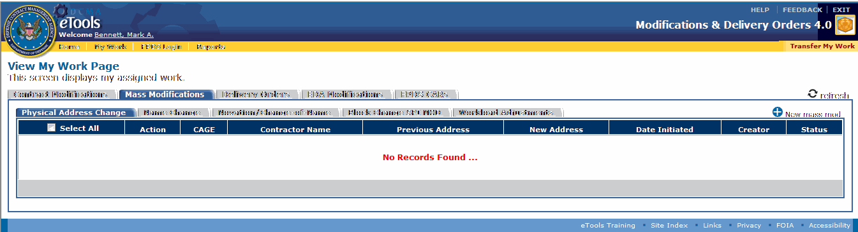

Figure 126: Mass MOD Workload page

Once submitted, the mass MOD appears in the FIRM Center User's Workload (Figure 127).

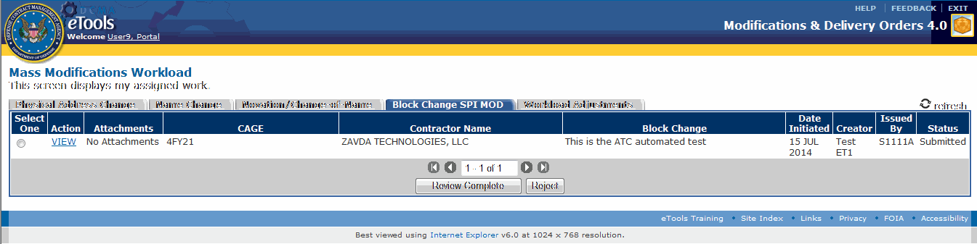

Figure 127: The FIRM Center Workload page

**To View the Mass MOD,** click the VIEW link. The View Mass Mod page appears. The FIRM Center User reviews the Mass MOD and notifies the ACO of any required changes.

**To Assign a MOD Release Date,** the FIRM Center user selects the Mass MOD to be released using the radio button on the left or through the View link under the Action column. Click the Review Complete button or click the View link which then takes the user to the Mass Mod View page where a Review Complete button appears. The Assign Release Date page then appears (Figure 128).

The FIRM Center user may also click the view link, then click the Review Complete button to assign a release date.

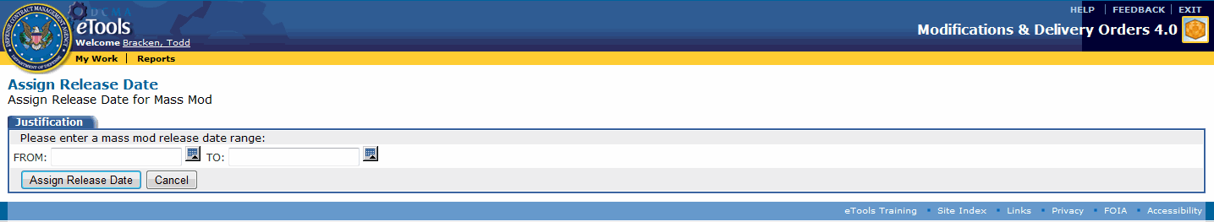

Figure 128: Assign Release Date page

Add dates in the date range fields using the calendar.gif calendar icon. Click the Assign Release Date button.

**Note:** The Mass MOD is now in "Approved" status.

Once a release date is assigned, the ACO receives an email with the following information:

**The following Mass Mod has been approved for release by the FIRM Center:  
New CAGE: CAGE1  
The release date assigned by the firm is 1 July 2014 to 4 July 2014.**

Once the FIRM Center approves the Mass MOD, there will be a Release link in the Action column of the Approved Mass MOD. Once clicked, the Mass MOD will move to the "Staged" status. The Mass MOD will then be released when the nightly job runs on that date.

A nightly job will run to create all the individual mods for each contract under the Mass Mod. After that is complete, the ACO will be able to release the Mass Mod within the release date range. Once submitted, the next sequential MOD number is assigned.

When a Mass mod is released, each individual contract mod is released just like the original mod process.  In addition, a PDF is released listing information about the overall Mass Mod, including a list of all the individual mods under the Mass mod and a list any attachments added to the Mass Mod.  Any attachments to the Mass mod will be released in the same manner as the original mod process.

**To Reject a Mass MOD,** the FIRM Center user selects the Mass MOD to be rejected using the radio button on the left. Click the Reject button. A confirmation page appears advising the mass mod will be rejected. Click the OK button to continue. A Mass Mod Rejection page appears (Figure 129). Enter the reason for the rejection. Click the Reject button.

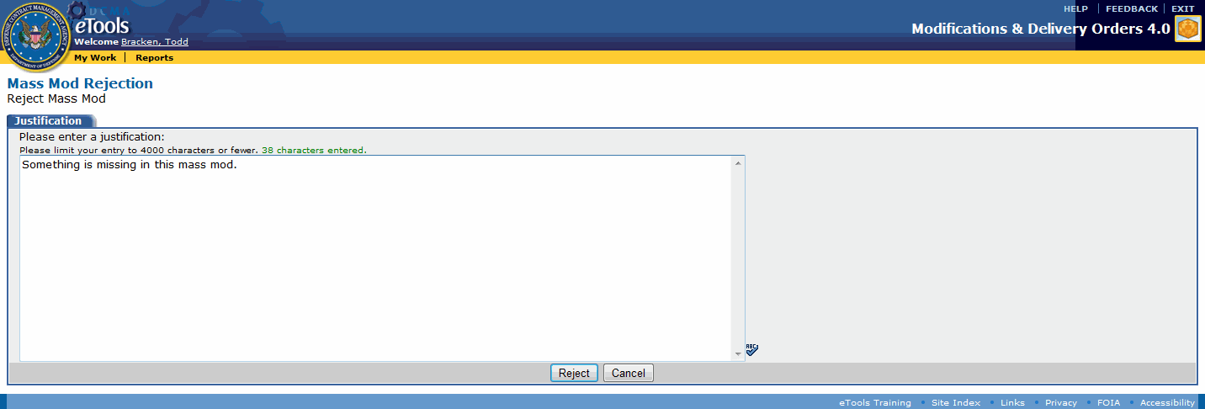

Figure 129: Rejection Justification page

If rejected, the Mass MOD returns to the ACO for revisions. An email is sent to the ACO with the text entered in the Mass Mod Rejection Justification page.

The email will contain the following information:

**The following Mass Mod has been rejected by the FIRM Center:  
New Name: 1  
The mass mod was rejected for the following reason, provided by the FIRM Center:**  
"This is a sample rejection!"

Once rejected, the Mass MOD returns to the ACO's workload page. The ACO can make any needed revisions to the mod.

## FPDS Mass Mods

Only ACO users will be able to view and approve any FPDS CARs created during the Mass Mod process. An ACO can only view the FPDS page when the Mass MOD is in "Generate FPDS CAR" status. While in this status, an FPDS link is in the Action column. Click the FPDS link to access a Mass MOD FPDS page. The Mass MOD FPDS page displays any FPDS CARs created for the Mass MOD that are in the "FPDS Draft" status (Figure 130). The ACO can attempt to validate and approve the FPDS CAR b clicking on one or more boxes in the first column and then click the Validate button. This will attempt to validate the FPDS CAR(s). If validated, the ACO can attempt to approve them.

The "Generate FPDS CAR" status follows the FIRM center approving the Mass MOD for release and the nightly job has run to create the records for the individual Mass MOD in FPDS. After the individual mods are created, MDO attempts to create the FPDS CARs for any base contracts (13 alphanumeric characters, also known as PIIN) under the Mass Mod.

The FPDS tab on the ACO's View My Work Page allows the ACO to view the current status of the FPDS CARs (Figure 131). The ACO can validate any number of FPDS CARs by clicking the validate button. MDO will compare the status of each FPDS CAR against what is actually in FPDS.

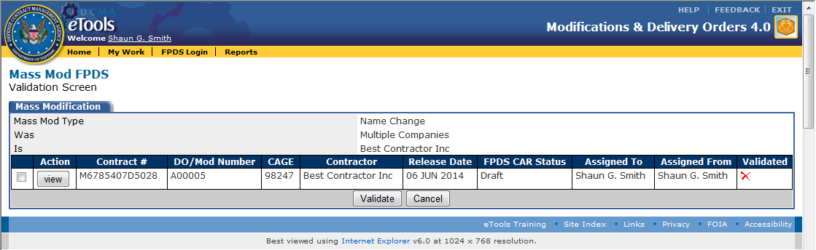

Figure 130: Mass MOD FPDS page

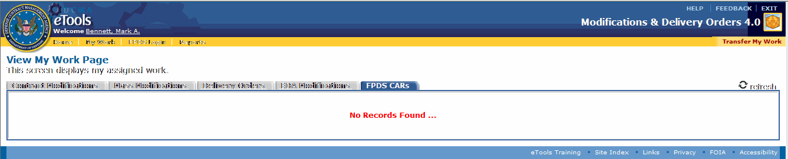

Figure 131: FPDS CAR Workload page

# FPDS CARs

## Entering Your FPDS Login Information

The FPDS (Federal Procurement Data System) Login link appears on the menu bar for the ACO user role. ACO user roles should type their FPDS user ID on this page or they will not be able to create FPDS CARs in MDO.

**To enter your FPDS login information into the MDO application,** do the following:

1. Click the FPDS Login link on the menu bar. The FPDS Login page appears (Figure 132).

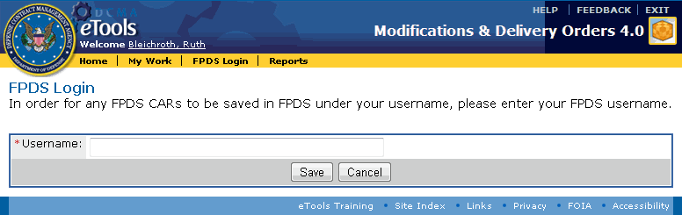

Figure 132: FPDS Login page

1. Type your FPDS user name in the Username text box (**Note:** Your FPDS user name is your DCMA email address).
2. Click the Save button.

## MDO-FPDS Overview and Process Flow

### DCMA Policy: Brief Overview

Before MDO 3.1, MDO reported, validated, and approved FPDS CARs (Federal Procurement Data System Contract Action Reports) automatically. DCMA changed the review and approval process to comply with DPAP-mandated system changes supporting strict compliance with FAR 4.604(b), which requires that FPDS CARs be reviewed for accuracy prior to release of the contract action.

The former two-step process required ACO's to issue contracts in MDO, then separately access the FPDS Web site to manually review any resulting FPDS CARs.

The newer integrated process provides an interface between MDO and FPDS that gives ACO's the capabilities of reviewing, validating, and approving FPDS CARs within the MDO application. MDO now has an FPDS CARs tab that enables CO’s to manage draft CARs pending validation and approval.

A button within MDO launches the FPDS Web site and generates draft FPDS CARs; links within MDO launch the FPDS Web site and open existing FPDS CARs for specified MDO transactions.

Data from MDO is pushed to the FPDS application in real time.

### Process Flow

If a ACO determines that generating an FPDS CAR is necessary, the new MDO-FPDS process flow is as follows (Figure 133):

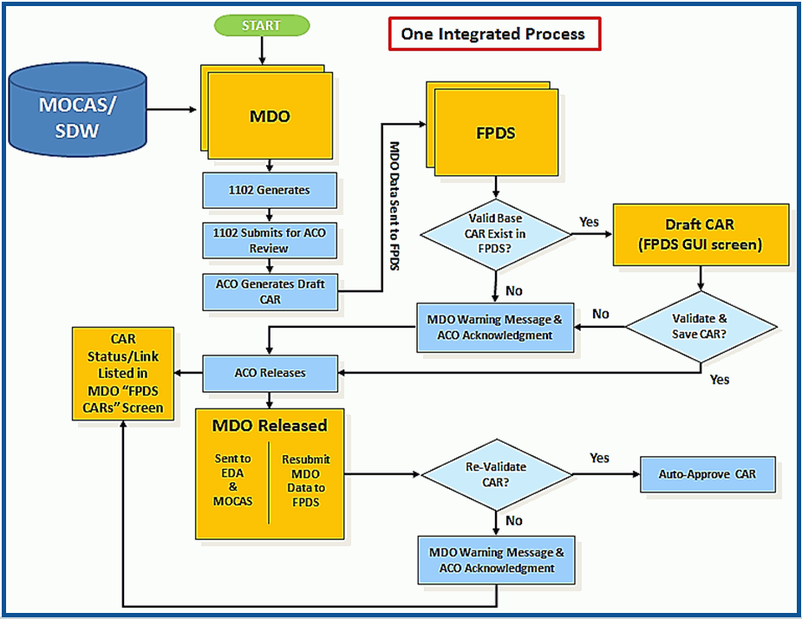

Figure 133: MDO-FPDS Process

1. Contract Administrator (CA) generates modification or delivery order within MDO.
2. CA submits modification or delivery order to Contracting Officer (ACO) for review within MDO.
3. ACO reviews modification or delivery order prior to initiating the release process.
4. ACO initiates the release process for the modification or delivery order from MDO.
   1. ACO clicks the Generate FPDS CAR button on the MDO Confirmation Page (see the topic [Releasing a MOD](#all_t_releasing_a_mod_htm)).
   2. The Generate FPDS CAR button generates a draft contract action report (CAR) for the contract action [MOD] and opens the FPDS Web site to the specific screen used to manage the CAR.
   3. The draft CAR is generated using data pulled from MDO and the existing base CAR pre-loaded in FPDS.
      1. CAR details are stored within the MDO database, CAR status set as "Draft."
   4. ACO reviews, validates and saves the draft CAR within the FPDS GUI.
      1. The "Approve" button within this screen is disabled to prevent ACO approval of CARs prior to MDO release.
5. ACO returns to the MDO Confirmation Page and releases the contract action [MOD], triggering the following automatic actions:
   1. MDO CAR data resent to FPDS, ensuring synchronization between MDO and FPDS datasets.
   2. FPDS CAR is revalidated.
      1. For Validation Issues [Problems]: ACO receives error message, the automatic approval process terminates, the FPDS CAR remains in "Draft" status.
      2. Validated/saved FPDS CAR automatically approved within FPDS; FPDS CAR status set as "Final" within the MDO database.

## Generating an FPDS CAR

The ACO user role can generate an FPDS CAR before releasing a contract modification or delivery order.

* The ACO user role should refer to FAR/DFAR to determine whether generating an FPDS CAR is necessary.
* Generating an FPDS CAR is solely the decision of the ACO; MDO provides no validation as to whether an FPDS CAR is necessary.
* Because a correct Treasury Account Symbol (TAS) is required to validate an FPDS CAR, the ACO may want to review the following topics before proceeding to generate an FPDS CAR: [Viewing an ACRN](#acrn_t_viewing_an_acrn_htm), [Adding an ACRN](#acrn_t_adding_an_acrn_htm) (including subtopic [DCMA Policy: LOA and FPDS](#acrn_t_adding_an_acrn_htm_dcma_p_4589)), [Editing an ACRN](#acrn_t_updating_an_acrn_htm).

**To generate an FPDS CAR before releasing a MOD,** do the following:

1. Locate the MOD for which you wish to generate an FPDS CAR before releasing the MOD. See the topic [Browsing Contract Modifications](#contract_mods_t_browsing_contrac_4723) or [Browsing Delivery Orders](#delivery_orders_t_browsing_deliv_8362) to locate a MOD.
2. On the Manage MOD Page, click the i_checkmark.gif Release MOD link; on the Manage Delivery Order Page, click the i_checkmark.gif Release Delivery Order link. The Confirmation Page appears.
3. On the Confirmation Page, click the Generate FPDS CAR button. The FPDS CAR (that is, the FPDS Graphical User Interface (GUI)) appears in a new window within the FPDS application (Figure 134). The Save Draft, Validate, Print, and Help buttons are displayed within the FPDS application.

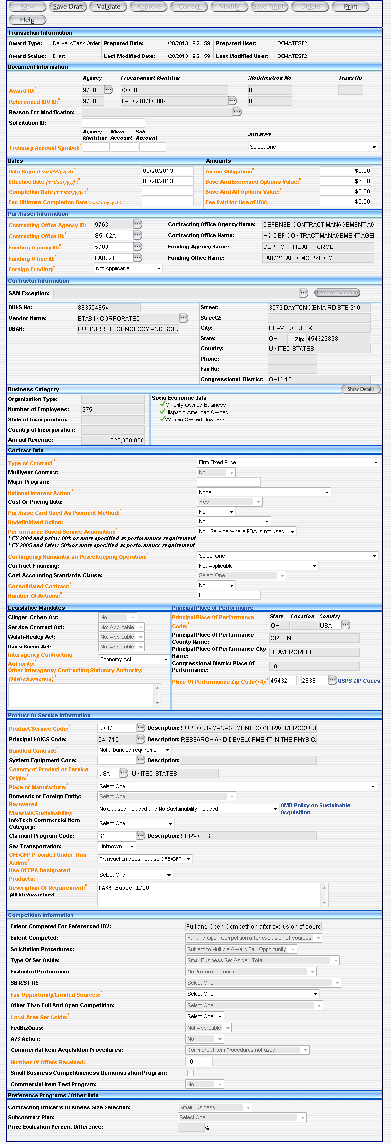

Figure 134: FPDS CAR GUI

**To validate and approve the FPDS CAR,** see the subtopic [Validating and Approving an FPDS CAR](#generating_an_fpds_car_before_re_8330) within this topic.

## Identifying FPDS Base Documents

The MDO-FPDS data exchange can accommodate cases where new FPDS CARs need to be created for the following:

* Modifications to contracts or orders with multiple FPDS CARs (that is, instances where multiple base CARs were posted to FPDS for the same contract action)
* Modifications to contracts or orders issued through a Federal Supply Schedule

ACO's can view each of these CARs before selecting the correct one to be used with the current contract MOD or order action.

**To identify base documentation,** do the following:

1. On the Confirmation Page (see the topic [Generating an FPDS CAR](#generating_an_fpds_car_before_re_4968)), click the Generate FPDS CAR button. If multiple base CARs were posted to FPDS for the same contract action, the Select Transaction for CAR page appears, from which the ACO can view and select the requisite base CAR (Figure 135).

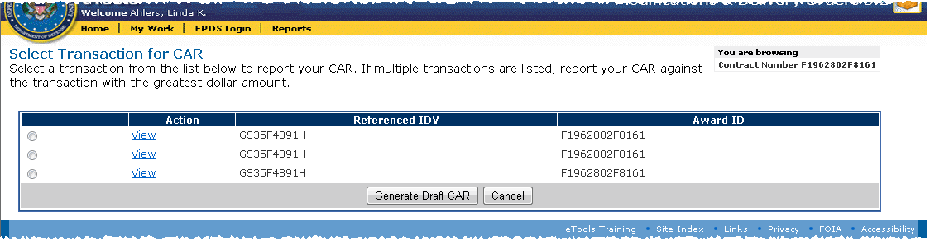

Figure 135: Select Transaction for CAR page

1. On the Select Transaction for CAR page, click the option button for the applicable transaction.

**To view a transaction,** click the View link for the transaction.

1. Click the Generate Draft CAR button. See the subtopic [Validating and Approving an FPDS CAR](#generating_an_fpds_car_before_re_8330) within this topic.

## Generation Errors

* If you click the Generate FPDS CAR button and do not receive any error messages, the CAR will appear in your FPDS CARs tab with the FPDS CAR Status of "Draft."
* If you receive error messages (due to errors in MDO or in FPDS), the FPDS CAR will appear in your FPDS CARs tab with the FPDS CAR Status of "Error" (Figure 136). See the topic [Browsing FPDS CARs](#browsing_fpds_cars_htm) to view FPDS CAR statuses.

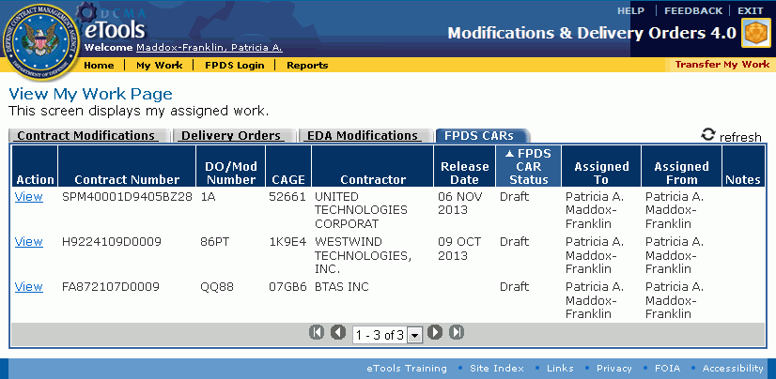

Figure 136: FPDS CAR Statuses

## MDO-FPDS Equivalencies

The following FPDS GUI fields should be edited in MDO; data in MDO overwrites data in FPDS (see the Editing topics within this user's manual to edit MDO data). MDO equivalent data is also shown (Figure 137):

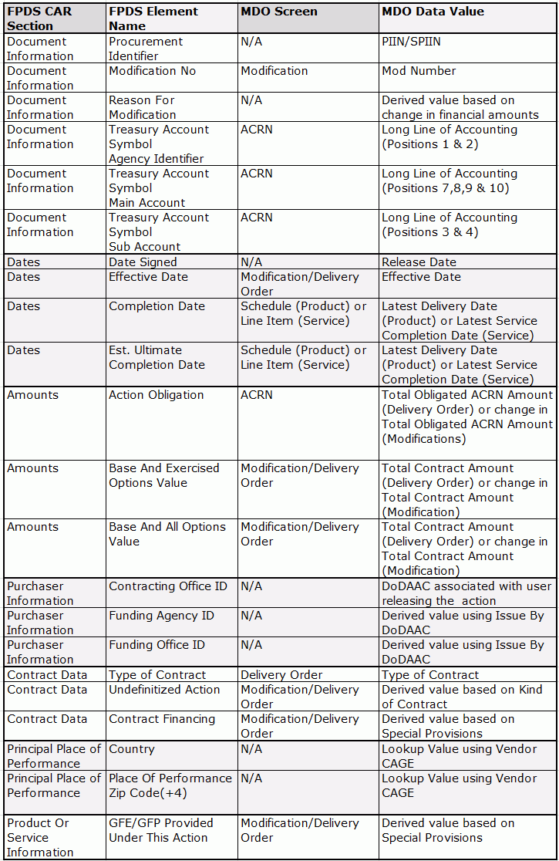

Figure 137: FPDS fields and MDO equivalent data

### DCMA Policy: Resolving Generation Errors

The following scenario describes receiving generation errors and the process for resolving generation errors:

1. ACO clicks Generate FPDS CAR button on the MDO Confirmation Page.
   1. The link opens the FPDS GUI, but the attempt to generate a Draft CAR for the delivery order or modification fails/[user receives] errors.
   2. An error message is displayed within the FPDS GUI.
   3. Details of the error are stored within the MDO database, CAR status set as "Error."
   4. The CAR is listed on the ACO's View My Work Page, FPDS CARs tab in MDO with an "Error" status (see the topic [Browsing FPDS CARs](#browsing_fpds_cars_htm) for information on viewing statuses).
2. ACO may proceed to release the modification or delivery order from MDO.
   1. A warning message appears; the ACO must acknowledge that the associated FPDS CAR has not been completed and that unresolved issues shall be resolved as soon as possible.
3. ACO consults with a DCMA FPDS Administrator for support with CAR errors.
   1. DCMA FPDS Administrator generates the Draft CAR within FPDS.
   2. CAR details are updated within the MDO database; CAR status changes from "Error" to "Draft."
4. ACO accesses the Draft CAR from their View My Work Page, FPDS CARs tab to complete FPDS review, validation and approval (see the subtopic [Validating and Approving an FPDS CAR](#generating_an_fpds_car_before_re_8330) within this topic and the topic [Managing an FPDS CAR](#managing_an_fpds_car_htm)).
   1. The CAR remains in "Draft" status within the MDO database until the CAR is approved within FPDS. Once approved, the CAR status is updated to "Final" within the MDO database.

## Validating and Approving an FPDS CAR

An ACO can validate and approve an FPDS CAR.

**Note:** Make sure that the Draft FPDS CAR does not contain a Treasury Account Symbol error before releasing a MOD or delivery order containing a new LOA. The LOA cannot be edited after the MOD or order has been released. As a result, it may be necessary to issue a modification to correct the erroneous data. See the subtopic [DCMA Policy: LOA and FPDS](#acrn_t_adding_an_acrn_htm_dcma_p_4589) within the topic [Adding an ACRN](#acrn_t_adding_an_acrn_htm) and the topic [Editing an ACRN](#acrn_t_updating_an_acrn_htm).

**To validate and approve an FPDS CAR,** do the following:

1. If you followed the steps for [Generating an FPDS CAR](#generating_an_fpds_car_before_re_4968) and immediately wish to validate and approve the FPDS CAR, you should still have the FPDS CAR window open. If the FPDS CAR window is open, proceed to step 2. If the FPDS CAR window is not open, locate the FPDS CAR you wish to validate and approve. See the topic [Browsing FPDS CARs](#browsing_fpds_cars_htm) or [Managing an FPDS CAR](#managing_an_fpds_car_htm) to locate an FPDS CAR.
2. In the FPDS CAR window, review and, if necessary, edit the FPDS CAR information.
3. Click the Validate button. The FPDS CAR window should refresh and the message "Award successfully validated" should appear.

If the "Award successfully validated message" does not appear, you may get error messages instead. Correct the errors and revalidate the FPDS CAR. Proceed to step 4. The FPDS application has its own help. Click the Help button in the FPDS CAR window for help with the FPDS application.

1. Click the Save Draft button. The FPDS CAR window should refresh.
2. Close the FPDS CAR window.
3. In the MDO application, on the Confirmation Page (see the topic [Releasing a MOD](#all_t_releasing_a_mod_htm)), click the OK button. The release confirmation page appears.

The MOD is released to MOCAS; the FPDS approval may or may not have been successful:

If the FPDS CAR approval is not successful, any error messages related to the unsuccessful FPDS approval are displayed on the MDO release confirmation page.

If the FPDS CAR approval is successful, the MDO release confirmation page is displayed normally and the CAR disappears from the FPDS CARs tab.

## FPDS Mass Mods

Only ACO users will be able to view and approve any FPDS CARs created during the Mass Mod process. An ACO can only view the FPDS page when the Mass MOD is in "Generate FPDS CAR" status (Figure 138). While in this status, an FPDS link is in the Action column. Click the FPDS link to access a Mass MOD FPDS page. The Mass MOD FPDS page displays any FPDS CARs created for the Mass MOD that are in the "FPDS Draft" status. The ACO can attempt to validate and approve the FPDS CAR b clicking on one or more boxes in the first column and then click the Validate button. This will attempt to validate the FPDS CAR(s). If validated, the ACO can attempt to approve them.

The "Generate FPDS CAR" status follows the FIRM center approving the Mass MOD for release and the nightly job has run to create the records for the individual Mass MOD in FPDS. After the individual mods are created, MDO attempts to create the FPDS CARs for any base contracts (13 alphanumeric characters, also known as PIIN) under the Mass Mod.

The FPDS tab on the ACO's View My Work Page allows the ACO to view the current status of the FPDS CARs (Figure 139). The ACO can validate any number of FPDS CARs by clicking the validate button. MDO will compare the status of each FPDS CAR against what is actually in FPDS.



Figure 138: Mass MOD FPDS page



Figure 139: FPDS CAR Workload page

### DCMA Policy: Approving an FPDS CAR After MOD Release

The subtopic [Validating and Approving an FPDS CAR](#generating_an_fpds_car_before_re_8330) within this topic addresses attempting to approve an FPDS CAR before releasing the MOD.

The following information describes the process of attempting to approve an FPDS CAR *after* a MOD has been released:

1. ACO accesses the FPDS CARs tab within their View My Work Page of MDO.
2. CO clicks the View link for the specified FPDS CAR. The Manage FPDS CAR Page appears.
   1. Clicking the View FPDS CAR link on the Manage FPDS CAR Page will automatically
      1. Resubmit MDO data to FPDS for the specific contract action [MOD].
      2. Open the FPDS GUI.
      3. Open the CAR for the specific contract action [MOD].
3. ACO reviews and validates the CAR within the FPDS GUI.
   1. If the ACO receives validation errors related to MDO data, The ACO will ...
      1. Delete the FPDS CAR by clicking the Delete FPDS CAR link on the Manage FPDS CAR Page within MDO.
      2. Issue a contract modification to correct the validation issue(s).
   2. For errors that cannot be resolved by the ACO (i.e. issues within the base FPDS CAR):
      1. ACO consults with associated PCO/Buying Activity to resolve validation errors.
4. ACO returns to their MDO View My Work Page, FPDS CARs tab and clicks the Approve link on the Manage FPDS CAR Page, triggering the following automatic actions:
   1. MDO CAR data resent to FPDS, ensuring synchronization between MDO and FPDS datasets.
   2. FPDS CAR is revalidated.
      1. For Validation Issues: ACO receives error message, the automatic approval process terminates, the CAR remains in "Draft" status.
   3. Validated/saved CAR automatically approved within FPDS.
   4. CAR status set as "Final" within the MDO database.

## Validation Errors

When you attempt to validate an FPDS CAR, errors in the Treasury Account Symbol, Dates, or Amounts fields in the FPDS CAR must be corrected in MDO.

The following scenario describes receiving validation errors and the process for resolving validation errors:

### DCMA Policy: Resolving Validation Errors

1. ACO receives validation errors [within the FPDS GUI] while reviewing and validating FPDS CARs initiated from MDO.
   1. For errors related to MDO data: ACO will close the FPDS GUI, revise the modification or delivery order as needed using MDO, and re-initiate the MDO release process.
      1. ACO clicks the Regenerate FPDS CAR link on the Manage FPDS CAR page. See the topic [Managing an FPDS CAR](#managing_an_fpds_car_htm).
   2. For errors that cannot be resolved by the ACO (i.e. issues within the base FPDS CAR):
      1. ACO may proceed to release the modification or delivery order from MDO (see the topic [Releasing a MOD](#all_t_releasing_a_mod_htm)).
         1. A warning message appears; ACO must acknowledge that the associated FPDS CAR has not been completed and unresolved issues shall be resolved as soon as possible.
         2. FPDS CAR details are stored within the MDO database; FPDS CAR status set as "Draft."
         3. The CAR is listed on the ACO's View My Work Page, FPDS CARs tab with "Draft" status.
      2. ACO consults with associated PCO/Buying Activity to resolve validation errors.
   3. ACO accesses the Draft CAR from their MDO FPDS CARs [View My Work Page] to complete FPDS review, validation and approval (see the subtopic [Validating and Approving and FPDS CAR](#generating_an_fpds_car_before_re_8330) within this topic and the topic [Managing an FPDS CAR](#managing_an_fpds_car_htm)).
      1. The CAR remains in "Draft" status within the MDO database until the CAR is approved within FPDS. Once approved, the CAR status is updated to "Final" within the MDO database.

See the topic [Additional Resources](#additional_resources_htm) for additional help with LOAs and FPDS.

## Browsing FPDS CARs

The ACO user role can browse FPDS CARs. ACO's will only see CARs they have initiated on the FPDS CARs tab.

Only FPDS CARs with the FPDS CAR Status of "Draft" or "Error" appear in the FPDS CARs tab. If an FPDS CAR is generated, validated, and released, it will not appear in the FPDS CARs tab. The approved and released FPDS CAR will, however, appear in the FPDS application with the status of "Final."

**To browse FPDS CARs,** do the following:

1. Click the My Work link on the menu bar. The View My Work Page appears.
2. Click the FPDS CARs tab. The FPDS CARs tab is displayed (Figure 140).



Figure 140: View My Work Page with FPDS CARs tab displayed

The column headings that appear on the View My Work Page, FPDS CARs tab are as follows:

* **Action:** Displays a View link to view the Manage FPDS CAR Page.
* **Contract Number:** Displays the contract number of the contract being modified.
* **DO/MOD Number:** Displays the Delivery Order number or MOD number.
* **CAGE:** Displays the CAGE.
* **Contractor:** Displays the contracting company name.
* **Release Date:** Displays the date the MOD was released from MDO. This is blank if the MOD has not yet been released.
* **FPDS CAR Status:** Displays the FPDS CAR's current status.
* **Assigned To:** Displays the name of the CA or ACO who currently has the MOD.
* **Assigned From:** Displays the name of the CA who assigned (or sent) the MOD.
* **Notes:** Displays Notes typed in the Manage FPDS CAR Page.

**To manage an FPDS CAR,** click the View link for the MOD whose FPDS CAR you wish to manage. The Manage FPDS CAR Page appears. See the topic [Managing an FPDS CAR](#managing_an_fpds_car_htm) for more information.

**To view an FPDS CAR,** on the Manage FPDS CAR Page, click the View link. The FPDS CAR appears in a new window.

To reassign work to another person, on the View My Work Page, click the Transfer My Work link on the menu bar. See the topic [Transferring Mods](#all_t_transferring_mods_htm) for more information.

To see the current contract modifications, on the View My Work Page, click the Contract Modifications tab. See the topic [Browsing Contract Modifications](#contract_mods_t_browsing_contrac_4723) for more information.

To see the current delivery orders, on the View My Work Page, click the Delivery Orders tab. See the topic [Browsing Delivery Orders](#delivery_orders_t_browsing_deliv_8362) for more information.

To update the View My Work Page, click the refresh refresh link.

## Managing an FPDS CAR

The ACO user role can manage an FPDS CAR.

**To manage an FPDS CAR,** do the following:

1. Click the My Work link on the menu bar. The View My Work Page appears.
2. Click the FPDS CARs tab. The FPDS CARs tab is displayed.
3. Click the View link for the MOD whose FPDS CAR you wish to manage. The Manage FPDS CAR Page appears (Figure 141) and (Figure 142).

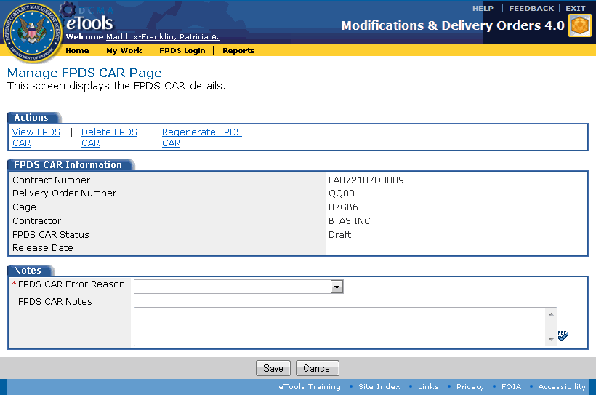

Figure 141: Manage FPDS CAR Page without Approve FPDS CAR link

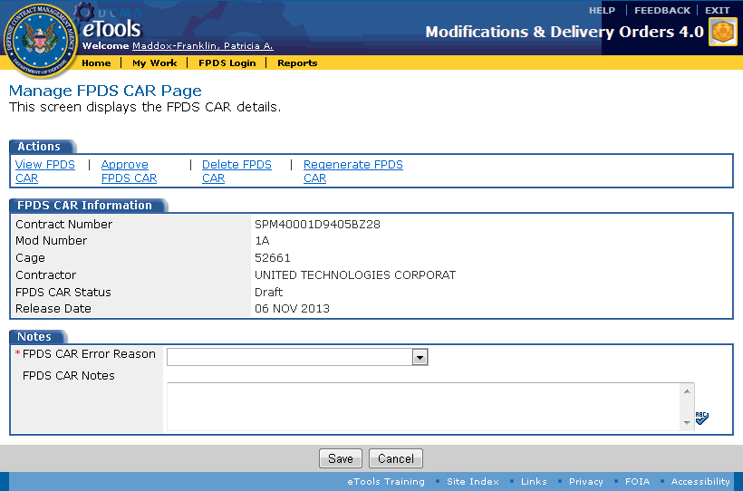

Figure 142: Manage FPDS CAR Page with Approve FPDS CAR link

The following links appear on the Manage FPDS CAR Page, in the Actions tab: View FPDS CAR, Approve FPDS CAR, Delete FPDS CAR, and Regenerate FPDS CAR.

The Approve FPDS CAR link only appears if the MOD or delivery order to which the FPDS CAR is assigned was released. See the topic [Releasing a MOD](#all_t_releasing_a_mod_htm) and the subtopic [DCMA Policy: Approving an FPDS CAR After MOD Release](#generating_an_fpds_car_before_re_6731) (within the topic [Generating an FPDS CAR](#generating_an_fpds_car_before_re_4968)) for more information.

**To view the FPDS CAR,** on the Manage FPDS CAR Page, click the View FPDS CAR link. The FPDS CAR appears in a new window within the FPDS application. See the subtopic [Validating and Approving an FPDS CAR](#generating_an_fpds_car_before_re_8330) within the topic [Generating an FPDS CAR](#generating_an_fpds_car_before_re_4968). The FPDS application has its own help. Click the Help link in FPDS to view the application's Help topics.

**To approve the FPDS CAR,** on the Manage FPDS CAR Page, click the Approve FPDS CAR link. The Approve link resends MDO data to FPDS, revalidates and (if the CAR is valid) approves the CAR.

**To delete the FPDS CAR,** on the Manage FPDS CAR Page, click the Delete FPDS CAR link. The FPDS CAR is deleted from FPDS and the record in the FPDS CAR tab is removed.

**To regenerate the FPDS CAR,** click the Regenerate FPDS CAR link. Regenerating an FPDS CAR deletes the current CAR from the FPDS system and starts the FPDS CAR process from scratch, as if you clicked the [Generate FPDS CAR](#generating_an_fpds_car_before_re_4968) button on the Confirmation Page. See the topic [Generating an FPDS CAR](#generating_an_fpds_car_before_re_4968).

The Notes tab on the Manage FPDS CAR Page contains the FPDS CAR Error Reason drop-down list box and the FPDS CAR Notes text box.

* If necessary, make a selection from the FPDS CAR Error Reason drop-down list box for any errors that may have occurred during the FPDS CAR generation/validation process.
* If necessary, type additional information in the FPDS CAR Notes text box (FPDS CAR Notes can include any efforts to resolve CAR errors/issues).

**To save changes on the Manage FPDS CAR Page,** click the Save button.

## Additional Resources

The following resources provide detailed information on LOAs, FPDS, MDO, and related policies, as well as, Points of Contacts to assist you when necessary. If you are unable to identify the Treasury Symbol, you should contact the PCO, FPDS Agency Representative, and/or the DCMA FPDS point of contact (preferably in that order) for assistance.

**Line of Accounting:**

* PCO Contact: EDW, EDA, & FPDS Agency Representatives (see "Additional Resources")
* Treasury Account Symbol Reporting Frequently Asked Questions
* DFAS Manual 7097.01 Treasury Symbol
* DoD Financial Management Regulation (DOD FMR 7000.14-R): Reporting Entity & Fund/Account Treasury Symbol (Vol. 6A Appendix A)
* DoD FMR 700.14-R, Volume 12, Chapter 1
* US Marine Corps Instructions on Construction of a LOA

**Dictionary, Generation Data Elements**

**FPDS-NG Government User’s Manual** (Version 1.4, April 2012)

**DoD FPDS-Policy Memos**

**MDO eTool Training Web Site**

**Contracts Modification Policy Point of Contact:** Sam Davis

**DCMA FPDS Points of Contact:** Daisy Pierce and Michael Deslippe

# Glossary

A

ACO: Administrative Contract Officer

ACRN: Accounting Classification Reference Number. A two-letter code that represents the control number associated with one Long Line Accounting Classification Citation Number for the contract.

B

Browse: Refers to pages where you can see a list of the generated mods, ACRNs, line items, schedules, or special provisions.

C

CA: Contract Administrator

CAR: Contract Action Report

CLIN: Contract Line Item Number

Copy of manage: Refers to pages where you can see details about a specific mod, ACRN, line item, or other type of record. Same as view.

D

DoDAAC: Department of Defense Activity Address Code

F

FPDS: Federal Procurement Data System

M

Manage: Refers to pages where you can see details about a specific mod, ACRN, line item, or other type of record. Same as view.

MILSTRIP: Military Standard Requisitioning and Issue Procedures. Associated with the CLIN, schedule and contract in SDW. Format is DoDAAC/YYYY or Julian Date/alpha-numeric serial number (total length equals 14 characters). MOCAS will reject any MILSTRIP that fails to use this format.

Mod: A contract modification, delivery order, or EDA-only contract modification.

P

PSC: Product Service Code

R

Release: Refers to the ACO's task of releasing the mod to EDA, EDI, and eventually, MOCAS.

S

Submit: Refers to the process where the CA sends a mod to the ACO for review and consideration for release.

T

TCO: Termination Contracting Officer

V

View: Refers to pages where you can see details about a specific mod, ACRN, line item, or other type of record. Same as manage.