

Preaward Survey System (PASS)

Version 2.0

Application User's Manual

External Users

02 May 2013
Table of Contents
1 About the Preaward Survey System (PASS) 1
1.1 About the Preaward Survey System (PASS) 1
1.2 Organization 1
1.2.1 User Roles and Tasks 1
1.3 Navigation Elements 2
1.3.1 Menu Bar 3
1.3.2 Tabs 4
1.3.3 Columns 5
1.3.4 Footer 5
1.3.5 Icons 6
1.4 Printing 6
1.5 Summary of the Preaward Survey Request Process 7
1.5.1 Email Notifications 9
2 Customer's Role 11
2.1 Customer's My Work Page 11
2.1.1 Menu Bar 11
2.1.2 Tabs 11
2.1.3 Columns 15
2.1.4 Understanding Survey Statuses 16
2.1.5 Viewing Preaward Survey Requests 17
2.2 Creating or Editing a Signature 17
2.3 Viewing Audit Logs and Evaluation Histories 18
2.3.1 Audit Log 18
2.3.2 Evaluation History 19
2.4 Searching for Contractors 20
2.4.1 Contractor - Search Results 23
2.4.2 Contractor Search - Company Review Page 24
2.5 Requesting a Preaward Survey 26
2.5.1 Preparing a Preaward Survey Request 26
2.5.2 I. Request Details Tab 27
2.5.3 II. Prospective Contractor Tab 29
2.5.4 III. Solicitation Data Tab 31
2.5.5 IV. Evaluation Factors Tab 34
2.5.6 V. Plant And Location Tab 37
2.5.7 VI. Requestor Comments Tab 37
2.5.8 Attachments Tab 38
2.5.9 Submitting the Preaward Survey Request 42
2.6 Adding and Editing a Location 45
2.6.1 Editing a Location 51
2.6.2 Deleting a Location 53
2.7 Deleting a Draft Survey Request 56
2.8 Unsubmitting a Survey Request 58
2.9 Viewing Completed Preaward Surveys 59
2.10 Editing Completed Preaward Surveys 65
2.10.1 Changing the Release Date 65
2.10.2 Adding and Deleting Buying Activity Users 66
3 Glossary 69

About the Preaward Survey System (PASS)

About the Preaward Survey System (PASS)
A preaward survey provides DCMA customers with an accurate assessment of a prospective contractor’s capabilities as they relate to specific government procurements. The Preaward Survey System (PASS) eTool was designed to support the preaward survey process from request to receipt of the preaward survey results.
This user's manual provides assistance with using the PASS eTool. For guidance regarding reporting requirements and insight into interviewing techniques, the purpose of individual analysis requirements, and a basic understanding of what customers require to make a determination of responsibility decision per FAR 9, see the Preaward Survey Guidebook, which describes the mandatory DCMA policy.
All DCMA personnel are encouraged to submit suggestions for changes to the PASS system. See the DCMA Home Page at http://www.dcma.mil for further information.
To learn how this user's manual is organized, see the topic Organization.
For help with using the links, tabs, and buttons in PASS, see the topic Navigation Elements.
To set the print margins in your browser software, see the topic Printing.
To read a summary of the preaward survey request process, see the topic Summary of the Preaward Survey Request Process.
The Business Sensitive and Proprietary Information in PASS is for Official Use Only.

Organization
The chapters of this user's manual are organized by user role and associated tasks. This helps you find the information relevant to your needs and tasks. It can also help you understand the tasks that others perform to support your objectives, and how your role interacts with their tasks.

User Roles and Tasks
The user roles in PASS are as follows: Customers, PASMs, Specialists, Financial PASMs, Administrators.
- Internal users are users internal to the Defense Contract Management Agency (DCMA); internal PASS users are PASMs (including Financial PASMs), Specialists, and Administrators.
- External users are users external to the Defense Contract Management Agency (DCMA); external PASS users are Customers.
Customers can do the following:
- Search for contractors and past preaward surveys
- Request a preaward survey
- Unsubmit a survey request
- See the results of a recently completed preaward survey
Preaward Survey Managers (PASMs) can do the following:
- Perform tasks that Customer and Specialist user roles can perform
- Search for contractors and past preaward surveys
- Request a preaward survey on behalf of a customer
- Unsubmit a survey request (if the PASM created the request)
- Assign factor evaluations to others
- Transfer survey requests
- Approve or not approve, assign final ratings to, compile, and submit completed surveys to customers
Specialists can do the following:
- Assign factor evaluations to others
- Complete factor evaluations
- Respond to factor evaluations that the PASM does not accept
Financial Preaward Survey Managers (PASMs) can do the following:
- Perform tasks that the (Financial) Specialist user role can perform
- Assign financial factor evaluations to others
- Approve or not approve financial factor evaluations
Administrators can do the following:
- Perform all the tasks other user roles can perform
- Configure the workload to view users' and DoDAACs' workloads
- Transfer users' workloads to other users
To read a description of the objectives of the Preaward Survey System application, see the topic About PASS.
For help with using the links, tabs, and buttons in PASS, see the topic Navigation Elements.
To read a summary of the preaward survey request process, see the topic Summary of the Preaward Survey Request Process.
To set the print margins in your browser software, see the topic Printing.

Navigation Elements
The navigation elements of the PASS application help you find information and complete tasks efficiently.
The top-left side of the page displays the DCMA logo, the menu bar, and your name as a link (Figure 1).

Figure 1: DCMA logo and user name link
If you click this link, your user information will appear in a new window (Figure 2).
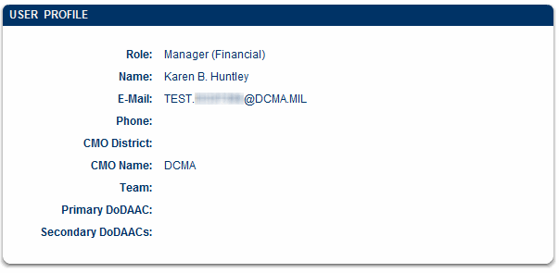
Figure 2: User information window
The right side of the top of the page provides the Help, Feedback, and Exit links (Figure 3), from which you can navigate this online Help system, go to a page where you can provide feedback about the application, or exit the application, respectively. You help ensure that only authorized persons access this application by using the Exit link.
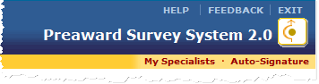
Figure 3: Right-side menu options

Menu Bar
The menu bar below your name provides links to functionality specific to the PASS application (Figure 4, Figure 5, and Figure 6).
Figure 4: Menu bar
Figure 5: Menu bar
Figure 6: Menu bar
The links on the menu bar vary depending upon your user role (if you do not see a link on either your home page or on another page in the PASS application, that link might not be applicable to your user role):
Home: Click the Home link at any time to go to the home page (Note: The specific Home link may differ for each user role; for example, Customer Home, Manager Home, etc.).
Reports: Click this link to open the PASS Reports application; appears on the home page (the PASS Reports application has its own Help).
My Specialists: Click this link to add Specialists to whom you can assign factor evaluations; appears on the home page. See the topic Adding a Specialist.
Auto-Signature: Click this link to create and/or activate a signature; appears on the home page. See the topic Creating a Signature.
Go Back: Click the Go Back link to return to the previously viewed page. The Go Back link is preferable to using the browser's Back button, which might navigate you to a page other than the previously viewed page. The Go Back link does not appear on the home page.
Audit Log: Click this link to view the actions history of a survey or evaluation factor (all actions taken and by whom they were taken); does not appear on the home page.
Evaluation History: Click this link to view the evaluation history of a factor; does not appear on the home page.
Print Version: Click this link to open a print-friendly view of the page; does not appear on the home page.

Tabs
Tabs show requests with a specific status (Figure 7).
To see information on a tab, click the tab. The tab is displayed.
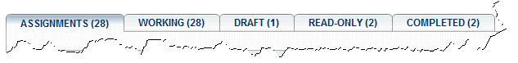
Figure 7: Tabs

Columns
Each column (Figure 8) in a table allows you to sort information in either ascending or descending order; click the column heading to sort the information in either ascending or descending order. Column widths can also be resized by clicking the side of a column's heading and dragging the mouse to the left or right.
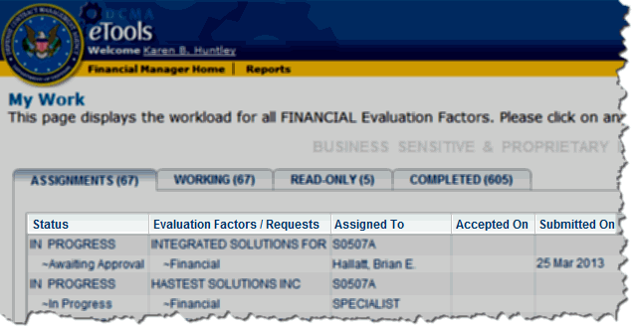
Figure 8: Columns headings
On pages that display multiple requests, the arrows and drop-down list box at the bottom of the page allow you to move to the first, previous, next, or last request, or to click in the box and type the sequence number of the requests you wish to see (Figure 9).

Figure 9: First, previous, next, and last buttons

Footer
The footer at the bottom of every page provides links to standard DCMA Web sites (Figure 10).
Figure 10: Page footer
These footer links display the following information:
eTools Training: Online videos with sound that describe how to use the application.
Site Index: Displays http://home.dcma.mil/siteindex.htm, which is an index of the DCMA Web site.
Links: Displays http://www.dcma.mil/links.htm, which lists US Government, DOD and DLA links.
Privacy: Displays http://home.dcma.mil/notice.htm, which states how the server shall be used.
FOIA: Displays http://www.dcma.mil/foia.htm, which states rights to information under the Freedom of Information Act (FOIA) and provides a contact for FOIA inquiries.
Accessibility: Displays http://home.dcma.mil/508.htm, which provides contact information for accessibility questions.

Icons
The following icons link to additional functionality:
View information.
Display a pop-up calendar to select a date.
Search for and/or populate information.
View the Audit Log.
Use the spelling checker to check the spelling of text.
To read a description of the objectives of the Preaward Survey System application, see the topic About PASS.
To learn how this user's manual is organized, see the topic Organization.
To set the print margins in your browser software, see the topic Printing.
To read a summary of the preaward survey request process, see the topic Summary of the Preaward Survey Request Process.

Printing
To print from PASS and have the results appear on a single page with no information cut off, be sure to set the margins in your web browser to .25 inches.
For Internet Explorer, do the following:
- Click the File menu.
- Choose Page Setup.
- In the Margins area, type .25 in each box.
- Click the OK button.
To read a description of the objectives of the Preaward Survey System application, see the topic About PASS.
To learn how this user's manual is organized, see the topic Organization.
For help with using the links, tabs, and buttons in PASS, see the topic Navigation Elements.
To read a summary of the preaward survey request process, see the topic Summary of the Preaward Survey Request Process.
Preaward Serial Numbers appear on printed (.pdf) surveys.

Summary of the Preaward Survey Request Process
The following tasks must occur to complete a preaward survey:
- The Customer submits a request for a preaward survey of a contractor. See the Customer's topic Requesting a Preaward Survey (or see the PASM's topic Requesting a Preaward Survey for a Customer).
- The request is routed to the contract management office (CMO) responsible for that contractor.
- A Preaward Survey Manager (PASM) at that CMO receives the request (financial surveys/financial factor evaluations are automatically routed to a Financial PASM; the primary PASM has visibility, but doesn't work the financial portions of requests). The PASM reviews the request and the evaluation factors that the Customer requested to be included in the preaward survey.
- The PASM assigns each of the evaluation factors to a person (usually a Specialist) who is responsible for completing the evaluation for that factor. The factor evaluation can be assigned to a Specialist, to a different PASM, or to the primary PASM who received the preaward survey request. See the PASM's topic Assigning Factor Evaluations (the Financial PASM assigns and processes the financial factor evaluations. See the Financial PASM's topics Assigning Factor Evaluations and Processing Preaward Survey Results).
- The PASM assigned to the Primary Survey Request can assign a secondary location survey request; the PASS eTool will route secondary location survey requests based upon the ZIP code of the contractor at the secondary location (where the survey will be performed), and the request will appear in the Secondary PASM's workload.
- The PASM assigned to the secondary location survey request assigns each of the factors in the secondary location survey request to Specialists. See the PASM's topic Assigning Factor Evaluations.
- The PASM assigned to the Secondary Survey Request can assign tertiary location survey requests; the PASS eTool will route tertiary location survey requests based on the ZIP code of the contractor at the tertiary location (where the survey will be performed), and the request will appear in the Tertiary PASM's workload.
- The PASM assigned to the tertiary location survey request assigns each of the factors in the Tertiary Evaluation Factor Report to Specialists. See the PASM's topic Assigning Factor Evaluations.
- The person assigned the evaluation for the factor (typically a Specialist, but possibly a PASM) can either complete or reassign the factor evaluation. See the Specialist's topic Completing Factor Evaluations or the topic Assigning Factor Evaluations.
- Upon completing the factor evaluation, the Specialist or PASM submits it to the PASM at the CMO that is responsible for the contractor.
- The PASM reviews each of the primary survey's factor evaluations and either accepts or does not accept them. If not accepted, the evaluation is routed back to the Specialist to edit and resubmit. See the PASM's topic Processing Preaward Survey Results or the Specialist's topic Responding to Not Accepted Factor Evaluations.
- If Secondary (and Tertiary) requests have been assigned, once all factor evaluations are received and approved, the PASM at the Tertiary Location will perform a compilation, finalizing the tertiary location survey request and submitting the approved request back to the Secondary Survey Request PASM. See the PASM's topic Processing Preaward Survey Results.
- The Secondary Survey Request PASM can then review the entire tertiary location survey request and approve it or not accept it. See the PASM's topic Processing Preaward Survey Results.
- Once all Tertiary and Secondary factor evaluations are received and approved, the Secondary Location PASM will compile the survey requests. Once compiled, the request is forwarded to the Primary PASM. See the PASM's topic Processing Preaward Survey Results.
- The Primary PASM can then review the entire tertiary location survey request and the secondary location survey request and approve them or not accept them. See the PASM's topic Processing Preaward Survey Results.
- The Primary PASM assigns final ratings to the primary survey request's factor evaluations. If the PASM accepts a factor evaluation, the PASM then assigns a final rating to the factor evaluation. See the PASM's topic Processing Preaward Survey Results.
- Once the PASM has assigned a final rating to all of the primary survey request's factor evaluations, the PASM can compile the entire survey request. See the PASM's topic Processing Preaward Survey Results.
- Once the survey is compiled, the PASM can return the survey to the Customer. See the PASM's topic Processing Preaward Survey Results.
- The Customer can view the survey immediately. See the Customer's topic Viewing Completed Preaward Surveys. By default, the completed preaward survey is visible only to the person who requested the survey, to the PASM who returned the survey, to any Specialists who evaluated the request, and to any added buying activity users until the release date passes. By default, the preaward survey's release date is 90 days after the completion date. The Customer can change the release date to any date after the completion date (see the topic Editing Completed Preaward Surveys). Once the release date passes, the completed preaward survey is visible to any person who has access to PASS.

Email Notifications
Email notifications are sent for the following:
- To primary PASMs when a survey request is submitted.
- To primary PASMs when a survey request is unsubmitted.
- To the receiving primary PASM when a survey request is transferred.
- To Customers and any additional email addressees when surveys are completed.
- To Financial PASMs when survey requests (containing Financial factors) have been accepted by the primary PASM.
- To primary PASMs and Specialists (to whom the factor evaluations are assigned) when factor evaluations are assigned.
- To Specialists when factor evaluations are not accepted.
To read a description of the objectives of the Preaward Survey System application, see the topic About PASS.
To learn how this user's manual is organized, see the topic Organization.
For help with using the links, tabs, and buttons in PASS, see the topic Navigation Elements.
To set the print margins in your browser software, see the topic Printing.

Customer's Role

Customer's My Work Page
If you are a PASS Customer, the My Work home page appears when you log into the DCMA eTools portal and click the PASS icon (Figure 11).
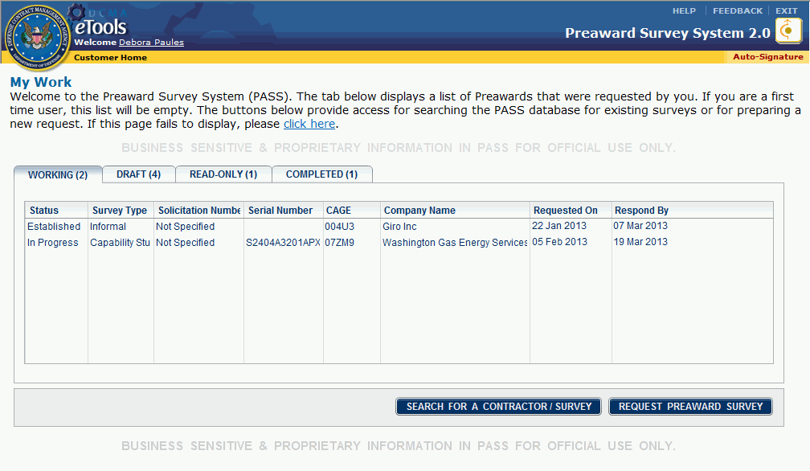
Figure 11: Customer's My Work Page
The Customer's My Work Page allows you to do the following:
- View your requests
- Search for a contractor or existing preaward survey
- Request a preaward survey

Menu Bar
See the topic Navigation Elements for more information on the links on the menu bar.
The My Work page provides a summary of your work with functionality to navigate to survey actions of interest.

Tabs
Tabs only appear if data is present within them (for example, if you have no Draft surveys, you will not see the Draft tab).
Working Tab: The Working tab (Figure 12) summarizes all In Progress preaward survey requests and their current status. "In Progress" means the survey request has been created, submitted, accepted by a CMO, and is currently being worked. Newly-submitted Established survey requests also appear in the Working tab.
Figure 12: Working tab
Draft Tab: The Draft Tab (Figure 13) lists preaward survey requests in draft status; that is, you've created the survey request, but have not yet submitted the request.
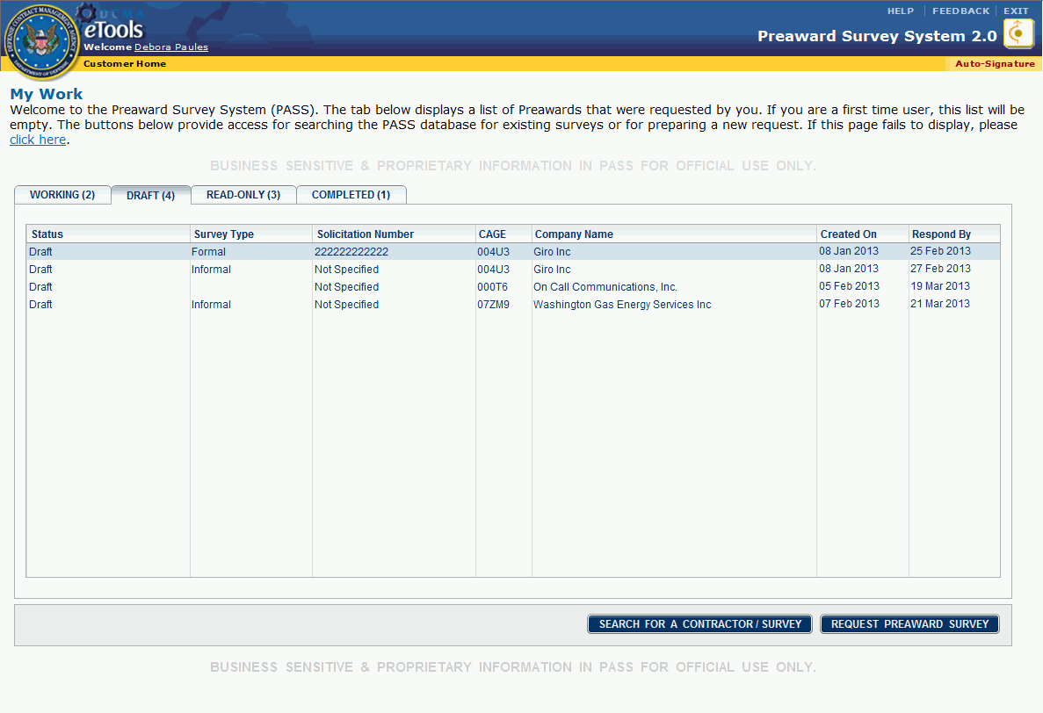
Figure 13: Draft tab
Read-Only Tab: The Read-Only tab (Figure 14) lists surveys that fall into one of the following categories:
- Survey requests which have been completed, but that have not yet been released to all PASS users (the Release Date has not passed); only the Customer who requested the survey, individuals added as Buying Activity Users, and the PASS users who worked the survey can view the survey. These surveys have the status Pending Release.
- Survey requests which have been completed, the Release Date has not yet passed, but on which you have been added as a Buying Activity User. These surveys have the status Pending Release.
- Survey requests that are on hold because they require DCAA Approval and/or DSS Approval. These surveys have the status Pending DCAA/DSS Approval. The survey will remain in the Read-Only tab until the Agency Concurrence provision has been removed (even if the Release Date passes). On or after the Release Date, however, the survey will be searchable by all PASS users, even if the Agency Concurrence provision remains.
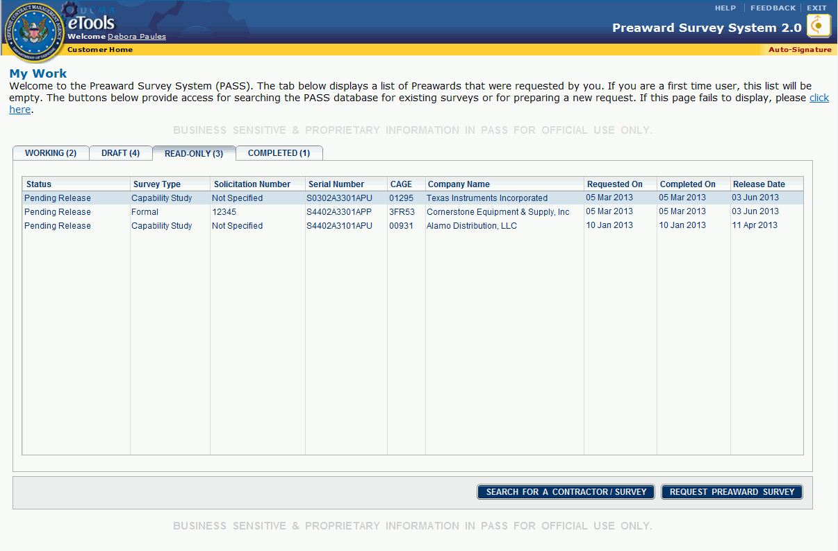
Figure 14: Read-Only tab
Completed Tab: The Completed tab (Figure 15) lists surveys you requested, which have been completed, for which the Release Date has passed, and for which there are no pending DCAA approvals. The survey is now searchable by all PASS users.
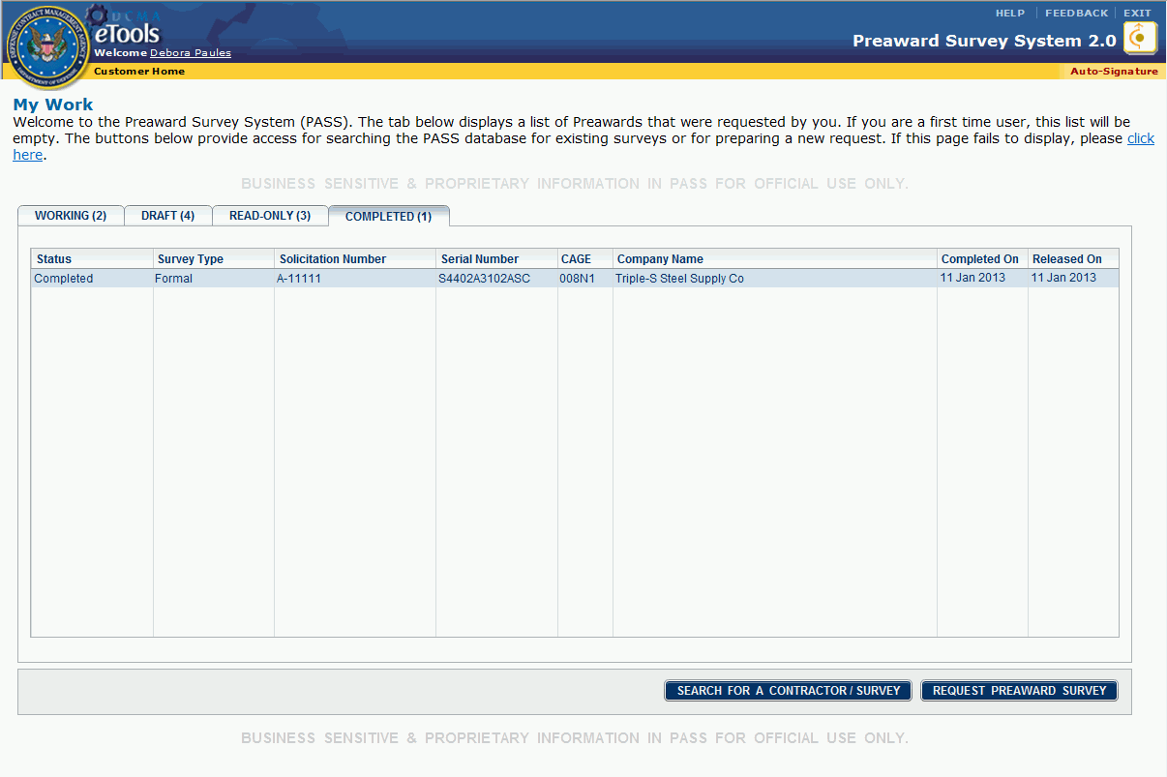
Figure 15: Completed tab

Columns
Columns in the tabs on the home page display information about the evaluation factors and/or survey requests:
Status: The status of survey requests.
Survey Type: The type of survey requested: Formal, Informal, or Capability Study / General Survey. If the survey to be worked is a Secondary survey, the term *Secondary* will be displayed in the Survey Type column.
Solicitation Number: The solicitation identifier, if present, recorded in the preaward survey request.
Serial Number: A 13-character value automatically assigned by the application to uniquely identify preaward survey requests. The values within the serial number have specific meaning:
  - Positions 1–6: the DoDAAC of the surveying activity CMO that has primary cognizance for completing the survey.
  - Position 7: the last digit of the current calendar year.
  - Position 8: month code (1-9 = January through September, O = October, N = November, D = December).
  - Positions 9–10: sequence number (01–99) assigned to survey requests for a CMO in the order that the request was submitted to the system within the month.
  - Positions 11–12: identifies survey as primary or secondary and relationship, as follows:
    - AP: Primary survey with no associated secondary surveys
    - AS: Primary survey for a survey set having one or more secondary surveys
    - AI: Informal survey
    - B–Z followed by S: Unique sequence for the secondary surveys supporting the primary survey identified as AS.
  - Position 13: a code indicating the status or recommendation:
    - C: Recommended Complete Award
    - N: Recommended No Award
    - P: Recommended Partial Award
    - U: Recommendation Not Applicable/Capability Survey
    - X: Survey still in work
CAGE: The CAGE code, if present, of the prospective contractor in the preaward survey request.
Company Name: The name of the prospective contractor in the preaward survey request.
Created On: The date the request was created; appears on the Draft tab only.
Requested On: The date you submitted the primary preaward request.
Respond By: The date that you asked for completion of the survey; the default is 30 business days.
Completed On: The date the survey was completed.
Release Date: The date the survey is released and viewable by all PASS users.

Understanding Survey Statuses
Statuses of surveys appear in the columns within tabs.
Survey statuses are as follows:
- Draft: The survey request has been created, but not yet submitted (appears on the Draft tab only).
- Established: The survey request has been submitted to, but not yet accepted by the CMO.
- In Progress: The survey is being worked.
- Pending Release: The survey has been worked, completed, and submitted to the Customer; the survey is not viewable to all PASS users until the Release Date has passed. Pending Release surveys cannot be found in a search.
- Completed: The survey has been completed, the Release Date has passed, and the survey is viewable by all PASS users. Completed surveys can be found in a search.

Viewing Preaward Survey Requests
To view a survey request in a tab, click the tab to display the tab, then click the item you wish to view.

Creating or Editing a Signature
To create and/or activate a signature, do the following:
- Click the Auto-Signature link on the menu bar. The Custom Signature Block tab appears in a new window.
- In the Custom Signature Block tab's text box, type or paste your signature. Note: If you do not wish to make your signature active, skip step 3 and go to step 4.
- Click the Automatically append signature to comments? check box to activate the signature so that it will automatically appear in Comments (Figure 16).
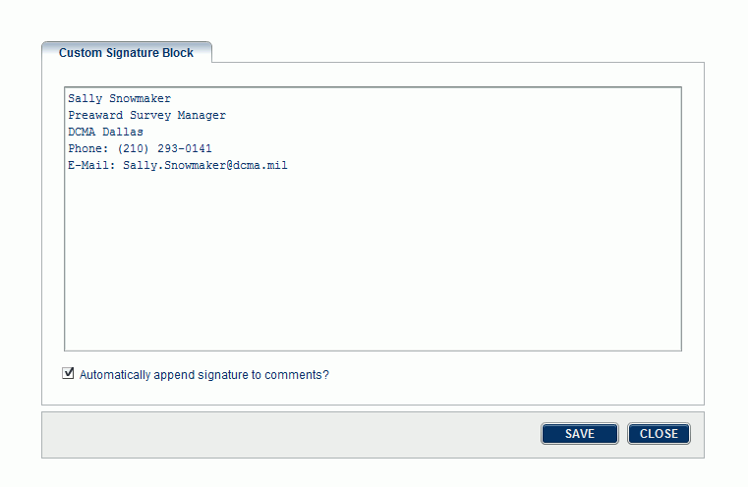
Figure 16: Custom Signature Block tab
- Click the Save button.
- Click the Close button.
To edit and/or deactivate a signature, do the following:
- Click the Auto-Signature link on the menu bar. The Custom Signature Block tab appears in a new window.
- In the Custom Signature Block tab's text box, edit your signature as you wish (you can type or paste your signature in the text box). If you do not wish to deactivate your signature, skip step 3 and go to step 4.
- If you wish to deactivate your signature so that it no longer automatically appends to comments, clear the Automatically append signature to comments? check box (if the check box is already checked, click the check box again to clear the check box).
- Click the Save button.
- Click the Close button.

Viewing Audit Logs and Evaluation Histories
- Audit Log shows the actions history of a survey or evaluation factor (all actions taken and by whom they were taken).
- Evaluation History shows the history of factor evaluations.
Customers, PASMs, Administrators, and Specialists can view audit logs and evaluation histories.
Click the Audit Log link or the Evaluation History link on the menu bar at any time to view a history (Note: These links do not appear on the home page).

Audit Log
To view an audit log, do the following:
- On the home page, click the survey or factor whose audit log you wish to view.
- Click the Audit Log link on the menu bar. The Audit Log appears in a new window (Figure 17).
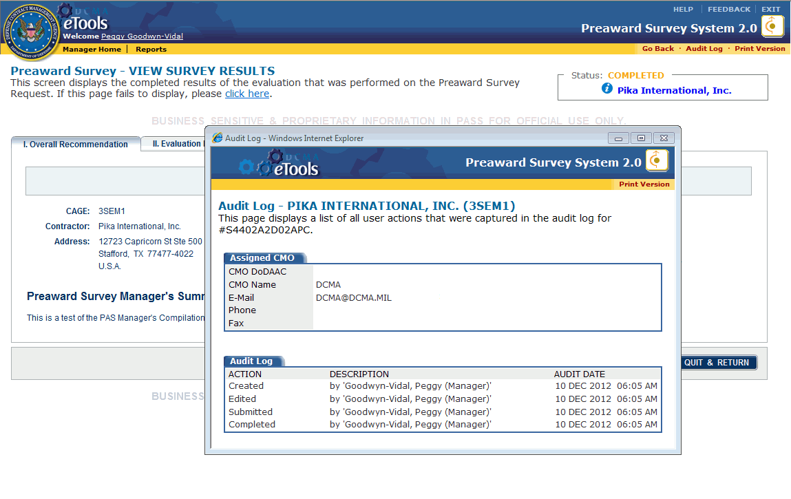
Figure 17: Audit Log window
To open a print-friendly view of the audit log, click the Print Version link in the Audit Log window.
If no records exist or if the request was created prior to the latest version of the PASS application, you may see the message, "No Records Available."

Evaluation History
To view an evaluation history, do the following:
- On the home page, in the Assignments tab, click the factor evaluation whose history you wish to view.
- Click the Evaluation History link on the menu bar. The Evaluation History appears in a new window; a three-month history is the default view (Figure 18).
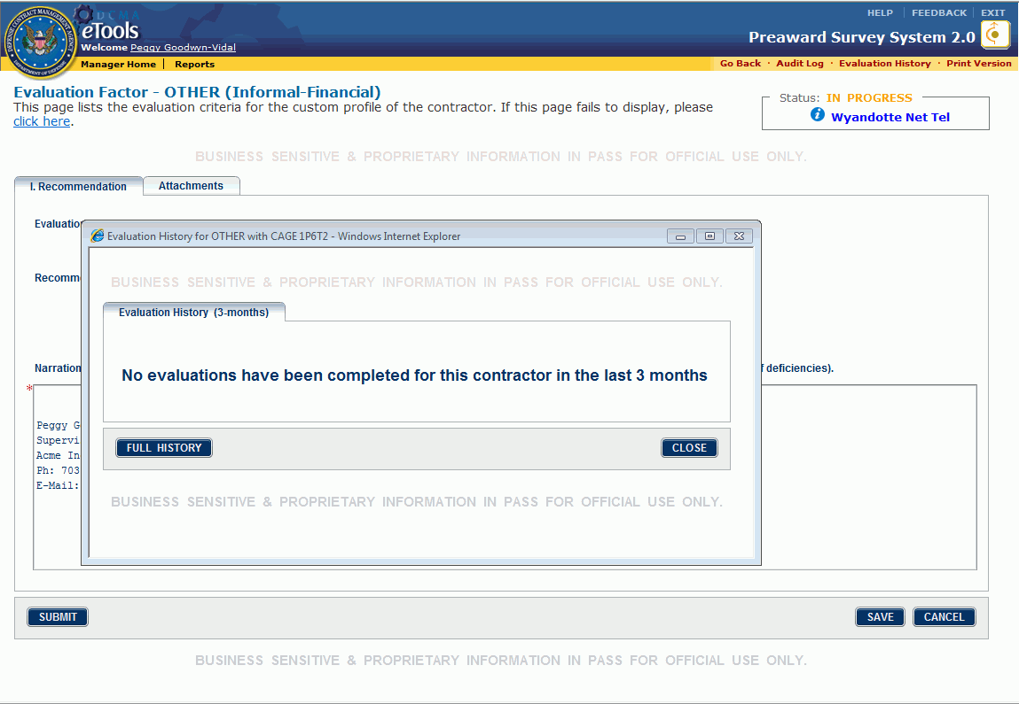
Figure 18: Evaluation History window
To view the full history, click the Full History button in the Evaluation History window.
To view the recent history (three months), click the Recent History button (visible after clicking the Full History button) in the Evaluation History window.
If no records exist or if the request was created prior to the latest version of the application, you will see the message, "No evaluations have been completed for this contractor..."
To close the Evaluation History window, click the Close button in the Evaluation History window.

Searching for Contractors
Customers can search for contractors.
To search for a contractor, do the following:
- On the home page, click the Search For a Contractor / Survey button (Figure 19).
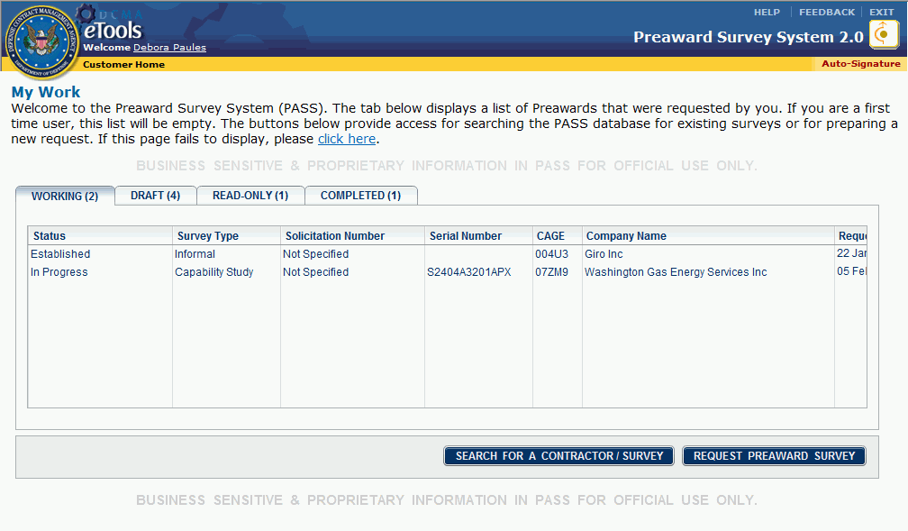
Figure 19: Search For A Contractor Survey button
The Contractor - Search page appears (Figure 20). Search fields are optional, but at least one search criterion must be selected.
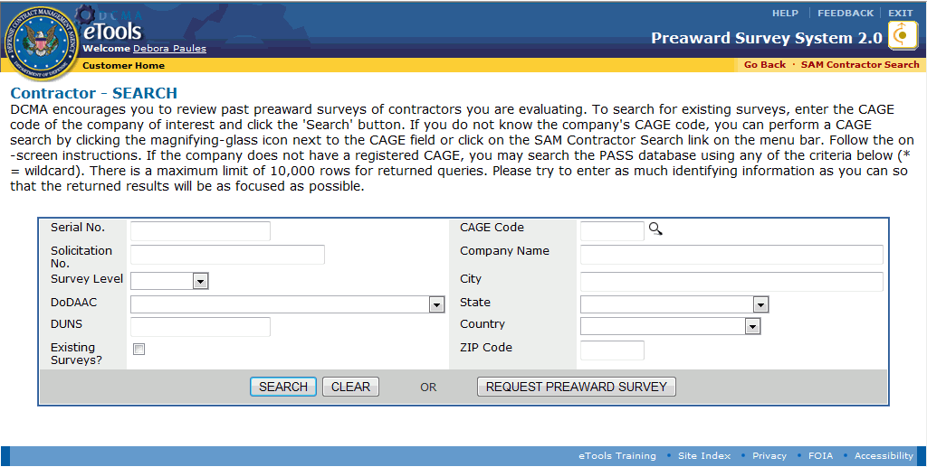
Figure 20: Contractor Search page
- Type applicable data or make a selection for any or all of the following:
- Serial No.: Type the serial number (type an asterisk (*) as a wildcard character to represent any character, and any number of characters).
- Solicitation No.: Type the solicitation number (type an asterisk (*) as a wildcard character to represent any character, and any number of characters).
- Survey Level: Select the survey level from the drop-down list box; options are Primary, Secondary, Tertiary, Other.
- DoDAAC: Select a DoDAAC from the drop-down list box. The DoDAAC search is used to limit the search to companies under the preaward cognizance of a specific DCMA CMO.
- DUNS: Type the 9-digit DUNS code or 13-digit DUNS + 4 code (numeric values only, without spaces) for the company, if known. DUNS codes can be found using the System For Award Management (SAM) Web site.
- Existing Surveys?: Select this check box to find only the companies that both (1) meet the parameters and (2) have one or more preaward surveys on file in the eTools database that were completed within the past 18 months and have passed their release dates.
- CAGE Code: Type the company's 5-character CAGE code, if known. To look up a company's CAGE code, click the search icon . A new window appears, displaying the SAM Web site at https://www.sam.gov/portal/public/SAM/. Follow the instructions on the page to perform your search. If you find a CAGE code you wish to use to continue your search within PASS, you can either copy and paste the CAGE code from the SAM Web site or type the CAGE code into the boxes on the Contractor Search page. To return to PASS, either close the SAM window or click the PASS window that has remained open.
- Company Name: Type a full or partial name in the name box. To do a partial name search, type an asterisk (*) as a wildcard character to represent any character, and any number of characters. Using a partial name will return a list of the contracting companies whose names contain the specified characters. An effective technique is to specify as many characters as possible because a general search may return a very long, unmanageable list of companies.
- City: Type the city in which the contractor is located (type an asterisk (*) as a wildcard character to represent any character, and any number of characters).
- State: Select the state in which the contractor is located from the drop-down list box.
- Country: Select a country from the drop-down list box. The search results will display only the contracting companies that have addresses in the country you selected.
- ZIP Code: Type the 5-digit value in the text box.
- Click the Search button. The Contractor - Search Results page appears.
- If the search criteria you used identifies more than one company as a match, the Contractor Search Results page appears (Figure 21).
- If only one company matched the search criteria, the Contractor - Company Review page appears, displaying the most current name and address information about the contractor, current contract and line activity in MOCAS, and a list of completed preaward surveys (Figure 22).

Contractor - Search Results
The Contractor Search Results page displays all companies found in the DCMA eTools database that meet the criteria used in your search.
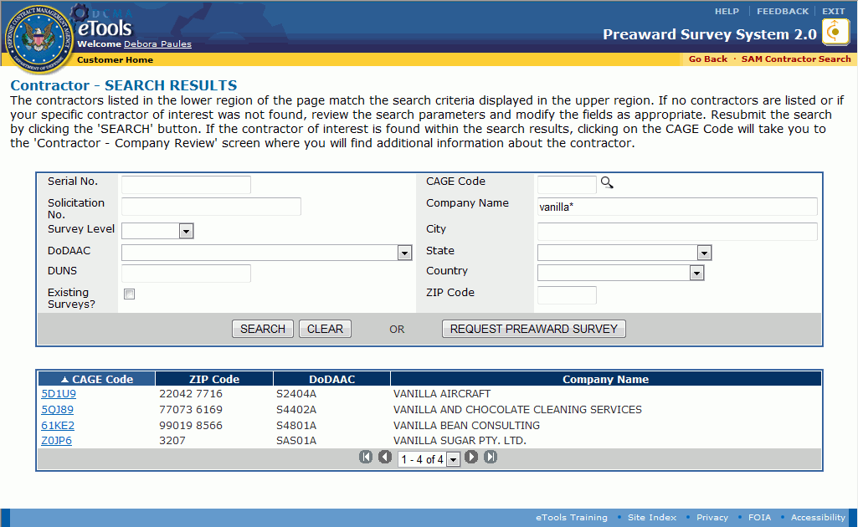
Figure 21: Contractor Search Results page
The Contractor Search Results page has two sections:
- The upper section, which displays the search criteria that were used. For a description of how to use the upper section of the page, see the topic Searching for Contractors.
- The lower section, which displays the search results. If your search returns no companies and/or you would like to search again, try changing the search parameters in the upper section of the page and clicking the Search button. Using multiple values and selecting the check box for companies with surveys will limit your results.
To view a contractor, on the Contractor - Search Results page, click the CAGE code link for the contractor you wish to view. The Contractor-Company Review page appears with additional information about the company including its current name and address, number of current contracts and contract line items being managed by DCMA, the responsible CMO, and preaward surveys that may be on file.
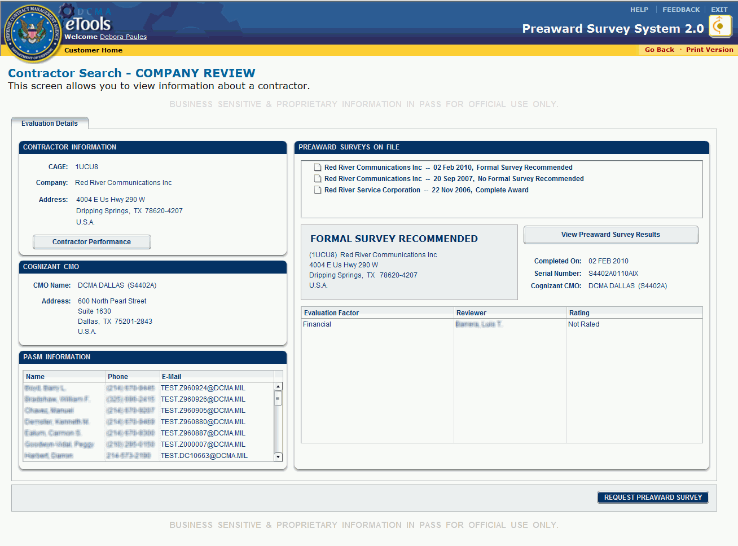
Figure 22: Contractor Search - Company Review page
To see an existing preaward survey, on the Contractor-Company Review page, in the Preaward Surveys On File section, click the survey you wish to view.
The PASS eTool holds two years' worth of data.
To request a preaward survey, on the Contractor Search - Company Review page, click the Request Preaward Survey button. The Preaward Survey - Primary Request page appears.

Contractor Search - Company Review Page
The Contractor Search-Company Review page (Figure 23) presents information about the contractor. It appears when you click a contractor's CAGE code on the Contractor Search Results page, or if your search using the Contractor Search page locates only one contractor.
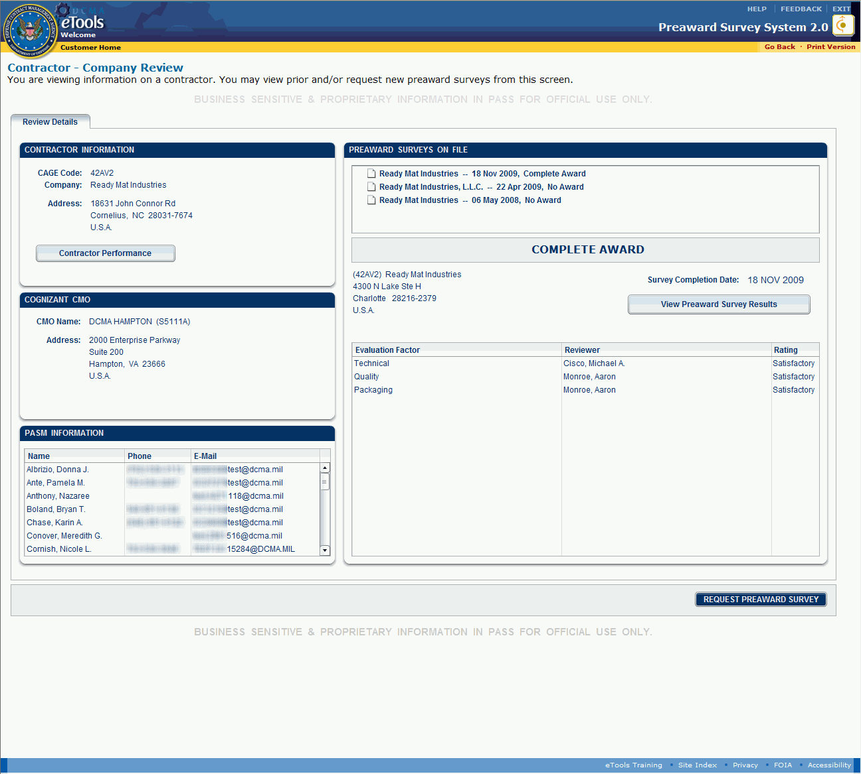
Figure 23: Contractor Search-Company Review page
- Contractor Information: The contractor’s current name and address as recorded in the eTools database. A contractor may have contracts that are not being managed by DCMA.
- Cognizant CMO: The name and address of the DCMA CMO responsible for preaward surveys for the referenced contractor.
- PASM Information: The names, phone numbers, and email addresses of the PASMs within the Cognizant CMO.
- Preaward Surveys on File: Preaward surveys, if any, completed on the contractor within the past 18 months. Summary information about the surveys appears below the list. If there are multiple surveys listed, the summary information defaults to the survey at the top of the list. To select a survey for review, click the survey of interest. The summary information below the survey list will update to correspond with the selected survey. To view survey details, click the View Preaward Survey Request button. The survey information is presented in a format for online viewing or local printing as appropriate.
To request a preaward survey, click the Request Preaward Survey button. Using this method will populate the Request Preaward Survey page with available data regarding the prospective contractor, surveying activity, and your name will be shown as the requestor.
To return to previous pages, click the Go Back link on the menu bar.

Requesting a Preaward Survey
Customers can request a preaward survey.
To request a preaward survey, click the Request Preaward Survey button that appears on one of the following:
- The Contractor Search-Company Review page
- The Contractor Search page
- The Contractor Search Results page
The Preaward Survey - Primary Request page appears.

Preparing a Preaward Survey Request
The Preaward Survey - Primary Request page (Figure 24) is used to create, save, and submit the preaward survey request.
Tasks are:
- Selecting the contractor to be surveyed
- Specifying the contract details
- Specifying the solicitation data relevant to the survey
- Selecting the evaluation factors for the survey
- Identifying the plant and locations to be surveyed
- Providing comments to the preaward survey team
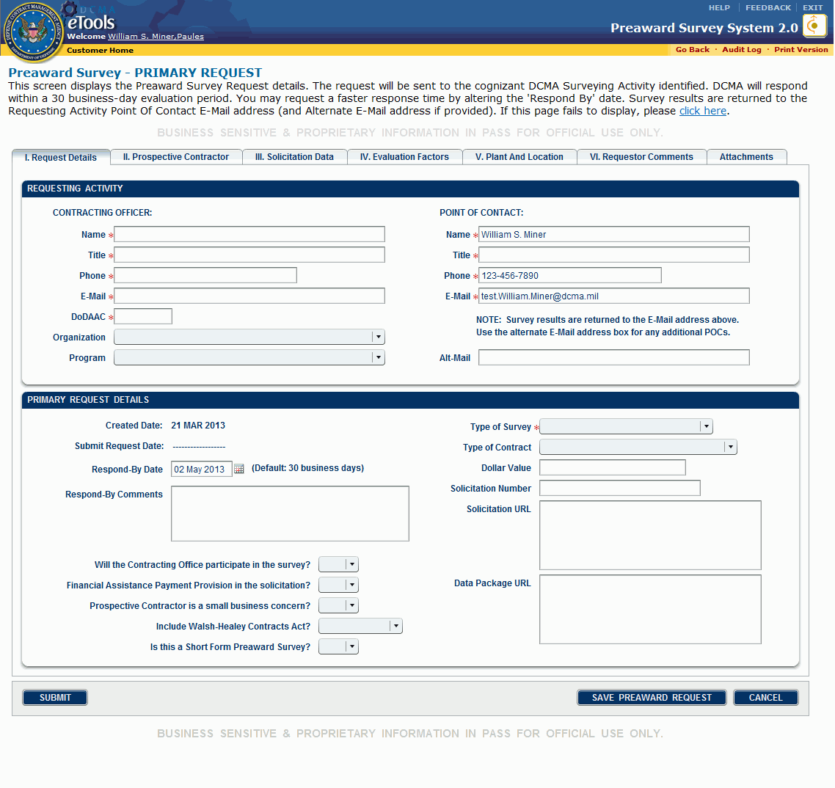
Figure 24: Preaward Survey-Primary Request page

I. Request Details Tab
The Preaward Survey-Primary Request page displays the I. Request Details tab by default (Figure 25).
Figure 25: Preaward Survey-Primary Request page, I. Request Details tab
Note: Fields with an asterisk (*) are required. You can save the request without completing all required fields, but you cannot submit the request without completing all required fields.
To begin preparing the preaward survey request, do the following:

Requesting Activity
- Type the Contracting Officer's Name, Title, Phone number, E-Mail address, and DoDAAC in the text boxes provided.
- Make selections from the Organization and Program drop-down list boxes.
- The Point of Contact information is autopopulated with your information; however, these fields are editable.

Primary Request Details
- In the Primary Request Details section, the Respond-By Date is the date by which you need the completed survey. On new requests, that date defaults to 30 business days from the current date. If a faster or slower response is needed, click the calendar icon and select a new date from the pop-up calendar. The selected date must be in the future.
- Type comments in the Respond-By Comments text box, if necessary.
- Make selections from the following drop-down list boxes:
- Will the Contracting Office participate in the survey?
- Financial Assistance Payment Provision in the solicitation?
- Prospective Contractor is a small business concern?
- Include Walsh-Healey Contracts Act?
- Is this a Short Form Preaward Survey?
- Select a Type of Survey from the drop-down list box.
- Select the Type of Contract from the drop-down list box.
- Type an estimated Dollar Value of the solicitation in the text box provided (the dollar sign ($) and decimal points are acceptable).
- Type a Solicitation Number in the box provided (may be left blank if the Solicitation Number is not applicable or is unavailable).
- Type the Web site address where the PASM can find an electronic copy of the solicitation in the Solicitation URL text box and type the Web site address where the PASM can find an electronic copy of the technical data package in the Data Package URL text box (Web site addresses can also be copied and pasted into the text boxes).
- Click the Save Preaward Request button.
- Click the next tab to proceed; see the following sections for instructions on completing the remaining tabs and submitting the request.
To save the preaward survey request, click the Save Preaward Request button. You can save the preaward survey request as frequently as you wish.
To continue, click the II. Prospective Contractor tab.
To delete the draft preaward survey request, on the Preaward Survey - Primary Request page, click the Delete button. Once you delete the preaward survey request, you cannot restore or edit it.
To leave the page without saving changes, on the Preaward Survey - Primary Request page, click the Cancel button.

II. Prospective Contractor Tab
The Preaward Survey-Primary Request page, II. Prospective Contractor tab appears when you click the II. Prospective Contractor tab (Figure 26).
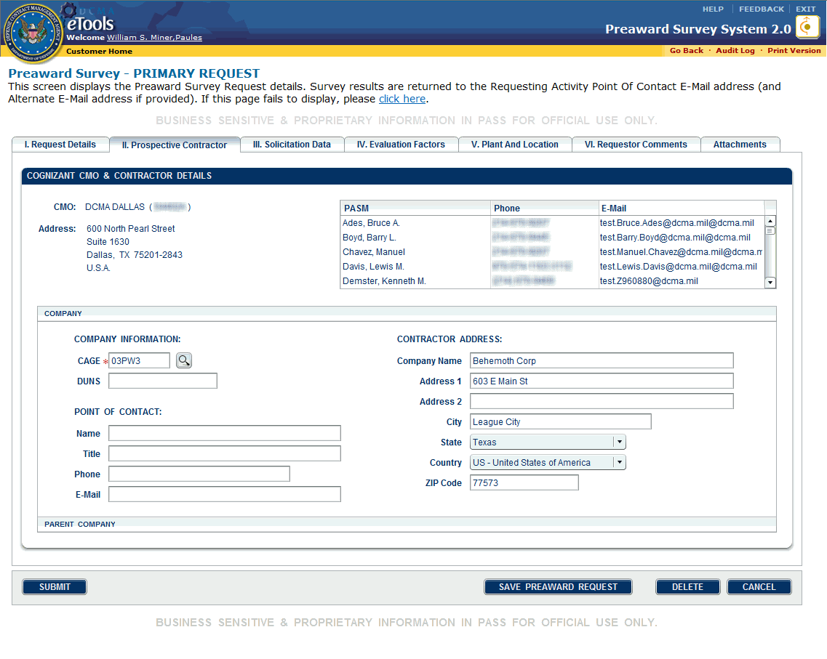
Figure 26: Preaward Survey-Primary Request page, II. Prospective Contractor tab

Cognizant CMO & Contractor Details
- The PASS application determines the cognizant CMO based upon the contractor's location.

Company
The Company Information section is used to identify the prospective contractor of interest and a point of contact for that contractor. The boxes are populated according to the following rules:
- If you know the CAGE code, type that value in the CAGE text box. If you do not know the CAGE code of the company of interest, click the search icon . The System for Award Management (SAM) page at https://www.sam.gov/portal/public/SAM/ appears in a new window and allows you to look up contractor information. If that CAGE code is in the eTools CAGE database, available CAGE data will be provided automatically from the database. If the CAGE code is registered in the SAM CAGE database, any data you provide on this form will be overwritten by data from the SAM database when you save the preaward survey request.
Note: If the eTools CAGE database provides data that is significantly different from the values provided by the requesting buying activity, consider contacting the requestor to resolve the difference. The SAM values are presumed to be accurate since it is the vendor’s responsibility to maintain their information.
- For contractors who do not have CAGE codes registered in SAM, type company data in the text boxes provided.
- In all cases, the ZIP Code entry (if in the United States) or Country entry (if outside the United States) will determine the identification of the Surveying Activity. The ZIP Code entry will override State or Country selections.
- The Point of Contact Name, Title, Phone, and E-Mail fields are freeform text boxes; type applicable data in these text boxes.
The Parent Company Information section is used if the company being surveyed is a subsidiary of a company:
- If the CAGE code typed here is present in the eTools database, the company data are provided automatically. If the CAGE code is registered in the SAM, the company data cannot be edited. All other entries are freeform.
- The Point of Contact Name, Title, Phone number, and E-Mail address entries are freeform text boxes.
To save your request, click the Save Preaward Request button.
To continue, click the III. Solicitation Data tab.
To delete the draft survey request, click the Delete button. A dialog box appears asking confirmation for the deletion. Click the OK button in the dialog box.
To leave the page without saving changes, click the Cancel button.

III. Solicitation Data Tab
The Preaward Survey-Primary Request page, III. Solicitation Data tab is where the solicitation data items appear (Figure 27).
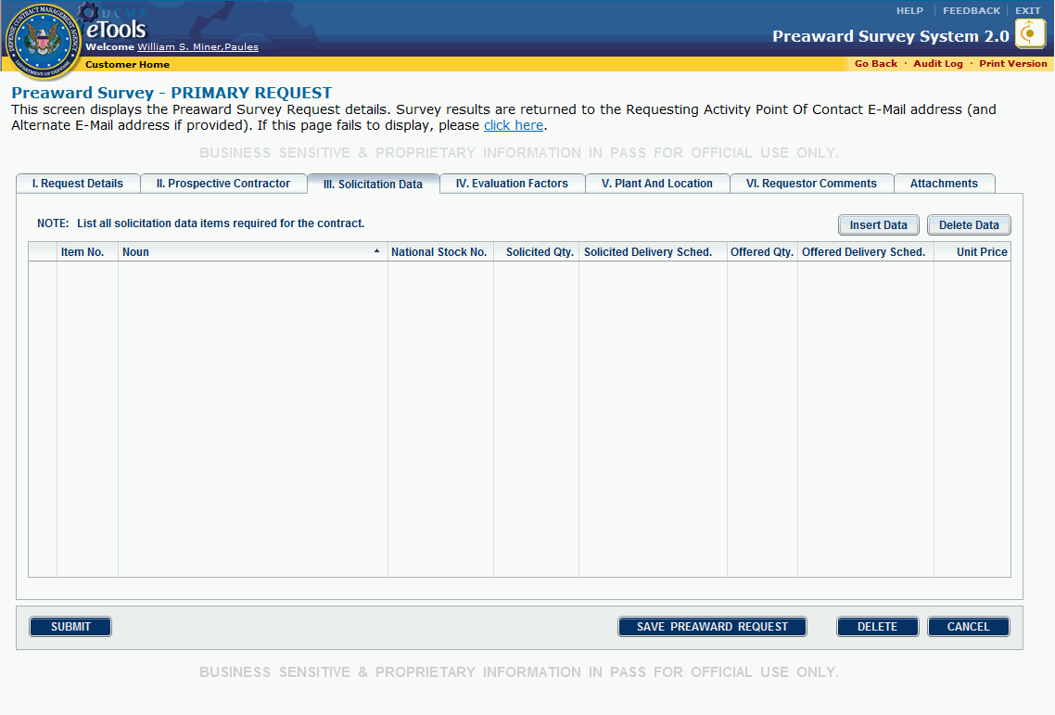
Figure 27: Preaward Survey-Primary Request page, III. Solicitation Data tab
When a solicitation is involved with the preaward survey request, you can specify relevant line item data in this section.
To add line item data, do the following:
- Click the Insert Data button.
- Click on the line under the column in which you want to type data.
- Type your data. Tab across or click in the next column to type more data (Figure 28).
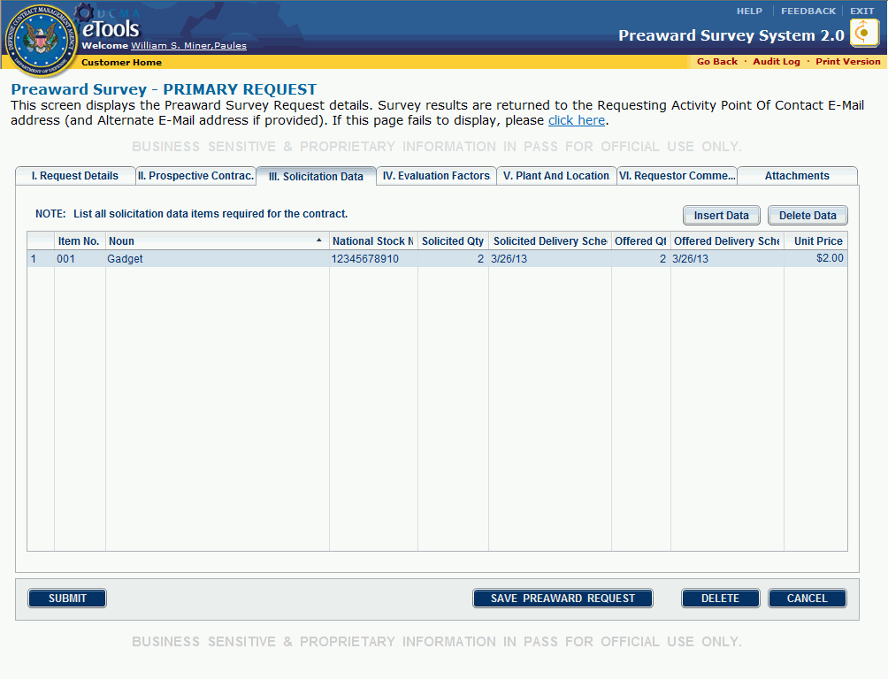
Figure 28: Data in III. Solicitation Data tab
The Delivery Schedule columns will accept numbers and letters. If additional information regarding the schedule for a line is needed, provide that information on the VI. Requestor Comments tab and cross-reference to the applicable line item(s).
To delete a row, do the following:
- Highlight the line by clicking it.
- Click the Delete Data button. A dialog box appears asking confirmation for the deletion (Figure 29).
- Click the Yes button in the dialog box.
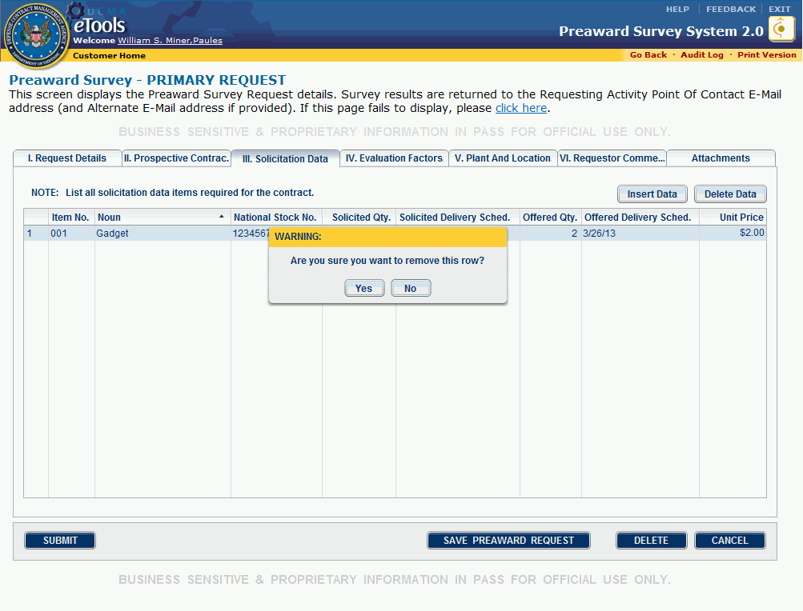
Figure 29: Dialog box
To save your request, click the Save Preaward Request button.
To continue, click the IV. Evaluation Factors tab.
To delete the draft survey request, click the Delete button. A dialog box appears asking confirmation for the deletion. Click the OK button in the dialog box.
To leave the page without saving changes, click the Cancel button.

IV. Evaluation Factors Tab
The Preaward Survey-Primary Request page, IV. Evaluation Factors tab appears when you click the IV. Evaluation Factors tab (Figure 30 and Figure 31).
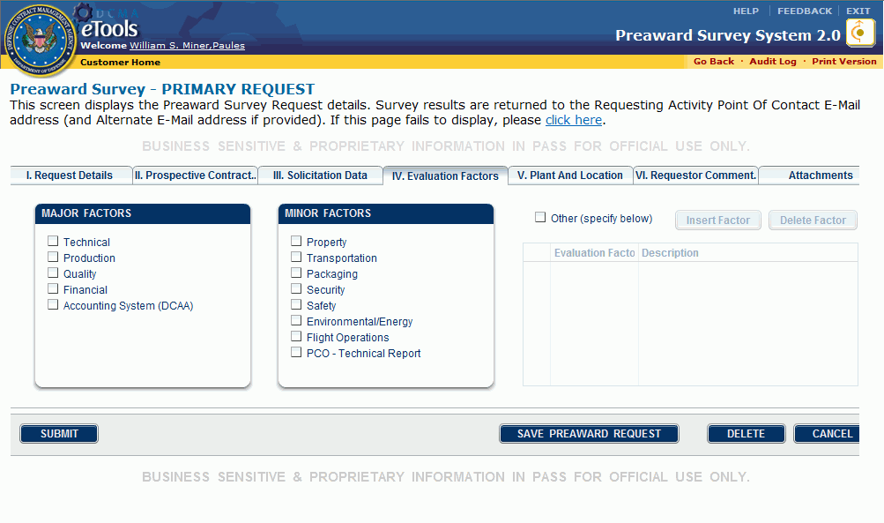
Figure 30: Preaward Survey-Primary Request page, IV. Evaluation Factors tab
The Evaluation Factors tab is used to identify the Major and Minor Factors that are to be evaluated in the preaward survey. Special instructions regarding any of the factors selected should be documented on tab VI. Requestor Comments and cross referenced to the applicable factor.
- Major Factors: Click the check box or boxes of interest. The check boxes can be switched between checked and unchecked by clicking the box. The major factors are as follows:
- Technical
- Production
- Quality
- Financial
- Accounting System (DCAA)
- Minor Factors: Click the check box or boxes of interest as described above. The minor factors are as follows:
- Property
- Transportation
- Packaging
- Security
- Safety
- Environmental/Energy
- Flight Operations
- PCO-Technical Report
- Other (specify below). If a specific factor does not appear on the list, click the Other check box. The Evaluation Factor Name box becomes active.
To insert an Other factor, do the following:
1. Click the Insert Factor button.
2. Click inside the new line under the Evaluation Factor Name header.
3. Type the Name (limited to 50 characters) and Description (limited to 4,000 characters) of the Other evaluation factor in the respective columns.
Repeat steps 1-3 to insert additional Other factors.
To delete an Other factor, do the following:
1. Click the line you wish to delete in the Evaluation Factor Name box.
2. Click the Delete Factor button. A dialog box appears.
3. Click the Yes button in the dialog box.
Repeat steps 1-3 to delete additional Other factors.
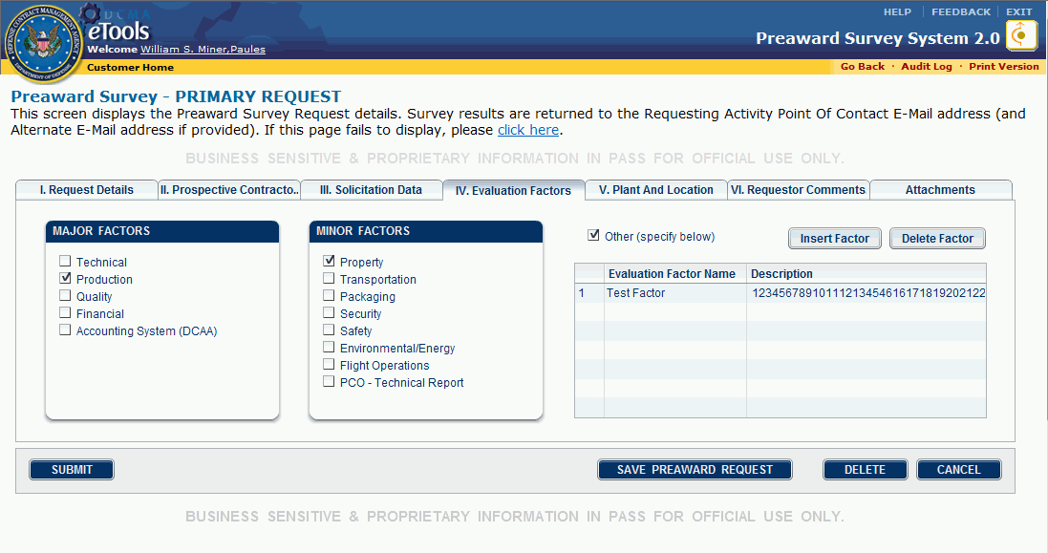
Figure 31: Evaluation Factor Name box
To save your request, click the Save Preaward Request button.
To continue, click the V. Plant And Location tab.
To delete the draft survey request, click the Delete button. A dialog box appears asking confirmation for the deletion. Click the OK button in the dialog box.
To leave the page without saving changes, click the Cancel button.

V. Plant And Location Tab
The Preaward Survey-Primary Request page, V. Plant And Location tab appears when you click the V. Plant And Location tab (Figure 32).
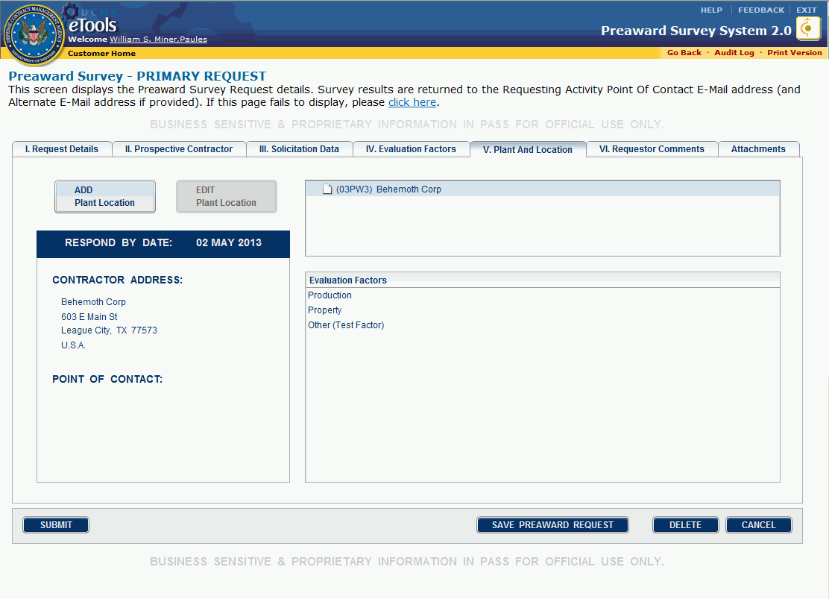
Figure 32: Preaward Survey-Primary Request page, V. Plant And Location tab
- If the only facility where the survey actions will be conducted already appears on the page, no additional action is required. Click the VI. Requestor Comments tab.
- If some or all of the requested survey actions are to be conducted at a location or locations different from the prospective contractor location, the additional locations must be added here. Provide the relevant locations in a sequence that relates it to a parent location, which is normally the primary location (prospective contractor) at the top. Click the Save Preaward Request button, then see the topic Adding and Editing a Location.

VI. Requestor Comments Tab
The Preaward Survey-Primary Request page, VI. Requestor Comments tab appears when you click the VI. Requestor Comments tab (Figure 33).
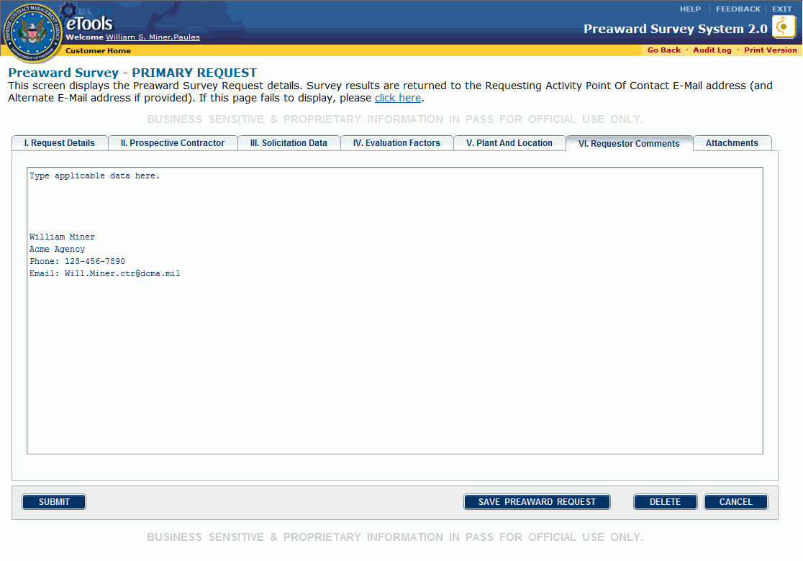
Figure 33: Preaward Survey-Primary Request page, VI. Requestor Comments tab
The Requestor Comments section is a free-form text box used to record clarifying or additional information to assist the PASM who will conduct the requested survey actions.
If you have created and activated a signature, the signature will appear in the VI. Requestor Comments tab. See the topic Creating a Signature.
To save the preaward survey request, click the Save Preaward Request button.
To continue, click the Attachments tab.
To delete the draft survey request, click the Delete button. A dialog box appears asking confirmation for the deletion. Click the OK button in the dialog box.
To leave the page without saving changes, click the Cancel button.

Attachments Tab
The Attachments tab (Figure 34) allows you to attach relevant support files.
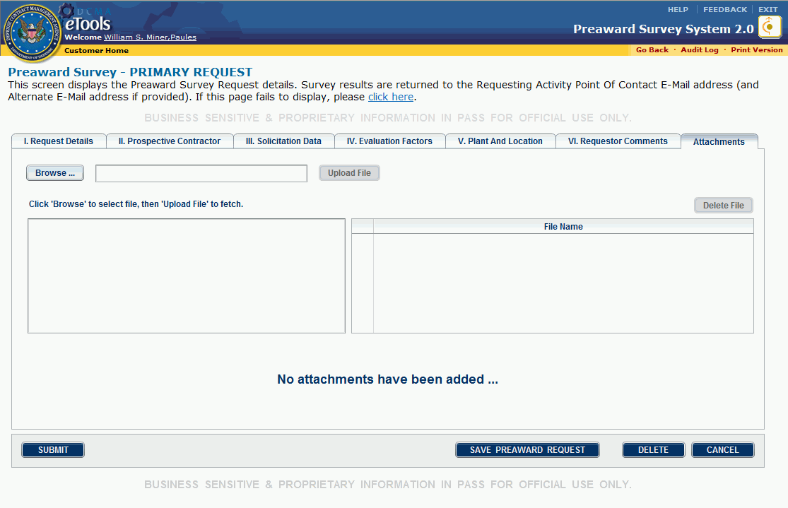
Figure 34: Attachments tab
To attach a file, do the following:
- Click the Browse button. A file upload window appears.
- Locate the file you wish to attach. When the file is found, double-click the file. The file name appears in the text box.
- Click the Upload File button. A dialog box appears confirming the success of the upload (Figure 35).
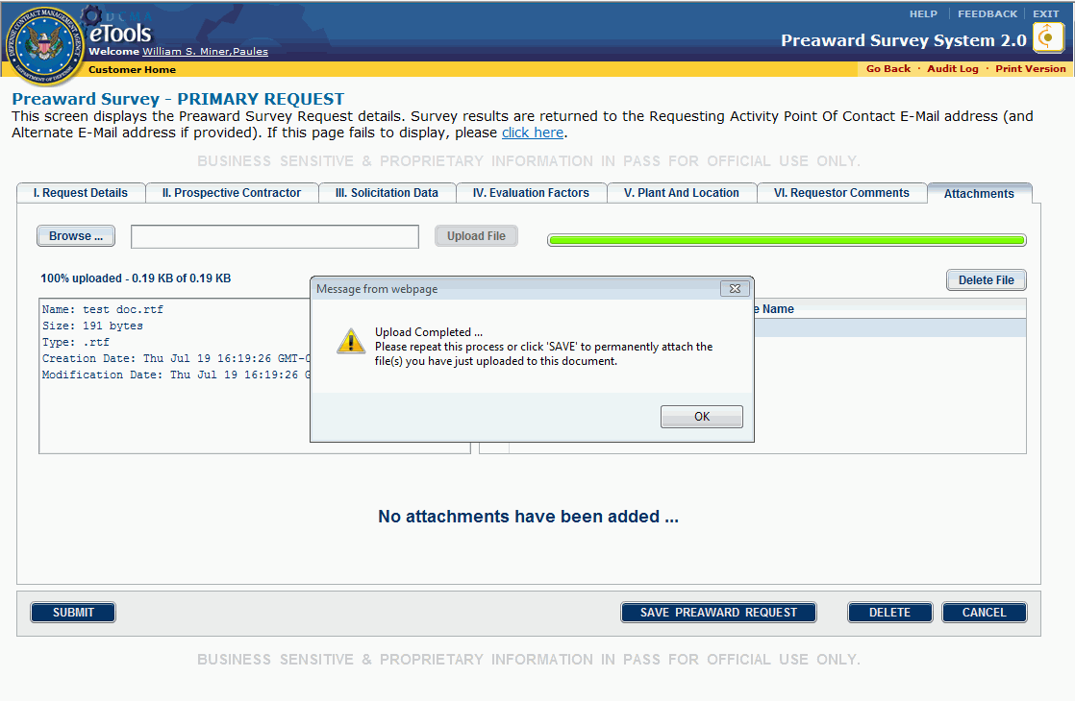
Figure 35: Dialog box
- Click the OK button in the dialog box. The name of the attached file appears in the File Name box.
- Click the Save Preaward Request button. The attached file appears as a button (Figure 36).
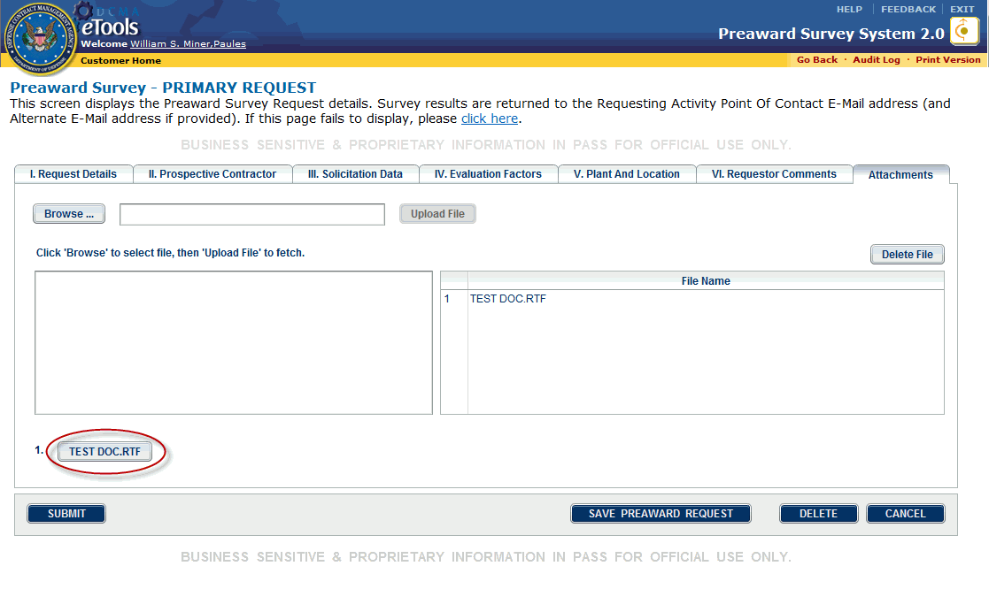
Figure 36: Attached file button
- Repeat steps 1-5 to attach additional files.
To download and/or view an attached file, in the Attachments tab, click the button for the attached file you wish to download or view.
To delete an attached file, do the following:
- Click the file's name in the File Name box so that the line becomes highlighted.
- Click the Delete File button (Figure 37).
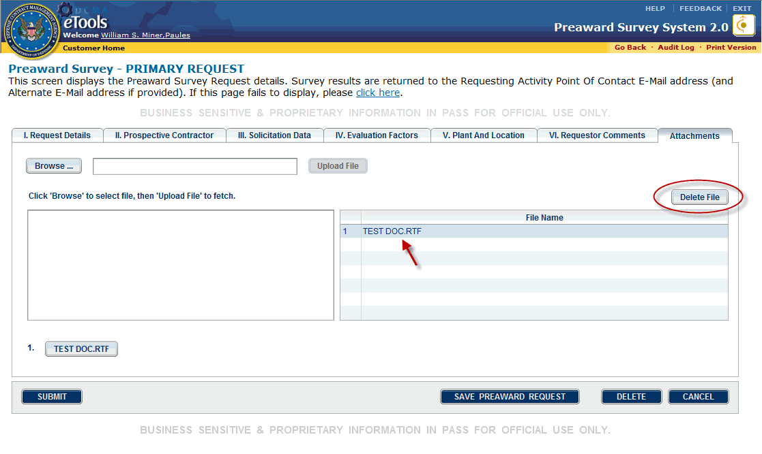
Figure 37: File highlighted and Delete File button
A dialog box appears asking confirmation for the deletion (Figure 38).
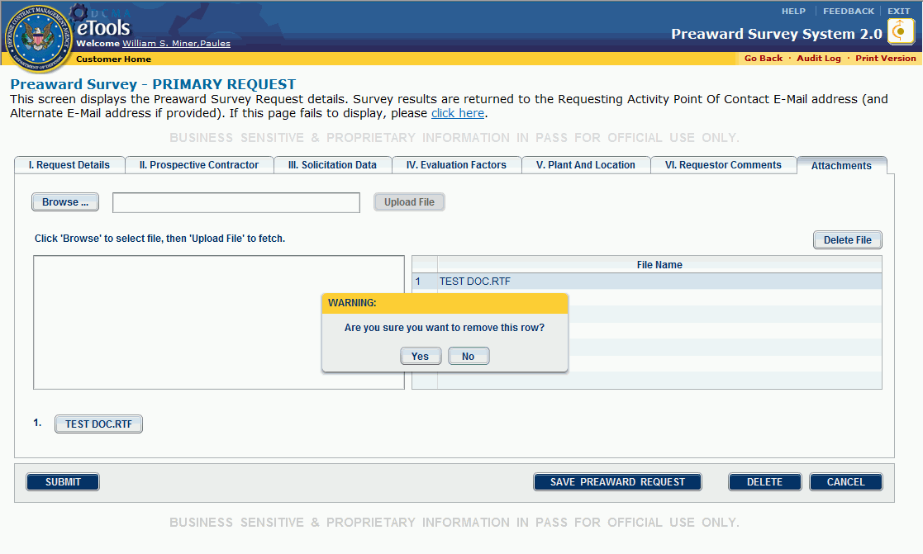
Figure 38: Dialog box
- Click the OK button in the dialog box.
- Click the Save Preaward Request button.
To save the preaward survey request, click the Save Preaward Request button.
To delete the draft survey request, click the Delete button. A dialog box appears asking confirmation for the deletion. Click the OK button in the dialog box.
To leave the page without saving changes, click the Cancel button.

Submitting the Preaward Survey Request
To submit the preaward survey request, do the following:
- If you are already on the Preaward Survey - Primary Request page, click the Submit button; or, on the home page, locate and click the draft survey request you wish to submit. On the Preaward Survey - Primary Request page, click the Submit button.
- If you have not completed all required fields, a dialog box appears notifying you of the required fields requiring completion (Figure 39). Click the OK button in the dialog box, enter applicable data in the required fields, then click the Submit button.
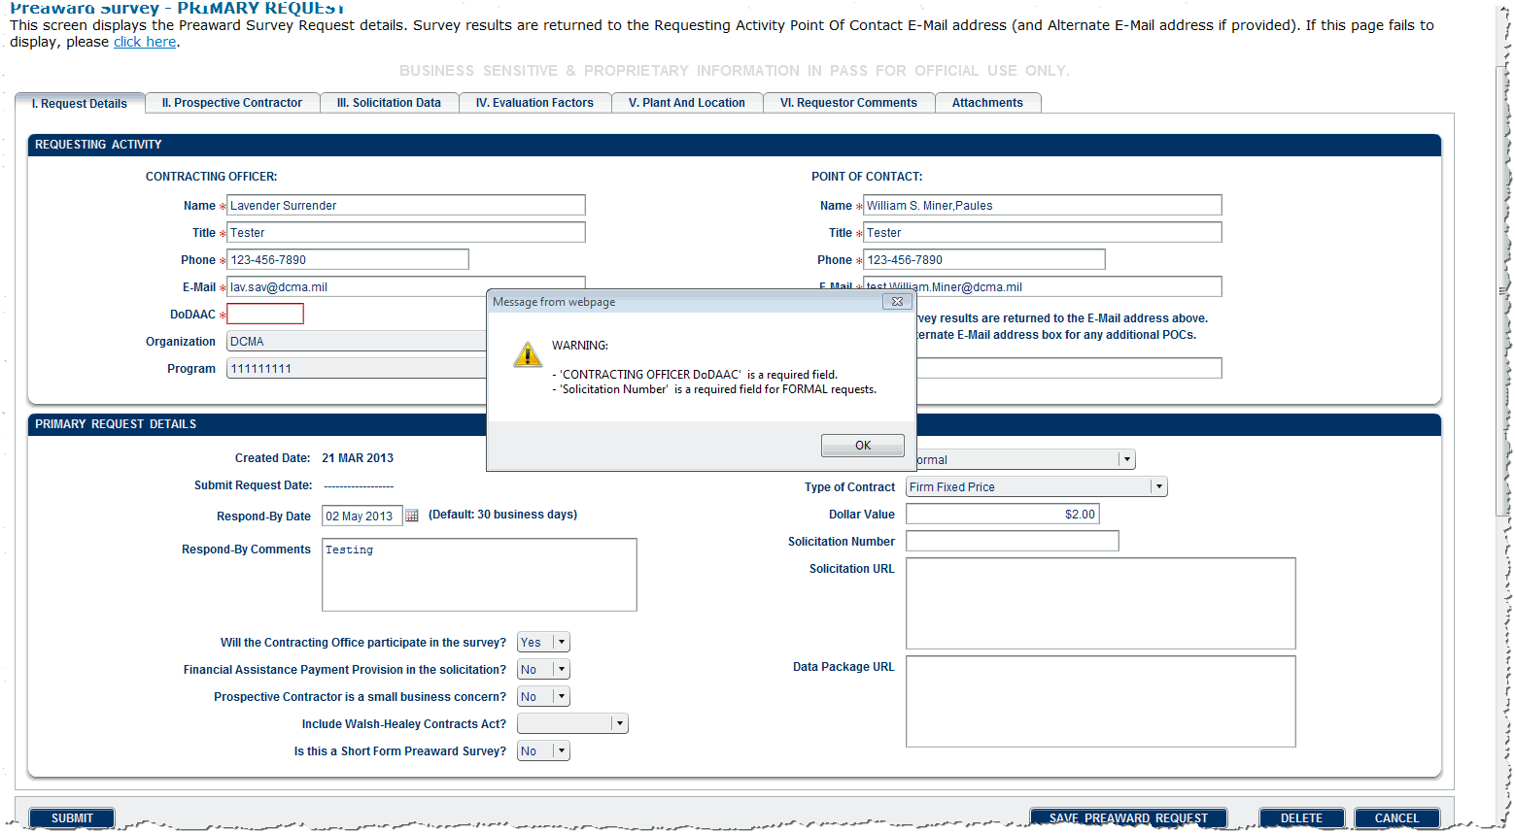
Figure 39: Dialog box
- If all the required fields have been completed, a dialog box appears reminding you of the Respond-By Date and asking confirmation for the submission. (Figure 40).
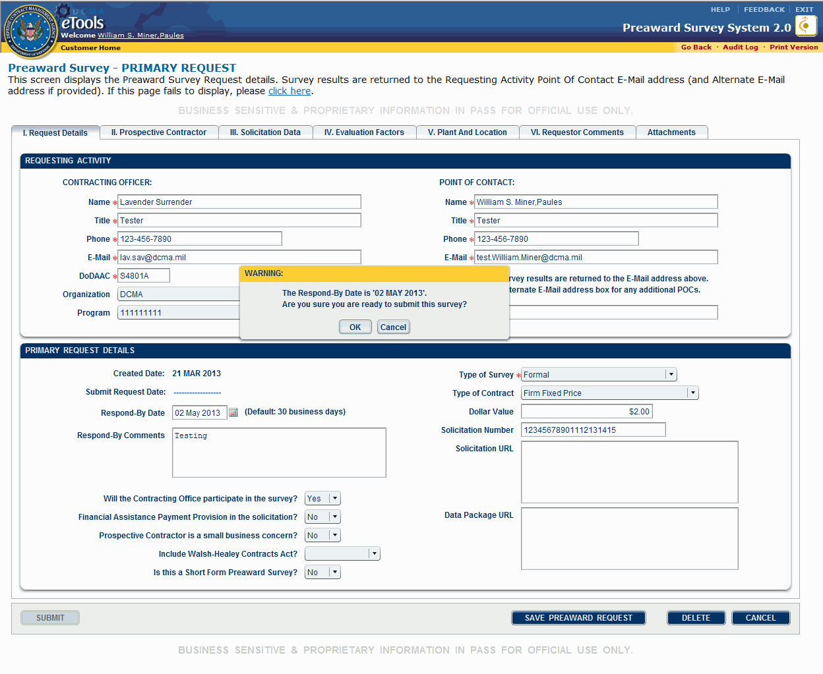
Figure 40: Dialog box
- Click the OK button in the dialog box (if you still wish to edit the draft survey request, click the Cancel button). Once you submit the preaward survey request, the request appears on the Customer Home page in the Working tab, with the status Established and in read-only format (Figure 41). An email is sent, notifying the primary PASM that a survey request has been submitted.
Once the survey request is completed, you will receive an email, notifying you of the completion.
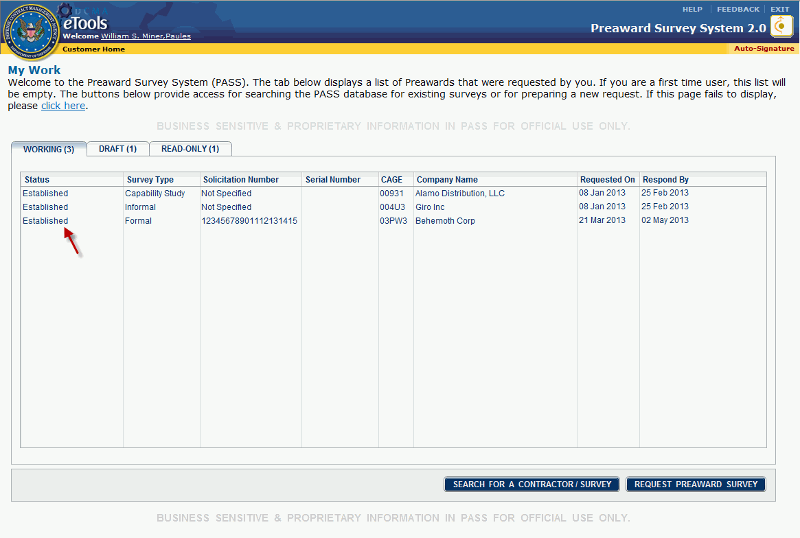
Figure 41: Established survey request
To sort information in tabs in ascending or descending order, click a column heading. This may help you quickly locate a survey request.
To unsubmit the survey request, see the topic Unsubmitting a Survey Request.

Adding and Editing a Location
- Customers can add and edit locations for survey requests in Draft status. Survey requests are not editable once they have been submitted and are in Established status. An Established survey request; however, can be unsubmitted. Once the Established survey request is unsubmitted, it will return to Draft status and will be editable. See the topic Unsubmitting a Survey Request.
- PASMs and Administrators can add and edit locations for survey requests until the survey request has been completed and returned to the customer.
To add a location, do the following:
- Locate the survey request to which you wish to add a location. See your user role's topic My Work page for one way to locate a survey request.
- On the Preaward Survey - Primary Request page, in the V. Plant And Location tab, click the company name to which you wish to add a location, to highlight it (Figure 42). If the Add Plant Location button is unavailable in the V. Plant and Location tab, click the Save Preaward Request button. The V. Plant and Location tab becomes editable.
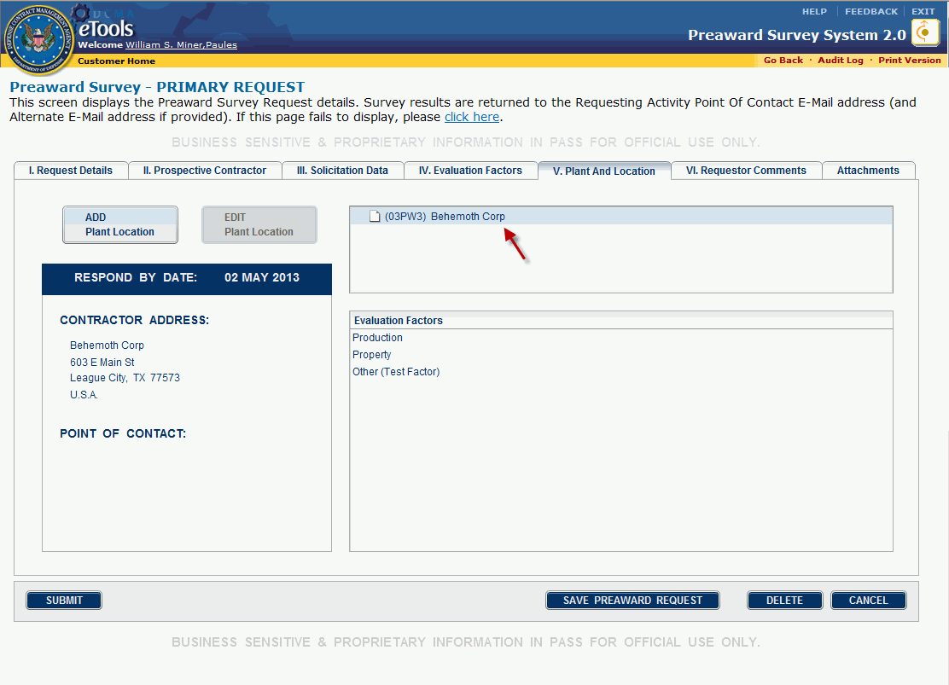
Figure 42: Company name highlighted
- Click the Add Plant Location button. The Preaward Survey - Plant Location Request page, I. Plant Location tab appears (Figure 43).
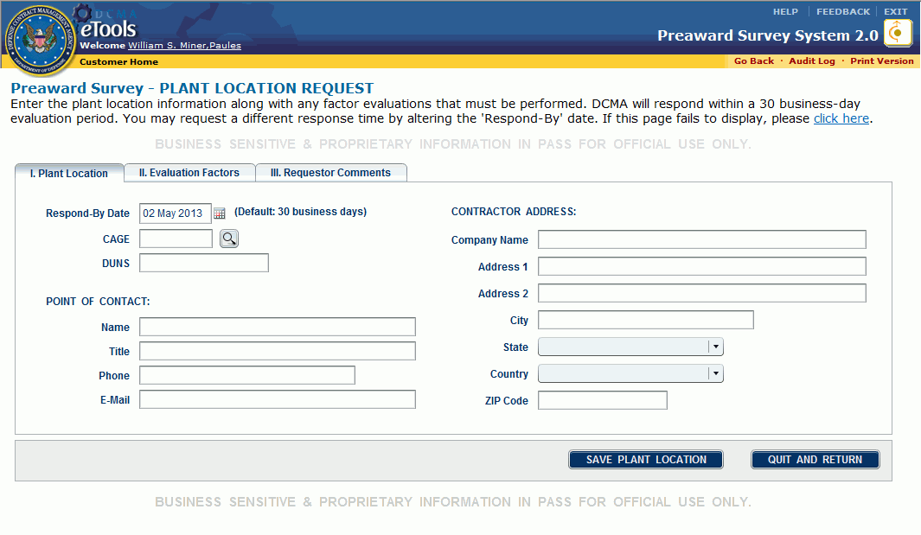
Figure 43: Preaward Survey-Plant Location Request page, I. Plant Location tab
- In the I. Plant Location tab, type the CAGE code of the location in the text box provided.
- If that CAGE code is found in the eTools database, the relevant company information will appear in the boxes on this page (Figure 44). If the CAGE code is registered in the SAM CAGE database, those data cannot be edited. Any name and address data manually entered for a SAM CAGE value before the Save action will be overwritten by the system when the Save action occurs.
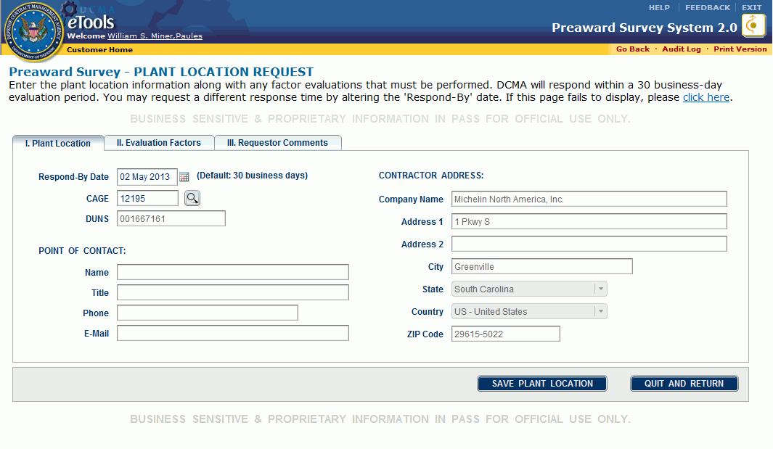
Figure 44: Autopopulated contractor data
- If the contractor does not have its CAGE code registered in SAM, type the company data in the boxes provided.
- If you do not know the CAGE code of the company of interest, click the search icon . The System for Award Management (SAM) page at https://www.sam.gov/portal/public/SAM/ allows you to look up contractor information.
- You must provide a ZIP code (if in the United States) or Country (if outside the United States). The ZIP Code entry will override State or Country selections.
- Type or paste data into the text boxes for the Point of Contact Name, Title, Phone number, and E-Mail address.
- Click the II. Evaluation Factors tab. The II. Evaluation Factors tab is displayed (Figure 45).
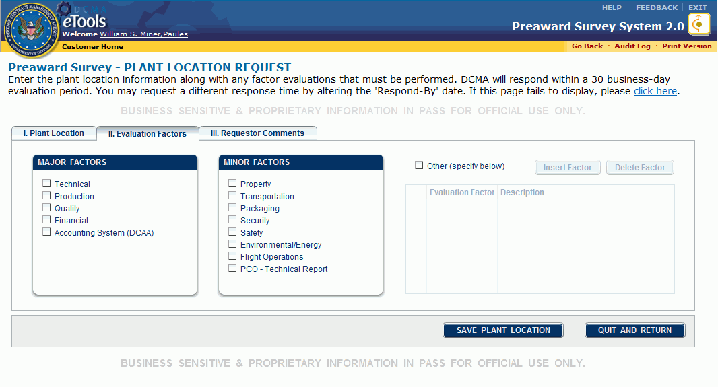
Figure 45: II. Evaluation Factors tab
- Click the check box for the Factor(s) to be evaluated.
- Major Factors: Click the check box or boxes of interest. The check boxes can be switched between checked and unchecked by clicking the box. The major factors are as follows:
- Technical
- Production
- Quality
- Financial
- Accounting System (DCAA)
- Minor Factors: Click the check box or boxes of interest as described above. The minor factors are as follows:
- Property
- Transportation
- Packaging
- Security
- Safety
- Environmental/Energy
- Flight Operations
- PCO-Technical Report
- Other (specify below). If a specific factor does not appear on the list, click the Other check box. The Evaluation Factor Name box becomes active.
To insert an Other factor, do the following:
1. Click the Insert Factor button.
2. Click inside the new line under the Evaluation Factor Name header.
3. Type the Name (limited to 50 characters) and Description (limited to 4,000 characters) of the Other evaluation factor in the respective columns.
Repeat steps 1-3 to insert additional Other factors.
To delete an Other factor, do the following:
1. Click the line you wish to delete in the Evaluation Factor Name box.
2. Click the Delete Factor button. A dialog box appears.
3. Click the Yes button in the dialog box.
Repeat steps 1-3 to delete additional Other factors.
- Click the III. Requestor Comments tab (optional); type comments in the III. Requestor Comments tab (Figure 46), if you wish.
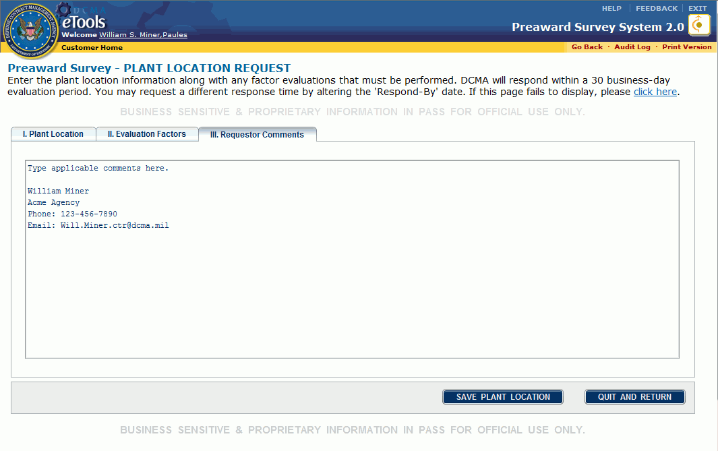
Figure 46: III. Requestor Comments tab
- Click the Save Plant Location button. A dialog box appears, reminding you of the Respond-By date and asking confirmation for the save (Figure 47).
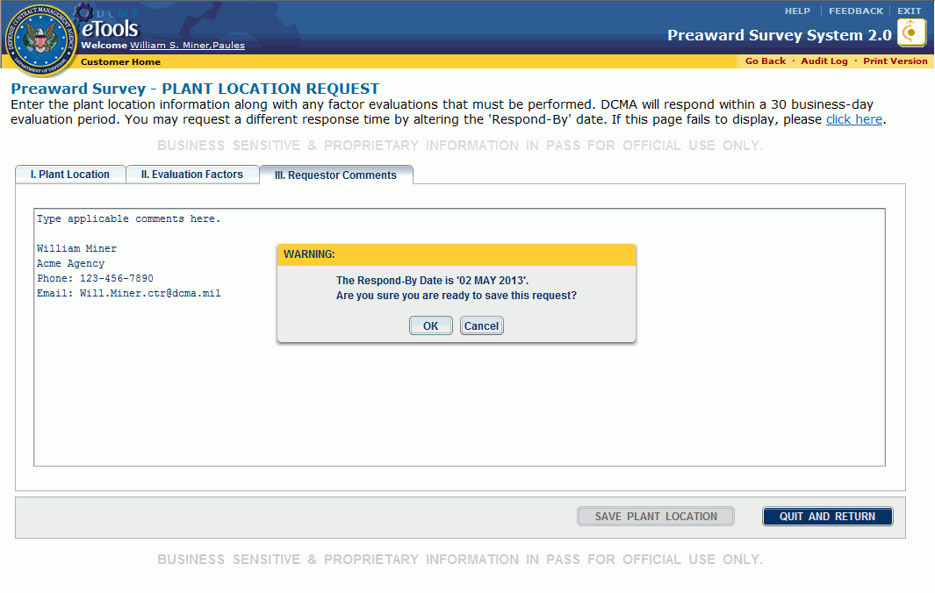
Figure 47: Dialog box
- Click the OK button in the dialog box. The Preaward Survey - Primary Request page appears.
Repeat these steps until all locations and their specific survey requirements have been added.

Editing a Location
To edit a location, do the following:
- Locate the request whose location you wish to edit. See your user role's topic My Work Page for one way to locate a request.
- On the Preaward Survey - Primary Request page, in the V. Plant And Location tab, click the location you wish to edit, to highlight the location (Figure 48).
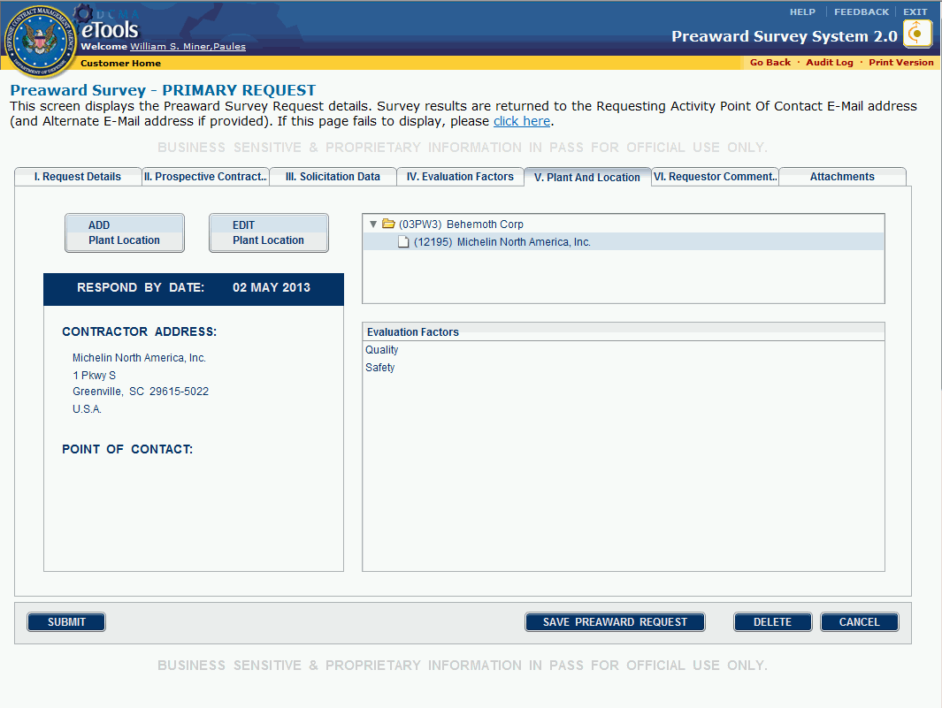
Figure 48: Location highlighted
- Click the Edit Plant Location button. The Preaward Survey - Plant Location Request page, I. Plant Location tab appears (Figure 49).
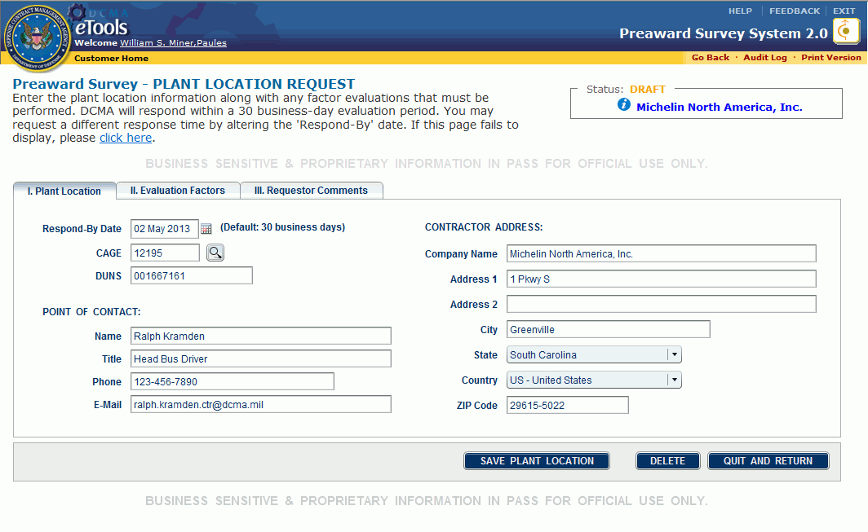
Figure 49: Preaward Survey - Plant Location Request page
- Make your desired edits in each tab.
- Click the Save Plant Location button. A dialog box appears, reminding you of the Respond-By date and asking confirmation for the save.
- Click the OK button in the dialog box. The Preaward Survey - Primary Request page appears.

Deleting a Location
To delete a location, do the following:
- Locate the request whose location you wish to delete. See your user role's topic My Work Page for one way to locate a request.
- On the Preaward Survey - Primary Request page, in the V. Plant And Location tab, click the location you wish to delete, to highlight the location (Figure 50).
Figure 50: Location highlighted
- Click the Edit Plant Location button. The Preaward Survey - Plant Location Request page, I. Plant Location tab appears (Figure 51).
Figure 51: Preaward Survey - Plant Location Request page
- Click the Delete button. A dialog box appears asking confirmation for the deletion (Figure 52).
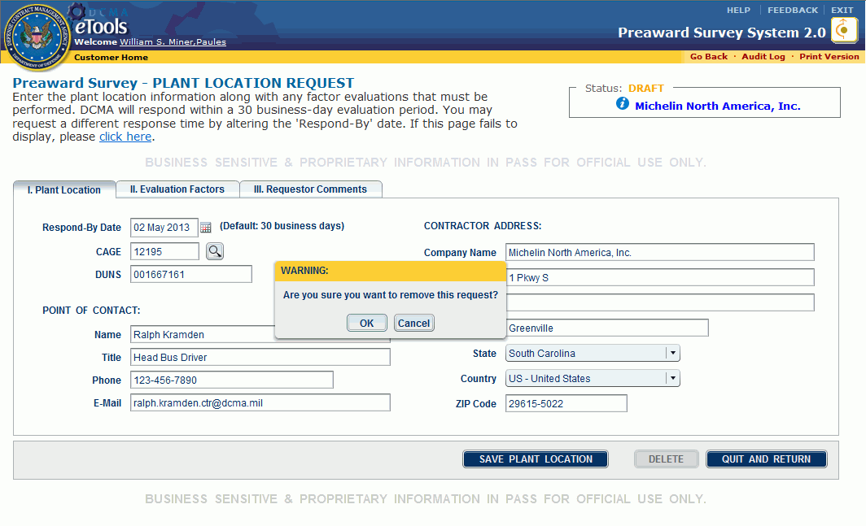
Figure 52: Dialog box
- Click the OK button in the dialog box. The location is deleted.

Deleting a Draft Survey Request
Customers, PASMs, and Administrators can delete draft survey requests.
To delete a draft survey request, do the following:
- On the home page, in the Draft tab, click the survey request you wish to delete (Figure 53).
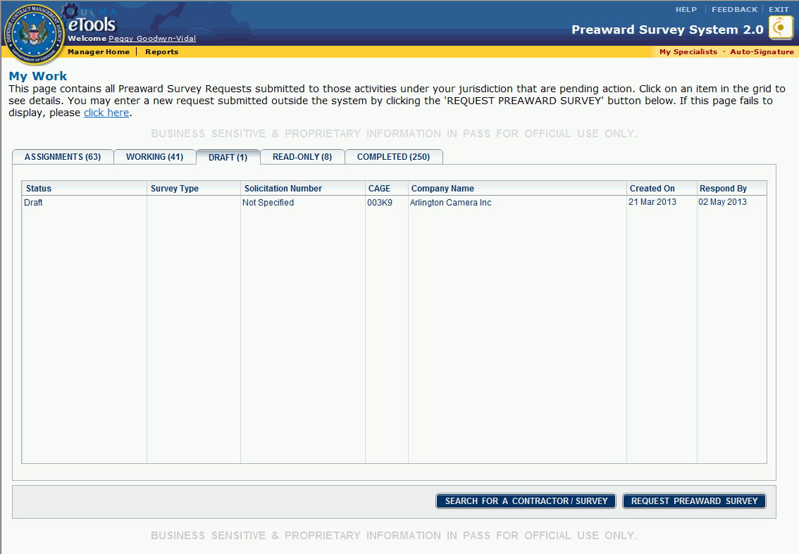
Figure 53: Draft survey request
The Preaward Survey - Primary Request page appears.
- Click the Delete button (Figure 54).
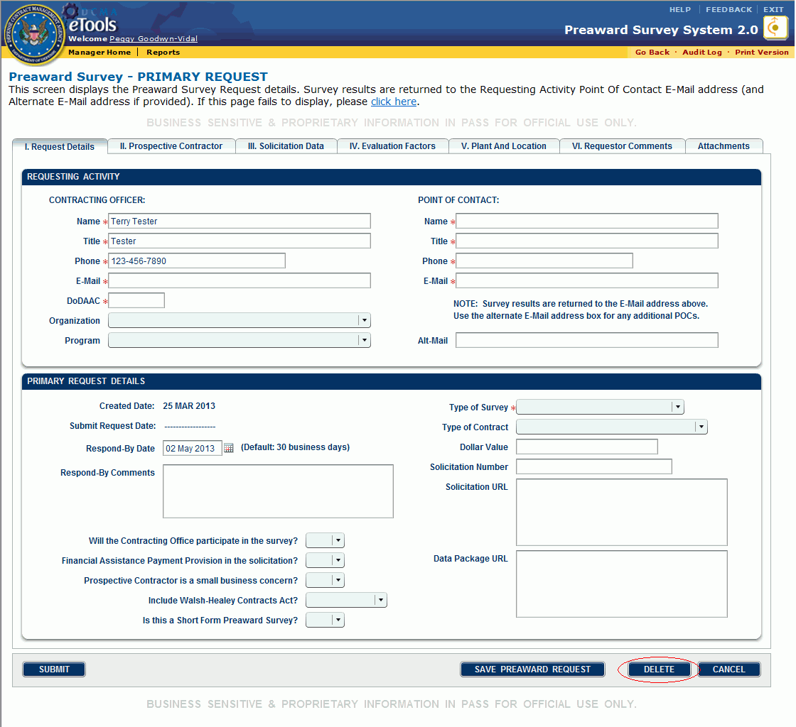
Figure 54: Delete button
A dialog box appears asking confirmation for the deletion (Figure 55).
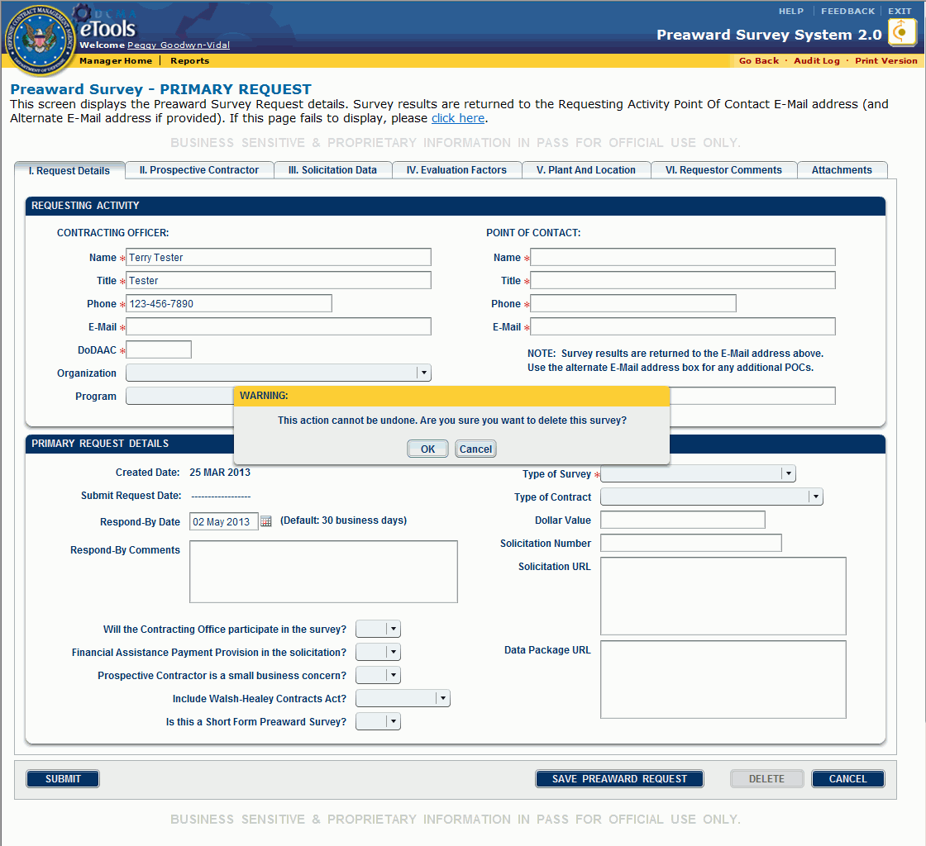
Figure 55: Dialog box
- Click the OK button in the dialog box. The draft survey request is deleted.

Unsubmitting a Survey Request
- The creator of a survey request can unsubmit the survey request (the status of the submitted survey request is Established; Established status means the survey request has been submitted, but not yet accepted by the CMO).
- Once the status of the survey request is In Progress (that is, the CMO has accepted and is processing the request), the survey request cannot be unsubmitted.
Note: If a PASM creates a survey request, the Unsubmit button will only be viewable to that PASM.
To unsubmit a survey request, do the following:
- On the home page, click the survey request (with Established status) you wish to unsubmit. The Preaward Survey - Primary Request page appears.
- Click the Unsubmit button (Figure 56). The survey request returns to Draft status. An email is sent, notifying the primary PASM that the survey request has been unsubmitted.
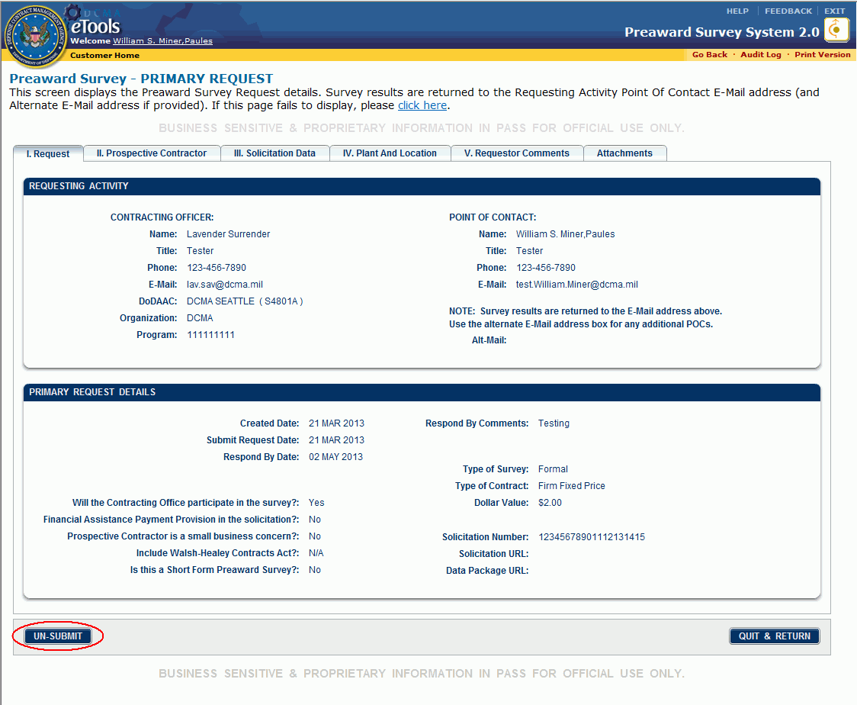
Figure 56: Unsubmit button

Viewing Completed Preaward Surveys
Completed preaward surveys on file in the DCMA eTools database are presented to you as follows:
- The Read-Only tab: Completed surveys whose Release Date has not passed; these surveys are available to the customer who requested the survey and to those who worked the survey. See the topic Customer's My Work Page for more information on the Read-Only tab.
- The Completed tab: Completed surveys whose Release Date has come or passed; these surveys are searchable by all PASS users. See the topic Customer's My Work Page for more information on the Completed tab.
To view a completed preaward survey, on the home page, in the Read-Only tab, click the survey you wish to view. The Preaward Survey-View Survey Results page, I. Overall Recommendation tab appears (Figure 57).
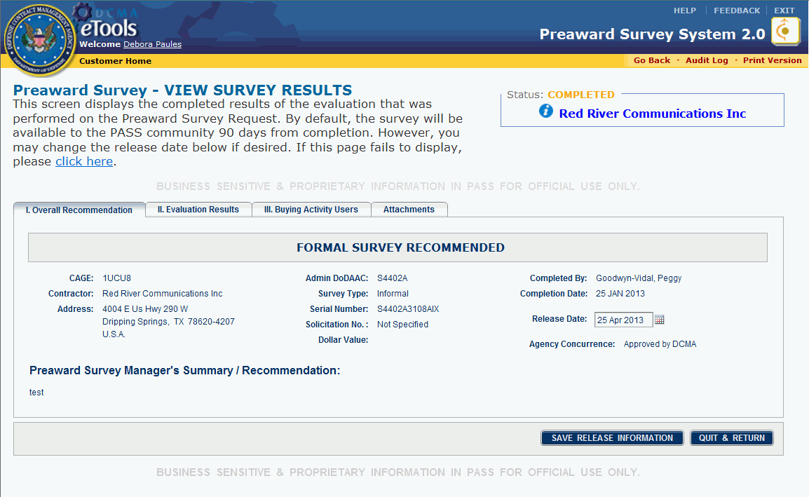
Figure 57: Preaward Survey-View Survey Results page
The I. Overall Recommendations tab displays the PASM's recommendation, general survey information, and the PASM's comments.
The Release Date box, by default, displays a date 90 days after the Completion Date. If the Release Date is a date in the future, only you, the PASM, the Specialist who prepared the survey, and anyone added as a POC or Buying Activity User can see it until the Release Date arrives or passes. This prevents others from viewing the survey results while they may be procurement sensitive.
As the person who requested the survey, you can change the Release Date as needed to protect the report. The default release setting is three months from the completion date, but you can adjust that to an earlier or later date as appropriate. Once the Release Date passes, the survey is available to all people who can access PASS. You cannot change the Release Date again after the Release Date arrives or passes.
To edit the Release Date, see the topic Editing Completed Preaward Surveys.
To see the details of the survey, click the II. Evaluation Results tab (Figure 58).
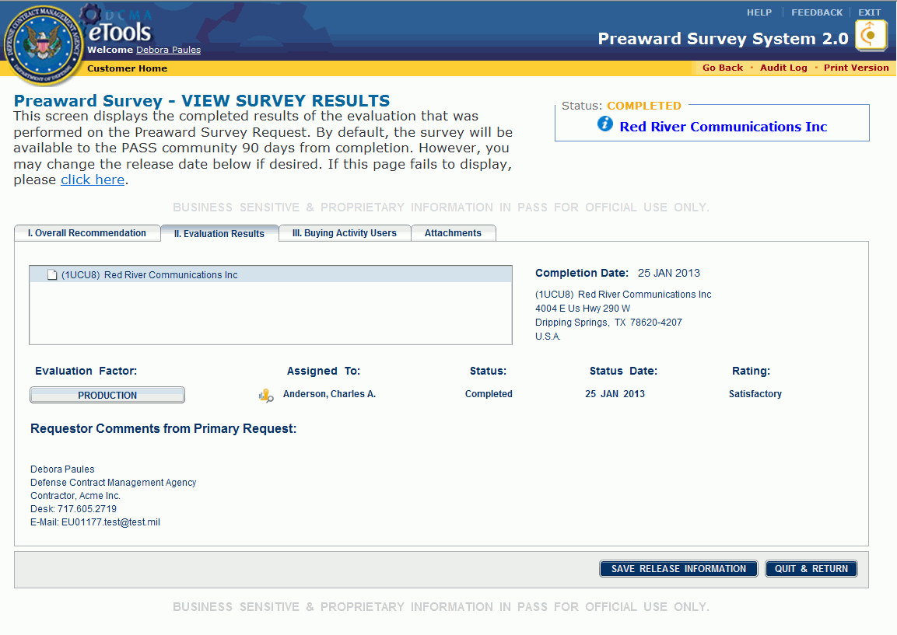
Figure 58: Preaward Survey-View Survey Results page, II. Evaluation Results tab
The II. Evaluation Results tab displays the results of the survey for that factor. For additional information, click the company name to highlight the line, then click the button that appears for the evaluation factor (Figure 59).
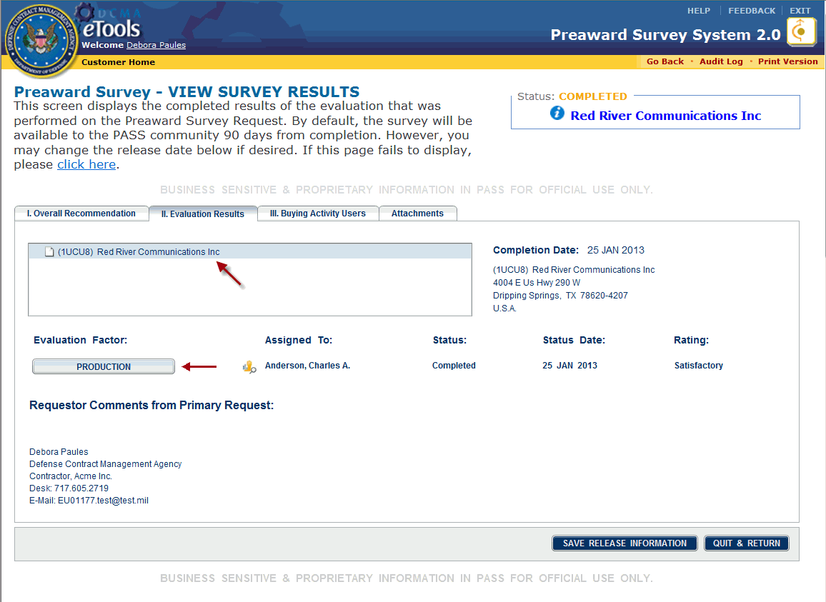
Figure 59: Company name and Evaluation Factor button
The Evaluation Factor page appears in a new window and displays the results of the survey for that factor (Figure 60).
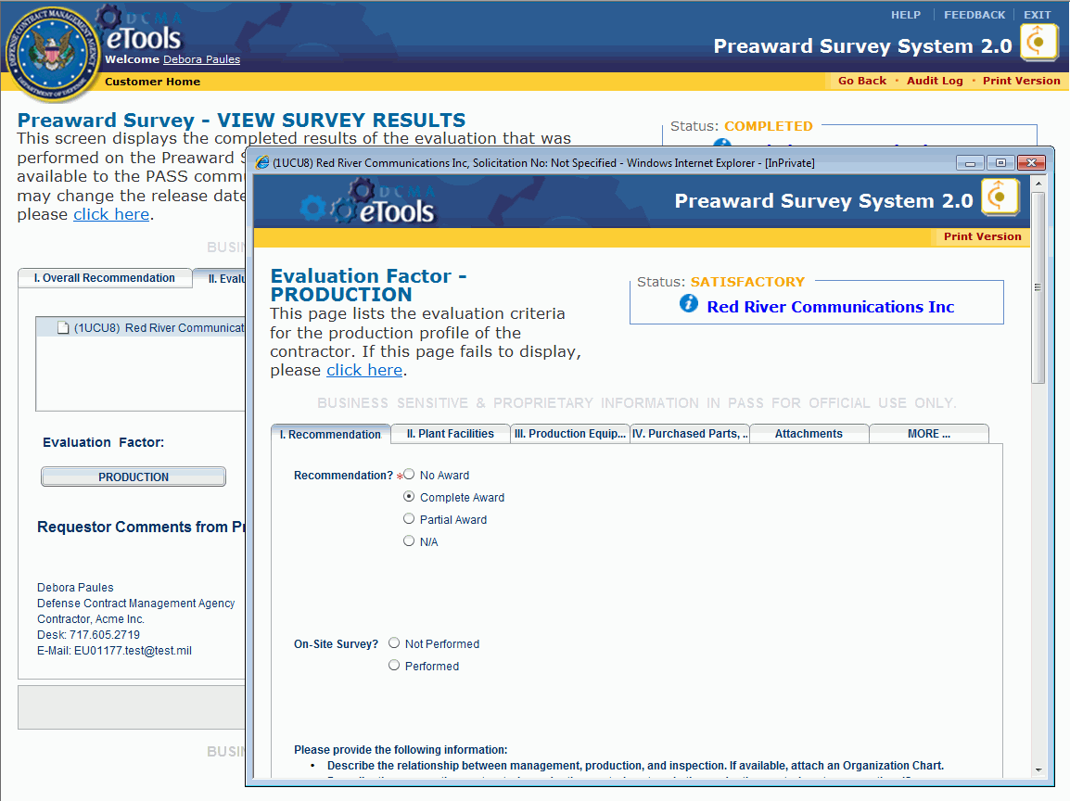
Figure 60: Evaluation Factor page (example)
To see information about the company being evaluated, click the view icon inside the Status box. A page appears with a summary of the company's information.
To see the primary survey for the evaluation factor, click the company name inside the Status box. The Preaward Survey-Primary Request page appears.
To return to the Preaward Survey-View Survey Results page, click the Preaward Survey - View Survey Results window. You can also minimize or close the Evaluation Factor window.
To view buying activity users, click the III. Buying Activity Users tab (Figure 61).
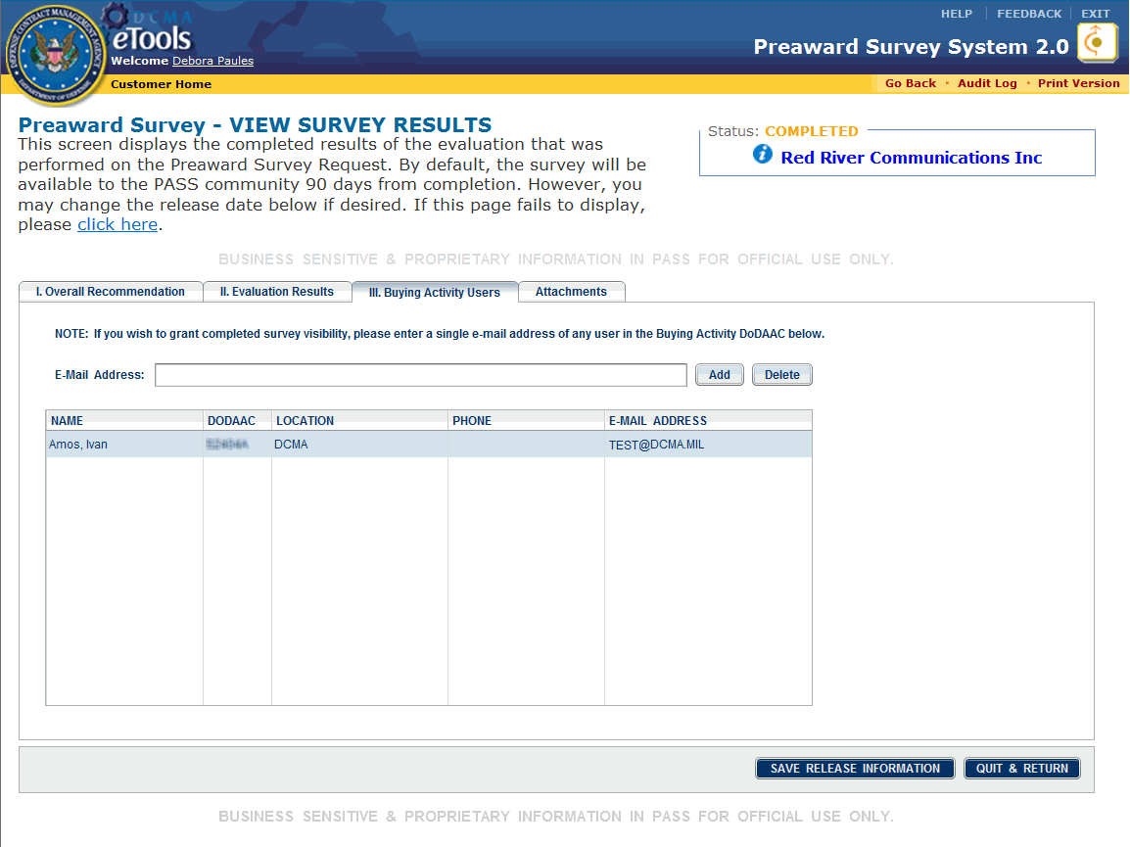
Figure 61: III. Buying Activity Users tab
To add a Buying Activity User, see the topic Editing Completed Preaward Surveys.
To view attached files, click the Attachments tab (Figure 62).
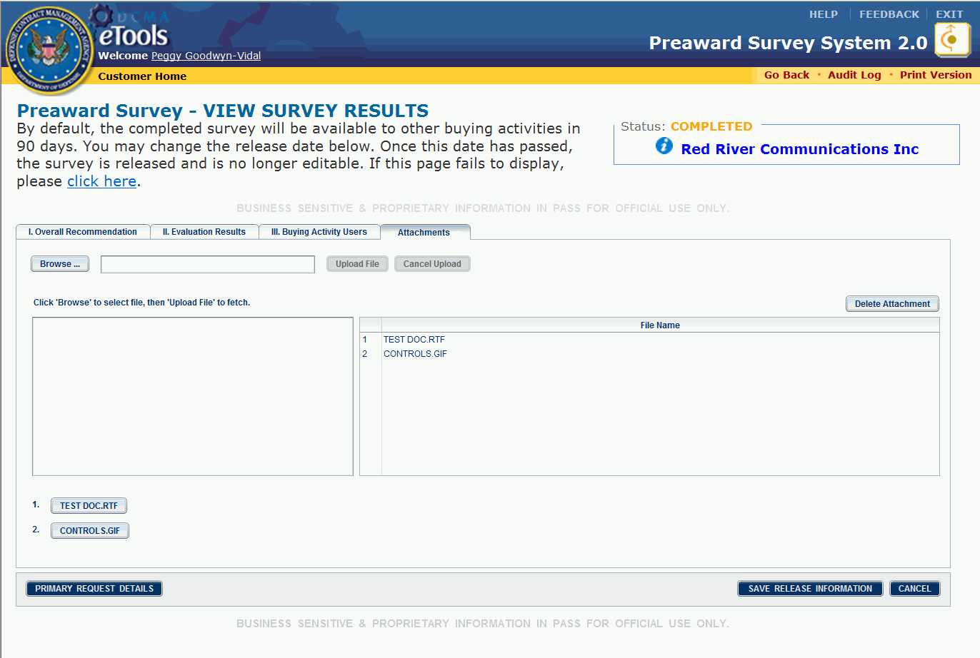
Figure 62: Preaward Survey-View Survey Results page, Attachments tab
To view or download an attachment, click the button with the file name of interest to download and/or view the attachment.
To view the preaward survey request, click the Primary Request Details button.

Editing Completed Preaward Surveys
Customers can edit the release date and buying activity users on completed surveys.

Changing the Release Date
To change the Release Date, do the following:
- On the home page, in the Read-Only tab, click the survey whose release date you wish to edit. The Preaward Survey - View Survey Results page, I. Overall Recommendation tab appears.
- Click the Release Date box or the calendar icon next to it (Figure 63). A pop-up calendar appears.
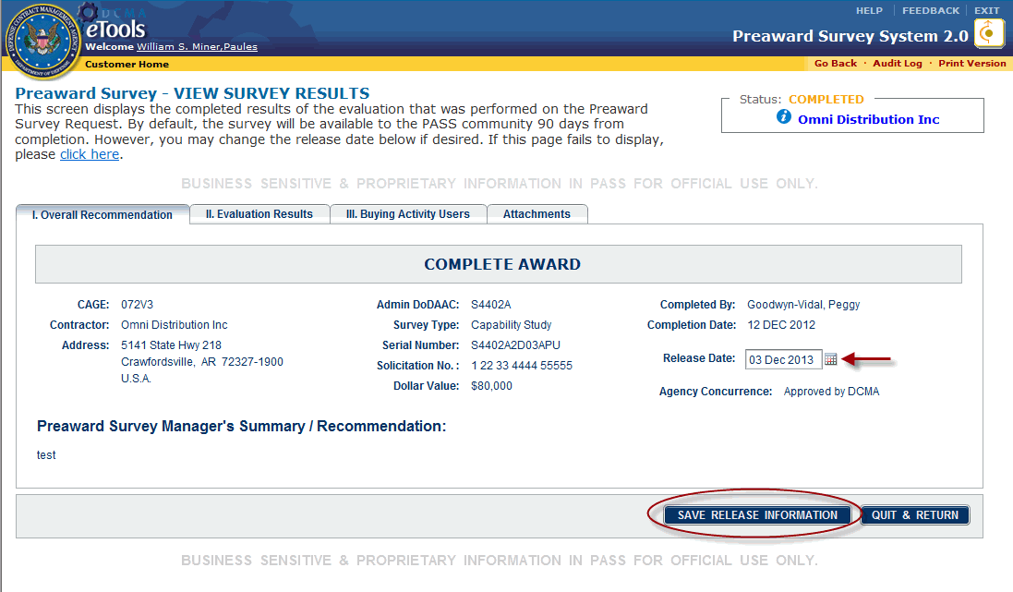
Figure 63: Release Date box and calendar
- Select the release date you wish to use from the pop-up calendar. You can change the release date to today's date or any date in the future.
- Once the date you wish to use appears in the Release Date box, click the Save Release Information button. The new release date appears in the box and will appear the next time you view the Preaward Survey - View Survey Results page.

Adding and Deleting Buying Activity Users
To add buying activity users, do the following:
- On the home page, in the Read-Only tab, click the survey to which you wish to add a buying activity user. The Preaward Survey - View Survey Results page appears.
- Click the III. Buying Activity Users tab. The III. Buying Activity Users tab is displayed.
- In the E-Mail Address text box, type the email address of the individual in the Buying Activity DoDAAC to whom you wish to grant visibility (Figure 64).
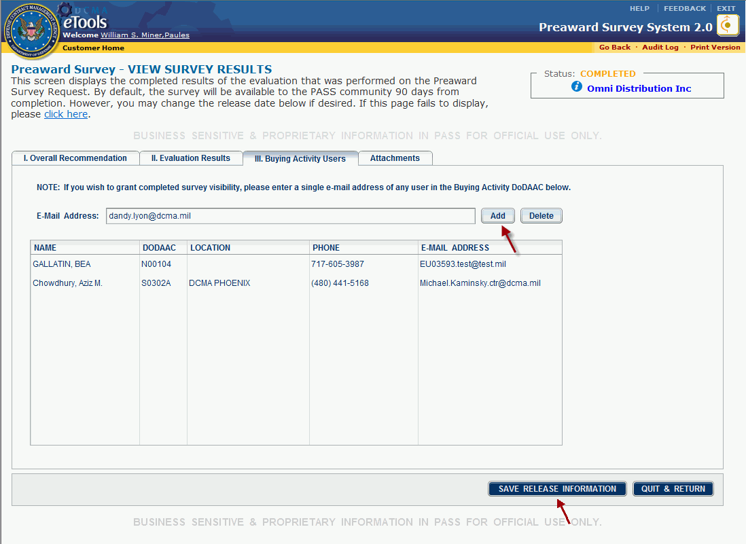
Figure 64: E-Mail Address text box
- Click the Add button.
- Click the Save Release Information button. The survey now appears in the added user's Read-Only tab.
Repeat the steps to add additional users.
To delete buying activity users, do the following:
- On the home page, in the Read-Only tab, click the survey from which you wish to delete a buying activity user. The Preaward Survey - View Survey Results page appears.
- Click the III. Buying Activity Users tab. The III. Buying Activity Users tab is displayed.
- Click the Name of the user you wish to delete to highlight the line (Figure 65).
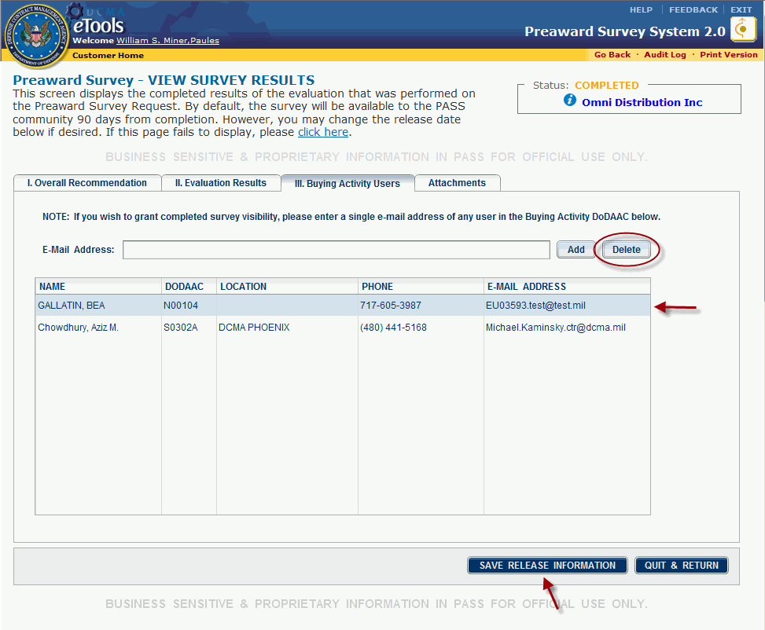
Figure 65: User's name highlighted
- Click the Delete button. A dialog box appears asking confirmation for the deletion.
- Click the Yes button in the dialog box.
- Click the Save Release Information button.
Repeat the steps to delete additional users.

Glossary
C
CAGE: Contractor and Government Entity
CMO: Contract Management Office
D
DCMA: Defense Contract Management Agency
DCMAD: Defense Contract Management Agency Directive
DoDAAC: Department of Defense Activity Address Code
DUNS: Data Universal Numbering System
F
FAR: Federal Acquisition Regulation
M
MOCAS: Mechanization of Contract Administration Services
P
PAS: Preaward Survey
PASM: Preaward Survey Manager
S
SAM: System for Award Management
SDW: Shared Data Warehouse
SICM: System for Integrated Contract Management
T
TBD: To Be Determined
U
URL: Uniform Resource Locator. Also known as a Web site address.
Z
ZIP: Zone Improvement Program

