Property Loss (PL)

Version 3.2

Application User's Manual

3 November 2016

Table of Contents
1 Overview 1
1.1 Organization of this User's Manual 1
1.2 Understanding the Property Loss Process 1
1.2.1 Basic Property Loss Process 1
1.2.2 Case Statuses Throughout the Property Loss Process 2
1.3 User Roles and Tasks 3
1.3.1 Contractor Role 3
1.3.2 Property Administrator (PA) Role 3
1.3.3 Administrator Role 4
1.3.4 Administrative Contracting Officer (ACO) Role 4
1.3.5 External User Role 5
1.4 Navigating Property Loss 5
1.4.1 Home Page 5
1.4.2 Header 5
1.4.3 Menu Bar 6
1.4.4 Footer 6
1.4.5 Tabs and Columns 7
1.4.6 Page Controls 7
1.4.7 Icons 7
2 Contractor Role 9
2.1 Viewing the Workload 9
2.1.1 Viewing the Active Cases Tab 9
2.1.2 Viewing the Draft Cases Tab 10
2.1.3 Viewing the Inactive Cases Tab 11
2.1.4 Filtering Cases 12
2.2 Searching for Cases 12
2.2.1 Using the Search 12
2.2.2 Looking Up the PA E-Mail Address 14
2.2.3 Looking Up the Prime CAGE 15
2.2.4 Looking Up the Location CAGE 16
2.3 Creating a New Case 17
2.3.1 Entering Case Information 17
2.3.2 Adding Line Items 20
2.3.3 Submitting the Case 22
2.4 Viewing Case Information 24
2.5 Managing Line Items on a Case 26
2.5.1 Viewing a Line Item 27
2.5.2 Adding a Line Item 28
2.5.3 Uploading a Line Item 30
2.5.4 Editing a Line Item 31
2.5.5 Deleting a Line Item 33
2.6 Managing Documents on a Case 33
2.6.1 Viewing Documents 34
2.6.2 Adding Documents 34
2.6.3 Deleting Documents 35
2.7 Managing Contacts on a Case 36
2.7.1 Adding Contacts 37
2.7.2 Editing Contacts 37
2.7.3 Deleting Contacts 38
2.8 Editing a Case 38
2.8.1 Editing Cases in Draft or Rejected Status 38
2.8.2 Editing Cases in Investigating or Pending Status 41
2.9 Deleting a Case 43
2.10 Rejecting a Case 44
2.11 Withdrawing a Case 46
2.12 Requesting the PA to Reopen a Case 47
3 PA and Administrator Roles 50
3.1 Viewing the Workload 50
3.1.1 Viewing the Active Cases Tab 50
3.1.2 Viewing the Draft Cases Tab 51
3.1.3 Viewing the Inactive Cases Tab 52
3.2 Searching for Cases 53
3.2.1 Using the Search 53
3.2.2 Looking Up the PA E-Mail Address 54
3.2.3 Looking Up the Prime CAGE 55
3.2.4 Looking Up the Location CAGE 56
3.3 Creating a New Case 57
3.3.1 Entering Case Information 58
3.3.2 Adding Line Items 60
3.3.3 Submitting the Case 63
3.4 Viewing Case Information 65
3.5 Managing Line Items on a Case 66
3.5.1 Viewing a Line Item 68
3.5.2 Adding a Line Item 68
3.5.3 Uploading a Line Item 71
3.5.4 Editing a Line Item 72
3.5.5 Deleting a Line Item 73
3.6 Managing Documents on a Case 73
3.6.1 Viewing Documents 74
3.6.2 Adding Documents 75
3.6.3 Deleting Documents 75
3.7 Managing Contacts on a Case 76
3.7.1 Adding Contacts 77
3.7.2 Editing Contacts 78
3.7.3 Deleting Contacts 78
3.8 Editing a Case 78
3.8.1 Editing Cases in Draft or Rejected Status 79
3.8.2 Editing Cases in Investigating Status 81
3.8.3 Editing Cases in Pending or Reopened Status 84
3.9 Deleting a Case 87
3.10 Rejecting a Case 89
3.11 Reassigning a Case 90
3.12 Relieving a Case 92
3.13 Finding a Contractor Liable 95
3.14 Closing a Case 98
3.15 Reopening a Case 100
3.15.1 Activating the Case 103
3.16 Withdrawing a Case 104
4 Administrator Role Tasks 106
4.1 Reassigning Work 106
5 ACO Role 109
5.1 Viewing Case Information 109
5.1.1 Reassigning a case to another ACO 111
5.1.2 Viewing Line Items on the Case 111
5.1.3 Viewing Documents Attached to the Case 112
5.1.4 Viewing Contacts Associated With the Case 113
5.2 Managing Documents on a Case 114
5.2.1 Viewing Documents 114
5.2.2 Adding Documents 115
5.2.3 Deleting Documents 115
5.3 Editing a Case 116
5.4 Finding a Contractor Liable 117
6 External User Role 120
6.1 Searching for Cases 120
6.1.1 Using the Search 120
6.1.2 Looking Up the PA E-Mail Address 121
6.1.3 Looking Up the Prime CAGE 122
6.1.4 Looking Up the Location CAGE 123
6.2 Viewing Case Information 124
6.2.1 Viewing Line Items on the Case 125
6.2.2 Viewing Documents Attached to the Case 125
6.2.3 Viewing Contacts Associated With the Case 126
7 Glossary 127

Overview

Organization of this User's Manual
This user's manual is organized by user role and associated tasks. This helps you find the information relevant to your needs and tasks. It can also help you understand the tasks that others perform to support your objectives and how your role interacts with their tasks.

Understanding the Property Loss Process
The Property Loss (PL) version 3.2 application is designed to facilitate the process of determining liability for the unintended, unforeseen, or accidental loss, damage or destruction of Government property that reduces the Government's expected economic benefits of the property.
This includes the following:
- Property that can't be found after a reasonable search
- Theft
- Damage or destruction from unexpected incidents rendering the item useless for its intended purpose
This does not include the following:
- Reasonable inventory adjustments
- Purposeful destruction testing
- Obsolescence
- Normal wear and tear
- Manufacturing defect
The Property Loss application allows users to work with and track Property Loss cases throughout the process of determining contractor liability.

Basic Property Loss Process
The Property Loss process is as follows:
- A Contractor or Property Administrator (PA) creates and submits a case to a Property Administrator. If the case is not administered by DCMA, the creator of the case specifies the Property Administrator to receive the case. If the case is administered by DCMA, the Property Administrator who receives the case is determined based on the contract number, CAGE, and DoDAAC in CMT.
- The Property Administrator receives the case in Investigating status. He or she may do one of the following:
  - Recommend to the ACO that the Contractor be held liable for the lost, stolen, damaged, destroyed, repairable, or replaceable property and assist the ACO in determining the extent of contractor liability.
  - Relieve the Contractor of liability for the lost, stolen, damaged, destroyed, repairable, or replaceable property. Once the Property Administrator relieves the case, the case is closed.
  - Reject the case. When a case is rejected, the Contractor can edit the case to make necessary corrections and resubmit it to the Property Administrator, or simply withdraw it.
- The case is closed once it meets one of the following two criteria:
  - The Contractor is relieved of liability for the lost, stolen, damaged, destroyed, repairable, or replaceable property. In this event, the case is closed automatically.
  - The Contractor has paid the total assessed liability amount. In this event, the Property Administrator will close the case manually.
- The closed case can be reopened by either the Property Administrator or Administrator. The case may be requested for reopen by the Contractor.

Case Statuses Throughout the Property Loss Process
Cases are assigned a different status based on which part of the Property Loss process they are currently in. A case can be in any of the following six statuses:
- Draft: Cases that have been created but not yet submitted to a Property Administrator.
- Investigating: Cases that have been submitted to a Property Administrator.
- Rejected: Cases that have been rejected by a Property Administrator.
- Pending: Cases where the Property Administrator recommends that the ACO find the Contractor liable for at least some portion of the total liability value. After the Contractor has paid the assessed liability amount, the case will be closed.
- Closed: Cases that have been relieved by a Property Administrator, as well as cases where the Contractor has paid the government for the liability amount assessed.
- Reopened: A case that was previously closed but is now reopened. It will need to be reactivated to be moved back to Investigating status.
Depending on a case's given status, some tasks may be unavailable to you. For instance, a Contractor can only withdraw a case in Rejected status. For more information about the tasks available to your user role, see the topic User Roles and Tasks.

User Roles and Tasks
The Property Loss application supports four user roles: Contractor, Property Administrator (PA), Administrator, and Administrative Contracting Officer (ACO). The abilities of each of the four user roles are listed below:

Contractor Role
Users with the Contractor role log into Property Loss via EWAM, consist of both Prime and Subcontractors, and can perform the following tasks:
- Search for and view the cases they created as well as cases where their CAGE is identified as the Prime or Location CAGE
- Create new cases
- Add, edit, and delete line items on Draft and Rejected cases
- Add and delete documents on Draft and Rejected cases; or submit a request to add or delete documents from cases in Investigating or Pending status
- Add, edit, and delete contacts on Draft cases; add and edit contacts on Rejected cases
- Edit cases in Draft or Rejected status; edit Remarks on cases after submission
- Delete their own Draft and Rejected cases
- Withdraw their own Rejected cases
- Submit a request to Reopen one of their own Closed cases

Property Administrator (PA) Role
Users with the Property Administrator role log into Property Loss via the eTools application and can perform the following tasks:
- Search for and view the cases they created as well as cases assigned to them
- Create new cases
- Add, edit, and delete line items on open cases that are assigned to them
- Add documents to open cases and delete documents from Draft, Investigating, and Pending cases that are assigned to them
- Add and edit contacts on open cases that are assigned to them; delete contacts on Draft cases
- Edit open cases that are assigned to them
- Delete Draft cases and Rejected cases
- Reject cases in Investigating status that are assigned to them
- Withdraw cases in Rejected status that they created
- Determine if the Contractor should be relieved or recommend the ACO hold Contractors liable for cases in Investigating status that are assigned to them
- Close cases that are assigned to them
- Reopen closed cases if necessary
- Reassign cases from their own workload to another Property Administrator (Property Administrators who are external to DCMA cannot reassign cases)

Administrator Role
Users with the Administrator role log into Property Loss via IWAM and can perform the following tasks:
- Search for and view any case in Property Loss
- Create new cases
- Add, edit, and delete line items on any case in Draft, Investigating, Pending, or Rejected status
- Add and delete documents on any open case
- Add or edit contacts on any open case and delete contacts on any case in Draft status
- Edit any open case
- Delete any Draft or Rejected case
- Reject any case in Investigating status
- Withdraw any case in Rejected status
- Determine if the Contractor is liable or should be relieved on any case in Investigating status
- Close any case in Pending status
- Reopen any closed case
- Reassign cases from one Property Administrator to another or from one ACO to another

Administrative Contracting Officer (ACO) Role
Users with the ACO role log into Property Loss via IWAM or EWAM and can perform the following task:
- Edit ACO Information on Pending cases
- Add documents to and delete documents from cases in Pending status that are assigned to them
- Determine if the Contractor is liable for individual items on cases in Pending status that are assigned to them
- Can reassign cases from their workload to another ACO

External User Role
Users with the External User role log into Property Loss via EWAM and can perform the following tasks:
- Search for Cases
- View Case Information, and export case details to PDF
- View Line Items associated with a case, and export line item details to PDF
- View documents attached to a case
- View contacts associated with a case, and export contact details to PDF

Navigating Property Loss
The navigation elements of Property Loss help you find information and complete tasks efficiently.

Home Page
When you log into the Property Loss application, the Home Page is the initial page you see (Figure 1).
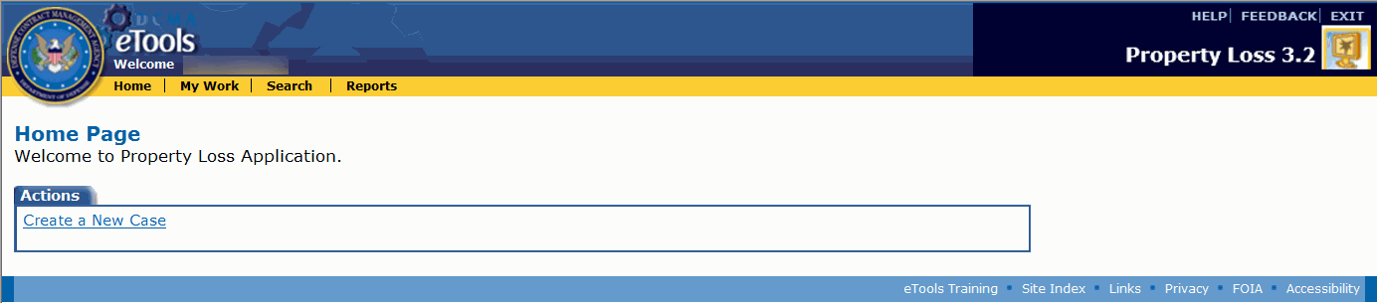
Figure 1: Property Loss Home Page for a Property Administrator
The Create a New Case link appears on the Home Page for all the user roles except the ACO. See the topic Creating a New Case.

Header
The top left side of the page displays the DCMA logo and your name with a link (Figure 2).
Figure 2: DCMA logo and user name link, with menu options for an Administrator
If you click this link, your user information will appear in a pop-up window (Figure 3).
Figure 3: User profile pop-up window
The right side of the top of the page provides the following links (Figure 4).
Figure 4: Property Loss icon and right-side menu options
Help: Provides assistance for specific pages in Property Loss. If you are viewing a page and need answers regarding the format of information, or if you need to find where a certain task is performed in the application, or to discover who does what task, online help can provide the answer.
Feedback: Allows you to provide your ideas for future enhancements to the Property Loss application.
Exit: Closes Property Loss and the page that displays it. By using the Exit link, you ensure that your session is closed securely.

Menu Bar
The menu bar that appears below your name provides links to functionality in Property Loss (Figure 5).
Figure 5: Property Loss Menu bar
The links that appear on the menu bar depend on your user role:
Home: Displays the Home Page. This link appears for all user roles.
My Work: Displays the My Work Page. This link appears for all user roles. Be aware that although External Users can view this link, they will not be able to see any cases by clicking on it.
Search: Displays the Property Loss Search page. This link does not appear for the ACO role.
Administration: Displays the Administration page. This link appears for the Administrator role only.
Reports: Displays the Property Loss Report List. This link does not appear for the Contractor role. For more information on the Property Loss reporting functionality, see the Property Loss 3.0 Reports User Manual.

Footer
The footer at the bottom of every page provides links to standard DCMA web sites (Figure 6).
Figure 6: Property Loss page footer

Tabs and Columns
Tabs, such as the Active Cases tab, show records with a specific status. To see information under a tab, click the tab (Figure 7).
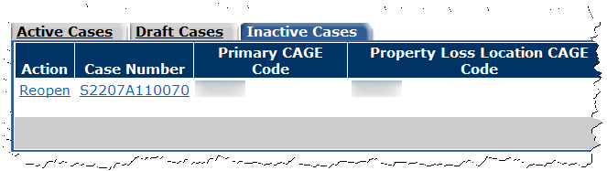
Figure 7: Example of Tabs, table, columns, and column headings
Each column in a table allows you to sort information in either ascending or descending order. To sort the information, click a column heading. Click the column heading again to sort the information in reverse order.

Page Controls
On pages that display multiple records, the controls at the bottom of the table allow you to move to the first, previous, next, or last request. You may also use the drop-down list box to select the sequence number of the requests you wish to see and click the Go button (Figure 8).
Figure 8: Example of page controls

Icons
The following icons link to additional functionality:
Icon | Description
 | Opens a page where you may edit a case or line item.
 | Opens a page where you may add a case or line item.
 | Deletes a case or line item.
 | Opens a pop-up with additional information.
 | Displays a pop-up calendar from which you can select a date.
 | Displays a search page in a new window which allows you to search for data to populate in a field.
 | Closes the window you are viewing.

Contractor Role

Viewing the Workload
The cases that appear in your workload depend on your user role:
- Contractors' workloads display the cases where their CAGE is identified as the Prime CAGE or Location CAGE.
- Property Administrators' workloads display the cases that they created or are assigned to them. For cases they created, they have view-only access. For cases assigned to them, they have the ability to work the case. Property Administrators who are external to DCMA can only receive cases from contractors who are within their own service.
- Administrators' workloads display all the cases in Property Loss.
- ACOs' workloads display the cases that are assigned to them. The ACO assigned to the case is identified by the ACO Code in MOCAS.
- External Users can access the My Work Page, but active, draft, and inactive cases will not appear for them there.
The My Work Page appears when you click the My Work link on the menu bar and displays your case workload on three tabs: Active Cases, Draft Cases, and Inactive Cases.

Viewing the Active Cases Tab
To view your active cases, click the My Work link on the menu bar. The My Work Page appears, displaying the Active Cases tab by default (Figure 9).
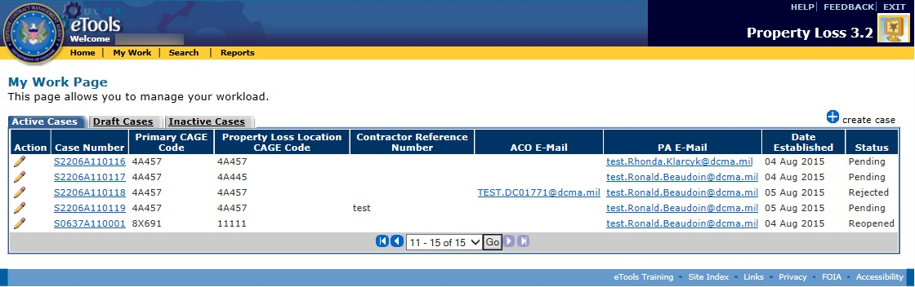
Figure 9: My Work Page, Active Cases tab
The Active Cases tab displays information about your active cases in the following columns:
- Action: Displays the edit icon . The edit icon allows you to edit the case.
- Case Number: The auto-generated number identifying the case in Property Loss. Case numbers follow the following format: the DoDAAC based on the contract number and CAGE in SDW, the last two digits of the calendar year, and a four-digit sequence number.
- Primary CAGE Code: The Primary CAGE of the property.
- Property Loss Location CAGE Code: The Location CAGE of the property.
- Contractor Reference Number: The Contractor Reference Number on the case.
- ACO E-Mail: The E-Mail address of the ACO assigned to the case.
- PA E-Mail: The E-Mail address of the Property Administrator assigned to the case.
- Date Established: The Date Established is populated when the case has been submitted to the PA.
- Status: The status of the case (Investigating, Rejected, Pending, Reopened).
To view the case, click the link on the case number. See the topic Viewing Case Information.
To create a new case, click the create case link. See the topic Creating a New Case.

Viewing the Draft Cases Tab
To view your draft cases, click the Draft Cases tab. The Draft Cases tab is displayed (Figure 10).
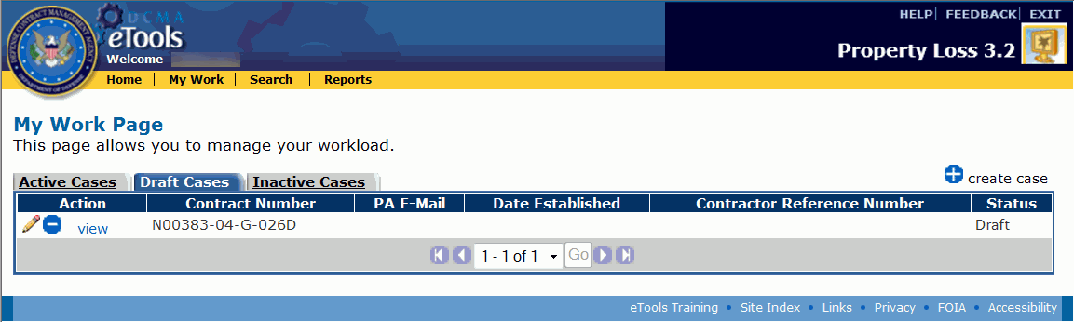
Figure 10: My Work Page, Draft Cases tab
The Draft Cases tab displays information about your draft cases in the following columns:
- Action: Displays the edit icon and the delete icon , as well as the view link. The edit icon allows you to edit and submit the case and the delete icon allows you to delete the case. The view link allows you to view the case.
- Contract Number: The Contract Number on the case.
- PA E-Mail: The E-Mail address of the Property Administrator assigned to the case. Does not display for draft cases that are internal to DCMA.
- Date Established: The Date Established is populated when the case has been submitted to the PA.
- Contractor Reference Number: The Contractor Reference Number on the case.
- Status: The status of the case (Draft).
To view the case, click the view link next to the case you wish to view. See the topic Viewing Case Information.
To create a new case, click the create case link. See the topic Creating a New Case.

Viewing the Inactive Cases Tab
To view your inactive cases, click the Inactive Cases tab. The Inactive Cases tab is displayed (Figure 11).
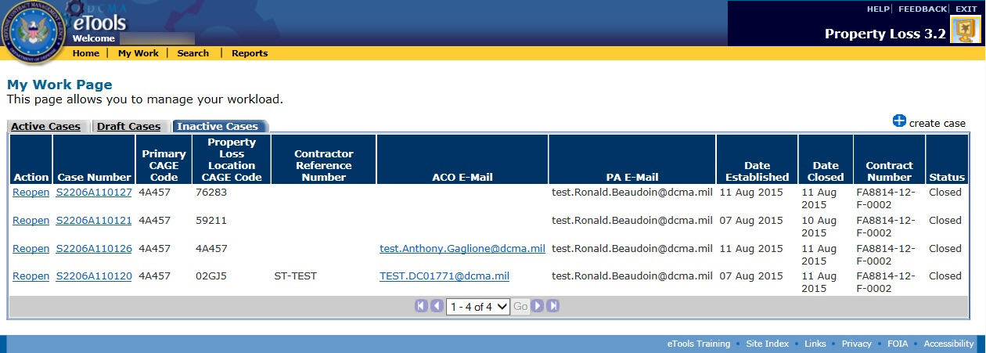
Figure 11: My Work Page, Inactive Cases tab
The Inactive Cases tab displays information about your closed cases in the following columns:
- Action: Displays the Reopen link, where you can reopen the case. If you are a Property Administrator, see the topic Reopening a Case. If you are a Contractor, see the topic Requesting the PA to Reopen a Case.
- Case Number: The auto-generated number identifying the case in Property Loss. Case numbers follow the following format: the DoDAAC based on the contract number and CAGE in SDW, the last two digits of the calendar year, and a four-digit sequence number.
- Primary CAGE Code: The Primary CAGE of the property.
- Property Loss Location CAGE Code: The Location CAGE of the property.
- Contractor Reference Number: The Contractor Reference Number on the case.
- ACO E-Mail: The E-Mail address of the ACO assigned to the case.
- PA E-Mail: The E-Mail address of the Property Administrator assigned to the case.
- Date Established: The date the case is submitted to the PA.
- Date Closed: The date the case was closed.
- Contract Number: The Contract Number on the case.
- Status: The status of the case (Closed).
To view the case, click the link on the case number. See the topic Viewing Case Information.
To create a new case, click the create case link. See the topic Creating a New Case.

Filtering Cases
The administered by DCMA link allows you to filter the cases you see in your workload by selecting whether you wish to see only the cases administered by DCMA, only the cases external to DCMA, or all of your cases.
To see only the cases administered by DCMA in your workload, select Yes from the drop-down list box and click the administered by DCMA link.
To see only the cases external to DCMA in your workload, select No from the drop-down list box and click the administered by DCMA link.
To see all of your cases in your workload, select Both from the drop-down list box and click the administered by DCMA link.

Searching for Cases
The cases you can search for depend on your user role:
- Contractors can search for cases they created, as well as cases where their CAGE is the prime or sub.
- Property Administrators can search for cases that are assigned to them and the cases they created.
- Administrators can search for any cases in Property Loss.
- ACOs cannot search for cases.
- External Users can only search for cases where their DoDAAC is the prime or sub.

Using the Search
To search for cases in Property Loss, do the following:
- Click the Search link on the menu bar. The Property Loss Search page appears (Figure 12).
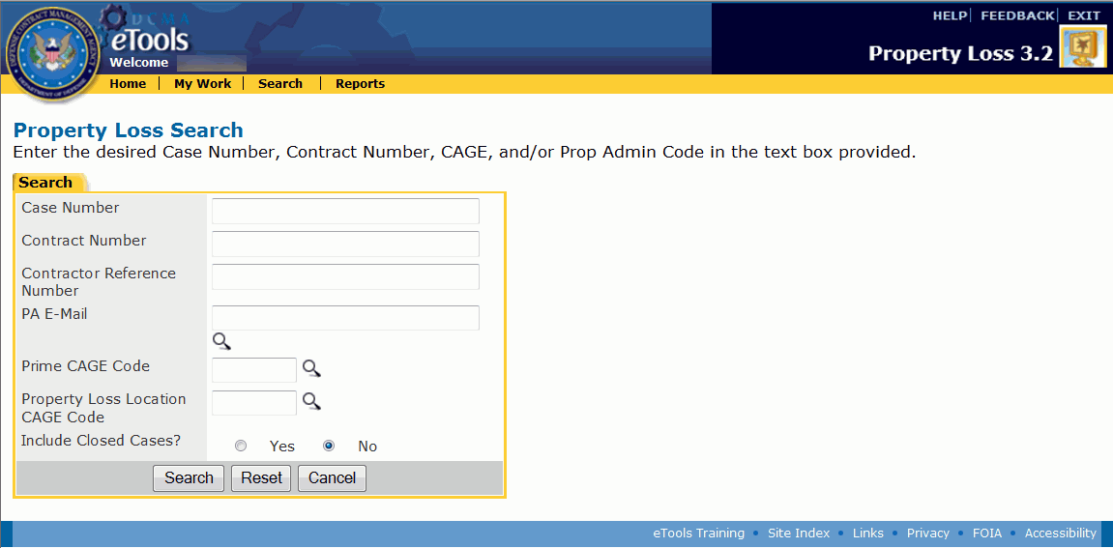
Figure 12: Property Loss Search page
- Type the search criteria necessary to help you find the cases for which you are looking. You can type information in none, some, or all of the search fields. The more information you specify, the easier it will be to find your desired cases. If you type information in none of the search fields, the search results will yield all the cases to which you have access.
You can also click an option button (Yes or No) to include Closed cases in your search; No is the default option.
Note: If you do not know the Prime CAGE, Location CAGE, or PA E-Mail on the case you are looking for, you can click the icon next to the applicable field to search for a PA E-Mail, Prime CAGE, or Location CAGE. See the subtopics Looking Up the PA E-Mail Address, Looking Up the Prime CAGE, and Looking Up the Location CAGE within this topic.
- Click the Search button. The Search Results page appears, displaying the cases that match the search criteria you entered (Figure 13).
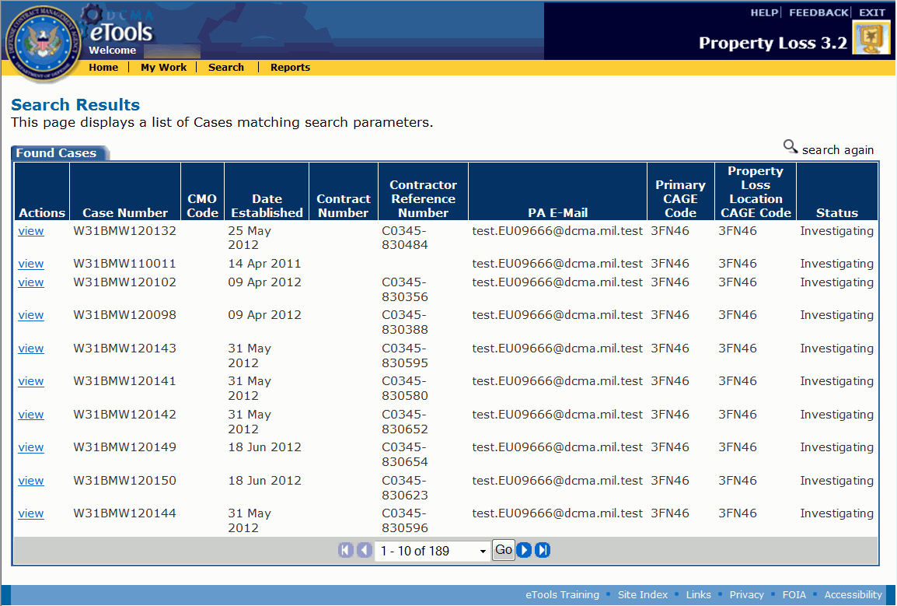
Figure 13: Search Results page
To view a case, click the view link. The View Case page appears.
To search again, click the search again link.

Looking Up the PA E-Mail Address
If you do not know the E-Mail Address of the Property Administrator assigned to the case but would like to search for the case based on the assigned Property Administrator, you can find the PA's E-Mail address by searching on the PA's first or last name.
To look up the E-Mail address of the PA assigned to the case, do the following:
- Click the icon next to the PA E-Mail field on the Property Loss Search page. The PA E-Mail Search appears in a new window (Figure 14).
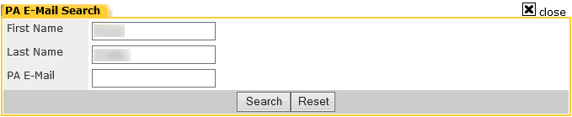
Figure 14: PA E-Mail Search window
- Type the PA's First Name or Last Name in the search fields.
- Click the Search button. The search results appear in the same window (Figure 15).
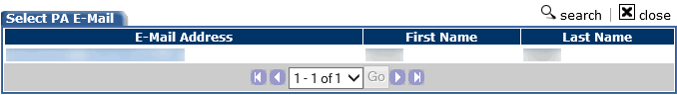
Figure 15: Select PA E-Mail window
- Click the link on the PA E-Mail address if you found the PA you are looking for. The Select PA E-Mail window disappears, and the PA's E-Mail address is populated in the PA E-Mail field on the Property Loss Search page.
To search for another PA E-Mail address, click the search link within the Select PA E-Mail window.
To close the Select PA E-Mail window without selecting an E-Mail address, click the close link.
- Type additional search criteria if you wish.
- Click the Search button. The Search Results page appears.
To view a case, click the view link. The View Case page appears.

Looking Up the Prime CAGE
If you do not know the prime CAGE on the case but would like to search for the case based on the prime CAGE, you can find the prime CAGE by searching on the DoDAAC, Company Name, or ZIP Code.
To look up the prime CAGE on the case, do the following:
- Click the icon next to the Prime CAGE Code field on the Property Loss Search page. The Prime CAGE Search appears in a new window (Figure 16).
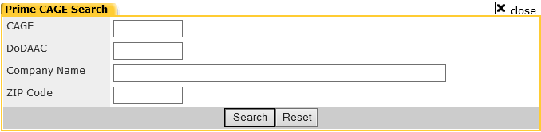
Figure 16: Prime CAGE Search window
- Type the DoDAAC, Company Name, or ZIP Code in the search fields.
- Click the Search button. The search results appear in the same window (Figure 17).
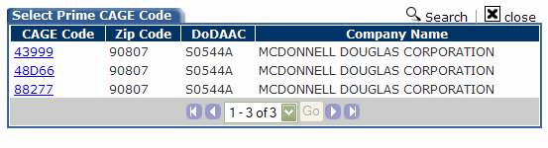
Figure 17: Select Prime CAGE window
- Click the link on the CAGE if you found the CAGE you are looking for. The Select Prime CAGE Code window disappears, and the prime CAGE is populated in the Prime CAGE Code field on the Property Loss Search page.
To search for another prime CAGE, click the search link within the Select Prime CAGE Code window.
To close the Select Prime CAGE Code window without selecting a prime CAGE, click the close link.
- Type additional search criteria if you wish.
- Click the Search button. The Search Results page appears.
To view a case, click the view link. The View Case page appears.

Looking Up the Location CAGE
If you do not know the location CAGE on the case but would like to search for the case based on the location CAGE, you can find the location CAGE by searching on the DoDAAC, Company Name, or ZIP Code.
To look up the location CAGE on the case, do the following:
- Click the icon next to the Property Loss Location CAGE Code field on the Property Loss Search page. The Location CAGE Search appears in a new window (Figure 18).
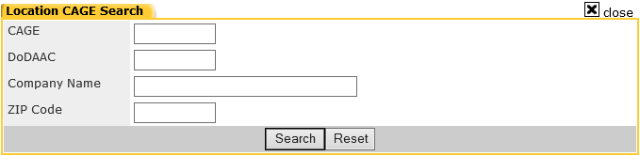
Figure 18: Location CAGE Search window
- Type the DoDAAC, Company Name, or ZIP Code in the search fields.
- Click the Search button. The search results appear in the same window (Figure 19).
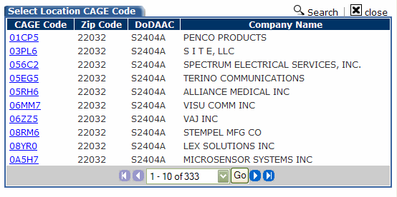
Figure 19: Select Location CAGE window
- Click the link on the CAGE if you found the CAGE you are looking for. The Select Location CAGE Code window disappears, and the location CAGE is populated in the Property Loss Location CAGE Code field on the Property Loss Search page.
To search for another location CAGE, click the search link within the Select Location CAGE Code window.
To close the Select Location CAGE Code window without selecting a location CAGE, click the close link.
- Type additional search criteria if you wish.
- Click the Search button. The Search Results page appears.
To view a case, click the view link. The View Case page appears.

Creating a New Case
Contractors, Property Administrators, and Administrators can create new cases in Property Loss.
There are three steps to creating a new case: Entering Case Information, Adding Line Items, and Submitting the Case. You may also add documents and contacts to the case.

Entering Case Information
The first step in creating a Property Loss case is entering basic contract data and general information regarding the property that was lost, stolen, damaged, destroyed, repairable, or replaceable.
To create a new case in Property Loss, do the following:
- Click either the Create a New Case link on the Home Page or the create case link on the My Work Page. The Create Case page appears (Figure 20 and Figure 21).
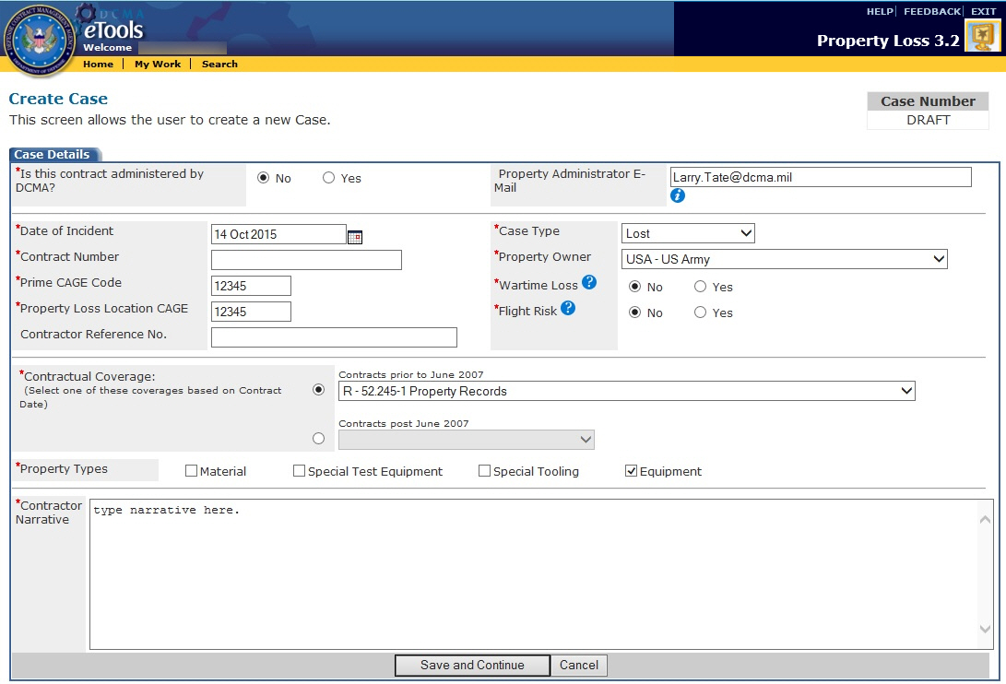
Figure 20: Create Case page for Contractor or External PA
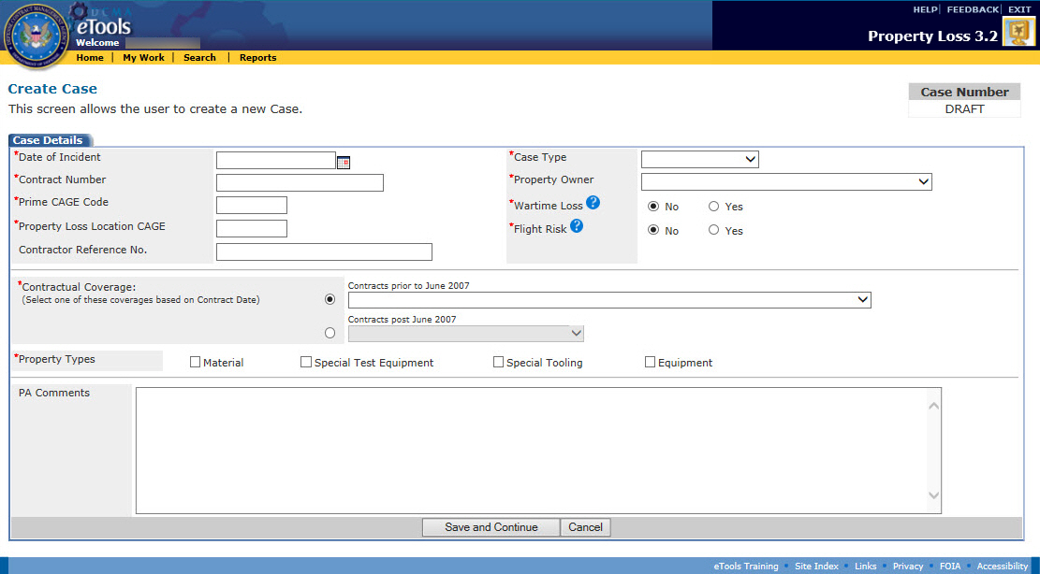
Figure 21: Create Case page for Internal PA
- Contractors and Property Administrators who are external to DCMA are required to select whether or not the case is administered by DCMA by clicking one of the option buttons.
  - If the case is NOT administered by DCMA, you will need to type the E-Mail address of the Property Administrator for the contract in the Property Administrator E-Mail field. You can only submit cases to Property Administrators within your own service.
  - If the case is administered by DCMA, the Property Administrator E-Mail field becomes disabled and you will not be able to specify a Property Administrator. Instead, Property Loss automatically routes the case to the appropriate Property Administrator based on the contract number, CAGE, and DoDAAC in CMT.
- Select the Date of Incident. Click the calendar icon to select the date from a calendar.
- Type the Contract Number. If the case is administered by DCMA, Property Loss will validate the contract number in MOCAS. If Property Loss cannot find the contract number in MOCAS, you will receive an error message.
- Type the Prime CAGE Code of the contractor. This CAGE must have a current MOCAS record and includes international CAGEs. When you create the case, Property Loss will validate the CAGE you entered against the contract number. If the CAGE is incorrect, Property Loss will automatically replace it with the correct CAGE in SDW.
- Type the Property Loss Location CAGE Code of the property.
- Type the Contractor Reference Number. Note that this field is not required.
- Select a Contractual Coverage based on the contract date. Use the first drop-down list box for contracts prior to June 2007 and the second drop-down list box for contracts post June 2007.
- Select the applicable Property Types by clicking the check boxes. Options include: Material, Special Test Equipment, Special Tooling, and Equipment.
- Select a Case Type from the drop-down list box. Options include: Lost, Damaged, Theft, Destroyed Accident, Destroyed Combat, Repair, or Replacement.
- Select a Property Owner from the drop-down list box.
- Select whether the property is a Wartime Loss by clicking one of the option buttons. The default value is No.
- Select whether the property is a Flight Risk by clicking one of the option buttons. The default value is No.
- Type a Contractor Narrative or PA Comments in the text box at the bottom.
Note: You must enter values in the required fields. Required fields are marked with an asterisk (*).
To save the case information and continue creating the case, click the Save and Continue button.

Adding Line Items
The second step in creating a Property Loss case is adding one or more line items to the case. Note that the case must have at least one line item before you can submit it.
To add a line item, do the following:
- Finish entering values in all the required fields on the Create Case page and click the Save and Continue button. The Add Line Item page appears (Figure 22 and Figure 23).
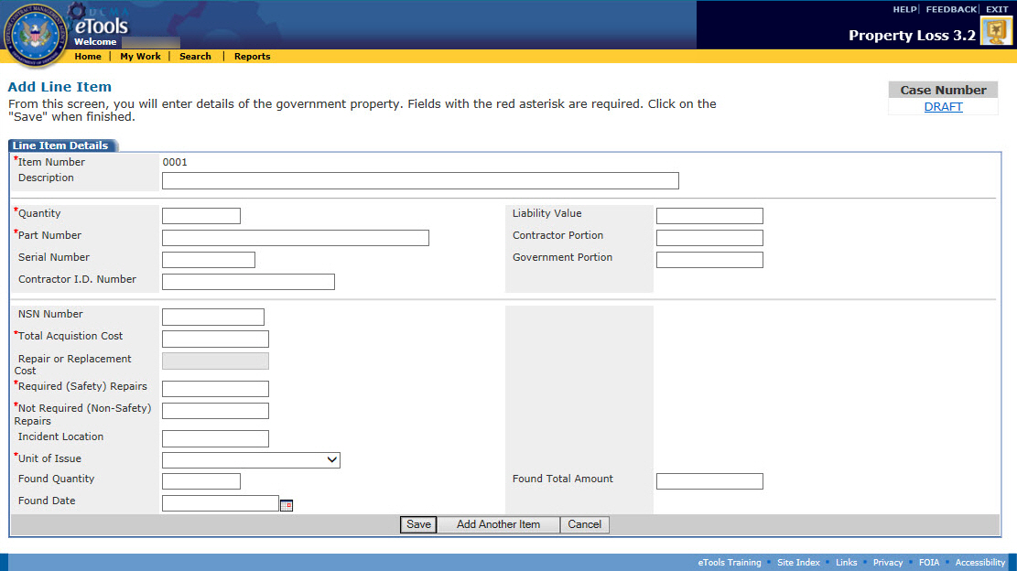
Figure 22: Add Line Item page for external case
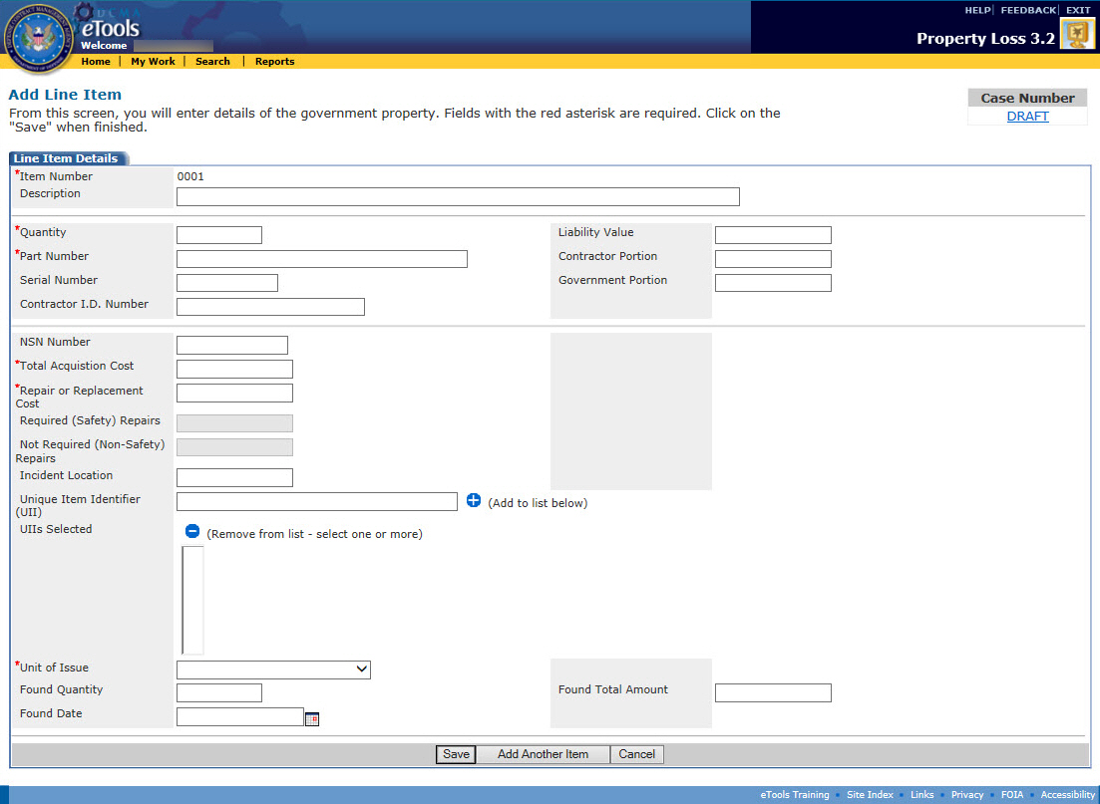
Figure 23: Add Line Item page for internal case
- Type a Description of the item. Note that this field is not required.
- Type the Quantity of the item.
- Type the Part Number of the item.
- Type the Serial Number of the item. Note that this field is not required.
- Type the Contractor I.D. Number of the item. Note that this field is not required.
- Type the National Stock Number (NSN) of the item. Note that this field is not required.
- Type the Total Acquisition Cost of the item.
- If the Repair or Replace options are selected for the case type, then the Repair and Replacement Cost field will be required.
- If the Damaged option is selected for the case type, then the Required (Safety) Repairs and Not Required (Safety) Repairs fields will be required.
Note: The Required (Safety) Repairs and Not Required (Safety) Repairs must equal the Liability Value.
- Type the Incident Location of the item. Note that this field is not required.
- Select the Unit of Issue from the drop-down list box.
- (For internal cases only) Type a Unique Item Identifier (UII) in the UII box and click the add icon to add it to the UIIs Selected box which appears below. Repeat for each UII. A UII cannot exceed 72 characters and the number of UIIs in the list must not exceed the total quantity of items. Click the delete icon next to the UIIs Selected list to remove UIIs. Note that this field is not required.
Note: Unique Item Identifier (UII) information does not display when creating a line item on an external case.
- Type the Liability Value of the items lost, stolen, damaged, destroyed, repairable, or replaceable. Note that this field is not available to the Contractor.
Note: Liability Value, Contractor Portion, and Government Portion are required fields for PAs and Administrators when the case is in Investigating status.
- Type the Contractor Portion of the Liability Value. Note that this field is not available to the Contractor.
- Type the Government Portion of the Liability Value. Note that this field is not available to the Contractor.
- If any part of the item was found, type the quantity found in the Found Quantity text box and the total amount of the found quantity in the Found Total Amount text box.
- Click the calendar icon to select a date from the calendar for the Found Date text box.
Note: You must enter values in the required fields. Required fields are marked with an asterisk (*).
To add another item to the case, click the Add Another Item button.
To save the item and continue to the View Case page, click the Save button.
To upload multiple line items to the case, click the upload line items link. The Upload Line Items page appears. See the subtopic Uploading a Line Item.
To add documents to the case, on the View Case page, click the Documents tab (see the topic Managing Documents on a Case).
To add contacts to the case, on the View Case page, click the Contacts tab (see the topic Managing Contacts on a Case).
To return to the View Case page without saving, click the Cancel button.

Submitting the Case
The third step in creating a Property Loss case is submitting the case. Note that the case must have at least one line item before you can submit it.
To submit the case, do the following:
- Finish entering values in the required fields and click the Save button on the Add Line Item page (or, if you are not on the Add Line Item Page, click the Case Details tab). The View Case page appears displaying the case in Draft status (Figure 24).
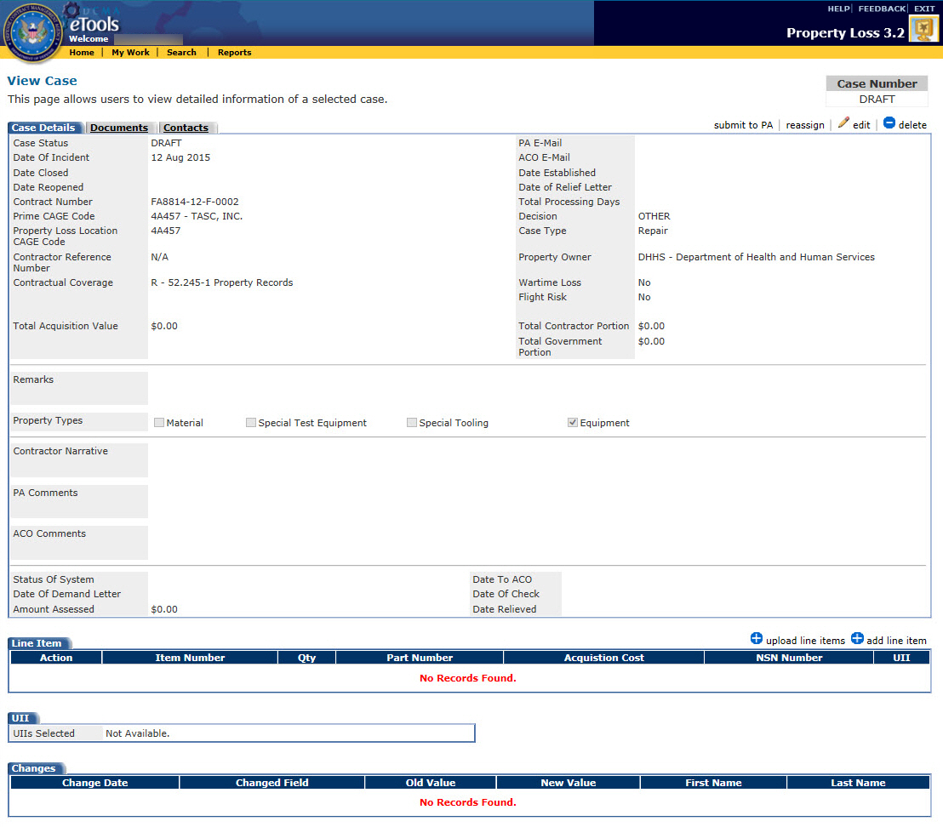
Figure 24: View Case page in Draft status
- Click the submit to PA link. Once you submit the case, Property Loss automatically sends an E-Mail to the person who submitted the case as well as the Property Administrator assigned to the case (Figure 25). The case status is updated to "investigating.”
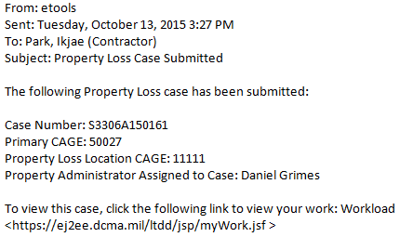
Figure 25: Sample case submitted E-Mail

Viewing Case Information
The cases you can view depend on your user role:
- Contractors can view the cases they created, as well as cases where their CAGE is the prime or sub.
- Property Administrators can view the cases that are assigned to them and the cases they created.
- Administrators can view any cases in Property Loss.
- ACOs can view the cases assigned to them.
- External Users can only view cases where their DoDAAC is the prime or sub.
To view a case, do the following:
- Click the My Work link on the menu bar. The My Work Page appears.
- Locate the case on the Active Cases tab, Draft Cases tab, or Inactive Cases tab (click the tab to display the tab; also, see the topic Viewing the Workload or Searching for Cases).
- Click the link on the case number of the case you wish to view (on the Draft Cases tab or Found Cases tab, click the view link). The View Case page appears (Figure 26).
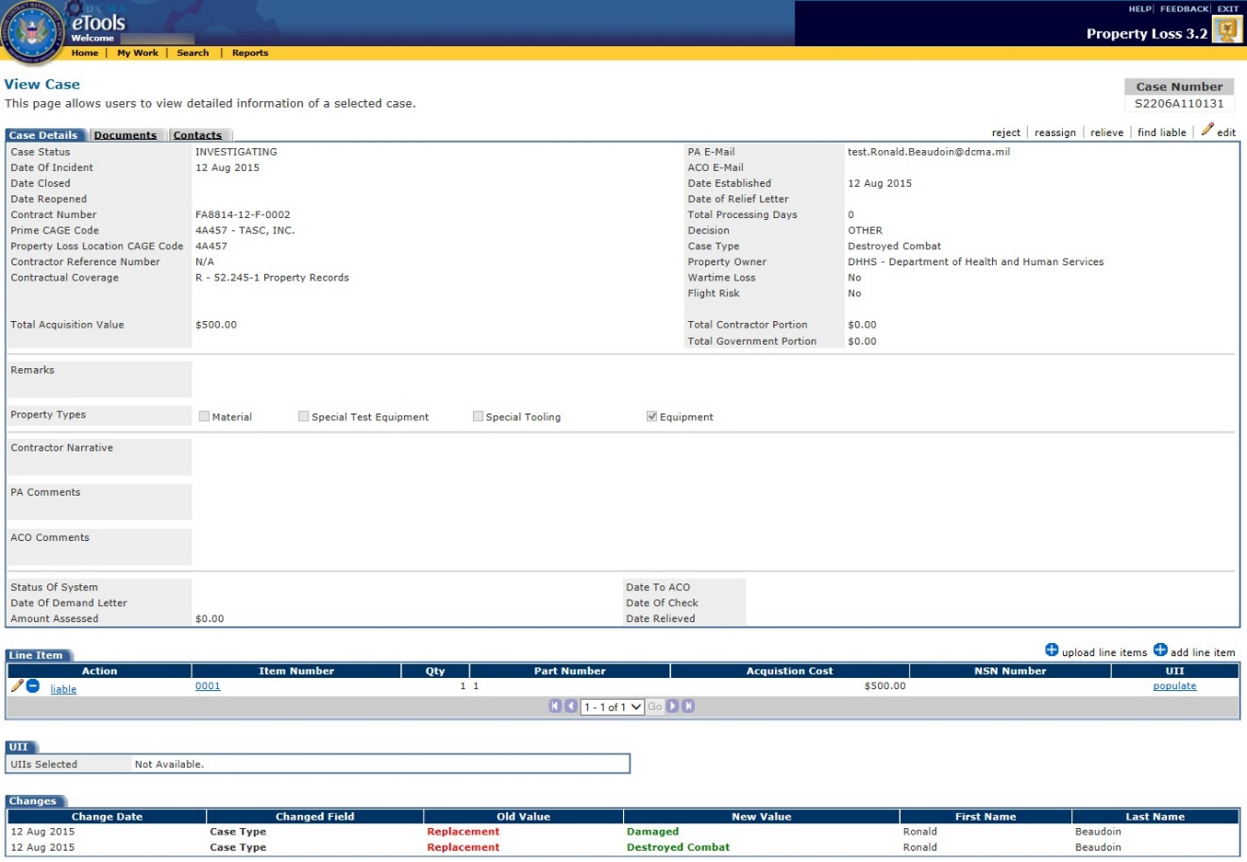
Figure 26: View Case page in Investigating status
The Changes section at the bottom of the page displays all the changes that were made to the case since it was submitted. It displays the date the change was made, field that was changed, what it was changed from and to, as well as who made the change.
Note: The Total Processing Days will be calculated nightly on a calendar basis. It is the number of days between Date Established and Date Closed inclusive. If the case is reopened, start counting again starting from the number of processing days already calculated.
To submit the case to the PA, click the submit to PA link. See the subtopic Submitting the Case within the topic Creating a New Case.
To edit the case, click the edit link. The edit link appears on cases that are in Draft, Rejected, Investigating, and Pending status. See the topic Editing a Case.
To withdraw the case, click the withdraw link. The withdraw link appears on cases that you created and are in Rejected status. See the topic Withdrawing a Case.
To delete the case, click the delete link. The delete link appears on cases that you created and are in Draft or Rejected status. See the topic Deleting a Case.
To view, add, edit, or delete line items on the case, on the Case Details tab, locate the Line Item tab (see the topic Managing Line Items on a Case).
To view, add, or delete documents attached to the case, click the Documents tab (see the topic Managing Documents on a Case).
To view, add, edit, or delete contacts associated with the case, click the Contacts tab (see the topic Managing Contacts on a Case).

Managing Line Items on a Case
The cases you can add, edit, or delete line items from depend on your user role:
- Contractors can add, edit, or delete line items on cases in Draft or Rejected status.
- Property Administrators can add and delete line items on cases in Draft, Investigating, and Rejected status and edit line items in any status except Closed (Note: Cases in Draft status are editable by PAs if they've created the cases; cases in other statuses are editable by PAs if they've been assigned the cases).
- Administrators can add, edit, or delete line items from any case in any status except Closed.
- ACOs cannot add, edit, or delete line items.
- External Users cannot add, edit, or delete line items.
You can view, add, edit, or delete line items from a case by scrolling down to the Line Item tab on the View Case page, Case Details tab (see the topic Viewing Case Information). The Line Item tab allows you to view a list of the line items on the case (Figure 27).
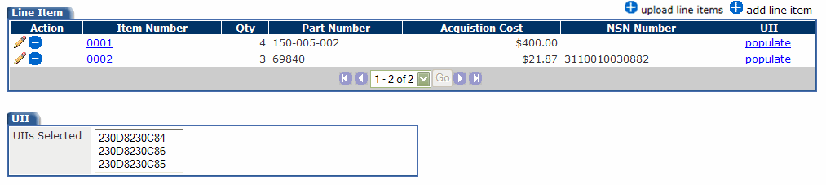
Figure 27: Line Item tab on View Case page
To view the UIIs on an item, click the populate link in the UII column for that item. The UIIs associated with that item are populated in the drop-down list box in the UII section on the View Case page. Note that this feature is only available for items on internal cases.
To add a line item to the case, click the add line item link. The Add Line Item page appears. See the subtopic Adding a Line Item within this topic.
To upload multiple line items to the case, click the upload line items link. The Upload Line Items page appears. See the subtopic Uploading a Line Item within this topic.
To view a line item, click the link on the Item Number. The View Line Item page appears. See the subtopic Viewing a Line Item within this topic.
To edit a line item, click the edit icon in the Action column for the line item. The Edit Line Item page appears. See the subtopic Editing a Line Item within this topic.
To delete a line item, click the delete icon in the Action column for the line item. A dialog box appears asking you to confirm the deletion. Click the OK button on the dialog box. Note: The case is deleted from your workload if the only line item present is deleted.
To recommend that the contractor be held liable for an item on the case, click the liable link next to that item. Note that the liable link does not appear for Contractors. See the topic Finding a Contractor Liable.

Viewing a Line Item
To view a line item, on the View Case page, in the Line Item tab, click the Item Number link for the line item you wish to view. The View Line Item page appears (Figure 28).
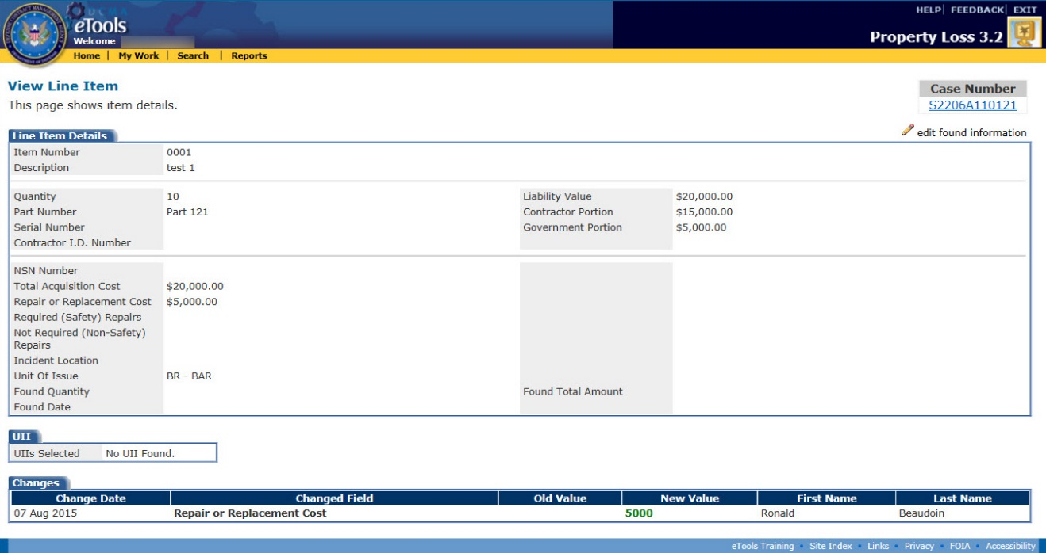
Figure 28: View Line Item page
The Changes section at the bottom of the page displays all the changes that were made to the line item since the case was submitted. It displays the date the change was made, field that was changed, what it was changed from and to, as well as who made the change.
To edit the line item, click the edit found information link. The Edit Line Item page appears. See the subtopic Editing a Line Item within this topic.
To delete a line item, click the delete link. A dialog box appears asking you to confirm the deletion. Click the OK button on the dialog box. Note: The case is deleted from your workload if the only line item present is deleted.
To return to the View Case page, click the link on the case number under the Case Number heading (for cases in Draft status, click the DRAFT link under the Case Number heading). The View Case page appears.

Adding a Line Item
To add a line item to an existing case, do the following:
- On the View Case page, click the add line item link. The Add Line Item page appears (Figure 29 and Figure 30).
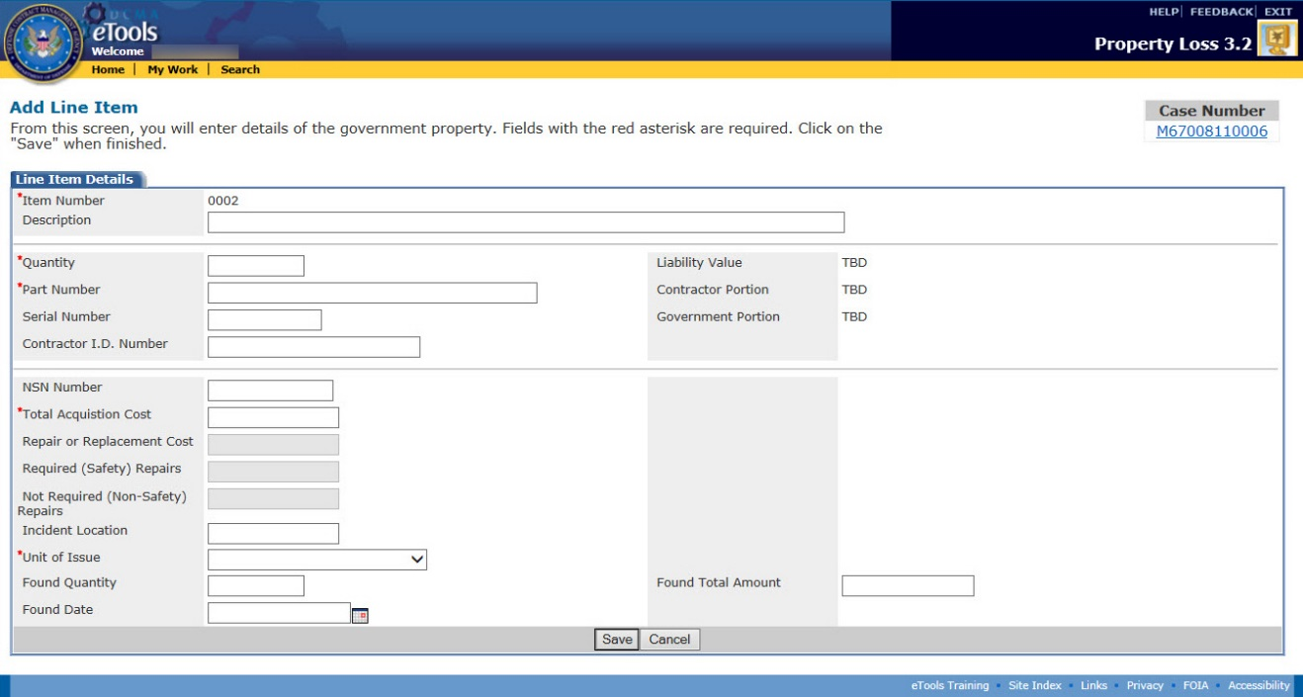
Figure 29: Add Line Item page for external case
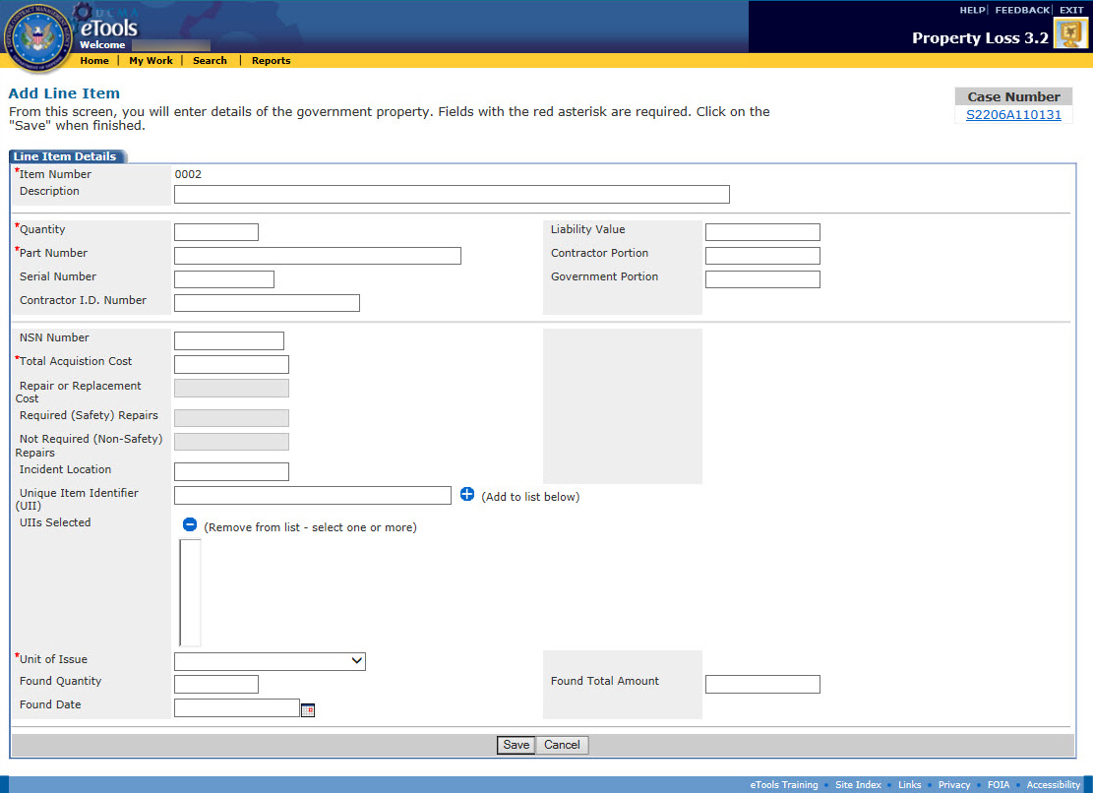
Figure 30: Add Line Item page for internal case
- Type a Description of the item. Note that this field is not required.
- Type the Quantity of the item.
- Type the Part Number of the item.
- Type the Serial Number of the item. Note that this field is not required.
- Type the Contractor I.D. Number of the item. Note that this field is not required.
- Type the National Stock Number (NSN) of the item. Note that this field is not required.
- Type the Total Acquisition Cost of the item.
- If the Repair or Replace options are selected for the case type, then the Repair and Replacement Cost field will be required.
- If the Damaged option is selected for the case type, then the Required (Safety) Repairs and Not Required (Safety) Repairs fields will be required.
Note: The Required (Safety) Repairs and Not Required (Safety) Repairs must equal the Liability Value.
- Type the Incident Location of the item. Note that this field is not required.
- Select the Unit of Issue from the drop-down list box.
- (For internal cases only) Type a Unique Item Identifier (UII) in the UII box and click the add icon to add it to the UIIs Selected box which appears below. Repeat for each UII. A UII cannot exceed 72 characters and the number of UIIs in the list must not exceed the total quantity of items. Click the delete icon next to the UIIs Selected list to remove UIIs. Note that this field is not required.
Note: Unique Item Identifier (UII) information does not display when creating a line item on an external case.
- Type the Liability Value of the items lost, stolen, damaged, destroyed, repairable, or replaceable. Note that this field is not available to the Contractor.
Note: Liability Value, Contractor Portion, and Government Portion are required fields for PAs and Administrators when the case is in Investigating status.
- Type the Contractor Portion of the Liability Value. Note that this field is not available to the Contractor.
- Type the Government Portion of the Liability Value. Note that this field is not available to the Contractor.
- If any part of the item was found, type the quantity found in the Found Quantity text box and the total amount of the found quantity in the Found Total Amount text box.
- Click the calendar icon to select a date from the calendar for the Found Date text box.
Note: You must enter values in the required fields. Required fields are marked with an asterisk (*).
To save the line item to the case, click the Save button.
To return to the Create Case page without saving, click the Cancel button.

Uploading a Line Item
To upload a line item, do the following:
- On the View Case page, click the upload line items link. The Upload Line Items page appears (Figure 31).
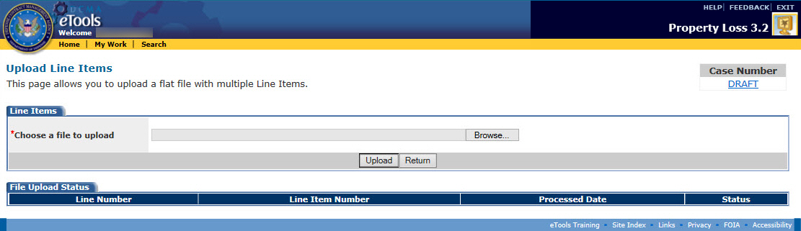
Figure 31: Upload Line Items Page
- Click on the Browse... button to find and select a file. The file must be a CSV file.
- After selecting the file, click the Upload button. The file is now attached to the case.
Note: In order to accurately import the line record items from the spreadsheet, the CSV file must follow the format listed.
- Item Number*
- Description
- Quantity*
- Part Number*
- Serial Number
- Contractor I.D. Number
- Liability Value
- Contractor Portion
- Government Portion
- NSN Number
- Total Acquisition Cost*
- Repair or Replacement Cost
- Required (Safety) Repairs
- Not Required (Safety) Repairs
- Incident Location
- Unique Item Identifier (UII) - comma delimited list
- Unite of Issue*
- Found Quantity
- Found Amount
- Date Found

Editing a Line Item
To edit a line item, do the following:
- On the View Case page, in the Line Item tab, click the edit icon for the line item you wish to edit. The Edit Line Item page appears (Figure 32 and Figure 33).
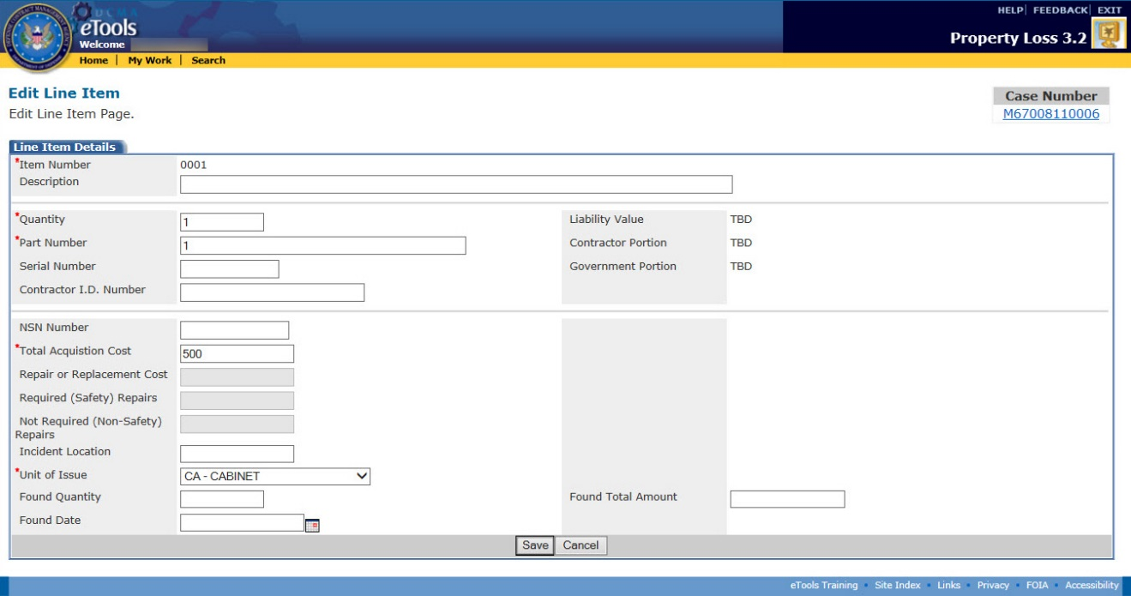
Figure 32: Edit Line Item page for external case
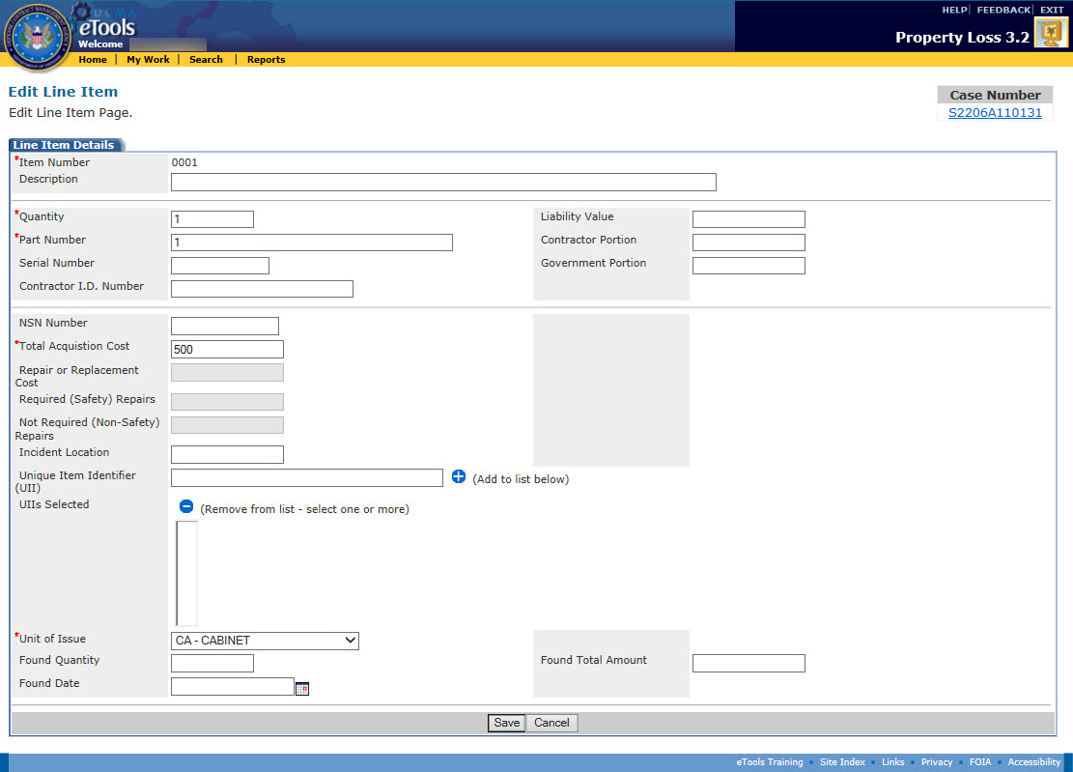
Figure 33: Edit Line Item page for internal case
- Make your desired edits. For explanations of each field on the page, see the subtopic Adding a Line Item within this topic.
Note: Liability Value, Contractor Portion, and Government Portion become required fields for Property Administrators after the case is submitted.
- Click the Save button when finished. The View Line Item page appears and your changes are saved.
To return to the View Case page, click the link on the case number under the Case Number heading (for cases in Draft status, click the DRAFT link under the Case Number heading). The View Case page appears.

Deleting a Line Item
To delete a line item, on the View Case page, in the Line Item tab, click the delete icon for the line item you wish to delete. A dialog box appears asking you to confirm the deletion. Click the OK button on the dialog box.
The case is deleted from your workload if the only line item present is deleted.

Managing Documents on a Case
The cases you can add, edit, or delete documents from depend on your user role:
- Contractors can add documents to or delete documents from cases in Draft or Rejected status that they created. Contractors can submit a request to add documents to or delete documents from a case in Investigating or Pending status.
- Property Administrators can add documents to or delete documents from cases in Draft status, Investigating status, or Pending status; Property Administrators can add documents to cases in Rejected status, but cannot delete documents from cases in Rejected status (Note: Cases in Draft status are editable by PAs whether they've created the cases or have been assigned the cases; cases in other statuses are editable by PAs if they've been assigned the cases).
- Administrators can add or delete documents from any case in any status except Closed.
- ACOs can add documents to or delete documents from cases in Pending status that are assigned to them.
- External Users cannot add or edit documents.
You can view, add, or delete documents from a case by clicking the Documents tab on the View Case page (see the topic Viewing Case Information). The Manage Documents page appears and allows you to view a list of the documents attached to the case (Figure 34).
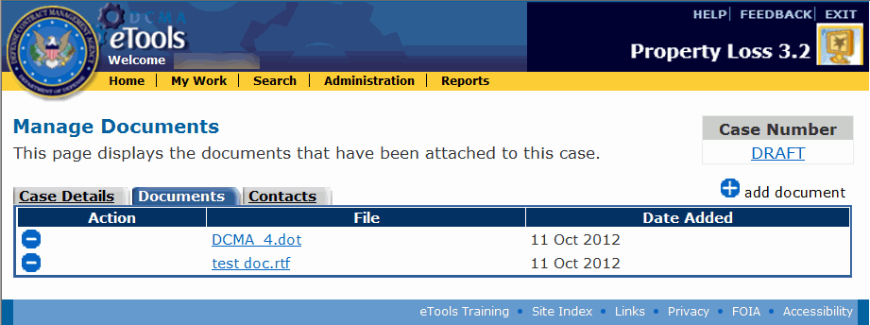
Figure 34: Manage Documents page

Viewing Documents
To view an attached document, do the following:
- On the Manage Documents page, click the link on the document's file name. The File Download window appears.
- Select whether you wish to open the document or save the document to your computer: If you click the Open button, the file download begins and the document will open as soon as the download is complete. If you click the Save button, the Save As window appears and prompts you to select a location to save the file to on your computer before the download begins.

Adding Documents
- Property Administrators can add documents to cases in Draft status (cases they created or cases assigned to them), Investigating status, Pending status, or Rejected status (cases assigned to them).
- Contractors can add documents to cases in Draft or Rejected status that they created.
- Administrators can add documents to any case in any status except Closed.
- ACOs can add documents to cases in Pending status that are assigned to them.
To add a document, do the following:
- On the Manage Documents page, click the add document link. The Add Documents page appears (Figure 35).
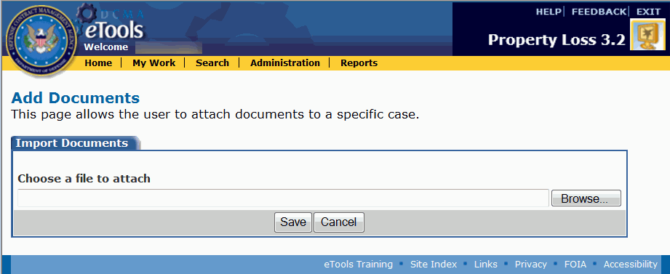
Figure 35: Add Documents page
- Click the Browse button.
- Click the file you wish to attach (acceptable document types include: .doc, .pdf, .xls, .tif, and .jpg). Click the Open button. The file name and path appear in the text box next to the Browse button.
- Click the Save button. The Manage Documents page appears, displaying the file you have attached.

Deleting Documents
- Property Administrators can delete documents from cases in Draft status (cases they've created and cases assigned to them), in Investigating status, and in Pending status (cases assigned to them).
- Contractors can delete documents from cases in Draft or Rejected status that they created, but must submit a request to delete an attachment from a case in Investigating or Pending status.
- Administrators can delete documents from cases in any status except Closed.
- ACOs can delete documents from cases in Pending status that are assigned to them.
To delete an attached document, on the Manage Documents page, click the delete icon for the document you wish to delete. A dialog box appears asking you to confirm the deletion. Click the OK button on the dialog box to delete the document or click the Cancel button to cancel the deletion.
To request the Property Administrator to delete an attached document, on the Manage Documents page, click the request delete link for the document you wish to delete. Property Loss automatically sends an E-Mail message to the Property Administrator assigned to the case to notify him or her of the request (Figure 36).
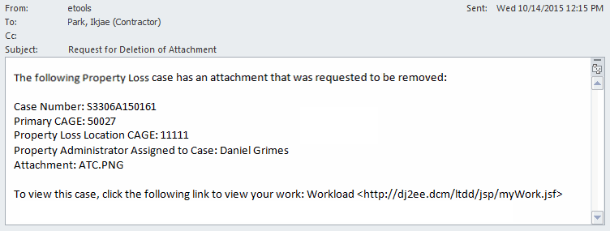
Figure 36: Sample Request for Deletion of Attachment E-Mail

Managing Contacts on a Case
The cases you can add, edit, or delete contacts from depend on your user role:
- Contractors can add, edit, or delete contacts on cases in Draft status that they created; they can add or edit contacts on cases in Rejected status that they created.
- Property Administrators can add or edit contacts on open cases and delete contacts on cases in Draft status (Note: Cases in Draft status are editable by PAs whether they've created the cases or have been assigned the cases; cases in other statuses are editable by PAs if they've been assigned the cases).
- Administrators can add or edit contacts on any open case and can delete contacts from any case in Draft status.
- ACOs cannot add, edit, or delete contacts.
- External Users cannot add, edit, or delete contacts.
You can add, edit, or delete contacts from a case by clicking the Contacts tab on the View Case page (see the topic Viewing Case Information). The Contact Information page appears and allows you to view a list of the contacts assigned to the case (Figure 37).
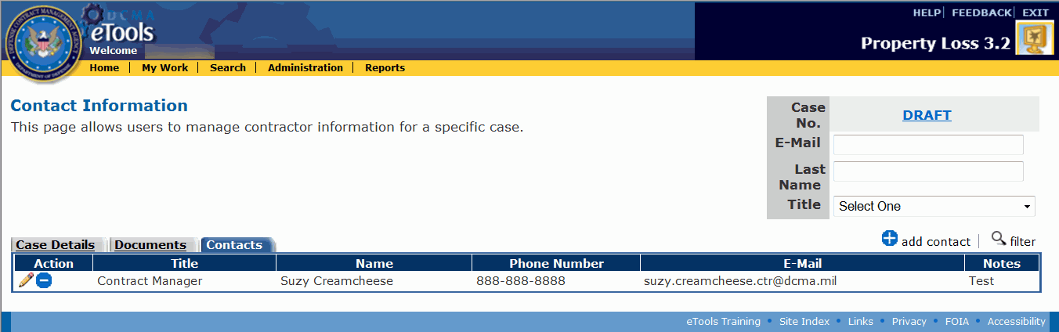
Figure 37: Contact Information of Contractor page
To filter the contacts within a case, type an E-Mail address, Last Name, or select a Title in the corresponding search boxes at the top right corner of the page and click the filter link. The page now displays only the contacts that match the search criteria you entered and all the rest are filtered out.
To clear a filter and display all the contacts, remove any search criteria and click the filter link. The page now displays all the contacts.

Adding Contacts
To add a new contact to the case, do the following:
- On the Contact Information page, click the add contact link. The Add Contact Information page appears (Figure 38).
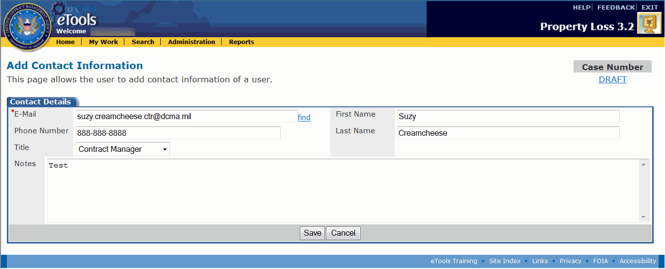
Figure 38: Add Contact Information page
- Type the contact's E-Mail address in the E-Mail text box and click the find link. If the contact is already in the database, his or her information will appear in the remaining boxes. If Property Loss could not find the contact, you will get a message saying that a contact could not be found. You will need to type the contact's information.
- Type any additional information as necessary.
- Click the Save button. The Contact Information page appears, displaying the contact you added.

Editing Contacts
To edit the information for a contact currently on the case, do the following:
- On the Contact Information page, click the edit icon for the contact you wish to edit. The Edit Contact page appears (Figure 39).
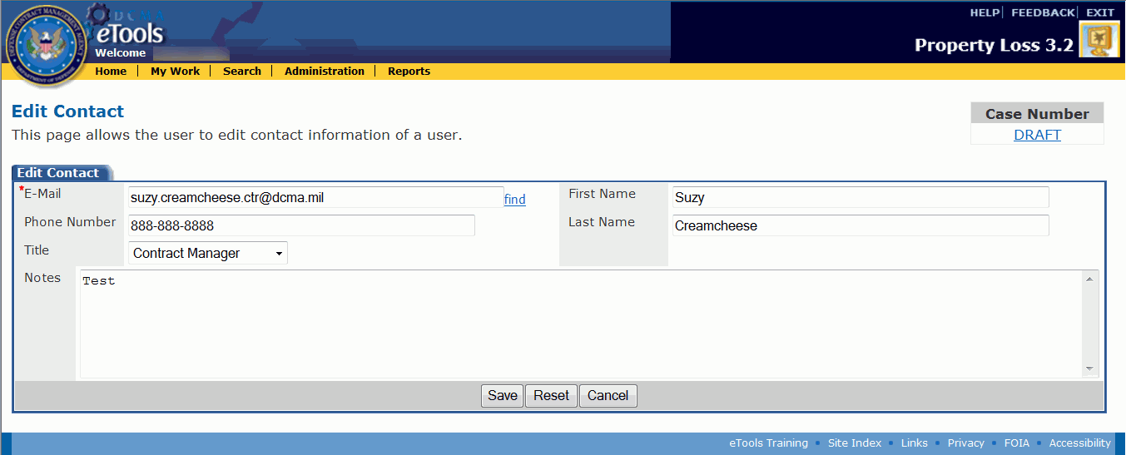
Figure 39: Edit Contact page
- Make your desired edits. Note: You cannot edit the contact's E-Mail address. If you want to edit the E-Mail address, you must delete the contact and create a new one.
- Click the Save button (click the Reset button to undo your edits; click the Cancel button to leave the page without making or saving edits).

Deleting Contacts
To delete a contact from the case, on the Contact Information page, click the delete icon in the Action column for the contact you wish to delete. A dialog box appears asking you to confirm the deletion. Click the OK button on the dialog box to delete the contact or click the Cancel button to cancel the deletion.

Editing a Case
The cases you can edit depend on your user role:
- Contractors can edit cases in Draft or Rejected status that they created. If the case is in Investigating or Pending status, they may edit the Remarks. This allows Contractors to update the case if property is found after the case has been submitted.
- Property Administrators can edit cases that are assigned to them in any status except Closed.
- Administrators can edit any case in any status except Closed.
- ACOs can edit the ACO Comments on cases in Pending status that are assigned to them.
- External Users cannot edit cases.

Editing Cases in Draft or Rejected Status
To edit a case in Draft or Rejected status, click the edit icon in the Action column for the case you wish to edit on the My Work Page or click the edit link on the View Case page (see the topic Viewing Case Information). The Edit Case page appears (Figure 40 and Figure 41).
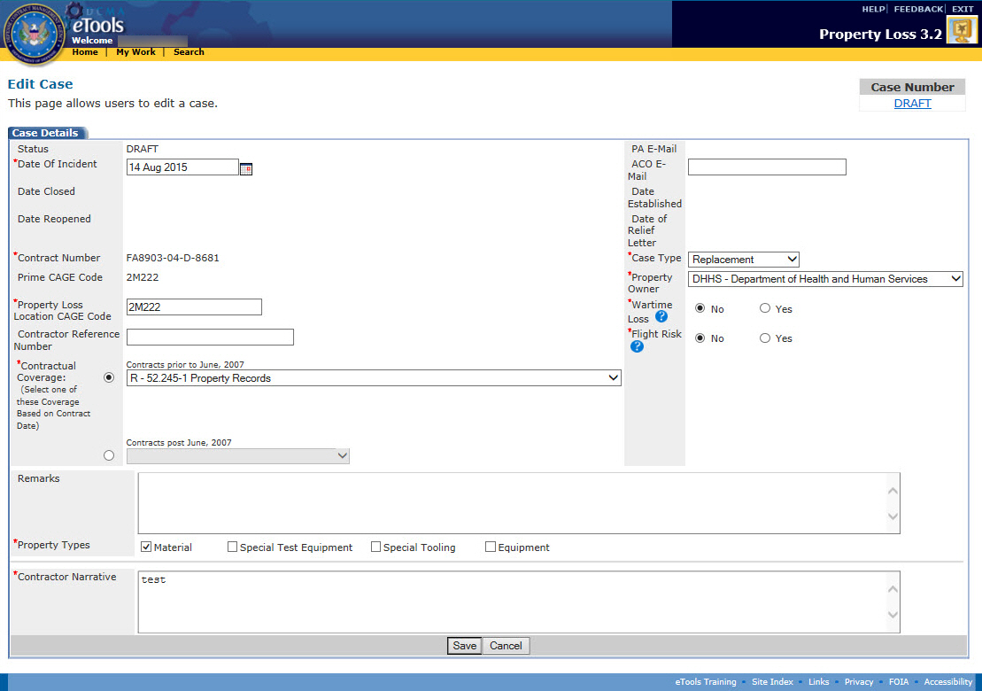
Figure 40: Edit Case page in Draft status for internal case
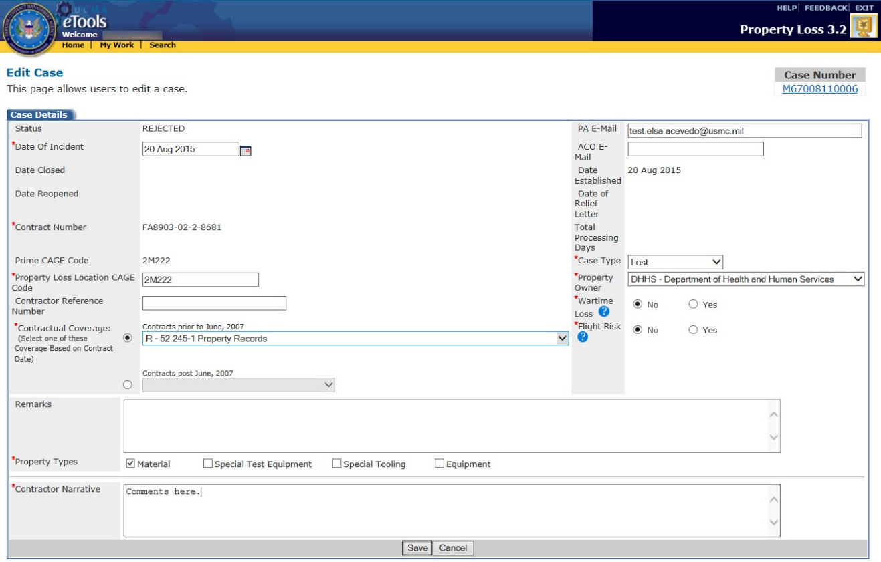
Figure 41: Edit Case page in Rejected status for external case
If the case is external to DCMA, you can edit the PA E-Mail address on the case. If the case is internal to DCMA, you cannot change the PA E-Mail address because the case will be routed automatically to the appropriate Property Administrator based on the contract number, CAGE, and DoDAAC in CMT.
For all cases in Draft or Rejected status, you can edit the following information:
- Date of Incident
- Property Loss Location CAGE Code
- Contractual Coverage
- Remarks
- Property Types
- Contractor Narrative/PA Comments
- ACO E-mail
- Case Type
- Property Owner
- Wartime Loss
- Flight Risk
To save your changes, click the Save button.
To submit the case to the Property Administrator, on the View Case page, click the submit to PA link.

Editing Cases in Investigating or Pending Status
To edit a case in Investigating or Pending status, click the edit icon in the Action column for the case you wish to edit on the My Work Page or click the edit link on the View Case page (see the topic Viewing Case Information). The Edit Case page appears (Figure 42).
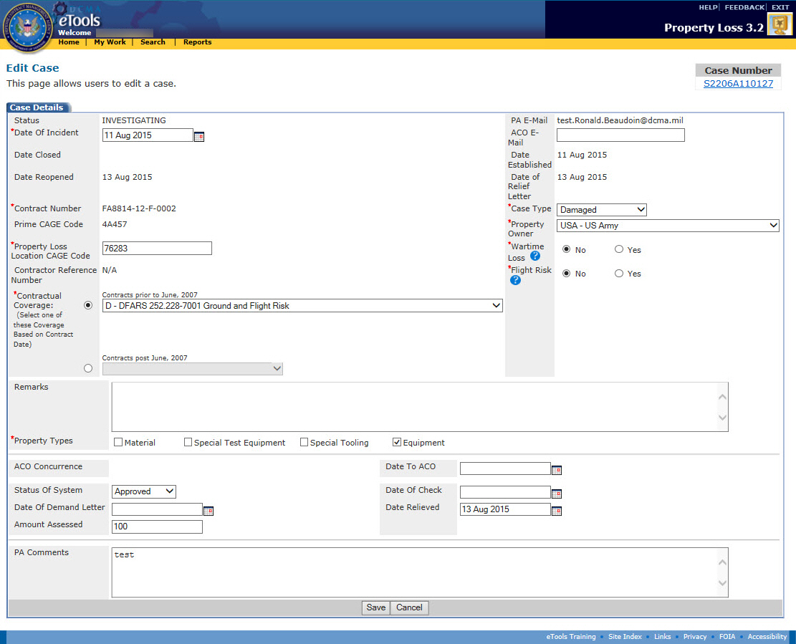
Figure 42: Edit Case page in Investigating status
For all cases in Investigating or Pending status that you created, you may modify the following information:
- Date Of Incident
- Property Loss Location Cage Code
- Contractual Coverage
- Remarks
- Property Types
- Status Of System
- Date Of Demand Letter
- Amount Assessed
- ACO E-mail
- Case Type
- Property Owner
- Wartime Loss
- Flight Risk
- Date To ACO
- Date Of Check
- Date Relieved
- PA Comments
To save your changes, click the Save button.

If the user has entered a dollar amount in Repair or Replacement Cost and then goes back to change the case type to any option other than Repair or Replacement, a message will pop-up indicating "If case type is changed, Repair or Replacement cost will be zero'd out. Do you want to continue?" If the user continues, the dollar amounts will be zero'd out and the case type will be changed. If the user refuses to continue, the dollar amounts will not be zero'd out and the case type will remain as it was (Repair or Replacement) (Figure 43).
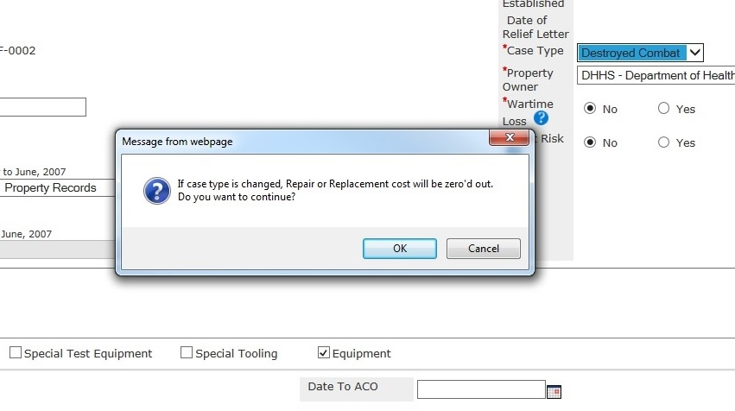
Figure 43: Edit Case Page - Repair and Replacement Cost Change

If the user has entered a dollar amount in Required (Safety) Repairs and then goes back to change the case type to any option other than Damaged, a message will pop-up indicating "If case type is changed, Required (Safety) Repairs and Not Required (Safety) Repairs will be zero'd out. Do you want to continue?" If the user continues, the dollar amounts will be zero'd out and the case type will be changed. If the user refuses to continue, the dollar amounts will not be zero'd out and the case type will remain as it was (Damaged) (Figure 44).
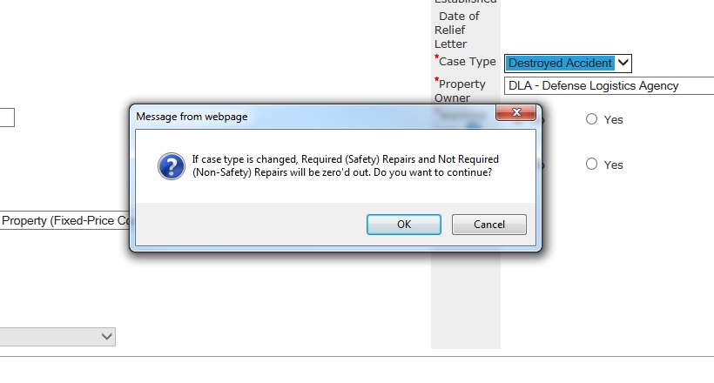
Figure 44: Edit Case Page - Required Repairs and Not Required Repairs Cost Change

Deleting a Case
The cases you can delete depend on your user role:
- Contractors can delete cases in Draft or Rejected status that they created.
- Property Administrators can delete cases in Draft status or in Rejected status.
- Administrators can delete any case in Draft or Rejected status.
- ACOs cannot delete cases.
- External Users cannot delete cases.
You can delete a case from either the My Work Page or the View Case page.
Note: When you delete a case, Property Loss automatically deletes all the line items and documents attached to the case. Contacts associated with the case will be available for reuse by using the Find link on the Add Contact Information page.
To delete a Draft case from the My Work Page, do the following:
- Click the My Work link in the menu bar. The My Work Page appears.
- Click the Draft Cases tab on the My Work Page. The Draft Cases tab is displayed (Figure 45).
Figure 45: My Work Page, Draft Cases tab
- Click the delete icon next to the case you wish to delete. A dialog box appears asking you to confirm the deletion.
- Click the OK button on the dialog box. The case is deleted from your workload.
To delete a Draft case from the View Case page, do the following:
- From the My Work Page, Draft Cases tab, click the view link next to the draft case you wish to delete. The View Case page appears (Figure 46).
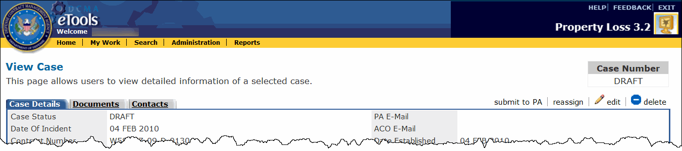
Figure 46: View Case page, top portion only
- Click the delete link. A dialog box appears asking you to confirm the deletion.
- Click the OK button on the dialog box. The case is deleted from your workload.
To delete a Rejected case, do the following:
- Locate the Rejected case you wish to delete (see the topics Viewing the Workload, Searching for Cases, and Viewing Case Information for ways to locate the case).
- On the View Case page, click the delete link. A dialog box appears asking you to confirm the deletion.
- Click the OK button on the dialog box to delete the case.

Rejecting a Case
The cases you can reject depend on your user role:
- Property Administrators can reject cases in Investigating status that are assigned to them.
- Administrators can reject any case in Investigating status.
- ACOs cannot reject cases.
- External Users cannot reject cases.
To reject a case, do the following:
- From the My Work Page, Active Cases tab, click the link on the case number of the case you wish to reject. The View Case page appears (Figure 47).
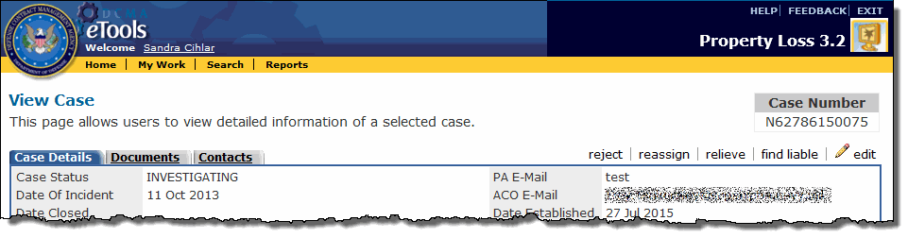
Figure 47: View Case page in Investigating status, top portion only
- Click the reject link on the View Case page. The Reason for Rejection page appears (Figure 48).
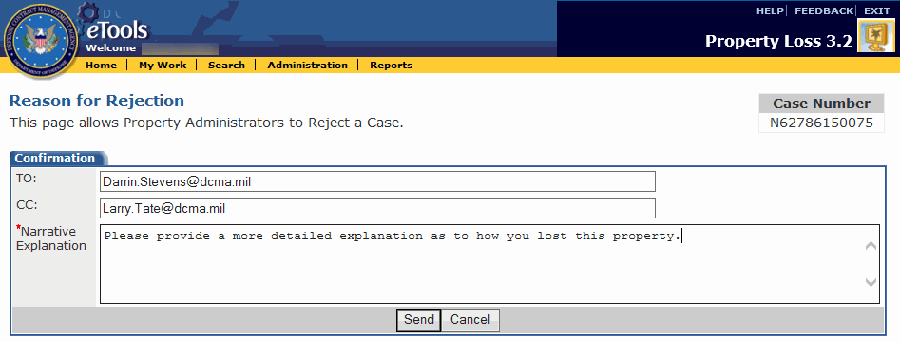
Figure 48: Reason for Rejection page
- Property Loss will automatically send an E-Mail to the person who submitted the case; however, you may type the E-Mail addresses of anyone you wish to receive the rejection E-Mail. Use a semicolon (;) to separate E-Mail addresses.
- Type your reason for rejecting the case in the Narrative Explanation text box.
- Click the Send button. The case's status becomes Rejected and Property Loss automatically sends an E-Mail to the Contractor, as well as anyone else you specified, to let them know the case has been rejected (Figure 49).
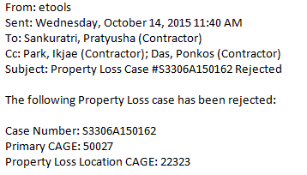
Figure 49: Sample case rejection E-Mail

Withdrawing a Case
The cases you can withdraw depend on your user role:
- Contractors can withdraw cases in Rejected status that they created.
- Property Administrators can withdraw cases in Rejected status that are assigned to them.
- Administrators can withdraw any case in Rejected status.
- ACOs cannot withdraw cases.
- External Users cannot withdraw cases.
To withdraw a case, do the following:
- On the My Work Page, Active Cases tab, click the link on the case number of a Rejected case. The View Case page appears (Figure 50).
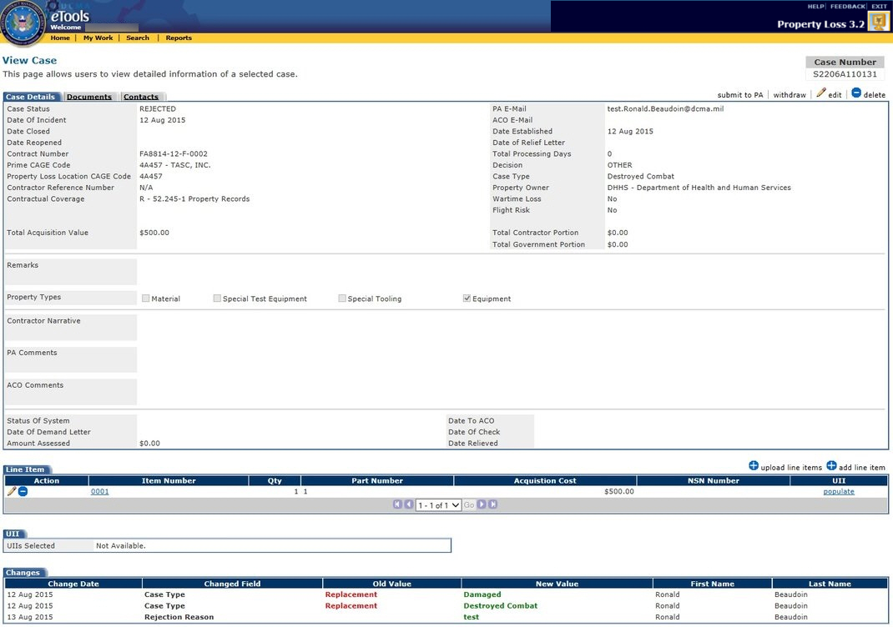
Figure 50: View Case page with Withdraw link available
- Click the withdraw link. The case is now in Closed status. You can find the case under the Inactive Cases tab on the My Work Page.
To request the case to be reopened, see the topic Reopening a Case.
To request the PA to reopen the case for you, see the topic Requesting the PA to Reopen a Case.

Requesting the PA to Reopen a Case
The cases you can reopen depend on your user role:
- Contractors can request to reopen cases in Closed status that they created. Note that these cases must be reopened by the Property Administrator.
- Property Administrators can reopen cases in Closed status that they created or that are assigned to them.
- Administrators can reopen any case in Closed status.
- ACOs cannot reopen cases.
- External Users cannot reopen cases.
To request the Property Administrator to reopen a case, do the following:
- As a Contractor, from the My Work Page, click the Inactive Cases tab to display your closed cases. The Inactive Cases tab is displayed (Figure 51).
Figure 51: My Work Page, Inactive Cases tab
- Click the Reopen link for the case you wish to reopen. The Reopen Request page appears. You will now send a request to the Property Administrator, asking him or her to reopen the case (Figure 52).
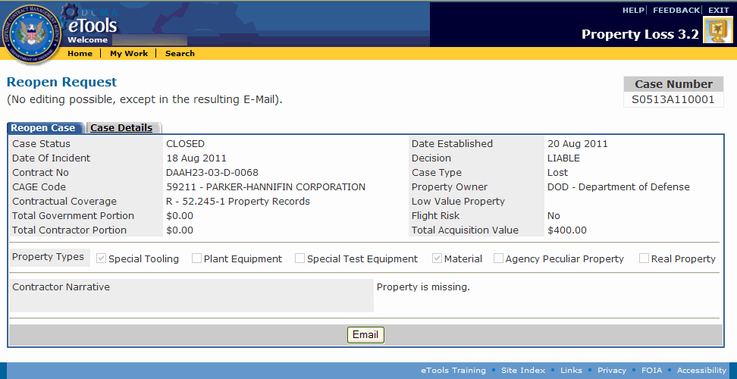
Figure 52: Reopen Request page
- Type a Contractor Narrative on this page, if necessary.
- Click the Email button. The Reason for Reopen page appears where you may type additional explanation for the reopen request (Figure 53).
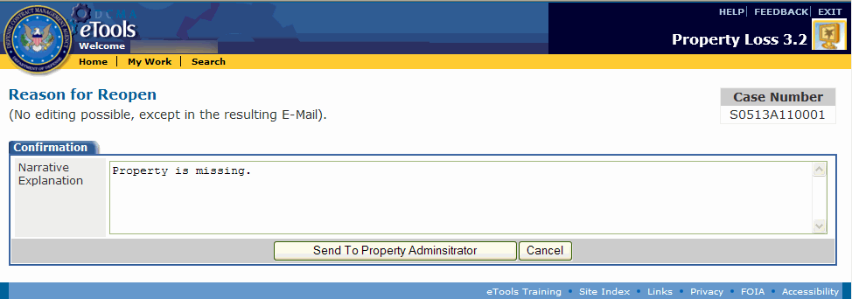
Figure 53: Reason for Reopen page
- Click the Send to Property Administrator button. The Property Administrator assigned to the case receives an E-Mail to notify him or her of the request. The Property Administrator will then need to activate the case through the Edit Case page to switch the case to Investigating status (Figure 54).
Note: When a case is reopened, the date will be stored in the Date Reopened field. The original Date Established will not be changed. If a case is reopened more than once, the first reopened date will be replaced by the new reopen date. All reopened cases will receive a new Date Closed even if there is no change in Liability/Relief.
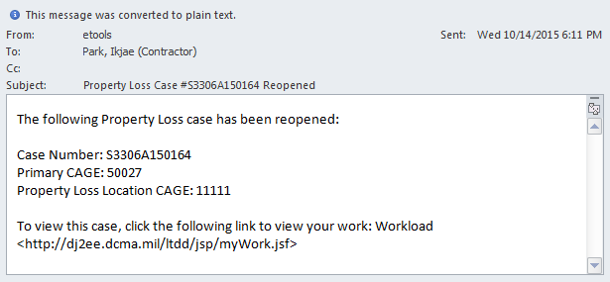
Figure 54: Sample reopen request E-Mail

PA and Administrator Roles

Viewing the Workload
The cases that appear in your workload depend on your user role:
- Property Administrators' workloads display the cases that they created or are assigned to them. For cases they created, they have view-only access. For cases assigned to them, they have the ability to work the case. Property Administrators who are external to DCMA can only receive cases from contractors who are within their own service.
- Contractors' workloads display the cases where their CAGE is identified as the Prime CAGE or Location CAGE.
- Administrators' workloads display all the cases in Property Loss.
- ACOs' workloads display the cases that are assigned to them. The ACO assigned to the case is identified by the ACO Code in MOCAS.
- External Users can access the My Work Page, but active, draft, and inactive cases will not appear for them there.
The My Work Page appears when you click the My Work link on the menu bar and displays your case workload on three tabs: Active Cases, Draft Cases, and Inactive Cases.

Viewing the Active Cases Tab
To view your active cases, click the My Work link on the menu bar. The My Work Page appears, displaying the Active Cases tab by default (Figure 55).
Figure 55: My Work Page, Active Cases tab
The Active Cases tab displays information about your active cases in the following columns:
- Action: Displays the edit icon . The edit icon allows you to edit the case.
- Case Number: The auto-generated number identifying the case in Property Loss. Case numbers follow the following format: the DoDAAC based on the contract number and CAGE in SDW, the last two digits of the calendar year, and a four-digit sequence number.
- Primary CAGE Code: The Primary CAGE of the property.
- Property Loss Location CAGE Code: The Location CAGE of the property.
- Contractor Reference Number: The Contractor Reference Number on the case.
- ACO E-Mail: The E-Mail address of the ACO assigned to the case.
- PA E-Mail: The E-Mail address of the Property Administrator assigned to the case.
- Date Established: The Date Established is populated when the case has been submitted to the PA.
- Status: The status of the case (Investigating, Rejected, Pending, Reopened).
To view the case, click the link on the case number. See the topic Viewing Case Information.
To create a new case, click the create case link. See the topic Creating a New Case.

Viewing the Draft Cases Tab
To view your draft cases, click the Draft Cases tab. The Draft Cases tab is displayed (Figure 56).
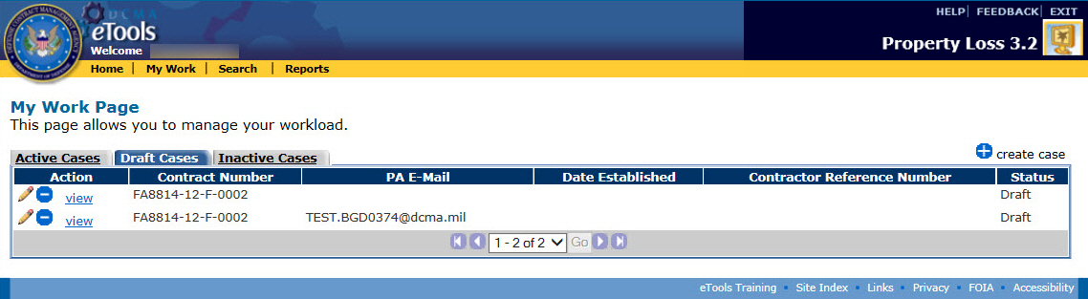
Figure 56: My Work Page, Draft Cases tab
The Draft Cases tab displays information about your draft cases in the following columns:
- Action: Displays the edit icon and the delete icon , as well as the view link. The edit icon allows you to edit and submit the case and the delete icon allows you to delete the case. The view link allows you to view the case.
- Contract Number: The Contract Number on the case.
- PA E-Mail: The E-Mail address of the Property Administrator assigned to the case. Does not display for draft cases that are internal to DCMA.
- Date Established: The Date Established is populated when the case has been submitted to the PA.
- Contractor Reference Number: The Contractor Reference Number on the case.
- Status: The status of the case (Draft).
To view the case, click the view link next to the case you wish to view. See the topic Viewing Case Information.
To create a new case, click the create case link. See the topic Creating a New Case.

Viewing the Inactive Cases Tab
To view your inactive cases, click the Inactive Cases tab. The Inactive Cases tab is displayed (Figure 57).
Figure 57: My Work Page, Inactive Cases tab
The Inactive Cases tab displays information about your closed cases in the following columns:
- Action: Displays the Reopen link, where you can reopen the case. If you are a Property Administrator, see the topic Reopening a Case. If you are a Contractor, see the topic Requesting the PA to Reopen a Case.
- Case Number: The auto-generated number identifying the case in Property Loss. Case numbers follow the following format: the DoDAAC based on the contract number and CAGE in SDW, the last two digits of the calendar year, and a four-digit sequence number.
- Primary CAGE Code: The Primary CAGE of the property.
- Property Loss Location CAGE Code: The Location CAGE of the property.
- Contractor Reference Number: The Contractor Reference Number on the case.
- ACO E-Mail: The E-Mail address of the ACO assigned to the case.
- PA E-Mail: The E-Mail address of the Property Administrator assigned to the case.
- Date Established: The date the case is submitted to the PA.
- Date Closed: The date the case was closed.
- Contract Number: The Contract Number on the case.
- Status: The status of the case (Closed).
To view the case, click the link on the case number. See the topic Viewing Case Information.
To create a new case, click the create case link. See the topic Creating a New Case.

Searching for Cases
The cases you can search for depend on your user role:
- Contractors can search for cases they created, as well as cases where their CAGE is the prime or sub.
- Property Administrators can search for cases that are assigned to them and the cases they created.
- Administrators can search for any cases in Property Loss.
- ACOs cannot search for cases.
- External Users can only search for cases where their DoDAAC is the prime or sub.

Using the Search
To search for cases in Property Loss, do the following:
- Click the Search link on the menu bar. The Property Loss Search page appears (Figure 58).
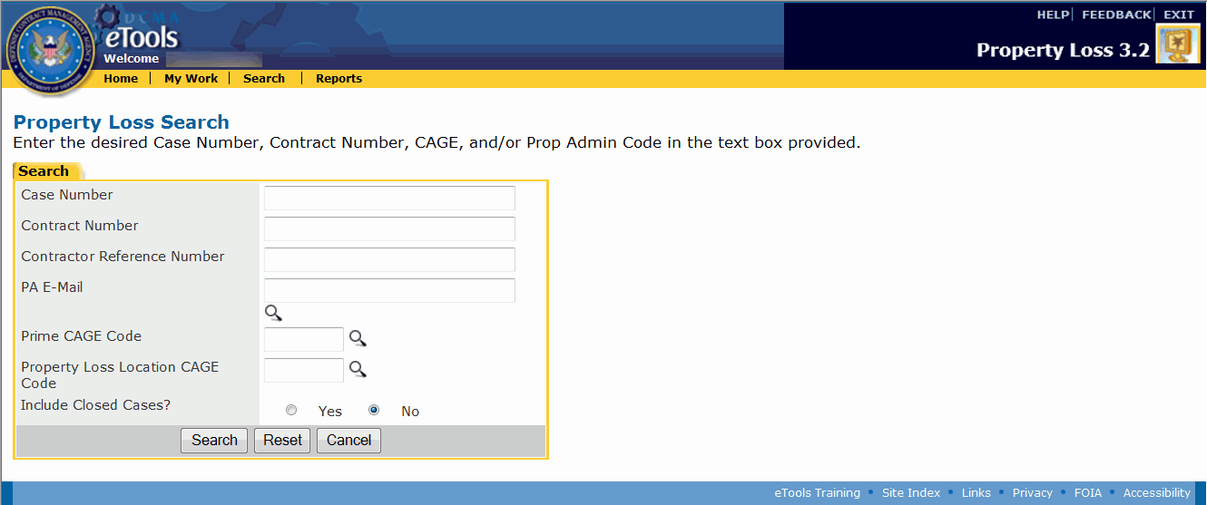
Figure 58: Property Loss Search page
- Type the search criteria necessary to help you find the cases you are looking for. You can type information in none, some, or all of the search fields. The more information you specify, the easier it will be to find your desired cases. If you type information in none of the search fields, the search results will yield all the cases you have access to.
You can also click an option button (Yes or No) to include Closed cases in your search; No is the default option.
Note: If you do not know the Prime CAGE, Location CAGE, or PA E-Mail on the case you are looking for, you can click the icon next to the applicable field to search for a PA E-Mail, Prime CAGE, or Location CAGE. See the subtopics Looking Up the PA E-Mail Address, Looking Up the Prime CAGE, and Looking Up the Location CAGE within this topic.
- Click the Search button. The Search Results page appears, displaying the cases that match the search criteria you entered. If you are PA who is internal to DCMA, only contracts administered by DCMA are included in the search. If you are a PA who is external to DCMA, only contracts not administered by DCMA are included in the search, and your search results are also restricted to contracts within your service (Figure 59).
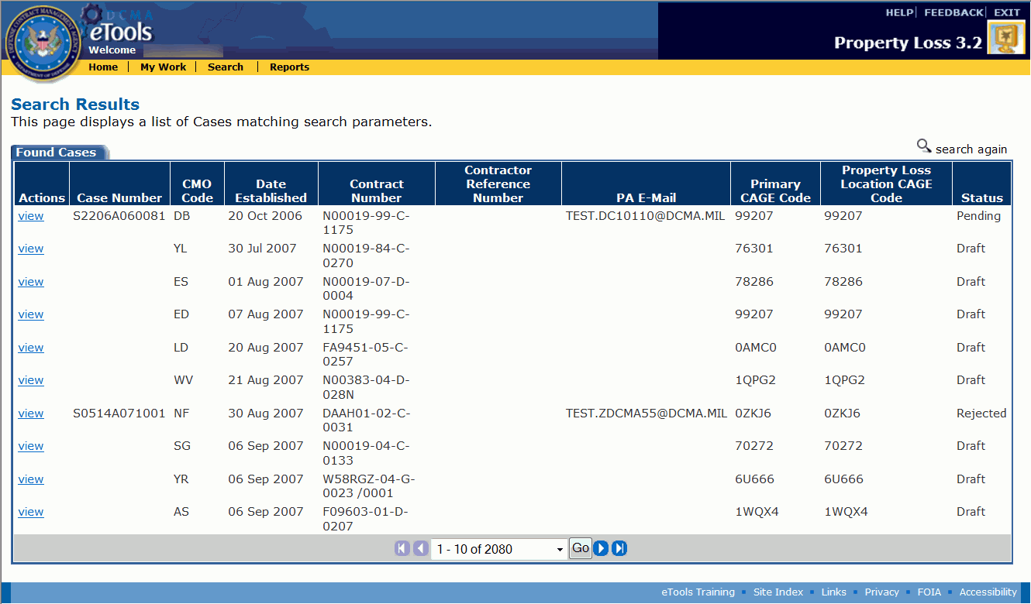
Figure 59: Search Results page
To view a case, click the view link. The View Case page appears.
To search again, click the search again link.

Looking Up the PA E-Mail Address
If you do not know the E-Mail Address of the PA assigned to the case but would like to search for the case based on the assigned PA, you can find the PA's E-Mail address by searching on the PA's first or last name.
To look up the E-Mail address of the PA assigned to the case, do the following:
- Click the icon next to the PA E-Mail field on the Property Loss Search page. The PA E-Mail Search appears in a new window (Figure 60).
Figure 60: PA E-Mail Search window
- Type the PA's First Name or Last Name in the search fields.
- Click the Search button. The search results appear in the same window (Figure 61).
Figure 61: Select PA E-Mail window
- Click the link on the PA E-Mail address if you found the PA you are looking for. The Select PA E-Mail window disappears, and the PA's E-Mail address is populated in the PA E-Mail field on the Property Loss Search page.
To search for another PA E-Mail address, click the search link within the Select PA E-Mail window.
To close the Select PA E-Mail window without selecting an E-Mail address, click the close link.
- Type additional search criteria if you wish.
- Click the Search button. The Search Results page appears.
To view a case, click the view link. The View Case page appears.

Looking Up the Prime CAGE
If you do not know the prime CAGE on the case but would like to search for the case based on the prime CAGE, you can find the prime CAGE by searching on the DoDAAC, Company Name, or ZIP Code.
To look up the prime CAGE on the case, do the following:
- Click the icon next to the Prime CAGE Code field on the Property Loss Search page. The Prime CAGE Search appears in a new window (Figure 62).
Figure 62: Prime CAGE Search window
- Type the DoDAAC, Company Name, or ZIP Code in the search fields.
- Click the Search button. The search results appear in the same window (Figure 63).
Figure 63: Select Prime CAGE window
- Click the link on the CAGE if you found the CAGE you are looking for. The Select Prime CAGE Code window disappears, and the prime CAGE is populated in the Prime CAGE Code field on the Property Loss Search page.
To search for another prime CAGE, click the search link within the Select Prime CAGE Code window.
To close the Select Prime CAGE Code window without selecting a prime CAGE, click the close link.
- Type additional search criteria if you wish.
- Click the Search button. The Search Results page appears.
To view a case, click the view link. The View Case page appears.

Looking Up the Location CAGE
If you do not know the location CAGE on the case but would like to search for the case based on the location CAGE, you can find the location CAGE by searching on the DoDAAC, Company Name, or ZIP Code.
To look up the location CAGE on the case, do the following:
- Click the icon next to the Property Loss Location CAGE Code field on the Property Loss Search page. The Location CAGE Search appears in a new window (Figure 64).
Figure 64: Location CAGE Search window
- Type the DoDAAC, Company Name, or ZIP Code in the search fields.
- Click the Search button. The search results appear in the same window (Figure 65).
Figure 65: Select Location CAGE window
- Click the link on the CAGE if you found the CAGE you are looking for. The Select Location CAGE Code window disappears, and the location CAGE is populated in the Property Loss Location CAGE Code field on the Property Loss Search page.
To search for another location CAGE, click the search link within the Select Location CAGE Code window.
To close the Select Location CAGE Code window without selecting a location CAGE, click the close link.
- Type additional search criteria if you wish.
- Click the Search button. The Search Results page appears.
To view a case, click the view link. The View Case page appears.

Creating a New Case
Contractors, Property Administrators, and Administrators can create new cases in Property Loss.
There are three steps to creating a new case: Entering Case Information, Adding Line Items, and Submitting the Case. You may also add documents and contacts to the case.

Entering Case Information
The first step in creating a Property Loss case is entering basic contract data and general information regarding the property that was lost, stolen, damaged, destroyed, repairable, or replaceable.
To create a new case in Property Loss, do the following:
- Click either the Create a New Case link on the Home Page or the create case link on the My Work Page. The Create Case page appears (Figure 66 and Figure 67).
Figure 66: Create Case page for Contractor or External PA
Figure 67: Create Case page for Internal PA
- Contractors and Property Administrators who are external to DCMA are required to select whether or not the case is administered by DCMA by clicking one of the option buttons.
  - If the case is NOT administered by DCMA, you will need to type the E-Mail address of the Property Administrator for the contract in the Property Administrator E-Mail field. You can only submit cases to Property Administrators within your own service.
  - If the case is administered by DCMA, the Property Administrator E-Mail field becomes disabled and you will not be able to specify a Property Administrator. Instead, Property Loss automatically routes the case to the appropriate Property Administrator based on the contract number, CAGE, and DoDAAC in CMT.
- Select the Date of Incident. Click the calendar icon to select the date from a calendar.
- Type the Contract Number. If the case is administered by DCMA, Property Loss will validate the contract number in MOCAS. If Property Loss cannot find the contract number in MOCAS, you will receive an error message.
- Type the Prime CAGE Code of the contractor. This CAGE must have a current MOCAS record and includes international CAGEs. When you create the case, Property Loss will validate the CAGE you entered against the contract number. If the CAGE is incorrect, Property Loss will automatically replace it with the correct CAGE in SDW.
- Type the Property Loss Location CAGE Code of the property.
- Type the Contractor Reference Number. Note that this field is not required.
- Select a Contractual Coverage based on the contract date. Use the first drop-down list box for contracts prior to June 2007 and the second drop-down list box for contracts post June 2007.
- Select the applicable Property Types by clicking the check boxes. Options include: Material, Special Test Equipment, Special Tooling, and Equipment.
- Select a Case Type from the drop-down list box. Options include: Lost, Damaged, Theft, Destroyed Accident, Destroyed Combat, Repair, or Replacement.
- Select a Property Owner from the drop-down list box.
- Select whether the property is a Wartime Loss by clicking one of the option buttons. The default value is No.
- Select whether the property is a Flight Risk by clicking one of the option buttons. The default value is No.
- Type a Contractor Narrative or PA Comments in the text box at the bottom.
Note: You must enter values in the required fields. Required fields are marked with an asterisk (*).
To save the case information and continue creating the case, click the Save and Continue button.

Adding Line Items
The second step in creating a Property Loss case is adding one or more line items to the case. Note that the case must have at least one line item before you can submit it.
To add a line item, do the following:
- Finish entering values in all the required fields on the Create Case page and click the Save and Continue button. The Add Line Item page appears (Figure 68 and Figure 69).
Figure 68: Add Line Item page for external case
Figure 69: Add Line Item page for internal case
- Type a Description of the item. Note that this field is not required.
- Type the Quantity of the item.
- Type the Part Number of the item.
- Type the Serial Number of the item. Note that this field is not required.
- Type the Contractor I.D. Number of the item. Note that this field is not required.
- Type the National Stock Number (NSN) of the item. Note that this field is not required.
- Type the Total Acquisition Cost of the item.
- If the Repair or Replace options are selected for the case type, then the Repair and Replacement Cost field will be required.
- If the Damaged option is selected for the case type, then the Required (Safety) Repairs and Not Required (Safety) Repairs fields will be required.
Note: The Required (Safety) Repairs and Not Required (Safety) Repairs must equal the Liability Value.
- Type the Incident Location of the item. Note that this field is not required.
- Select the Unit of Issue from the drop-down list box.
- (For internal cases only) Type a Unique Item Identifier (UII) in the UII box and click the add icon to add it to the UIIs Selected box which appears below. Repeat for each UII. A UII cannot exceed 72 characters and the number of UIIs in the list must not exceed the total quantity of items. Click the delete icon next to the UIIs Selected list to remove UIIs. Note that this field is not required.
Note: Unique Item Identifier (UII) information does not display when creating a line item on an external case.
- Type the Liability Value of the items lost, stolen, damaged, destroyed, repairable, or replaceable. Note that this field is not available to the Contractor.
Note: Liability Value, Contractor Portion, and Government Portion are required fields for PAs and Administrators when the case is in Investigating status.
- Type the Contractor Portion of the Liability Value. Note that this field is not available to the Contractor.
- Type the Government Portion of the Liability Value. Note that this field is not available to the Contractor.
- If any part of the item was found, type the quantity found in the Found Quantity text box and the total amount of the found quantity in the Found Total Amount text box.
- Click the calendar icon to select a date from the calendar for the Found Date text box.
Note: You must enter values in the required fields. Required fields are marked with an asterisk (*).
To add another item to the case, click the Add Another Item button.
To save the item and continue to the View Case page, click the Save button.
To upload multiple line items to the case, click the upload line items link. The Upload Line Items page appears. See the subtopic Uploading a Line Item.
To add documents to the case, on the View Case page, click the Documents tab (see the topic Managing Documents on a Case).
To add contacts to the case, on the View Case page, click the Contacts tab (see the topic Managing Contacts on a Case).
To return to the View Case page without saving, click the Cancel button.

Submitting the Case
The third step in creating a Property Loss case is submitting the case. Note that the case must have at least one line item before you can submit it.
To submit the case, do the following:
- Finish entering values in the required fields and click the Save button on the Add Line Item page (or, if you are not on the Add Line Item Page, click the Case Details tab). The View Case page appears displaying the case in Draft status (Figure 70).
Figure 70: View Case page in Draft status
- Click the submit to PA link. Once you submit the case, Property Loss automatically sends an E-Mail to the person who submitted the case as well as the Property Administrator assigned to the case (Figure 71). The case status is updated to "investigating.”
Figure 71: Sample case submitted E-Mail

Viewing Case Information
The cases you can view depend on your user role:
- Contractors view the cases they created, as well as cases where their CAGE is the prime or sub.
- Property Administrators can view the cases that are assigned to them and the cases they created.
- Administrators can view any cases in Property Loss.
- ACOs can view the cases assigned to them.
- External Users can only view cases where their DoDAAC is the prime or sub.
To view a case, do the following:
- Click the My Work link on the menu bar. The My Work Page appears.
- Locate the case on the Active Cases tab, Draft Cases tab, or Inactive Cases tab (click the tab to display the tab; also, see the topic Viewing the Workload or Searching for Cases).
- Click the link on the case number of the case you wish to view (on the Draft Cases tab or Found Cases tab, click the view link). The View Case page appears (Figure 72).
Figure 72: View Case page in Investigating status for an internal PA
The Changes section at the bottom of the page displays all the changes that were made to the case since it was submitted. It displays the date the change was made, field that was changed, what it was changed from and to, as well as who made the change.
Note: The Total Processing Days will be calculated nightly on a calendar basis. It is the number of days between Date Established and Date Closed inclusive. If the case is reopened, start counting again starting from the number of processing days already calculated.

To submit the case to the PA, click the submit to PA link. See the subtopic Submitting the Case within the topic Creating a New Case.
To reject the case, click the reject link. The reject link appears on cases that are assigned to you and in Investigating status. See the topic Rejecting a Case.
To reassign the case, click the reassign link. The reassign link appears only if you are a PA internal to DCMA and the case is assigned to you and in a status other than Rejected or Closed. See the topic Reassigning a Case.
To relieve the case, click the relieve link. The relieve link appears on cases that are assigned to you and in Investigating status. See the topic Relieving a Case.
To recommend the contractor be held liable for the case, click the find liable link. The find liable link appears on cases that are assigned to you and in Investigating status. See the topic Finding a Contractor Liable.
To edit the case, click the edit link. The edit link appears on cases that are assigned to you and are in a status other than Closed. See the topic Editing a Case.
To withdraw the case, click the withdraw link. The withdraw link appears on cases that you created and are in Rejected status. See the topic Withdrawing a Case.
To delete the case, click the delete link. The delete link appears on cases that you created and are in Draft or Rejected status. See the topic Deleting a Case.
To view, add, edit, or delete line items on the case, on the Case Details tab, locate the Line Item tab (see the topic Managing Line Items on a Case).
To view, add, or delete documents attached to the case, click the Documents tab (see the topic Managing Documents on a Case).
To view, add, edit, or delete contacts associated with the case, click the Contacts tab (see the topic Managing Contacts on a Case).

Managing Line Items on a Case
The cases you can add, edit, or delete line items from depend on your user role:
- Contractors can add, edit, or delete line items on cases in Draft or Rejected status.
- Property Administrators can add and delete line items on cases in Draft, Investigating, and Rejected status and edit line items in any status except Closed (Note: Cases in Draft status are editable by PAs if they've created the cases; cases in other statuses are editable by PAs if they've been assigned the cases).
- Administrators can add, edit, or delete line items from any case in any status except Closed.
- ACOs cannot add, edit, or delete line items.
- External Users cannot add, edit, or delete line items.
You can view, add, edit, or delete line items from a case by scrolling down to the Line Item tab on the View Case page, Case Details tab (see the topic Viewing Case Information). The Line Item tab allows you to view a list of the line items on the case (Figure 73).
Figure 73: Line Item tab on View Case page
To view the UIIs on an item, click the populate link in the UII column for that item. The UIIs associated with that item are populated in the drop-down list box in the UII section on the View Case page. Note that this feature is only available for items on internal cases.
To add a line item to the case, click the add line item link. The Add Line Item page appears. See the subtopic Adding a Line Item within this topic.
To upload multiple line items to the case, click the upload line items link. The Upload Line Items page appears. See the subtopic Uploading a Line Item within this topic.
To view a line item, click the link on the Item Number. The View Line Item page appears. See the subtopic Viewing a Line Item within this topic.
To edit a line item, click the edit icon in the Action column for the line item. The Edit Line Item page appears. See the subtopic Editing a Line Item within this topic.
To delete a line item, click the delete icon in the Action column for the line item. A dialog box appears asking you to confirm the deletion. Click the OK button on the dialog box. Note: The case is deleted from your workload if the only line item present is deleted.
To recommend that the contractor be held liable for an item on the case, click the liable link next to that item. Note that the liable link does not appear for Contractors. See the topic Finding a Contractor Liable.

Viewing a Line Item
To view a line item, on the View Case page, in the Line Item tab, click the Item Number link for the line item you wish to view. The View Line Item page appears (Figure 74).
Figure 74: View Line Item page
The Changes section at the bottom of the page displays all the changes that were made to the line item since the case was submitted. It displays the date the change was made, field that was changed, what it was changed from and to, as well as who made the change.
To edit the line item, click the edit found information link. The Edit Line Item page appears. See the subtopic Editing a Line Item within this topic.
To delete a line item, click the delete link. A dialog box appears asking you to confirm the deletion. Click the OK button on the dialog box. Note: The case is deleted from your workload if the only line item present is deleted.
To return to the View Case page, click the link on the case number under the Case Number heading (for cases in Draft status, click the DRAFT link under the Case Number heading). The View Case page appears.

Adding a Line Item
To add a line item to an existing case, do the following:
- On the View Case page, click the add line item link. The Add Line Item page appears (Figure 75 and Figure 76).
Figure 75: Add Line Item page for external case
Figure 76: Add Line Item page for internal case
- Type a Description of the item. Note that this field is not required.
- Type the Quantity of the item.
- Type the Part Number of the item.
- Type the Serial Number of the item. Note that this field is not required.
- Type the Contractor I.D. Number of the item. Note that this field is not required.
- Type the National Stock Number (NSN) of the item. Note that this field is not required.
- Type the Total Acquisition Cost of the item.
- If the Repair or Replace options are selected for the case type, then the Repair and Replacement Cost field will be required.
- If the Damaged option is selected for the case type, then the Required (Safety) Repairs and Not Required (Safety) Repairs fields will be required.
Note: The Required (Safety) Repairs and Not Required (Safety) Repairs must equal the Liability Value.
- Type the Incident Location of the item. Note that this field is not required.
- Select the Unit of Issue from the drop-down list box.
- (For internal cases only) Type a Unique Item Identifier (UII) in the UII box and click the add icon to add it to the UIIs Selected box which appears below. Repeat for each UII. A UII cannot exceed 72 characters and the number of UIIs in the list must not exceed the total quantity of items. Click the delete icon next to the UIIs Selected list to remove UIIs. Note that this field is not required.
Note: Unique Item Identifier (UII) information does not display when creating a line item on an external case.
- Type the Liability Value of the items lost, stolen, damaged, destroyed, repairable, or replaceable. Note that this field is not available to the Contractor.
Note: Liability Value, Contractor Portion, and Government Portion are required fields for PAs and Administrators when the case is in Investigating status.
- Type the Contractor Portion of the Liability Value. Note that this field is not available to the Contractor.
- Type the Government Portion of the Liability Value. Note that this field is not available to the Contractor.
- If any part of the item was found, type the quantity found in the Found Quantity text box and the total amount of the found quantity in the Found Total Amount text box.
- Click the calendar icon to select a date from the calendar for the Found Date text box.
Note: You must enter values in the required fields. Required fields are marked with an asterisk (*).
To save the line item to the case, click the Save button.
To return to the Create Case page without saving, click the Cancel button.

Uploading a Line Item
To upload a line item, do the following:
- On the View Case page, click the upload line items link. The Upload Line Items page appears (Figure 77).
Figure 77: Upload Line Items Page
- Click on the Browse... button to find and select a file. The file must be a CSV file.
- After selecting the file, click the Upload button. The file is now attached to the case.
Note: In order to accurately import the line record items from the spreadsheet, the CSV file must follow the format listed.
- Item Number*
- Description
- Quantity*
- Part Number*
- Serial Number
- Contractor I.D. Number
- Liability Value
- Contractor Portion
- Government Portion
- NSN Number
- Total Acquisition Cost*
- Repair or Replacement Cost
- Required (Safety) Repairs
- Not Required (Safety) Repairs
- Incident Location
- Unique Item Identifier (UII) - comma delimited list
- Unite of Issue*
- Found Quantity
- Found Amount
- Date Found

Editing a Line Item
To edit a line item, do the following:
- On the View Case page, in the Line Item tab, click the edit icon for the line item you wish to edit. The Edit Line Item page appears (Figure 78 and Figure 79).
Figure 78: Edit Line Item page for external case
Figure 79: Edit Line Item page for internal case
- Make your desired edits. For explanations of each field on the page, see the subtopic Adding a Line Item within this topic.
Note: Liability Value, Contractor Portion, and Government Portion become required fields for Property Administrators after the case is submitted.
- Click the Save button when finished. The View Line Item page appears and your changes are saved.
To return to the View Case page, click the link on the case number under the Case Number heading (for cases in Draft status, click the DRAFT link under the Case Number heading). The View Case page appears.

Deleting a Line Item
To delete a line item, on the View Case page, in the Line Item tab, click the delete icon for the line item you wish to delete. A dialog box appears asking you to confirm the deletion. Click the OK button on the dialog box.
The case is deleted from your workload if the only line item present is deleted.

Managing Documents on a Case
The cases you can add, edit, or delete documents from depend on your user role:
- Contractors can add documents to or delete documents from cases in Draft or Rejected status that they created. Contractors can submit a request to add documents to or delete documents from a case in Investigating or Pending status.
- Property Administrators can add documents to or delete documents from cases in Draft status, Investigating status, or Pending status; Property Administrators can add documents to cases in Rejected status, but cannot delete documents from cases in Rejected status (Note: Cases in Draft status are editable by PAs whether they've created the cases or have been assigned the cases; cases in other statuses are editable by PAs if they've been assigned the cases).
- Administrators can add or delete documents from any case in any status except Closed.
- ACOs can add documents to or delete documents from cases in Pending status that are assigned to them.
- External Users cannot add or edit documents.
You can view, add, or delete documents from a case by clicking the Documents tab on the View Case page (see the topic Viewing Case Information). The Manage Documents page appears and allows you to view a list of the documents attached to the case (Figure 80).
Figure 80: Manage Documents page

Viewing Documents
To view an attached document, do the following:
- On the Manage Documents page, click the link on the document's file name. The File Download window appears.
- Select whether you wish to open the document or save the document to your computer: If you click the Open button, the file download begins and the document will open as soon as the download is complete. If you click the Save button, the Save As window appears and prompts you to select a location to save the file to on your computer before the download begins.

Adding Documents
- Property Administrators can add documents to cases in Draft status (cases they created or cases assigned to them), Investigating status, Pending status, or Rejected status (cases assigned to them).
- Contractors can add documents to cases in Draft or Rejected status that they created.
- Administrators can add documents to any case in any status except Closed.
- ACOs can add documents to cases in Pending status that are assigned to them.
To add a document, do the following:
- On the Manage Documents page, click the add document link. The Add Documents page appears (Figure 81).
Figure 81: Add Documents page
- Click the Browse button.
- Click the file you wish to attach (acceptable document types include: .doc, .pdf, .xls, .tif, and .jpg). Click the Open button. The file name and path appear in the text box next to the Browse button.
- Click the Save button. The Manage Documents page appears, displaying the file you have attached.

Deleting Documents
- Property Administrators can delete documents from cases in Draft status (cases they've created and cases assigned to them), in Investigating status, and in Pending status (cases assigned to them).
- Contractors can delete documents from cases in Draft or Rejected status that they created, but must submit a request to delete an attachment from a case in Investigating or Pending status.
- Administrators can delete documents from cases in any status except Closed.
- ACOs can delete documents from cases in Pending status that are assigned to them.
To delete an attached document, on the Manage Documents page, click the delete icon for the document you wish to delete. A dialog box appears asking you to confirm the deletion. Click the OK button on the dialog box to delete the document or click the Cancel button to cancel the deletion.
To request the Property Administrator to delete an attached document, on the Manage Documents page, click the request delete link for the document you wish to delete. Property Loss automatically sends an E-Mail message to the Property Administrator assigned to the case to notify him or her of the request (Figure 82).
Figure 82: Sample Request for Deletion of Attachment E-Mail

Managing Contacts on a Case
The cases you can add, edit, or delete contacts from depend on your user role:
- Contractors can add, edit, or delete contacts on cases in Draft status that they created; they can add or edit contacts on cases in Rejected status that they created.
- Property Administrators can add or edit contacts on open cases and delete contacts on cases in Draft status (Note: Cases in Draft status are editable by PAs whether they've created the cases or have been assigned the cases; cases in other statuses are editable by PAs if they've been assigned the cases).
- Administrators can add or edit contacts on any open case and can delete contacts from any case in Draft status.
- ACOs cannot add, edit, or delete contacts.
- External Users cannot add, edit, or delete contacts.
You can add, edit, or delete contacts from a case by clicking the Contacts tab on the View Case page (see the topic Viewing Case Information). The Contact Information page appears and allows you to view a list of the contacts assigned to the case (Figure 83).
Figure 83: Contact Information of Contractor page
To filter the contacts within a case, type an E-Mail address, Last Name, or select a Title in the corresponding search boxes at the top right corner of the page and click the filter link. The page now displays only the contacts that match the search criteria you entered and all the rest are filtered out.
To clear a filter and display all the contacts, remove any search criteria and click the filter link. The page now displays all the contacts.

Adding Contacts
To add a new contact to the case, do the following:
- On the Contact Information page, click the add contact link. The Add Contact Information page appears (Figure 84).
Figure 84: Add Contact Information page
- Type the contact's E-Mail address in the E-Mail text box and click the find link. If the contact is already in the database, his or her information will appear in the remaining boxes. If Property Loss could not find the contact, you will get a message saying that a contact could not be found. You will need to type the contact's information.
- Type any additional information as necessary.
- Click the Save button. The Contact Information page appears, displaying the contact you added.

Editing Contacts
To edit the information for a contact currently on the case, do the following:
- On the Contact Information page, click the edit icon for the contact you wish to edit. The Edit Contact page appears (Figure 85).
Figure 85: Edit Contact page
- Make your desired edits. Note: You cannot edit the contact's E-Mail address. If you want to edit the E-Mail address, you must delete the contact and create a new one.
- Click the Save button (click the Reset button to undo your edits; click the Cancel button to leave the page without making or saving edits).

Deleting Contacts
To delete a contact from the case, on the Contact Information page, click the delete icon in the Action column for the contact you wish to delete. A dialog box appears asking you to confirm the deletion. Click the OK button on the dialog box to delete the contact or click the Cancel button to cancel the deletion.

Editing a Case
The cases you can edit depend on your user role:
- Property Administrators (PAs) can edit cases in any status except Closed (Note: Cases in Draft status are editable by PAs whether they've created the cases or been assigned the cases; cases in other statuses are editable by PAs if they've been assigned the cases).
- Contractors can edit cases in Draft or Rejected status that they created. If the case is in Investigating or Pending status, they may edit the Remarks. This allows Contractors to update the case if property is found after the case has been submitted.
- Administrators can edit any case in any status except Closed.
- ACOs can edit the ACO Comments on cases in Pending status that are assigned to them.
- External Users cannot edit cases.

Editing Cases in Draft or Rejected Status
To edit a case, click the edit icon in the Action column for the case you wish to edit on the My Work Page or click the edit link on the View Case page (see the topic Viewing Case Information). The Edit Case page appears (Figure 86 and Figure 87).
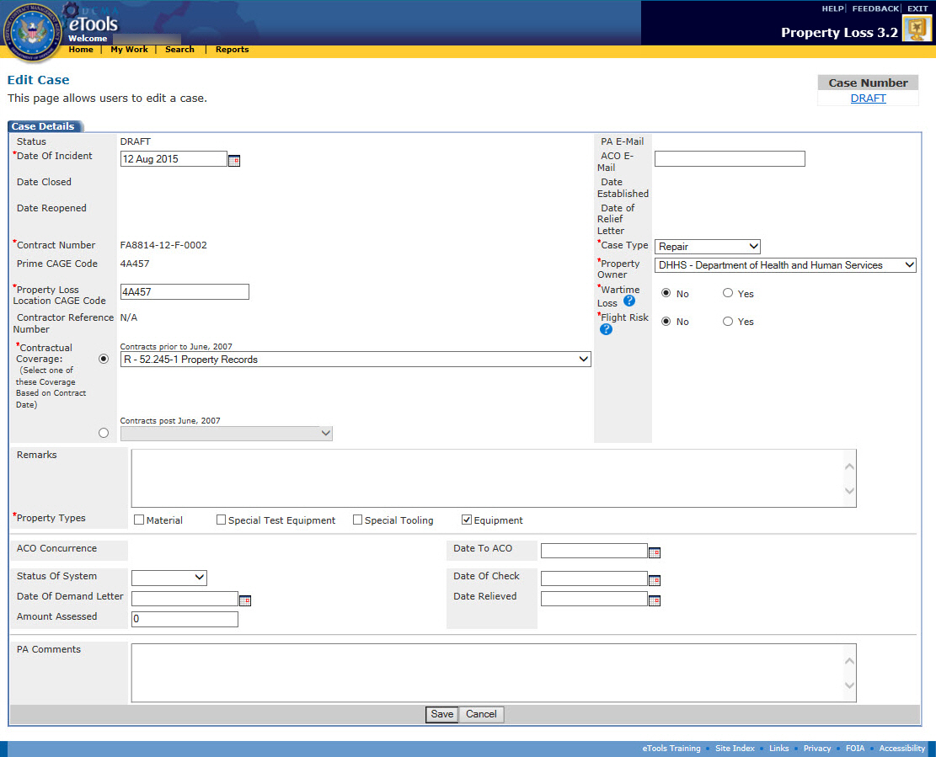
Figure 86: Edit Case page in Draft status for internal case
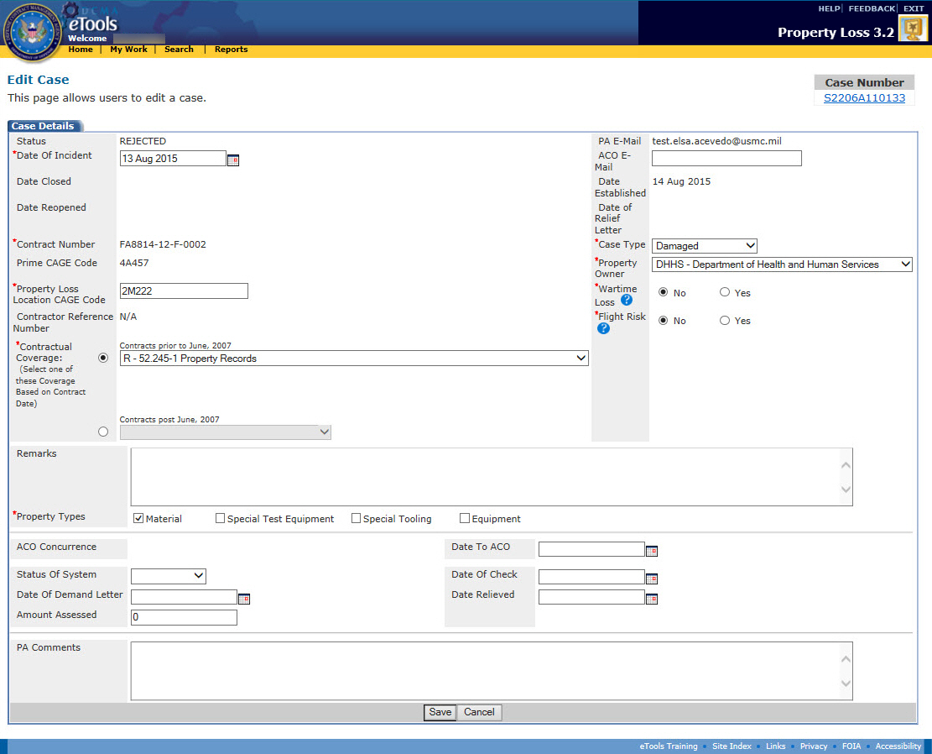
Figure 87: Edit Case page in Rejected status for external case
If the case is external to DCMA, you can edit the PA E-Mail address on the case. If the case is internal to DCMA, you cannot change the PA E-Mail address because the case will be routed automatically to the appropriate PA based on the contract number, CAGE, and DoDAAC in CMT.
Once you have rejected a case, you cannot edit it until it has been submitted back to you.
For all cases in Draft or Rejected status, you can edit the following information:
- Date of Incident
- Property Loss Location CAGE Code
- Contractual Coverage
- Remarks
- Property Types
- ACO E-Mail
- Case Type
- Property Owner
- Wartime Loss
- Flight Risk
- Status of System
- Date of Demand Letter
- Amount Assessed
- Date to ACO
- Date of Check
- Date Relieved
- PA Comments
To save your changes, click the Save button.
To save your changes and move a rejected case into Investigating status, click the Accept button.

Editing Cases in Investigating Status
To edit a case in Investigating status, click the edit icon in the Action column for the case you wish to edit on the My Work Page or click the edit link on the View Case page (see the topic Viewing Case Information). The Edit Case page appears (Figure 88 and Figure 89).
Figure 88: Edit Case page in Investigating status for internal case
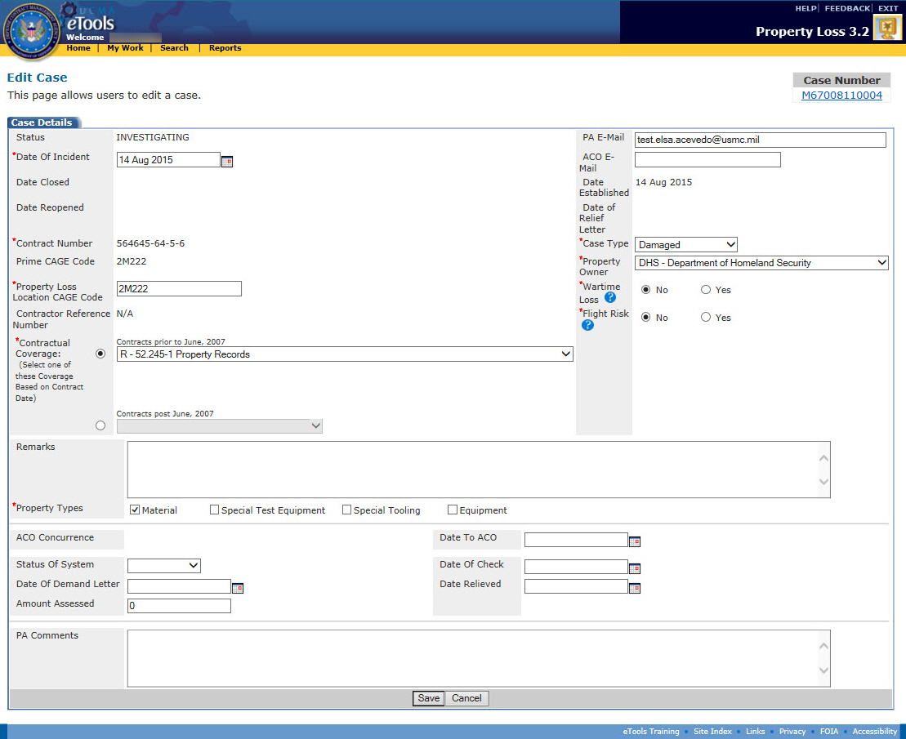
Figure 89: Edit Case page in Investigating status for external case
If the case is external to DCMA, you can edit the PA E-Mail address on the case. If the case is internal to DCMA, you cannot change the PA E-Mail address because the case will be routed automatically to the appropriate PA based on the contract number, CAGE, and DoDAAC in CMT.
For all cases in Investigating status that are assigned to you, you can edit the following information:
- Date of Incident
- Property Loss Location CAGE Code
- Contractual Coverage
- Remarks
- Property Types
- ACO E-Mail
- Case Type
- Property Owner
- Wartime Loss
- Flight Risk
- Status of System
- Date of Demand Letter
- Amount Assessed
- Date of Check
- Date to ACO
- Date Relieved
- PA Comments
To save your changes, click the Save button.

Editing Cases in Pending or Reopened Status
To edit a case in Pending or Reopened status, click the edit icon in the Action column for the case you wish to edit on the My Work Page or click the edit link on the View Case page (see the topic Viewing Case Information). The Edit Case page appears (Figure 90 and Figure 91).
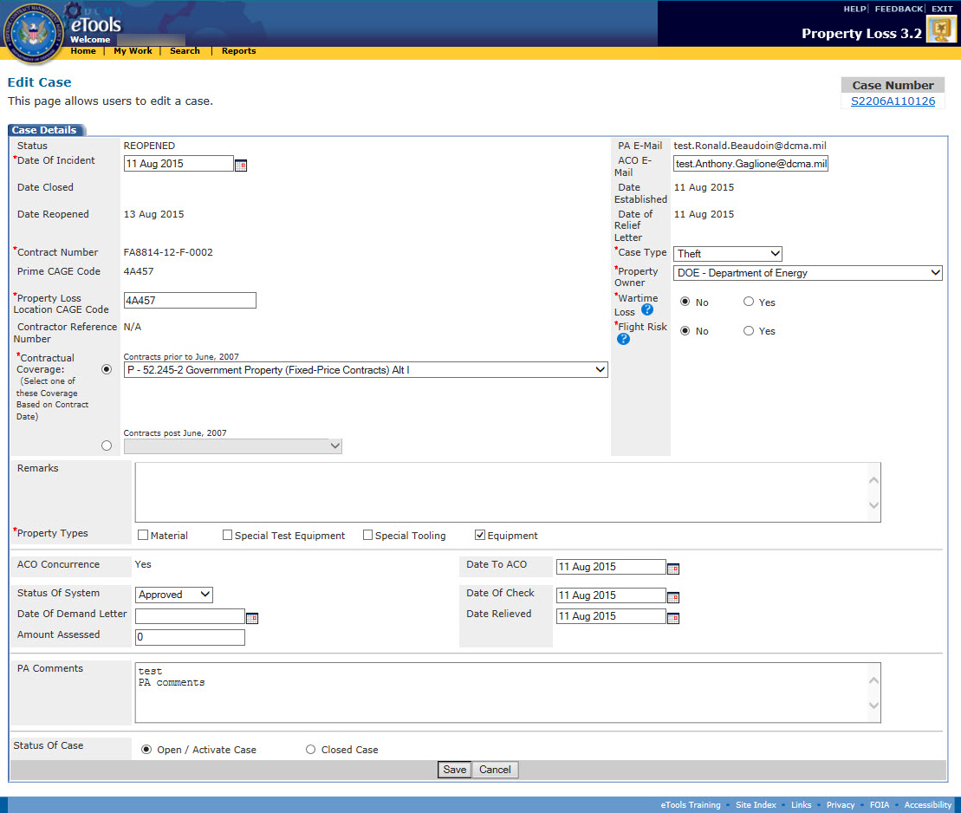
Figure 90: Edit Case page in Reopened status for internal case
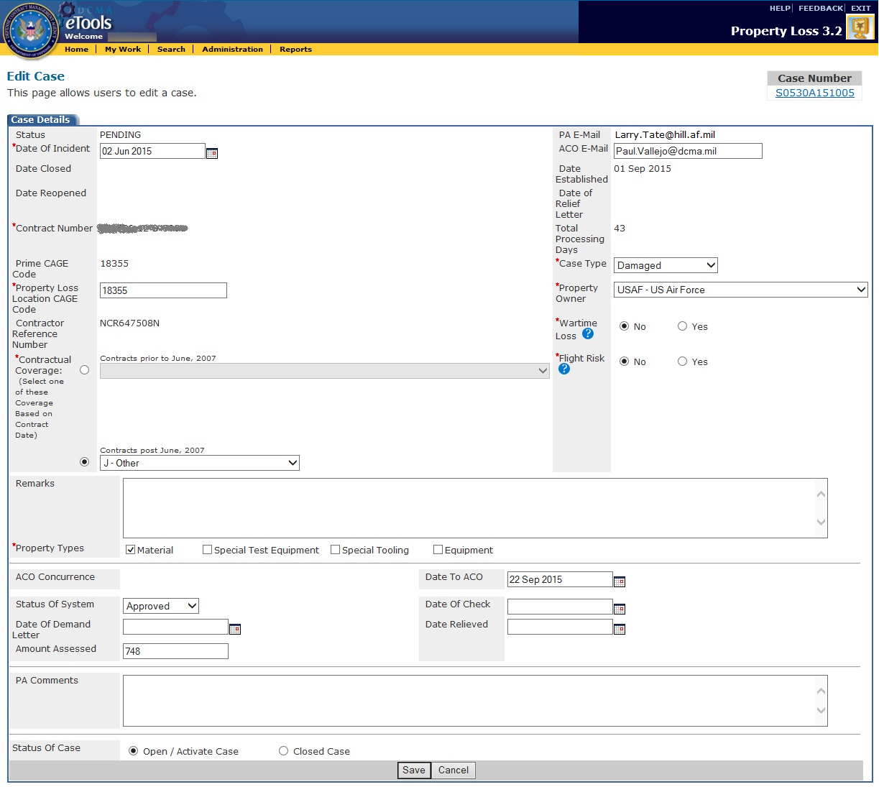
Figure 91: Edit Case page in Pending status for external case
If the case is external to DCMA, you can edit the PA E-Mail address on the case. If the case is internal to DCMA, you cannot change the PA E-Mail address because the case will be routed automatically to the appropriate PA based on the contract number, CAGE, and DoDAAC in CMT.
For all cases in Pending or Reopened status that are assigned to you, you can edit the following information:
- Date of Incident
- Property Loss Location CAGE Code
- Contractual Coverage
- Remarks
- Property Types
- ACO E-Mail
- Case Type
- Property Owner
- Wartime Loss
- Flight Risk
- Status of System
- Date of Demand Letter
- Amount Assessed
- Date to ACO
- Date of Check
- Date Relieved
- PA Comments
- Status of Case

If the user has entered a dollar amount in Repair or Replacement Cost and then goes back to change the case type to any option other than Repair or Replacement, a message will pop-up indicating "If case type is changed, Repair or Replacement cost will be zeroed out. Do you want to continue?" If the user continues, the dollar amounts will be zero'd out and the case type will be changed. If the user refuses to continue, the dollar amounts will not be zeroed out and the case type will remain as it was (Repair or Replacement) (Figure 92).
Figure 92: Edit Case Page - Repair and Replacement Cost Change

If the user has entered a dollar amount in Required (Safety) Repairs and then goes back to change the case type to any option other than Damaged, a message will pop-up indicating "If case type is changed, Required (Safety) Repairs and Not Required (Safety) Repairs will be zeroed out. Do you want to continue?" If the user continues, the dollar amounts will be zeroed out and the case type will be changed. If the user refuses to continue, the dollar amounts will not be zeroed out and the case type will remain as it was (Damaged) (Figure 93).
Figure 93: Edit Case Page - Required Repairs and Not Required Repairs Cost Change

To save your changes, click the Save button.
To close a case in Pending status, see the topic Closing a Case.
To activate a case in Reopened status, see the topic Reopening a Case.
If a new ACO is assigned to the case after the case has been submitted, Property Loss automatically sends an E-Mail to the PA, the formerly assigned ACO (if applicable), and the newly assigned ACO to notify them of the change (Figure 94).
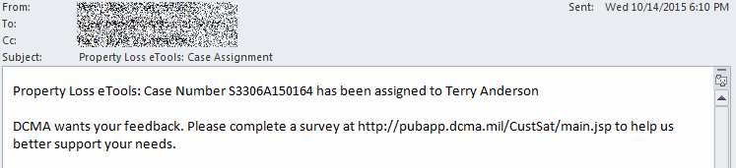
Figure 94: Sample ACO reassignment E-Mail

Deleting a Case
The cases you can delete depend on your user role:
- Contractors can delete cases in Draft or Rejected status that they created.
- Property Administrators can delete cases in Draft status or in Rejected status.
- Administrators can delete any case in Draft or Rejected status.
- ACOs cannot delete cases.
- External Users cannot delete cases.
You can delete a case from either the My Work Page or the View Case page.
Note: When you delete a case, Property Loss automatically deletes all the line items and documents attached to the case. Contacts associated with the case will be available for reuse by using the Find link on the Add Contact Information page.
To delete a Draft case from the My Work Page, do the following:
- Click the My Work link in the menu bar. The My Work Page appears.
- Click the Draft Cases tab on the My Work Page. The Draft Cases tab is displayed (Figure 95).
Figure 95: My Work Page, Draft Cases tab
- Click the delete icon next to the case you wish to delete. A dialog box appears asking you to confirm the deletion.
- Click the OK button on the dialog box. The case is deleted from your workload.
To delete a Draft case from the View Case page, do the following:
- From the My Work Page, Draft Cases tab, click the view link next to the draft case you wish to delete. The View Case page appears (Figure 96).
Figure 96: View Case page, top portion only
- Click the delete link. A dialog box appears asking you to confirm the deletion.
- Click the OK button on the dialog box. The case is deleted from your workload.
To delete a Rejected case, do the following:
- Locate the Rejected case you wish to delete (see the topics Viewing the Workload, Searching for Cases, and Viewing Case Information for ways to locate the case).
- On the View Case page, click the delete link. A dialog box appears asking you to confirm the deletion.
- Click the OK button on the dialog box to delete the case.

Rejecting a Case
The cases you can reject depend on your user role:
- Property Administrators can reject cases in Investigating status that are assigned to them.
- Administrators can reject any case in Investigating status.
- ACOs cannot reject cases.
- External Users cannot reject cases.
To reject a case, do the following:
- From the My Work Page, Active Cases tab, click the link on the case number of the case you wish to reject. The View Case page appears (Figure 97).
Figure 97: View Case page in Investigating status, top portion only
- Click the reject link on the View Case page. The Reason for Rejection page appears (Figure 98).
Figure 98: Reason for Rejection page
- Property Loss will automatically send an E-Mail to the person who submitted the case; however, you may type the E-Mail addresses of anyone you wish to receive the rejection E-Mail. Use a semicolon (;) to separate E-Mail addresses.
- Type your reason for rejecting the case in the Narrative Explanation text box.
- Click the Send button. The case's status becomes Rejected and Property Loss automatically sends an E-Mail to the Contractor, as well as anyone else you specified, to let them know the case has been rejected (Figure 99).
Figure 99: Sample case rejection E-Mail

Reassigning a Case
The cases you can reassign depend on your user role:
- Property Administrators who are internal to DCMA can reassign cases that are assigned to them in any status except Rejected or Closed. Property Administrators who are external to DCMA cannot reassign cases.
- Administrators can reassign any case in any status except Closed.
- Contractors cannot reassign cases.
- External Users cannot reassign cases.
To reassign a case, do the following:
- Locate the case you wish to reassign (see the topics Viewing the Workload, Searching for Cases, and Viewing Case Information for ways to locate the case). The View Case page appears (Figure 100).
Figure 100: View Case page, top portion only
- Click the reassign link on the View Case page (see the topic Reassigning Work). The Reassign Case page appears (Figure 101).
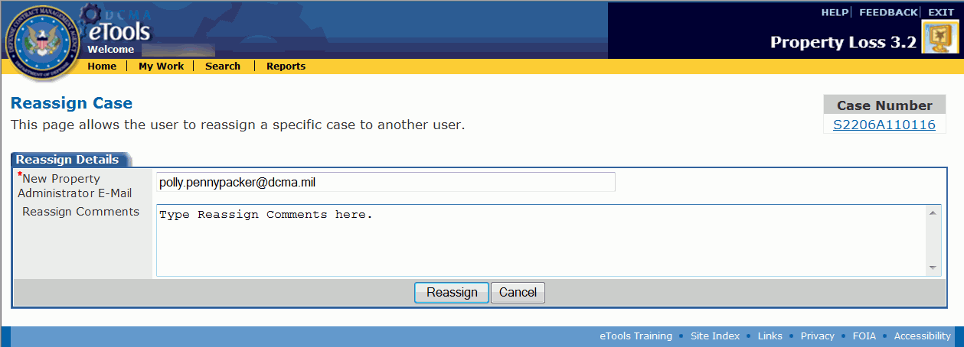
Figure 101: Reassign Case page
- Type the E-Mail address of the PA who will be assigned to take over the case. This must be a valid Property Loss Property Administrator E-Mail address.
- Type any comments you have regarding the case reassignment.
- Click the Reassign button. The case is removed from your workload and will now appear in the workload of the PA who is reassigned to the case. The new PA receives an E-Mail notifying him or her that the case has been reassigned (Figure 102 and Figure 103).
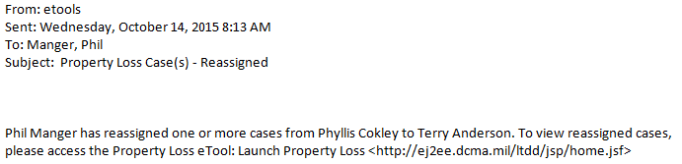
Figure 102: Sample case reassigned E-Mail from ACO
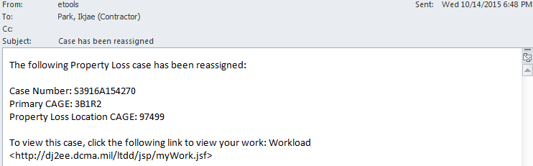
Figure 103: Sample case reassigned E-Mail from PA to PA

Relieving a Case
The Property Administrator can either relieve a case or recommend the contractor be held liable for at least some portion of the case.
The cases you can relieve depend on your user role:
- Property Administrators can relieve cases in Investigating status that are assigned to them.
- Administrators can relieve any case in Investigating status.
- Contractors ACOs, and External Users cannot relieve cases.
To relieve a case, do the following:
- Locate the case you wish to relieve (see the topics Viewing the Workload, Searching for Cases, and Viewing Case Information for ways to locate the case). The View Case page appears (Figure 104).
Figure 104: View Case page in Investigating status, top portion
- Click the relieve link. The Relieve Case (Letter) page appears (Figure 105).
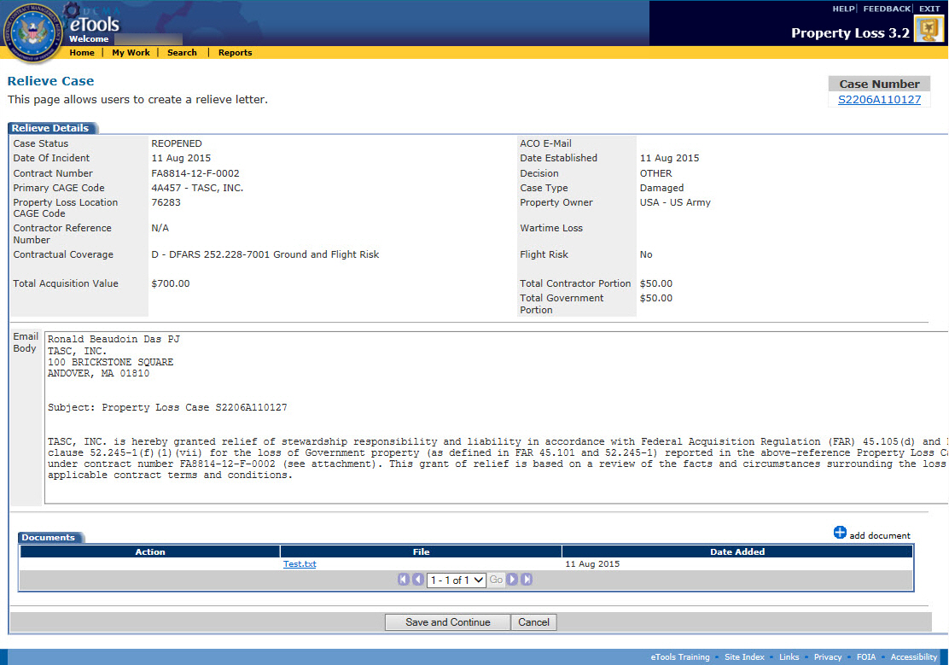
Figure 105: Initiating Letter - Relieve Case Page
- This page generates a letter of relief in the Email Body field. The Email Body may be edited and additional documents may be attached by clicking the add document link under the Email Body.
Note: A copy of the letter will be stored as a PDF file under the Documents tab of the case.
- Click Save and Continue. The Relieve Case page appears (Figure 106).
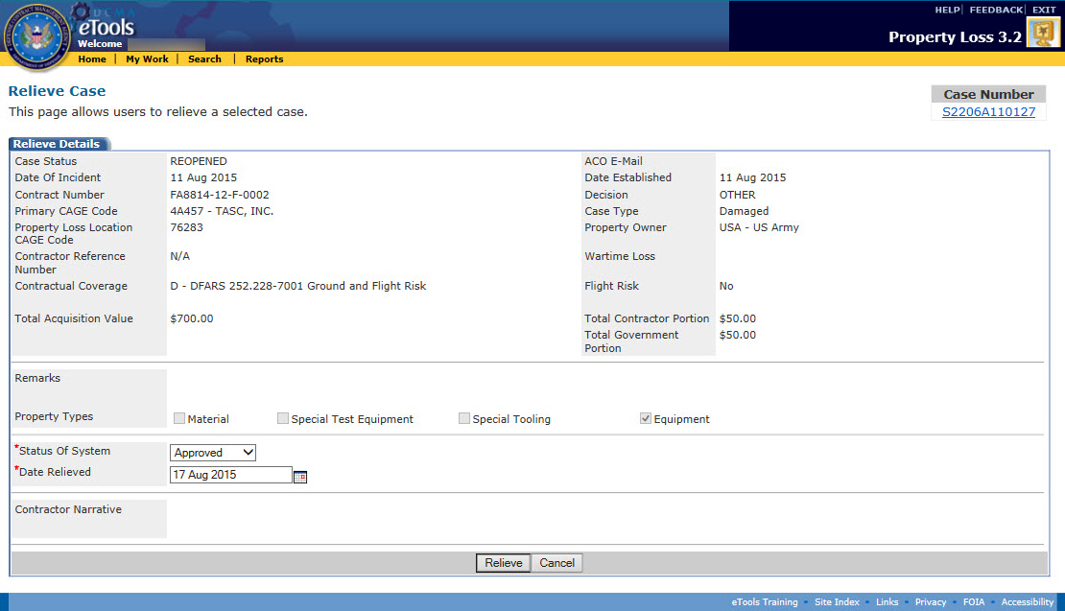
Figure 106: Relieve Case page
- Select the Date Relieved. Click the calendar icon to select the date from a calendar. Click the Relieve Button. The Email Notification page appears (Figure 107).
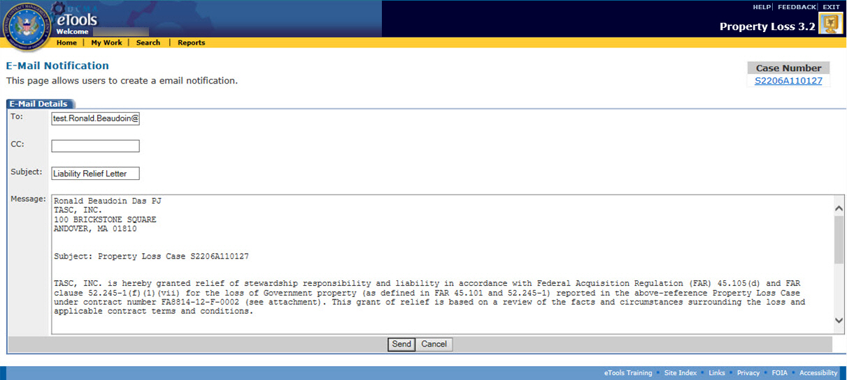
Figure 107: Email Notification page
- The To, Subject, and Message fields are automatically populated. The user may add additional email addresses to the CC field and edit the Message field.
- Click Send to send the letter or cancel to not send it. If letter is not sent, it will still be saved as a PDF in the Documents tab. The case is relieved and is now closed. You can find the case under the Inactive Cases tab on the My Work Page.
To reopen the case as a PA, see the topic Reopening a Case.
To request the PA to reopen the case for you, see the topic Requesting the PA to Reopen a Case.

Finding a Contractor Liable
Once a Contractor submits a case, the Property Administrator or ACO can relieve the case. The Property Administrator may recommend to the ACO that the Contract be held liable. The ACO determines if the Contractor will be liable. The Contractor can be liable for one, some, or all of the items on the case.
The cases you can find liable depend on your user role:
- Property Administrators can recommend to the ACO that the Contractor be held liable for cases in Investigating status that are assigned to them.
- ACOs can find the contractor liable for individual line items on cases in Pending status that are assigned to them.
- Administrators can find the contractor liable for any case in Investigating status.
- Contractors cannot find contractors liable.
- External Users cannot find contractors liable.
To find a contractor liable, do the following:
- Click the My Work link on the menu bar. The My Work page appears.
- Click the link on the case number of the case you wish to view. The View Case page appears (Figure 108).
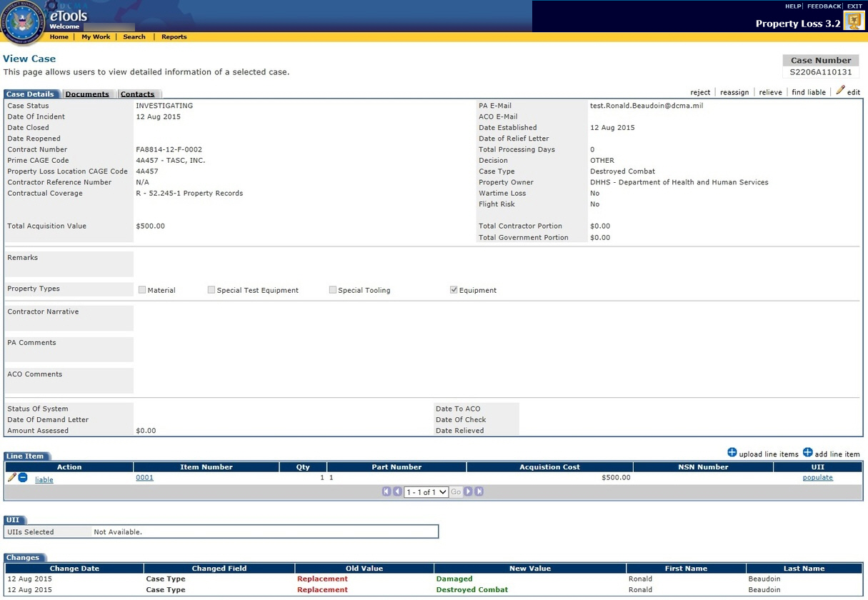
Figure 108: View Case page in Investigating status
To input the liability amount, contractor portion, and government portion, do the following:
- Scroll down to the Line Items section on the View Case page.
- Click the liable link next to the line item for which the Contractor is liable. The Find Liable page appears for that line item (Figure 109).
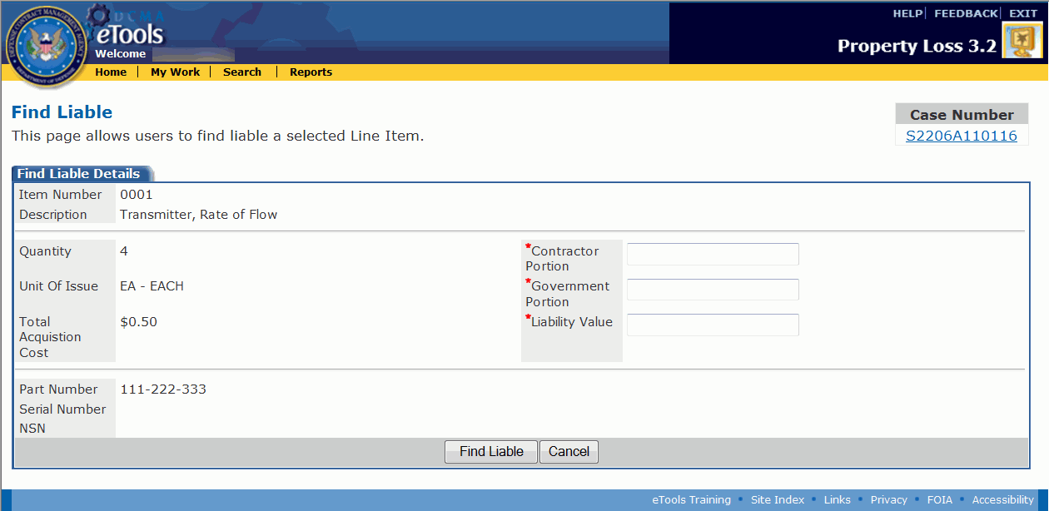
Figure 109: Find Liable page
- Type the total Liability Value. The Contractor Portion and the Government Portion must add up to the Liability Value.
- Type the Contractor Portion.
- Type the Government Portion.
- Click the Submit button. The View Case page appears.
- Repeat steps 1-6 for any other line items on the case for which the Contractor is liable.
To notify the contractor and ACO of the decision, do the following:
- Click the find liable link on the View Case page. The Find Liable Case page appears (Figure 110).
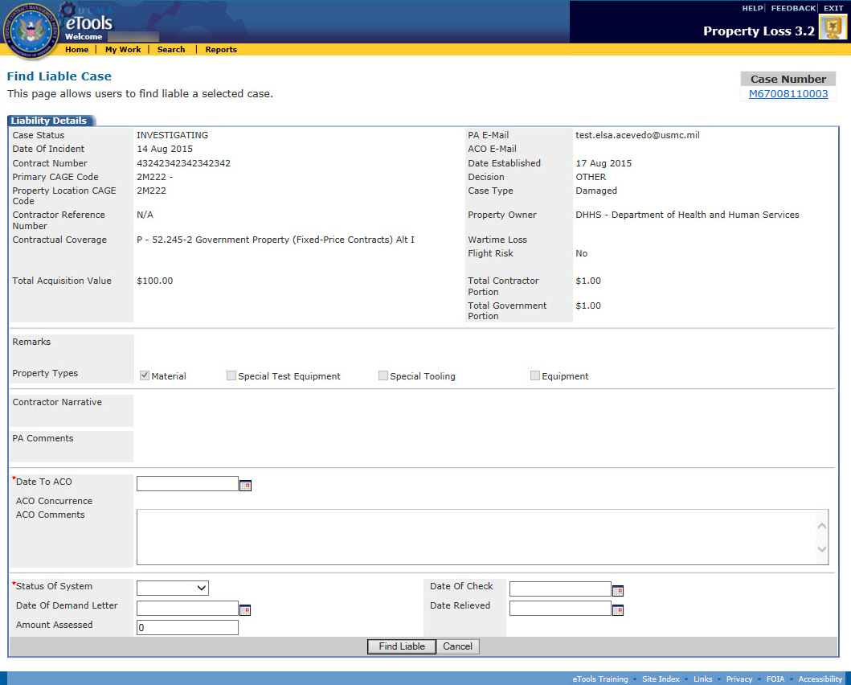
Figure 110: Find Liable Case page
- Click the calendar icon to select a date for the Date to ACO text box.
- Click the Status of System drop down box to select a status.
- Type remarks regarding the decision in the ACO Comments text box. Click the Find Liable button. The Email Notification page will open (Figure 111).
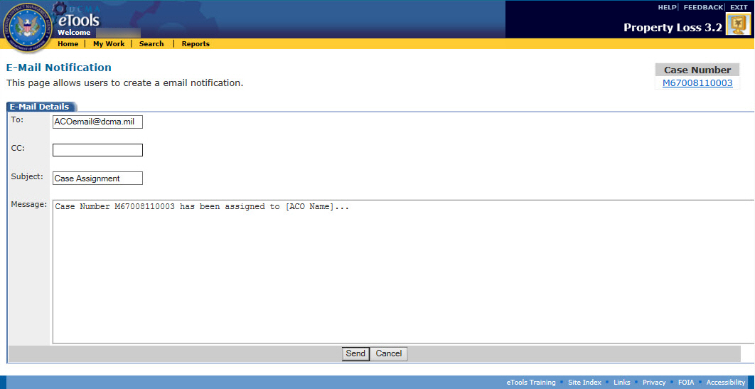
Figure 111: Email Notification page
- The user may CC the email notification to multiple users by separating the email addresses with a semicolon.
- Click the Send button. The case is now in Pending status, and when the Contractor has paid the assessed amount for all the line items, the case can be closed. (Figure 112).
Note: If the ACO does not concur with finding the case liable, then the system will return the status of the case from Pending to Investigating and reassign the case back to the PA.
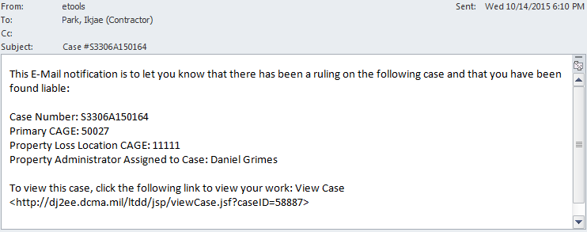
Figure 112: Example found liable E-Mail

Closing a Case
If the case has been relieved by a Property Administrator, or the Contractor has paid the government for the liability amount assessed, the case can be closed.
The cases you can close depend on your user role:
- Property Administrators can close cases in Investigating status that are assigned to them by relieving the case. They can close cases in Pending status that are assigned to them by editing the case.
- Administrators can close any case in Investigating status by relieving the case; they can close any cases in Pending status by editing the case.
- Contractors, ACOs, and External Users cannot close cases.
To close a case, do the following:
- On the My Work Page, Active Cases tab, click the link on the case number for the case you wish to close. The View Case page appears (Figure 113).
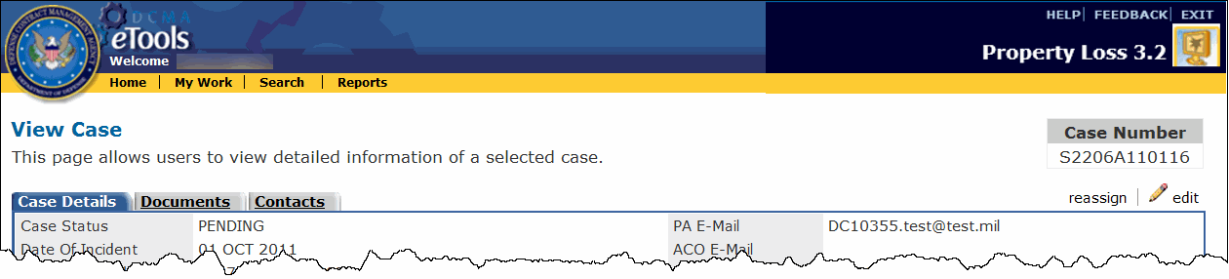
Figure 113: View Case page in Pending status, top portion only
- Click the edit link to edit the case. The Edit Case page appears (Figure 114).
Figure 114: Edit Case page with Close Case option
- If you received a check from the Contractor, you can enter the date of the check in the Date of Check text box. Click the calendar icon to select the date from a calendar, or type the date using the format dd mmm yyyy.
- For the Status of Case field, click the Closed Case option button.
- Click the Save button. The case is now closed. You can find the case under the Inactive Cases tab on the My Work Page.
To reopen the case as a PA, see the topic Reopening a Case.
To request the PA to reopen the case for you, see the topic Requesting the PA to Reopen a Case.

Reopening a Case
The cases you can reopen depend on your user role:
- Property Administrators can reopen cases in Closed status that they created or are assigned to them.
- Contractors can request to reopen cases in Closed status that they created. Note that these cases must be reopened by the Property Administrator.
- Administrators can reopen any case in Closed status.
- ACOs cannot reopen cases.
- External Users cannot reopen cases.
You can reopen a case from either the My Work Page or the View Case page.
To reopen a case from the My Work Page, do the following:
- Click the My Work link in the menu bar. The My Work Page appears.
- Click the Inactive Cases tab on the My Work Page. The Inactive Cases tab is displayed (Figure 115).
Figure 115: My Work Page, Inactive Cases tab
- Click the reopen link for the case you wish to reopen.
To reopen a case from the View Case page, do the following:
- From the My Work Page, Inactive Cases tab, click the link on the case number of the case you wish to reopen. The View Case page appears (Figure 116).
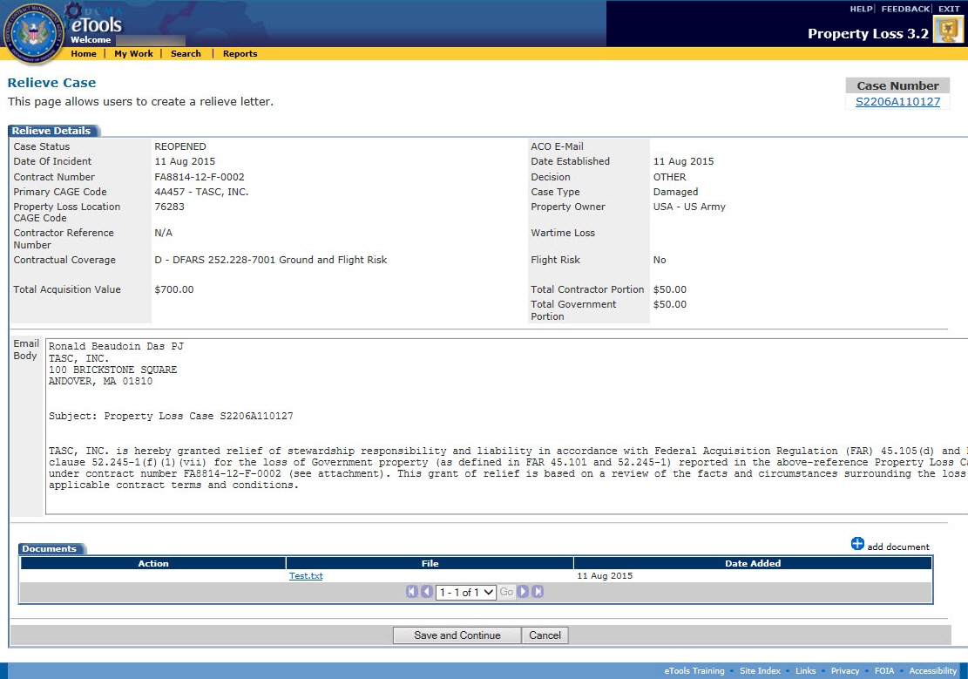
Figure 116: View Case page for a case in Closed status
- Click the reopen link.
When reopened by the PA, the case goes immediately to Reopened status and appears under the Active Cases tab. The PA will then need to activate the case through the Edit Case page to switch the case to Investigating status.
When reopened by the Contractor, the PA receives an E-Mail to notify him or her of the request. The PA will then need to activate the case via the Edit Case page to switch the case to Investigating status (Figure 117).
Figure 117: Sample reopen request E-Mail

Activating the Case
Once a case has been reopened, the case needs to be activated for the status of the case to be changed to Investigating.
To activate the case, do the following:
- On the My Work Page, Active Cases tab, click the link on the case number of the case you wish to reactivate. The View Case page appears (Figure 118).
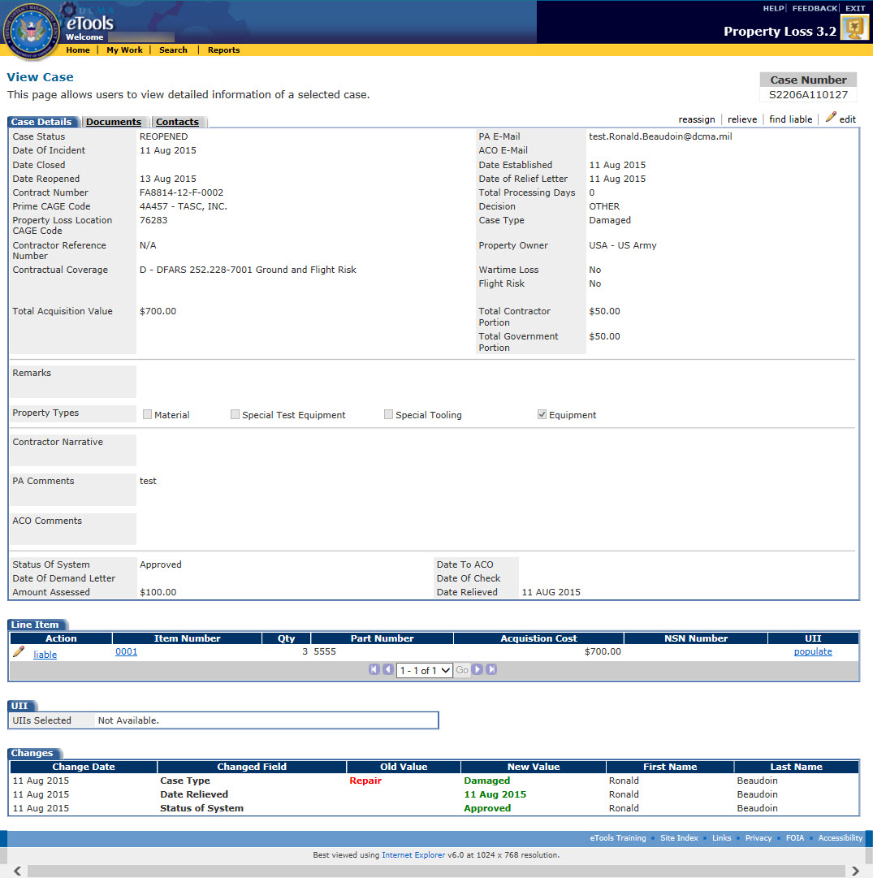
Figure 118: View Case page for case in Reopened status
- Click the edit link. The edit case page appears, displaying an option to activate the case (Figure 119).
Figure 119: Edit Case page with the Activate Case option
- The Status of Case is preselected to Open/Activate Case, but you may type PA Comments if you wish.
- Click the Save button. The View Case page appears and the case is now in Investigating status.
Note: When a case is reopened, the date will be stored in the Date Reopened field. The original Date Established will not be changed. If a case is reopened more than once, the first reopened date will be replaced by the new reopen date. All reopened cases will receive a new Date Closed even if there is no change in Liability/Relief.

Withdrawing a Case
The cases you can withdraw depend on your user role:
- Contractors can withdraw cases in Rejected status that they created.
- Property Administrators can withdraw cases in Rejected status that are assigned to them.
- Administrators can withdraw any case in Rejected status.
- ACOs cannot withdraw cases.
- External Users cannot withdraw cases.
To withdraw a case, do the following:
- On the My Work Page, Active Cases tab, click the link on the case number of a Rejected case. The View Case page appears (Figure 120).
Figure 120: View Case page with Withdraw link available
- Click the withdraw link. The case is now in Closed status. You can find the case under the Inactive Cases tab on the My Work Page.
To request the case to be reopened, see the topic Reopening a Case.
To request the PA to reopen the case for you, see the topic Requesting the PA to Reopen a Case.

Administrator Role Tasks

Reassigning Work
The administrator role can reassign work from one PA to another or one ACO to another. Contractors, property administrators, ACOs, and External Users cannot perform this task.
To reassign a workload from one Property Administrator or ACO to another, do the following:
- Click the Administration link on the menu bar. The Administration page appears (Figure 121).
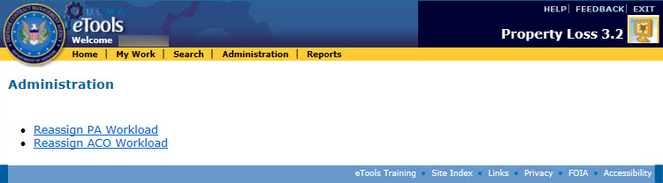
Figure 121: Administration page
- Click on either the Reassign PA Workload link or the Reassign ACO Workload link. The Reassign Workload page for either the PA or the ACO appears (Figure 122 and 123).
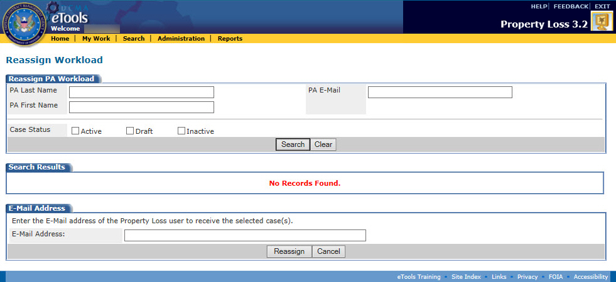
Figure 122: Reassign PA Workload page
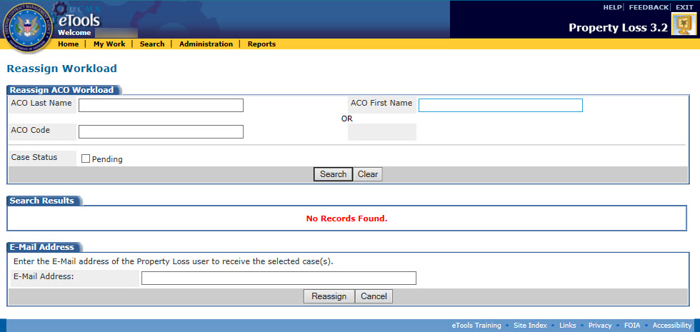
Figure 123: Reassign ACO Workload page
- Search for the Property Administrator's or ACO's cases. You may search with the Last Name, First Name, or E-Mail. For the PA, you may also select whether you wish to filter Active, Draft, or Inactive cases by checking the appropriate check boxes. For the ACO, you may select whether you wish to filter Pending cases by checking the Pending box.
- Click the Search button. The Reassign Workload page refreshes, and the cases found by the search appear (Figure 124).
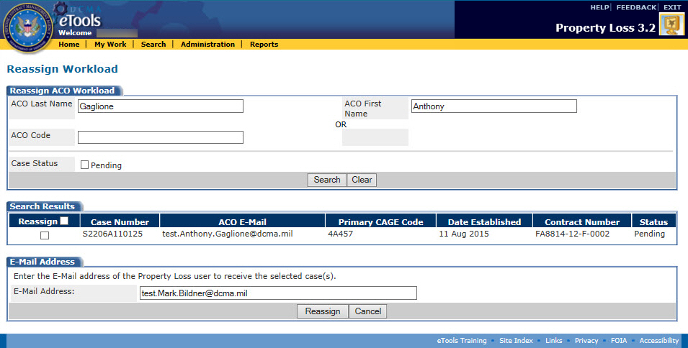
Figure 124: Reassign Workload page
- Select the cases to reassign by clicking the appropriate check boxes. You may select one, some, or all of the cases.
- Type the E-Mail address of the PA or ACO who will be receiving the selected case(s) in the E-Mail Address text box.
- Click the Reassign button. The reassigned case(s) move to the new PA or ACO's workload and are removed from the original workload. The new PA or ACO will possess all the capabilities and access that the original workload retainer had.
Property Loss automatically sends an E-Mail notification to the PA or ACO who is receiving the workload. The original PA or ACO, as well as the Administrator who reassigned the workload, are copied on the E-Mail (Figure 125).
Figure 125: Sample reassign workload E-Mail

ACO Role

Viewing Case Information
If a case is submitted and an ACO has already been assigned, Property Loss automatically sends an E-Mail to the ACO, the person who submitted the case, and the Property Administrator assigned to the case (Figure 126).
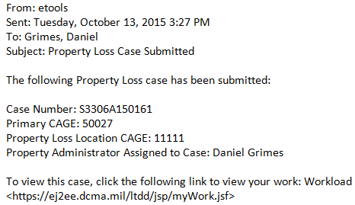
Figure 126: Sample case submitted E-Mail
If a new ACO is assigned to the case after the case has been submitted, Property Loss automatically sends an E-Mail to the Property Administrator, the formerly assigned ACO (if applicable), and the newly assigned ACO to notify them of the change (Figure 127).
Figure 127: Sample ACO assignment E-Mail
To view a case, do the following:
- Click the My Work link on the menu bar. The My Work page appears.
- Click the link on the case number of the case you wish to view. The View Case page appears (Figure 128).
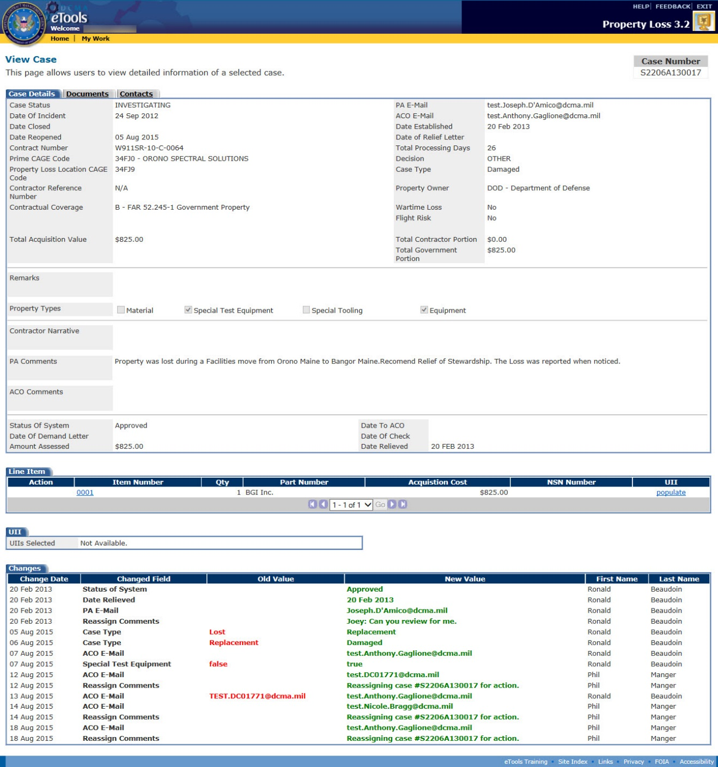
Figure 128: View Case page
The Changes section at the bottom of the page displays all the changes that were made to the case since it was submitted. It displays the date the change was made, field that was changed, what it was changed from and to, as well as who made the change.
Note: The Total Processing Days will be calculated nightly on a calendar basis. It is the number of days between Date Established and Date Closed inclusive. If the case is reopened, start counting again starting from the number of processing days already calculated.
To edit the case, click the edit link. Note that the edit link is only available if the case is in Pending status. Cases gain Pending status if the Property Administrator recommends that the Contractor be held liable for property on the case. See the topic Editing a Case.
To view the line items on the case, scroll down to the Line Item tab. See the subtopic Viewing Line Items on the Case within this topic.
To view the UIIs on an item, click the populate link in the UII column for that item. The UIIs associated with that item are populated in the drop-down list box in the UII section on the View Case page. Note that this feature is only available for items on internal cases.
To view the documents attached to the case, click the Documents tab. See the subtopic Viewing Documents Attached to the Case within this topic.
To view the contacts associated with the case, click the Contacts tab. See the subtopic Viewing Contacts Associated with the Case within this topic.

Reassigning a case to another ACO
An ACO may reassign their own pending cases to another ACO.
To reassign a case, do the following:
- From the View Case page, click the reassign link. The Reassign Case Page opens (Figure 129).
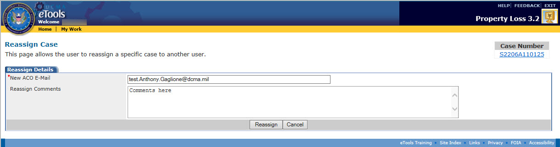
Figure 129: Reassign Case Page
- Enter the new ACO Email (Required) and any Reassign Comments if desired. Click Reassign.
- The case is now reassigned to the new ACO and the user returns to the Workload page.

Viewing Line Items on the Case
To view the line items on the case, scroll down to the Line Item tab on the View Case page and click the link on an item number. The View Line Item page appears (Figure 130).
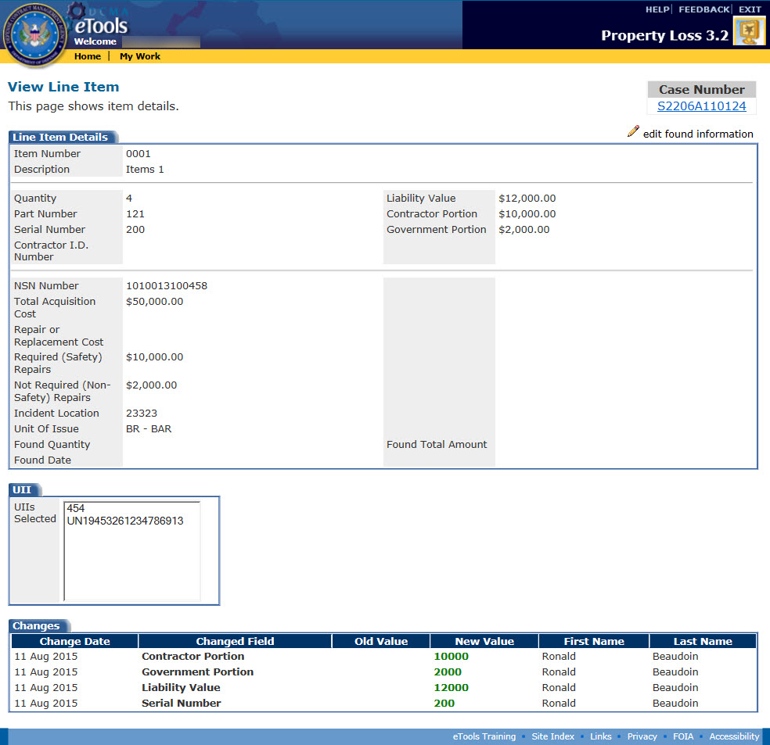
Figure 130: View Line Item page
The Changes section at the bottom of the page displays all the changes that were made to the line item since the case was submitted. It displays the date the change was made, field that was changed, what it was changed from and to, as well as who made the change.
To return to the View Case page, click the link on the case number under the Case Number heading (for cases in Draft status, click the DRAFT link under the Case Number heading). The View Case page appears.

Viewing Documents Attached to the Case
To view the documents attached to the case, click the Documents tab on the View Case page. The Manage Documents page appears (Figure 131).
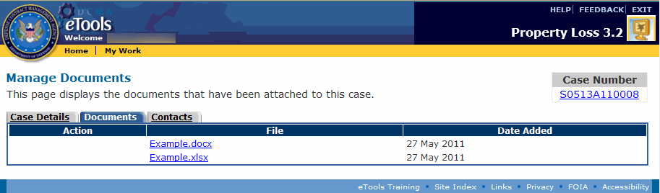
Figure 131: Manage Documents page
To view an attached document, do the following:
- Click the link on the document's file name. The File Download window appears.
- Select whether you wish to open the document or save the document to your computer: If you click the Open button, the file download begins and the document will open as soon as the download is complete. If you click the Save button, the Save As window appears and prompts you to select a location to save the file to on your computer before the download begins.

Viewing Contacts Associated With the Case
To view contacts associated with the case, click the Contacts tab on the View Case page. The Contact Information of Contractor page appears (Figure 132).
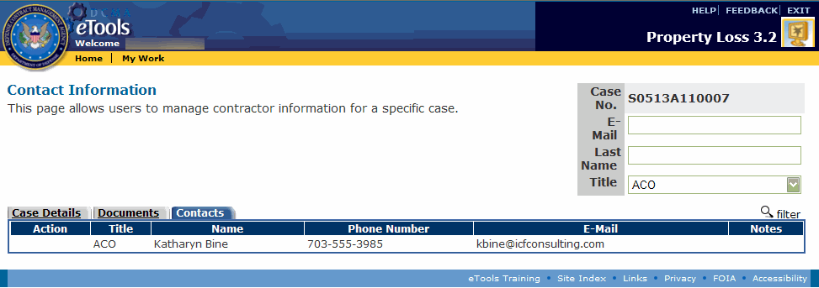
Figure 132: Contact Information of Contractor page
To filter the contacts within a case, type an E-Mail address, Last Name, or select a Title in the corresponding search boxes at the top right corner of the page and click the filter link. The page now displays only the contacts that match the search criteria you entered and all the rest are filtered out.
To clear a filter and display all the contacts, remove any search criteria and click the filter link. The page now displays all the contacts.

Managing Documents on a Case
The cases you can add, edit, or delete documents from depend on your user role:
- Contractors can add documents to or delete documents from cases in Draft or Rejected status that they created. Contractors can submit a request to add documents to or delete documents from a case in Investigating or Pending status.
- Property Administrators can add documents to or delete documents from cases in Draft status, Investigating status, or Pending status; Property Administrators can add documents to cases in Rejected status, but cannot delete documents from cases in Rejected status (Note: Cases in Draft status are editable by PAs whether they've created the cases or have been assigned the cases; cases in other statuses are editable by PAs if they've been assigned the cases).
- Administrators can add or delete documents from any case in any status except Closed.
- ACOs can add documents to or delete documents from cases in Pending status that are assigned to them.
- External Users cannot add or edit documents.
You can view, add, or delete documents from a case by clicking the Documents tab on the View Case page (see the topic Viewing Case Information). The Manage Documents page appears and allows you to view a list of the documents attached to the case (Figure 133).
Figure 133: Manage Documents page

Viewing Documents
To view an attached document, do the following:
- On the Manage Documents page, click the link on the document's file name. The File Download window appears.
- Select whether you wish to open the document or save the document to your computer: If you click the Open button, the file download begins and the document will open as soon as the download is complete. If you click the Save button, the Save As window appears and prompts you to select a location to save the file to on your computer before the download begins.

Adding Documents
- Property Administrators can add documents to cases in Draft status (cases they created or cases assigned to them), Investigating status, Pending status, or Rejected status (cases assigned to them).
- Contractors can add documents to cases in Draft or Rejected status that they created.
- Administrators can add documents to any case in any status except Closed.
- ACOs can add documents to cases in Pending status that are assigned to them.
To add a document, do the following:
- On the Manage Documents page, click the add document link. The Add Documents page appears (Figure 134).
Figure 134: Add Documents page
- Click the Browse button.
- Click the file you wish to attach (acceptable document types include: .doc, .pdf, .xls, .tif, and .jpg). Click the Open button. The file name and path appear in the text box next to the Browse button.
- Click the Save button. The Manage Documents page appears, displaying the file you have attached.

Deleting Documents
- Property Administrators can delete documents from cases in Draft status (cases they've created and cases assigned to them), in Investigating status, and in Pending status (cases assigned to them).
- Contractors can delete documents from cases in Draft or Rejected status that they created, but must submit a request to delete an attachment from a case in Investigating or Pending status.
- Administrators can delete documents from cases in any status except Closed.
- ACOs can delete documents from cases in Pending status that are assigned to them.
To delete an attached document, on the Manage Documents page, click the delete icon for the document you wish to delete. A dialog box appears asking you to confirm the deletion. Click the OK button on the dialog box to delete the document or click the Cancel button to cancel the deletion.
To request the Property Administrator to delete an attached document, on the Manage Documents page, click the request delete link for the document you wish to delete. Property Loss automatically sends an E-Mail message to the Property Administrator assigned to the case to notify him or her of the request (Figure 135).
Figure 135: Sample Request for Deletion of Attachment E-Mail

Editing a Case
If the Property Administrator recommends that the contractor be held liable, Property Loss automatically sends an E-Mail notification to the ACO to notify him or her of this decision.
Cases gain Pending status when the Property Administrator recommends the contractor be held liable for property on the case. ACOs are only able to edit cases in Pending status.
To edit a case, click the edit link on the View Case page. The Edit Case page appears (Figure 136).
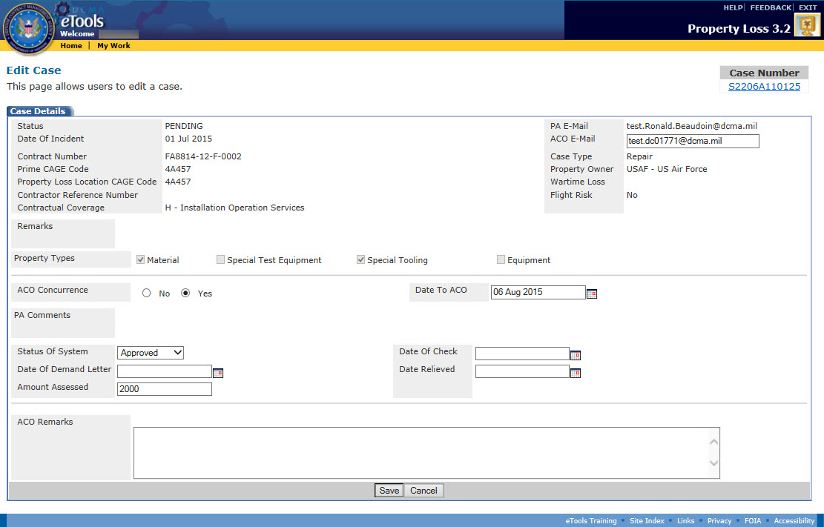
Figure 136: Edit Case page
For all cases in Pending status that are assigned to you, you may edit the following information:
- Property Types
- ACO Concurrence
- Date to ACO
- Status of System
- Date of Demand Letter
- Amount Assessed
- ACO E-mail
- Date To ACO
- Date of Check
- Date Relieved
- ACO Remarks
To save your changes, click the Save button.

Finding a Contractor Liable
Once a Contractor submits a case, the Property Administrator can either relieve the case or recommend to the ACO that the contractor be held liable for at least some portion of the case. The Contractor can be liable for one, some, or all of the items on the case. The ACO can also find the contractor liable for individual line items on cases.
The cases you can find liable depend on your user role:
- Property Administrators can recommend that the contractor be held liable for cases in Investigating status that are assigned to them.
- ACOs can find the contractor liable for individual line items on cases in Pending status that are assigned to them.
- Administrators can find the contractor liable for any case in Investigating status.
- Contractors cannot find contractors liable.
- External Users cannot find contractors liable.
To find a contractor liable, do the following:
- Click the My Work link on the menu bar. The My Work page appears.
- Click the link on the case number of the case you wish to view. The View Case page appears (Figure 137).
Figure 137: View Case page in Investigating status
To input the liability amount, contractor portion, and government portion, do the following:
- Scroll down to the Line Items section on the View Case page.
- Click the liable link for the line item for which the Contractor is liable. The Find Liable page appears for that line item (Figure 138).
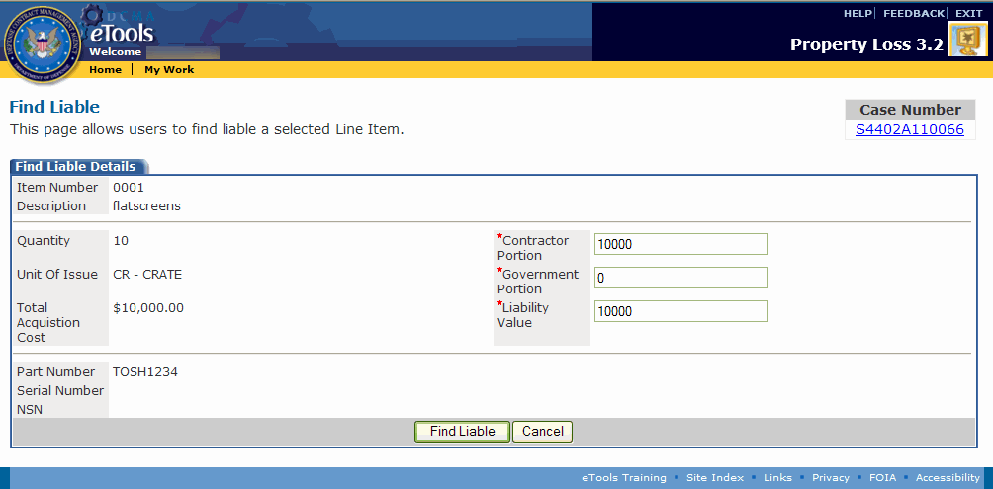
Figure 138: Find Liable page
- Type the total Liability Value. The Contractor Portion and the Government Portion must add up to the Liability Value.
- Type the Contractor Portion.
- Type the Government Portion.
- Click the Find Liable button. The View Case page appears.
- Repeat steps 1-6 for any other line items on the case for which the Contractor is liable.
Note: If the ACO does not concur with finding the case liable, then the system will return the status of the case from Pending to Investigating and reassign the case back to the PA.

External User Role

Searching for Cases
The cases you can search for depend on your user role:
- Contractors can search for cases they created, as well as cases where their CAGE is the prime or sub.
- Property Administrators can search for cases that are assigned to them and the cases they created.
- Administrators can search for any cases in Property Loss.
- ACOs cannot search for cases.
- External Users can only search for cases where their DoDAAC is the prime or sub.

Using the Search
To search for cases in Property Loss, do the following:
- Click the Search link on the menu bar. The Property Loss Search page appears (Figure 139).
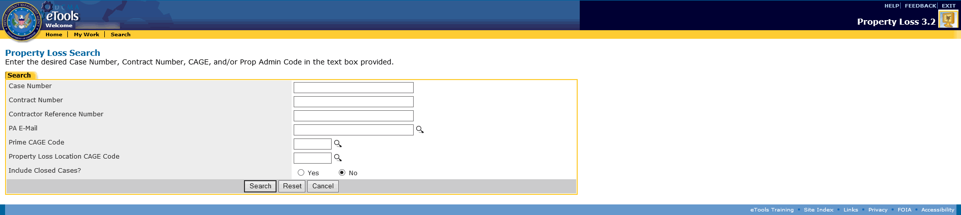
Figure 139: Property Loss Search page
- Type the search criteria necessary to help you find the cases you are looking for. You can type information in none, some, or all of the search fields. The more information you specify, the easier it will be to find your desired cases. If you type information in none of the search fields, the search results will yield all the cases you have access to.
You can also click an option button (Yes or No) to include Closed cases in your search; No is the default option.
Note: If you do not know the Prime CAGE, Location CAGE, or PA E-Mail on the case you are looking for, you can click the icon next to the applicable field to search for a PA E-Mail, Prime CAGE, or Location CAGE. See the subtopics Looking Up the PA E-Mail Address, Looking Up the Prime CAGE, and Looking Up the Location CAGE within this topic.
- Click the Search button. The Search Results page appears, displaying the cases that match the search criteria you entered (Figure 140).
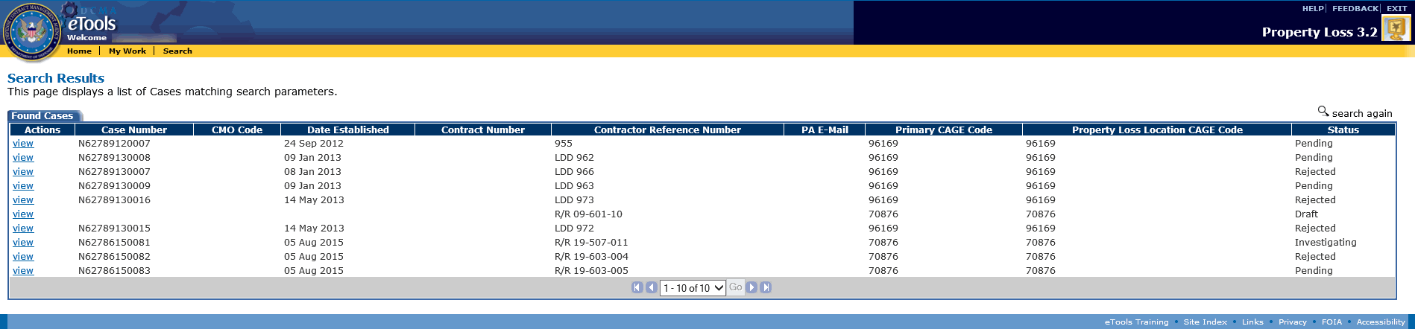
Figure 140: Search Results page
To view a case, click the view link. The View Case page appears.
To search again, click the search again link.

Looking Up the PA E-Mail Address
If you do not know the E-Mail Address of the PA assigned to the case but would like to search for the case based on the assigned PA, you can find the PA's E-Mail address by searching on the PA's first or last name.
To look up the E-Mail address of the PA assigned to the case, do the following:
- Click the icon next to the PA E-Mail field on the Property Loss Search page. The PA E-Mail Search appears in a new window (Figure 141).
Figure 141: PA E-Mail Search window
- Type the PA's First Name or Last Name in the search fields.
- Click the Search button. The search results appear in the same window (Figure 142).
Figure 142: Select PA E-Mail window
- Click the link on the PA E-Mail address if you found the PA you are looking for. The Select PA E-Mail window disappears, and the PA's E-Mail address is populated in the PA E-Mail field on the Property Loss Search page.
To search for another PA E-Mail address, click the search link within the Select PA E-Mail window.
To close the Select PA E-Mail window without selecting an E-Mail address, click the close link.
- Type additional search criteria if you wish.
- Click the Search button. The Search Results page appears.
To view a case, click the view link. The View Case page appears.

Looking Up the Prime CAGE
If you do not know the prime CAGE on the case but would like to search for the case based on the prime CAGE, you can find the prime CAGE by searching on the DoDAAC, Company Name, or ZIP Code.
To look up the prime CAGE on the case, do the following:
- Click the icon next to the Prime CAGE Code field on the Property Loss Search page. The Prime CAGE Search appears in a new window (Figure 143).
Figure 143: Prime CAGE Search window
- Type the DoDAAC, Company Name, or ZIP Code in the search fields.
- Click the Search button. The search results appear in the same window (Figure 144).
Figure 144: Select Prime CAGE window
- Click the link on the CAGE if you found the CAGE you are looking for. The Select Prime CAGE Code window disappears, and the prime CAGE is populated in the Prime CAGE Code field on the Property Loss Search page.
To search for another prime CAGE, click the search link within the Select Prime CAGE Code window.
To close the Select Prime CAGE Code window without selecting a prime CAGE, click the close link.
- Type additional search criteria if you wish.
- Click the Search button. The Search Results page appears.
To view a case, click the view link. The View Case page appears.

Looking Up the Location CAGE
If you do not know the location CAGE on the case but would like to search for the case based on the location CAGE, you can find the location CAGE by searching on the DoDAAC, Company Name, or ZIP Code.
To look up the location CAGE on the case, do the following:
- Click the icon next to the Property Loss Location CAGE Code field on the Property Loss Search page. The Location CAGE Search appears in a new window (Figure 145).
Figure 145: Location CAGE Search window
- Type the DoDAAC, Company Name, or ZIP Code in the search fields.
- Click the Search button. The search results appear in the same window (Figure 146).
Figure 146: Select Location CAGE window
- Click the link on the CAGE if you found the CAGE you are looking for. The Select Location CAGE Code window disappears, and the location CAGE is populated in the Property Loss Location CAGE Code field on the Property Loss Search page.
To search for another location CAGE, click the search link within the Select Location CAGE Code window.
To close the Select Location CAGE Code window without selecting a location CAGE, click the close link.
- Type additional search criteria if you wish.
- Click the Search button. The Search Results page appears.
To view a case, click the view link. The View Case page appears.

Viewing Case Information
The cases you can view depend on your user role:
- Contractors can view the cases they created, as well as cases where their CAGE is the prime or sub.
- Property Administrators can view the cases that are assigned to them and the cases they created.
- Administrators can view any cases in Property Loss.
- ACOs can view the cases assigned to them.
- External Users can only view cases where their DoDAAC is the prime or sub.
To view a case, do the following:
- Click the Search link on the menu bar. The Property Loss Search appears.
- Fill out search criteria to search for the desired case. For more information on search for cases, see the topic Searching for Cases.
- After searching for cases, click the view link next to the desired case. The View Case page appears (Figure 147).
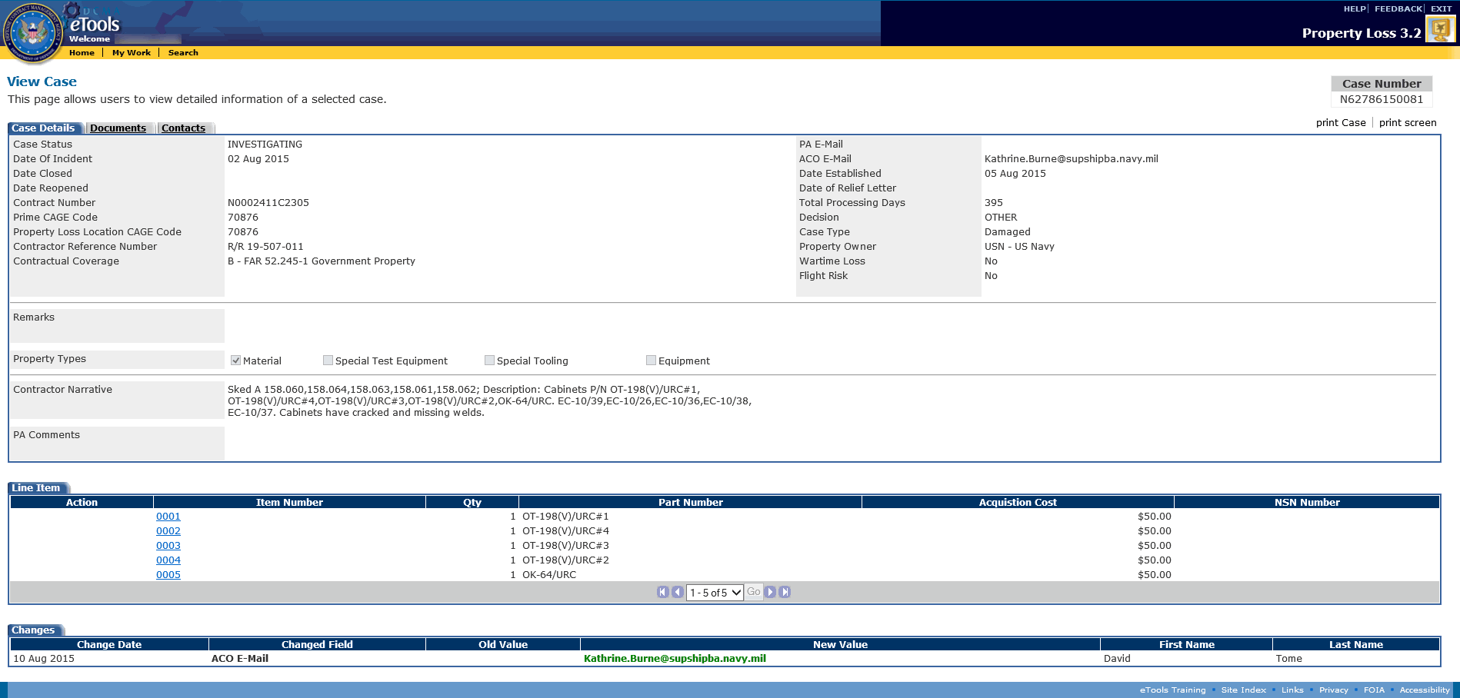
Figure 147: View Case page
The Changes section at the bottom of the page displays all the changes that were made to the case since it was submitted. It displays the date the change was made, field that was changed, what it was changed from and to, as well as who made the change.
Note: The Total Processing Days will be calculated nightly on a calendar basis. It is the number of days between Date Established and Date Closed inclusive. If the case is reopened, start counting again starting from the number of processing days already calculated.
To view the line items on the case, scroll down to the Line Item tab. See the subtopic Viewing Line Items on the Case within this topic.
To view the documents attached to the case, click the Documents tab. See the subtopic Viewing Documents Attached to the Case within this topic.
To view the contacts associated with the case, click the Contacts tab. See the subtopic Viewing Contacts Associated with the Case within this topic.

Viewing Line Items on the Case
To view the line items on the case, scroll down to the Line Item tab on the View Case page and click the link on an item number. The View Line Item page appears (Figure 148).
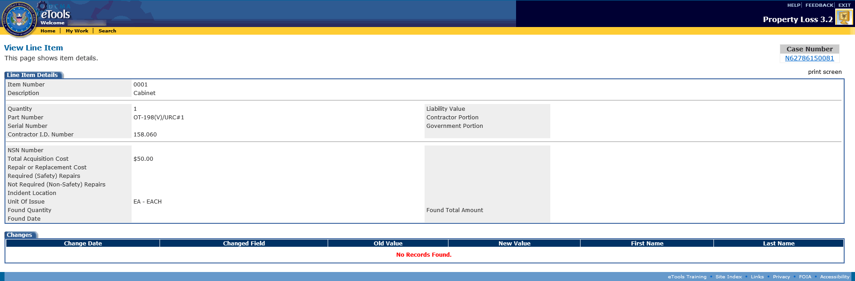
Figure 148: View Line Item page
The Changes section at the bottom of the page displays all the changes that were made to the line item since the case was submitted. It displays the date the change was made, field that was changed, what it was changed from and to, as well as who made the change.
To return to the View Case page, click the link on the case number under the Case Number heading (for cases in Draft status, click the DRAFT link under the Case Number heading). The View Case page appears.
To export the line item as a PDF file, click the Print Screen action. This enables you to save and/or print the line item. Be aware that the PDF file will not be editable.

Viewing Documents Attached to the Case
To view the documents attached to the case, click the Documents tab on the View Case page. The Manage Documents page appears (Figure 149).
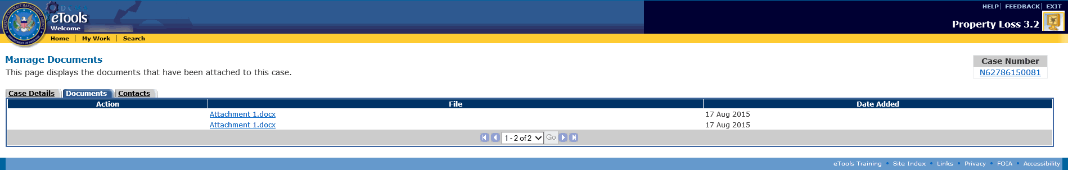
Figure 149: Manage Documents page
To view an attached document, do the following:
- Click the link on the document's file name. The File Download window appears.
- Select whether you wish to open the document or save the document to your computer: If you click the Open button, the file download begins and the document will open as soon as the download is complete. If you click the Save button, the Save As window appears and prompts you to select a location to save the file to on your computer before the download begins.

Viewing Contacts Associated With the Case
To view contacts associated with the case, click the Contacts tab on the View Case page. The Contact Information page appears (Figure 150).
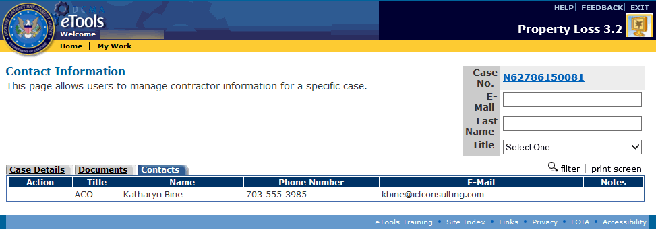
Figure 150: Contact Information page
To filter the contacts within a case, type an E-Mail address, Last Name, or select a Title in the corresponding search boxes at the top right corner of the page and click the filter link. The page now displays only the contacts that match the search criteria you entered and all the rest are filtered out.
To clear a filter and display all the contacts, remove any search criteria and click the filter link. The page now displays all the contacts.
To export the contact information as a PDF file, click the Print Screen action. This enables you to save and/or print the contact information. Be aware that the PDF file will not be editable.

Glossary
A
ACO: Administrative Contracting Officer
E
EWAM: External Web Access Manager
I
IWAM: Internal Web Access Manager
P
PA: Property Administrator
PL: Property Loss

