External Web Access Management (EWAM) 2.0

End User Manual

Defense Contract Management Agency



31 July 2026

DCMA EWAM User GUIDE
Registration and End User Guide

System Access
To access the EWAM application, go to http://www.dcma.mil. On the eTools Customer Home Page (Figure 1), select the EWAM icon. You will be directed to the EWAM 2 Registration Page (Figure 4).
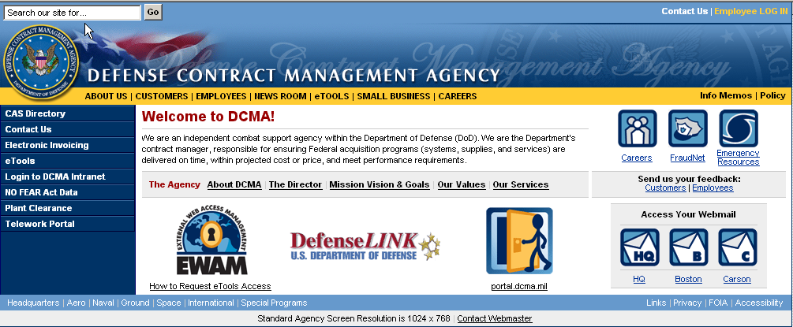
EWAM icon
Figure 1. eTools Customer Home Page

End-User

How to Register
New users accessing the system will need to enter their user attributes on the Emulate Login for EWAM 2 Registration Page (Figure 4). New users must first click on the ‘Register as New User’ link to begin the registration process.
On the Registration Page Profile tab, click on the Radio button to select an Organization type:
- DoD
- Other Government
- Commercial
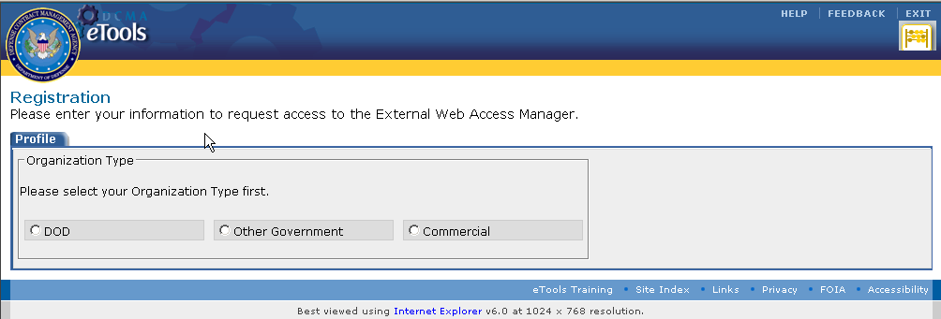
Figure 4. Registration Page
Depending on the Organization Type you selected, the User Profile information will differ.
Please refer to the DoD User Profile (Figure 5), Other Government User Profile (Figure 6), or Commercial User Profile (Figure 7) for inputs that pertain to your organization.
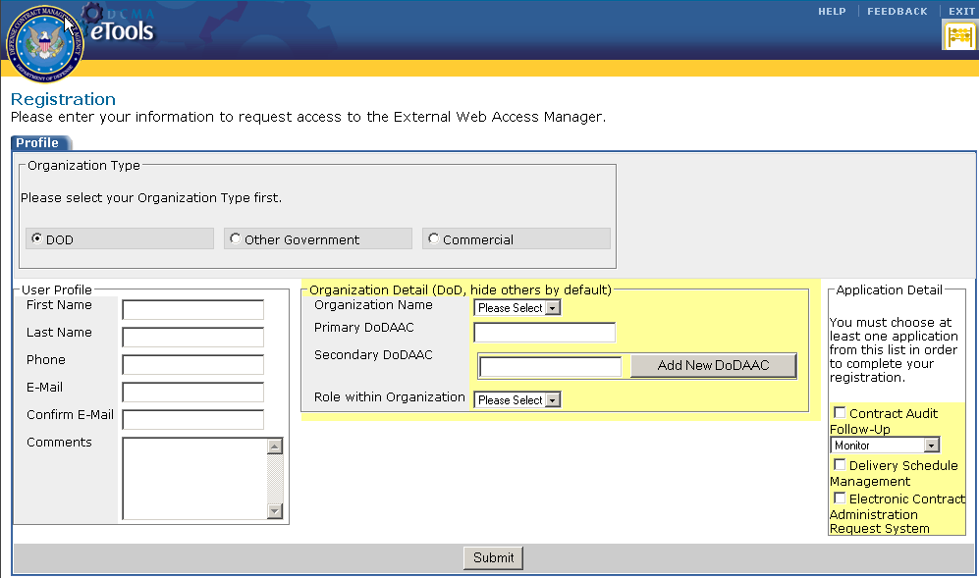
Figure 5. DoD User Profile
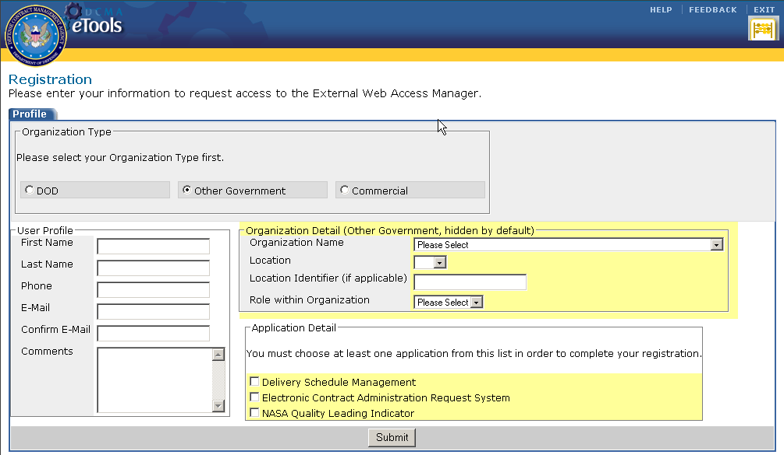
Figure 6. Other Government User Profile
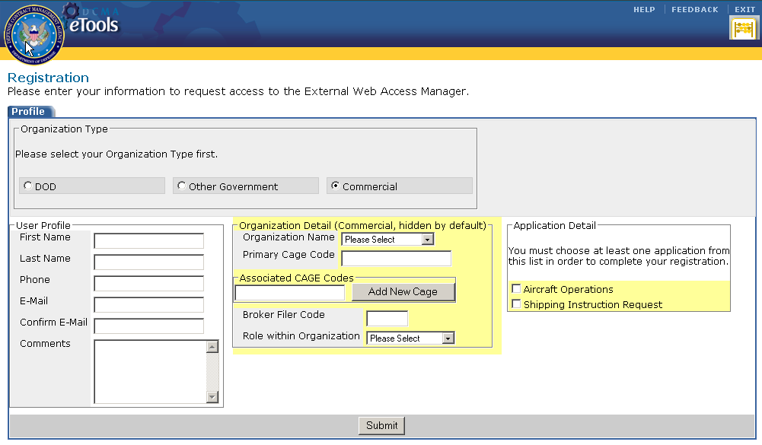
Figure 7. Commercial User Profile

DoD User Profile Input
If you are a DoD user, enter or select the following information in the respective fields.
Profile Field Description:
User Profile:
First Name | The user’s First Name. Alphanumeric field with a maximum length of 18 characters.
Last Name | The user’s Last Name. Alphanumeric field with a maximum length of 20 characters.
Phone | The user’s Phone Number. Numeric field with a maximum length of 20 characters.
E-Mail | The user’s E-Mail address. Alphanumeric field with a maximum length of 80 characters. Allows special characters. Validated for the correct E-Mail format (ie. Ewam2@ewam2.mil).
Confirm E-Mail | The user’s E-Mail address. Alphanumeric field with a maximum length of 80 characters. Allows special characters. *Validated to match the E-Mail field and correct E-Mail format (ie. Ewam2@ewam2.mil).
Comments | Additional comments input. Alphanumeric field with a maximum length of 200 characters.

Organization Details:
Organization Name | The name of the Organization the user belongs to. Drop-down list.
Primary DoDAAC | The user’s Primary DoDAAC. Alphanumeric field with a maximum length of 6 characters.
Secondary DoDAAC | The user’s Secondary DoDAAC. Alphanumeric field with a maximum length of 6 characters. The Add New DoDAAC button () allows users to add a secondary DoDAAC. Clicking on the Remove link ( will delete the added DoDAAC.
Role Within Organization | The user’s Role within the Organization. Drop-down list.

Application Detail:
Select the application you would like to request access to by clicking on the checkboxes.

Non Government User Profile Input
If you are a Non Government user, enter or select the following information in the respective fields.
Profile Field Description:
User Profile:
First Name | The user’s First Name. Alphanumeric field with a maximum length of 18 characters.
Last Name | The user’s Last Name. Alphanumeric field with a maximum length of 20 characters.
Phone | User’s Phone Number. Numeric field with a maximum length of 20 characters.
E-Mail | User’s E-Mail address. Alphanumeric field with a maximum length of 80 characters. Allows special characters. Validated for the correct E-Mail format (ie. Ewam2@ewam2.mil).
Confirm E-Mail | User’s E-Mail address. Alphanumeric field with a maximum length of 80 characters. Allows special characters. *Validated to match the E-Mail field and correct E-Mail format (ie. Ewam2@ewam2.mil).
Comments | Additional comments input. Alphanumeric field with a maximum length of 200 characters.

Organization Details:
Organization Name | The name of the Organization the user belongs to. Drop-down list.
Location | The Location of the Organization. Drop-down list.
Location Identifier | The Location identifier. There will be no value in this field unless the Location is NASA. If so, this field is a Drop-down list.
Role Within Organization | The user’s Role within the Organization. Drop-down list.

Application Detail:
Select the application you would like to request access to by clicking on the checkboxes.

Commercial User Profile Input
If you are a Commercial user, enter or select the following information in the respective fields.

Profile Field Description:
User Profile:
First Name | The user’s First Name. Alphanumeric field with a maximum length of 18 characters
Last Name | The user’s Last Name. Alphanumeric field with a maximum length of 20 characters.
Phone | The user’s Phone Number. Numeric field with a maximum length of 20 characters.
E-Mail | The user’s E-Mail address. Alphanumeric field with a maximum length of 80 characters. Allows special characters. Validated for the correct E-Mail format (ie. Ewam2@ewam2.mil).
Confirm E-Mail | The user’s E-Mail address. Alphanumeric field with a maximum length of 80 characters. Allows special characters. *Validated to match the E-Mail field and correct E-Mail format (ie. Ewam2@ewam2.mil).
Comments | Additional comments input. Alphanumeric field with a maximum length of 200 characters.

Organization Details:
Organization Name | The name of the Organization the user belongs to. Drop-down list.
Primary CAGE Code | User’s Primary DoDAAC. Alphanumeric field with a maximum length of 5 characters.
Associated CAGE Codes | User’s Associated CAGE Code. Alphanumeric field with a maximum length of 5 characters. The Add New CAGE button () allows users to add an associated CAGE Code. Clicking on the Remove link ( will delete the added CAGE Code.
Broker Filer Code | Enter this field if you do not have a Primary CAGE Code. Alphanumeric field with a maximum length of 3 characters.
Role Within Organization | The user’s Role within the Organization. Drop-down list.

Application Detail:
Select the application you would like to request access to by clicking on the checkboxes.

Once you have entered the relevant information on the Registration page, click on the Submit button. You will be directed to the Confirmation Page (Figure 8).
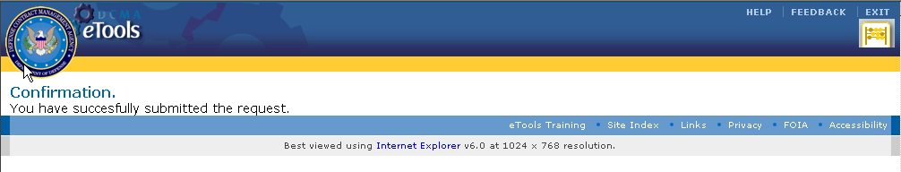
Figure 8. Confirmation Page

Registration Approval and Rejection E-Mail
Once you have submitted your request, you will receive either an Approval or Rejection E-Mail.
If you received the Approval E-Mail, use the Username and Password provided in the E-Mail to login to eTools.
If you received a Rejection E-Mail, please observe the rejection reason. If you feel that your request has been rejected in error, please contact DCMA Help Desk for further assistance.

How to Modify User Profile
Once you receive your account information login to http://etools.dcma.mil. Click on the EWAM icon on your Portal Page. You will be directed to the EWAM 2 Update page (Figure 9). You can enter updates to your User Profile, Organization Detail, and Application Detail on this screen. Under the Application Detail section, you will be able to view applications that are pending approval and application that are available for request.
Once you have completed entering the relevant edits, click on the Submit button (). A Confirmation Page (Figure 8) will appear after you submit the updates.
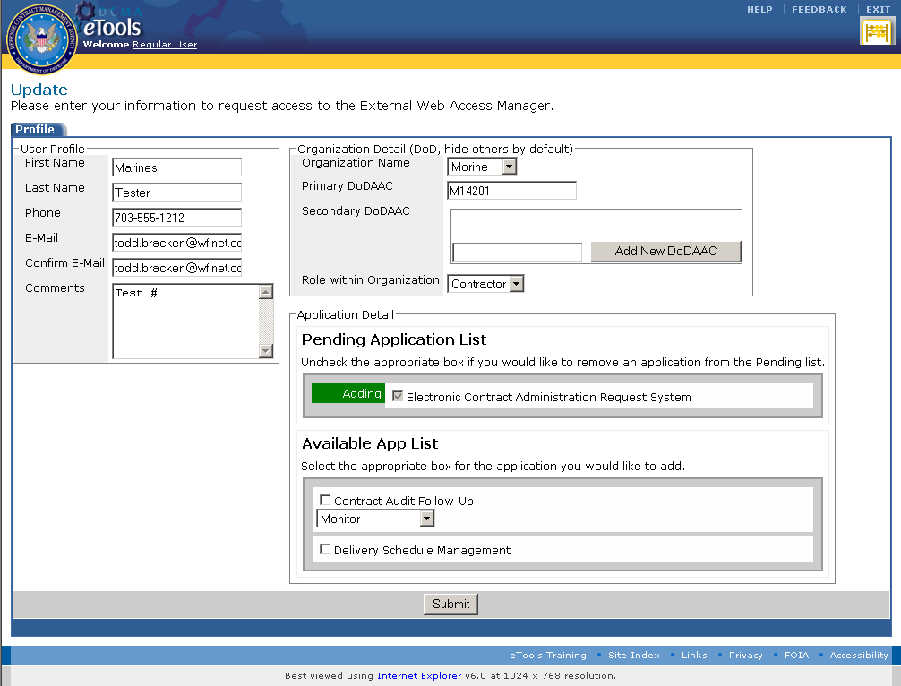 Figure 9. EWAM 2 Update Page

Glossary
List of Acronyms and Abbreviations used in the EWAM 2 application are listed below.
DCMA | Defense Contract Management Agency
DoD | Department of Defense
eTools | Electronic Tools
EWAM | Electronic Web Access Manager

