External Web Access Management (EWAM) 2.0

Password Maintenance Manual

Defense Contract Management Agency

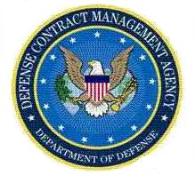

31 July 2026

DCMA EWAM User GUIDE
Security and Password Setup
Introduction

After approval of any of your DCMA eTools access requests, you will receive an email detailing some important information on logging in with your new account and accessing your applications. It will be a good idea to save this email for future reference. Here is an example of what that email will look like. Please note - the information included in the email such as User ID, Password, etc. are all sample values and not information that you will use to access your account.

Figure 1 – Approval and access notification from EWAM

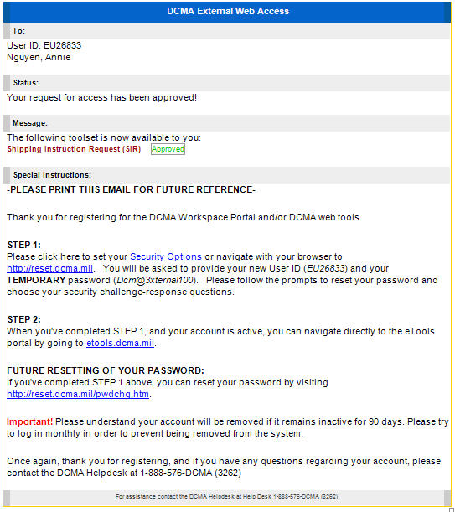

Your User ID
Your Name

The application you were approved for access
Web address for setting up your security information
(GO HERE FIRST)

Web address if you ever need to reset your password.

DCMA Helpdesk Phone #
Setting up your security information for your account

Step 1

After clicking the link from your confirmation email you will be brought to the security information setup website. The first screen will ask for the EWAM User ID and the temporary password found in your confirmation email.

Figure 2 – Initial screen for setting up your security info. Enter your EWAM User ID and temporary password here.

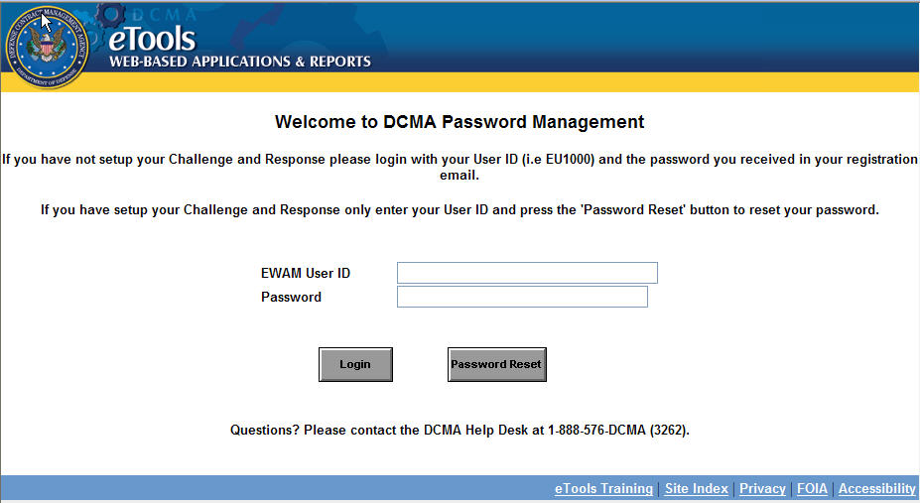

Step 2
Setup your Challenge questions and responses, and click Save. Please note, the responses you provide here are case sensitive, so if you ever need to use the responses you provide here to reset your password, they will have to be entered in the same case you initially input them.
Figure 3 – Screen for setup your security challenge questions and responses.

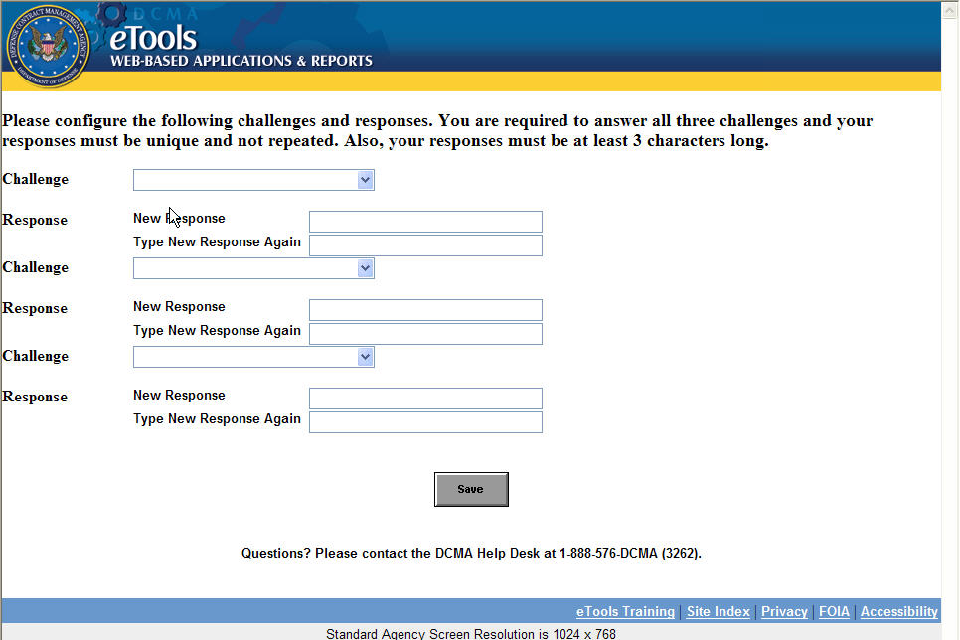

Step 3

You will be redirected to the Password Management screen to reset your permanent password. On this screen, you need to enter your EWAM User ID and click the Submit button to proceed.
Figure 4 – Password Management screen to reset permanent password.

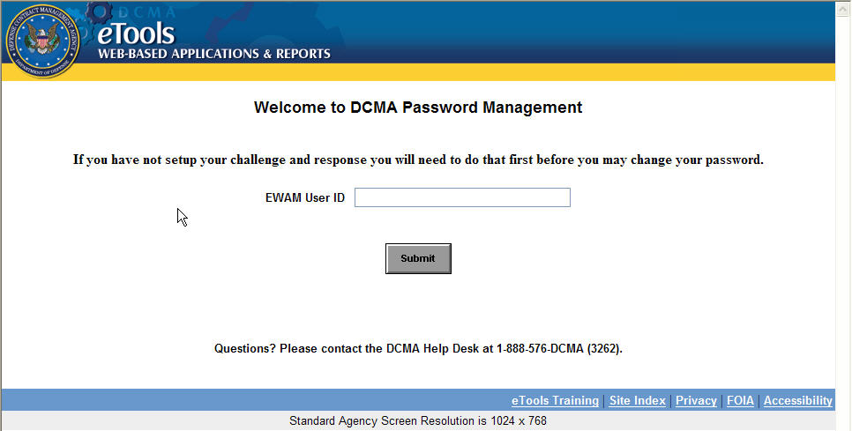
Step 4

You will be taken to the screen where you are required to answer to your security challenge questions and click the Submit button to proceed.

Figure 5 – Answer to challenge questions.

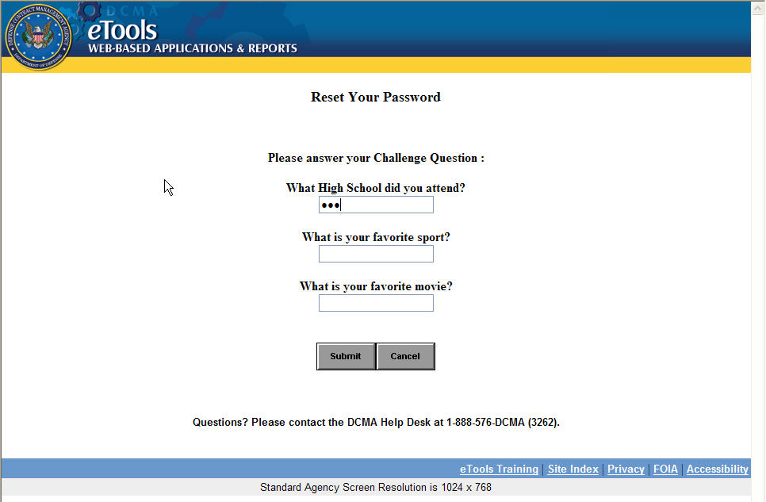
Step 5

After answering to your challenge question, you will be taken to the Change Password screen. Review the password requirements, enter the new password, retype the new password and click the Save button.
Figure 6 – Enter new password and save it.

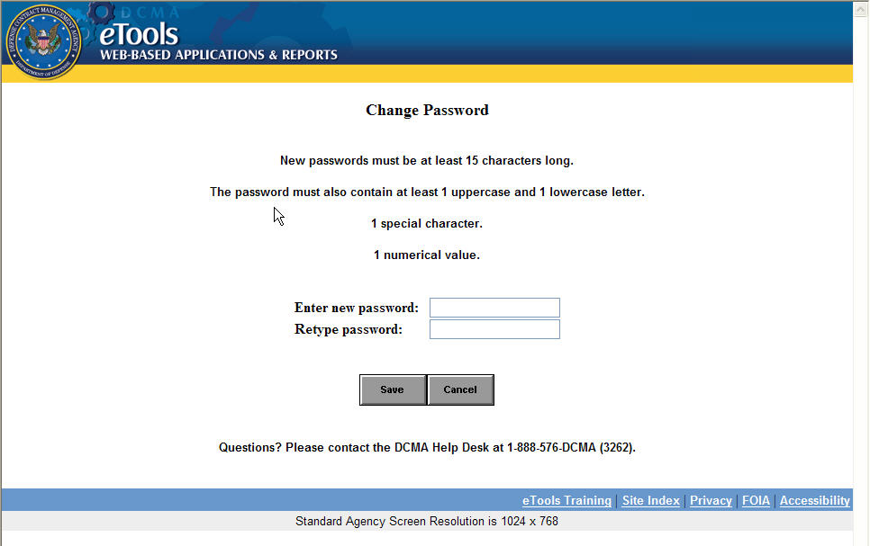

You now are brought to the Password-change confirmation page. From this screen, click the Back button to go to the eTools banner page.

Figure 7 – Password-change confirmation screen.

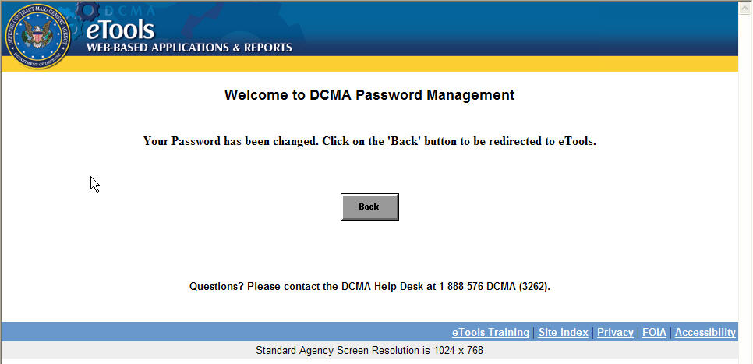

Step 6

Click the Accept button on the banner page will take you to the login screen.
Figure 8 – eTools banner page

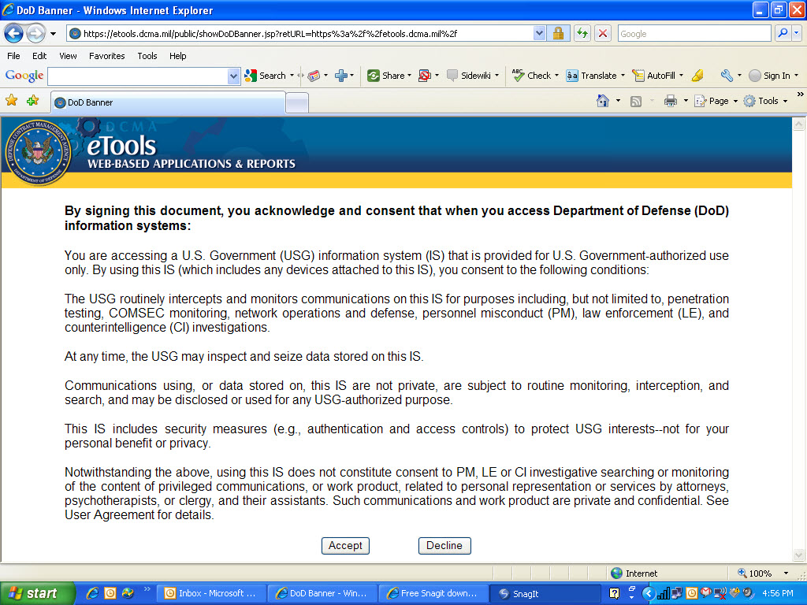

Step 7

At the login screen, you will be asked to enter your User ID and newly created password to log in.
Figure 9 – eTools login page

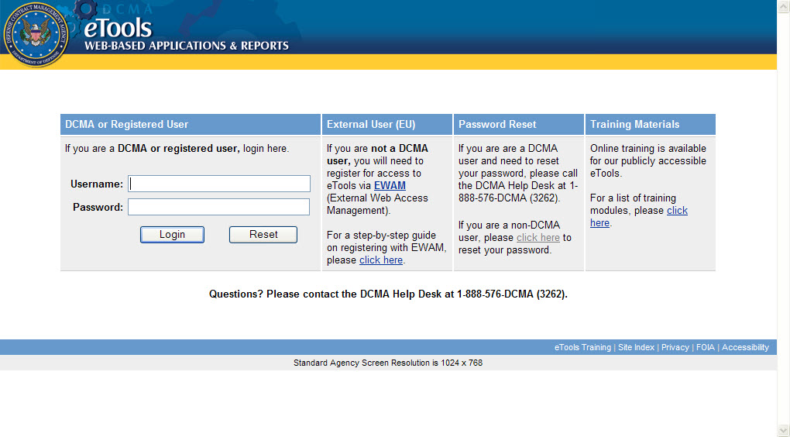
After logging into eTools, you will see the Portal with the icons for EWAM and any eTools applications that you’ve been approved for. For information on usage of EWAM, please see the EWAM End User Manual.

Figure 10 – eTools Portal with EWAM and your approved Application icons

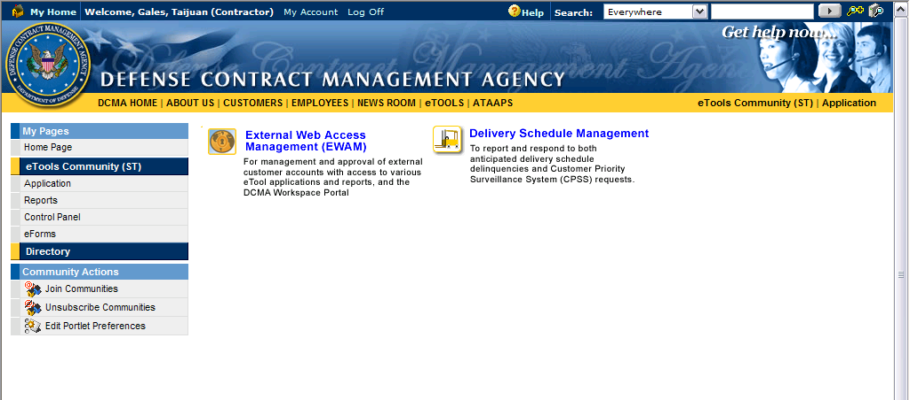
Resetting your Password

Step 1

Contact the DCMA Service Center at (888) 576-3262.

