External Web Access Management (EWAM)
User Manual
Version 2.5
Updated November 28, 2011
Defense Contract Management Agency


By


Contents
1 Introduction 1
2 System Access 1
3 Screen Layout 1
3.1 Header 1
3.2 Content 3
3.3 Footer 3
4 Common Elements 3
5 User Roles 3
5.1 End-User 3
5.2 Approver 3
5.3 Administrator 4
6 User Tasks 4
6.1 End-User 5
6.1.1 How to Register 5
6.1.1.1 DoD User Profile Input 8
6.1.1.2 Other Government User Profile Input 10
6.1.1.3 Commercial User Profile Input 11
6.1.2 Registration Approval and Rejection E-Mail 12
6.1.3 How to Modify User Profile 12
6.2 Approver 14
6.2.1 Tab and Column Descriptions 14
6.2.1.1 Tabs 14
6.2.1.2 Columns 14
6.2.2 Search Request 15
6.2.3 Approve Request 16
6.2.4 Reject Request 16
6.2.5 Transfer Request 17
6.3 Administrator 18
6.3.1 View Workload Summary 19
6.3.1.1 Tab and Column Descriptions 19
6.3.1.1.1 Tabs 19
6.3.1.1.2 Columns 19
6.3.1.2 Search Requests 19
6.3.1.3 Approve Requests 21
6.3.1.4 Reject Requests 21
6.3.1.5 Transfer Requests 22
6.3.2 Perform User Management 22
6.3.2.1 Search Request 23
6.3.2.2 Edit User 25
6.3.2.3 Delete User 26
6.3.3 Perform Approval Profile Management 27
6.3.3.1 Add, Edit, and Delete Approval Profiles 28
6.3.3.1.1 Add Approval Profile 28
6.3.3.1.2 Edit Approval Profile 29
6.3.3.1.3 Delete Approval Profile 30
6.3.3.2 View Approvers 31
6.3.3.3 Add and Delete Approvers 31
6.3.3.3.1 Add Approver 32
6.3.3.3.2 Delete Approver 33
6.3.3.4 View Profiles 34
7 Reports 35
8 Glossary 35

Introduction
The External Web Access Management (EWAM) application defines external user permissions for applications on DCMA’s eTool Portal. The current EWAM supports three Organization Types (Contractors, DoD, and Other Governmental agencies). The updates to this tool will further classify a user as a Government employee or Contractor working for the Government, incorporates Self Service and workload management for the approvers, and includes another level of administration to support approval and user management processes.

System Access
To access the EWAM application, go to http://www.dcma.mil. On the eTools Customer Home Page (Figure 1), select the EWAM icon. You will be directed to the E-Mail Address Screen (Figure 4).
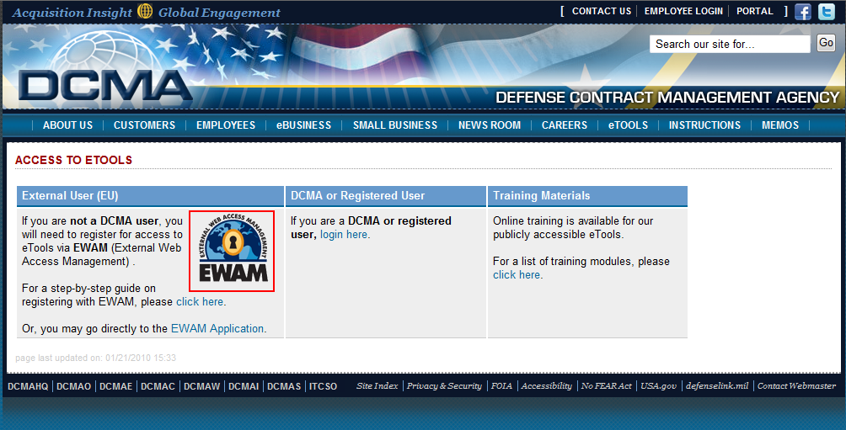
Figure 1. eTools Customer Home Page

Screen Layout
This section covers the overall look and feel of the User Interface for the EWAM application.

Header
The Header section contains the eTools logo, application Name and Version, Username, Menu bar, Help, Feedback, and Exit links (Figure 2).
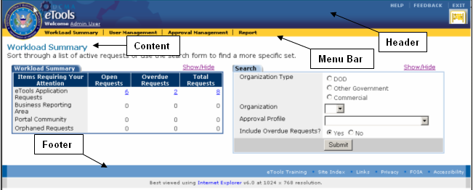
Figure 2. Screen Layout
- Branding – eTools logo and application name with version.
- Username – Displays the name of the user. Clicking on the user’s name shows the user‘s profile information.
- Help – Provides access to the applications online help files.
- Feedback – Allows user to send feedback to the applications Performance Advocate. Opens up a new message on Microsoft Outlook (or similar email client application).
- Exit – Logs users out of the application.
- Toolbar– Provides links for easy navigation throughout the application. Depending on your user role some links will not be available.
EWAM provides 5 links:
  - Approver Workload – Displays Requests awaiting action by the approver. Only available for Approvers.
  - Workload Summary – Lists all active Requests awaiting action by Approvers. Only available for Admin users.
  - User Management – Allows users to manage user information. Only available for Admin users.
  - Approval Management – Enables users to manage Profiles and Approvers. Only available for Admin users.
  - Report – Takes users to the Reports List screen for the application. Only available for Approvers and Admin users.

Content
The Content section contains the title and description of the current page and one or more data tables with information pertaining to the application presented (Figure 2).

Footer
The Footer section provides links to standard DCMA web sites (Figure 2).

Common Elements
Standard icons and indicators are used throughout the application to provide consistent behavior and improve usability.
The following are icons used on EWAM:
Icon | Name | Description
 | Edit | Edits the current record.
 | Delete | Deletes a record.
 | Add | Adds a new record.
 | Records Navigation Bar | Navigates to the next or previous records sets using the back and forward arrow keys. Navigates to the first and last record sets using the lined back and forward arrow keys. Navigates to the record sets using the drop down list.

User Roles
Three types of users will be able to use this application to create, update, and manage the request and approval system for EWAM.
Roles are defined in the following sections:

End-User
End-Users will be able to register as a new user, access the self-service central to update user profile, and request additional access.

Approver
Approvers will have all capabilities of a registered end-user, performs the task of granting user access to one or more assigned eTool applications or Portal areas, and manage user access within his or her routing visibility for the assigned application.

Administrator
Administrators will have all capabilities of an approver. In addition, Admin users will be able to perform user profile administration by adding, updating, and removing user accounts, manages approvers, access reports, and has work transfer capabilities from one approver to another.

User Tasks
This section describes the tasks of the three users (End-User, Approver, and Administrator) and explains how to execute these tasks. Tasks are readily depicted in a Process Flow Diagram (Figure 3) that shows the process of requesting access, approving requests, and management of accounts.
The process begins with the user entering their E-Mail address. The E-Mail address is verified with the database to determine if the user already exists in the system. If an account already exists, the user will be directed to the Pending Approval or Active Account Screens (Figures 5a or 5b). If an account does not exist in the system, new users will need to enter their Profile, Organization, and Application Request information on the Registration Screen (Figure 6)
The Request is submitted to the designated Approvers or Administrators. Approvers and Administrators grant access, modify and grant access, or reject access based on the user profile.
Finally, the Requestor receives a Confirmation or Rejection E-Mail.

New User Registration
Check E-Mail in the database, Enter User, Organization, Application Request Information and Submits Request.
Approver Review/Action:
(1) Grant Access
(2) Modify and Grant Access
(3) Reject Access
IDB
Updates User Access Profile in EWAM
Rejected/Approved Request Notification
Requestor Receives Confirmation or Rejection E-Mails.
Request Routed to Approver(s)
Routing is based on the user profile information and application selected. Request for applications are handled by approvers separately.
Figure 3. Process Flow Diagram

End-User

How to Register
New users accessing the system will need to enter their E-Mail address on the E-Mail Address screen (Figure 4).
- E-Mail Address – Enter a valid E-mail address. This is an alphanumeric field with a maximum length of 80 characters. Special characters are allowed. This field is validated for the correct E-Mail format (ie. Ewam@ewam.mil).
- Confirm E-Mail – Enter a valid E-Mail address. Please be sure that the E-Mail address provided in the E-Mail Address field matches the Confirm E-Mail Address field.
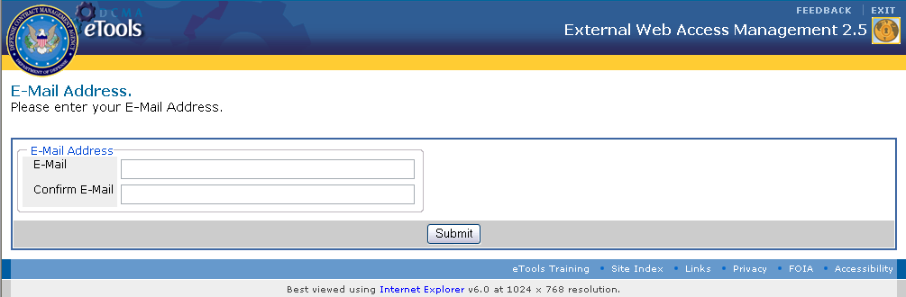
Figure 4. E-Mail Address Screen
If your E-Mail address already exists in the system but you have not been approved for your requested applications, you will be taken to Pending Account Exist screen (Figure 5a). This screen states that your account in pending approval and you will need to wait until the account has been reviewed and access determined. If your requested applications have already been approved, you will be directed to the Active Account Exist screen (Figure 5b). This screen states that your account has been approved and you can log into the application to view or modify your information.
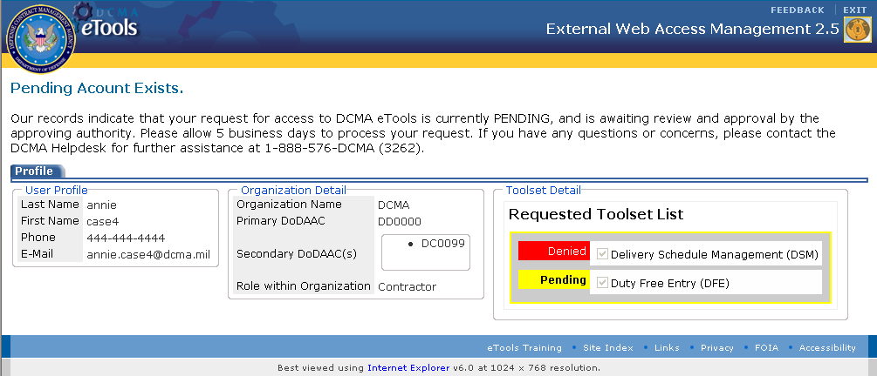
Figure 5a. Pending Account Exist Screen
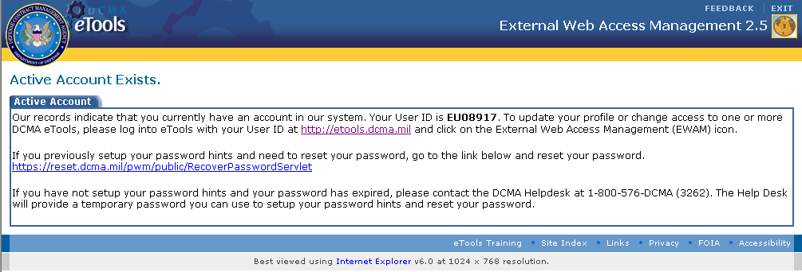
Figure 5b. Active Account Exist Screen
If the E-Mail address you entered is not in the system, you will be directed to the Registration screen (Figure 6).
On the Registration Page Profile tab, click on the Radio button to select an Organization type:
- DoD
- Other Government
- Commercial
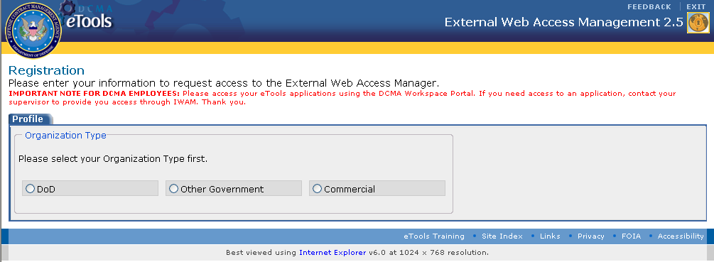
Figure 6. Registration Page
Depending on the Organization Type you selected, the User Profile information will differ.
Please refer to the DoD User Profile (Figure 7), Other Government User Profile (Figure 8), or Commercial User Profile (Figure 9) for inputs that pertain to your organization.
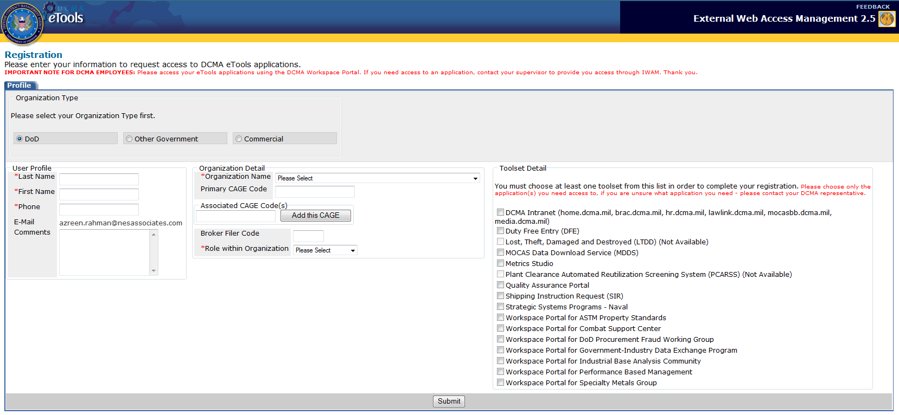
Figure 7. DoD User Profile
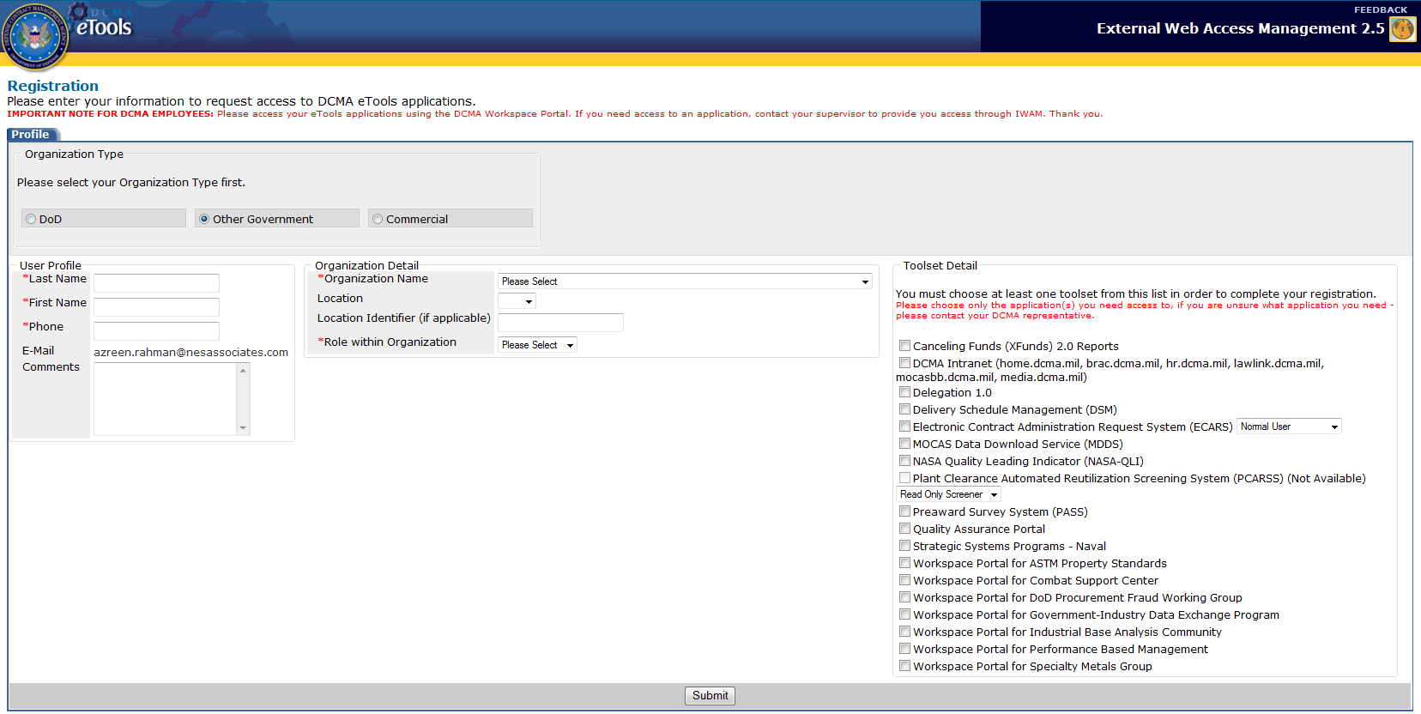
Figure 8. Other Government User Profile
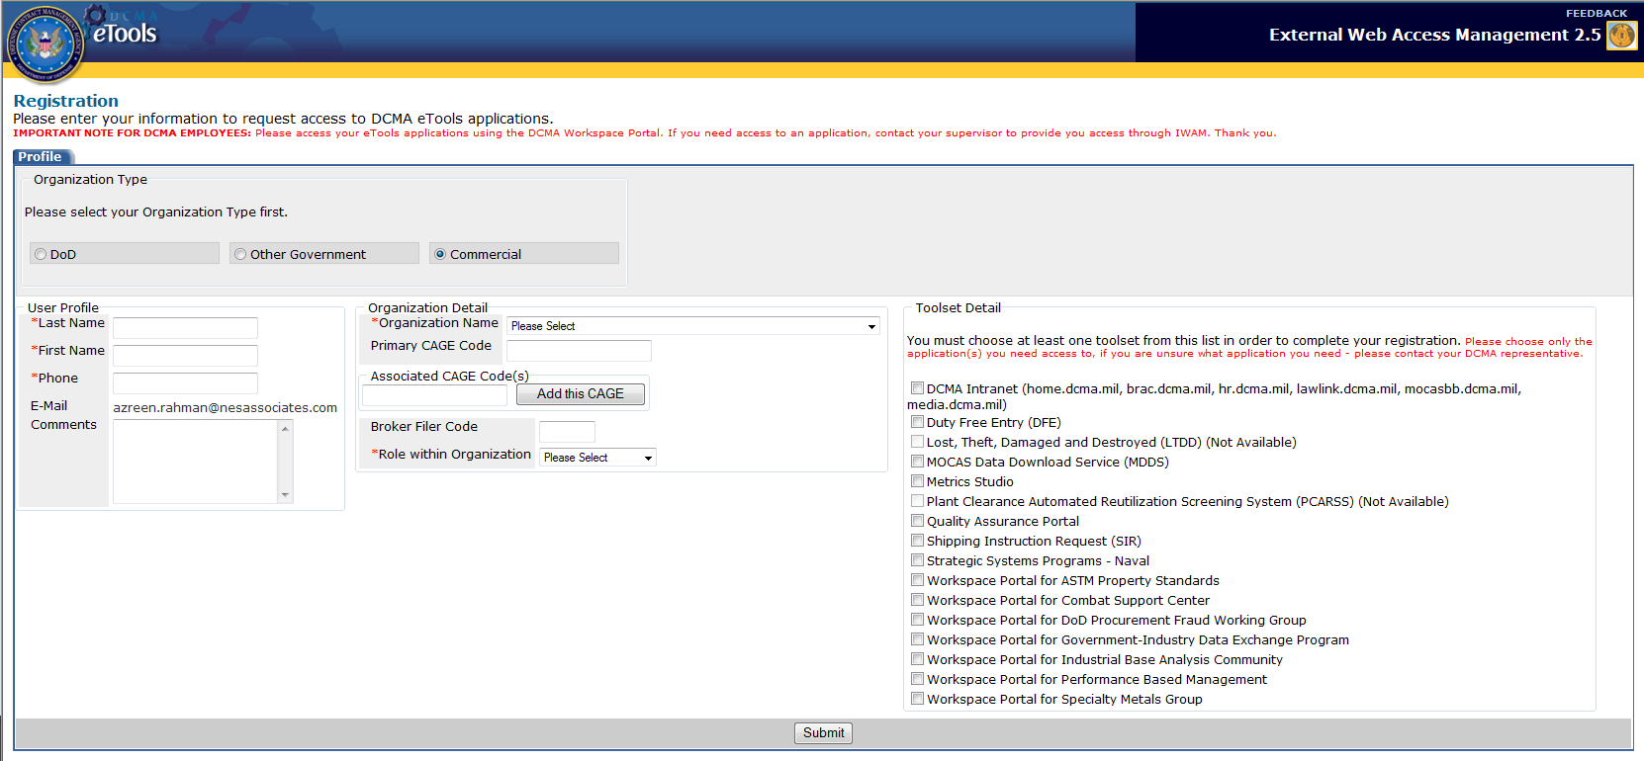
Figure 9. Commercial User Profile

DoD User Profile Input
If you are a DoD user, enter or select the following information in the respective fields.
User Profile:
Last Name | The user’s Last Name. Alphanumeric field with a maximum length of 20 characters.
First Name | The user’s First Name. Alphanumeric field with a maximum length of 18 characters.
Phone | The user’s Phone Number. Numeric field with a maximum length of 20 characters.
E-Mail | The user’s E-Mail address. Alphanumeric field with a maximum length of 80 characters. Allows special characters. Validated for the correct E-Mail format (ie. Ewam@ewam.mil).
Comments | Additional comments input. Alphanumeric field with a maximum length of 200 characters. This field will be used by the registrant to provide any additional information that may be needed by the approver.

Organization Details:
Organization Name | The name of the Organization the user belongs to. Drop-down list.
Primary DoDAAC | The user’s Primary DoDAAC. Alphanumeric field with a maximum length of 6 characters.
Secondary DoDAAC | The user’s Secondary DoDAAC. Alphanumeric field with a maximum length of 6 characters. The Add this DoDAAC button () allows users to add a secondary DoDAAC. Clicking on the Remove link ( will delete the added DoDAAC.
Role Within Organization | The user’s Role within the Organization. Drop-down list.

Toolset Detail:
Select the application you would like to request access to by clicking on the checkboxes.
Note: If you selected a Toolset that does not have an Approver set-up, ‘Not Available’ will be listed next to the application name. You will not be able to select the checkbox.
Note: If a drop-down list appears next to the Toolset selection, click on the drop-down to select the user type you are requesting access to.

Other Government User Profile Input
If you are an Other Government user, enter or select the following information in the respective fields.
User Profile:
Last Name | The user’s Last Name. Alphanumeric field with a maximum length of 20 characters.
First Name | The user’s First Name. Alphanumeric field with a maximum length of 18 characters.
Phone | User’s Phone Number. Numeric field with a maximum length of 20 characters.
E-Mail | The user’s E-Mail address. Alphanumeric field with a maximum length of 80 characters. Allows special characters. Validated for the correct E-Mail format (ie. Ewam@ewam.mil).
Comments | Additional comments input. Alphanumeric field with a maximum length of 200 characters. This field will be used by the registrant to provide any additional information that may be needed by the approver.

Organization Details:
Organization Name | The name of the Organization the user belongs to. Drop-down list.
Location | The Location of the Organization. Drop-down list.
Location Identifier | The Location identifier. There will be no value in this field unless the Location is NASA. If so, this field is a Drop-down list.
Role Within Organization | The user’s Role within the Organization. Drop-down list.

Toolset Detail:
Select the application you would like to request access to by clicking on the checkboxes.
Note: If you selected a Toolset that does not have an Approver set-up, ‘Not Available’ will be listed next to the application name. You will not be able to select the checkbox.
Note: If a drop-down list appears next to the Toolset selection, click on the drop-down to select the user type you are requesting access to.

Commercial User Profile Input
If you are a Commercial user, enter or select the following information in the respective fields.

User Profile:
Last Name | The user’s Last Name. Alphanumeric field with a maximum length of 20 characters.
First Name | The user’s First Name. Alphanumeric field with a maximum length of 18 characters
E-Mail | The user’s E-Mail address. Alphanumeric field with a maximum length of 80 characters. Allows special characters. Validated for the correct E-Mail format (ie. Ewam@ewam.mil).
Phone | The user’s Phone Number. Numeric field with a maximum length of 20 characters.
Comments | Additional comments input. Alphanumeric field with a maximum length of 200 characters. This field will be used by the registrant to provide any additional information that may be needed by the approver.

Organization Details:
Organization Name | The name of the Organization the user belongs to. Drop-down list.
Primary CAGE Code | User’s Primary CAGE. Alphanumeric field with a maximum length of 5 characters.
Associated CAGE Codes | User’s Associated CAGE Code. Alphanumeric field with a maximum length of 5 characters. The Add this CAGE button () allows users to add an associated CAGE Code. Clicking on the Remove link ( will delete the added CAGE Code.
Broker Filer Code | Enter this field if you do not have a Primary CAGE Code. Alphanumeric field with a maximum length of 3 characters.
Role Within Organization | The user’s Role within the Organization. Drop-down list.

Toolset Detail:
Select the application you would like to request access to by clicking on the checkboxes.
Note: If you selected a Toolset that does not have an Approver set-up, ‘Not Available’ will be listed next to the application name. You will not be able to select the checkbox.
Note: If a drop-down list appears next to the Toolset selection, click on the drop-down to select the user type you are requesting access to.

Once you have entered the relevant information on the Registration page, click on the Submit button .
You will be directed to the Confirmation Page (Figure 10).
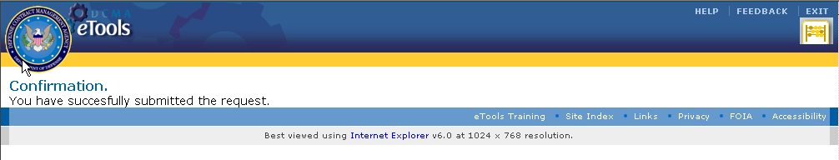
Figure 10. Confirmation Page

Registration Approval and Rejection E-Mail
Once you have submitted your request, you will receive either an Approval or Rejection E-Mail.
If you received the Approval E-Mail, use the Username and Password provided in the E-Mail to login to eTools.
If you received a Rejection E-Mail please observe the rejection reason. If you feel that your request has been rejected in error, please contact DCMA Help Desk at 1-888-576-DCMA (3262) for further assistance.

How to Modify User Profile
Once you receive your account information login to http://etools.dcma.mil. Click on the EWAM icon on your Portal Page. You will be directed to the EWAM Update page (Figure 11). You can enter updates to your User Profile, Organization Detail, and Application Detail on this screen. Under the Application Detail section, you will be able to view applications that are pending approval and application that are available for request.
Once you have completed entering the relevant edits, click on the Submit button (). A Confirmation Page (Figure 10) will appear after you submit the updates.
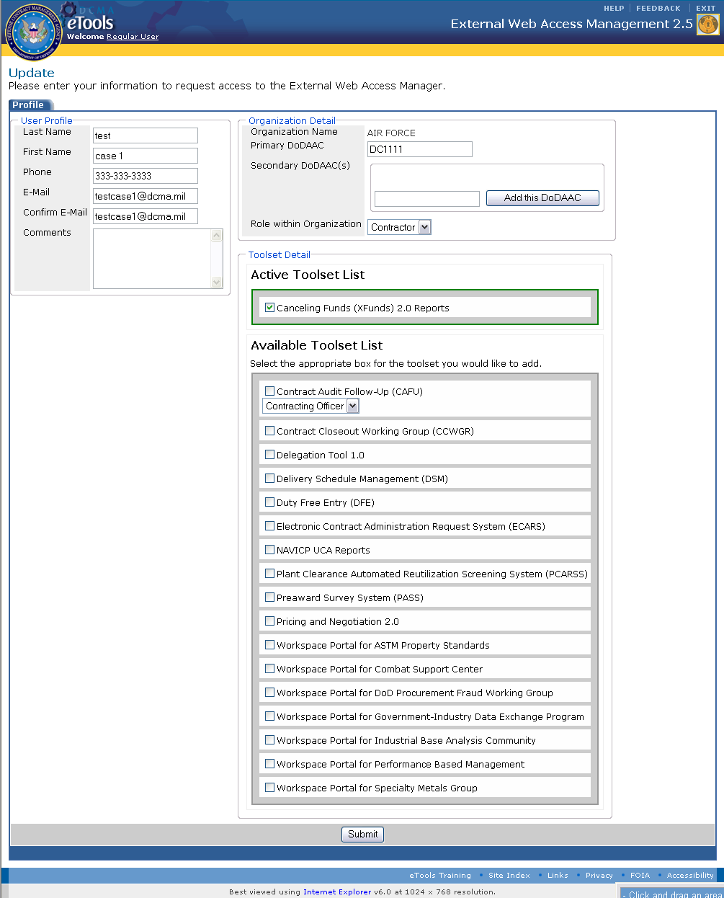 Figure 11. EWAM Update Page

Approver
Once a request has been submitted by the End-User, it is the role of the Approver to review the request and either Approve or Reject the Request.
To access the EWAM application, login to http://etools.dcma.mil and click on the EWAM icon on the eTools portal page.
You will be directed to the EWAM Approver Workload Page (Figure 12). You can also click on the Approver Workload link () on the application toolbar to get to this screen.

Tab and Column Descriptions

Tabs
Search Tab – Allows users to search for a particular Request based the Organization Type, Organization, Approval Profile, or Overdue Requests. Clicking on the Show/Hide link () will either collapse or expand the Search tab.

Open Requests Tab – Displays all Requests that are pending Approval or Rejection. The user information is displayed in the data table within the tab.
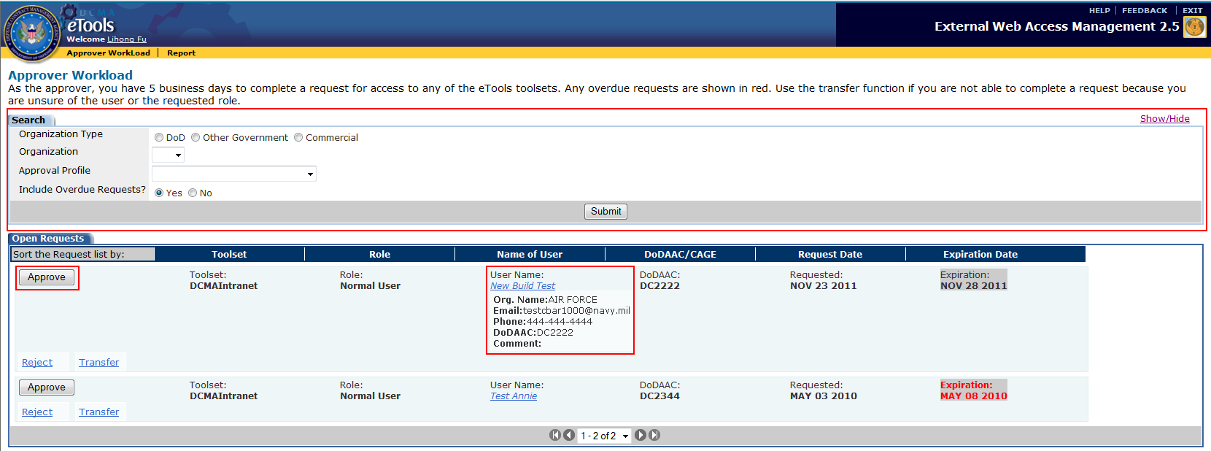
Figure 12. Approver Workload Page

Columns

Open Requests Tab Column Description:
Action | Contains the Approve button (), Reject link (), and Transfer link (). Approvers can perform application related actions using the button and links within this column.
Toolset | Displays the End-Users requested toolset.
Role | Shows the End-Users Role within the organization.
Name of User | Displays the user’s name. Clicking on the hyperlink displays additional information about the user.
DoDAAC/CAGE | Displays the DoDAAC, CAGE, or Filer for the user requesting access.
Request Date | Displays the Date the Request was submitted for approval.
Expiration Date | Shows the approval deadline for the Request.

Search Request
The Search Tab on the Approver Workload Page (Figure 12) allows users to search for a particular Request. Select or enter any or all of the inputs below to initiate the search.

Search Tab Field Descriptions:
Organization Type | Search by the user’s Organization Type. Radio button.
Organization | Search by the user’s Organization Name. Drop-down list.
Approval Profile | Search by the approval profile. Drop-down list.
Include Overdue Request? | Search for overdue requests. Radio button.
Once you have entered the search criteria, click on the Submit button () to generate your query. The results to your search will appear on the Search Results Tab below (Figure 13)

Search Results Tab Column Description:
Action | Allows users to perform certain Actions for the selected request. Users can Approve, Reject, or Transfer the request.
Toolset | Lists the Tools the user is requesting access to.
Role | Identifies the Role the user would access the requested toolset as.
Name of User | Displays the user’s name. Clicking on the hyperlink displays additional information about the user.
DoDAAC/CAGE | Displays the DoDAAC, CAGE, or Filer for the user requesting access.
Request Date | Shows the request submission Date.
Expiration Date | Displays the request approval deadline.

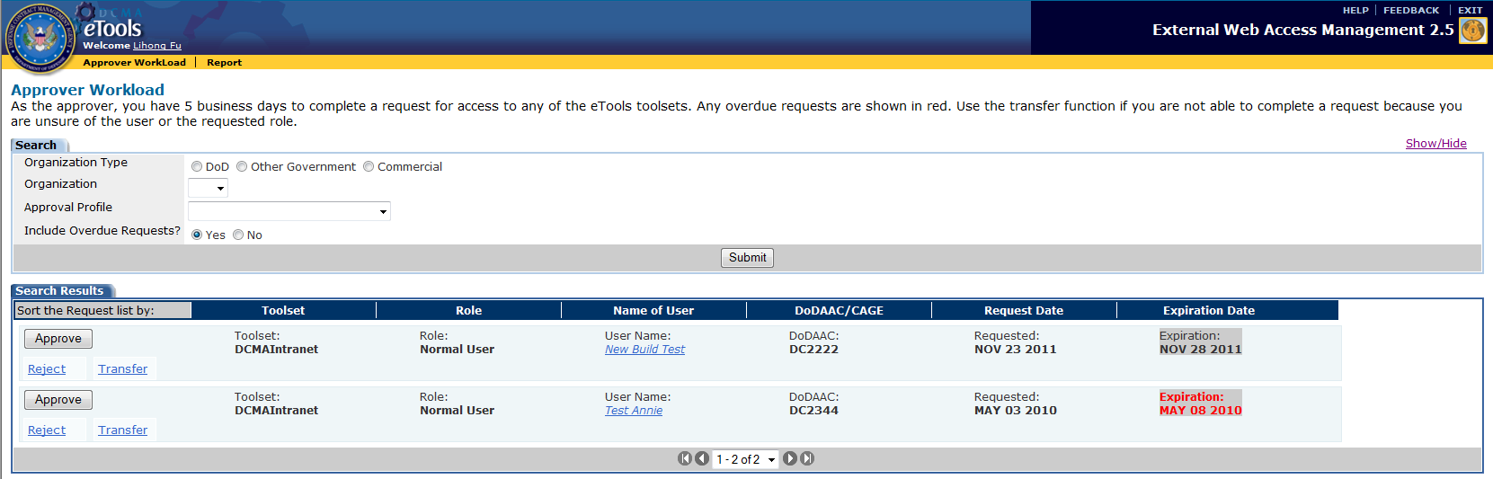
Figure 13. Approver Workload Page (Search Results Tab)

Approve Request
After reviewing the user request, click on the Approve button () within the Action column on the Approver Workload Page (Figure 12). The approved Request will no longer appear on the Approver Workload Open Requests Tab. The user will receive an Approval E-Mail with the Username and Password for eTools access.

Reject Request
Once you have reviewed the user information and would like to reject the request, click on the Reject link () within the Action column on the Approver Workload Page (Figure 14 ).
A Rejection Comments text box will appear below the rejected request (Figure 14). Enter the rejection reason in the Comments text box and click on the Reject Button ().
The request will no longer appear on the Approver Workload Open Requests Tab. The user will receive a Rejection E-Mail stating the rejection reason.
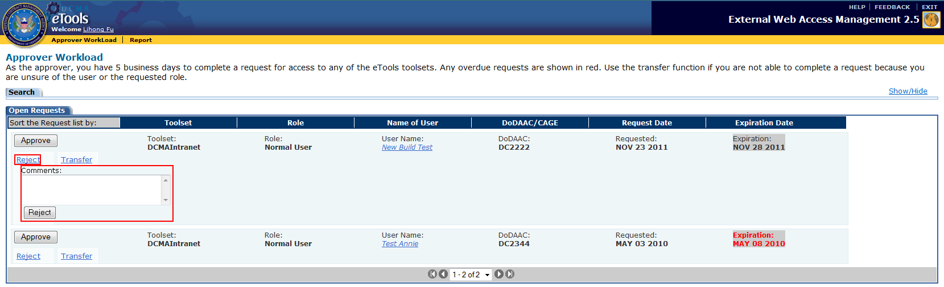
Figure 14. Approver Workload Page (Reject)

Transfer Request
If you would like to transfer a request to another Approver, click on the Transfer link () within the Action column on the Approver Workload Page (Figure 15). A Transfer drop-down list will appear below the request (Figure 15). Select the Approver you would like to transfer the request to a click on the Do It Button (). The request will no longer appear on your Approver Workload Open Requests Tab but will be transferred to the selected Approver’s Workload Page.
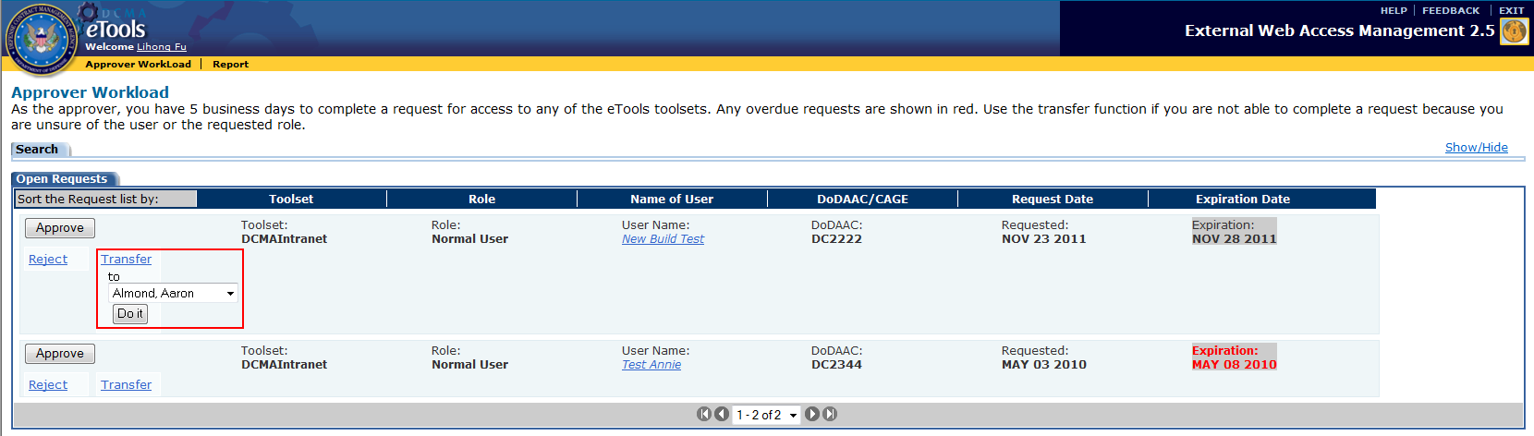
Figure 15. Approver Workload Page (Transfer)

Administrator
To access the EWAM application, login to http://etools.dcma.mil and click on the EWAM icon the eTools portal page.
You will be directed to the EWAM Workload Summary Page (Figure 16).
The Administrator performs several functions. These functions are described in the sections below.
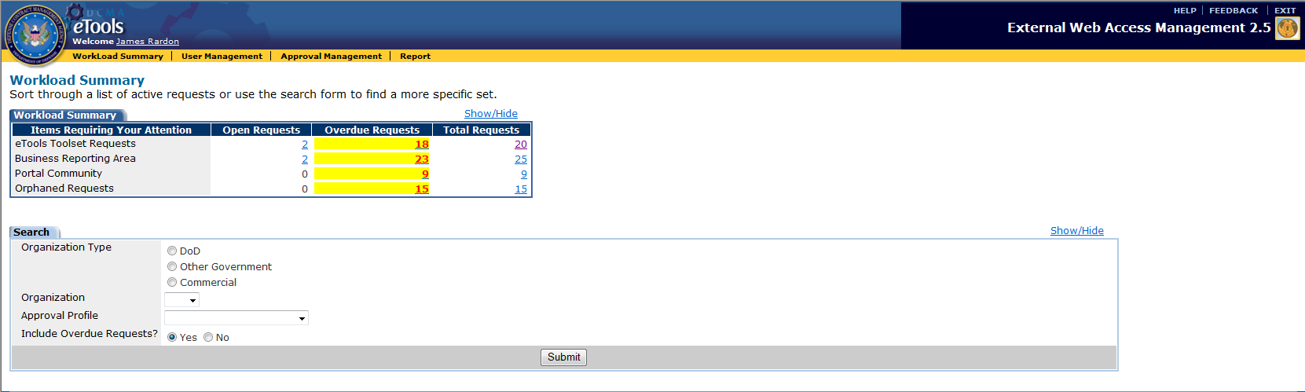
Figure 16. Workload Summary Page

View Workload Summary
The Workload Summary Page contains a list of active requests awaiting approval by the Admin user. This page also contains a request search area to locate specific user request.

Tab and Column Descriptions

Tabs

Workload Summary Tab - Displays Open, Overdue, and the Total number of Requests awaiting action. Click on the number hyperlinks to see the requests. Click on the Show/Hide link () to either collapse or expand the tab.

Search Tab – Allows Admin users to search for a specific request. . Clicking on the Show/Hide link () will either collapse or expand the tab.

Columns

Workload Summary Column Descriptions:
Items Requiring your Attention | Displays the areas available for access within the DCMA eTools Infrastructure.
Open Requests | Presents the number of open requests awaiting approval.
Overdue Requests | Shows the number of overdue requests awaiting approval.
Total Requests | Displays the total number of requests awaiting action.

Search Requests
The Search Tab on the Workload Summary Page (Figure 16) allows users to search for a particular request. Select or enter any or all of the inputs below to initiate the search.

Search Tab Field Description:
Organization Type | Search by the type of Organization the user belongs to. Radio button.
Organization | Search by the Organization Name. Drop-down list.
Approval Profile | Search by the approval profile.
Include Overdue Request? | Includes overdue requests in the search results. Radio button.
Once you have entered the search criteria, click on the Submit button () to generate your query. The results to your search will appear on the Search Results Tab below (Figure 17)

Search Results Tab Column Description:
Action | Allows users to perform certain Actions for the selected request. Users can Approve, Reject, or Transfer the request.
Toolset | Lists the Tools the user is requesting access to.
Role | Identifies the Role the user would access the requested toolset as.
Name of User | Displays the user’s name. Clicking on the hyperlink displays additional information about the user.
DoDAAC/CAGE | Displays the DoDAAC, CAGE, or Filer for the user requesting access.
Request Date | Shows the request submission Date.
Expiration Date | Displays the request approval deadline.

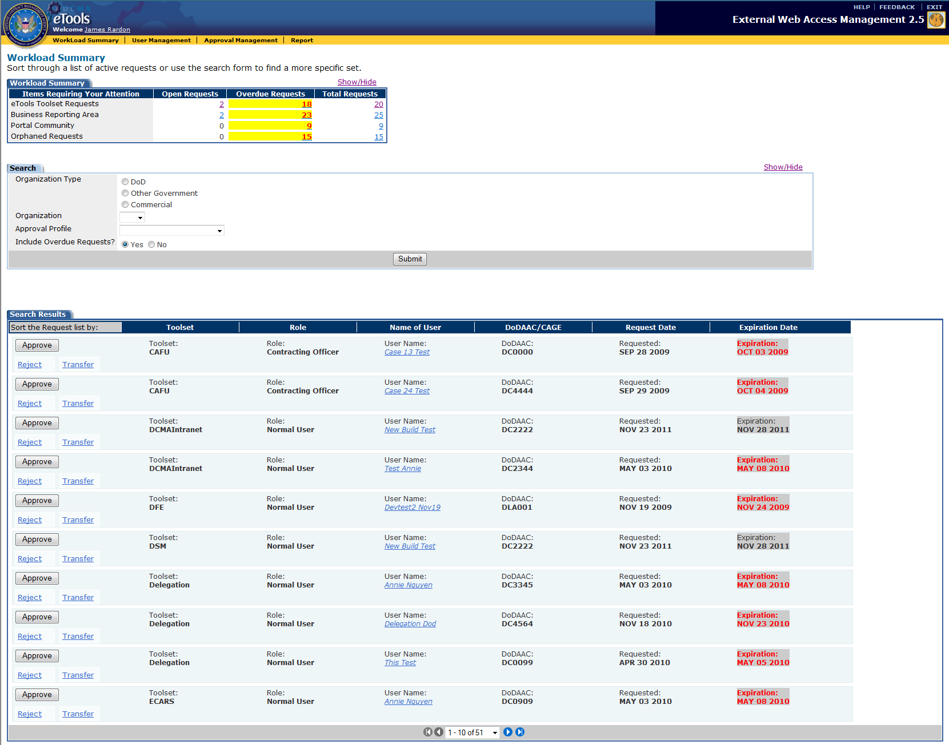
Figure 17. Workload Summary Page (Search Results Tab)

Approve Requests
If you would like to approve a submitted request, click on the number hyperlink in the Open or Overdue Request columns on the Workload Summary Tab within the Workload Summary Page (Figure 16). The Open Request Tab will appear below (Figure 18).

Open Request Tab Column Description:
Action | Allows users to perform certain Actions for the selected request. Users can Approve, Reject, or Transfer the request.
Toolset | Lists the Tools the user is requesting access to.
Role | Identifies the Role the user would access the requested toolset as.
Name of User | Displays the user’s name. Clicking on the hyperlink displays additional information about the user.
DoDAAC/CAGE | Displays the DoDAAC, CAGE, or Filer for the user requesting access.
Request Date | Shows the request submission Date.
Expiration Date | Displays the request approval deadline.

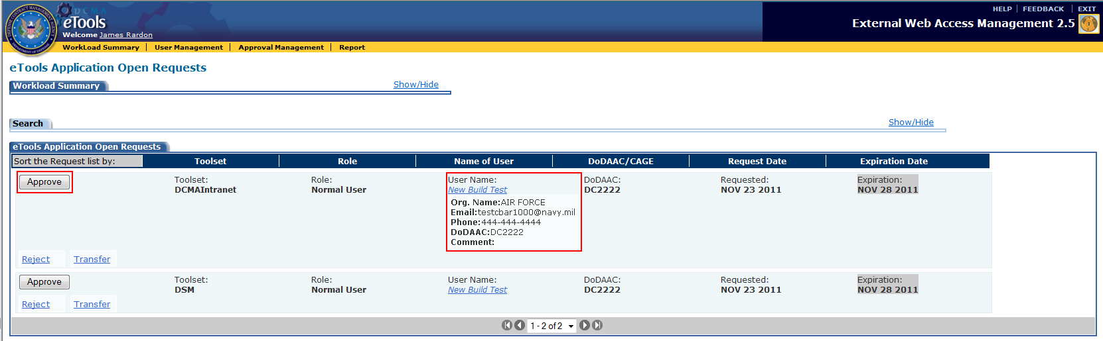
Figure 18. Workload Summary Page (Open Request Tab)
After reviewing the user request, click on the Approve button () within the Action column. The approved request will no longer appear on the Admin Workload Open Requests Tab. The user will receive an Approval E-Mail with the Username and Password for eTools access.

Reject Requests
If you need to reject a submitted request, click on the number hyperlink in the Open or Overdue Request columns on the Workload Summary Tab within the Workload Summary Page (Figure 16). The Open Request Tab will appear below (Figure19).

Once you have reviewed the user information and would like to reject the request, click on the Reject link () within the Action column. A Rejection Comments text box will appear below the rejected request (Figure19). Enter the Rejection Reason in the Comments text box and click on the Reject Button ().

The request will no longer appear on the Workload Open Requests Tab. The user will receive an EWAM Rejection E-Mail stating the rejection reason.
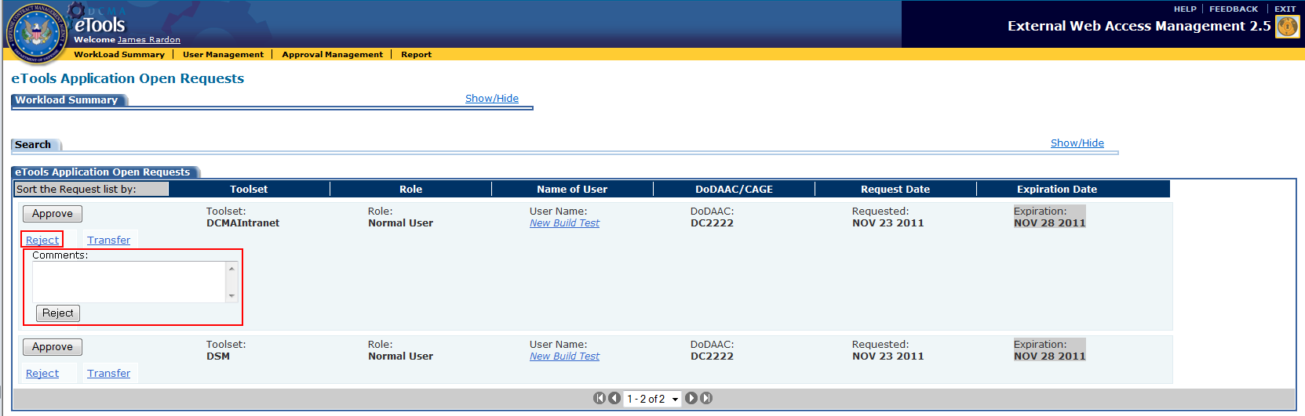
Figure 19. Workload Summary Page (Reject)

Transfer Requests
If you need to transfer a submitted request, click on the number hyperlink in the Open or Overdue Request columns on the Workload Summary Tab within the Workload Summary Page (Figure 16). The Open Request Tab will appear below (Figure 20).
If you would like to transfer a request to another Approver, click on the Transfer link () within the Action column. A Transfer drop-down list will appear below the request (Figure 20). Select the Approver you would like to transfer the request to and click on the Do It Button (). The request will no longer appear on your Workload Open Requests Tab but will be transferred to the selected Approver’s Workload page.
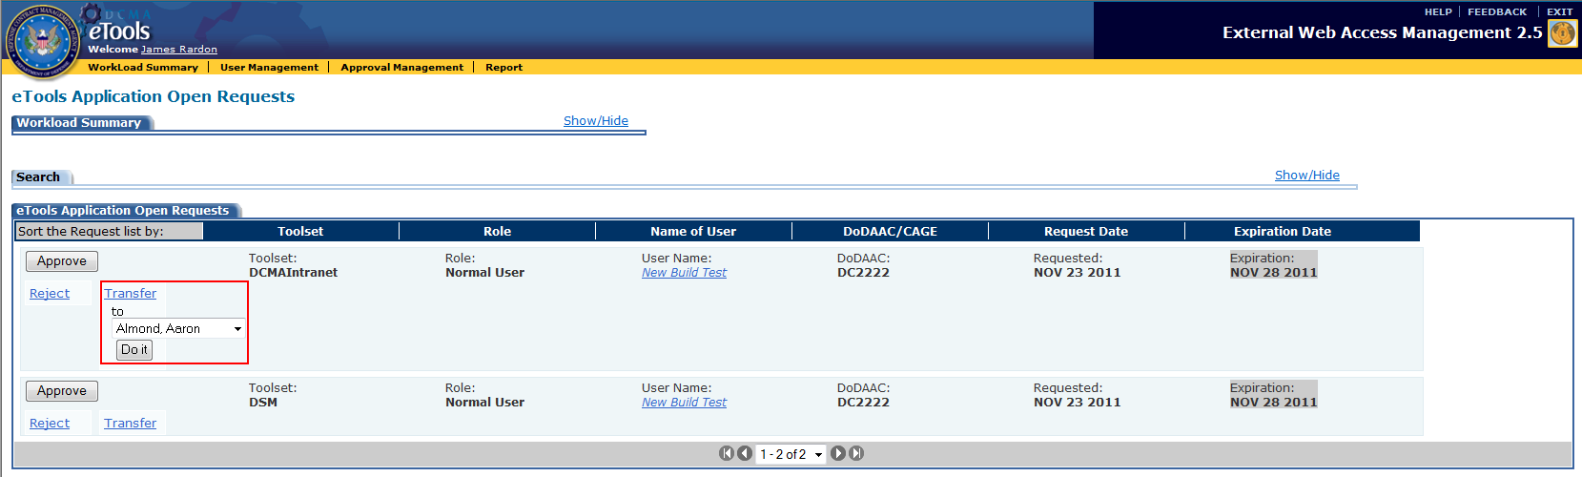
Figure 20. Workload Summary Page (Transfer)

Perform User Management
The User Management section in EWAM allows Admin users to search for a particular external user based on the user’s organization information, and request status.
To begin editing user profiles click on the User Management link () on the application toolbar to be directed to the User Management Page (Figure 21).

Search Request
Using the Search Tab, users will be able to search for a particular user. Select or enter any or all of the search criteria below to generate the search.
Search Tab Field Description:
User Information:
First Name | Search by the user’s First Name.
Last Name | Search by the user’s Last Name.
User ID | Search by the user’s User ID.
E-Mail | Search by the user’s E-Mail address.

DCMA Information:
Organization Type | Search by Organization type. Radio buttons.
Organization | Search by Organization Name. Drop-down list.
DoDAAC | Search by DoDAAC number.
CAGE | Search by CAGE Code.

Miscellaneous Information:
Open Request | Search for open requests. Radio button.
Filter on Approval Profile | Search by approval profile.

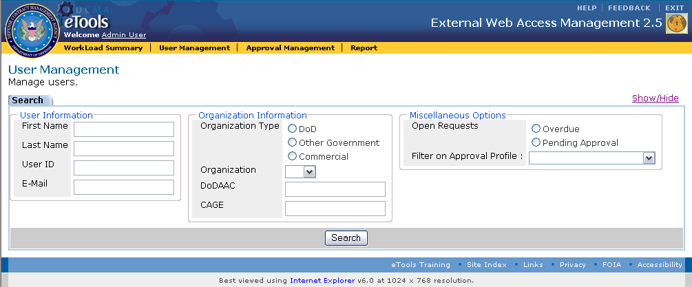
Figure 21. User Management Page
Click on the Search button () to initiate the query. The Search Results Tab (Figure 22) will appear below displaying the records that match your query.

Search Results Column Description:
Action | Allows user to either edit or delete a particular user.
Username | Displays the Name of the user.
Organization | Identifies the Organization the user belongs to.
Last Login | Shows the most recent login date.

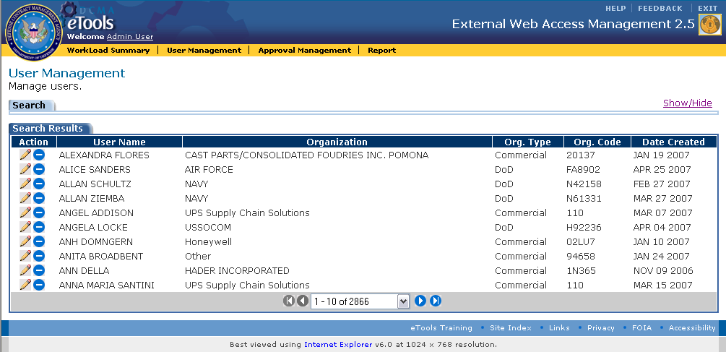
Figure 22. User Management Page (Search Results Tab)

Edit User
After locating the user you would like to edit, click on the edit icon () on the User Management Page Search Results Tab (Figure 22) to modify the selected user profile. You will be directed to the User Management Page Profile Tab (Figure 23). In this section, Admin users will be able to edit User Profile, Organization Detail, and Application Detail information.
Note: Please refer to sections 6.1.1.1, 6.1.1.2, and 6.1.1.3 for DOD, Other-Government, and Commercial Profile input field descriptions.
Enter the relevant edits to the user profile and click on the Submit button (). You will be directed back to the User Management Page Search Results Tab (Figure 23) reflecting the updates to the edited profile.
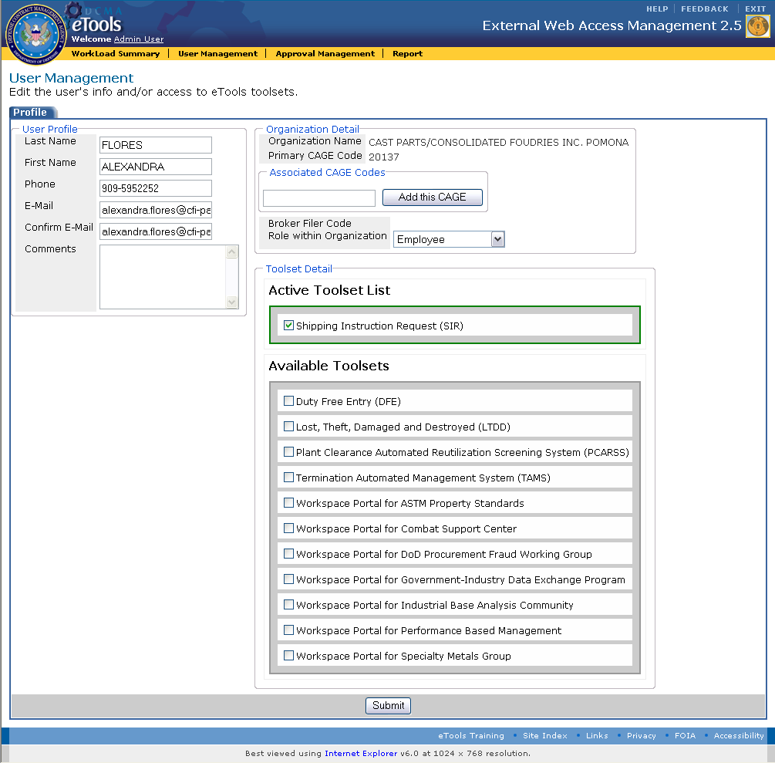
Figure 23. User Management Page (Profile Tab)

Delete User
Admin users will be able to delete external users that should no longer be on the system. If you would like to delete a particular user, click on the delete icon () on the User Management Page Search Results Tab (Figure 22).
A Delete Confirmation alert will appear (Figure 24). Click on the ‘Confirm this Delete’ link to proceed with the deletion. The Cancel link will countdown to 10 seconds before automatically aborting the delete action. To cancel the deletion prior to the end of the countdown, click on the Cancel link.

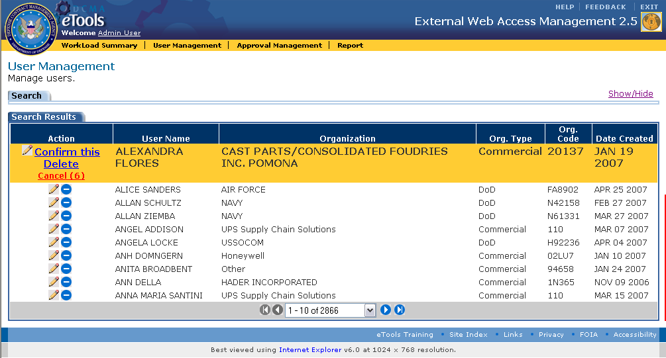
Figure 24. User Management Page (Search Results Tab Delete Confirmation)

Perform Approval Profile Management
The Approval Management section in EWAM allows Admin users to manage Profiles and Approvers.
If you would like to begin managing Profiles and Approvers, click on the Approval Management link () on the application toolbar. You will be directed to the Approval Management Page (Figure 25). This section allows Admin users to add, delete, and edit profile and approvers.
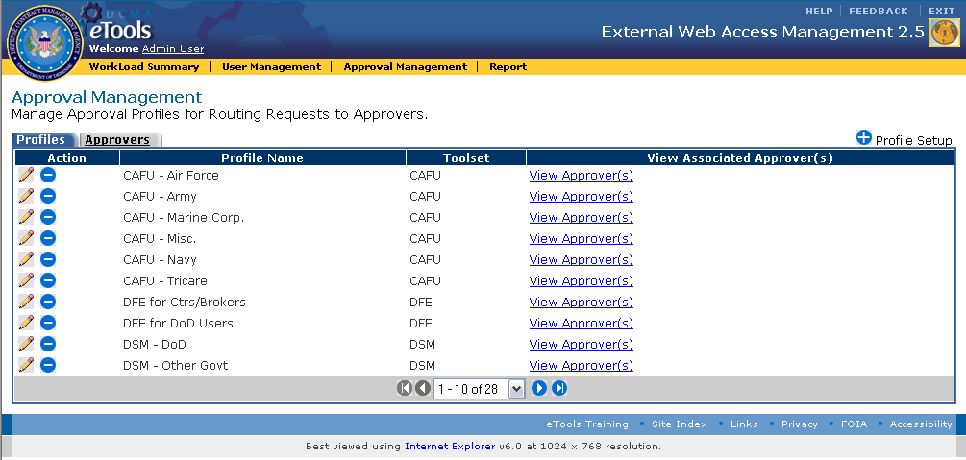
Figure 25. Approval Management Page

Add, Edit, and Delete Approval Profiles
The Approval Management Profiles Tab displays the profiles created based on a certain set of attributes. Attributes associated to the profile help route requests to a specific approver.
Profile Tab Column Description:
Action | Allows user to either edit or delete a selected profile.
Profile Name | Specifies the name of the profiles.
Toolset | Identifies the toolset the profiles are associated to.
View Associated Approver(s) | Displays the approver associated to the profiles. Clicking on the view approver link displays the approvers on the bottom of the Profiles tab. *Please see sections 6.3.3.2 for further illustration.

Add Approval Profile
If you would like to set up a profile, click on the add icon () located to the right of the Profiles Tab on the Approval Management Page (Figure 25).
You will be directed to the Approval Management New Profile Setup Tab (Figure 26). Enter or select the information below.
New Profile Setup Field Descriptions:
Profile Name | The name of the Profile. Alphanumeric field with a maximum length of 100 characters.
Toolset | Displays the available toolsets. Drop-down list.
Approver | Shows a list of available approvers. Drop-down list.
Once you have completed entering the information, click on the Submit button (). You will be directed to the Approval Management Page Edit Profile Tab (Figure 27).
*Follow the same steps illustrated in Sections 6.3.3.1.2 to edit profile attributes.
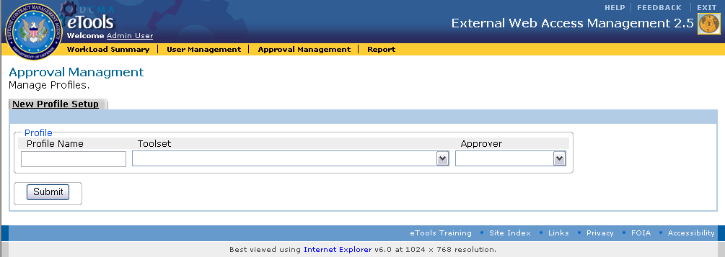
Figure 26. Approval Management Page (New Profile Setup Tab)

Edit Approval Profile
If you would like to edit a profile, click on the edit icon () for the selected record. You will be directed to the Approval Management Page Edit Profile Tab (Figure 27). The section above the drop-down list displays the attributes already associated to the profile (if there are any approval-profile roles already configured for this profile).

To add additional attributes, select a specific Profile Attribute Type from the drop-down list and click on the Add button (). Based on the attribute selected, another selection field will appear to allow you to further specify the attribute characteristic. Click on the Add button () until you complete the process.
For example, if you selected ‘Role’ from the Profile Attribute Type drop-down list, you must specify the exact role such as, Contracting Officer, HQ Monitor, or Normal User (Figure 28).

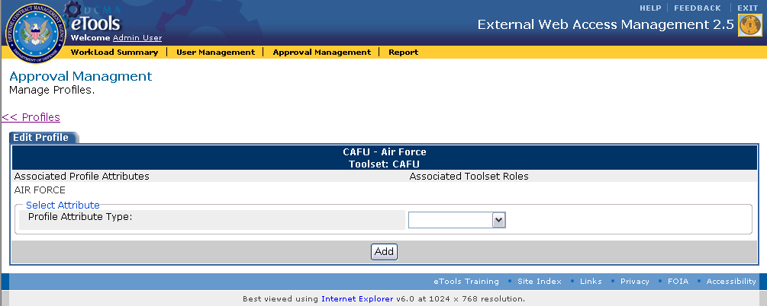
Figure 27. Approval Management Page (Edit Profile Tab)

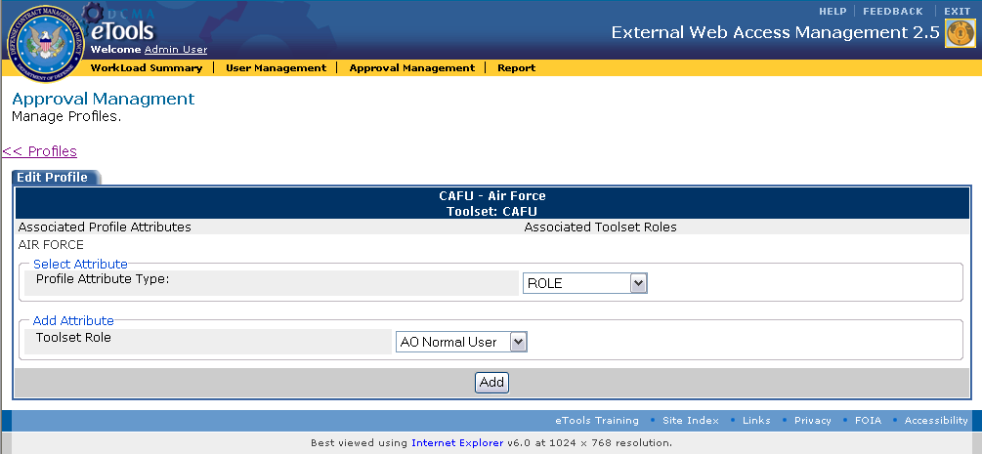
Figure 28. Approval Management Page (Edit Profile Tab Attribute Selection)
Click on the Profiles link () located above the Edit Profiles Tab to go back to the Approval Management Page (Figure 25).

Delete Approval Profile
If you would like to delete a profile, click on the delete icon () for the selected record on the Approval Management Page (Figure 25). A Delete Confirmation alert will appear (Figure 29).
Click on the ‘Confirm this Delete’ link to proceed with the deletion.
The Cancel link will countdown to 10 seconds before automatically aborting the delete action. To cancel the deletion prior to the end of the countdown, click on the Cancel link.
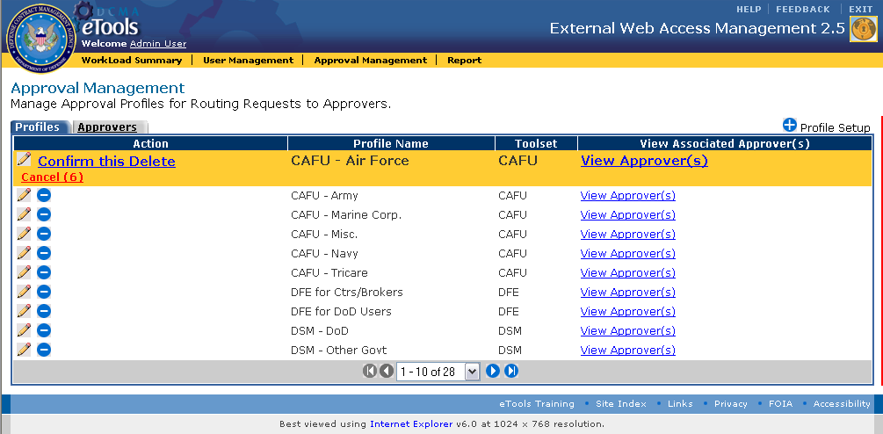
Figure 29. Approval Management Page (Profile Tab Delete Confirmation)

View Approvers
If you would like to view Approvers associated to a particular Profile, click on the View Approver link under the View Associated Approver(s) column of the Approval Management Page Profiles Tab (Figure 25).
You will see a list of associated Approvers below the Profiles Tab (Figure 30). Use the delete () or add icons () located below the Profiles Tab to delete or add an approver to the selected profile.
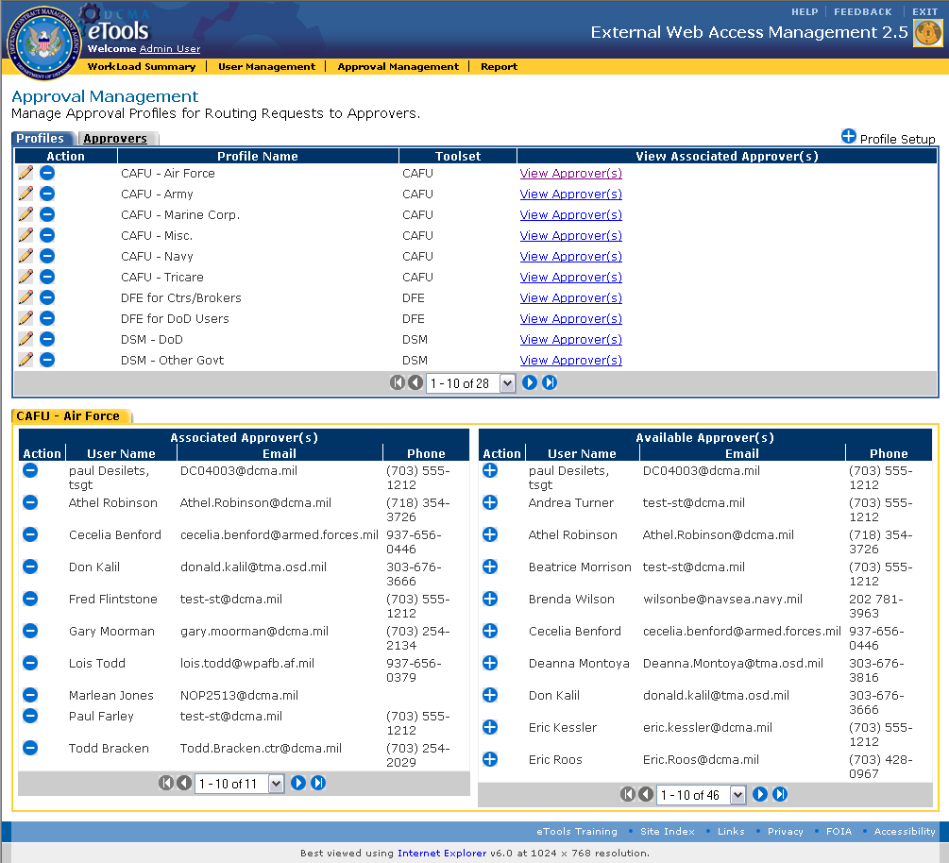
Figure 30. Approval Management Page (Profiles Tab Approver View)

Add and Delete Approvers
The Approval Management Approvers Tab displays the approvers created for each application area. Requests will be routed to the Approvers you create based on the attributes you specify in the profiles section.
To manage Approvers, click on the Approval Management link () on the application toolbar and select the Approvers Tab to be directed to the Approval Management Page Approvers Tab (Figure 31).
This section allows Admin users to delete and Add Approvers.
Approvers Tab Column Description:
Action | Allows users to delete a selected approver.
Username | Displays the approver’s Name.
E-Mail | Shows the user’s E-Mail address.
Telephone | Displays the user’s Telephone Number.
View Associated Profile | Displays the profiles associated with the approvers. Clicking on the view associated profile link displays the profiles on the bottom of the Approvers tab. *See sections 6.3.3.4 for further illustration.

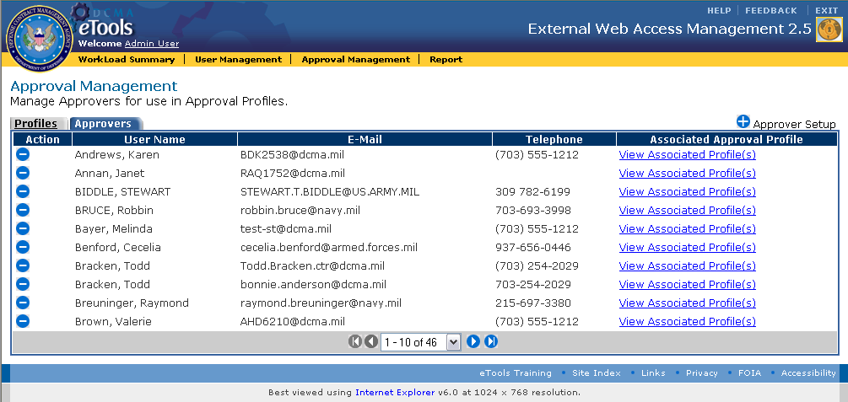
Figure 31. Approval Management Page (Approvers Tab)

Add Approver
To set up an approver, click on the Approver Setup icon () located to the right of the Approvers Tab on the Approval Management Page Approvers Tab (Figure 31).
You will be directed to the Approval Management Page Approvers Results Tab (Figure 32).

Results Tab Column Descriptions:
Action | Allows users to add a profile to an approver.
User Name | Displays the Approver’s Name.
E-Mail | Shows the Approver’s E-Mail address.
Telephone | Displays the Approver’s Telephone Number.
Profile to Assign To | Allows users to assign a Profile to an Approver. Drop-down list.

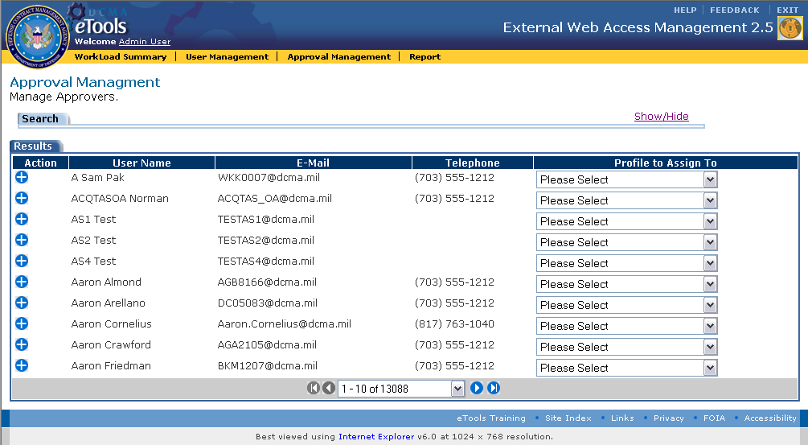
Figure 32. Approval Management Page (Approvers Results Tab)
To assign profiles to approvers, select the Profiles using the drop down list under the Profile to Assign To column for the selected Approver and click on the add icon (). You will be directed to the Approval Management Confirmation Page (Figure 33).

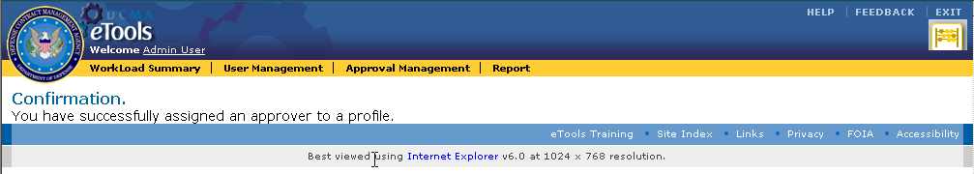
Figure 33. Approval Management Confirmation Page

Delete Approver
If you would like to delete an approver, click on the delete icon () for the selected approver on the Approval Management Page Approvers Tab (Figure 31). A Delete Confirmation alert will appear (Figure 34). Click on the ‘Confirm this Delete’ link to proceed with the deletion.

The Cancel link will countdown from 10 seconds before automatically aborting the delete action. To cancel the deletion prior to the end of the countdown, click on the Cancel link.
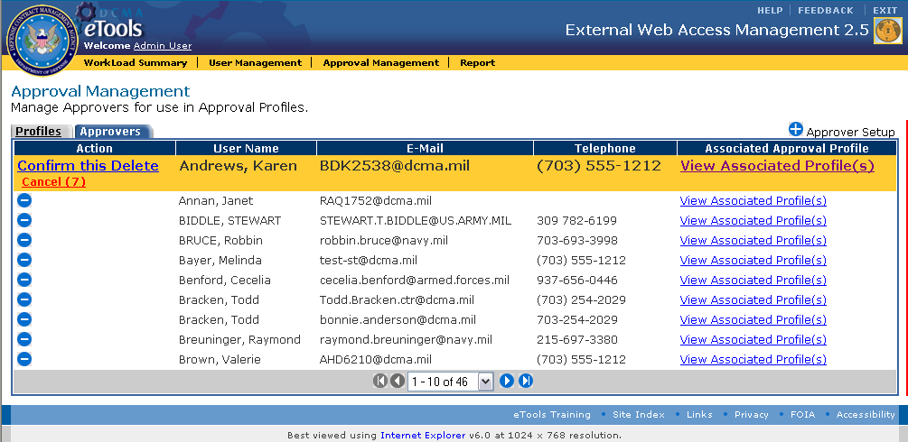
Figure 34. Approval Management Page (Approvers Tab Delete Confirmation)

View Profiles
To view Profiles associated with a particular Approver, click on the View Associated Profiles link under the Associated Approval Profile column of the Approval Management Page Approvers Tab (Figure 31).
You will see a list of Profiles associated with the Approver below the Approvers Tab (Figure 35).
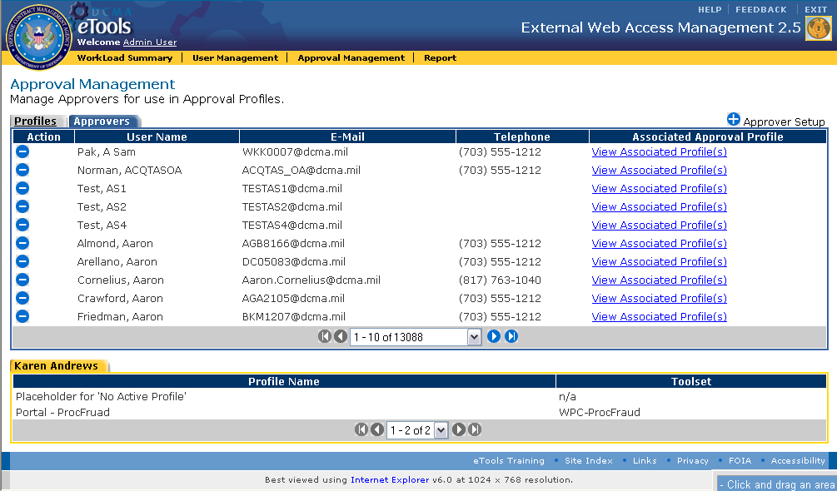
Figure 35. Approval Management Page (Approvers Tab Profile View)

Reports
For Approvers and Administrators, reports containing relevant information are available within every section of the EWAM application. Clicking on the Reports link () on the application toolbar launches the reports interface.

Glossary
List of Acronyms and Abbreviations used in the EWAM application are listed below.
DCMA | Defense Contract Management Agency
DoD | Department of Defense
eTools | Electronic Tools
EWAM | External Web Access Management

