

Form 1 Tracking Version 1.0

Application Users Manual

July 2011

Table of Contents

[1.0 Introduction 4](#_Toc301201284)

[2.0 Navigation Elements 5](#_Toc301201285)

[3.0 User Task Process Flows 7](#_Toc301201286)

[3.1 “Suspended” Form 1 Issued by DCAA 7](#_Toc301201287)

[3.2 “Suspended” Form 1 Issued by DCMA 9](#_Toc301201288)

[3.3 “Disapproved” Form 1 Issued by DCAA 11](#_Toc301201289)

[3.4 “Disapproved” Form 1 Issued by DCMA 13](#_Toc301201290)

[4.0 User Roles 14](#_Toc301201291)

[4.1 External Customers: 14](#_Toc301201292)

[4.1.2 DCAA Auditor 14](#_Toc301201294)

[4.1.3 DCAA Supervisor 14](#_Toc301201295)

[4.1.4 DCAA FAO Reviewer 14](#_Toc301201296)

[4.1.5 DCAA Regional Reviewer 14](#_Toc301201297)

[4.1.6 DCAA Administrator 15](#_Toc301201298)

[4.2 Internal Customers 15](#_Toc301201299)

[4.2.1 DCMA ACO 15](#_Toc301201300)

[4.2.2 DCMA Reviewer 15](#_Toc301201301)

[4.2.3 DCMA Region/HQ Personnel 15](#_Toc301201302)

[4.2.4 DCMA Administrator 15](#_Toc301201303)

[5.0 External DoD Customer User Role Tasks 16](#_Toc301201304)

[5.1 External DoD User, DCAA Auditor Home page 16](#_Toc301201305)

[5.2 “My Workload” Page 16](#_Toc301201306)

[5.3 DCAA Auditor Creates a Form 1 17](#_Toc301201307)

[5.3.1 DCAA Auditor Views and Finalizes a Form 1 20](#_Toc301201308)

[5.4 DCAA Supervisor Reviews/Approves Form 1 21](#_Toc301201310)

[5.5 DCAA FAO Reviewer Reviews/Approves Form 1 23](#_Toc301201311)

[5.6 DCAA Regional Reviewer Reviews/Approves Form 1 25](#_Toc301201312)

[5.7 DCAA Supervisor Finalizes/Submits Form 1 27](#_Toc301201313)

[5.7.1 DCAA Supervisor Prints Form 1 29](#_Toc301201314)

[5.8 DCAA Supervisor Releases “Finalized” Form 1 to ACO/CO 30](#_Toc301201315)

[5.9 DCMA ACO Releases Form 1 33](#_Toc301201316)

[**6.0 Editing a and Closing Released Form 1 34**](#_Toc301201317)

[**7.0 Additional Functionality 38**](#_Toc301201319)

[7.1 Search 38](#_Toc301201321)

[7.2 Delete a Form 1 – Auditor 40](#_Toc301201323)

[7.3 Transfer My Workload 40](#_Toc301201324)

[7.4 Administrator Transfer Work 42](#_Toc301201325)

[7.5 Withdraw Form 1 43](#_Toc301201326)

# 1.0 Introduction

Form 1 Tracking v1.0 is an eTool that automates the process of creating, editing, reviewing, approving, and tracking the **ACO/CO** communication and the final decision process for Form 1s. Form 1 Tracking v1.0 creates a centralized repository for all Form 1s issued, which can be utilized for tracking, searching, and reporting for the type, category and status of Form 1s. The eTool will also notify users via e-mail notifications per specifications and provide “Reports” to all users roles, ensuring that Form 1s are resolved timely and appropriately.

There are two (2) *types* of Form 1s:

* *DCAA Form 1*
* *NASA Form 456*

*DCAA Form 1s* can be issued/created, reviewed, approved, finalized, and edited by both **DCAA** and **DCMA**. *NASA Form 456s* can be issued/created, reviewed, approved, finalized and edited by **DCAA** only.

There are two (2) *kinds* of Form 1s:

* Blanket
* Regular

There are two (2) *categories* of Form 1s:

* Notice of “Disapproved” Costs
* Notice of “Suspended” Costs

# 2.0 Navigation Elements

The navigation elements of Form 1 Tracking 1.0 help the user find information and complete tasks efficiently.

**Home:** Displays the “Home” page and appears for all user roles (**DCAA Auditor, DCAA Supervisor, DCAA FAO Reviewer, DCAA Regional Reviewer, DCMA ACO and DCMA Reviewer**).

**Tabs:** “Home,” “My Workload,” “Reports,” “Search,” and “Transfer My Work.”

**Workload:** Displays Form 1s or NASA Form 456 assigned to the particular user role.

**Reports:** clicking on “Reports” takes the user to the available reports.

**Search Form 1s:** Displays a page where the user can type or select search criteria to see Form 1/NASA Form 456 records in various stages.

**Transfer My Work:** Allows user to transfer a Form 1 which is in their current workload for action to another recipient.

**Help:** View the online help for Form 1 Tracking 1.0.

**Feedback:** Provide your comments for enhancements of Form 1 Tracking 1.0.

**Exit:** Close Form 1 Tracking 1.0 and end your session.

|  |  |
| --- | --- |
| view | View a Form 1, or view information about a Form 1, such as the Form 1 history or status updates. A blue information icon will indicate that the form has already been submitted. Please see under status column. |
| edit | Edit, review details for, or save or submitted Form 1 |
| C:\Documents and Settings\dhuffman\My Documents\Applications\Delegation\Help\!SSL!\Printed_Documentation\!doc_tmp_folder_0\Images\i_search.gif | View the “Search” page, or look up information. |
| C:\Documents and Settings\dhuffman\My Documents\Applications\Delegation\Help\!SSL!\Printed_Documentation\!doc_tmp_folder_0\Images\i_copy.gif | Copy a Form 1. |
| C:\Documents and Settings\dhuffman\My Documents\Applications\Delegation\Help\!SSL!\Printed_Documentation\!doc_tmp_folder_0\Images\i_SpellChecker.gif | Display a pop-up that allows the user to check the spelling of words the user typed in text areas. |
| print | Display a print preview where the user can view a document and print or save it as a file. |
| delete | Delete a created Form 1. |
| Calendar | Display a calendar that allows the user to select a date. Where this icon appears, the user can also type the date in the text box. Use the format DD MON YYYY (e.g., 01 JAN 2009). |
| checkmark | Identify the contractor name and address information associated with a CAGE number. |
| checkmark | Reassign a Form 1 from one person to another. |
| C:\Documents and Settings\dhuffman\My Documents\Applications\Delegation\Help\!SSL!\Printed_Documentation\!doc_tmp_folder_0\Images\i_reopens.gif | Reopen a Form 1. |

Each of the functions tabs have text boxes that permit the user to type and save from 200 to 1,000 characters. Each of these boxes shows the maximum number of characters (including spaces, punctuation, letters, and numbers) that are permitted. Each box also has a counter that shows the current number of characters in the box.

# 3.0 User Task Process Flows

## 3.1 “Suspended” Form 1 Issued by DCAA

1. **Auditor** (user role) completes a new Form 1 by clicking on the “Submit” button. The Form 1 status is now “Submitted.”
2. The new Form 1 is then routed to the **Auditors** (user role) **Supervisor**.  
     
   The **Supervisor** is determined by the **Auditor** (user role).
3. The **Supervisor** (user role) can then approve or not approve the Form 1.
4. If the Form 1 is not approved, the Form 1 is then routed back to the **Auditor** (the originator of the Form 1). The Form 1 status is “Not Approved.”
5. If the Form 1 is approved, the Form 1 is routed to the **FAO Reviewer**. The **FAO Reviewer** is determined by the **Supervisor** (user role). The Form 1 status is “Reviewed.”
6. The **FAO Reviewer** (user role) can then approve or not approve the Form 1.
7. If the Form 1 is not approved, the Form 1 is routed back to the **Supervisor** or the **Auditor**, the choice is made by the **FAO Reviewer** (user role). The Form 1 status is “Not Approved.”
8. If the Form 1 is approved, the Form 1 is routed to the **Regional Reviewer**. The **Regional Reviewer** is determined by the **FAO Reviewer** (user role). The Form 1 status is “Reviewed.”
9. The **Regional Reviewer** can then approve or not approve the Form 1.
10. If the Form 1 is not approved the Form 1 is routed back to the **FAO Reviewer**, **Supervisor** or **Auditor**, the choice is made by the **Regional Reviewer** (user role). The Form 1 status is “Not Approved.”
11. If Form 1 is approved the Form 1 is routed to the **Supervisor** user role. The Form 1 status is now “Approved.”
12. The **Supervisor** (user role) will change the current action to “Finalized.” The Form 1 status is “Finalized.” The **Supervisor** will print the “Finalized” Form 1. Outside of the tool, **DCAA** will obtain the signature of the **FAO Reviewer** and then deliver the “Finalized” Form 1 to the **Contractor** for **Contractor** signature.
13. At some point **DCAA** will attached the scanned **Contractor** signed Form 1 to the record.
14. **DCAA** will “Release” the signed “Finalized” Form 1 to **the ACO or CO**. The Form 1 status is now “Released.”

***NOTE***: If the kind of Form 1 is *NASA Form 456*, and **NASA CO** is assigned, the **DCAA Auditor** (user role) will perform the **ACO/CO** process steps.

1. **DCAA** releases the Form 1 due to:
2. Withhold on Current Billings
3. Unsupported Costs for Final Overheads
4. No Future Billings
5. The **ACO/CO** receives the “Released” Form 1.
6. If it was “Released” due to: Withhold on Current Billings or Unsupported Costs for Final Overheads, do the following:  
     
   The **ACO/CO** does nothing further until **Contractor** contacts the **ACO/CO** for one of the following reasons:  
   1. The **Contractor** has submitted a “Written Form 1 for Re-consideration.” Once the **ACO/CO** receives, proceed to step #11.
   2. The **Contractor** Files “Claim” under “Disputes Clause.” Once the **ACO/CO** receives, proceed to step # 11.
   3. The **Contractor** submits updated data to the **ACO/CO** 
      1. The **ACO/CO** notifies **DCAA** of the updated data from the **Contractor**.
      2. **DCAA** receives the updated data.
      3. **DCAA** evaluates the updated data from the **Contractor**.
      4. Decision
         1. Accepts updated data and proceeds with Audit. “Suspend Form 1” closes.
         2. Updated data is inadequate, need to issue a “Disapproved” Form 1. “Suspend Form 1” closes and opens a “Disapprove Form 1.” Follow the “Disapproved” user task.
7. If it was “Released” due to: No Future Billings, proceed to step #11.
8. The **ACO/CO** Action.  
     
   The **ACO/CO** will complete the documentation outside of the tool, but will attach the Final Decision document and change the current action for the Form 1.
9. **DCAA** will be notified.
10. **Contractor** will be notified outside the tool.

## 3.2 “Suspended” Form 1 Issued by DCMA

1. **DCMA ACO** (user role) completes a new Form 1 by clicking on the “Submit” button. The Form 1 status is now “Submitted.”
2. The new Form 1 is then routed to the **DCMA Reviewer**.  
     
   The **DCMA Reviewer** is determined by the **DCMA ACO** (user role).
3. The **DCMA Reviewer** (user role) can then approve or not approve the Form 1.
4. If the Form 1 is not approved the Form 1 is routed back to the **DCMA ACO**. The Form 1 status is “Not Approved.”
5. If Form 1 is approved the Form 1 is routed to the **DCMA ACO**. The Form 1 status is now “Approved.”
6. The **DCMA ACO** (user role) will change the current action to “Finalized.” The Form 1 status is now “Finalized.” The **DCMA ACO** will print the “Finalized” Form 1. Outside of the tool, **DCMA** will deliver the “Finalized” Form 1 to the **Contractor** for **Contractor** signature.
7. At some point **DCMA ACO** will attached the scanned **Contractor** signed Form 1 to the record.
8. **DCMA ACO** will “Release” the Form 1.
9. **DCMA ACO** releases the Form 1 due to:
10. Withhold on Current Billings
11. Unsupported Costs for Final Overheads
12. No Future Billings
13. The **DCMA ACO** receives the “Released” Form 1
    * + 1. If it was “Released” due to: Withhold on Current Billings or Unsupported Costs for Final Overheads, do the following:

The **DCMA ACO** does nothing further until **Contractor** contacts **the ACO** for one of the following reasons:

The **Contractor** has submitted a “Written Request for Re-Consideration.” Once the **DCMA ACO** receives, proceed to step # 9.

The **Contractor** files “Claim” under “Disputes Clause.” Once the **DCMA ACO** receives, proceed to step # 9.

The **Contractor** submits updated data to the **ACO**.

The **DCMA ACO** receives the updated data.

**DCMA ACO** evaluates the updated data from the **Contractor**.

Decision

* + 1. Accepts update data and closes the “Suspended” Form 1. The Form 1 status is now “Closed.”
    2. Updated data is inadequate, need to issue a “Disapproved” Form 1. “Suspend Form 1” closes and opens a “Disapprove Form 1”. Follow the “Disapproved” user task. The Form 1 status is now “Closed.”   
       1. If it was “Released” due to: No Future Billings, proceed to step # 9.

1. **The ACO** Action.

The **DCMA ACO** will complete the documentation outside of the tool, but will attach the Final Decision document and change the current action for the Form 1.

1. **DCAA** will be notified.
2. **Contractor** will be notified outside the tool.

## 3.3 “Disapproved” Form 1 Issued by DCAA

1. **Auditor** (user role) completes a new Form 1 by clicking on the “Submit” button. The Form 1 status is now “Submitted.”
2. The new Form 1 is then routed to the **Auditor’s Supervisor**.  
     
   The **Supervisor** is determined by the **auditor** (user role).
3. The **Supervisor** (user role) can then approve or not approve the Form 1.
4. If the Form 1 is not approved the Form 1 is then routed back to the **Auditor** (the originator of the Form 1). The Form 1 status is “Not Approved.”
5. If the Form 1 is approved the Form 1 is routed to the **FAO Reviewer**. The **FAO Reviewer** is determined by the **Supervisor** (user role). The Form 1 status is “Reviewed.”
6. The **FAO Reviewer** (user role) can then approve or not approved the Form 1.
7. If the Form 1 is not approved, the Form 1 is routed back to the **Supervisor** or the **Auditor**, the choice is made by the **FAO Reviewer** (user role). The Form 1 status is “Not Approved.”
8. If the Form 1 is approved, the Form 1 is routed to the **Regional Reviewer**. The Regional Reviewer is determined by the **FAO Reviewer** (user role). The Form 1 status is “Reviewed.”
9. The **Regional Reviewer** (user role) can then approve or not approve the Form 1.
10. If the Form 1 is not approved the Form 1 is routed back to the **FAO Reviewer**, **Supervisor** or **Auditor**, the choice is made by the **Regional Reviewer** (user role). The Form 1 status is “Not Approved.”
11. If Form 1 is approved the Form 1 is routed to the **Supervisor** user role. The Form 1 status is now “Approved.”
12. The **Supervisor** (user role) will change the current action to “Finalized.” The Form 1 status is “Finalized.” The **Supervisor** will print the “Finalized” Form 1. Outside of the tool, **DCAA** will deliver the “Finalized” Form 1 to the **Contractor** for **Contractor** signature.
13. At some point **DCAA** will attached the scanned **Contractor** signed Form 1 to the record.
14. **DCAA** will Release the Form 1 to **the ACO or CO**.

***NOTE***: If the Kind of Form 1 is *NASA Form 456*, and **NASA CO** is assigned, the **DCAA** **Auditor** user role will perform the **ACO/CO** process stops.

1. **DCAA** releases the Form 1 due to:
2. Withhold on Current Billings
3. **Auditor** Determined Rates
   * + 1. No Future Billings
4. The **ACO/CO** receives the “Released” Form 1  
   * 1. If it was “Released” due to: Withhold on Current Billings or **Auditor** Determined Rates, do the following:
        1. The **ACO/CO** does nothing further until **Contractor** contacts the **ACO/CO** for one of the following reasons:  
           1. The **Contractor** has submitted a Written Request for Re-consideration
           2. The **Contractor** Files “Claim” under “Disputes Clause”
        2. Once the **ACO/CO** receives either of the above, proceed to step # 11.
     2. If it was “Released” due to: No Future Billings, proceed to step #11.
5. The **ACO/CO** Action.

The **ACO/CO** will complete the documentation outside of the tool, but will attach the “Final Decision” document and change the current action for the Form 1.

1. **DCAA** will be notified
2. **Contractor** will be notified outside the tool.

## 3.4 “Disapproved” Form 1 Issued by DCMA

1. **DCMA ACO** (user role) completes a new Form 1 by clicking on the “Submit” button. The Form 1 status is now “Submitted.”
2. The new Form 1 is then routed to the **DCMA Reviewer** (user role).  
     
   The **DCMA Reviewer** is determined by the **DCMA ACO** (user role).
3. The **DCMA Reviewer** (user role) can then approve or not approve the Form 1.
4. If the Form 1 is not approved the Form 1 is routed back to the **DCMA ACO**. The Form 1 status is “Not Approved.”
5. If Form 1 is approved the Form 1 is routed to the **DCMA ACO**. The Form 1 status is “Approved.”
6. The **DCMA ACO** (user role) will change the current action to “Finalized.” The Form 1 status is now “Finalized.” The **DCMA ACO** will print the “Finalized” Form 1. Outside of the tool, **DCMA** will deliver the “Finalized” Form 1 to the **Contractor** for contractor signature.
7. At some point **DCMA** will attached the scanned **Contractor** signed Form 1 to the record.
8. **DCMA ACO** will Release the Form 1.

7. **DCMA ACO** releases the Form 1 due to:

1. Withhold on Current Billings
2. **Auditor** Determined Rates
3. No Future Billings

8. The **DCMA ACO** receives the “Released” Form 1

1. If it was “Released” due to: Withhold on Current Billings or **Auditor** Determined Rates, do the following:  
   1. The **DCMA ACO** does nothing further until **Contractor** contacts **the ACO** for one of the following reasons:  
      1. The **Contractor** has submitted a Written Request for Re-consideration
      2. The **Contractor** Files “Claim” under “Disputes Clause”
   2. Once the **DCMA ACO** receives either of the above, proceed to step # 9.
2. If it was “Released” due to: No Future Billings, proceed to step # 9.

9. **The ACO** Action.  
  
The **DCMA ACO** will complete the documentation outside of the tool, but will attached the Final Decision document and change the current action for the Form 1.

10. **DCAA** will be notified

11. **Contractor** will be notified outside the tool.

# 4.0 User Roles

There are five (5) External user roles and four (4) Internal user roles:

## 4.1 External Customers:

## *(External customers are granted access to the tool through EWAM)*

### **4.1.2 DCAA Auditor**

* Access to create all Form 1s as well as view only (read-only) access to all Form 1s
* Can view, add and delete attachments
* Can transfer workload
* Can perform the **ACO/CO** functions for all *NASA Form 456s*
* Has access to “Reports”

### **4.1.3 DCAA Supervisor**

* Access to create, review, approve and not approved all Form 1s, as well as view only (read-only) access to the all Form 1s
* Can view, add and delete attachments
* Can finalize the approved Form 1s, print and edit Form 1s
* Can transfer workload
* Can perform the **ACO/CO** functions for all *NASA Form 456s*
* Has access to “Reports”

### **4.1.4 DCAA FAO Reviewer**

* Access to create, review, approve and not approved all Form 1s, as well as view only (read-only) access to the all Form 1s
* Can view, add and delete attachments
* Can transfer workload
* Can perform the **ACO/CO** functions for all *NASA Form 456s*
* Has access to “Reports”

### **4.1.5 DCAA Regional Reviewer**

* Access to create, review, approve and not approve all Form 1s, as well as view only (read-only) access to the all Form 1s; plus has the ability to withdraw Form 1s that are issued by **DCAA**
* The **DCAA** **Regional Reviewer** is the final approver for Form 1s issued by **DCAA**
* Can view, add and delete attachments
* Can transfer workload
* Can perform the **ACO/CO** functions for all *NASA Form 456s*
* Has access to “Reports”

### **4.1.6 DCAA Administrator**

* **DCAA** assigned Personnel have same access as all **DCAA** users plus has the ability to withdraw Form 1s that are issued by **DCAA**
* Can delete any **DCAA** user’s attachments
* Can transfer any **DCAA** user’s workload
* Has access to “canned” “Reports” and can create new “Reports” using the Ad-hoc function.

## 4.2 Internal Customers

### **4.2.1 DCMA ACO**

* Access to view all “Released” *DCAA Form 1s* and has access to *NASA Form 456*’s that are assigned to **DCMA ACO**s
* Can create, finalize and release a *DCAA Form 1*
* Can edit Form 1s that are “Released” to **DCMA** as well as view, add and delete attachments
* Can only delete attachments the user has added
* Can transfer workload
* Has access to “Reports”

### **4.2.2 DCMA Reviewer**

* **CMO** Contracts Director and designees will be **DCMA Reviewer**s
* Have the same access as **DCMA ACO**, plus review, approve and not approved Form 1s assigned to **DCMA ACO**s
* Is the final approver for Form 1s issued by **DCMA**
* Can view, add and delete attachments
* Can only delete attachments the user has added
* Can transfer workload
* Has access to “Reports”

### **4.2.3 DCMA Region/HQ Personnel**

* Has access to search and view all *DCAA Form 1s* and *NASA Form 456*’s that have been “Released” to **DCMA**
* Has access to “Reports”

### **4.2.4 DCMA Administrator**

* Have the same access as all **DCMA** users plus has the ability to withdraw Form 1s that are issued by **DCMA**
* Can transfer any **DCMA** user’s workload
* Can delete any users attachments
* Has access to “Reports”

# 5.0 External DoD Customer User Role Tasks

|  |  |  |  |  |
| --- | --- | --- | --- | --- |
| **User Tasks** | **DCAA Auditor / DCMA ACO** | **DCAA Supervisor** | **DCAA**  **FAO Reviewer** | **DCAA**  **Regional / DCMA**  **Reviewer** |
| Create and “Submit” a **DCAA** “Disapproved” Form 1 (user role – **Auditor**) | X |  |  |  |
| Review and approve a Form 1 (user role – **Supervisor**) |  | X |  |  |
| Review and approve a Form 1 (user role – **FAO Reviewer**) |  |  | X |  |
| Review and approved a Form 1 (user role – **Regional Reviewer**) |  |  |  | X |
| Submit (and prints) the “Finalized” Form 1 (user role - **Supervisor**) |  | X |  |  |
| Release “Finalized” Form 1 to **ACO / CO** (user role - **Supervisor**) |  | X |  |  |

## 5.1 External DoD User, DCAA Auditor Home page

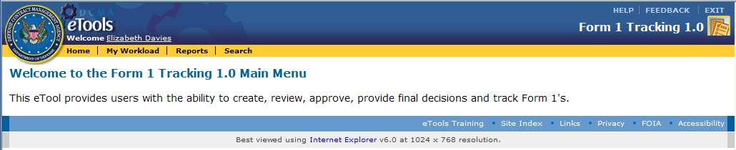   
Figure 5.1.1 DCAA Auditor Home Page

The “Gold Menu Bar” has the following function buttons:

* **Home** – clicking on “Home” takes the user to “Home” page.
* **My Workload** – clicking on “My Workload” takes the user to “My Workload” page.
* **Reports** – clicking on “Reports” takes the user to the available “Reports.”
* **Search** – clicking on “Search” function takes the user to the “Search” page (Only available for certain users)

## 5.2 “My Workload” Page

1. To start, Click on the “My Workload” Page.

My Workload page is organized into the two (2) tabs. The page by default will be on the “Form 1 – In Process” tab:

* **Form 1 – In process**: Form 1s with status of “Draft,” “Submitted,” “Under Review,” “Reviewed,” “Under Approval,” “Approved,” “Not Approved” and “Finalized.”
* **Form 1 – Released**: Form 1s with status of Released

**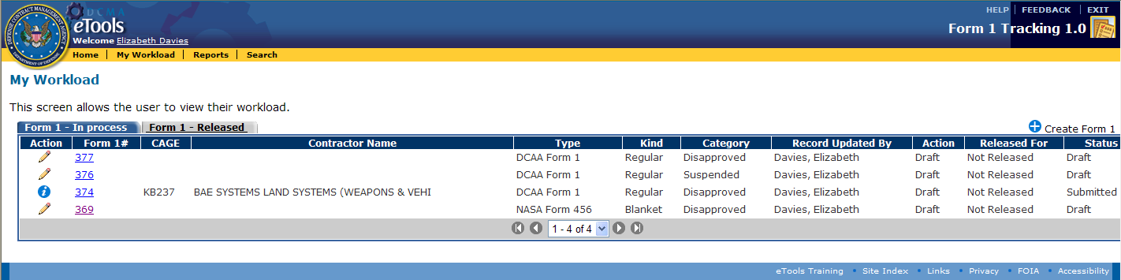**

Figure 5.2.1 “My Workload” page: “Form 1 – In Process” Tab

## 5.3 DCAA Auditor Creates a Form 1

1. The user (**DCAA** **Auditor**) clicks on the “Create Form 1” icon to create a Form 1:

- Clicking this icon will take the user to the first “Create Form 1” page



Figure 5.3.1 DCAA Auditor “My Workload” page – “Create Form 1”

2. Clicking on “Create Form 1” will display the first page in the “Create Form 1” user task:

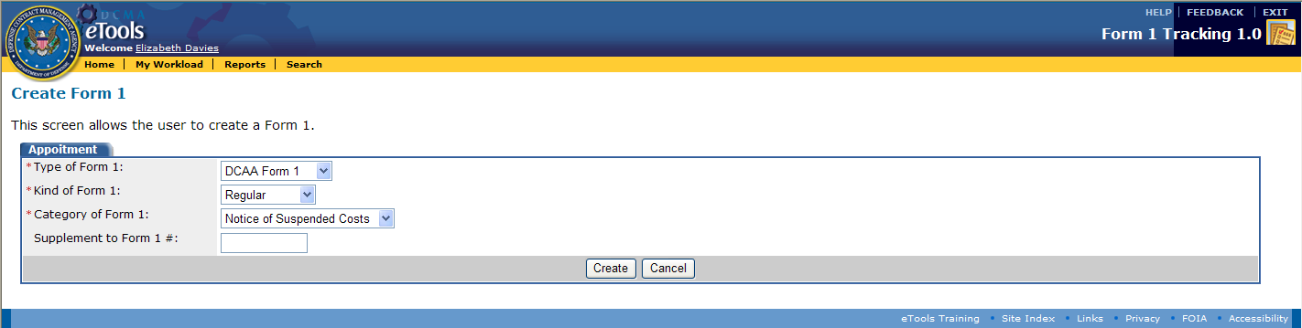  
 Figure 5.3.2 Initial “Create Form 1” Page with Appointment Fields

3. The **DCAA** **Auditor** makes the following choices from the drop-down menus (Red asterisks are mandatory fields. “Supplement to Form 1 #” is a non-mandatory field)

* **Type of Form 1**: *DCAA Form 1* or *NASA Form 456* (for this example, select *DCAA Form 1)*
* **Kind of Form 1**: Regularor Blanket (for this example, “Regular” is selected*)*
* **Category of Form 1**: Notice of “Disapproved” Costs
* **Supplement to Form 1**: Optional field

4. Once all fields with red asterisks are complete, the user then clicks on the “Create” button  and is taken to the “Create a DCAA Form 1” page:

**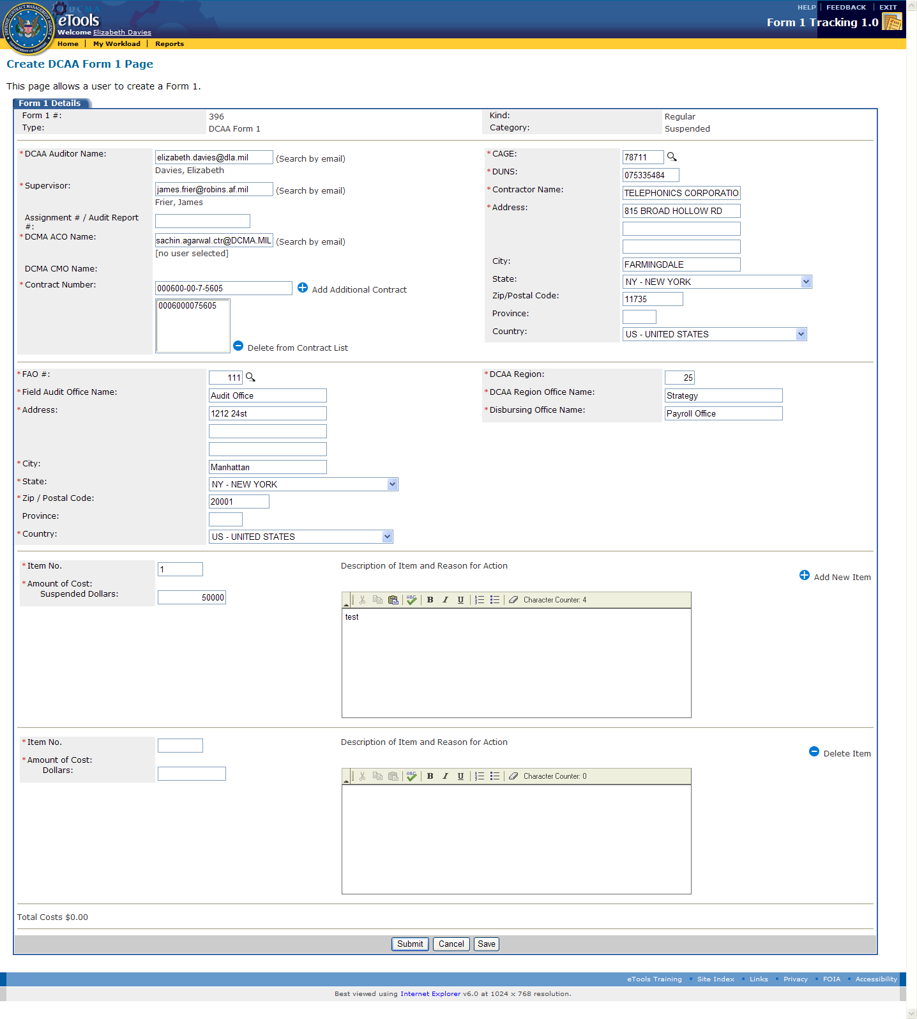** Figure 5.3.3 “Create DCAA Form 1” Page

5. The user (**DCAA** **Auditor**) types in the following data:

* + DCAA Auditor Name
  + Supervisor
  + DCMA ACO Name – chooses
  + DCMA CMOName (auto populated)
  + Contract number
  + CAGE number
  + DUNS
  + Contractor Name, Address, City, State and Zip code.
  + FAO #, Field Audit Office Name, Address, City, State and Zip code
  + DCAA Region # and DCAA Region Office Name
  + Disbursing Office Name
  + Disapproved Dollars
  + Description of the reason for Action
  + Clicks on the “Submit” button

6. Once data is entered, the user (DCAA Auditor) will hit the “Submit” button.

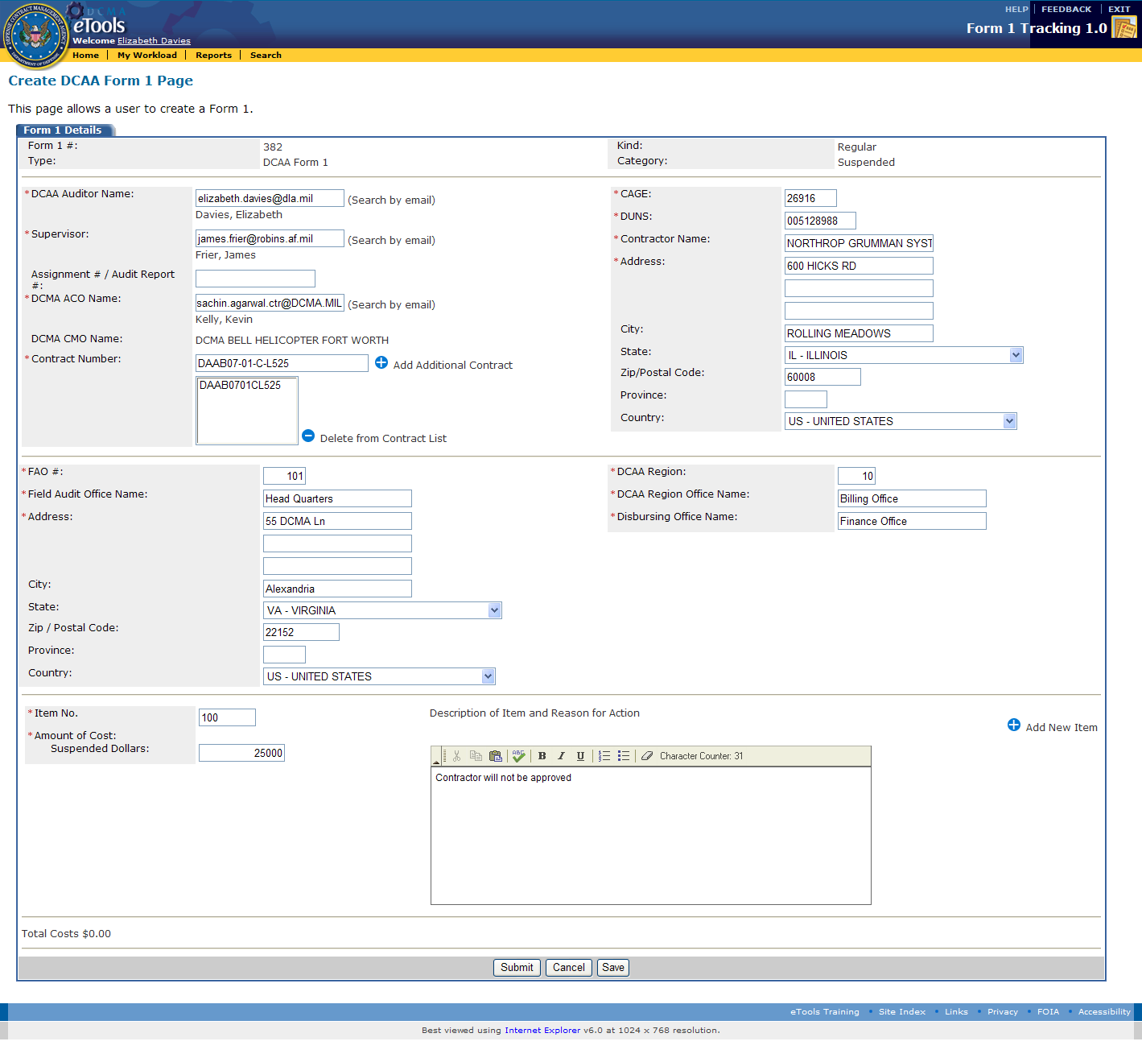

Figure 5.3.1 DCAA Auditor Submits Form 1

7. The user (**DCAA** **Auditor**) is then taken to the “My Workload” page. Note that the Form 1 now has a status of “Submitted.” The Form 1 status (in the Status column) will update as the Form 1 moves through the approval user task.

Note: The user (**DCAA** **Auditor**) can view the current “Action,” “Release For,” “Status,” and other details of the Form 1 throughout the approval process from the “Status” column on the “My Workload” page.

### 

### **5.3.1 DCAA Auditor Views and Finalizes a Form 1**

### 1. The DCAA Auditor can view and finalize Form 1 using the “View” page.

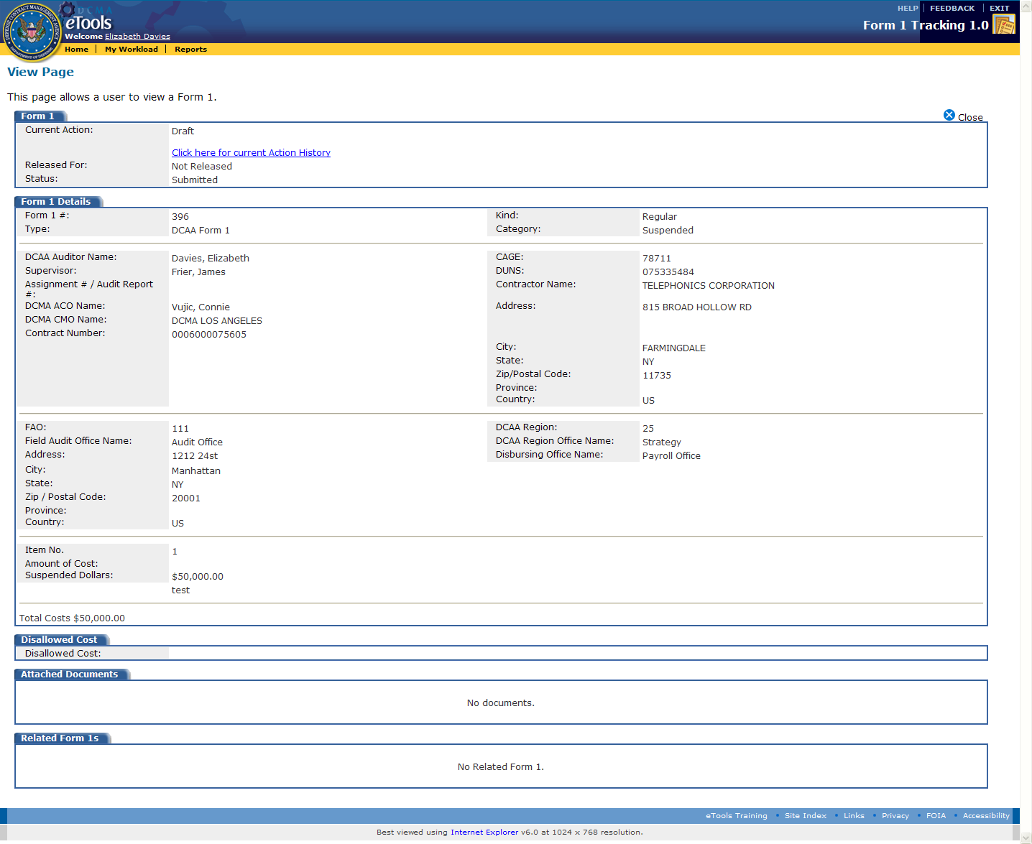

Figure 5.3 View Page

2. Once the user hits “Close”  , note that the Form 1 has been now been routed to the **Supervisor**, which is the next user in the Form 1 user task for action.

## 5.4 DCAA Supervisor Reviews/Approves Form 1

1. To start, the user (**DCAA** **Supervisor**) clicks on the “Edit” icon edit from the “My Workload” page. Clicking on this icon will take the user to the “Review page” to review the Form 1:

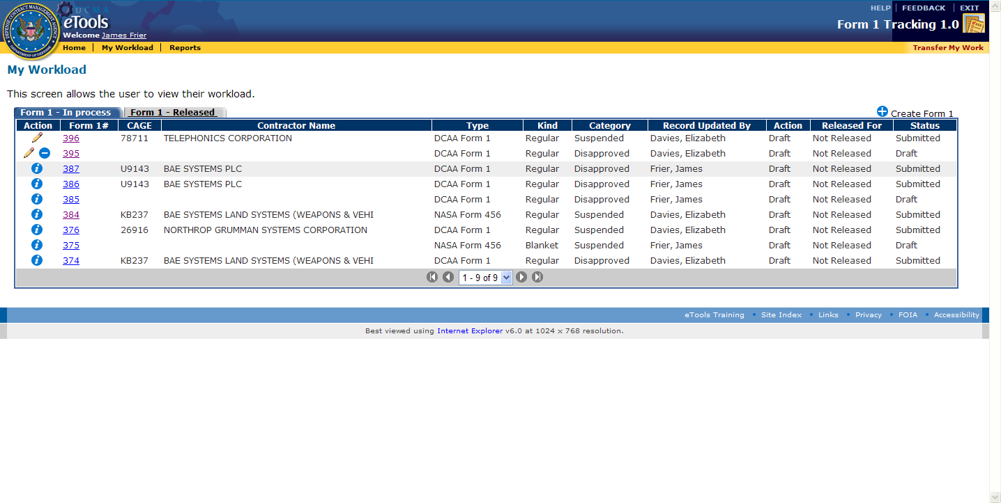

Figure 5.4.1 DCAA Supervisor’s “My Workload” Page with “Edit” icon

2. The user (**DCAA** **Supervisor**) is taken to the “Review” page where the “Form 1 Details” section data can be reviewed.  
  
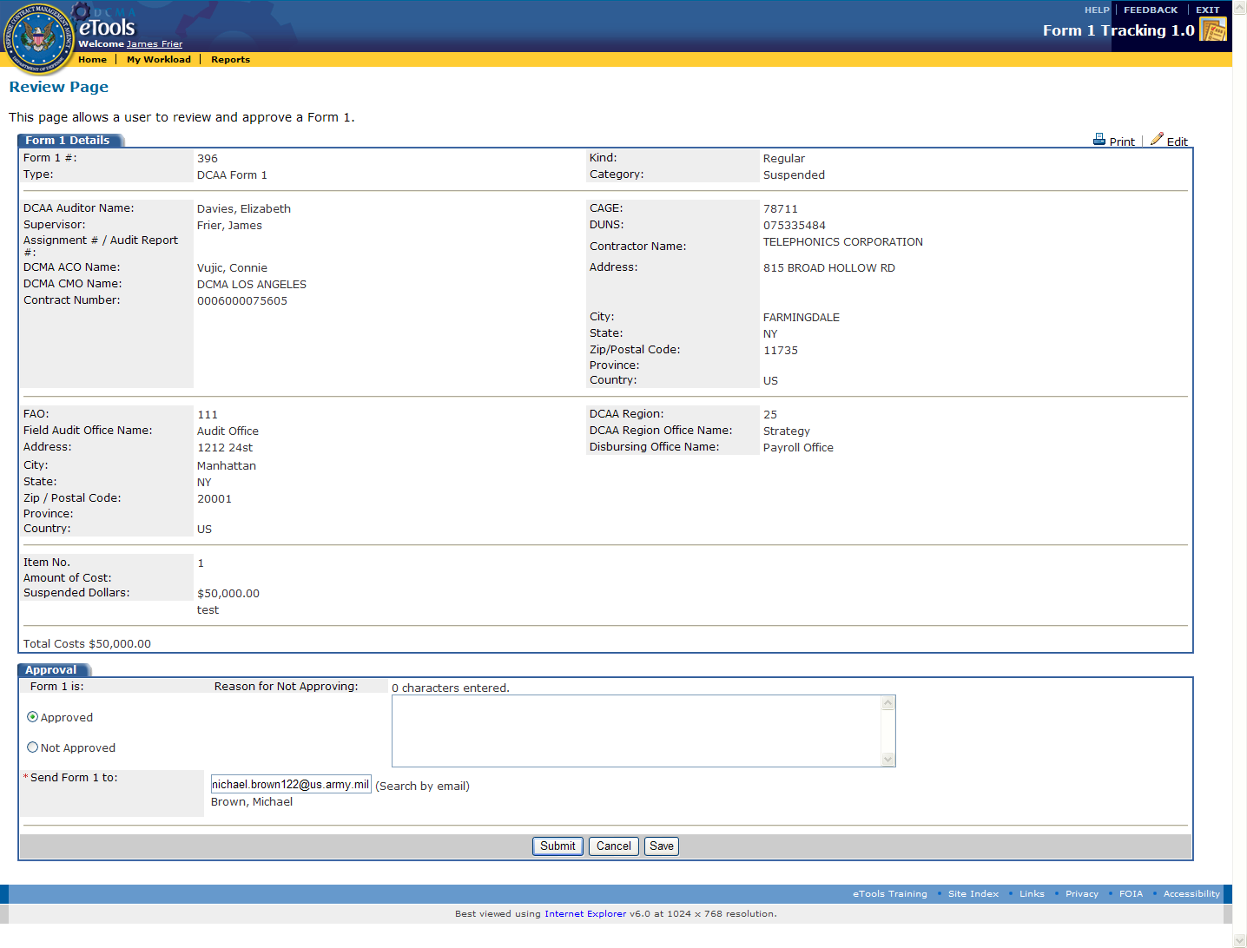 Figure 5.4.2 DCAA Supervisor’s “Review Page with “Approved”/”Not Approved” Selections

3. Under the Approval Tab, the Supervisor has 2 options:

1. Approved  
2. Not Approved (Provide “Reason for Not Approving” in the text box on the right side)

In this case, the **DCAA Supervisor** selects “Approved”

4. The **DCAA Supervisor** then chooses the next reviewer in the process, the **FAO Reviewer** user role, and clicks on the “Submit” button.



Figure 5.4.3 DCAA Supervisor Submits the Form 1 to the FAO Reviewer

5. After clicking “Submit,” the user (**DCAA** **Supervisor**) is taken to the users “My Workload” page. Note that the Form 1 status has now changed to “Reviewed.” The Form 1 has now been routed to the next user in the Form 1 user task for action.

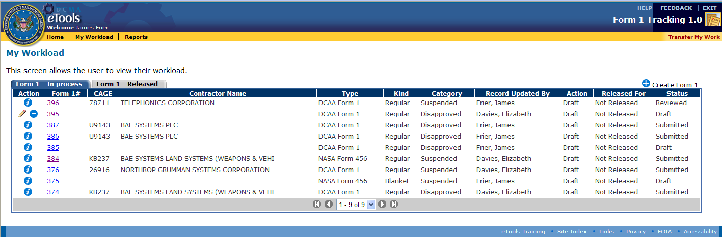

Figure 5.4.4 Supervisor “My Workload” page and Status of “Reviewed”

Note: The user (**DCAA** **Supervisor**) can view the current Action, “Released For,” and “Status” of the Form 1 throughout the approval user task from the Status column. The status under the “Status” column will update as the Form 1 moves through the approval user task.

## 5.5 DCAA FAO Reviewer Reviews/Approves Form 1

1. To start, the user (**DCAA** **FAO Reviewer**) clicks on the “Edit” icon edit. Clicking on this icon will take the user to the “Review page” to review the Form 1:

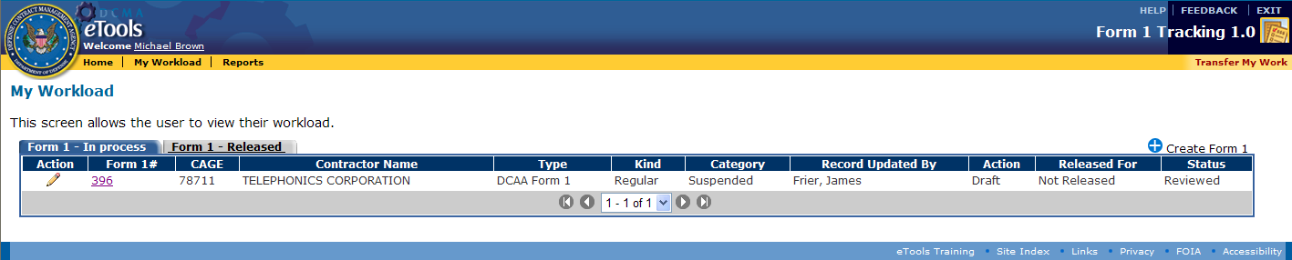  
 Figure 5.5.1 FAO Reviewer’s “My Workload” page with “Edit” icon

2. The user (**DCAA FAO Reviewer**) will then be taken to the “Review” page, where the user reviews the Form 1 Details section data.

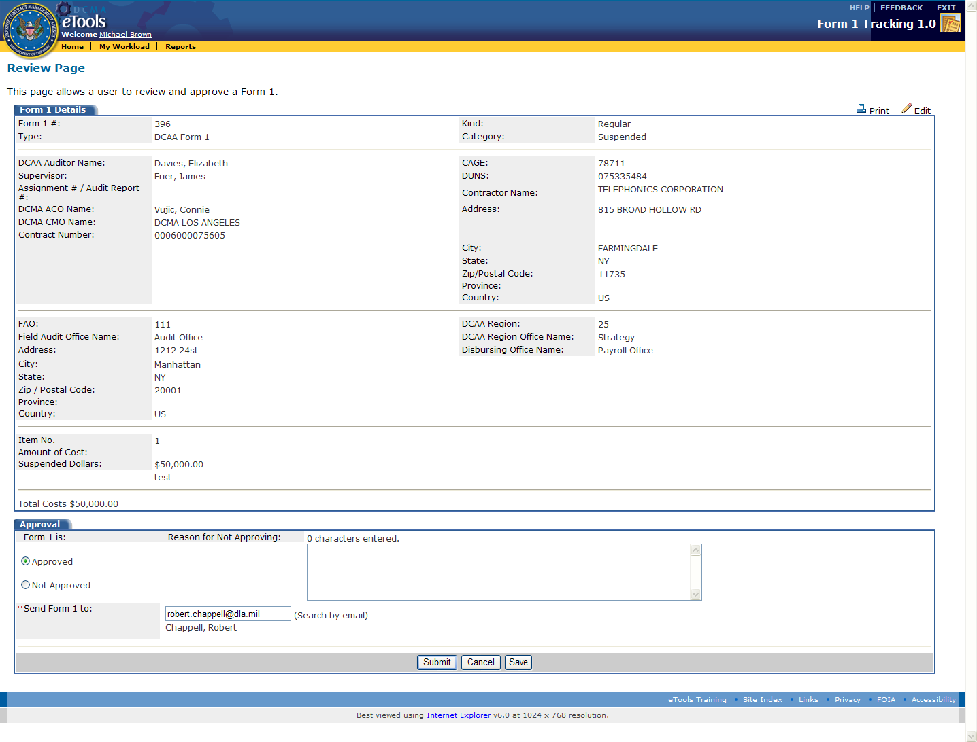Figure 5.5.2 FAO Reviewer’s “Review” Page Form 1 Details

3. Under the Approval Tab, the Supervisor has 2 options:

1. Approved  
2. Not Approved

In this case, the **DCAA FAO Reviewer** selects “Approved”

4. The **DCAA FAO Reviewer** then chooses the next reviewer in the process, the **Regional Reviewer** user role, and clicks on the “Submit” button.

5. After clicking “Submit,” the user (**DCAA FAO Reviewer**) is taken to the users “My Workload” page. Note that the Form 1 status has now changed to “Reviewed.” The Form 1 has now been routed to the next user in the Form 1 user task for action.

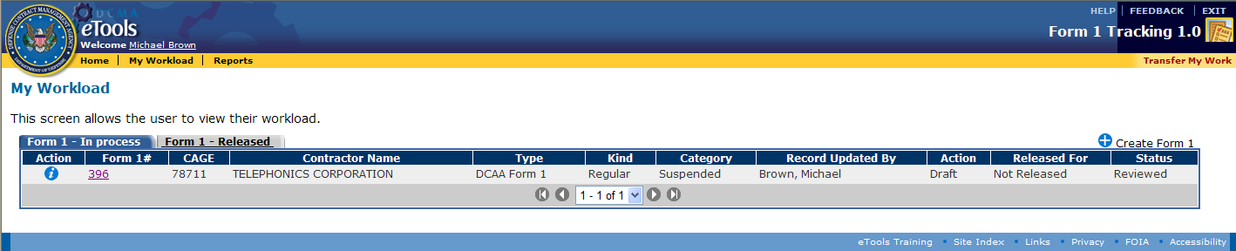

Figure 5.5.3 DCAA FAO Reviewer’s “My Workload” page and Status of “Reviewed”

Note: The user (**DCAA** **Supervisor**) can view the current Action, “Released” For, and Status of the Form 1 throughout the approval user task from the Status column. The status under the “Status” column will update as the Form 1 moves through the approval user task.

## 5.6 DCAA Regional Reviewer Reviews/Approves Form 1

1. To start, the user (**DCAA** **Regional Reviewer**) clicks on the “Edit” icon edit to review the Form 1. Clicking on this icon will take the user to the “Review” page.

**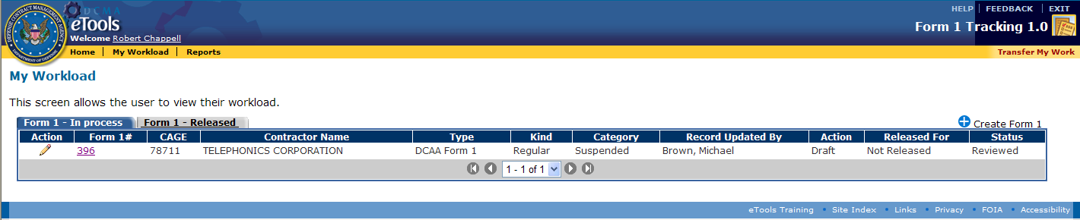**

Figure 5.6.1 Regional Reviewer’s “My Workload” page and “Edit” Icon

2. The user (**DCAA** **Regional Reviewer**) can then review the Form 1 Details section data.

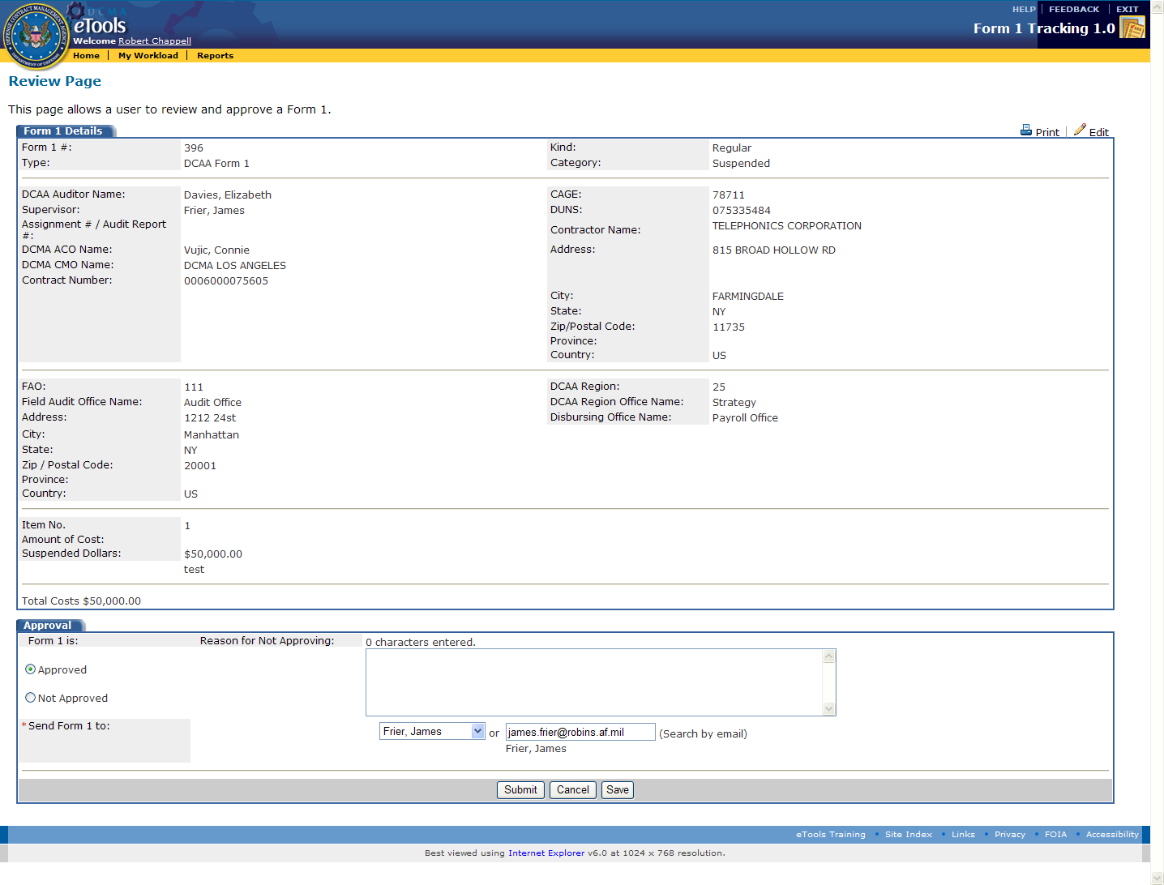

Figure 5.6.2 Regional Reviewer’s “Review” Page and “Approved”/”Not Approved” Selections

3. Under the Approval Tab, the Supervisor has 2 options:

1. Approved  
2. Not Approved

In this case, the **DCAA** **Regional Reviewer** selects “Approved”

At this state the **DCAA Supervisor** email address will be automatically entered for submission.

3. After hitting, “Submit,” the user (**DCAA** **Regional Reviewer**) is taken to the users “My Workload” page. Note the Form 1 now has a status of “Approved.” The status under the “Status” column will update as the Form 1 moves through the approval user task. The Form 1 has been routed to the next user in the Form 1 user task for action.

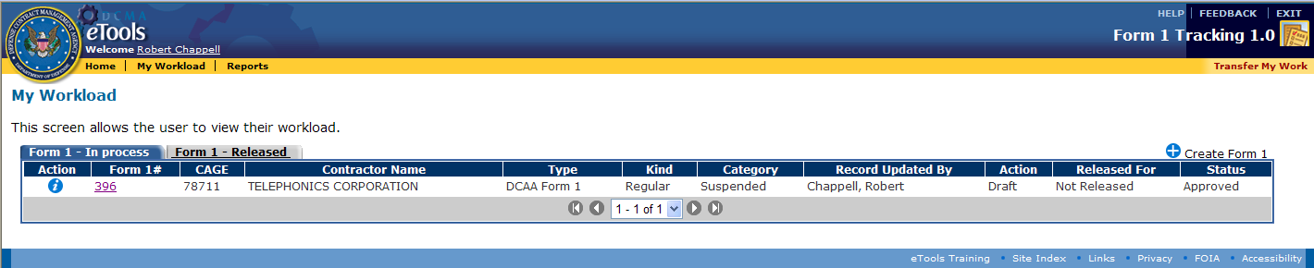  
Figure 5.6.3 Regional Reviewer’s “My Workload” page and “Approved” Status

The user (**DCAA** **Regional Reviewer)** can choose the “Send Form 1 to Data Field” for action.

Note: The user (**DCAA** **Regional Reviewer**) can view the current “Action,” “Released For,” and “Status” of the Form 1 throughout the approval process from the Status column.

## 5.7 DCAA Supervisor Finalizes/Submits Form 1

1. To start, the user (**DCAA** **Supervisor**) clicks on the “Edit” icon edit on the “My Workload” page.

### 

Figure 5.7.1 “Edit” Icon on DCAA Supervisor “My Workload” Page

2. After clicking the “Edit” icon edit , the DCAA Supervisor will be taken to the “Finalize” page, where the following fields will be completed:

1. Current Action dropdown – From “Draft” to “Finalize” state.  
2. “Released For”  
3. Current “Action” comments

4. “Finalized” Date

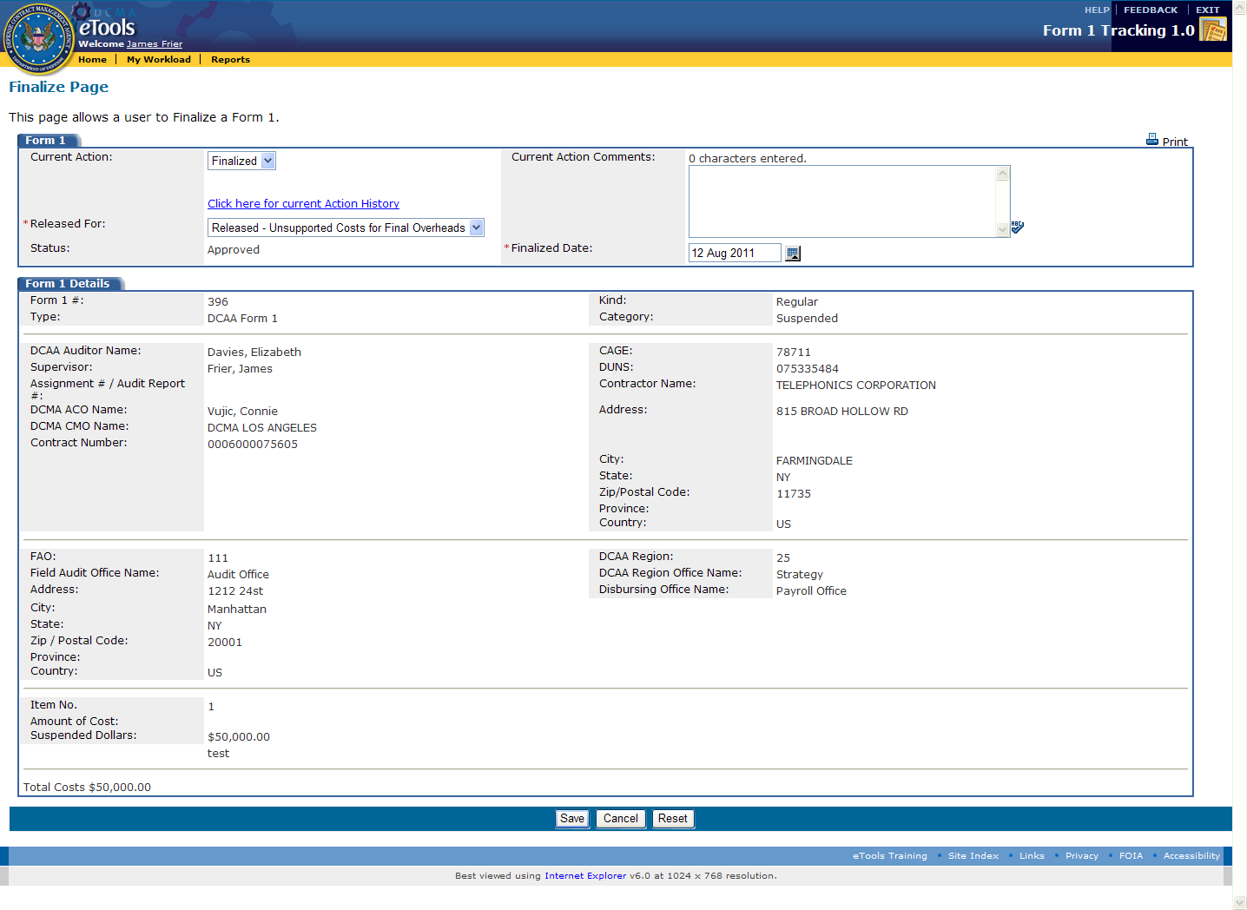

Figure 5.7.2 DCAA Supervisor’s “Finalize” Page for Form 1

4. The user (**DCAA** **Supervisor**) will change the Current Action to “Finalized.” Type in the reason for changing the “Current Action” field in the “Current Action Comments.”

5. Change the “Released For” data field to reason the Form 1 will be “Released” to the **ACO/CO**.

6. Click on the “Save” button to save all modified data.



7. The user (**DCAA** **Supervisor**) is then taken back to the users “My Workload." The My Workload has now changed. The “Released For” column has now been updated to the “Released” status.

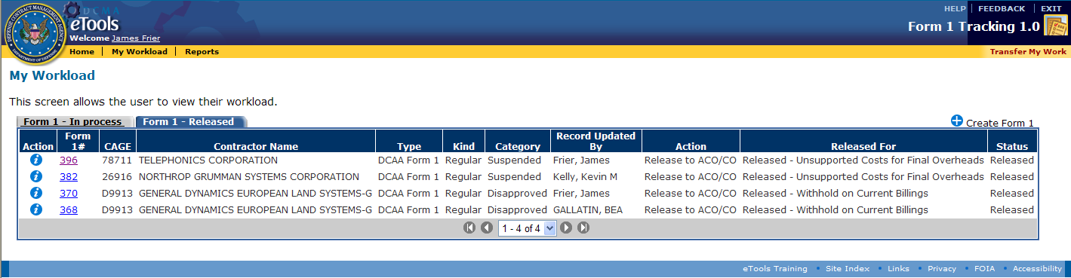

Figure 5.7.3 DCAA Supervisor’s “My Workload” Page with Status of “Released”

## 5.7.1 DCAA Supervisor Prints Form 1

From the “Finalize” page, note the user can also print the Form 1.



Figure 5.8.1 Printing Form 1  
1. The user (**DCAA** **Supervisor**) clicks the “Print”  icon in the top right corner of the page to print out the *DCAA Form 1*. The user is then taken to the print page.

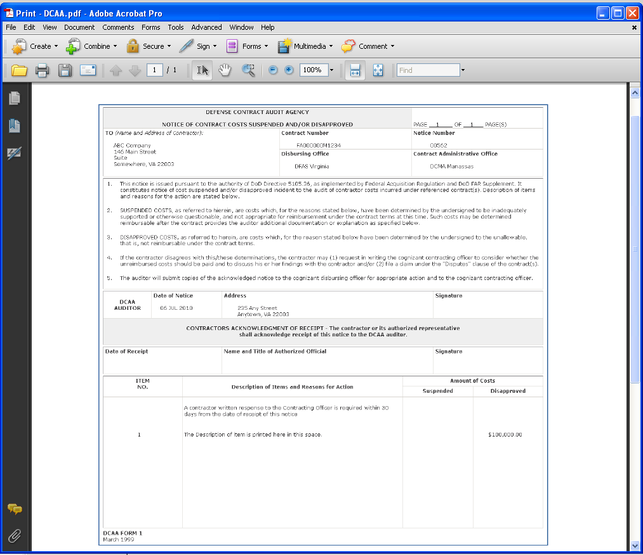

Figure 5.8.1 Form 1 Print Page

## 5.8 DCAA Supervisor Releases “Finalized” Form 1 to ACO/CO

**The DCAA Supervisor** will now attach the contractor’s signed Form 1 and releases the Form 1 to the **ACO/CO** for action.

1. To start, from the “My Workload” page, the user (**DCAA** **Supervisor**) clicks on the “Edit” icon edit . Clicking on this icon with Form 1 status of “Finalized” will take the user to the “Review” page to add a document and release the *DCAA Form 1* to the **DCMA ACO**.

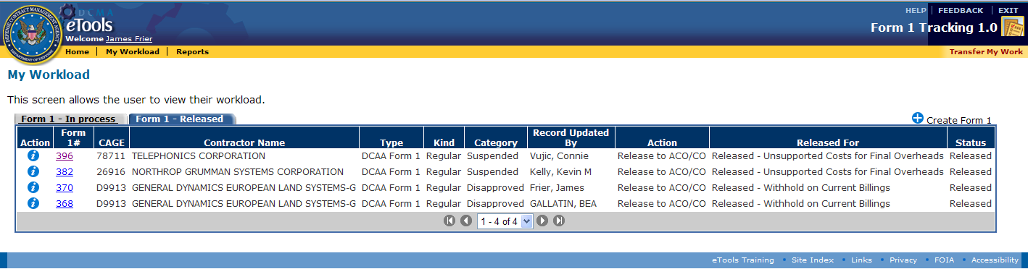

Figure 5.9.1 DCAA Supervisor’s “My Workload” Page

2. Edit Page:The user (**DCAA Supervisor**) will now attach the signed Form 1.

3. From the “Edit” page, the user clicks on the “Add” icon under the “Attached Documents” tab. 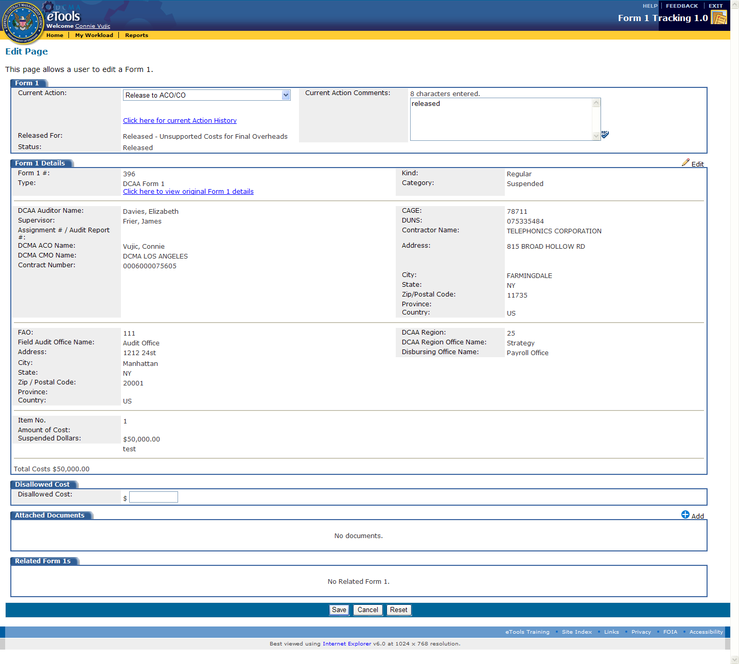   
  
Clicking the “Add” icon then takes the user to the “Attachments” page.

4. Attachments Page:The user (**DCAA** **Supervisor**) will click on the Browse button, locate the document to add, types in the document description and clicks on the “Add” button.

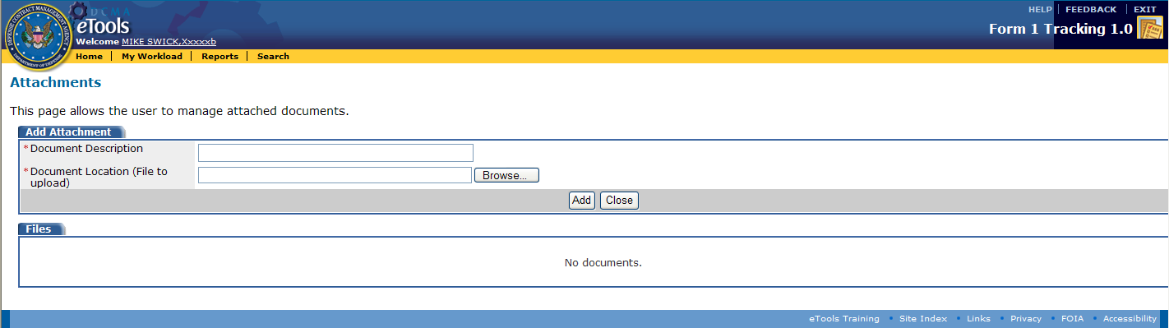

Figure 5.9.2 DCAA Supervisor’s “Attachments” Page and “Add” Button

Note that the document is now added under the “Attachments Documents” tab.

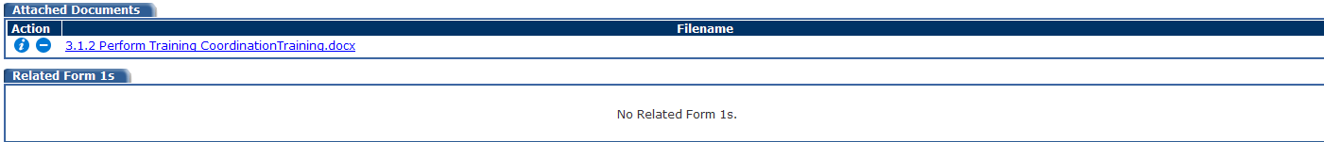

Figure 5.9.3 Attached Documents Tab with Attached Document

5. The user then clicks on the “Close” icon  and is taken back to the “Edit” page (previous page). Note that the document attached is now listed under the “Attached Documents” tab.

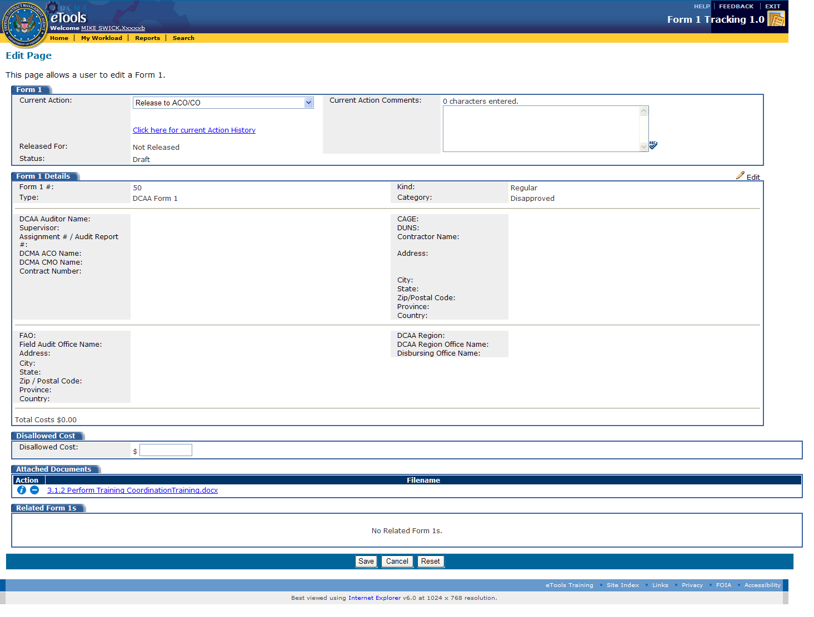

Figure 5.9.4 “Edit” Page showing Attached Document

6. The user (**DCAA Supervisor**) will change the Current Action to: “Released” to **ACO/CO**, types in the reason in the Current Action Comments and clicks on the “Save” button.

7. Click the “Save” button to save the data on this page. Doing so will bring the user back “My Workload” page.

  
5.9.5 “My Workload” Page Showing Form 1 Under Form 1 – Released” Tab

Note that the Form 1 remains in the user’s workload under the “Form 1 – Released” Tab.

### **5.9 DCMA ACO Releases Form 1**

**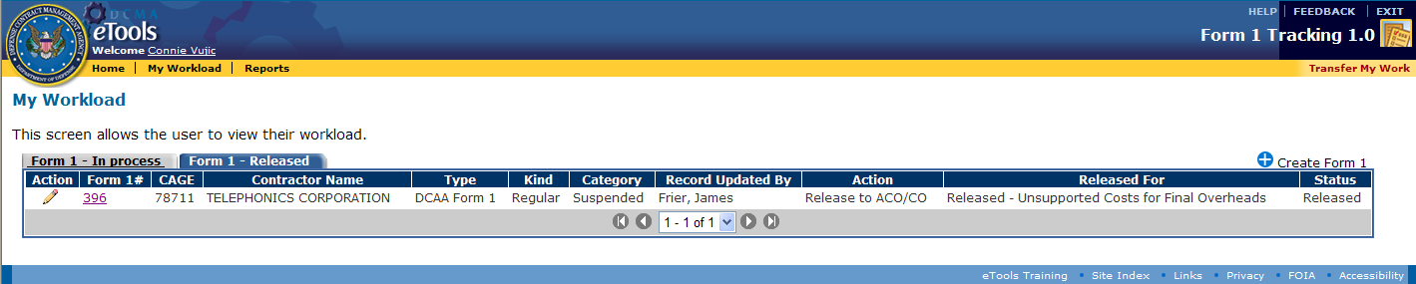**

Figure 5.9.1 DCMA ACO’s “My Workload” Page

1. The ACO will begin on the “My Workload” page. The **DCMA ACO** can now click on the “Form 1 – Released” tab to find the Form 1 record. Note that the Form 1 is now present in the ACO’s “My Workload” page as “Released.”

**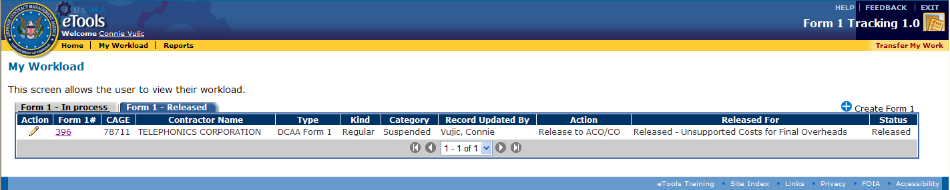**

Figure 5.9.2 DCMA ACO’s “My Workload” Page, “Form 1 – Released” Tab

2. Click on the “Edit” icon edit , which will then take the user to “Edit” page.

****

Figure 5.9.3 “Edit” Page

3. The ACO/CO will then edit the Form 1 “Current Actions” and other data before clicking “Save.”

## 6.0 Editing a and Closing Released Form 1

A DCAA User or DCMA ACO can edit the Form 1 after it has been “Released” using the “Edit” page.

1. From the “My Workload” page, the user (**DCMA ACO**) will click on the “Edit” icon edit next to the Form 1, which will then take the user to “Edit” page.

## 

Figure 6.1.1 “Edit” Page

2. On this page, under the “Form 1” field, the user will choose from one of twelve (12) different “Current Action” options in the drop down menu.

## 

Figure 6.1.2 “Current Action” Drop-Down Menu

Note: All user roles *except* for the **DCAA** and **DCMA Administrator** can “Close” a “Suspended” Form 1 and “move to Disapproved.” Additionally, a **DCAA Supervisor** or any **DCAA** user acting as a **NASA CO** can “Close” a Form 1.

3. Selecting any of the following “Current Actions” will then close the Form 1: “Contracting Officer Final Decision Issued,” “Post Negotiation Memorandum Issued,” or “Written Determination to Withdraw Notice Issued.”

## 4. When a user changes the Current Action data field to any of the following: “Contracting Officer Final Decision Issuesd,” “Post Negotiation Memorandum Issued,” or “Written Determination to Withdraw Notice Issued”, the user will be required to fill in the “Disallowed Costs” field. The user must enter a dollar amount in the format of $ 0,000,000.00

## 

Figure 6.1.5 “Disallowed Cost” on the “Edit” page  
  
Note: A closed Form 1 will stay in a user’s workload for only one (1) business day before it is no longer viewable in the “My Workload” page.

4. When Current Action value has been change to: “Contractor Filed Claim Under Disputes Clause,” then “Date of Claim” is a required field and the user must enter the date.

## 

Figure 6.1.3 “Contractor Filed Claim Under Disputes Clause” Selected and the “Date of Claim” Field Required

5. When Current Action value has been change to: “Received Written Request for Re-consideration,” “Date of Reconsideration Request” is a required field and the user must enter the date.

## 

Figure 6.1.4 “Received Written Request for Re-Consideration” Selected and the “Date of Reconsideration Request” Field Required

## 7.0 Additional Functionality

## The following chart identifies which user roles have access to each of the additional functions:

|  |  |  |  |  |  |  |
| --- | --- | --- | --- | --- | --- | --- |
| **User Tasks** | **DCAA**  **Auditor** | **DCAA**  **Supervisor** | **DCAA**  **FAO**  **Reviewer** | **DCAA**  **Regional /**  **DCMA**  **Reviewer** | **DCMA**  **ACO / NASA CO** | **DCAA / DCMA**  **Administrator** |
| Search |  |  |  |  |  | X |
| Not Approved Form 1 - Supervisor |  | X | X | X |  |  |
| View and edit a Not Approved Form 1 - Auditor | X |  |  |  | X |  |
| Delete a Form 1 - Auditor | X | X | X | X | X | X |
| Transfer My Workload | X | X | X | X | X |  |
| Transfer Others Work |  |  |  |  |  | X |
| Withdraw Form 1 |  |  |  |  |  | X |

## 7.1 Search

Note: Only **Administrators** (DCAA and DCMA) and **DCMA Region/HQ Personnel** can utilize the “Search” function.

“Search” page rules:

* All data fields are optional on this page, but the user must enter at least one field.
* Allow for wildcard searches
* Searches are within the eTool data only
* DCAA can search on all Form 1s.
* DCMA users can only search for Form 1s with a status of “Released” and assigned to DCMAs ACOs

### 1. Click on “Search” from the Golden Menu Bar

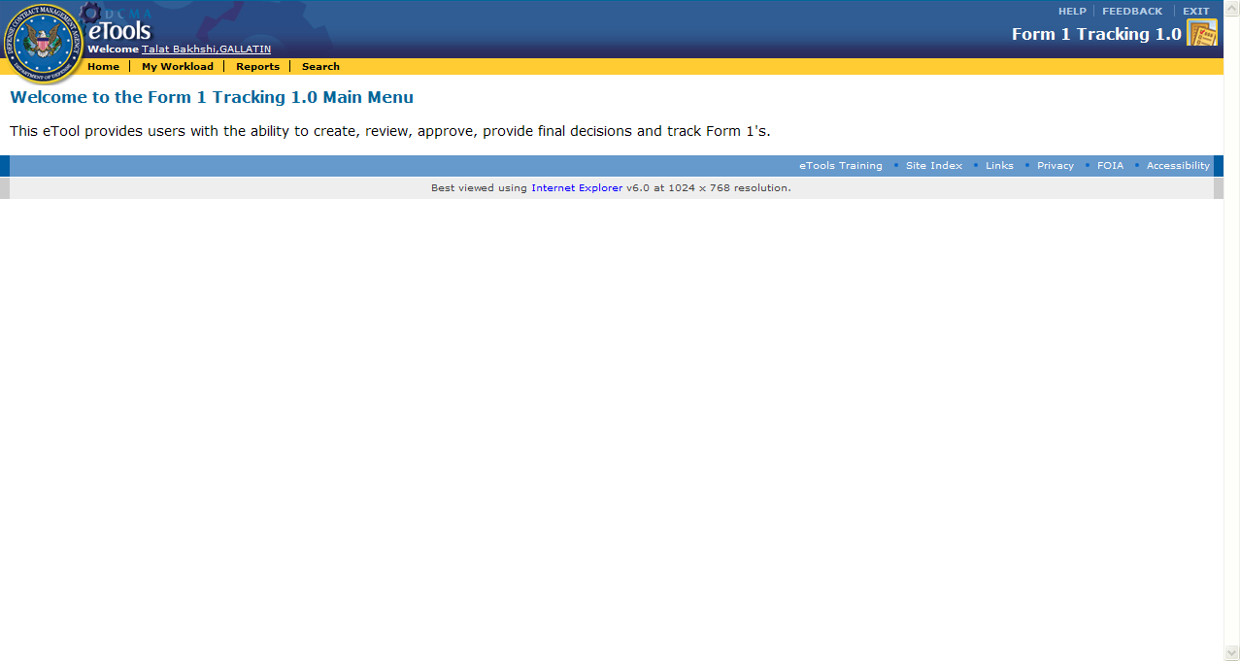

Figure 6.1.1 “Search” Tab

2. Once on the “Search” page, enter in data desired to narrow the search results.

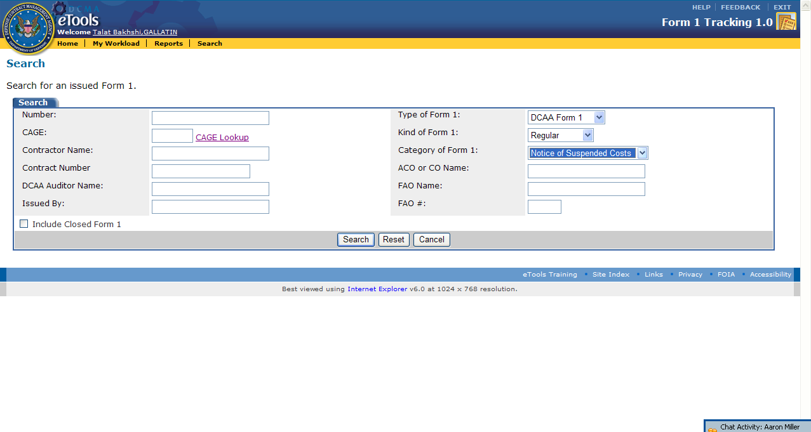

Figure 6.1.2 Search Page and Related Fields

3. Once all necessary fields are filled out, the user has three options:

* “Search”– Provides Form 1 data based on the given criteria.
* “Reset”– Resets all data fields on this page
* “Cancel”– Takes the user back to the previous page (in this use case it is the users “Home” page.

In this case, the user will view the search results on the “Search Results” page by clicking the “Search” button.



4. The search results based on the given fields will be then be displayed on the subsequent screen.

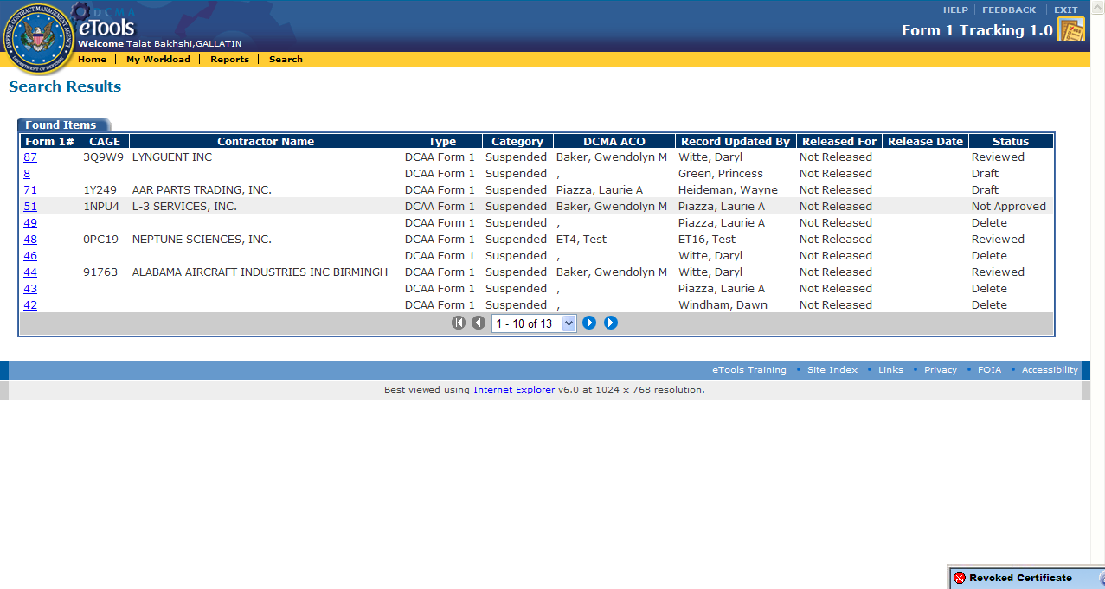

Figure 6.1.3 Search Results page

## 7.2 Delete a Form 1 – Auditor

Note: This feature is available to all **DCAA** user roles and the **DCMA ACO** user role (if **DCMA ACO** issued the DCAA Form 1). Users can only delete Form 1s with a current Action: “Draft,” “Released” for: Not “Released” and with a status of “Draft” or “Not Approved.” The user deleting the Form 1 must also be the creator of the Form 1.

1. To Delete a Form 1 the user (**Auditor**) starts on the “My Workload” Page.

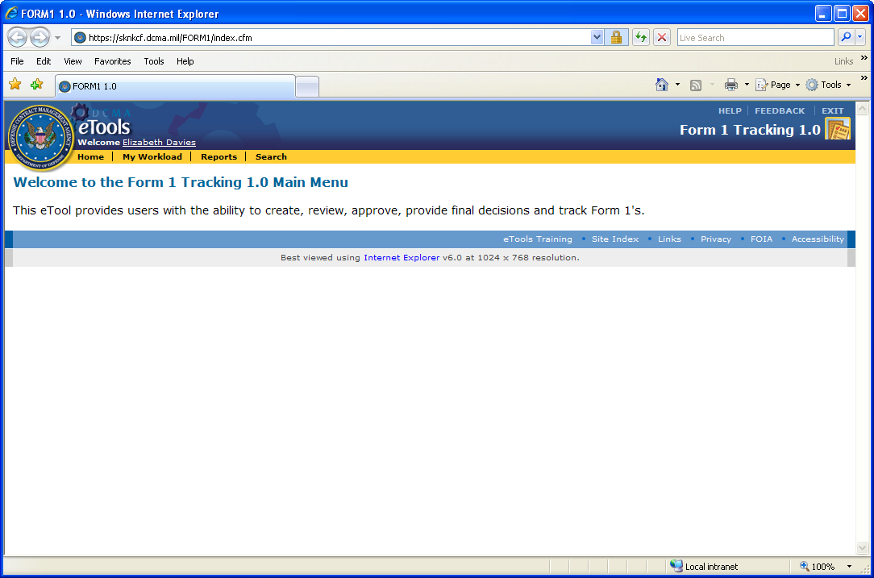

Figure 6.2.1 Auditor’s “Home” Page

delete2. Once on the “My Workload” page, the user will click on the delete icon on the left, under the Action column, next to the Form 1 the user wants to delete.

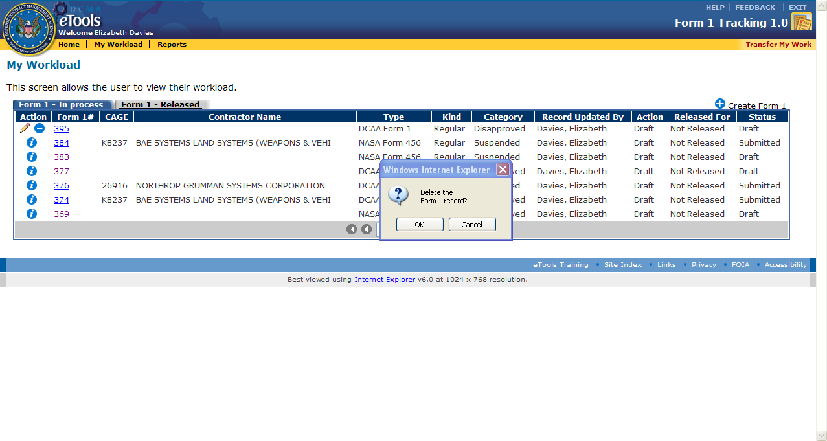

Figure 6.2.2 Deleting a Form 1 Record from Users’ Workload Page

3. Click “ok” when the confirmation window prompt appears. The Form 1 is now deleted and will no longer appear in the workload.

## 7.3 Transfer My Workload

Using the “Transfer My Workload” function, the **DCAA Auditor** (user role) can transfer their work to another user. Users can only transfer work that has been created by that user.

Note: All user roles can perform this function except for **DCMA Region/HQ Personnel** (this user role doesn’t have “My Workload” functionality). The workload page shows Form 1s that the user has worked on, as well as Form 1s that are currently assigned to that user. Only work that is assigned to that user can be transferred to another user.

1. From the home page, select the “My Workload” tab from the “Gold Menu Bar.”



Figure 6.3.1 Auditor’s “Home” Page

2. Once on the “My Workload” page, click on the “Transfer My Work” on the right side of “Gold Menu Bar.”   
  
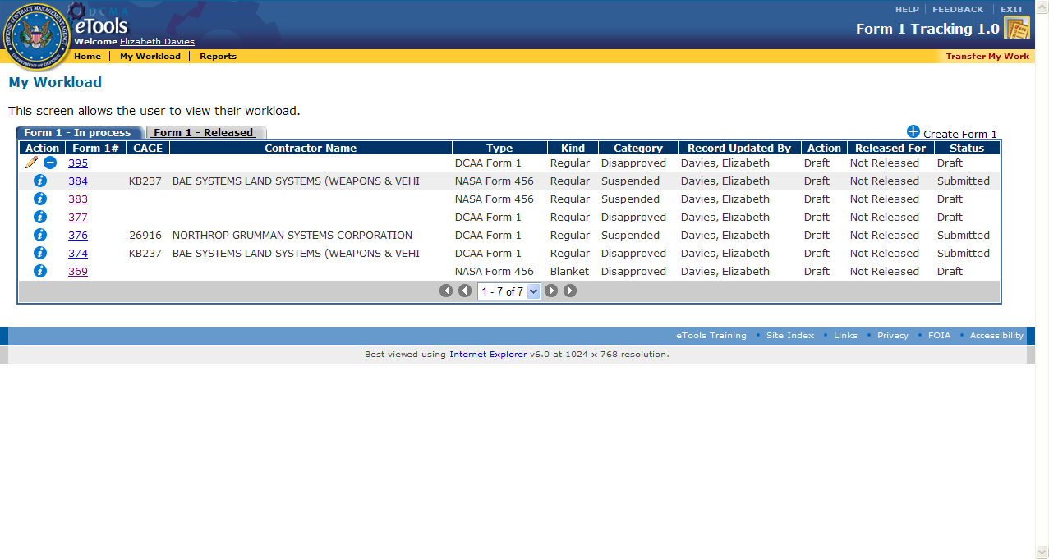

Figure 6.3.1 “My Workload” page

2. The user (**DCAA Auditor**) will be taken to the “Transfer” page on which any work that can be transferred is displayed. Select a user from the drop down list.   
  
**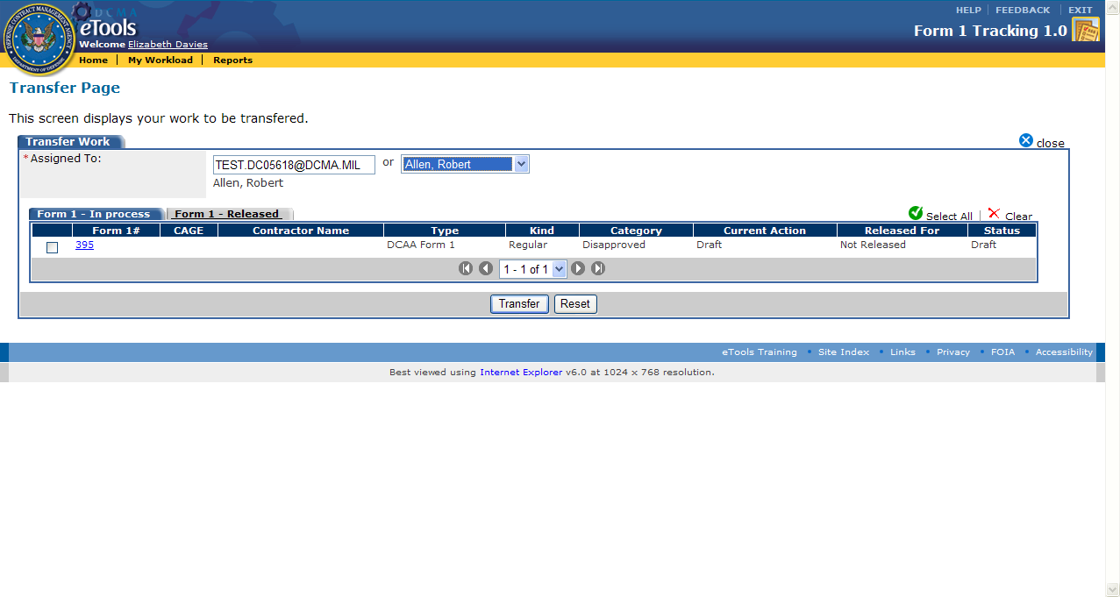**   
Figure 6.3.1 “Transfer” page

* **Assign To:** This is a required field. The user can type in an email address or select a user name from the drop down list. User names will be in alphabetical order last name, first name.
* **Select all:**  Theuser can select all work Form 1s displayed by clicking on the “Select All” icon on the right corner. All work Form 1s will then display a mark in the box to the left of the Form 1. (User can select each Form 1 individually by clicking on the check box to the left of the Form 1.)
* **Clear:** The user can clear work Form 1s selected (that display a mark in the box) by clicking on the red X “clear” on the right corner.

3. Click on the “Select All” icon  in the top right-hand corner to select all listed Form 1 records, or, if selecting specific Form 1 records, use the checkbox in the left column .

4. Click on the “Transfer” button to finalize. The work is then transferred to the new user.

****   
Figure 6.3.1 “Transfer” button on “Transfer” Page

3. The user (**DCAA Auditor**) is then taken back to the user’s “My Workload” page.

## 7.4 Administrator Transfer Work

Note: *Only* a **DCAA Administrator** user role can transfer a **DCAA** users’ workload to another DCAA user. Additionally, *only* the **DCMA Administrator** user role can transfer a **DCMA** users’ workload to another DCMA user.

1. To Transfer a user’s workload to another user, the **Administrator** first begins on the “My Workload” page.

2. The user clicks on the “Transfer Work” function button found on the right side of the “Gold Menu Bar.”

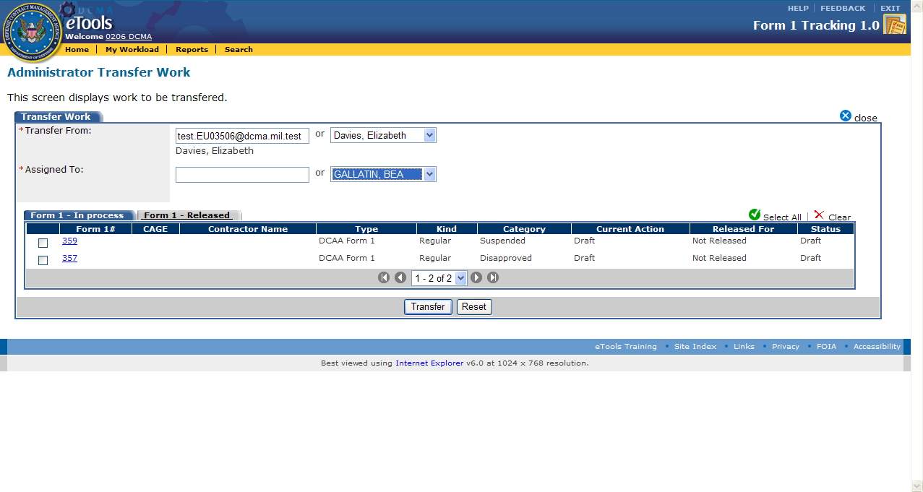

Figure 6.4.1 “Administrator Transfer Work” Page

3 The user will click the “Transfer” button to complete the action and transfer the work to another user.



## 7.5 Withdraw Form 1

Note: **Administrators** are the only user roles that can withdraw a Form 1. **DCAA Administrator**s can only withdraw Form 1s issued by DCAA. **DCMA Administrators** can only withdraw Form 1s issued by DCMA. Users can not withdraw a Form 1 with a status of “Closed” or “Closed – Move to Disapproved.”

1. To withdraw a Form 1, the action is started by clicking the “Search” function on the “Gold Menu Bar.”

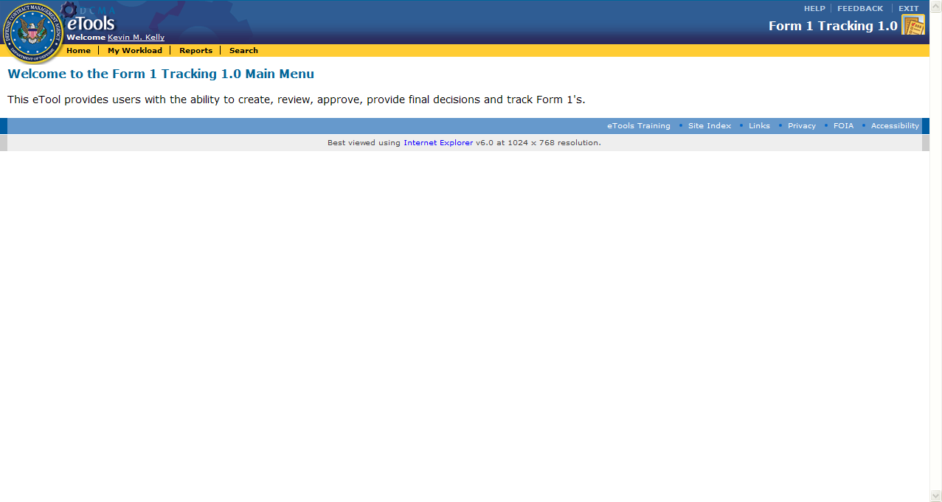

Figure 6.5.1 Administrator “Home” Page

2. The user (**DCAA Administrator**) then clicks on the “Withdraw Form 1” on the “Gold Menu Bar.”

3. Warning/Alert box: the user will receive this warning when the user clicks on the delete action icon. The “Yes” button will withdraw the Form 1 and the user is taken to the “Search” page.

Note: Withdrawn Form 1s are archived for 3 years.

4. Note that once the Form 1 is withdrawn, the Form 1 is no longer in the process flow.

5. The Form 1 is now in the status of “Withdraw” and the user is taken back to the “Search” page.

**8.0** **Glossary**

A

**ACO**: Administrative Contracting Officer

C

**CO**: Contracting Officer

**COGNOS**

F

**Form 1**: A notice of costs “Suspended” and/or “Disapproved” incident to the audit of contractor costs incurred under a contract

D

**DCAA**: Defense Contract Audit Agency

**DCMA**: Defense Contract Management Agency

**DoD**: Department of Defense

E

**EWAM**: External Web Access Management

I

**IDB**: Integrated Database

**IWAM**: Internal Web Access Management

N

**NASA**: National Aeronautics and Space Administration